

Assessment 1 – Reading Task Template
PART 1: Upload your photo of your A3 in-class notes here:
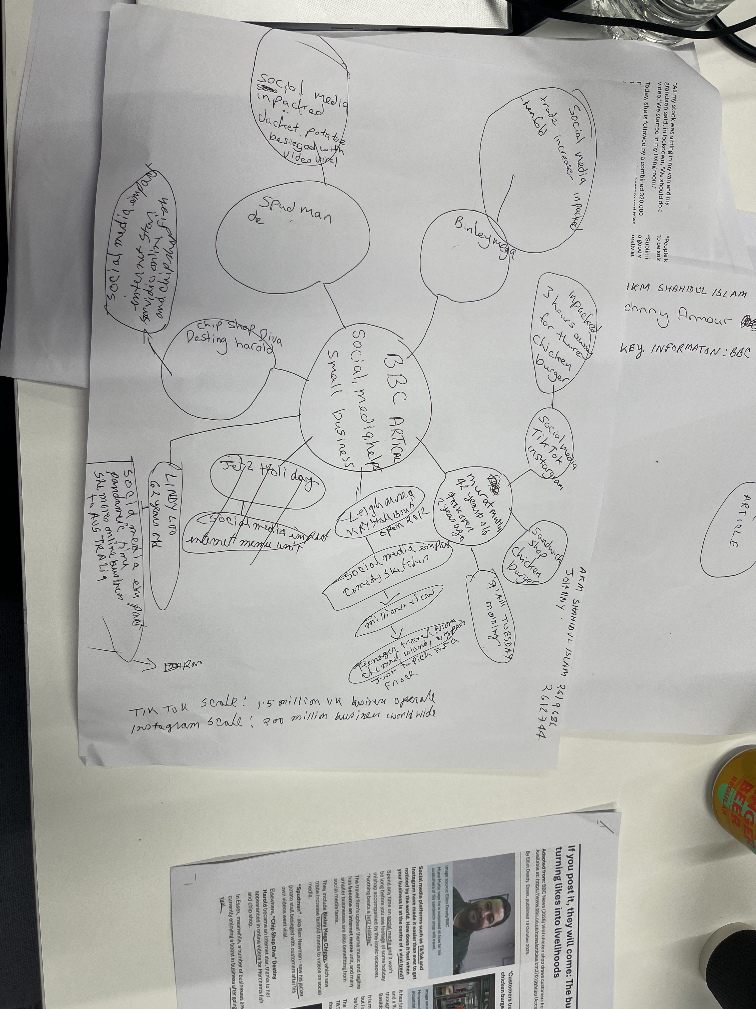

PART 2:
- Answer every question below in 1-3 full sentences.
- Use your own words. Do not use generative AI to answer these questions.
- Include a specific detail from the text when asked.
REMINDER
- The main idea is the overall message of the whole text.
- A key point helps to explain the main idea.
- A specific detail or example from the text shows that the key point is true.

1. What is the main idea of the whole text?
Answer: Social media helps small local businesses a lot. When they share real posts that people like, they can reach customers from far away. This helps them get more sales and keep their business going.
2. What is one key point that supports the main idea, and which specific example from the text shows this?
Answer: Social media helps businesses reach people who live far away. For example, customers travelled up to three hours to visit Honywood Sandwich Shop just because they saw it online.
3. What is a different key point that supports the main idea, and which specific example from the text shows this?
Answer: Posts from customers work better than the business’s own ads. Honywood Sandwich Shop grew mostly because customers shared their own videos. Little Love’s Pamper Bus also did well by posting simple, real posts instead of fancy ads.
4. Which part of the text do you think is most important, and why?
Answer: I think the most important part is that real posts from people work better than paid ads. This is important because it shows small businesses don’t need lots of money to grow — being real online is enough.
5. What did you find difficult in this task, and why was it difficult?
Answer: At first, I found it hard to tell the main idea apart from the smaller points. They sounded similar, so I had to read slowly and carefully to see the difference.
6. What helped you with this difficulty, and how did it help you?
Answer: Reading the text in small parts helped a lot. It made it easier to identify the main message and the examples used so I could answer each question clearly.

