ACDA 5021
Systems Engineering
Systems Thinking Design Student Name:- Alun Morris
4th May 2026 Student Number:- 2314593

Systems Thinking Design Report

Contents
Introduction 2
Customer Requirements and Critical Functionality 2
Requirements 2
Pairwise Comparison 2
Quality Function Deployment 3
Developing Functionality 5
Functional Decomposition 5
Function-Means Analysis 6
Generating the Concept 7
Translating FMA into Ideas 7
Pugh Matrix 8
Conclusion 8
References: 9

Academic integrity declaration
I declare that:
- the assignment submitted has been written by me alone.
- the assignment submitted has not been previously submitted to this university or any other.
- that all content, including primary and/or secondary data, is true to the best of my knowledge.
- that all quotations and references have been duly acknowledged according to the requirements of academic research.
I understand that to knowingly submit work in violation of the above statement will be considered by examiners as academic misconduct.

Introduction
This report examines the application of Systems Engineering toolsets in the development of a concept design in response to a defined customer brief. The brief required the development of a light vehicle portable mine clearance system capable of defeating both anti-personnel and anti-vehicle mines.
The report is structured around key stages of the systems engineering framework, including the identification of customer requirements, definition of critical system functionality, concept development etc. For each stage, the relevant engineering tools are described, their effectiveness evaluated, and, where appropriate, alternative methods are considered. Emphasis is placed on the Research and Development perspective in guiding concept generation and early-stage design decisions.

Customer Requirements and Critical Functionality

Requirements
The customer did not provide a specific list of requirements. A design brief was issued containing bullet points which mentioned the objective, terrain, threat and rough size requirement of the system. From the brief a list of requirements was distilled. Each requirement was a short sentence and contained either “shall” “should” or “must”. With “shall” being used for perceived customer requirements of the system. “Should” being used for requirements that could fail to be met in some circumstances if other functionality outweighed them and “must” for any requirements that were legally obligated to be fulfilled. For example, the design brief stated that “Time on the operation is critical. The emphasis is on a rapid move in, clear the objects and move on.” This was then distilled into the requirement “The system shall defeat the mine threat on a minimal timescale.”. There were requirements that were not specifically stated in the brief that were generated from researching the threat and minefield laying techniques. The requirement “The system shall always detect buried mines up to a depth of 15cm.” was included after learning that common practice for deploying anti-tank mines was for them to be buried at around 12cm deep and a further 3cm was added to capture any anomalies.
Distilling requirements from the customer brief in this fashion provided a list of requirements for moving on to the next step in the process which is a pairwise comparison. However, as the requirements are a foundation that feeds the remaining design process it is possible that some requirements that were assumed by the customer were missed by the design team since they were not explicitly stated.

Pairwise Comparison
Pairwise comparisons Matrices (PCM) are widely used in the analytical hierarchy process (AHP) to identify qualitative or quantitative criteria of specific artefacts [1]. In this case pairwise was used to identify the levels of importance of each requirement by comparing them against each other. The AHP algorithm used took the product of the row, calculated the nth root of the row product where n would be the number of values in the row and then normalised the total. See Figure 1 for an example.
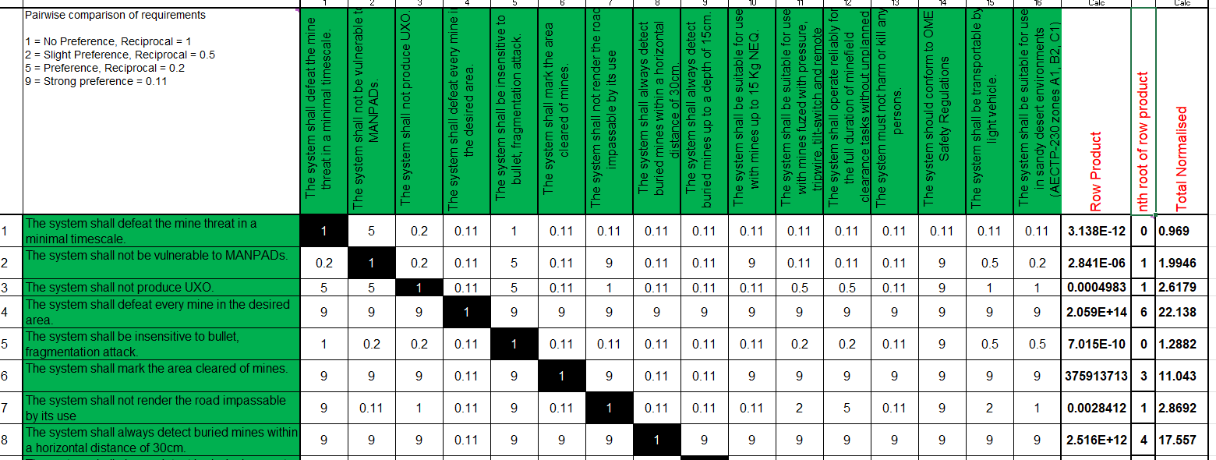
Figure 1: Pairwise
Each of the values given to the comparisons was thoroughly discussed by the team before being assigned. It should be noted that the consistency /accuracy of the values being assigned is heavily influenced by factors such as group expertise and the complexity of the decision, a potential weakness of the pairwise comparison as is also discussed in [1] which examines developments in the AHP process, reviews modern pairwise comparison methods and algorithms and explores mitigations for expert bias such as consistency ratios.
For this project no formal consistency check was performed which may have impacted the values for weightings moving forwards with the design process.

Quality Function Deployment
Quality Function Deployment (QFD) developed in Japan around the 1960s by Yoji Akao is a tool which can be used to ensure quality throughout the design process [3]. The QFD process is where the relationship between how’s and what’s of a system are quantified using a matrix as illustrated in Figure 2 taken from Dr. Stuart Burge’s article on Quality Function Deployment [2]
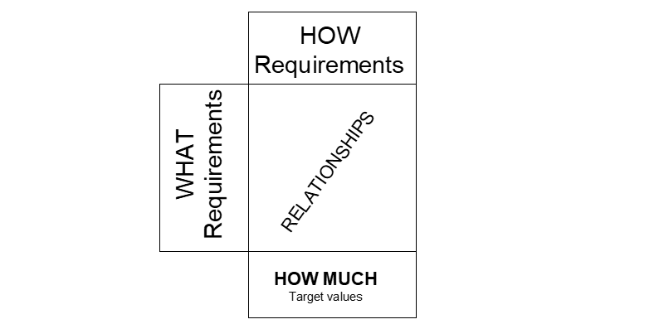
Figure 2: QFD basic structure [2]
Typically, the QFD process is separated into four phases; QFD 1 in which the customer requirements are translated into measurable technical requirements. QFD 2 where the technical requirements are translated into a design solution. QFD 3 where the system is realised through testing and evaluation and QFD 4 for delivery requirements [2].
The design QFD 1 process for mine clearing device in this report sought to analyse the relationships between the “what’s” the requirements and the “how’s” the required functionality. The required functionality of the system was developed by looking at the requirements and assigning verb noun relationships that would meet each requirement. The initial design QFD 1 containing the requirements and required functionality can be seen at Figure 3. A scoring system of 1 (weak), 3 (moderate), and 9 (strong) was applied to quantify the strength of each relationship, enabling the design team to systematically evaluate how well each function contributed to meeting customer requirements, highlighting key functional areas that required prioritisation during concept development and ensuring traceability from initial customer requirements through to design functionality decisions.
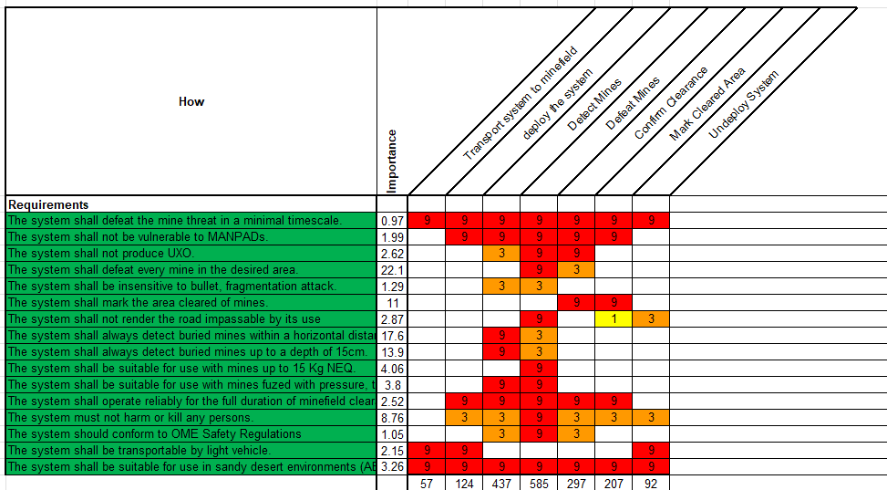
Figure 3: Initial Design QFD 1
While the QFD process is powerful and produces valuable information it should be highlighted that it is an iterative process and as the concept develops it is often necessary to revisit previously created documents and update them to include any new developments which in turn can impact many of the subsequently created documents. In complex systems this can be a lengthy process. While this is still more cost efficient than carrying through the wrong design all the way to testing or even the delivery phase alternative methods are being explored such as Model Based Systems Engineering (MBSE). According to [4] MBSE addressed the weakness of inconsistency and difficulty to manage complex systems in document based systems engineering approaches by replacing the need for multiple documents with models representing system and software architecture. This purportedly improves requirements traceability in complex systems [5].

Developing Functionality

Functional Decomposition
During the process of identifying the means of achieving the required functionality via a Function-Means Analysis (which will be discussed in the next section) it became evident that identifying means against only the critical functionality derived from the initial QFD analysis did not provide the necessary granularity to enable concept generation.
To address this, functional decomposition was used to enable a more comprehensive exploration of solutions for the next step in the design process. This is where the critical functions were broken down into the lower-level functions required to achieve the critical function.
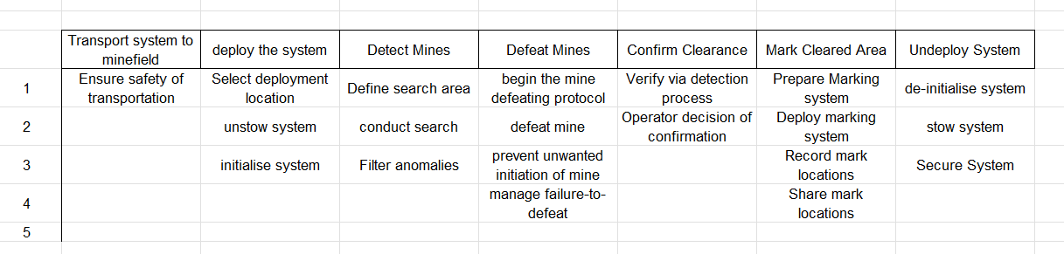
Figure 4: Functional Decomposition Mine Clearing Device
This provided a greater number of functions to perform a means analysis against. Also, as noted in [6] a key product of functional decomposition is its ability to identify redundancies. By inputting the functions from the decomposition into a QFD table and outputting the results to a graph (Figure 5) the “Share mark locations” functionality showed consistently low scoring against the functional requirements. This indicated that it was likely a redundant feature within the system.
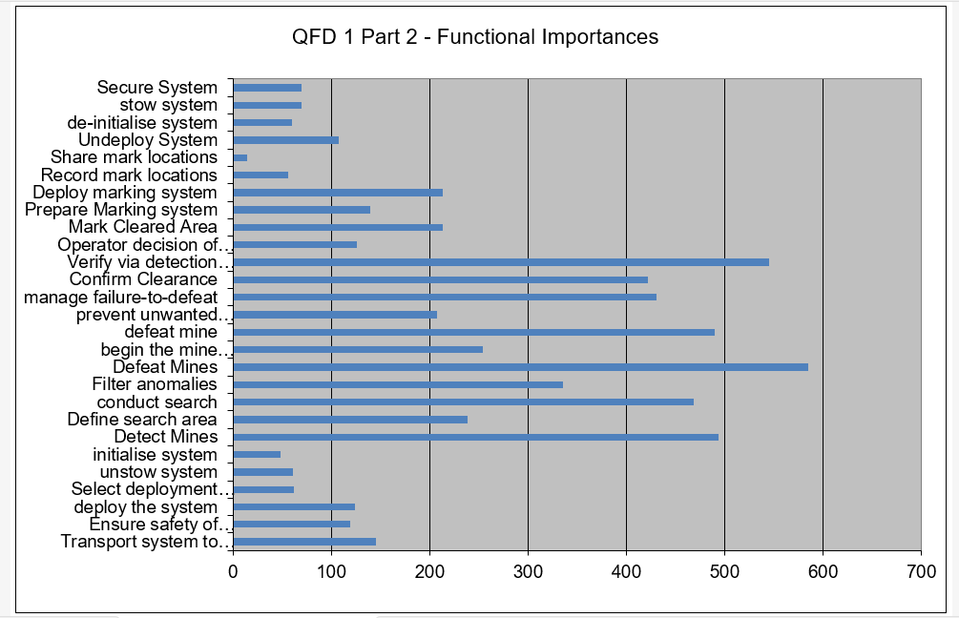
Figure 5: Functional Decomposition QFD
Most importantly, functional decomposition ensures that lower-level functionality directly contributes to the critical functionality, thereby maintaining traceability throughout the design process.

Function-Means Analysis
Following functional decomposition, a Function-Means Analysis (FMA) is conducted where the team suggests potential means (solutions) to achieve each function. It is important to conduct the analysis with a variety of team members from different disciplines. This is because at this stage in the design process a wide range of ideas are encouraged and if the process was done with only subject matter experts there may be a bias towards already proven solutions and therefore potentially groundbreaking means to some functions may be missed.
A Function-Means Analysis is usually in tabular form where the functions are on the left-hand column and the means against each function in the corresponding rows.
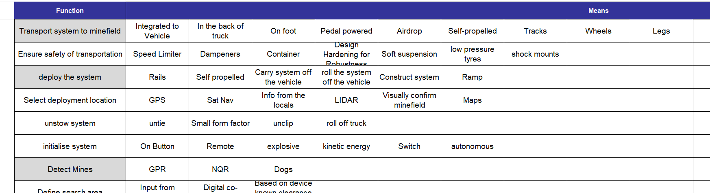
Figure 6: Extract from FMA
For example, in Figure 6 against the Detect Mines function three means have been proposed: Ground
Penetrating Radar (GPR) widely used in off-the-shelf mine detection systems [8], Nuclear Quadrupole Resonance Spectroscopy (NQR) a technique that is being explored for detecting explosives [7] and Dogs were also suggested as they can be trained to detect explosives.
Once the team is satisfied with their discussions and feel they have explored all possible avenues for potential solutions then, the most applicable means are highlighted to inform the concept generation step. Choosing the most applicable options is done using criteria such as feasibility, development cost, relevance to the customer requirements. Using the Detect Mines example only one of the three proposed solutions was accepted after the team discussed the options. The reasoning being that GPR is proven, widely available and can be integrated into the system with relative ease.
The FMA process ensured that as many solution avenues as possible were explored, and that the selected solutions were both practically viable and directly traceable to the customer requirements and overall system objectives.

Generating the Concept

Translating FMA into Ideas
The Function-Means Analysis identified several key considerations that guided concept generation. These included the systems need to be robust enough to survive harsh operating environments, safety of the operators was paramount, it should be a system that is either integrated into or easily deployable from a light vehicle, rapid deployability and low power consumption since the location is remote.
To support concept development, further research was conducted into current mine clearance methods employed in modern conflict environments, including those observed in Ukraine, alongside user feedback from operational personnel. In addition, emerging and novel technologies within the mine clearance domain were investigated and assessed for their potential applicability.
Using this research in conjunction with the outputs from the FMA, a range of concepts were generated, comprising of adaptations to existing mine clearance systems and novel approaches designed to meet the critical functions identified throughout the design process.
The concepts maintained the thread from customer brief all the way through to Function-Means Analysis to enable confirmation that the critical requirements were being met.
After presenting several concepts to the team, three were agreed upon to be taken forwards to the next stage in the design process. A mine displacing rake system that safely gathers the mines in one location for swift disposal at a safe distance using a drone deployed charge, A Fuel Air Explosion System that disperses above the minefield then detonates with enough pressure to activate the pressure sensors on the mines and a Seismic System that sends shockwaves through the soil to trigger the mines.
A limitation of the FMA to concept generation process is that, while individual functional solutions are well defined, the integration of these functions into a complete system still requires higher level engineering judgement. As a result, concept development remains partially dependent on the subjective design decisions of the research and development team to ensure that all functions operate cohesively within a unified system.

Pugh Matrix
A Pugh Matrix is a technique to select the best possible option among a number of alternatives by setting datum which would score a zero against all the criteria and then ranking the options with either a +1 if its superior to the datum or -1 if its inferior [9]. For the mine clearing device, the datum was set as PYTHON a mine clearing line charge i.e. a deployable tube of explosives that defeats mines rapidly via detonation since PYTHON closely matched the customers’ requirements on a number of deltas. The criteria to which the options were compared were the customer requirements including weightings drawn from the pairwise. Then, columns are added for each concept being put forward and scored. Each score is multiplied by the weighting and the total calculated at the end. The datums overall score will always be zero and if a concept scores over zero then it could be considered a closer match to the customer requirements or not as suitable if the score is less than zero.
The total score of a concept using this method is strongly influenced by the accuracy of the pairwise ratings and the subjective opinion of the team discussing the concept is superior of inferior to the datum against the selected criteria. For the project this report is analysing the mine displacing rake concept scored the highest on the Pugh Matrix and was chosen to be taken further into the design process. The Pugh Matrix served as a powerful tool to dissolve any conflict between the team about which design should be chosen. However, as a critique of the toolset, when down selecting the concepts against the datum each feature was considered as if it functioned perfectly when in reality no testing and verification had been done to confirm if the ideas would function in the real world. On the other hand, any such weaknesses would be revealed as the systems engineering process continues.

Conclusion
This report has demonstrated the application of a systems engineering toolset to develop a customer brief into a workable concept that can be taken forwards into the next stages of development where subsystems and noise factors will be identified and analysed.
The toolset used transformed the qualitative needs of the customer into a measurable set of engineering requirements beginning with deriving the customer requirements from the brief, using a pairwise comparison to identify the critical requirements and the QFD process to identify critical functionality and redundancies. These outputs then informed the functional decomposition process which fed into the Function-Means Analysis enabling a detailed exploration of potential solutions which could be compared using the Pugh Matrix to ensure that the concept chosen aligned with the critical customer requirements.
It was identified that parts of the systems engineering toolset used relied on subjectivity and assumptions from the design team. This means that potentially incorrect assumptions made early in the process may impact future design choices. However, as systems engineering is by definition an iterative process with a key feature being traceability all the back to the customer brief it should be considerably easier to identify and improve design flaws when compared to alternative non systems based approaches.

References:
[1] G. KOU, D. ERGU, Y. CHEN, and C. LIN, “PAIRWISE COMPARISON MATRIX IN MULTIPLE CRITERIA DECISION MAKING,” Technological and Economic Development of Economy, vol. 22, no. 5, pp. 738–765, Sep. 2016, doi: https://doi.org/10.3846/20294913.2016.1210694.
[2] S. Burge, “A Functional Approach to Quality Function Deployment (Putting the Function back into Quality Function Deployment),” 2007. Available: https://www.burgehugheswalsh.co.uk/uploaded/1/documents/a-functional-approach-to-quality-function-deployement-v3.pdf
[3] Yoji Akao, Quality function deployment : integrating customer requirements into product design. Cambridge, Mass.: Productivity Press, 2004.
[4] A. Akundi and V. Lopez, “A Review on Application of Model Based Systems Engineering to Manufacturing and Production Engineering Systems,” Procedia Computer Science, vol. 185, pp. 101–108, 2021, doi: https://doi.org/10.1016/j.procs.2021.05.011.
[5] A. W. Wymore, “Model-Based Systems Engineering.” CRC Press, 2018. doi: https://doi.org/10.1201/9780203746936.
‌[6] B. Zupan, M. Bohanec, J. Demsar and I. Bratko, "Feature transformation by function decomposition," in IEEE Intelligent Systems and their Applications, vol. 13, no. 2, pp. 38-43, March-April 1998, doi: 10.1109/5254.671090. keywords: {Matrix decomposition;Intelligent systems}
[7] J. Seliger, “Nuclear Quadrupole Resonance, Theory*,” Encyclopedia of Spectroscopy and Spectrometry, pp. 1975–1983, 1999, doi: https://doi.org/10.1016/b978-0-12-374413-5.00235-9.
[8] “Handheld Ground Penetrating Radar - Mistral Solutions,” Mistral Solutions, Jan. 07, 2026. https://mistralsolutions.com/defence-products/handheld-ground-penetrating-radar/ (accessed Apr. 11, 2026).
[9] Joshi A.K, Dendekar I.A, Gaikwad M. V., Harge C. G. “Pugh Matrix and Kano Model-The Significant Techniques for Customer‟s Survey” in International Journal of Emerging Technology and Advanced Engineering vol. 9, issue 6 June 2019, Pugh-Matrix-and-Kano-Model-The-Significant-Techniques-for-Customers-Survey.pdf
‌

‌

‌

‌

‌

‌

‌

‌

