Critical analysis of decision support
Introduction
‘Too often, adverse events due to prescription medications are a cause of death and disability. Many of these events could be prevented, but most efforts to do so have had limited success, mainly due to the challenges of having the information that is necessary for safe prescribing available at the time when prescriptions are being written’ (Woosley, 2022).
The aforementioned statement refers to challenges faced by healthcare organisations when prescribing medications. Armando et al., (2023) describe that digital technologies, including clinical decision support systems (CDSS) can be utilised as strategies to aid in the reduction and prevention of such issues. Jia et al., (2016) define CDSS as computerised platforms that aid clinicians in evaluating disease status, diagnosing conditions, selecting suitable therapies, or making other clinical decisions. These systems have the potential to improve medication safety, using advisory tools that include drug selection, dosage, interactions and allergy considerations.
NHS England, (2023) add that CDSS promotes best practice by ensuring users are supplied with the relevant information at the time of decision-making, adding that the ‘5 rights’ (image 1) and the ‘6i’s’ (image 2) should be considered to maximise effectiveness. In summary, pertinent information ought to be presented to all applicable team members in the suitable location and in a format that facilitates workflows and is easily accessible.

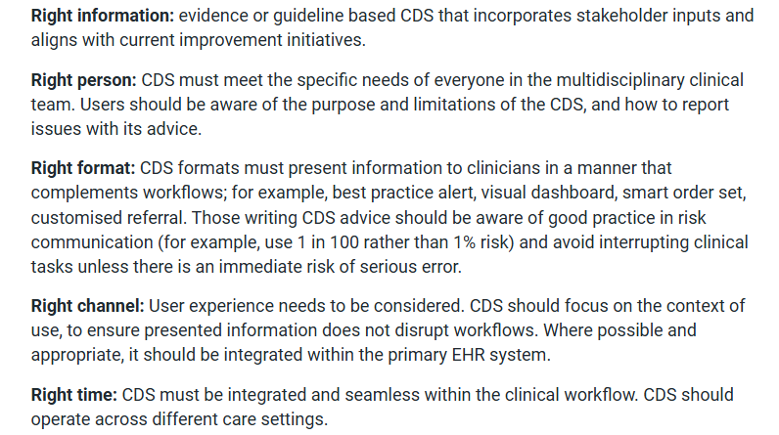
Image 1illustrating the 5 rights as described by NHS England (2023)

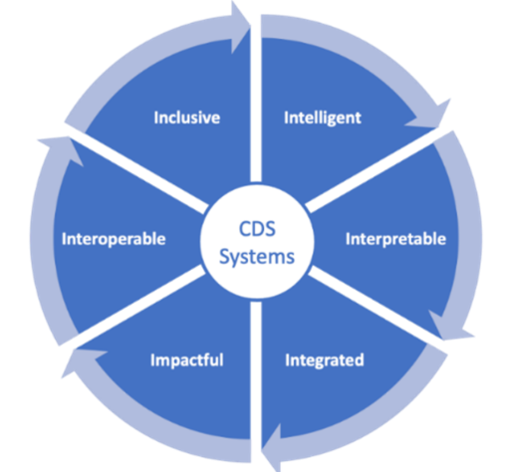
Image 2 illustrating the 6i's as described by NHS England (2023)

The practice of prescribing and administering medications on paper persists to varying degrees throughout the United Kingdom (UK). The UK Government had pledged to eradicate paper-based prescribing in hospitals and to implement digital prescribing across the National Health Service (NHS) by the year 2024. However, a Special Report rated the initiative as inadequate, highlighting significant disparities in digital maturity among NHS Trusts, leading the Government to acknowledge that they would not achieve the target they set (The Health and Social Care Committee, 2023). Williams et al., (2022) acknowledge that global health system priorities involve the transition from paper-based processes to digital systems, asserting that this shift will enhance the modernisation, efficiency, and safety of healthcare.
Benefits of electronic prescribing include the elimination of illegibility, enhancement of pharmacy efficiency, reduction in adverse drug reactions, and the encouragement of formulary adherence by prescribers. Furthermore, electronic prescribing systems that incorporate CDSS are considered to be of higher quality (Aluga et al., 2021).

Evidence review (will allow +/- 2000 words)

- Describing what a critical literature review is and what it involves, keeping it relevant to CDS and electronic prescribing. Describing scholarly literature vs grey lit (briefly), and a brief overview of why both are useful
- Finding the sources- describing the literature review undertaken, linking to the PRISMA flow diagram. Note the exclusion dates (pre-2020) and why the decision was made to exclude older studies.

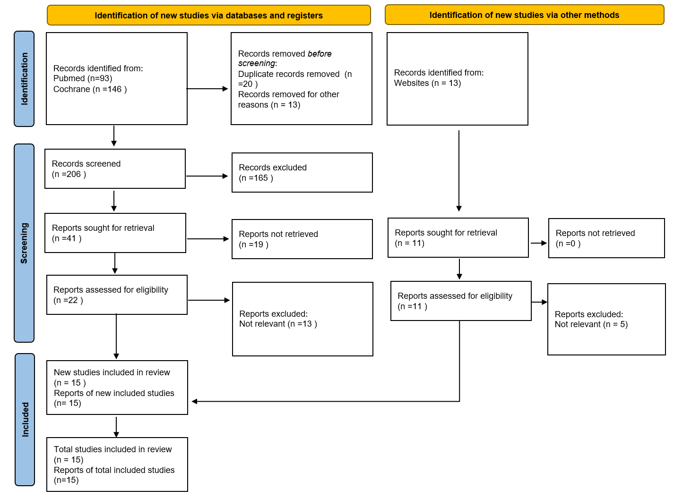
Image 3 PRISMA 2020 flow diagram for the conducted literature search (Page et al., 2021).

- Organising the sources- would you suggest including the literature matrix below in the essay or not? (this is the scholarly literature matrix; it doesn’t include the 6 grey lit publications) It’s probably too wordy?

Author/Year published | Purpose | Methodology | Sample design | Year data collected | Key findings
Dahmke, H et. Al. (2024) | To develop a CDSS to prevent duplication of anticoagulant therapy | Retrospective observational study | All adult inpatients | 3 phases- Aug 2017-Aug 2018.  Aug 2018-Aug 2019.  Aug 2020-Aug  2021 | The frequency and duration of anticoagulant duplication was significantly reduced following the introduction of CDSS
Russ-Jara, A et. Al. (2023) | To understand how clinicians make decisions when managing drug-drug interactions (to help inform the design of effective CDS alerts) | Qualitative, semi structured interviews with the clinicians | 20 clinicians selected using purposive sampling | 2019-2020 | Current drug-drug interaction alerts did not align with the way clinicians work
Sundermann, M et. Al. (2024) | To examine whether removing interruptive CDS alerts (used for duplicate antithrombotic prescribing) for stat dose prescriptions would improve prescriber adherence and reduce alert burden | Retrospective observational study- comparing alert and prescribing data before and after the reconfiguring of alerts | All antithrombotic medication prescriptions and associated duplicate prescribing alerts during the allotted time periods | Jan 2017-Aug 2022 (the ‘before’ period)  October 2022- Sept 2023 (the ‘after’ period | A large reduction in interruptive alerts, with improved adherence by clinicians.  No increase in unsafe prescribing
Ruutiainen, H et. Al. (2024) | To examine whether computerised physician order entry (CPOE) systems with their CDSS reduce errors in preventing dose errors in paediatric prescribing | Systematic review of studies that included CPOE, CDSS and measured dose error outcomes related to paediatric prescribing | 17 studies that met the inclusion criteria | Data collection up to Sept 2023 (the included studies were published between 2007 and 2021) | Most studies showed a reduction in errors where CPOE with CDS was used.  Dose errors were not eliminated fully
Loh, S et. Al. (2025) | To evaluate whether the addition of CDSS within a CPOE system could improve the rate of a timely venous thromboembolism (VTE) risk assessment and the rate of guideline-compliant VTE prophylaxis prescribing | Retrospective observational study, with a pre and post implementation comparison | Hospitalised adult patients who were eligible for VTE screening.  850 total (458 pre-intervention, 392 post-intervention) | Pre-intervention data- 7 consecutive days in April 2022.  Post- intervention data, 7 consecutive days end March/early April 2023 | Significant improvement in VTE risk assessment documented within 24 hours of admission.  Improved rate of guideline- compliant VTE prophylaxis prescribing
Taheri Moghadam, S et. Al. (2021) | To evaluate the effects of CDSS on patient outcomes and physician performance when utilised for medication prescribing | Systematic review and meta-analysis | 45 published studies | Primary studies published up to 2020 | Significant improvement in physician performance during prescribing.  Positive impact on patient outcomes
Weir, C et. Al. (2024) | To assess the feasibility of introducing a complex electronic prescribing intervention (ePAMS+) to aid with antimicrobial stewardship | Mixed methods study, utilising before and after the introduction of ePAMS+ | 1958 total (1358 pre- intervention, 600 post-intervention).  The qualitative data came from prescribing/  reviewing clinicians.  The quantitative data from all adult admitted inpatients that had antibiotics prescribed on ePMA | April 2021-Nov 2022 | ePAMS+ was successfully integrated into the hospital ePMA.  Signs of improved antimicrobial stewardship.  Acceptability and usability were mixed
Corny, J et. Al. (2020) | To improve patient safety outcomes (reducing the risk of prescribing errors) using a hybrid CDSS that prioritised prescription checks for pharmacists | Applied informatics evaluation study (using retrospective electronic health record EHR data) | Data collected from EHR, 10,716 patients with 133,179 prescriptions | Jan 2017- Aug 2018 | Machine based CDSS more effectively predicted high risk of error prescriptions over traditional rule-based systems
Smith, S et. Al. (2024) | To evaluate the feasibility, acceptability, accuracy, and utilisation of EHR- based medication alerts for oral anticoagulants | Prescriber- level randomised control trial | All prescribers who triggered an alert for an inappropriate initial prescription of oral anticoagulant. 243 clinician encounters | Aug 2022- April 2023 | The alerts were appropriate; the majority of prescribers paid attention to the alerts and followed the advice given

- Synthesising the sources- looking for any themes, any agreement between sources, any challenging of ideas. Possibly use a synthesis matrix, again, is the matrix something that should be included in the essay?
- Themes- reduction in med errors, improved prescriber adherence, improved outcomes for pts, prescriber performance improvement.
- Limitations of the studies- small sample numbers, small areas of focus (one setting), potential for bias in the interviews, some retrospective studies, lack of long-term evaluation, multiple systems, multiple configurations so no direct comparisons available. Grey lit- one source is info from the system provider, can show extreme bias, one web page (EPMA hub) unclear how accurate the info is, shows people’s opinions rather than facts.
- Comparing CDS in electronic prescribing to CDS in other areas of healthcare (CDS for patients themselves rather than for staff like this example?)
- Grading the evidence of CDS effectiveness, any gaps in evidence.

Implementation issues (will allow +/- 2000 words)

- Discussing clinical decision support in electronic prescribing systems key risks and constraints- alert fatigue, over reliance on it and not using clinical judgement, workflow disruption, reliance of CDS on accurate inputting of information (weight, allergies), difference in CDS ‘rules’ to local practice/policies- requires ongoing configuration and updating.
- Suggestions for managing/mitigating these- management of alerts (only high severity being very visible & requiring overriding),
testing, end-user involvement, scenarios,
ensuring the alignment of the CDS to local policies,
training (reminding clinicians to use their existing clinical judgement, rather than believing everything the CDS displays),
monitoring of CDS and override rates/reasons

Evaluation (will allow +/- 500 words)

- User experience assessment ideas- surveys/questionnaires, examining the reporting metrics in the system (number of overrides of alerts etc), interviews/lessons learnt groups. Looking at user interface too, scenario testing, to deliberately trigger CDS and see if helps or hinders clinician
- Effectiveness assessment ideas- does CDS improve prescribing
- Safety and efficiency assessment ideas- reporting from within the system, number of Datixs under the category of medication/prescribing errors and number attributed to CDS in ePMA- comparing data pre and post ePMA/CDS. Looking at workflows, time and motion studies (pre and post). Are the number/level of alerts appropriate?

References

Aluga, D., Nnyanzi, L. A., King, N., Okolie, E. A., & Raby, P. (2021). Effect of Electronic Prescribing Compared to Paper-Based (Handwritten) Prescribing on Primary Medication Adherence in an Outpatient Setting: A Systematic Review. Applied Clinical Informatics, 12(4), 845. https://doi.org/10.1055/S-0041-1735182
Armando, L. G., Miglio, G., De Cosmo, P., & Cena, C. (2023). Clinical decision support systems to improve drug prescription and therapy optimisation in clinical practice: a scoping review. BMJ Health & Care Informatics, 30(1). https://doi.org/10.1136/BMJHCI-2022-100683
Jia, P., Zhang, L., Chen, J., Zhao, P., & Zhang, M. (2016). The effects of clinical decision support systems on medication safety: An overview. PLoS ONE, 11(12). https://doi.org/10.1371/journal.pone.0167683
NHS England. (2023, August 16). Supporting clinical decisions with health information technology. https://www.england.nhs.uk/long-read/supporting-clinical-decisions-with-health-information-technology/
Page, M. J., McKenzie, J. E., Bossuyt, P. M., Boutron, I., Hoffmann, T. C., Mulrow, C. D., Shamseer, L., Tetzlaff, J. M., Akl, E. A., Brennan, S. E., Chou, R., Glanville, J., Grimshaw, J. M., Hróbjartsson, A., Lalu, M. M., Li, T., Loder, E. W., Mayo-Wilson, E., McDonald, S., … Moher, D. (2021). The PRISMA 2020 statement: an updated guideline for reporting systematic reviews. BMJ, 372. https://doi.org/10.1136/BMJ.N71
The Health and Social Care Committee. (2023). House of Commons Health and Social Care Committee Government Response to the Health and Social Care Committee’s Expert Panel: Evaluation of Government’s commitments in the area of the pharmacy in England Thirteenth Special Report of Session 2022-23. www.parliament.uk/hsccom
Williams, J., Malden, S., Heeney, C., Bouamrane, M., Holder, M., Perera, U., Bates, D. W., & Sheikh, A. (2022). Optimizing Hospital Electronic Prescribing Systems: A Systematic Scoping Review. Journal of Patient Safety, 18(2), E547–E562. https://doi.org/10.1097/PTS.0000000000000867
Woosley, R. L. (2022). Assisted prescribing: Clinical decision support with MedSafety Scan now available. Trends in Cardiovascular Medicine, 32(1), 44–49. https://doi.org/10.1016/J.TCM.2020.11.002

