Title
Student Name: Jervis Alexis Payne
Student Number: 2127853
Course Name: MSc Data and AI
Module Name: Advanced Statistical Programming
Module Code: ACCA7022
Assignment Title: Data Analysis
Submission Date: 20th March 2026
14:00 (2 PM)

Table of Contents
Title 1
Table of Contents 2
Table of Figures 2
Reflective Summary 3
References 6

Table of Figures
Figure 1 Example code used for Time Trends 3
Figure 2 Example code used for Pollutants - Meteorology relationship 4

Reflective Summary

Visualisation
The largest change in this assignment was the transition from a controlled workflow to a real-world dataset workflow, in which information must be checked before any analysis can be deemed reliable [1]. Due to this, I employed visualisation not only as a presentation method but also as a validation and comprehension method.
I decided to investigate the time trends first to understand the behaviour of the pollutants over the entire time span, followed by scatter-based plots to examine the relationship between meteorological conditions and pollutant levels. Those steps enabled me to observe patterns that cannot be visualised with summary statistics alone, such as spikes, prolonged episodes, and seasonal movements [2].
For time trends, I selected line plots because the dataset is hourly in nature, and a line plot is ideal for illustrating variations in a measured value over time. It facilitates the simple detection of peak periods, extended periods of elevation, and slow trends in seasonal changes. I will at least plot two pollutants (CO and NO2) to determine whether they move in the same direction and to assess which pollutant is more variable.

Figure 1 Example code used for Time Trends
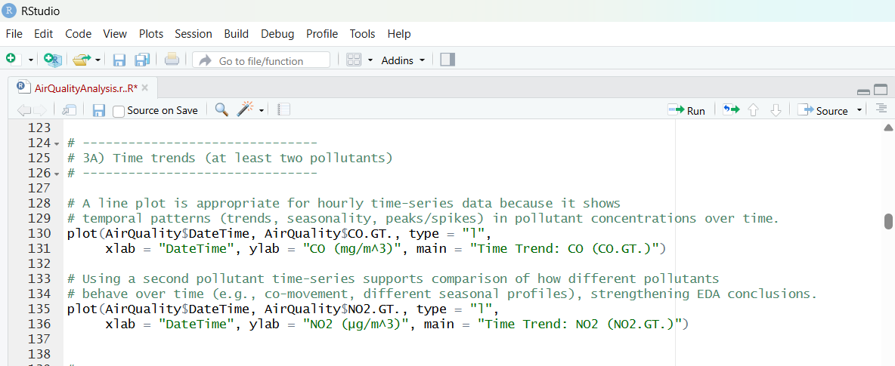

I used scatter plots to investigate the relationship between pollutants and weather-related variables. The use of scatterplots is justified because both axes represent continuous variables (e.g., temperature and CO) and the plot can reveal non-linear relationships, clusters, and outliers. These trends are significant, as they affect how results are estimated and which statistical procedures are used in the future (e.g., whether a nonparametric test is better justified). On top of these, I used LOWESS trend lines to help summarise the overall direction of noisy real-world points. Still, it dawned on me rather quickly that smoothing must account for missingness, which is particularly sensitive to it.
Figure 2 Example code used for Pollutants - Meteorology relationship
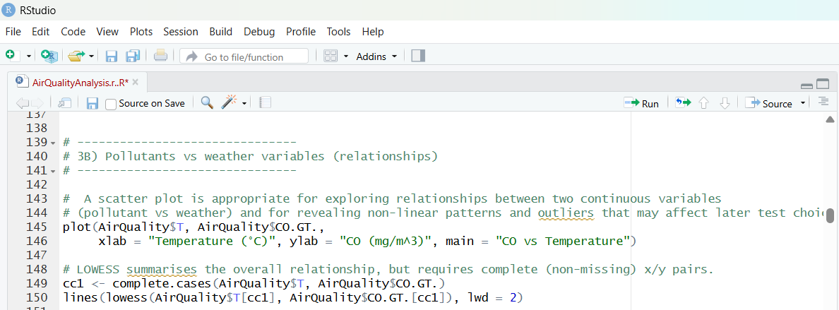

I used the same trend pattern to repeat the relationship between NO2 vs RH and CO vs AH, ensuring I was not making a deduction based on only one variable. Overall, such visualisations helped me convey the data clearly and allowed me to check whether the cleaning process was underway (e.g., a plot with an abundance of extreme negative values would indicate that -200 values were not processed properly).

Difficulties and Things Learned
One of the greatest difficulties during this assignment was realising that real-world data sets may become silent. At first, my script produced output that looked plausible: the dataset loaded, summary () printed numbers, and plots were drawn. The descriptive statistics were, however, misleading as the dataset had invalid sensor readings, which were coded as -200, and there were also two columns (X and X.1) completely missing. The major lesson of this was that working code did not necessarily imply valid analysis. I was required to be more conservative and evidence-based, and I would not trust subsequent results until initial checks assured me that the dataset was cleaned and the interpretation was correct.
Another challenge generated by the cleaning step itself was that, as soon as -200 values were converted to NA, some functions began to fail due to missing values. The most illustrative one was LOWESS, which constructed an error: delta should be valid and greater than 0. Along the way, I thought the problem was the smoothing function itself, since it was caused by NA values in the x or y vectors. This forced me to think more carefully about how missingness affects plotting and statistical methods. The fix of complete-case filtering prior to LOWESS, however, was a useful learning experience, as it revealed that even minor, esoteric tasks such as smoothing a line of data require proper data conditioning.
I also gained the knowledge that statistical significance can be easily obtained with large datasets. My Wilcoxon rank-sum test of NO2 in the HighRH and LowRH conditions yielded a p-value. Although this is statistically significant, the more profound lesson is that the p-value cannot be accepted on its own, since even with thousands of data points, even minor differences can be considered significant. To address this, I started reporting practical differences (medians, IQRs, and median shifts). In the case of the HighRH vs LowRH, the mean difference in the NO2 levels (Low-High) was 12. To test seasonal variation under Kruskal-Wallis, the seasons differed significantly, and the median change between winter and summer was 46.5. The incorporation of such values made the interpretation more legitimate and more justifiable.
The other key learning outcome was to write an analysis code, which is markable. I also made my script in point plans according to the rubric, and I placed the justification remarks directly above the plots and tests. This was so that the marker could not see how I did it, but why I did. It was then necessary to justify the use of line plots of time trends, scatterplots of continuous-variable relationships, and nonparametric tests (rather than the Kruskal-Wallis test) because the pollutant data were skewed and contained outliers. This was a move away from making it work to making it work and demonstrating that it is sound methodologically.
In practise, on another aspect, I also discovered that changing the software styles remains a difficulty. I have already developed a comfort level with notebook workflows (like Google Colab), in which analysis is inherently divided into chunks, and results are always shown in-line. In the code working in RStudio scripts, delineated printing, verifying objects in the Environment pane, and ensuring that the script performs its intended tasks in a top-down manner with no use of unseen notebook state is a necessity. To maintain control, I applied intermediate checks of evidence (between major steps), such as checking X/X.1 removal, verifying that DateTime parsing returned zero NAs, and verifying that minimum values were no longer -200.
In terms of generative AI applications, I relied on it primarily as a complement to troubleshooting certain mistakes (such as how to use LOWESS with missing values) and clarifying the meaning of code commentaries; I did not consider it an authority, and all the output was confirmed by running the script in RStudio and checking the results against the expectations.

Future Work Improvements.
Assuming I repeated this analysis, I would reinforce it in several ways. First, I would introduce additional formal diagnostics in advance of selecting tests: distribution checks by group (histograms, Q-Q plots) and maybe a cursory normality/outlier analysis on accountability, even in the context of non-parametric tests. Second, I would go over sensitivity to various group definitions. To take one instance, rather than a median split of RH, I would compare quartiles (e.g., bottom 25% vs top 25%) and determine whether the effect is even greater under more drastic conditions. Third, I would take into consideration time-conscious analysis. Due to the hourly data, there is a possibility of autocorrelation; in future studies, it might be useful to employ an approach that accounts for time dependence, such as a daily summation of the data for some analysis or time-series modelling. Lastly, I would specify the logic of cleaning as more of a reusable checklist of data validation, since this project emphasised that the initial decisions about cleaning may affect the validity of the rest of the analysis.

References

[1] | F. a. P. Liu, ““Real-world data: a brief review of the methods, applications, challenges and opportunities,”,” BMC Medical Research Methodology, vol. 22, no. 287, 2022.
[2] | Y. a. Z. Y. a. L. J. Liu, “Exploring the relationship between air pollution and meteorological conditions in China under environmental governance,” Scientific reports, vol. 10, no. 1, p. 14518, 2020.

