Screenshot/Photo 1
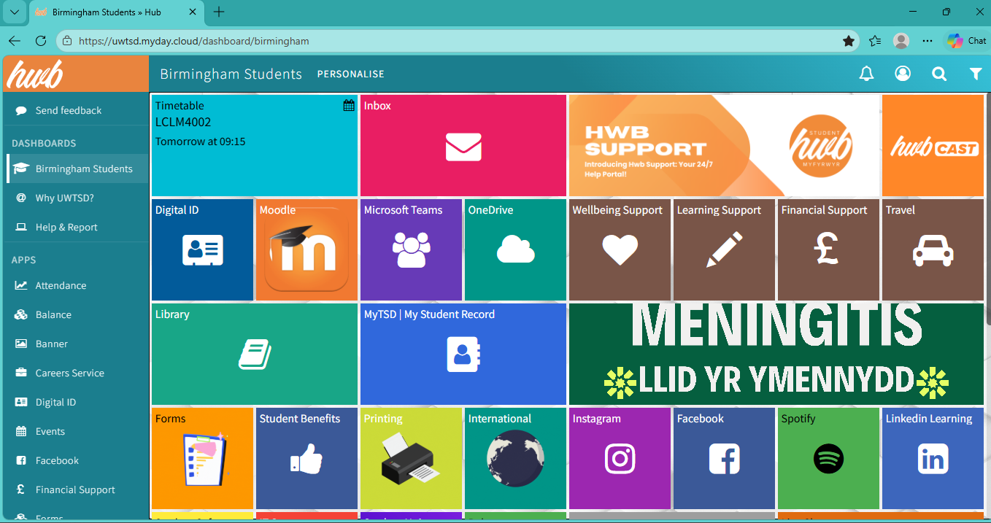
This is the UWTSD hwb app. This is where students and I can access welcome guides and timetables. You can also access other resources such as social media, Microsoft, one drive and email. This helps me with my digital life as I can access the Moodle where I can view my assignments and track my progress in my studies.

Screenshot/Photo 2
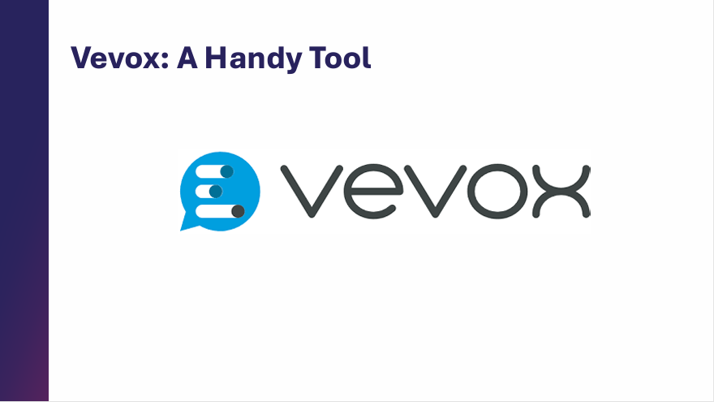
This is VEVOX. An app designed to answer questions and share my opinions. This helps me in my digital life due to making learning more interactive and keeping students engaged as it allows students to join sessions from any device.

Screenshot/Photo 3
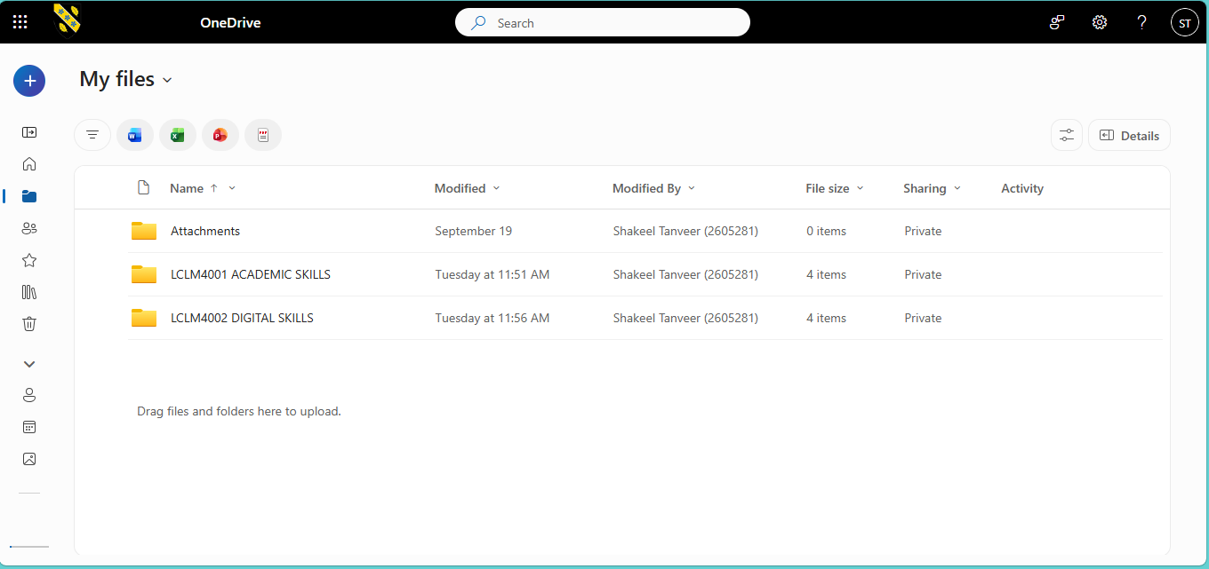
This is one drive. I can access this through my UWTSD hwb app. This helps me in my digital life by allowing me to back up my files and documents. This also helps to keep my folders organised as they can be re-named. I can also put up reminders of upcoming events and deadlines for my assignments or any relevant work.

Screenshot/Photo 4
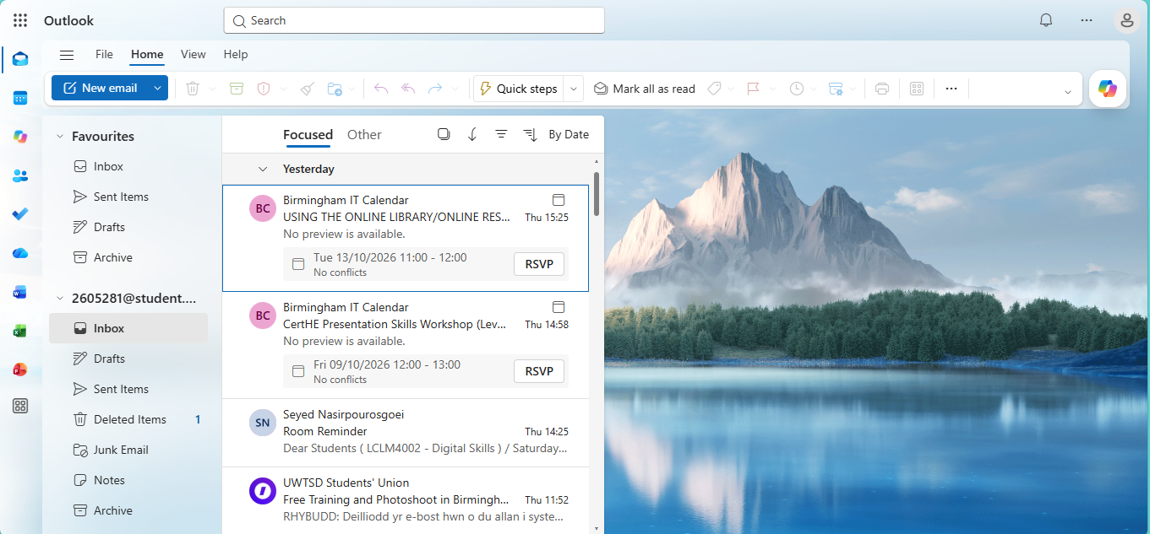
This is Microsoft Outlook. An emailing management. This helps my digital life by giving me access to send and receive emails, schedule appointments, managing daily tasks, organise business and personal folders and allows it to integrate with other tools such as Microsoft Teams and One-Drive.

Screenshot/Photo 5
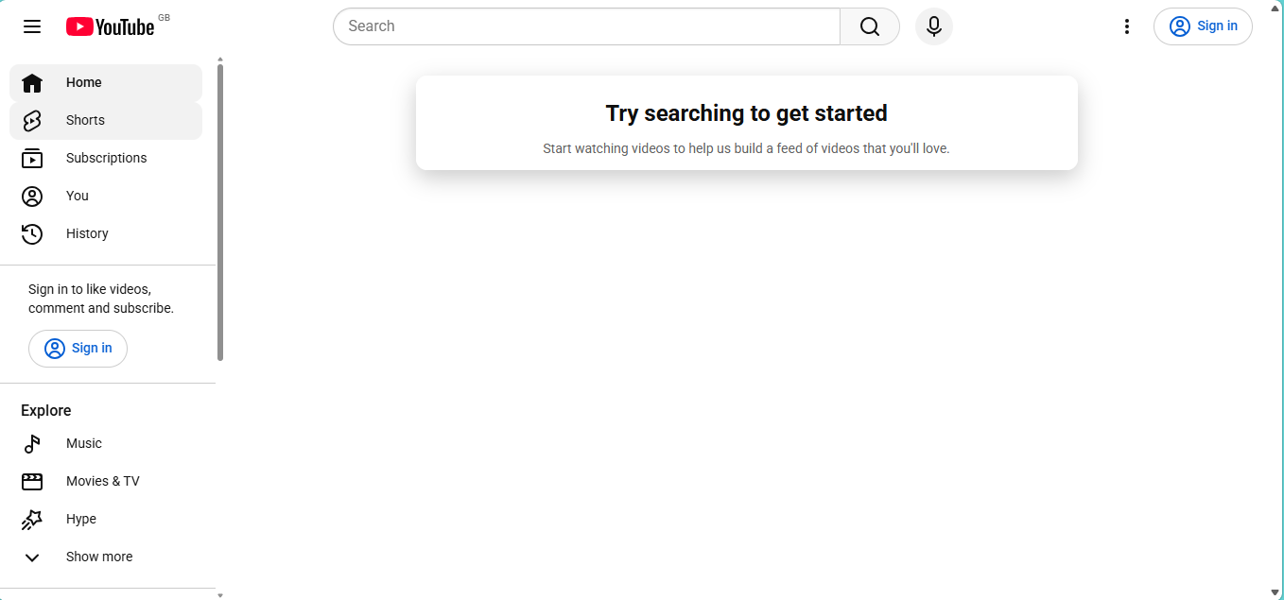
This is YouTube. A free online video-sharing platform ideally created to watch videos, upload content and to interact with others. This helps my digital life by giving me access to education videos, tech support/troubleshooting videos and helps me gain knowledge for my student life. You can also create your own playlist of videos and name them for organisation.

Screenshot/Photo 6
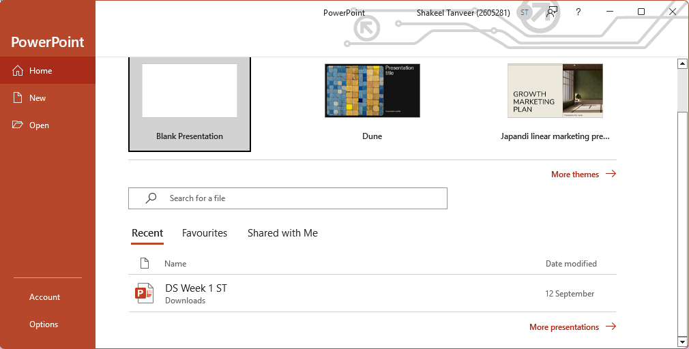
This is PowerPoint. A digital presentation software. This helps me in my digital life by letting me create visual slideshows and presentation with texts, images, videos. This also supports me to mix audio and animations into a single project which can become useful for my assignments and gives me access to my classroom power points.

My Short Reflection
This is my short reflection about my digital life and how I feel about using digital tools. I use digital tools to help me with assignments, desktop applications and cloud platforms. I also use these tools at my workplace this is because I work in retail so I’m always using a PDA or tablet to locate stock and print out shelf labels. I feel confident when I’m accessing tools like outlook, one drive, power point, internet browser and the UWTSD hwb app. I also feel like improvement can be made like focusing more on classroom discussions and getting more involved with the group. I want to improve my digital skills by spending more time accessing these tools at my university, workplace and at home in my spare time. I can also improve my skills by going on some free online platforms or build through routine use. I sometimes feel nervous when I’m accessing new digital tools but since I have been back studying, I am getting in the hang of using new tools and understanding what they are. I hope this module will help me become more confident and comfortable with using new digital tools and how they work. This module has also taught me how to use different digital tools and what they are. Digital skills are important to me because they help me with my studies at my university, workplace and daily tasks. This helps me always be a lot more organised and on point. Digital skills are also incredibly important to me because it will prepare me for my future career and promotions that I could undertake.

