ECAD6007: A critical evaluation and the identification of next teaching and learning steps focusing on a case study of an individual learner or a group of learners, based on an observed critical incident.

Introduction.

This assignment will critically reflect and evaluate a classroom observation, using prominent theorists, literature, case studies and legislation. This evidence will be theory-based knowledge that can be used to further teaching practice. This holistic approach discusses how this method of classroom observation as a reflective tool can keep teaching practice relevant, benefit learners and links to the developing role of teaching as a profession and the four purposes of the new curriculum.

“The evidence tells us that teaching and leadership practice can be significantly improved if practitioners are given the opportunity to engage, both individually and collectively, in career long reflection… through evidence based professional learning activities.”
(Lewis, 2015)

The observation in this assignment is classed as a ‘critical incident’ and is inspired by the work of David Tripp. Tripp (2012, p. 24-25) writes critical incidents are historically significant moments that can be life changing, but for the most part are accounts of everyday events. They can take place in professional practice daily, but what makes them critical is the analysis of them.

This methodology is an accessible framework consisting of a classroom observation that is described by the observer who analyses what happened, and why it happened, to determine the next steps in teaching practice and the wider social context. (Tripp, 2012, p. 25)

The conclusion will evaluate what has been learnt from this process and make connections to the developing standards for teaching and leadership. This will identify the next steps that could be taken in teaching practice to become a more effective educator.

The role of critical reflection.

The role of critical reflection in recent years has been attached to improving the professional development of teaching professionals, most specifically “raising educational standards, performance management and whole-school planning.” (Zwozdiak-Myers, 2012, p. 3). The roots of reflective practice were grown from the work of John Dewey (1933). He believed that an experience had no value all by itself. That for it to be important, it is what an individual takes from that experience that will affect future learning and thus, no two experiences are the same. (Gray & Macblain, 2015, p. 39) His reflective thinking framework champions four principles that he believed were integral to reflective action (Zwozdiak-Myers, 2012, p. 6). These are wholeheartedness, directness, open mindedness, and responsibility. When combined, these principles create a readiness to engage in reflection.

This reflection model has influenced and been developed by many practitioners to facilitate learning. Prominent names in this field include Brookefield (1998, 2005), Schon (1978), Gibbs (1988) and the theory that will be used in the reflection of this assignment, Kolb’s Experiential Learning Cycle (see appendix 4). This method has associations with Piaget’s cognitive development as both account the development process of ‘assimilation’ and ‘accommodation.’ (Zwozdiak-Myers, 2012, p. 43). These processes involve the learner acquiring knowledge from their environment and building on their current knowledge to reflect and progress, thus learning from their experience. (Zwozdiak-Myers, 2012, p. 43).

Critical thinking and reflection have been recognised as core skills for teaching professionals and trainee teachers to possess, following reviews of the Welsh education system undertaken by many bodies. These include ESTYN, OECD, Professor Ralph Tabberer’s review of Initial Teacher Training in Wales (2013), Professor John Furlong’s review of Initial Teacher Education in Wales (2015) and Graham Donaldson’s Successful Futures (2015), which paved the way for the new Curriculum for Wales. In Furlong’s (2015, p. 6) Teaching Tomorrow’s Teachers report, he comments that Wales needs a fresh approach to professionalism and states teachers should be able to evaluate and use different kinds of evidence that relates to improving teaching standards. It echoes Donaldson (2015, p. 21) who agrees that the growth of teachers as reflective practitioners will make considerable change. In a report into teachers’ professional learning by the National Assembly for Wales (2017, p. 25) they recommend using INSET days with time put aside for professional reflection.

Ultimately, critical reflection is a tool that will be used in teacher education moving forward, as noted by these prominent figures and their reports. It is seen as part of the new Twelve pedagogical principles (Donaldson, 2015, pp. p 63-71) and it is the job of teaching professionals to take up the baton and develop the next steps.

Observation- School and Class Context.

In compliance with the BERA guidelines (2018) this critical incident reflection will respect the privacy, autonomy, and diversity of those involved and keep the names of the school, staff, and pupils anonymous.

The school attended for the observation is a Primary School in the Rhondda Cynon Taff local authority. According to the most recent data, it has 430 pupils, there is a 29.1 pupil to teacher ratio, it had 94.2% attendance during the year and 26.9% of pupils are on Free School Meals over a 3-year average, which is above the national average (My Local Schools, 2021). Please note that the attendance data has not been updated since 2019 due to the coronavirus pandemic. According to the most recent Estyn inspection (2014) almost all pupils come from a home where English is the main language, and no pupils speak Welsh as a first language. Also, since the last inspection, the school has merged with another local primary school and the new build has been completed to accommodate the increased capacity from 347-430. The classroom observed was part of that new build and was in the nursery class with children aged 3 and 4.

Critical Incident linked to Donaldson’s four purposes.

The new Curriculum for Wales framework rolls out in 2022 and the bedrock of its foundation is the four purposes. (See appendix 5.) They are the “starting point and aspiration for every young child” (Welsh Government, 2020, p. 4) providing learners with a broad and balanced curriculum. They set high expectations to equip them with the tools for lifelong learning.

Alongside the four purposes, the new curriculum framework consists of six Areas of Learning and Experience (AoLE’s) and within these AoLE’s are statements of what matters, descriptions of learning and the progression steps as they embark on their learning journey. (Welsh Government, 2020, pp. 11-15)

The ‘critical incident’ that was observed took place after the children had finished their snack time in the afternoon and were full of energy. The teacher got the pupils to sit in ‘circle time’ for a musical task to regroup. The song was called “Which instrument can you play?” and this song requires the children to choose an instrument from the middle of the circle as their favourite and play that instrument in front of their classmates. They then move on to the next child and so forth. Every child is included and named each time in this and has their moment ‘to shine.’ The children sing this song with lots of energy and vigour. The instruments are percussive: a tambourine, cymbals, triangle, and maracas. The children are all sat on their bottoms and the teacher doesn’t move on to the next person unless they all remain that way. There were also Teaching Assistants (TA’s) sat outside the circle, taking part, and supporting the children. The children remained engaged throughout and the teacher commented that the children love tasks like this as they are in suspense as to what will happen next and what instruments will be chosen. The children have many opportunities to sing in class and a song was used earlier in the lesson for another topic as well.

This observation can be linked to the four purposes as a collaborative, confidence building task. It appears to promote “healthy, confident individuals, ready to lead fulfilling lives” who “have confidence to participate in performance”. It can also develop “enterprising, creative contributors” who “express ideas and emotions through different media”. (Donaldson, 2015, p. 31).

There is a link to another of the four purposes with the use of the song in a method of circle time. This technique can encourage “ethical informed citizens” who “respect the needs and rights of others” (Donaldson, 2015, p. 31) allowing them to listen to each other and each take a turn.

Literature Review.

Area for research 1. Why are musical activities beneficial to children in the classroom?

Music plays an integral part in the lives of young children from the earliest age, with the use of sing-song baby talk, nursery rhymes and familiar songs sung to them by their mothers and caregivers. The psychologists Stephen Malloch and Colwyn Trevarthen (2009, p. 29) class the trio of pulse, quality and narrative as used in these methods as ‘communicative musicality’ that allows collaboration to unfold.

The idea that music can bring people together and create a sense of community can be associated with Robert Owen, who is credited with opening the first ever nursery school in New Lanark, Scotland in 1816. Davidson (2010, pp. 234-236) writes of a child centered curriculum that placed a huge emphasis on performing arts activities that develop strong friendships and cooperation. This belief is echoed by Professor Dai Smith (2013, p. 48) in his Welsh Arts Education report, where he describes the importance of arts-led, collaborative learning to enhance communication skills and build self-esteem. The musical element used in the classroom observation echoed these points as the children worked together as a group and supported one another as they took their turns performing.

A notable educational theorist and pioneer that “recognized and understood the value of music in the education of young children” (Gray & Macblain, 2015, p. 35) was the nineteenth century German educator, Friedrich Froebel. He created the first ever ‘Kindergarten’ or Garden for Children’ and believed that children’s learning was connected to their own experiences and that “creativity is part of human nature and fundamental to learning.” (Tovey, 2012, p. 3). His approach to music in education was not just to use it as a time filler or a bit of fun. Music was a way to make deep connections between the songs and the children’s own lives and songs with hand movements were a way to connect the body and mind. (Tovey, 2012, p. 101). Many of today’s rhymes and ring games originated from Froebel’s ‘mother songs’ that he believed were key learning experiences (Tovey, 2012, p. 100). He believed that songs should be specific and include whole body movements and be connected to everyday interests to enhance children’s learning. For example, the song used in the observation task required the children to sing, choose an instrument and then play it in time with everyone singing. This required them to use their linguistic skills, listening skills, and according to Tierney and Kraus (2013) the rhythmic ability to tap an acoustic beat as the children did here with their instruments, could be important for executive functions. According to Merriam Webster, executive functions are

“The group of complex mental processes (such as working memory, impulse inhibition, and reasoning) and cognitive abilities (such as organizing tasks, remembering details, managing time, and solving problems) that control the skills required for goal-directed behaviour.”
(Merriam-Webster, n.d.)

The argument here is you cannot attribute these skills and functions to musical activity alone. As Miendlarzewska & Trost (2014, p. 6) discuss, there are other aspects such as family background and situations, previous learning, and extracurricular activity to consider and there is a lack of current literature to conclude that music training alone has the biggest effect on these attributes in child development. Should future research confirm the idea that musical skills aid executive functions, then it can be a way to nurture the children to meet elements mentioned in ‘the four purposes.’ This includes executive functions, such as problem solving, critical thinking and everyday life skills (Welsh Government, 2020, p. 25).

The Welsh Government has placed an emphasis on the use of expressive arts throughout their new curriculum framework. They believe that it can link to other AoLE’s including health and wellbeing. Expressive Arts can “enable learners to develop a sense of self, build confidence, and explore different forms of communication and relationships which can support mental health and emotional well-being.” (Welsh Government, 2020, p. 70). This is in line with humanist thinker Maslow and his ‘Hierarchy of Needs.’ (See appendix 5.) He writes of a self-actualisation need that can be met through self-expression, creative action and reaching one’s potential. The flip side of this is that it depends on the needs below it and if these aren’t actualised then the ones above cannot be harnessed. (Petty, 2014). This is sometimes described as a too simplistic approach, but it is an accessible way to communicate with students effectively and plan accordingly for these needs. Other aspects of the observation that can be related to this method, are meeting the self-esteem need through use of collaboration and performance as discussed in an earlier paragraph. They are becoming self-confident, prepared to take risks, and trying something new. They would feel a sense of belonging and trust friends through this exercise, harnessing the third need of belongingness.

A final point to cover in this section is the connection between musical training and one of the cross curricular responsibilities in the new curriculum, Languages, Literacy and Communication (LLC). Miendlarzewska & Trost (2014, p. 6) report on two studies that show clear correlation between musical ability and expertise and learning a second language, singling out second language pronunciation accuracy. Should this be the case, then the inclusion of more musical related tasks in the curriculum would benefit greatly the learners in Wales as they are exposed more Welsh in the classroom as part of the drive by Welsh Government to increase the number of Welsh speakers to one million by 2050 (Welsh Government, 2017, p. 3). At present, the number of studies into this field is relatively small so the two studies mentioned above may be proven incorrect with more subject research. There is still so much to be learned from the use of music and its benefits, and it is difficult to reliably gauge how much influence on learning outcomes can be fully attributed to music as it relates to emotional as well as cognitive developments.

Area for research 2. Why is the ‘circle time’ method used in the classroom?

The emotional wellbeing of students and teachers is something that is being researched in detail worldwide as we move deeper into this century. In the past, teachers’ focus had been on student performance and passes in examinations (Cefai & Cooper, 2009, p. 15). However we have recently seen a shift towards more holistic, humanistic and socio-emotional approach to education practices (Cefai & Cooper, 2009, p. 16). Laevers (1994, quoted in Rose, 2016, p. 2) links wellbeing and emotional aspects of it to an “increased capacity to learn and (the ability to) engage with more complex and creative aspects of learning.” The teaching profession has to look for ways to develop this emotional literacy in pupils. It must be inclusive to all children and line with United Nations Convention on the Rights of the Child (UNCRC). Article 28 states that every child has the “right to an education” and article 29’s goals for education state that “education must develop every child’s personality, talents and abilities to the full.” (Unicef, 1989).

One strategy for encouraging emotional literacy is the use of ‘circle time.’ Circle time is described by educational consultant Jenny Mosley as

“Time set aside to talk or interact as a group in a mutually respectful way - to tackle issues between students or to socialise and collaborate on a set activity.”
(Mosley, 2015)

This strategy can provide learners with a safe environment to explore emotions and opinions. Mosley (2015) discusses that circle time must be conducted in a well structured manner with ground rules and clear aims. She believes behaviour desired by the teacher should be set out early on in the term using games or picking out instruments in a song. The classroom observation was inclusive of these attributes and it is important to note the age of the children who are starting their emotional learning. In the classroom observation, the children were aged between three and four years of age. Daniel Goleman (2020, p. 131) suggests that this time period in a child’s life is of great importance as the brain grows to about two thirds its full size and the key periods of learning, prominently emotional learning, develop enormously, making early experiences profound.

A conflicting argument for this method can be seen in ‘Critical Incidents in Teaching.” (Tripp, 2012, pp. 62-64). In this section, Tripp reflects that there is a physical constraint in the form of circle time and that as time passes, the children become indoctrinated to conform and have very little freedom. He writes that the teacher could get more benefit from it than the students as it is a way to “quickly checklist cognitive skill areas.” They also take the lead in controlling the regime of the circle time. He does argue that if the necessity of sitting in the circle and the teacher performing the circle time was taken away then no one could monitor the process and that there is still a place for the teacher to perform this activity with flexibility, structuring the learning environment to facilitate development in a Vygotskian way.

Lev Vygotsky was a social constructivist who believed that learning occurred through social interaction and that collaborative activity can be described as the bridge between higher and lower order thinking. (Gray & Macblain, 2015, p. 95). Vygotsky and his contemporary, Piaget believed that children are active learners, enhancing their own skills and knowledge through experience, as they did in the activity witnessed. However, Piaget disagreed that learning was a social occupation and described children as “lone scientist(s) who creates his or her own sense of the world.” (Gray & Macblain, 2015, p. 65). Vygotsky contradicts this through his use of scaffolding, whereby the learner carries out tasks in their Zone of Proximal Development (ZPD) with the help of a More Knowlegeable Other (MKO). This MKO can be a teacher or a friend and once they have completed a task collaboratively, such as a circle time, with the help from this MKO, they will be able to reflect, and perform the task independently (Aubrey & Riley, 2019, pp. 66-67). This ‘scaffolding’ was observed in the activity as the children helped each other and the teacher and TA’s were there to guide them as well.

Renowned educational academic Sue Roffey is another advocate of using a social collaboration to develop emotional literacy. She breaks down the aspects of circle sessions to implement social and emotional learning into an acronym: ASPIRE (See appendix 7). She reports that the process is a pedagogy framework that has been used in schools internationally through circle sessions in Australia, New Zealand, Singapore, Hong Kong, Egypt, China, Japan and the United Kingdom. I have chosen to focus on two of those aspects, safety and inclusion. Roffey (2017) explains that feeling safe in this sharing environment is key. Safe in the knowledge that it is ok to make mistakes and also safe in the knowledge that they don’t have to participate. One critique of ‘circle time’, especially in a musical aspect, is that it could force students to share and perform when they don’t feel comfortable and that this can be a source of anxiety and stress. (Miendlarzewska & Trost, 2014, p. 12). This could also be a source of discomfort for those with Additional Learning Needs who may not feel inclined to participate and this would contradict the new ALN bill for Wales that ensures that “all learners with ALN are supported to overcome barriers to learning and achieve their full potential.” (Welsh Government, 2020). They may require a different strategy for emotional literacy as this may not work for them. Inclusion is another important aspect of circle time. Roffey (2017) believes that this principle is being able to discuss diversity in the world and also appreciate uniqueness. Finding similarities can give students a sense of ‘belonging’. This is a link to the “ethical, informed citizens” aspect of the four purposes and is a way to give learners a sense of “cynefin” as mentioned in the humanities what matters statements. (Welsh Government, 2020, p. 101).

REFLECTION / EVALUATION & NEXT STEPS.

Following the critical incident observation, I have chosen to use Kolb’s model of reflection to analyse what has been learnt. (see appendix 4). The first step for Kolb is to describe the concrete experience (see appendix 3). My next steps describe the reflective observation to the experience, conclude on these reflections, identify the next steps and how to implement them.

My first response to the musical activity in class was pure joy at seeing the children take so much enjoyment from this exercise. They each took confident roles as they went around the circle and then encouraged the classmates who were less inclined to take part. This was visual proof for me that giving children opportunities to perform can create self-confidence, collaboration and a sense of belonging in class. However, I come from a career in the performing arts and and a trap I know I could fall into is that I could possibly put too much impetus on these activities in my classroom. My conclusions from the reflection have lead me to think about why I chose to research music and circle time in this assignment. I have gone with an area I am familiar with and feel ‘safe.’ This goes against Dewey (1933), who encourages thought between reflective practice and routine so as not to always go with what you know. This is something I will be implementing as I develop my teaching practice. Reflecting on the skills gained from musical activities and the cognitive development from them, I am encouraged by the research I have read. The linguistic, listening and executive functions developed by such tasks is something that I wasn’t expecting to discover. However, I am also aware that the areas of research regarding the cognitive development through music and how much you can actually attribute to musical tasks alone is flawed. There is currently limited recent research in this area and I would like to gradually perform action research in this area using different musical tasks with different ages to find the benefits of starting early and if the skills learnt can be developed at a later age.

When I first started researching ‘circle time,’ it seemed that this task didn’t quite fit the mould of traditional circle times used in classroom every day. However, when I looked deeper into the foundations of this strategy, a task such as this is an example of setting the ground rules early and getting the children familiar with the ideas behind it. Creating a safe space that they can make choices, share, listen to one another and feel like they belong in class. This aspect could also link to ‘Maslow’s Hierarchy of Needs’ providing the children a sense of belonging and self-esteem and one thing that we know is that if children feel safe and secure in school then that is the strongest foundation for learning. I will be mindful not to enforce participation and to be flexible as a facilitator for the children to make their own choices. The positives I saw from the task with regard to both research areas include communication, collaboration, confidence building, inclusivity, high expectations and key skills being learnt. These are attributes that can be connected to so many areas of the new curriculum, such as the four purposes, the what matters statements, the progression steps. Also, the ALN reform bill, the UNCRC, and the Welsh Future Generations Act.

The positive behaviour management I witnessed in this task is an avenue that I would like to research further. The teacher waited for them all to be settled before moving to the next child and I am interested in why this strategy was used and why it worked, but word count permits me from doing so.

CONCLUSION.

The term ‘critical incident’ makes it sound like there is a chair being thrown in class or something enormous taking place at school. However, following on from Tripp (2012), what has been completed in this assigment is indeed an observation of an everyday event, such as a musical activity in class, and what has been learnt from it. This reflective approach is a method that can be used to link to the new teaching standards for Wales. (see appendix 7.) This reflective practice links to pedagogy through the use of real life, authentic contexts and effectively managing the learning environment through the use of a musical task in circle time. The teacher set the challenges and expectations for the learners and set a task with a learning outcome to improve a sense of well-being. It links to the standard of leadership, and taking responsibility for one’s self is possibly one of the most important standards. If you can take responsibility for your actions, look at what you are inputting every day as an educator and reflect on your practice and how to make it better, you will be leading your learners and enhance your school and fellow teachers in the process. This standard also involves the other standards of collaboration, professional learning and innovation.

Furlong (2015, p. 12) said in his report that “there is virtually no explicit recognition of the role of research or critical reflection in teachers’ professional learning.” However, as we can see with these new standards coming in in 2022, this has been recitified, and the role of critical reflection has been integrated into them to develop more reflective teachers. Furlong (2015, p. 19) concludes with this quote:

“In the future, Wales will need a different type of teacher professional; one who has significantly more responsibility, one who understands the ‘why’ and the ‘how’ of teaching as well as the ‘what.’ These aspirations have major implications for both initial teacher education and CPD. The case for change is therefore undeniable.”
(Furlong, 2015)

This sums up the role of critical reflection, it’s importance, and it’s place in the life of a teaching practitioner in Wales in the 21st Century.

Reference List.

AUBREY, K. and RILEY, A. (2019) Understanding & using educational theories. 2 edn. London: SAGE Publications.

BERA, (2018) Ethical Guidelines for Educational Research, fourth edition. Available: https://www.bera.ac.uk/publication/ethical-guidelines-for-educational-research-2018 (Accessed:10 October 2021).

CEFAI, C. and COOPER, P. (2009) Promoting emotional education engaging children and young people with social, emotional and behavioural difficulties. London: J. Kingsley Publishers.

CHILDREN, YOUNG PEOPLE AND EDUCATION COMMITTEE (2017) Report on the Teachers’ Professional Learning and Education inquiry. Available at: https://senedd.wales/laid%20documents/cr-ld11338/cr-ld11338-e.pdf (Accessed: 18 October 2021).

DAVIDSON, L. (2010) ‘The Role of Music in Robert Owen’s New Lanark Community; A Quest for Harmony’. Utopian Studies, 21(2), pp. 232-251.URL: https://web-p-ebscohost-com.ezproxy.uwtsd.ac.uk/ehost/detail/detail?vid=0&sid=b3f5154e-94ab-46c2-b66c-4695a654a897%40redis&bdata=JnNpdGU9ZWhvc3QtbGl2ZQ%3d%3d#AN=54052896&db=aph (Accessed: October 14 2021).

DONALDSON, G. (2015) Successful futures: Independent review of curriculum and assessment arrangements in Wales. Welsh Government. Available at: https://gov.wales/sites/default/files/publications/2018-03/successful-futures.pdf (Accessed: October 2021).

EDUCATION WALES (2020) Curriculum for Wales guidance. Available at: https://hwb.gov.wales/storage/b44ad45b-ff78-430a-9423-36feb86aaf7e/curriculum-for-wales-guidance.pdf (Accessed: October 2 2021).

ESTYN, Her Majesty’s Inspectorate for Education and Training in Wales (2014) Estyn Report. Available: https://www.estyn.gov.wales/system/files/2020-09/Inspection_report_Treorchy_Primary_School_2014_%28English_only%29.pdf (Accessed: October 2 2021).

FURLONG, JOHN (2015) Teaching Tomorrow's Teachers. Available at: https://gov.wales/sites/default/files/publications/2018-03/teaching-tomorrow’s-teachers.pdf
(Accessed: October 24 2021).

GOLEMAN, DANIEL (1996) Emotional Intelligence : 25th Anniversary Edition. London: Bloomsbury Publishing. Available at: https://search-ebscohost-com.ezproxy.uwtsd.ac.uk/login.aspx?direct=true&db=nlebk&AN=2670959&site=ehost-live(Accessed: 27 October 2021).

GRAY, C. and MACBLAIN. (2015) Learning theories in childhood. Los Angeles: SAGE.

LEWIS, H (2015) ‘Written Statement - New deal for the education workforce.’ Available: https://gov.wales/written-statement-new-deal-education-workforce (Accessed October 20 2021).

MALLOCH, S. and TREVARTHEN, C. (2009) ‘Mothers and infants and communicative musicality.’ Exploring the basis of Human Companionship pp. 29-54. URL: https://www.soundconnectionsmt.ca/docs/Communicative_Musicality_1999-2000.pdf (Accessed: October 15 2021).

MERRIAM-WEBSTER (n.d) Definition of EXECUTIVE FUNCTION. Available: https://www.merriam-webster.com/dictionary/executive+function (Accessed: Oct 17 2021).

MIENDLARZEWSKA, E.A. and TROST, W.J. (2014) ‘How musical training affects cognitive development: rhythm, reward and other modulating variables.’ Frontiers in Neuroscience. URL: https://www.frontiersin.org/articles/10.3389/fnins.2013.00279/full (Accessed: October 24 2021).

MOSLEY, J (2015) ‘How circle time can turn learning around.’ The Times Educational Supplement, (5144), pp. n/a. URL: https://www.proquest.com/docview/1680503184?accountid=130472 (Accessed: October 26 2021).

MY LOCAL SCHOOLS (2021) My Local Schools. Available: https://mylocalschool.gov.wales/School/6742251?lang=en#0 (Accessed: September 27 2021).

PETTY, G (2014) Teaching today: a practical guide. 5 edn. Cheltenham: Nelson Thornes.

POUND, L. (2014) Pound, Linda. How Children Learn (New Edition), Mark Allen Group.

RAJAN, R.S (2017) ‘Music education in Montessori schools: An exploratory study of school directors’ perceptions in the United States’ International journal of music education, 35(2), pp. 227-238. URL https://journals-sagepub-com.ezproxy.uwtsd.ac.uk/doi/full/10.1177/0255761416659508 (Accessed: October 11 2021).

RODGERS, C (2002) ‘Defining Reflection: Another Look at John Dewey and Reflective Thinking.’ Teachers College Record. 104(4), pp. 842-866. Defining Reflection: Another Look at John Dewey and Reflective Thinking URL: https://www.researchgate.net/publication/240645823_Defining_Reflection_Another_Look_at_John_Dewey_and_Reflective_Thinking (Accessed: Oct 13 2021).

ROFFEY, S (2017) ‘The ASPIRE Principles and Pedagogy for the Implementation of Social and Emotional Learning and the Development of Whole School Well-Being.’ The international journal of emotional education. 9(2), pp. 59-71. URL: https://www.proquest.com/docview/2011262739/E0672354101341ADPQ/1?accountid=130472 (Accessed: October 18 2021)

ROSE, J., GILBERT, L. and RICHARDS, V. (2016) Health and well-being in early childhood. Los Angeles: SAGE.

SMITH, D (2013) ‘An independent report for the Welsh Government into arts in education in the schools of Wales.’ Cardiff: Welsh Government. Available at: https://gov.wales/sites/default/files/publications/2018-04/independent-report-for-the-welsh-government-into-arts-in-education-in-the-schools-of-wales_0.pdf (Accessed: October 15 2021).

TIERNEY, A.T. and KRAUS, N (2013) ‘The ability to tap to a beat relates to cognitive, linguistic, and perceptual skills.’ Brain and language. 124(3), pp. 225-231. URL: https://www-sciencedirect-com.ezproxy.uwtsd.ac.uk/science/article/pii/S0093934X13000175?via%3Dihub (Accessed October 17 2021).

TOVEY, H. (2013). Bringing the Froebel approach to your early years practice. Milton Park, Abingdon, Oxon: Routledge.

TRIPP, D. (2012). Critical incidents in teaching: developing professional judgement. London: Routledge.

UNICEF (1992) UN Convention on the Rights of the Child (UNCRC). Available: https://downloads.unicef.org.uk/wp-content/uploads/2019/10/UNCRC_summary-1_1.pdf?_adal_sd=www.unicef.org.uk.1634574613012&_adal_ca=so=google%26me=cpc%26gclid=EAIaIQobChMIgPb91rDU8wIV_hoGAB3pAwm2EAAYAiAAEgLD8_D_BwE.1634574613012&_adal_cw=1634473263701.1634574613012&_adal_id=380e754d-3c10-4f18-be7e-75321a35c949.1634473264.4.1634574548.1634574548.5592dcaf-0660-4c09-8a14-3ffe2be90fab.1634574613012&_ga=2.243305285.1527749299.1634574547-1510180709.1634473263&_gac=1.241437110.1634574548.EAIaIQobChMIgPb91rDU8wIV_hoGAB3pAwm2EAAYAiAAEgLD8_D_BwE (Accessed: October 18, 2021).

WELSH GOVERNMENT (2017) Cymraeg 2050: A Million Welsh Speakers. Available at https://gov.wales/sites/default/files/publications/2018-12/cymraeg-2050-welsh-language-strategy.pdf (Accessed: October 18 2021).

WELSH GOVERNMENT (2017) Education in Wales: Our national mission. Action plan 2017–21. Available at: https://gov.wales/sites/default/files/publications/2018-03/education-in-wales-our-national-mission.pdf (Accessed: October 18 2021).

WELSH GOVERNMENT (2020) Additional learning needs (ALN) transformation programme. Available: https://gov.wales/sites/default/files/publications/2020-09/additional-learning-needs-aln-transformation-programme-guide.pdf (Accessed: October 10 2021).

ZWOZDIAK-MYERS, P. (2012) The teacher's reflective practice handbook : becoming an extended professional through capturing evidence-informed practice. New York: Routledge.

Appendices.

- Appendix 1- Classroom observation 1
- Appendix 2- Classroom Observation 2
- Appendix 3- Classroom Observation 3
- Appendix 4- An image describing ‘Kolb’s Experiential Learning Cycle’
- Appendix 5- An image describing ‘The four purposes’ in the New Curriculum for Wales
- Appendix 6- An image describing ‘Maslow’s Hierarchy of Needs’
- Appendix 7- An image of the ASPIRE principles by Sue Roffey
- Appendix 8- An image of the new Welsh Teaching and Leadership Standards
Appendix 1.

Record 1
Date and time, year group: 22-9-21. 11:15-11:45. Reception Class (age 4-5)
Where and When: Context of the observation – subject/AOLE, general classroom context
I observed a baseline assessment for the coordinated movement part of the assessment. It was in the hall section of the building and consisted of a course made of benches and platforms. They had to walk across and balance on them and then climb on the platforms and jump off. The direction from the teaching assistants was explicit and the children knew exactly what to do before starting. AOLE is health and wellbeing or in this case Physical Development.

What happened: a detailed description of the critical incident(the more detail the better to refer to in your later work)
I observed that assessment through play and through doing was successful in this classroom context. The class consisted of 9 mixed gender children who did NOT know they were being assessed. When the TA gave her instruction, she made sure that the children were all quiet using the restorative hand up approach used throughout the local schools. Once quiet, she asked how best to balance and CHILD A that answered put her hand up and gave the correct answer. The TA said that because she had answered so nicely and put her hand up she could lead the line. The children went one by one around the course and whilst they were tentative and nervous the first few times around, by the end they had got plenty of confidence and were going around it no problem. Techniques to aid them included holding their hands the first few times before letting them go by themselves, positive reinforcement, allowing their peers to cheer them on and support At the end of the lesson the children commented how much fun they had had and there was no pressure on them to pass an assessment or hit a target. The teacher then used the restorative hands up approach to get them to listen and line up again before heading back. I took notice of one child (CHILD B) that had been quiet and looked disengaged in the class when the teacher was telling a story. In this class he was animated and one of the more confident children. This use of assessment or way of learning by doing seemed to work well for this child and this is something I could explore. The TA also commented that she had set some of the platforms higher than usual to see if they would be able to jump off them and every child eventually succeeded. This was with help and encouragement.

Areas of possible exploration: what you think could be” under the hood” in these incidents? What avenues of research could you consider?
Firstly, the first thing you could look at is the importance of play for children and how it aids learning for many children. There are theorists such as Dewey, Vygotsky and Piaget who all offer opinions from different aspects on this. Also, how blended learning in this manner and this approach for children, such as Child B could be used in other parts of the curriculum. You could look at the value of assessments, particularly these assessments as the curriculum is changing and is the antithesis of what Donaldson, the four purposes and the new curriculum are trying to achieve. Not targets but steps over a longer period. What can we gauge from assessments such as this?

This observation icluded many areas of the QTS, including Pedagogy and managing the learning environment, progression in learning as the teacher had put them higher than she had done before. Also use of collaboration between the TA and the children and some needed her help to get around before eventaually doing it them selves. A physical example of scaffolding by Vygotsky. The teaching standard of recording and reporting was also used as she filmed each child on the ipad for future reference.

Notes: any details you can note (is it a busy environment, is it after lunch, are there lots of distractions, are directions made explicit - the more you can refer to the better here)

The behaviour management in the hall was excellent from the TA’s as I mentioned. The use of restorative hands up and waiting until they were quiet before asking a question. Praising a child for putting hands up (positive reinforcemnt) and giving the children confidence and not shouting if they didnt get it first time round, but encouraging them.

Appendix 2.

Record 2

Date and time, year group:Nursery, 22-9-21, Nursery Class but also the whole school

Where and When: Context of the observation – subject/AOLE, general classroom context
I observed when walking into the nursery classroom the learning environment that had been created for these pupils. It immediately had an effect on me and made me wonder what effect would it have on the learner?

What happened: a detailed description of the critical incident(the more detail the better to refer to in your later work)

I walked into the classroom to observe and immediately I was effected by the environment of the room. It was relaxed and calm. The lights were dimmer, there were fairy lights around the room and the walls were painted a neutral colour. The display boards were spaced out well and clearly labelled for the AOLE’s and purposes. The room smelt of flowers and there was acoustic piano music playing on the TV. The tables and resources were all made from wood or recycled materials and the areas were set out clearly with a living room, bedroom, kitchen and building area. There weren’t too many tables and the tables that were in the class had been pushed to the side to allow the children to work collaboratively on the floor. It was a square piece of paper that they were all sat or lying around and they were drawing their emotions, based on the colours and emotions of the book ‘The color monster’ and ‘How are you feeling today?’ I commented to the teacher and the TA’s how well they all worked and how relaxed they were and the teacher said it had all stemmed from changing the classroom to this design. They said they had noticed a huge change in the behaviour of the children since doing this and that it had been influenced by something called ‘The Curiosity Approach.’ I’d never heard of it but I had seen some of it’s examples in other schools I have worked in but never questioned why they had done it. The teacher and TA went on to explain that by using the natural materials such as china and glass, that the children have a responsibility not to break them but if they do, there is a consequence as opposed to plastics, which can’t really break. Also, a single use plastic phone can’t compare to deconstructed natural toy which could become a phone or numerous other things- they called it open ended learning. They described to me that this was a whole school approach and that this would be something that all the classrooms would adopt. I saw this for myself because I was lucky enough to have some time in the Year 6 class, Year 5 class and reception class as well. The teacher in the Reception class also commented on the change in behaviour from this new approach and said that not only was it a positive influence on the children but also on her. She found that she was less distracted and also gave her displays and areas a meaning and a purpose. In the year 6 class, the same approach had been adopted and it meant that the areas of learning were set out clearly, especially with regards the 4 purposes. They had curiosity boxes for their class topics that they could refer to if needed. The class trip we went on also connected to the natural materials as this was the purpose of the trip. It was to find leaves, twigs, conkers, etc, that they could stick on to their green man sculptures made of clay. This was an opportunity for the older children to have blended learning and use all of their senses through this.
Another aspect is how the more neutral tones and less ‘busy’ walls can be a help to child with ALN. Less distracted, or less to look at.

Ultimately it gave a safe feeling to the learning environment and that is something that is vital for the wellbeing of these young people. For some of them, this is the only constant they have and it is one of our many jobs to ensure that they feel safe and comfortable.

One use of the natural materials was the glass bottles with coloured water to represent emotions. These bottles were a visual aid, a scaffold for those who couldn’t yet connect them but they also had tomake sure they didn’t break them so they were careful and took more time when using them. Type of scaffolding.

Teacher used TV to show a video of the colour monster story- dual coding and it’s merits- oliver caviglioli.

Natural theme has also been taken to the outdoor area with a garden, sandpit, mud kitchen. Including again the blended learning and opportunites to include the outdoors in education.

Areas of possible exploration: what you think could be” under the hood” in these incidents? What avenues of research could you consider?

My brain was spinning with ideas that came from this observation. How does environment effect learning (Pedagogy QTS) How effective is using natural resources and encouraging play for learning (Dewey and humanist approach, Montessori, Vygotsky, Piaget, Froebel) How does this relate to the rights of the child? Article 12, 29, 6. How does this relate to the four purpose, particularly health and well being but really it fits in all of them. How does it relate to Donaldson? The ALN Bill? Is this a form of behaviourism?

Froebel- kindergarten creators- Scandinavian curriculum so you could compare and link with new curriculum. Montessori- learning through real life things such as laces, learning through play in a real life context, foundation phase framework. Can talk about the current and new curriculums- what is the differences or similarities? How was this observed?

Putting the natural resources out for continuous provision to aid learning- scaffolding them because you are giving them the resources they need but letting them build them independently- phone for example. All children learn at different rates ZPD

And who contradicts this? Is there an argument for keeping the rooms bright and colourful and not trying to influence learners by environment? Is there an argument to say that a more diverse school shows the personality of the teacher and makes it unique if all rooms are the same?

The school has taken inspiration from another in it’s network and they are working together to make this cross curricular- collaboration QTS.

Notes: any details you can note (is it a busy environment, is it after lunch, are there lots of distractions, are directions made explicit - the more you can refer to the better here)
The lesson was after lunch and the children were already on task. Some of the pupils were just afternoon pupils but many of the class had been there all day. Their AOLE was health and wellbeing and their emotions and the working environment was calm and relaxed. I have observed not something that the teacher did IN the classroom but what the teacher had done TO the classroom to promote effective learning.

Appendix 3.

Record 3

Date and time, year group: Nursery Class- afternoon after lunch, 23-9-21.
Where and When: Context of the observation – subject/AOLE, general classroom context

This was a nursery class consisting of 18pupils. Some had been there all day and others were just there for the afternoon. The class teacher had sat the children down for ‘circle time’ and was using a song, taking in the Expressive Arts and also Health and wellbeing as the AoLE’s. This was the last task at the end of the day before home time.

What happened: a detailed description of the critical incident (the more detail the better to refer to in your later work)

After finishing a task where the children were sat in front of the teacher in a big group and had got quite excited, the teacher got the pupils to sit in’ circle time’ for a musical task to regroup. They were singing a song called “Which instrument can you play?’ and this song requires the children to choose an instrument from the middle of the circle as their favourite and play that instrument in front of their classmates. They then move on to the next child and so forth. Every child is included and named each time in this and has their moment ‘to shine.’. The children sing this song with lots of energy and vigour. The instruments are percussive- a tambourine, cymbals, triangle, maracas, The children are all sat on their bottoms and the teacher doesn’t move on to the next person unless they all remain that way. She didn’t start the song until they were settled and there were also TA’s sat outside the circle, taking part and supporting the children. This song is an early use of leading their own learning as they get to choose their favourite instrument and is also a fun task. I commented to the teacher that I was amazed all of the children remained engaged throughout the song as I expected them to start fidgeting and lose interest, considering there were 18 pupils. However, there were two boys who were losing focus towards the end but the teacher waited until they were settled before moving on. She replied that the children love tasks like this as they are in suspense as to what will happen next and what instruments will be chosen. She also said they love singing songs and I noticed she used a song earlier in the lesson for another task as well. At the end, the children had to put the instruments away, showing responsibility. The instruments were wooden and made of natural or natural looking materials, which was the same theme as many of the provisions left out. The TA said they followed an open ended learning theme which encourages them to be imaginative and explore.

Areas of possible exploration: what you think could be” under the hood” in these incidents?
The use of songs in the classroom (Froebel) is something i would like to look into. Also the use of circle time and it’s benefits. There was also excellent behaviour management in this task, waiting for sitting bottoms and taking turns. The children had freedom of choice so were in effect, leading their learning. This was a fun task and follows the use of play to enhance children’s experiences in school. All of these themes and theories have many theorists attached and I will be looking into some of them. There are many links here to the new curriculum, the current FP framework, the 12 pedagogical principle, the core purposes, the QTS standards, and AfL. Also the UNCRC and would this be suitable for all children considering the new ALN bill and the fact that the instruments were all percussive- a wider range for ones that would be effected by these.

Notes: any details you can note (is it a busy environment, is it after lunch, are there lots of distractions, are directions made explicit - the more you can refer to the better here)

The classroom has very little distraction as the environment, as mentioned in my previous CI is a calm and relaxing one. The children have been out for outdoor play and had a snack before this so have already had authentic experiences in the classroom. The directions are clear and concise and I think the children have used this song before as they knew where to sit and where to get the instruments from.

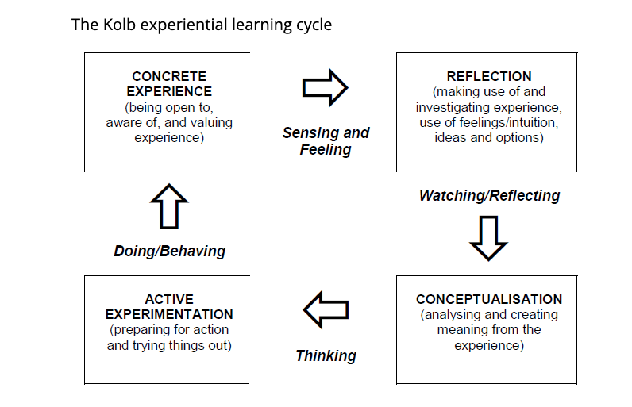
Appendix 4.

- ZWOZDIAK-MYERS, P., 2012. The teacher's reflective practice handbook : becoming an extended professional through capturing evidence-informed practice. New York: Routledge.

Appendix 5
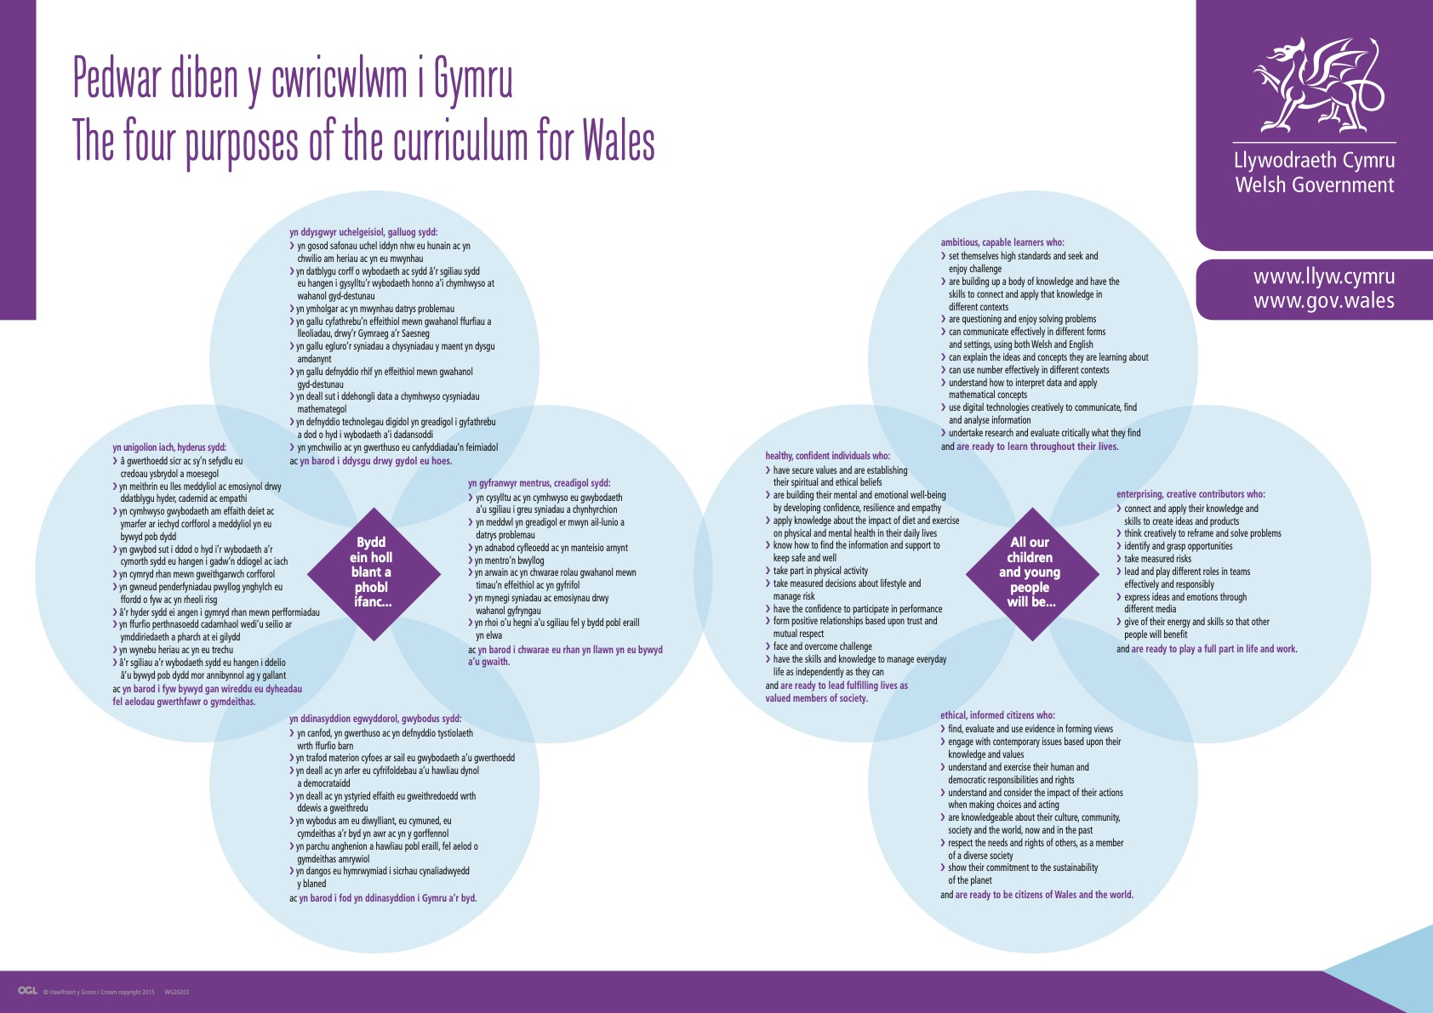

- https://gov.wales/sites/default/files/publications/2018-03/the-four-purposes-of-the-curriculum-for-wales.pdf
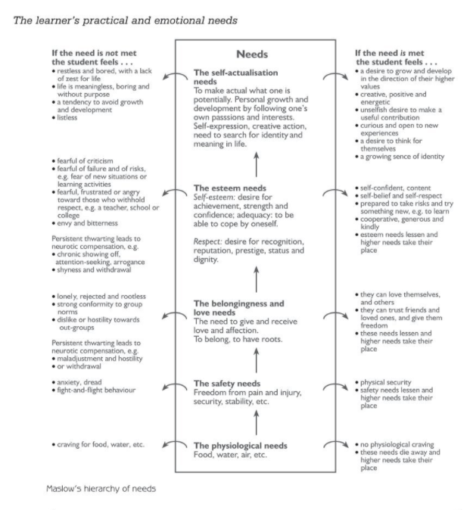
Appendix 6.

- Petty, G. (2014). Teaching today : a practical guide (5th ed.). Nelson Thornes.

Appendix 7.
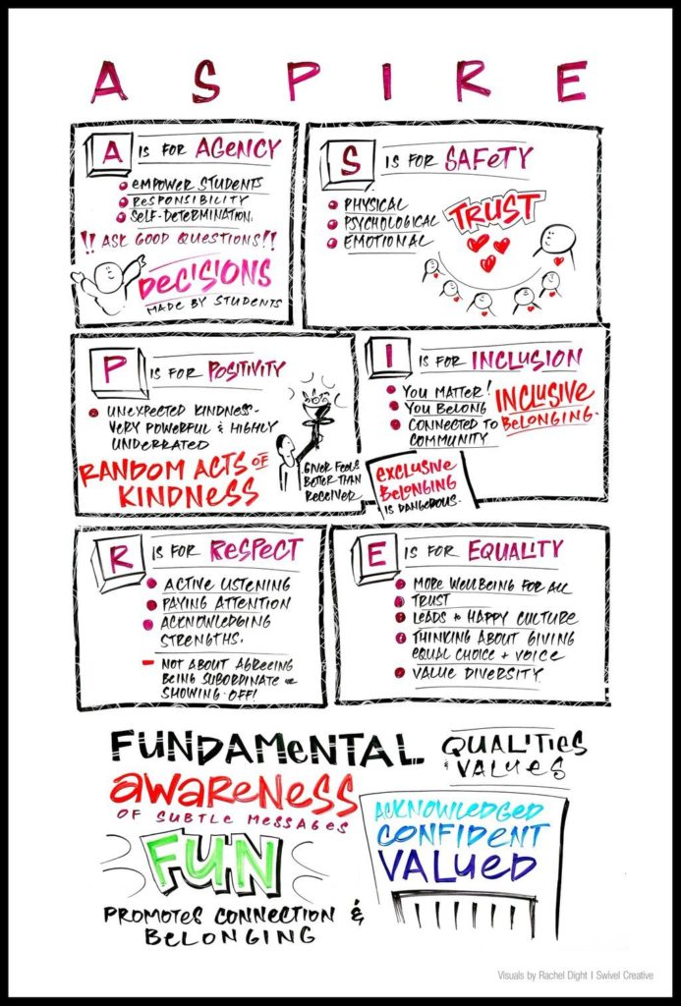

- http://growinggreatschoolsworldwide.com/csn/circle-principles/

Appendix 8.

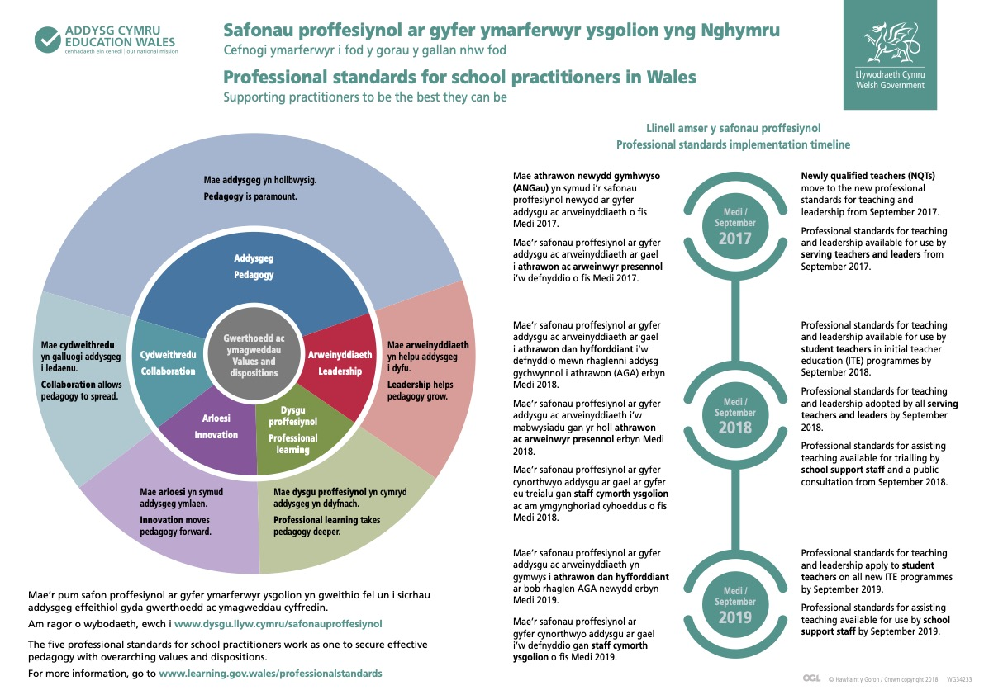

- https://hwb.gov.wales/api/storage/2e137fc7-73da-4ee7-8f66-d10dca6977d1/professional-standards-for-school-practitioners-in-wales.pdf

