Ventsislav Nedev
Student ID: 1912608
Certificate of Higher Education in Skills for the Workplace
MODULE CODE: BMSW4002
Effective Team Work and Communication
Assignment:1
Lecturer: Timothy Hopkins

Table of Contents
Introduction 3
Conversations for effective communication 3
Regular connection via effective communication 4
Two-way feedback 4
Development of listening skills 4
Exemplary Leaders 5
Theories on effective communication - Brief Study 5
Aristotle Model of Communication 5
Shannon and Weaver Model of Communication 6
Importance of effective communication 7
Conclusion 8
References 9
Appendix 10

Introduction
Communication is an integral part of reflecting an individual’s ideas and thoughts on both personal and professional fronts. This can be formally defined as a way of establishing a connection between individuals or groups of individuals or an individual and group or groups. This act of communication includes the use of gestures as signs of communicating one’s ideas or signals. The communication between individuals or groups can be categorized as written, verbal, face-to-face, or visual and non-verbal. A key need for the efficient management of any institution or work environment is effective communication. This is a key tool that will surely help in enhancing the basic performance related to the planning of the structure, managing it, and also designing the job roles and responsibilities. With the change in time, there have been shifts in management methodologies. So, the adoption of the art of effective and flawless communication by the managers is pivotal in running a business.

Conversations for effective communication
With a change in trend, technology, and lifestyles the most important change is the one coming up in the management of the business. Every organization is striving to bring out the best from its resources invested in the process of functioning or production. These resources largely comprise the human resources put to use apart from the physical raw materials (Dyer et al., 2019). The art of effective management and use of human capacities comes with a fancy name of HRM or Human Resource Management. The key factor of HRM is promoting effective communication among the employees and the managers which in turn ensures successful teamwork and effective leadership. With regular changes in functionalities and working areas, it is immensely important to maintain effective communication. In case there is a gap between the communication of the employees and the managers or team leaders it directly affects the given organization.
There should be an abundant emphasis on the communication between the employees and the management. This is the key to the success of any organization, be it a start-up or a tech giant. The focus should be on HR management, especially in the field of training the employees to maintain a proper tone of communication. This must be coupled with the choice of the right words while maintaining a fair protocol that is a required level of formality (Weaver et al., 2017). This is an underlying factor that requires much emphasis for it is responsible for creating a sustainable environment for efficient performances while serving the interests on all sides.

There is a basic need for practising formal, well-toned, and rightly built conversations. These will be aimed at delivering the required information while maintaining the basic communication protocols and work ethics (Mohanty and Mohanty, 2018). This will lead to two important outcomes. Firstly, it will develop a strong sense of confidence among the working teams, thereby enabling high-level performances. Secondly, it will help in developing a good workforce and an efficient working environment. The main accomplishment of the communication storyline is a plethora of management goals which include mutual trust, better work performances, and, of course, a good sense of understanding is bound to develop between functional groups (Weaver et al., 2017). The key requirement is effective communication between the management and the workers or employees. Apart from working with their specific set of skills the managers much put a strong emphasis on strengthening the communication with the employees. This is because they play a chief role in forming clear cut connect among the organization or corporation. The chief aspects that must be noted by all managers in an organization can be briefly discussed as follows:

Regular connection via effective communication
This implies a well-built model of communication is to be designed to bring out the best from the employees or the teams in a corporation (Gharaveis, Hamilton and Pati, 2018). The entire process of managing the organizational skills, giving job roles networking should be done in a comprehensive manner Conversations for effective communication.

Two-way feedback
This implies the facilitation of a process to enhance work performances from the end of both the managers as well as the employees (Gross et al., 2016). A feedback system is of utmost importance to ensure teamwork and effective communication among the workforce and managers. This is an aspect that needs much attention to help a business expand its influence by generating large returns while creating a competitive and compatible work environment.

Development of listening skills
The two-way key of an effective conversation is the right speech and right listening skills. These are the two most important factors that are to be stressed upon to enhance HRM or Human Resource Management and performance levels.

Exemplary Leaders
The credibility of the managers is something that the employees must be ensured. The team leaders must not resort to petty ego issues and admit their mistakes if any (Acai et al., 2017). This will build a two-way process of effective communication and good work bonding along with maintenance of work ethics.
It is necessary to briefly elaborate on the concept of Proxemics in relation to effective communication and teamwork. This is basically a process that deals with the ways in which an individual handles their personal space (Martin et al., 2019). As per Hall, the differences arising out of the personal space of individuals often leads to issues of anxiety and stress or relaxation. This is a measure that shows how close one is to a person. These are measured by physical distances in American culture. These can be listed in the following categorizations:
Intimate distance is the one in which there is a distance of 16–46cm at the time of embracing
Personal distance is the one in which there is a distance of 46–121cm for interaction occurring between friends
Social distance is the one in which there is a distance of 1.3–3.6m for interaction that is between the acquaintances
Public distance is the one in which there is a distance of over 3.6m for in case of public speaking
This is an important point that must be noted for it is an important parameter that enables effective communication (Logan, 2016). Another key concept under the study of effective communication is kinesics. This term was propounded by Ray Birdwhitsell in 1952, he was a noted anthropologist. This term, Kinesics defined the linkages or relationships between the motions of non-linguistic body movements and communications. This term strived to define how the gestures, gait, and postures of individuals enhanced communication.

Theories on effective communication - Brief Study
This segment briefly illustrates the Aristotle Model of Communication and the Shannon-Weaver model of communication.

Aristotle Model of Communication
This model state how the speaker plays a pivotal role in communication. The speaker is the one who takes charge of the task of generating effective communication. He or she is responsible for creating an effective and comprehensive content to deliver the right pieces of information. The speaker goes ahead by first preparing a content. This is done carefully by putting the plan points and thoughts into brief statements (Logan, 2016). This is done with the objective of informing and influencing the audience or the recipients, who are then supposed to respond in required wants. This is what is briefly stated in this model of communication. The Aristotle model of communication is widely applied and accepted a model of communication. This is where the speaker delivers the required information or a message to the listeners. This is done to influence them and make them respond and act accordingly. Aristotle’s model of communication is the golden rule to prosper in public speaking thereby enhancing teamwork and generating effective communication.

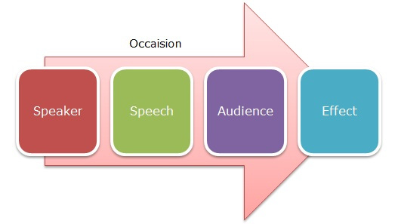
Figure 1: Aristotle Model of Communication
(Source: Logan, 2016)

Shannon and Weaver Model of Communication
Shannon and Weaver’s model is the most recent and popular model of effective communication. This is widely accepted and globally referred to and cited. This is often tagged as the mother of all models. This was theorized by Claude Shannon in 1948. This theory was reprinted in 1949 with co-author Warren Weaver (Jain et al., 2016) This model has five components - the Sender, Encoder, Channel, Decoder, Reciever. The model shows the effective transmission of a message by using a linear model. The model is starting from the sender who is sending a message and is thus the source of information. It further gets transmitted to the encoder who is the transmitter of the given message. It then comes to the channel. Where there is a noise component. This where the message gets transmitted from the mouth of the speaker to the brain of the listener (Jain et al., 2016). The noise is nothing but the factors which affect the communication between the two ends. Next comes the decoder. This is the phase where the received message is decoded by the listener or the individuals in the audience (Holmes and Lasen, 2017). The final stage is the receiver. In this stage, the complete information out of a message is retrieved and assimilated for further usage by the listener. The key aspect of this model is the clarity that is needed in the message, this clarity is ensured by the feedbacks exchanged between the “decoder “and the “encoder”.
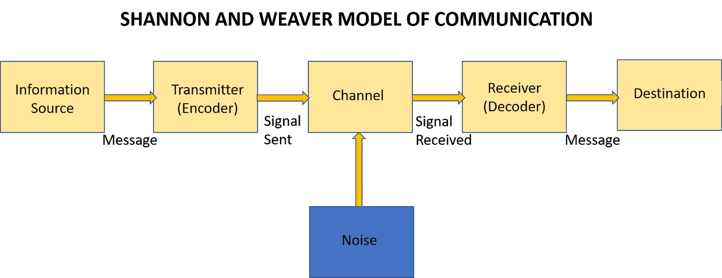
Figure 2: Shannon and Weaver Model of Communication
(Source: Holmes and Lasen, 2017)
This model has been widely used by managers and Corporations to delineate and manage the intricate strands in the promotion of effective communication and leadership amongst the employees. This has served as a key aspect of human resource management to date (Hastie, 2018). An important point in this regard is the high and low context concepts in ensuring effective communication. The main instances are that of the cross-cultural communication exchanges. The high context communications are found in Western countries where oral or verbal communication is preferred as opposed to Eastern countries where written communication modes are preferred.

Importance of effective communication
The key factor that is comprehensively outlined in this analysis is the dire need of effective connect or communication amongst individuals. This is an important area that I feel is often ignored. This in the future might prove to be an underlying issue causing major losses in terms of resource management and proper functioning of the organization (Kadda, 2019). The importance of effective communication is something that I have felt and observe in daily life. This starts from the basic communication between my family members which ensures the smooth running of the family household while peace and harmony are prevailing. This can be referred by the instance of effective communication regarding monthly bill payment and expenditure management conversations.
Family fund management and personal issues are also solved by utilizing effective communication. This can be also be elaborated by the instance of the working of the management of the departmental store where I often go for part-time work. The core leadership and effective communication between the store manager and the employees, the conversations between the retailers, and the manager are perfect instances of everyday use of effective communication (Hastie, 2018). Other formal instances are that of the big corporate houses that I often read about in the dailies. There is a critical elaboration of their economic performance based on human resource management. These aforesaid instances also reflect the concepts discussed in the introductory segments (Weller et al., 2016). The popular models are macro-level illustrations of these daily events of management decisions. These are logically reasoned and effectively communicated decisions and messages that help in the regular functioning of individuals.

Conclusion
It can be concluded that this assessment comprehensively elaborates on the key aspects related to effective communication at all levels. This starts from the individual to organizational levels. This is nothing but a maze of effective management guided by core concepts of effective communication and decision making. These two points when ensured surely, guarantees a good team performance at any level of management. This is a field that can be enormously researched and studied.

References
Acai, A., McQueen, S.A., McKinnon, V. and Sonnadara, R.R., 2017. Using art for the development of teamwork and communication skills among health professionals: a literature review. Arts & Health, 9(1), pp.60-72.
Dyer, J.D., Morgan, M.C., Cohen, S., Ghosh, R., Raney, J., Spindler, H., Mahapatra, T., Christmas, A., Walker, D.M. and Medvedev, M., 2019. Does teamwork and communication improve with simulation training? An evaluation of simulation training videos in Bihar, India. East Afr J Appl Health Monitor, 3, pp.1-10.
Gharaveis, A., Hamilton, D.K. and Pati, D., 2018. The impact of environmental design on teamwork and communication in healthcare facilities: a systematic literature review. HERD: Health Environments Research & Design Journal, 11(1), pp.119-137.
Gross, A.H., Leib,R.K.,Tonachel, A., Tonachel, R., Bowers, D.M., Burnard, R.A., Rhinehart, C.A., Valentim, R. and Bunnell, C.A., 2016. Teamwork and electronic health record implementation: a case study of preserving effective communication and mutual trust in a changing environment. Journal of Oncology Practice, 12(11), pp.1075-1083.
Hastie, C.R., 2018. ‘TeamUP’: An approach to developing teamwork skills in undergraduate midwifery students. Midwifery, 58, pp.93-95.
Holmes, D.W. and Lasen, M., 2017. Explicitly teaching teamwork and written communication within a problem based curriculum: Development of a generalised framework. In Proceedings of the 28th Annual Conference of the Australasian Association for Engineering Education (AAEE 2017) (pp. 448-455). School of Engineering, Macquarie University, Sydney, Australia.
Jain, A.K., Fennell, M.L., Chagpar, A.B., Connolly, H.K. and Nembhard, I.M., 2016. Moving toward improved teamwork in cancer care: the role of psychological safety in team communication. Journal of oncology practice, 12(11), pp.1000-1011.
Kadda, O., 2019. Teamwork in cardiac rehabilitation. Health & Research Journal, 5(2), pp.38-40.
Logan, T.R., 2016. Influence of teamwork behaviors on workplace incivility as it applies to nurses. Creighton Journal of Interdisciplinary Leadership, 2(1), pp.47-53.
Martin, G., Khajuria, A., Arora, S., King, D., Ashrafian, H. and Darzi, A., 2019. The impact of mobile technology on teamwork and communication in hospitals: a systematic review. Journal of the American Medical Informatics Association, 26(4), pp.339-355.
Mohanty, A. and Mohanty, S., 2018. The impact of communication and group dynamics on teamwork effectiveness: The case of service sector organisations. Academy of Strategic Management Journal, 17(4), pp.1-14.
Weaver, S.J., Benishek, L.E., Leeds, I. and Wick, E.C., 2017. The relationship between teamwork and patient safety. In Surgical patient care (pp. 51-66). Springer, Cham.
Weller, J., Cumin, D., Civil, I., Torrie, J., Garden, A., MacCormick, A., Gurusinghe, N., Boyd, M., Frampton, C., Selander, L. and Cokorilo, M., 2016. Improved scores for observed teamwork in the clinical environment following a multidisciplinary operating room simulation intervention. The New Zealand Medical Journal (Online), 129(1439), p.59.

Appendix

In class activities.

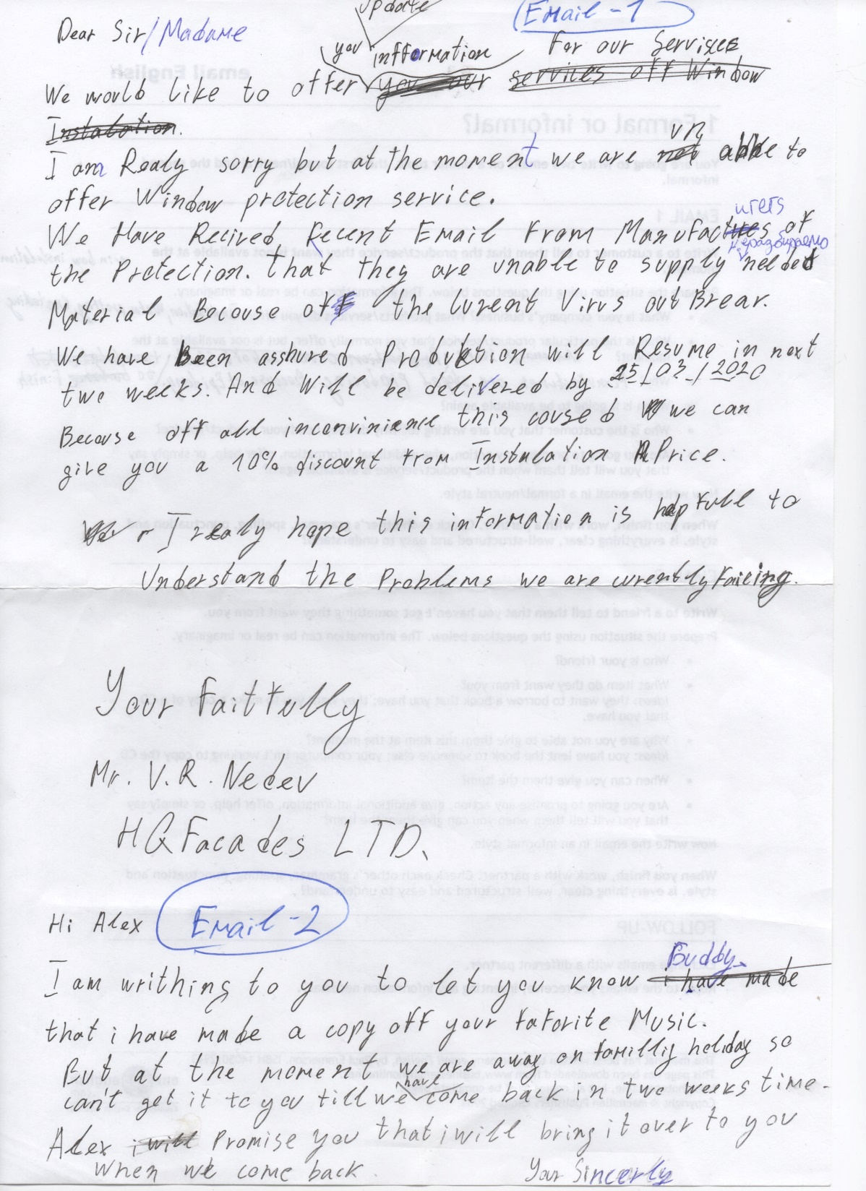

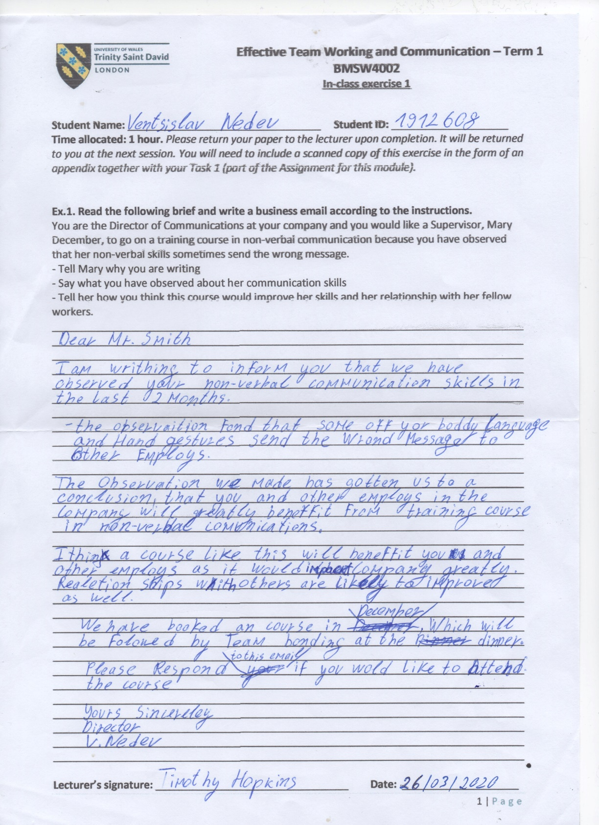
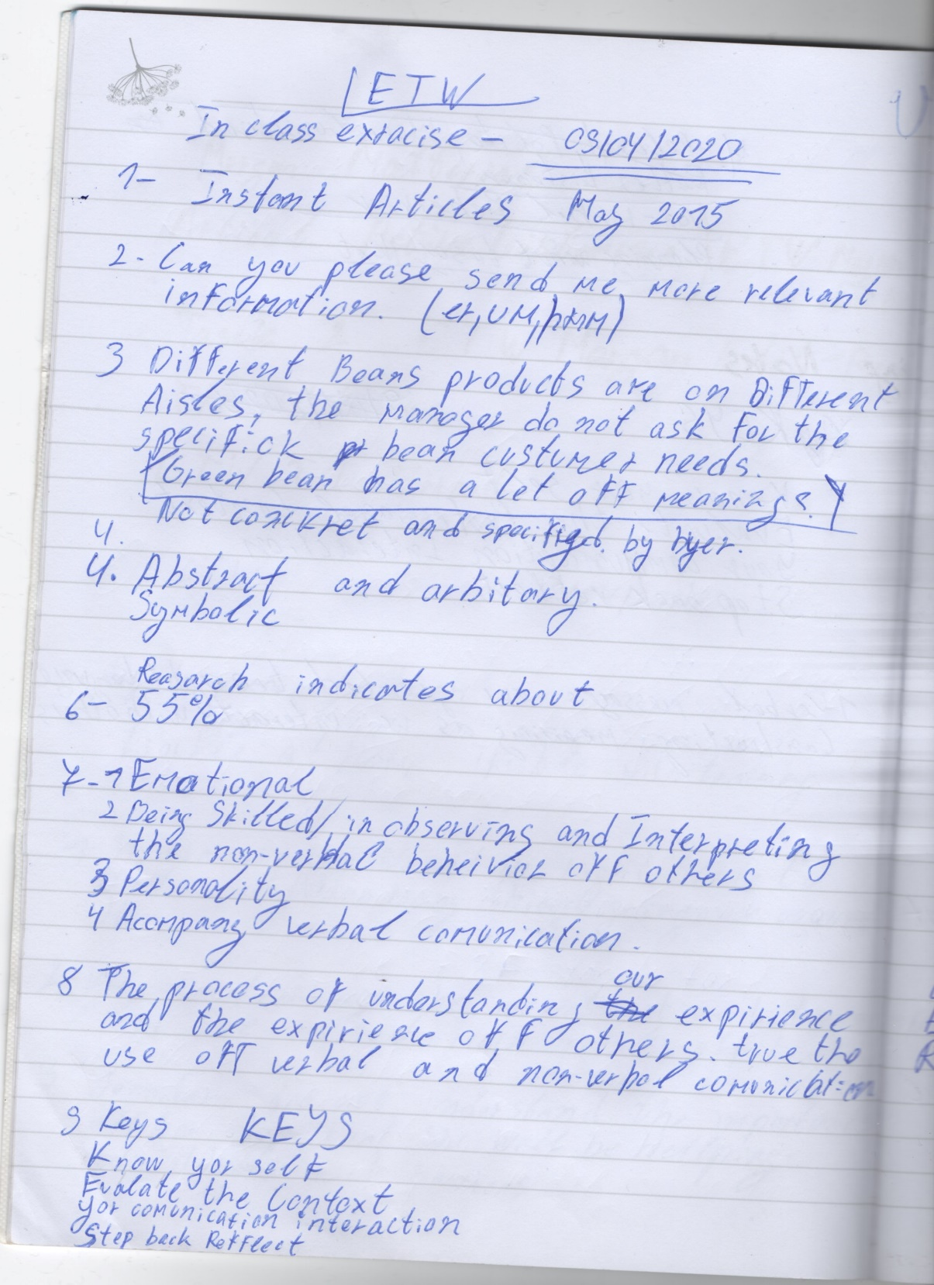

Module-ETW 11/04/2020
Ventsislav Nedev
Student Number-1912608
Lecturer-Timothy Hopkins

Me:
Good morning everyone. Hopefully, you are all feeling well prepared for the upcoming tasks today.

The whole group have a discussion for ten minutes about yesterday’s progress on site with a lot off details on existing problems about incorrect drawings and possible solutions.

First off all I want to inform all off you that I received email with information about certain areas we can’t have work done today because of other works been carried out in the same area.
This are block B levels 3,4,5 and block C levels 2,3.

Supervisor:
I will transfer the 2 teams working yesterday in those areas not possible work to be carried out today to block A.
Our time schedule on finalising all external works is 30 days from today on block A and in that case the other teams working on block A can use the 2 teams to catch up with some outstanding works. It will really help with handing over all keys and locks on scheduled date in 30 days.

Me:
Sound like a great plan please try to get all the outstanding Window protection missing on block A done as soon as possible because I have been receiving emails with complains from Managers for uncompleted external protection and some Windows been slightly scratched because of that.
By the way I have a meeting today at 11am, I would like you to join me I think if more detailed information about progress on site is needed you can help support me.

Supervisor:
Sure, I will organise the installation teams to start caring out all outstanding works in block A and will catch up with you 11am at the site meeting hall. If there is anything you need from me, please contact me.


