
developing relationships and workplace achievement

Table of Contents
INTRODUCTION 2
MAIN BODY 2
Critically evaluate development vehicles available to company and explain to meet the development needs and expectations of the individual. 2
Develop a plan to understand and identify development needs and expectations of an individual. 3
Introduce the available training and development vehicles that your chosen organisation currently uses. 5
CONCLUSION 5
REFERENCES 7

INTRODUCTION
Developing relationship is important because it contributes to inner stability which lead to personal satisfaction and a good atmosphere in the workforce. When people have trust then they can enjoy their job (Belwalkar, Vohra, and Pandey, 2018). The organisation benefits when workers have a good, stable relationship with their employees. The study shows that employees with respect to each other are likely to satisfied, committed and profitable in the long term. When workers are respected and employees are satisfied and productive as they are encouraged to continue which helps them to enhance their successful work. With the effort’s enterprise recognize the contributions of the staff which will increase the overall working atmosphere. The company chosen in this report is ITSU.The company is founded by Julian Metcafle in the year 1997. The headquarters of this organisation is situated in London, United Kingdom with a British chain of East Asian which delivers fast food and restaurants as well as manage and operate their business in grocery and fast-food shop. I chose to work with this company because I’ve seen that company listed as one of the top places to work, and because of my experience of 3 years working through hospitality path, I thought that is the position which suits me the best. During all this time, small incidents also happened, but the HR department always helped the organization to evolve, to solve all conflicts, to underline the failures and to contribute to their resolution. HR could be considered a strategic partner of the company's management, but also the support we needed to solve the various problems that may have arisen.

As an hr officer I will cooperate well with the organization that I work for, applying the tools and techniques which we have studied in the first semester.
This report includes development ways of company which meet the development needs of the individual and plan to meet the identified needs as well as expectations of people.

Main body

Critically evaluate development vehicles available to company and explain to meet the development needs and expectations of the individual.
Personal development is defined as the process of self enhancement is personal growth aimed at developing one’s own experience, abilities and sense of belonging. Itsu trained their workers to increase their skills, knowledge as well as ability in order to achieve the business goals and objectives. Itsu has adapted Holland’s and Schein’s model which are explained below:
Holland’s model: Holland says that collaborating with each other in a job creates an experience that suits and promotes its kind. The principle of Holland is based on the idea that other personalities fit one of the six different categories of individuals:
- Realistic: These type of people like the use of running machinery, appliances or instruments to primarily operate with hands, make, repair, assemble and create objects and they learn to work outside organisation. In this category labour of Itsu comes which manufacture their food with the machinery (Bueno, Rodríguez-Baltanás and Gallego, 2018). They are the someone who primarily by creating and attaching items, constructing or working machinery using their hands.
- Investigative: They want to explore thoughts, look, study and practice, to ask answerable questions. In context to Itsu, people bring new ideas and give opinions to launch new products and services. They don’t how to negotiate, they want to deal with some other leaders. However, they are precisely and intellectually aware of the contributions and would like to recognize them.
- Artistic: They are the person who likes to talk, sing or articulate language, design, songs, actions to produce and layout objects. In context to Itsu, people see each other as creative and innovative and wish to accept or extremely coordinated tasks. They love teamwork and collaboration but unless imaginative, freedom is permitted and their thoughts are welcomed to express.
- Social: They wishes to partner with individuals to educate prepare and advise them about the quality of life, helping, treating, healing and many more. Selected organisation provides training and development in order to give knowledge and skills of the technology and other activities. They support programmes for those in specific and love interacting together with others.
- Enterprising: The individuals would like to meet a lot of people, guide, and converse, encourage other to operate their business. In context to Itsu, this people are marketing individuals which promote their business in market in order to attract customers. They consider themselves as cooperative and competitive and people have a habit of leaning up a gathering of users. They make sure that people who are too logical and intellectual but really who clearly and regularly engaged are avoided.
- Conventional: The people want to work inside and position that involves the organisation as well as accuracy of operations, work with statistics, figures or activities. In selected organisation, a member of the community would typically choose to use numbers, logs and computers. Repeating operations are performed in an organized way and repetitive actions are avoided. In the specific ways, individuals consider themselves superior, coordinated and healthy. The people admire corporate results and love partnering with others, but they perform their effectively and efficiently in the systematic communities in which individuals know their responsibilities.
- 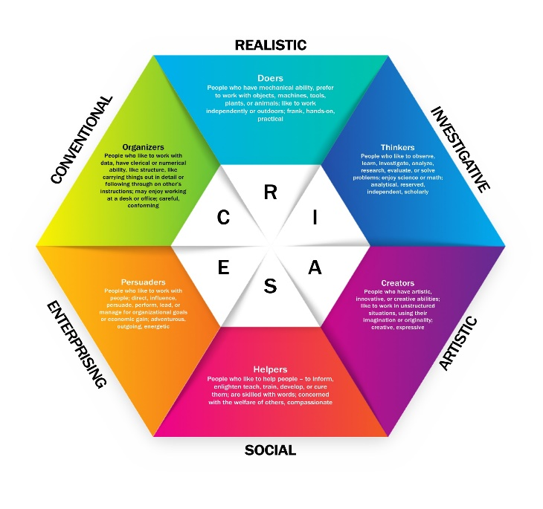
Schein’s model: It refers of demonstrating the idea of culture and the ways it influences organisation. It is flexible learning strategy and a changing team. This model emphasis the various layers and theories to be considered in each organisational culture which are mentioned below:
- Artifacts: The first stage is the organisation’s features which people usually described as objects can clearly see, feel and hear. For example, in selected organisation worker uniform, workplace decoration, facility, subordinate’s behaviour, purpose of organisation and goal are all objects which go far and wide in the determination of work environment (Kerzner, 2018).
- Values: The values of workers are the next step according to Schein and is part of environment of company. This is the principles of people in the business which plays a crucial role in determining the atmosphere of the organisation. Considering Itsu company, the ways people think and behave affect the atmosphere of every specific business. Perception does not require persons acting according to their beliefs. In context to Itsu the corporate factors guide team leaders to distinguish between beneficial or unwanted alternatives and behaviour. Value involves orientation of expectations, description and organisation of goals following expression of standards. For example, there are businesses in which women staff dominated male staff because they’re not compatible with that style of corporate culture which will not participate in remaining late on the job. Instead, male workers are rude and willing to remain late.
- Assumed value: The third degree is the principles adopted by the workers that cannot be calculated, but who affect the company's culture. Some values and evidence remain unknown but influence the corporate strategy. The internal dimensions of human experience are part of the third stage of community and organisation. In the food and grocery shops of Itsu they have to take proper care of their women while working in their firm and have different shifts for their female employees (Lee, Park and Baker, 2018).
- 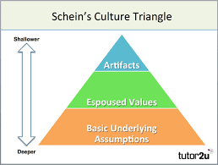

Develop a plan to understand and identify development needs and expectations of an individual.
Development is a formation, improvement, meaningful action, or material, social, financial, cultural and generational extension. A planning strategy lays out strategies and plans of a municipal government regarding property use in its region. Mentioned below are the needs and expectations of workers which are given as:
Enhance skills as well as knowledge: Employee development is crucial as it contributes to the improvement of their abilities and experience that improves their success. Training and learning programme enable an individual to learn their new developments. Such competencies are necessary to finish the work of Itsu. Thus, to inspire the workforce which lead to accomplish corporate objectives. This type of development offered by institution assists people to attract unique skilled staff and furthermore focuses on improving their brand loyalty.
Personal and professional growth of workers: For professional as well as personal growth of workers, progress of employees is essential. These developments enable a person to cope with a negative circumstance and an unpredictable company condition. Such abilities allow an individual to fulfil his or her tasks as well as to grow their profession, such as advocacy, transition to a good position etc. In context to Itsu, it is critical that they have a strategic edge to expand on the marketplace. Career planning provides industry organisations with a comparative edge.
Growth of members in a leader: Development allows people to flourish as it supports the corporation’s long-term sustainability. This lets companies such as Itsu they retain jobs as it is more expensive to hire new staff. However, this makes people not travel about in another company when a corporate culture takes time to learn.
Human resource theories: HRM based on the creation of analytical concepts or frameworks in order to research and interpret human resources improved quality practises.... The corporate role Human Resources addresses individuals and problems relating to individuals like benefits, recruitment, progress improvement and education. The theory which is adapted by management of Itsu is mentioned below:
AMO theory which comprises of ability, motivation and opportunity as staff working component constitute individual features and contribute to corporate performance. Goals of the organisation are best done by these three elements because AMO theory allows top management to use effective approaches that motivate employees to use laws and procedures on human resources.
Ability: Ability refers to procedures and policy implemented by HR in order to guarantee that workers are able to do their jobs under minimal supervision, or have the expertise, experience and ability they deserve.
Motivation: Motivation applies to the success of the employees, HR's modification policies to control their encouragement. It also applies to the forms in which workers are encouraged to do their work more and more by encouraging them mostly for the things they've done previously.
Opportunity: Improve HRM activities that seek to engage employees by creating resources. Opportunity enhancing HRM activities are applied to by exchanging knowledge as activity that transfer judgement authority and influence from highest position to lower levels of hierarchy. This approach strengthens worker confidence in the company and enhances the development of the company through collaborative effort.
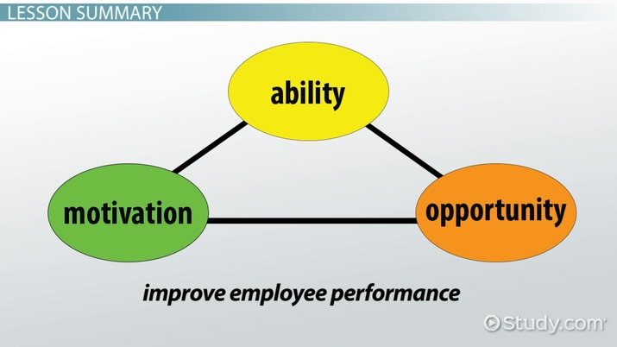
From the above analysis, it is evaluated that people that training and development is necessary for an individual which helps them to develop the knowledge, skills as well as abilities to achieve the organisational goals and objectives. In relation to Itsu, when management has to give some training and workshop to teach about the different types of fast food in restaurant then employees will learn from the cook to make the dishes in order to increase efficiency in business. On the other hand, job rotation is the best approach to enhance the skills and meet the needs of individuals by rotating their job roles. This method helps them to experience many work in practical which help them to devlop their knowledge in all sectors. In Itsu company people by rotating their work assist them to make and produce different recipes in order to attract customers in their fast food and grocery shops (Schein and von Ameln, 2019).
Development plan of Itsu Company which is mentioned in below table:
Skills to be improve | Communication skills, teamwork skills, collaboration.
Objectives of improvement | Communication skills: Communication is critical because they want to develop consumer relationships and give a comfortable atmosphere. It contributes to improving the reputation of the entity when staff addresses their guests directly.  Teamwork skills: It is vital that workers understand when to operate together as a group because it allows each other to function more effectively without trouble. Teamwork skills consist of interconnected skills that allow you to function in an integrated community successfully  Collaboration: is a practise that contributes to improved staff performance too and prevents misunderstanding at job.
Technique of improvement | Training: Interactions could be improved by professional development and include approaches such as lecture instruction which lets them strengthen their interpersonal abilities and connect effectively with their guests and also lets their organisational reputation to develop.  Creation of jobs: Team work can be enhanced by practising jobs as it can be taught by doing jobs that allow management to properly arrange different tasks in the organisation.

Introduce the available training and development vehicles that your chosen organisation currently uses.
There are various ways of training and development which is adapted by Itsu company which are mentioned below:
- Internship: Practices on all parts are excellent. Workers can learn from administrative staff, and workers can take advantage of managers' advice and preparation. However, it may be increased or inconsistent in some instances.
- Job rotation: Employee morale and dedication will do a lot is called as job rotation. This approach provides individuals with opportunities for further development and advancement and creates fulfilment and collaboration (Singh and et.al., 2019).
- Mentoring and apprenticeship: This is the perfect preparation tool to consider as businesses plan to prepare employees for advancement and development. Trainees will really profit from this customised education framework, enhance the interaction between mentors and apprentices and promote their potential job.
- Programmed instructions: The programmed training does not function with personality, but in situations where any distraction from the curriculum does not damage the performance of the enterprise, it is quite successful. However, this approach is successful and scalable.
From the above analysis, it is evaluated that the fast-food shop and grocery company as they give proper training to their members to serve their customers in a proper manner so that they attract their visitors and innovating new recipes in order to remain competitive in the market.

CONCLUSION
From the above analysis, it is concluded that it can be derived from the above project summary that the growth strategy applies to a mechanism that enables the growth of different competencies in an enterprise. Staff members continue to improve and they boost their results and maximise a person's employment potential. It also offers a person the ability to learn new skills and ability to operate in an entity efficiently. An organisation also benefits from developing staff talents by reducing time waste production at workplace and increasing business efficiency. Supervisors follow different methods to enhance the abilities of individuals, through preparation, career creation, and training and work rotation. Trainings provide knowledge learning by seminars, recording or other means for a person. Training is a mechanism in which top leadership provides advice and work-related issues for their junior teams. Managers follow Schein Model, which identifies the corporate environment as a working culture, assumes an essential part in building employees' performance. It covers three major aspects including objects, principles and hypotheses. An individual’s personal advancement needs are different and it offers them both personal and career development. It also improves workers' skills and capacity.

REFERENCES
Books and Journals
Belwalkar, S., Vohra, V. and Pandey, A., 2018. The relationship between workplace spirituality, job satisfaction and organizational citizenship behaviors–an empirical study. Social Responsibility Journal.
Bueno, S., Rodríguez-Baltanás, G. and Gallego, M. D., 2018. Coworking spaces: a new way of achieving productivity. Journal of Facilities Management.
Kerzner, H., 2018. Project management best practices: Achieving global excellence. John Wiley & Sons.
Lee, J. Y., Park, S. and Baker, R., 2018. The moderating role of top management support on employees’ attitudes in response to human resource development efforts. Journal of Management and Organization. 24(3). pp.369-387.
Schein, E. H. and von Ameln, F., 2019. Relationships as a key to change. Ed Schein on the legacy and future of Change Management. Gruppe. Interaktion. Organisation. Zeitschrift für Angewandte Organisationspsychologie (GIO). 50(2). pp.141-144.
Singh, S. K. and et.al., 2019. Self-efficacy and workplace well-being: moderating role of sustainability practices. Benchmarking: An International Journal.
Strycharczyk, D. and Clough, P. eds., 2018. Developing mental toughness in young people: Approaches to achievement, well-being, employability, and positive behaviour. Routledge.
Turki, F. J., Jdaitawi, M. and Sheta, H., 2018. Fostering positive adjustment behaviour: Social connectedness, achievement motivation and emotional-social learning among male and female university students. Active Learning in Higher Education. 19(2). pp.145-158.

