IPV6
SECURITY AND VULNERABILITY

IPV6
University of Wales Trinity Saint David
INTERNET PROTOCOL
SECURITY AND
VULNERABILITY
MODOU PENE
1810381
SUMMARY

INTRODUCTION……………………………………………………………..I

SECURITY…………………………………………………………………..II
- IPV6 Address Spoofing
- Unicast IEEE 802
- Multiple addresses
- Extension header security
- Fragmentation
- Neighbour discovery
COMMON ATTACKS………………………………………………………III
- Trespassing
- Bypass filter device
- Denial-of-service (DOS)

CONCLUSION……………………………………………………………IIII

Introduction

Internet Protocol (IP) is the basis of Internet architecture. The current version, four, standardized in 1981, is now insufficient with respect to the enormous development of the Network and its current needs. For this reason, the introduction of the new version, IPv6, is imminent, which introduces important innovations also in the perspective, now probable, of convergence on IP as a single protocol for each communication device.
IPv6 was born with the idea of optimizing the performance of the routers, and for this reason the concept of addressing hierarchy was introduced, that is, how telephone exchanges sort calls based on the prefix and the identifier of the location, so in IPv6 the packets they are routed by analysing only a part of the address at a time. This feature combined with the assignment of the addresses (more precisely of the "prefixes") on a geographical basis will clearly improve the performance of the routers and eliminate the problem of the routing tables explosion.
There are three types of IPv6 addresses:
- Unicast
- Multicast
- Anycast
IPv6 also offers advantages such as:
- More addresses available
- Higher speeds
- Automatic configuration
- Strong security
- More conversion
And also disadvantages:
• IPv6 and IPv4 cannot communicate directly and require a server
IPv4 brief
IPv4 (Internet Protocol version 4) its purpose is to allow computers, routers and all other connected devices to connect to the Internet to communicate with each other, to exchange information and above all to find themselves. When no one was created, people dreamed that there would be millions of computers connected to the Internet. They had not foreseen that there were connected to the cellular network, first of all machines without humans behind. Cameras, beverage dispensers, televisions and automobile sensors billions of devices connected by a central computer "Internet of Things" and all these devices need an IP address. So, there is a problem because an ip address is like a phone number there can't be two equal and each one must have a unique one. In doing so, they realized that the addresses would soon end and there would be a risk that the new devices that came would not be accepted. Thus, was created IPv6.

Security and Vulnerability
The new IPv6 addresses, with the dramatic increase in the number of available addresses, have raised some concerns about data security and protection. The new addresses create different security implications. Thanks to its amplitudes, the protocol allows attackers to reduce the search space when a scan is carried out to identify specific addresses.

- IPV6 Address Spoofing
It is difficult to track the traffic of a dial-up user on the Internet based on the address, because the IPV4-based Internet an Internet user connects to an Internet service provider (ISP) and obtains an IPv4 address using the PPP protocol ( Point-to-Point Protocol) and IPCP (Internet Protocol Control Protocol)

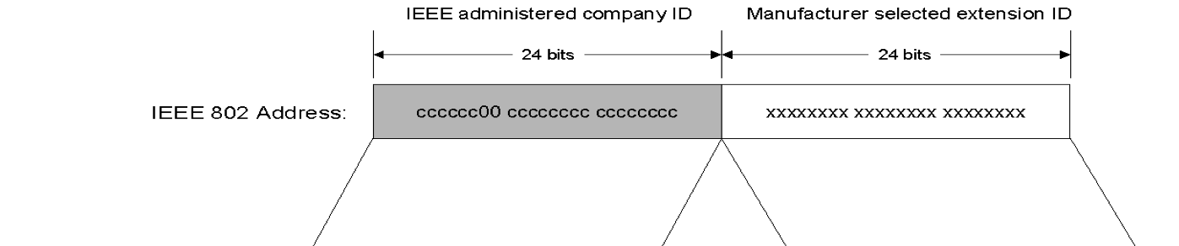
- Unicast IEEE 802 address to an IPv6 interface identifier

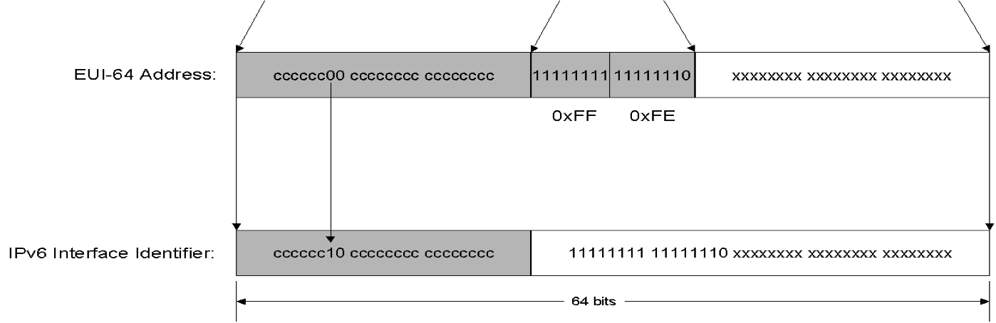

- Multiple addresses
By assigning multiple addresses to an interface, IPv6 challenges the filtering rules in firewalls and access control lists. In these cases, all dynamic addresses must be stored on the firewall so other addresses will have to be automatically generated IPv6 has no broadcast method of packet forwarding and instead uses multicast for all one-to-many communications.

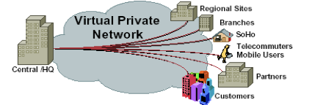
- Extension header security
The figure shows the structure of an extension header and describes how they form a linked list of headers before the packet payload
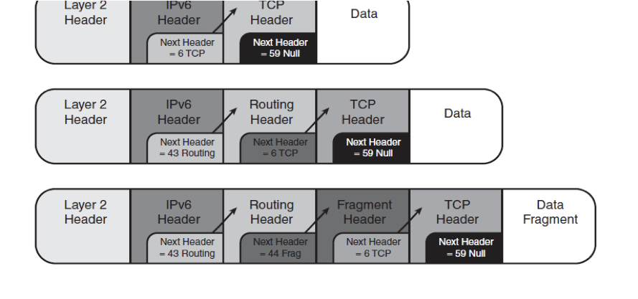
An attacker could perform header manipulation on the extension headers to create attacks. Someone could create an IPv6 packet that meets the protocol specification and has an unlimited number of extension headers linked together in a big list.
• Chaining lots of extension headers together is a way for attackers to avoid firewalls and Intrusion Prevention Systems (IPS).

- Fragmentation 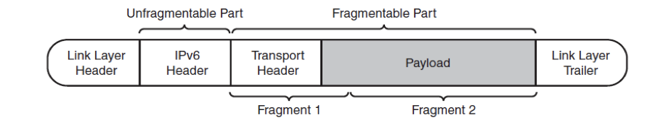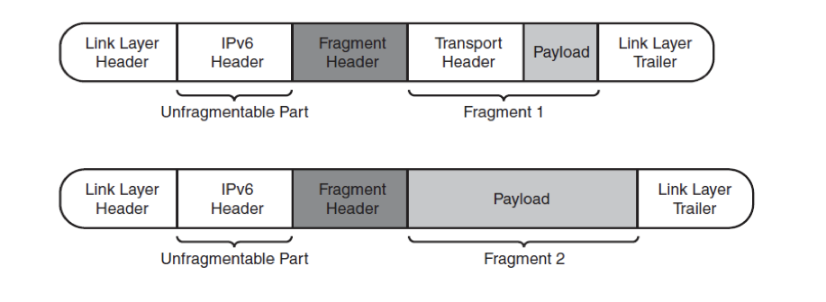

In IPv6, fragmentation is never performed by the intermediary routers but by the end nodes themselves. So, only the end hosts are allowed to create and reassemble fragments.
• This process can be used by attackers to either hide their attacks or to attack a node. By putting the attack into many small fragments, the attacker can try to bypass filtering or detection.
• Fragmentation attacks are typically used by hackers with tools such as: Whisker, Frag router.

- Neighbour discovery
In IPv4, subnets are generally small, made just large enough to cover the actual number of machines on the subnet.
• In contrast, the default IPv6 subnet size is a /64, a number so large it covers trillions of addresses, the overwhelming number of which will be unassigned
Consequently, simplistic implementations of Neighbour Discovery can be vulnerable to denial of service attacks whereby they attempt to perform address resolution for large numbers of unassigned addresses.
• Such denial of service attacks can be launched intentionally or result from legal operational tools that scan networks for inventory and other purposes.

The problems on IPv6 however remain the same as for IPv4, but there are also new features that affect system and network security. IPv6 generally operates fully independently of the same level 2 infrastructure, so many areas will need revision, such as firewall, monitoring and accounting.
There are various types of security to implement security such as:
- MULTICAST E ICMP
IPv4 blocks ICMP packets to keep security measures, as IPv6 depends on ICMPv6 for error messages, MTU path detection, multicast group management and neighbour discovery. IPv6 is based on the availability of multicast that there will be an impact on firewalls, intrusion detection and access rules.
- Automatic Tunnel
The packets of a protocol are encapsulated by packets of a second protocol for migration through a second type network. The tunnels are an IPv6 transition technique and in any case, they are willing to autoconfigure themselves on some operational seismic systems when someone is connected to a server and it is possible to set new routes
- Autoconfiguration
IPv6 autoconfiguration is one of the economic and efficient processes, but one of vulnerabilities. SLAAC is a process by which a host is the process by which a host configures its address based on its hardware address (MAC). However, the exposure of MAC addresses can allow the identification of the host through interface ID, NIC provider or host provider. Addresses generated by random, temporary or cryptographic media can address this problem. DHCPv6 (Dynamic Host Configuration Protocol) allows a server to provide addresses to hosts. DHCP in IPv4 needed external support, but in IPv6 it requires nothing but a working router for the connected host to be immediately reachable.

- Dual Stacking
Dual Stacking works like an IPv4, IPv6 protocol. Very often it is seen as an essential transition method for its progressive distribution of IPv6, implies that there are two protocols as large organizations are now operating IPv6 using conversion methods at the edge of the network

- Scansion e IPv6
With 18 billion addresses in a subnet / 64, sequential scanning is useless. It would take 500,000 years to scan a single / 64 at a million probes per second. However, the suggested scan (using other sources to get information on address ranges) may still be possible. This can take advantage of services like Neighbour Discovery, routing table, whose or reverse DNS to identify vulnerable hosts.

Common of Attack
IPv6 is supported in the most recent operating systems and network devices for end to end or peer to peer communication. Thanks to its addressing magnitude compared to its predecessor, it presents security problems, particularly in the routing staging phases by the "CanSecWest" conference of the experts reveal the vulnerability and how it is possible to make attacks.

1. Trespassing

Advanced IPv6 network exploration allows you to select the path to the packets, but it could also allow an attacker to go where it shouldn't go. "You can get them to place they shouldn't reach and interact with non-sighted equipment," according to Biondi and Abelard. In addition, an attacker could drill down and get more information on remote networks.
2. Bypass filter device
Many filtering devices currently installed, such as firewalls, were not designed for IPv6. DMZ protection for IPv6 traffic varies in many products, as does the IPv6 packet filter firewall. Experts fear that with such devices in place, an attacker could hide traffic or payload by using Route Header 0.
3. Denial-of-service (DOS)
DOS attacks can occur when IPv6 packets are sent back and forth across the same link to exceed bandwidth. And you know what can happen next - not only the interruption of the service itself, but also other attacks masked by DOS.

Conclusion
IPv6 polling is ready, but the huge fleet of IPv4 machines is a barrier to migration to IPv6. Many IP world players agree that IPv6 does not provide any additional services over IPv4. Indeed, on the quality of service IPv6 does not invent anything, it takes over the DiffServ procedure. Nevertheless, the advent of IPv6 is inevitable. The addressing potential of IPv6 is now the only valid reason for migration. Today, the pioneers of IPv6 belong to the academic and scientific community, telecom operators and their customers remain more discreet about the vagaries of IPv6, migration is likely to last a long time.
References

F. Gont, “Security Assessment of the Internet Protocol Version 4,” RFC 6274 (Informational), IETF, Jul. 2011.

Narten,t, Nordmark, E, & Simpson, W.(1998). IETF RFC2461. Neighbour Discovery for IP
Version 6 (IPv6). http://www.faqs.org/rfcs/rfc2461.html

Googlecouk. 2019. Googlecouk. [Online]. [1 May 2019]. Available from: https://books.google.co.uk/IPv6/
Warfield, M. H. 2003. Security Implications of IPv6 Whitepaper. Internet Security Systems, http://documents.iss.net/whitepapers/IPv6.pdf.

White paper 2004. IPv6 and IPv4 Threat Comparison and Practice Evaluation (v1.0), Cisco Press, USA.

TASK 2
Description
Design an IP addressing schema for school Computerscience and Engineering
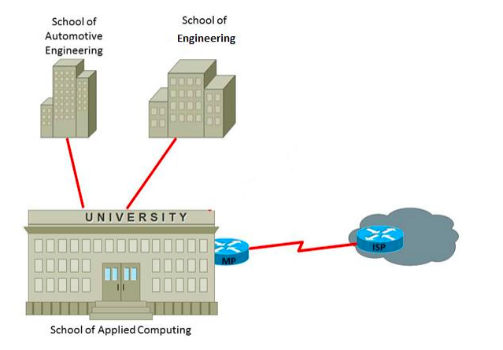
In the second part we used class B to satisfy the request of 2000 IP addresses
Private IP
School of automotive 172.16.1.0
School of Engineering 172.17.0.0
School of Applied Computing 172.18.0.0
In each lab we growth 2 bit

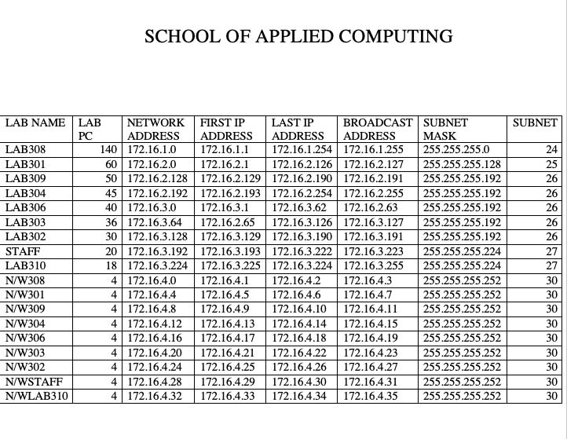

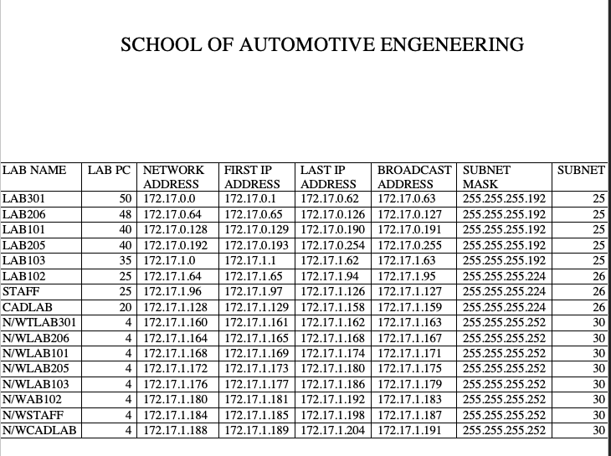

SCHOOL OF ENGINEERING



