Samuel Jay Lloyd

2110666
Digital Signal Processing and Communication
ACDA5008

Contents
Abstract 4
Introduction 4
ASK Research 4
PSK Research 5
QPSK Research 5
16-State QAM Research 8
Simulation Models 9
ASK Model 11
PSK Model 12
QPSK Model 13
QAM Model 14
Testing Methodology 17
Results 17
Discussion 23
Conclusion 23
References 24

Figure 1: ASK Example 4
Figure 2: PSK Example 5
Figure 3: QPSK Modulation 6
Figure 4: I & Q wave 7
Figure 5: QPSK Outputs 7
Figure 6: QPSK Constellation Graph 8
Figure 7: Constellation Graph for 16-state QAM 9
Figure 8: Standard Filter 10
Figure 9: ASK Simulink Model 11
Figure 10: ASK Scope output 11
Figure 11: PSK Simulink model 12
Figure 12: PSK Scope output 12
Figure 13: QPSK Simulink Model 13
Figure 14: QPSK Modulation 13
Figure 15: QPSK Noise & Demodulation 14
Figure 16: QAM Simulink model 14
Figure 17: QAM I Wave Modulation. 15
Figure 18: QAM Q Wave Modulation. 15
Figure 19: QAM I&Q Wave Combined- Final Modulation. 16
Figure 20: I Wave Demodulation. 16
Figure 21: Q Wave Demodulation. 17
Figure 22: Test Results graphed. 18
Figure 23: QAM Constellation with 10dB noise 18
Figure 24: QAM Constellation with 0dB noise 19
Figure 25: QAM Constellation with -10dB noise 19
Figure 26: QAM Constellation with -20dB noise 20
Figure 27: QPSK Constellation with 10dB noise 20
Figure 28: QPSK Constellation with 0dB noise 21
Figure 29: QPSK Constellation with -10dB noise 21
Figure 30: QPSK Constellation with -20dB noise 22
Figure 31: Binary Example [7] 22

Equation 1: ASK Formula [1] 4
Equation 2: PSK Formula [1] 5
Equation 3: QPSK Formula [1] 6
Equation 4: QAM Formula [1] 8

Abstract
The documentation will describe how to test ASK (amplitude-shift keying), PSK (Phase-shift Keying), QPSK (Quadrature Phase-Shift keying) and 16-state QAM (Quadrature Amplitude Modulation), how this is done and the differences in the systems and how them deal with gradually increasing levels of additive white Gaussian noise. This testing will be completed by creating simulations within Simulink and comparing the results when a random binary input is made and testing the output. The results will show that QPSK and PSK are the best systems for this but also discuss the advantages to QAM and ASK in situations.

Introduction
Before creating the simulations, it was important to carry out research on each of the modulation’s methods to understand how they work and how to build the systems.

ASK Research
For ASK the formula for the modulation for the binary of 1 & 0 is:
$$logic 1-X_{ASK}=A_{1}x\cos{ω_{C}t} logic 0-X_{ASK}=A_{2}x\cos{ω_{C}t}$$
Equation 1: ASK Formula [1]
A = amplitude
ω_{c}t = frequency in rad/s
This formula shows that the value that varies between the logic 1 and 2 messages are Amplitude, example in Figure 1.
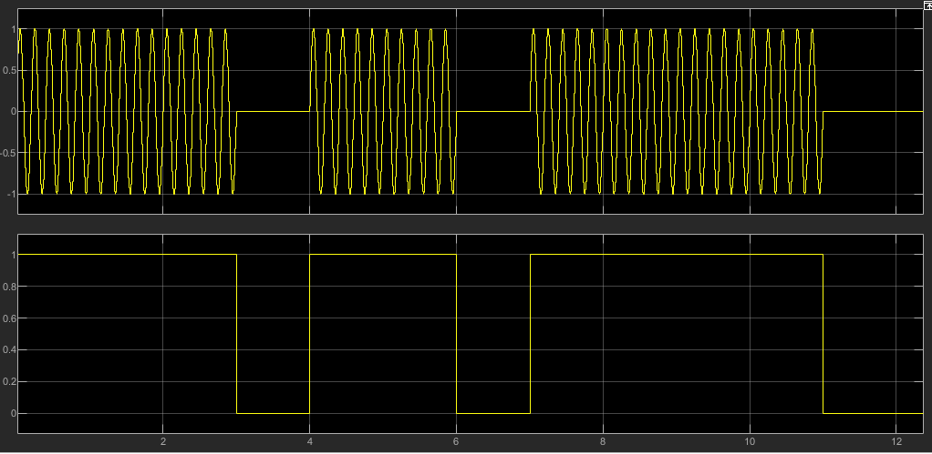
Figure 1: ASK Example
This shows ASK where when in state logic 1 the Amplitude is equal to 1 and during Logic 0 the Amplitude is equal to 0 [2]. The positive of ASK is it’s a very simple modulation technique and is easy to set up which is seen later but the negative is its very susceptible to noise. This is due to the fact the main thing effected by noise is the amplitude, noise will create large spikes in the amplitude making it more inaccurate of a modulation much easier than other methods, this will be seen later in the results section. ASK can be used for more than 1 bit per message [3] but in this case it is just 1. ASK is used in optical cables to transmit data [4].

PSK Research
For PSK the formula for the modulation for the binary of 1 & 0 is:
$$logic 1-X_{PSK}=Ax\cos{{(ω}_{C}t)} logic 0-X_{PSK}=Ax\cos\left(ω_{C}t-θ\right)$$
Equation 2: PSK Formula [1]
A = amplitude
ω_{c}t = frequency in rad/s
θ = phase
When looking at Equation 2 this shows the clear difference being the phase, an example of how this would look is Figure 2.
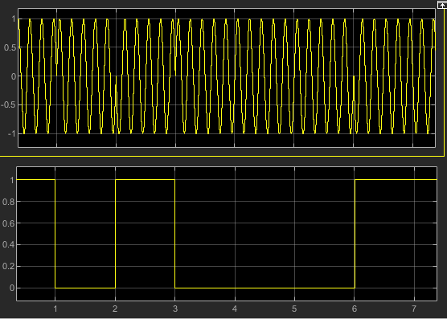
Figure 2: PSK Example
In this example you can see when the logic changes between 1 and 0 there is a clear switch in Phase as the wave appears to reverses [5]. The advantage to using PSK is its less susceptible to noise as phase cannot be affected by noise but still will be at some point as this can loss the data when the noise is high enough levels. The negative of this is compared to ASK modulation the demodulation is more complicated which can be seen later. BPSK is commonly used in Bluetooth [6].

QPSK Research
For QPSK the formula for the modulation for the binary of 00 -> 11 is:
$$X_{QPSK}=Ax\cos\left(ω_{C}t-θ\right)$$
Equation 3: QPSK Formula [1]
A = amplitude
ω_{c}t = frequency in rad/s
θ = phase
Where:
Logic 11 –> θ = $\frac{π}{4}$ Logic 01 –> θ = $\frac{3π}{4}$ Logic 00 –> θ = $\frac{-3π}{4}$ Logic 10 –> θ = $\frac{-π}{4}$
QPSK is very similar to PSK with main difference being there are 4 different phases instead of 2, this allows for 2 bits to be passed instead of 1 per cycle. An example of how this modulation would look can be seen in Figure 3, the 2 input waves can be seen in Figure 4, and An example of what the output waves would look like can be seen in Figure 5. The output waves can also be seen in the constellation graph in Figure 6 which plots Quadrature amplitude against in-phase amplitude, this clearly shows the 4 points, one for each of the 4 binary states (11, 10, 01, 00).
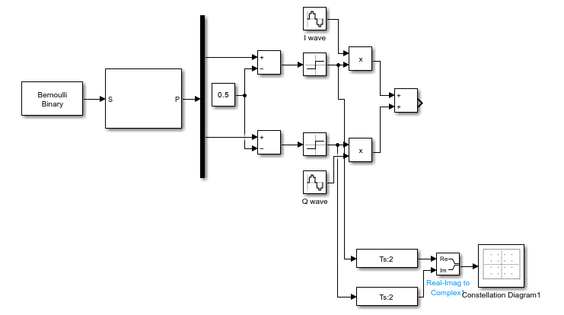
Figure 3: QPSK Modulation
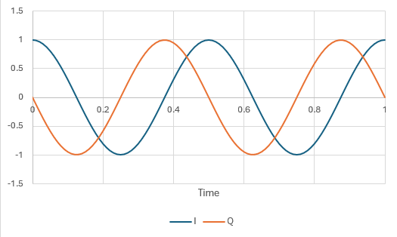
Figure 4: I & Q wave
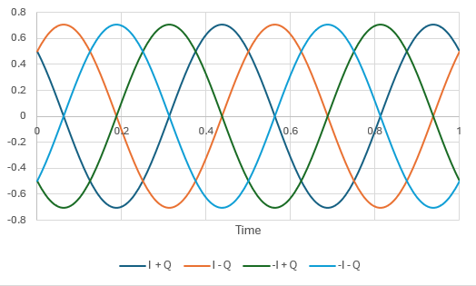
Figure 5: QPSK Outputs
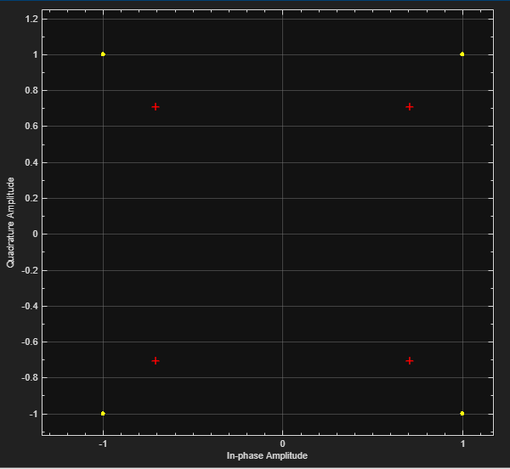
Figure 6: QPSK Constellation Graph
All this information means that the QPSK has the advantage that it can send more data than the PSK and is almost as good at transmitting data, this has a negative of being very complicated to setup. QPSK is commonly used in cellular signals, such as 2G and 3G [6]

16-State QAM Research
The QAM is a combination FSK and ASK modulation techniques looked at before [7], it uses the varying amplitude and phase to be able to pass more data while keeping it as safe from noise.
For a QAM modulator the formula is:
$$X_{QAM}=Ax\cos\left(ω_{C}t+θ\right)$$
Equation 4: QAM Formula [1]
A = amplitude
ω_{c}t = frequency in rad/s
θ = phase
To create a 16-state QAM this means having 4 Amplitudes and 4 varying phases, this is done using:
A: 1, 0.3, -0.3 & -1
θ: $\frac{π}{4},\frac{3π}{4},\frac{-3π}{4} \& \frac{-π}{4}$
This creates 16 variants which are assigned to 1111 -> 0000 depending on the setup, an example can be seen in the constellation graph in the Figure 7 bellow.
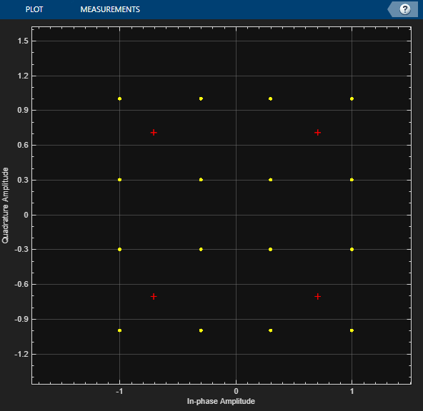
Figure 7: Constellation Graph for 16-state QAM
QAM advantages of QAM is the ability to pass larger amounts of data then the other techniques, this is because it gives more variables being able to alter the Amplitude and Phase. If you tried to pass 16 states of data using just an ASK or PSK method, the data would be very easily lost to noise, whereas using the QAM this spreads out the data, so it is more secure. This makes the devise a lot more complicated than the others that can be seen bellow in Figure 16. QAM is commonly used in cellular and Wi-Fi [8].

Simulation Models
For Simulating the models Simulink was used, [9], Simulink is a part of MATLAB used for graphical programming, modelling, and analysing of multi dynamical systems. This is perfect for the job as will allow creation of the models and then simulating the models to ensure they are outputting the expected results. Once decided on I then took the next steps into building the models.
Bellow in Figure 8 you can see the standard filter I decided to use, this was done as it was a order I thought wasn’t too high and the filter wouldn’t create a massive delay in data, but would still do the expected job in the output removing an appropriate level of noise.
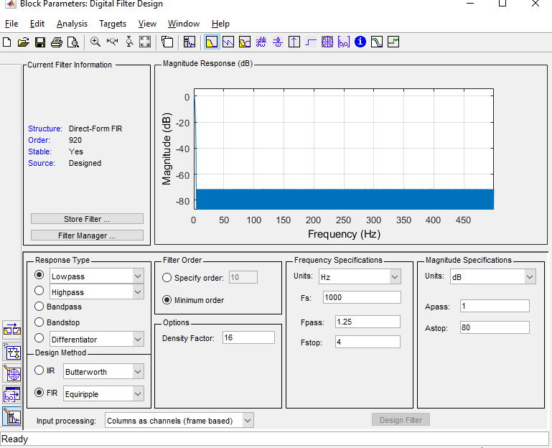
Figure 8: Standard Filter
Once the Filter was decided on, I then began building the models. At this point it was also decided that the carrier waves would be of a standard amplitude of 1 and a frequency of 5Hz, and the binary data will be transmitted at 1 Hz.

ASK Model
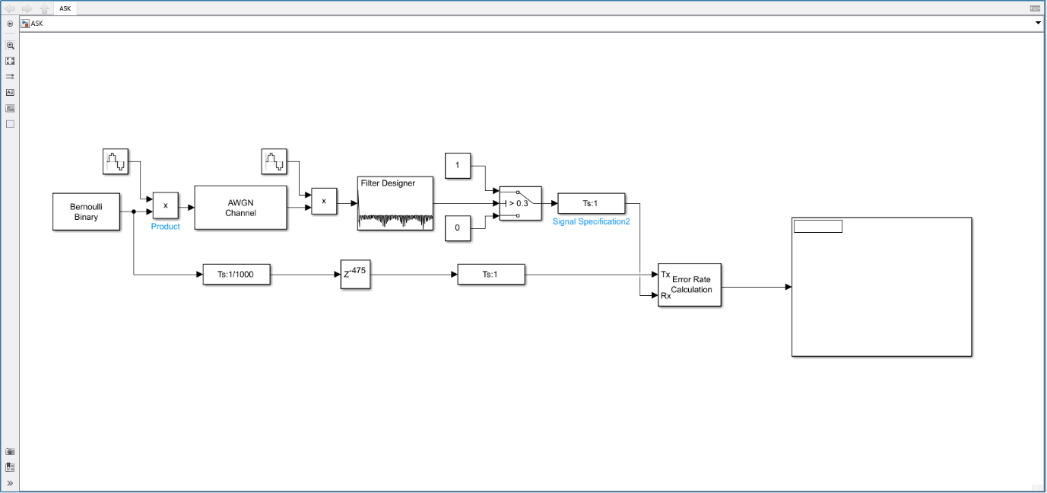
Figure 9: ASK Simulink Model
Figure 9 above shows the model of an ASK system, the Bernoulli Binary random outputs 1 or 0 then multiplies this with the carrier, this creates the modulation, seen in Figure 10 top 3 scopes (1- sine wave in, 2- Bernoulli Binary, 3- modulated wave). This then passes through the AWGN channel, Figure 10 scope 4, which adds white noise then starts the demodulation. In the demodulation this is then multiplied by the carrier again to remove it, then passes through the filter which smooths out the noise, then goes into a switch which will detect if the value input is above or below 0.3, if above the switch outputs 1 else 0. The output is then compared to the input, the input is delayed, and then compared using the error rate calculations then displayed next to it, Figure 10 scopes 5->7.
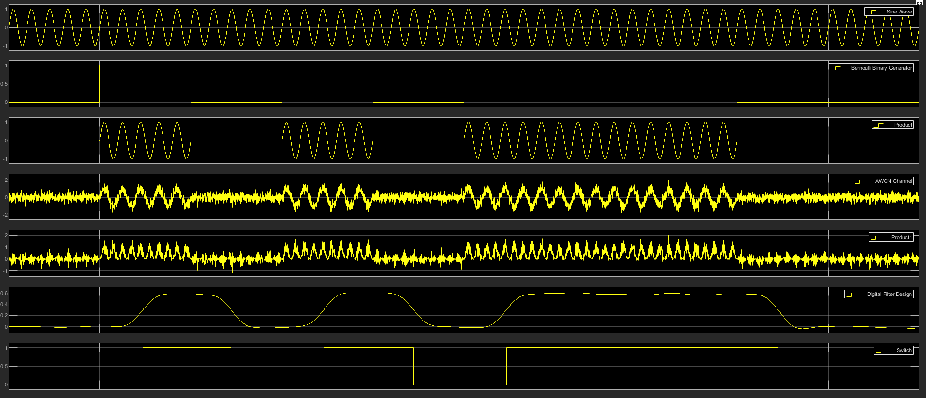
Figure 10: ASK Scope output

PSK Model
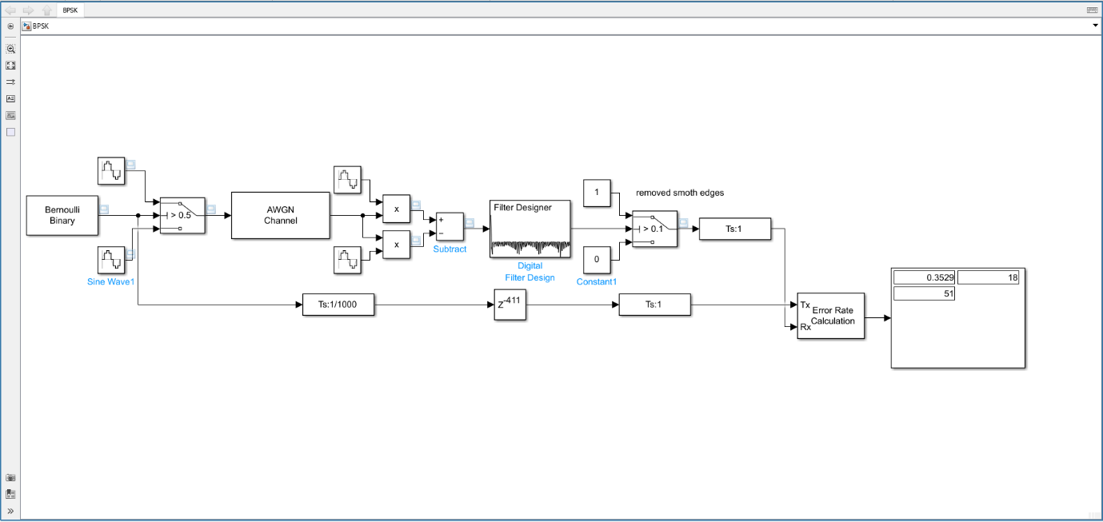
Figure 11: PSK Simulink model
Figure 11 above shows the model of a PSK system, the Bernoulli Binary random outputs 1 or 0 then using a switch this then output wave 1 or 2, these are identical waves just wave 2 is 180⁰ out of phase, Figure 12 channels 1->4. This signal then passes through the AWGN channel, Figure 12 channel 5, adding noise then needs to be demodulated. The signal received is multiplied with wave 1 and wave 2 then the outputs are subtracted, and this is the end out, this then passes through the same end as the ASK and tested the same way, Figure 12 channel 6->10.
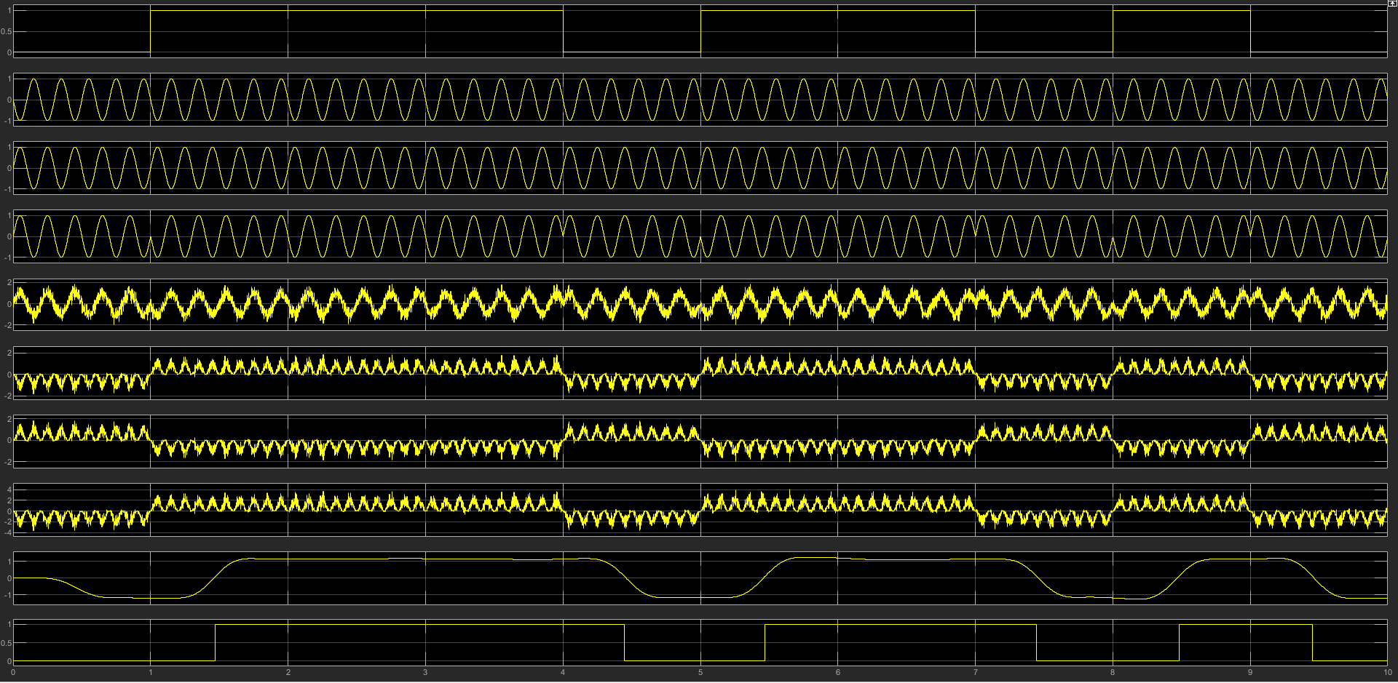
Figure 12: PSK Scope output

QPSK Model
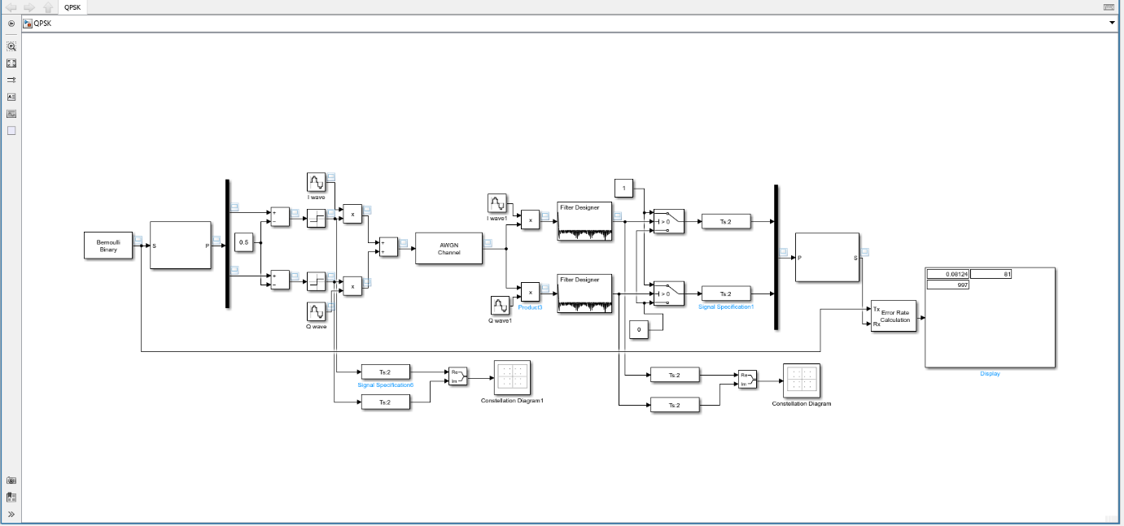
Figure 13: QPSK Simulink Model
Figure 13, this is like PSK just with an additional bit of data being passed at once, to do this the binary is backed up and then output on the de-mux with 2 bits of data at the same time. 1 bit of data is then output from the mux then 0.5 is subtracted, meaning 1 -> 0.5 and 0 -> -0.5 so when you then multiply this with the wave if it’s a 0 the wave is inverted/ phase changed by 180. For the second bit this is the same, but the wave is 90⁰ out of phase, when these 2 waves are added together this creates the phases discussed in the research phase, seen in Figure 14. This is then passes through the AWGN channel. The demodulator works like the PSK just with 2 separate waves. Once demodulated this works the passes into the mux and then the output is tested the same as before, seen in Figure 15.
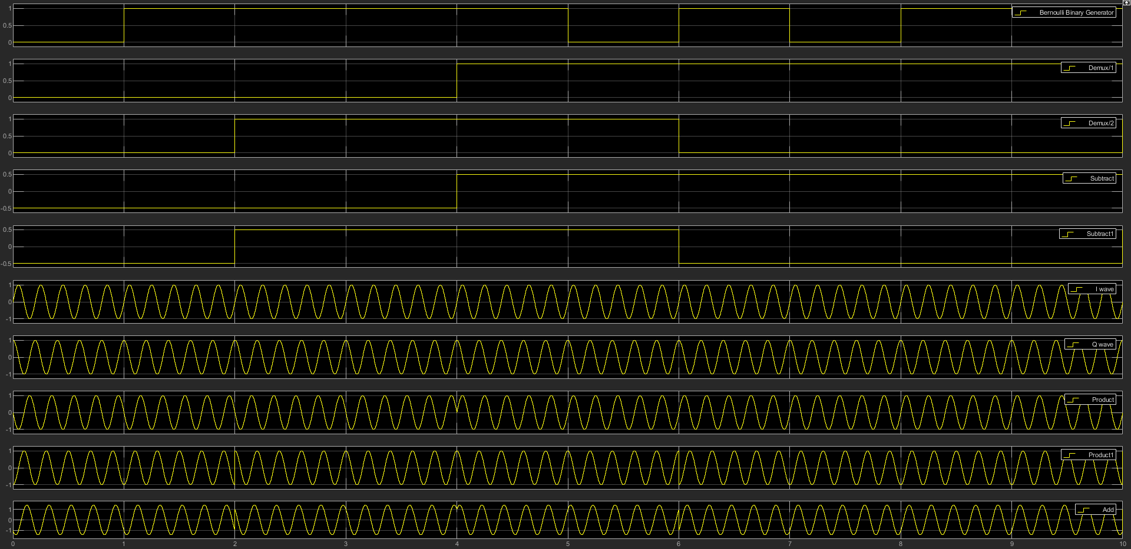
Figure 14: QPSK Modulation
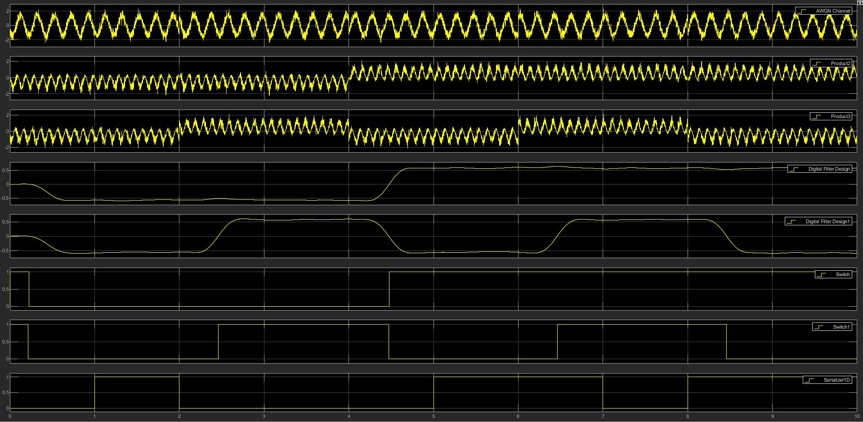
Figure 15: QPSK Noise & Demodulation

QAM Model
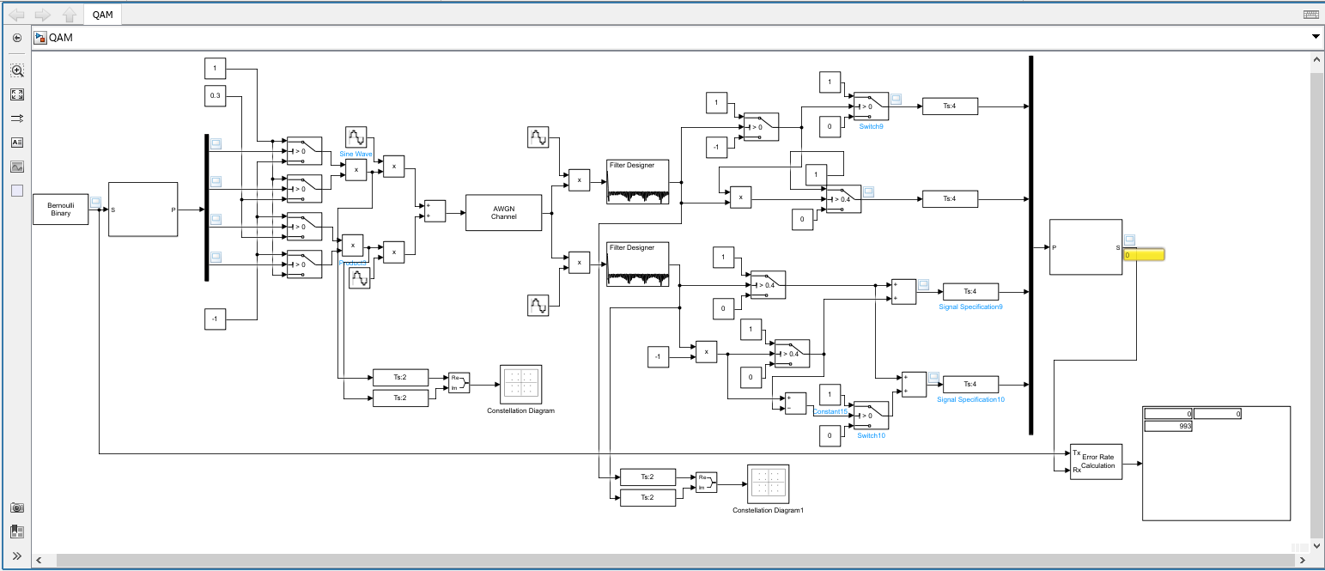
Figure 16: QAM Simulink model
Figure 16 shows the QAM, this is a combination of both the QPSK with ASK included as well. 4 bits are passed through the de-mux they are passed into a switch which creates varying outputs using the constants 1, 0.3 and -1 creating a range of outputs of 1, 0.3, -0.3 and -1 which are then multiplied with the I wave and Q wave (I wave 90⁰ out of phase), then adding these 2 waves together creates 16 varying outputs, this can be seen in Figure 17, Figure 18 and Figure 19. This then passes through the AWGN channel. Then needs to be demodulated this, is done by first using the QPSK technique to remove the 2 waves, then uses the ASK technique to get the individual bits, seen in Figure 20 and Figure 21.
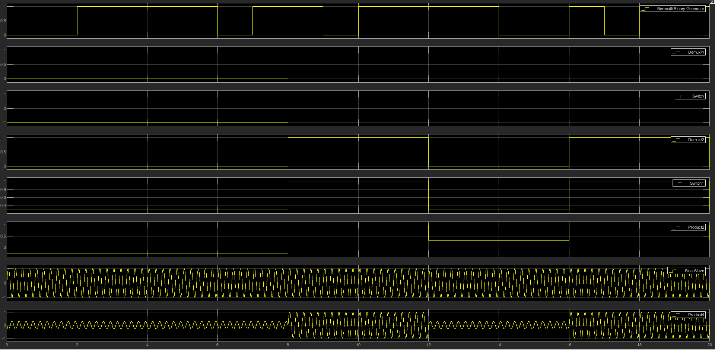
Figure 17: QAM I Wave Modulation.
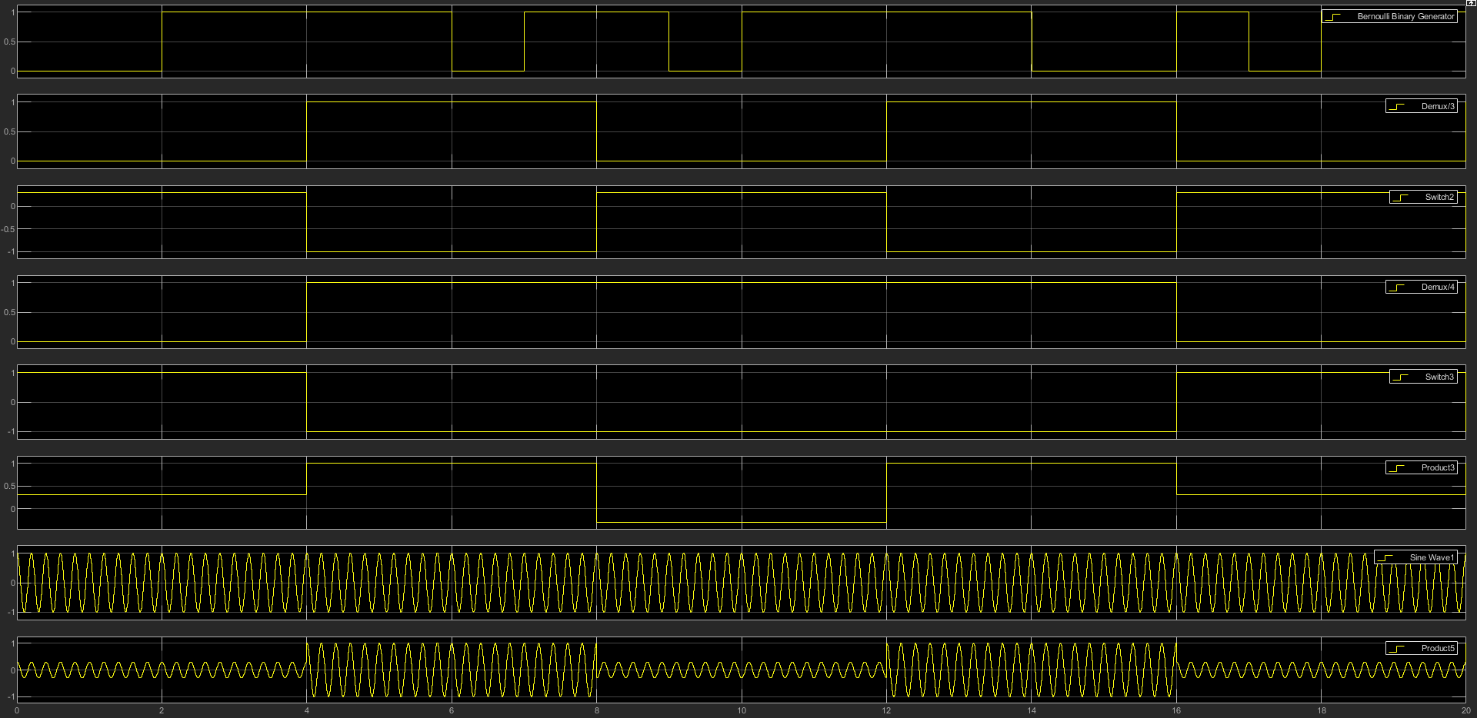
Figure 18: QAM Q Wave Modulation.
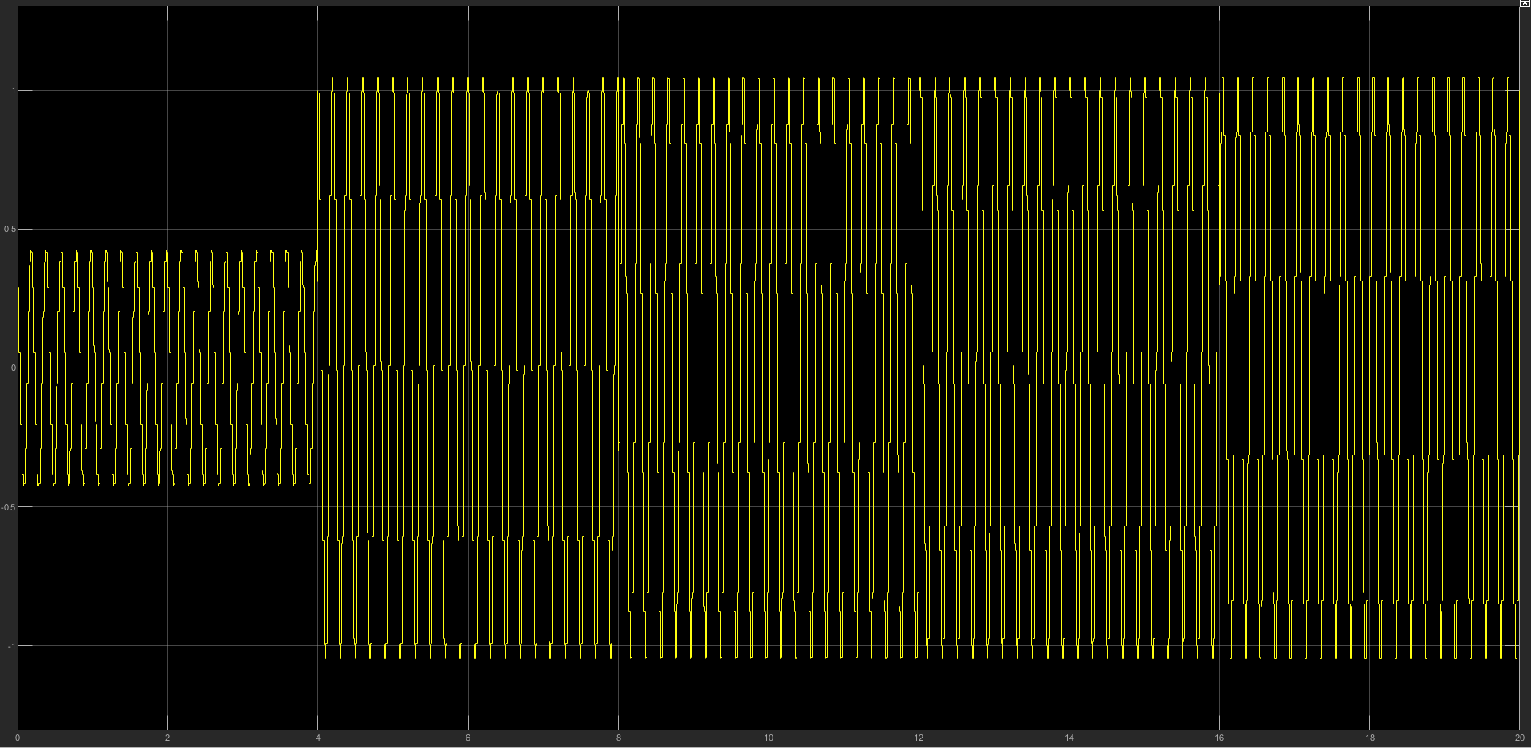
Figure 19: QAM I&Q Wave Combined- Final Modulation.
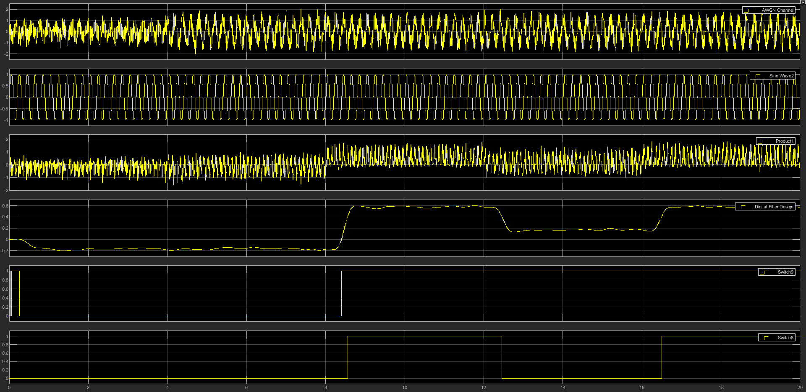
Figure 20: I Wave Demodulation.
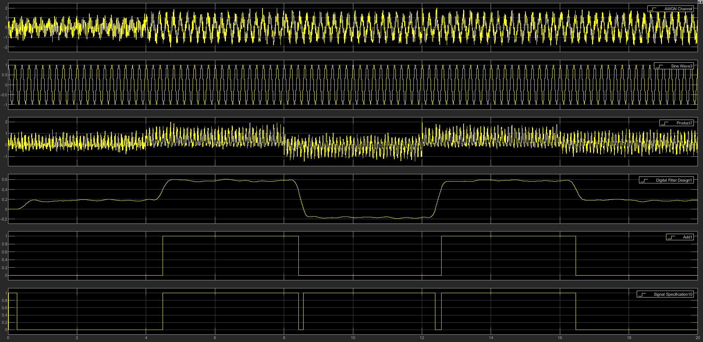
Figure 21: Q Wave Demodulation.

Testing Methodology
After carrying out the task of building each of the modulation methods in Simulink the next part is to carry out the testing on each one. This will be done by altering the value in the AWGN (Additive White Gaussian Noise) channel then using an error rate calculator work out the BER (Binary Error Rate) with each noise level. [10] BER is a method to examine the performance of the modulator, this is done by looking at the binary at one both ends of the devise and testing them against each other to see how many errors occur, this will mean using a delay method as it is not instant to pass 1 bit through modulation. Attempting to get a more accurate test result, each test would be carried out in as similar conditions as possible, for example: as similar inputs as possible and the same filter. Then when testing the tests were ran 20 times and these values were used to create an average and then the standard deviation which would be used to create error bars on the final graph.

Results
Bellow, Figure 22, the final graph can be seen which is a direct comparison between all 4 of the modulation techniques. This graph is plotting the data collected from the test ran using the test methodology stated above.
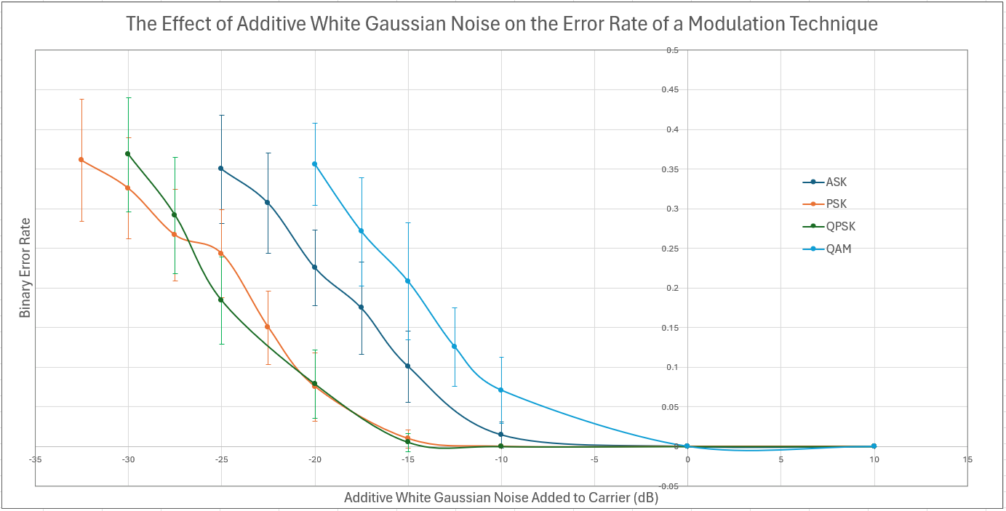
Figure 22: Test Results graphed.
The Below images Figure 23, Figure 24, Figure 25 and Figure 26 are photos of the constellation graph for a QAM with varying levels of noise started in there captions. Figure 27, Figure 28, Figure 29 and Figure 30 are for the QPSK, this also shows the data displaying with varying noise. The Graphs plat the Quadrature Amplitude against the In-Phase amplitude. In all these images each central point, shown best on the 10dB noise graphs, relate to one of the binary outputs, an example of this can be seen in Figure 31 where the binary for each point is displayed next to the point.
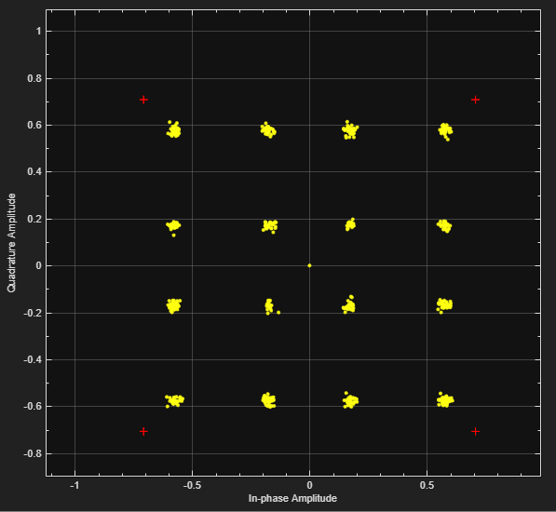
Figure 23: QAM Constellation with 10dB noise
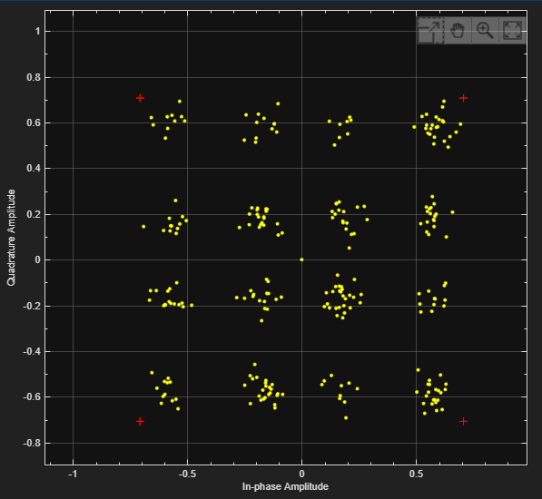
Figure 24: QAM Constellation with 0dB noise
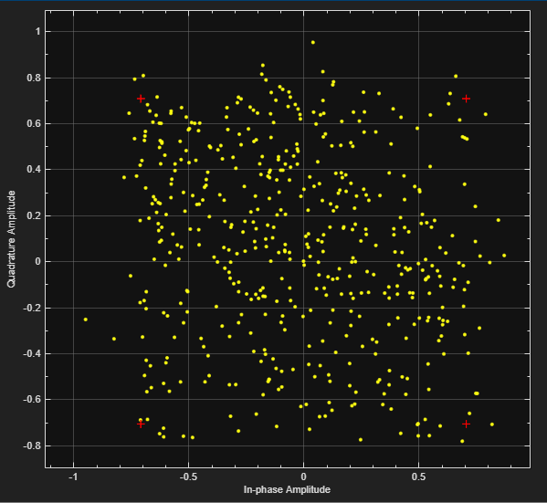
Figure 25: QAM Constellation with -10dB noise
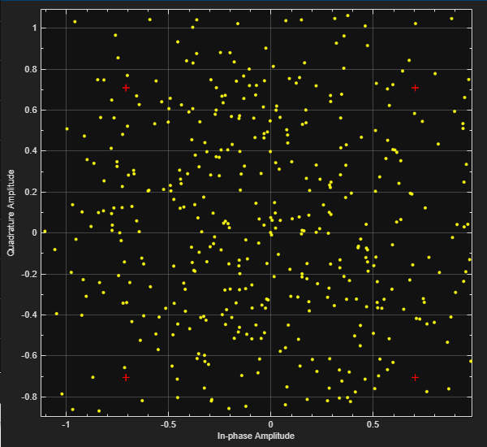
Figure 26: QAM Constellation with -20dB noise
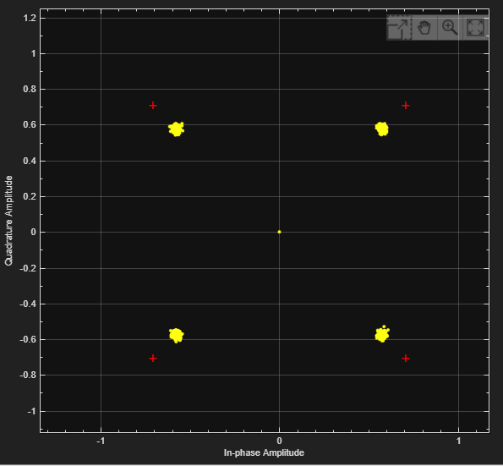
Figure 27: QPSK Constellation with 10dB noise
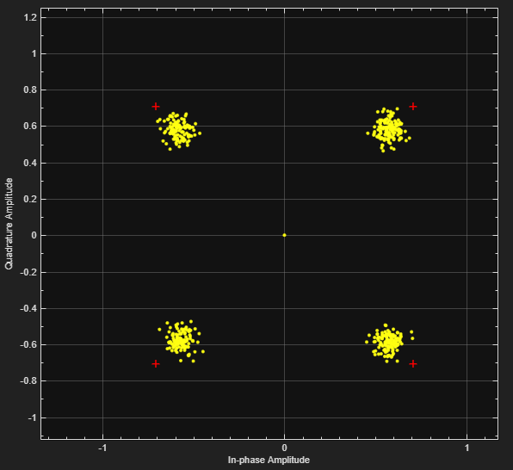
Figure 28: QPSK Constellation with 0dB noise
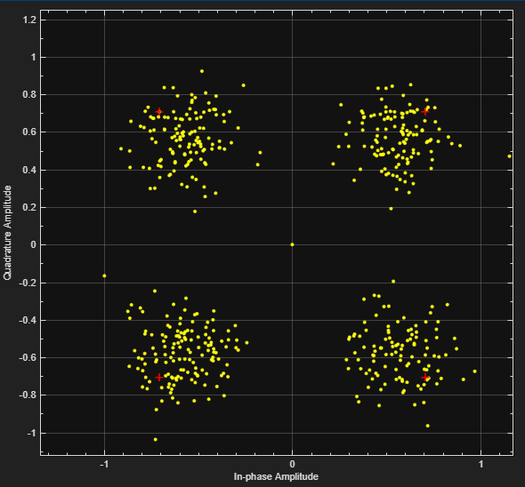
Figure 29: QPSK Constellation with -10dB noise
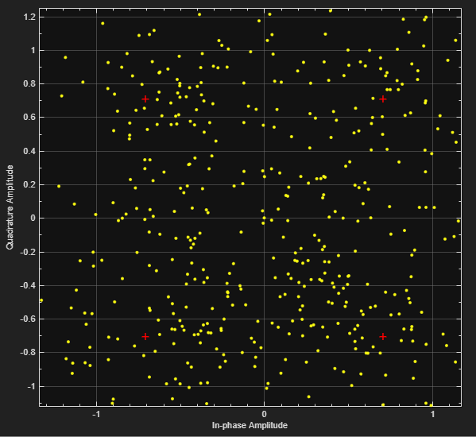
Figure 30: QPSK Constellation with -20dB noise
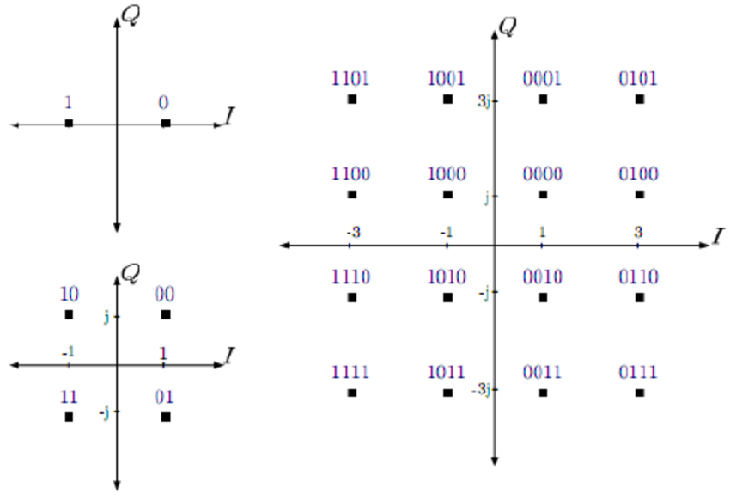
Figure 31: Binary Example [11]

Discussion
In Figure 22 you can see how the different systems coped with the addition of noise, the best performing being the PSK and QPSK with the PSK performing slightly better as expected with it carrying only 1 bit of data rather than 2 bits of data. Both these systems are not highly affected by noise, as discussed before, due to phase not being affected by noise meaning the errors start occurring a lot later when the noise is a lot higher. They are both complicated systems, PSK seen in Figure 11 and the QPSK seen in Figure 13, compared to the ASK, seen in Figure 9.
It was expected that QAM would have the worst result, even though this is a combination of ASK and PSK methods due to carrying much more data with 4 bits. This can be seen when comparing the Figure 23, Figure 24, Figure 25, Figure 26, Figure 27, Figure 28, Figure 29 and Figure 30 which are of the QAM and QPSK outputs to a constellation graph, this shows the massive difference noise creates for QAM interfering with the data where this only happens which much more noise for the QPSK. This is also very complicated to demodulate which can be seen in Figure 16. There are a lot of steps which when compared to the ASK in Figure 9 is very dramatic.
Finally, the 3rd best performing was ASK, this was expected to be far from the best due to how ASK’s work, due to using the amplitude to pass the data this is a bad method as this is very susceptible to additive white Gaussian noise.

Conclusion
In conclusion all these modulations systems have their uses, each one has a reason to be selected for a different task. ASK is good for simple transmissions where you know the noise levels are low as it’s an easy system to create and demodulate the signal. PSK and QPSK are very good in an area you know there is a higher level of noise as there is a reduced chance in data loss with QPSK being able to carry a larger amount of data in a message, this does make it slightly more susceptible to noise but only by a small amount, this can be seen in Figure 22 at the end of the graph. With QAM although it was the most susceptible to noise it can pass much more data in a short period of time compared to the other systems, so would be useful if you need to pass a large amount of data in a less noisy area but are a lot more complex system.

References

[1] | Z. C. K. P. Nihat Daldal, “Automatic determination of digital modulation types with different noises using Convolutional Neural Network based on time–frequency information,” https://www.sciencedirect.com/science/article/pii/S1568494619306155?ref=pdf_download&fr=RR-2&rr=817049fc5db852ab, 2020.
[2] | “Electronics Coach,” Amplitude Shift Keying – ASK, [Online]. Available: https://electronicscoach.com/amplitude-shift-keying.html.
[3] | OpenLearn, “Exploring communications technology,” https://www.open.edu/openlearn/digital-computing/exploring-communications-technology/content-section-1.4.
[4] | R. W. World, “ASK Advantages | ASK Disadvantages | Amplitude Shift Keying,” https://www.rfwireless-world.com/Terminology/Advantages-and-Disadvantages-of-ASK.html#:~:text=%E2%9E%A8It%20offers%20high%20bandwidth%20efficiency.%20%E2%9E%A8It%20has%20simple,used%20at%20radio%20frequencies%20to%20transmit%20morse%20codes..
[5] | “Electronics Coach,” Frequency Shift Keying – FSK, [Online]. Available: What is Phase Shift Keying (PSK)? BPSK modulation, BPSK demodulation, advantages, disadvantages and applications of PSK - Electronics Coach.
[6] | M. Steer, “Phase Shift Keying Modulation,” North Carolina State University, https://eng.libretexts.org/Bookshelves/Electrical_Engineering/Electronics/Microwave_and_RF_Design_I_-_Radio_Systems_(Steer)/02%3A_Modulation/2.13%3A_Phase_Shift_Keying_Modulation.
[7] | K. Peppas, F. Lazarakis, A. Alexandridis and K. Dangakis, “Error performance of digital modulation schemes with MRC diversity reception over η-μ fading channels,” https://ieeexplore-ieee-org.ezproxy.uwtsd.ac.uk/document/5288931, October 2009.
[8] | E. 4. U, “Quadrature Amplitude Modulation (QAM): What is it?,” https://www.electrical4u.com/quadrature-amplitude-modulation-qam/, 2020.
[9] | C. Devendra K, Modeling and simulation of systems using matlab and simulink, https://books.google.co.uk/books?hl=en&lr=&id=7WfMBQAAQBAJ&oi=fnd&pg=PP1&dq=using+simulink+matlab&ots=WlIIRIR_Uj&sig=-n085PZlRCOTptVvfYNdNOiUxP0#v=onepage&q&f=false, 2010.
[10] | H. Y. Q. W. J. J. C. L. Xianjin DENG, “Phase Noise Effects on the Performance of High-Order Digital Modulation Terahertz Communication System,” Reproducing Single-Carrier Digital Modulation Schemes for VLC by Controlling the First Switching Harmonic of the DC–DC Power Converter Output Voltage Ripple | IEEE Journals & Magazine | IEEE Xplore (uwtsd.ac.uk), 01 May 2022.
[11] | S. M. Arun Agarwal, “Combined Effect of Block interleaving and FEC on BER Performance of OFDM based WiMAX (IEEE 802.16d) System,” Mar 2015. [Online]. Available: https://www.researchgate.net/figure/BPSK-4-QAM-and-16-QAM-constellation-diagrams-10_fig4_287208899.

