Early Years Transitions:
A practical guide for key workers
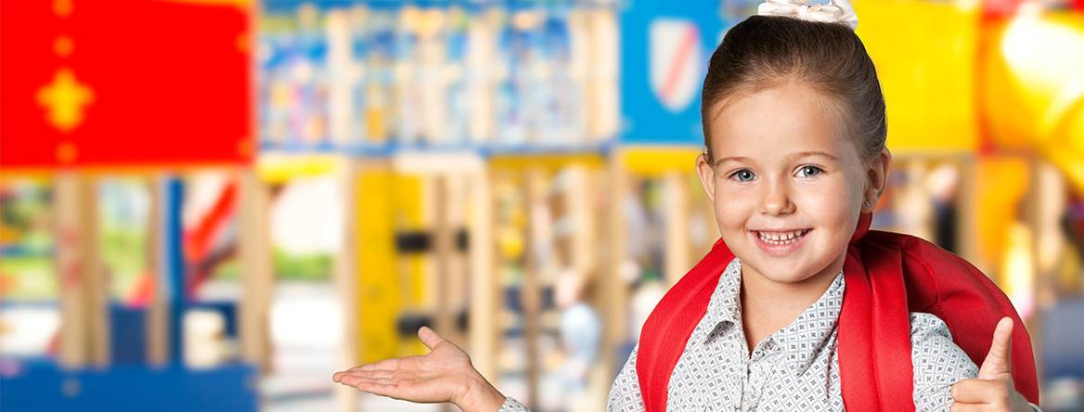

(Source: Achievement for All, 2020)
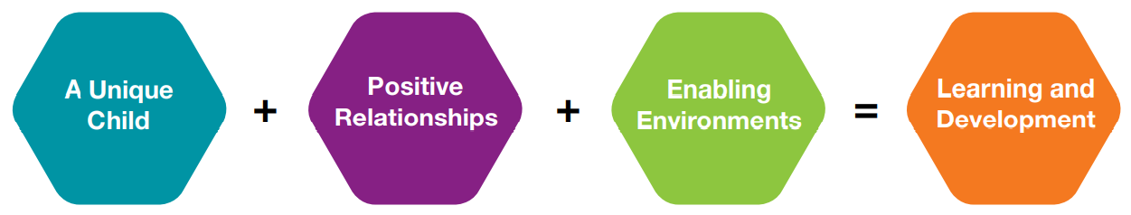

(Source: Early Education, 2012)

Aimee Beynon
2005750
EAEE4003
Human Development

Contents
Contents ………………………………………………………………… 2
Introduction ………………………………………………..…………. 3
How to use this handbook ……………………………….…………. 4
The role of the adult …………………………………….…………… 4
The needs of the child ……………………………………………….. 7
Partnerships …………………………………………………………... 9
Interventions ……………………………………………………….... 10
Proposed outcomes …………………………………………………… 11
Reference list …………………………………………………….…….13

Introduction
The aim of this handbook
The aim of this handbook is to provide information for key workers to successfully support the smooth transition of children in the early years – specifically from nursery into reception. To provide the best possible outcomes for children during transition, adults and all professionals involved must work together and communicate effectively (Oxfordshire County Council 2017). Lynch (2018) supports this by suggesting that while school environments are responsible for the smooth transition of children, it also falls upon the parents or guardians to ensure that they also support their child at what can be a difficult and frightening time.
What does ‘transition’ mean?
Early Years Matters (2020) states that ‘transition’ – to put it simply – means ‘change’. Children in the early years are constantly faced with different transition milestones which must be managed effectively in order to support their development. Allingham (2012) agrees as she suggests that ‘transition’ can be any form of change such as moving between settings, a child meeting a new member of staff or even having an unexpected visitor in the group.
Why is it important for transitions to be managed effectively?
There is a real possibility that children of today will face more transition milestones as they proceed through their early years than in any other aspect of their educational journey. For example, a child may transition from a home environment to attending day care, then they may move on to playgroup, through to nursery, before finally reaching formal education, all before they turn five years old (Achievement for all 2020). It is further suggested that every child is different and has individual needs. These needs must be supported correctly so that the child feels comfortable in their surroundings. In addition, children who have positive role models around them will find it easier to settle into new environments and will therefore adapt to a new transition quickly. On the other hand, Achievement for All (2020) states that the more challenged and uncomfortable a child may feel or the more disadvantaged they are, will contribute to how successfully they adjust to new relationships. This will ultimately have a direct effect on their learning and development. Therefore, it is crucial that key workers take a holistic approach to ensure that the appropriate plans are put in place to uplift every child from all walks of life to accommodate smooth transitions.
How to use this handbook
This handbook is specifically designed to help key workers understand the importance of their role in supporting children through transition periods. This handbook focusses on children within nursery settings – normally between the ages of two and four years old – transitioning into a reception class environment. Practitioners who use this handbook should be able to:
- Recognise the significance of their own role within these settings, as well as understand the primary caregiver’s role.
- Understand the needs of all children as individuals to be able to support their physical, social, cognitive and emotional development.
- Understand the importance of communication between partnerships.
- Put interventions in place to help minimize the negative impacts of transitions on children.
- Achieve the proposed outcomes and successfully support all children transitioning from nursery to reception.
Accomplishing such outcomes will take time and thorough planning from key workers. Transitions need to be viewed as a sensitive journey and not just a ‘one off event’ (Kirklees Council 2019).
The role of the adult
The importance of relationships
According to Essex County Council (2020), key workers must have in depth knowledge of each individual child’s needs and interests in order to successfully support their development. It is important that practitioners use this information to create a fun and enjoyable, yet suitably challenging environment for children to learn. By doing this, children are more likely to engage in activities. To support a child in all developmental and learning areas, Essex County Council (2020) states that the most important ideas to remember are:
- To pay attention to how a child learns and engages with others.
- When a child transitions from a home environment to an educational setting, from room to room or - as in this case - one class ability to another, key workers should build positive relationships by communicating with children, parents and other professionals in order to achieve the best outcomes.
- And finally, to respect children as independent learners who should be given the opportunity to go at their own pace, make their own choices and take control of their own learning where possible.
In relation to the final point, Jean Jacques Rousseau (1712 – 1778) believed that education should follow the individual needs of the child and that practitioners should focus completely on the ‘powers, abilities, interests and outlook of a child’ (John 2014). Crain (2015, p. 12) agrees by stating that Rousseau believed that children ‘grow according to nature’s plan, which urges them to develop different capacities and modalities and different stages’, ultimately meaning that a child’s natural rate of development and ability should be the centre focus of educational ideas. Key workers should take this into consideration, allowing children to feel at ease and comfortable with their learning and environment. This will result in children being able to transition smoothly into a new educational setting, rather than feel out of their depth.
Attachment
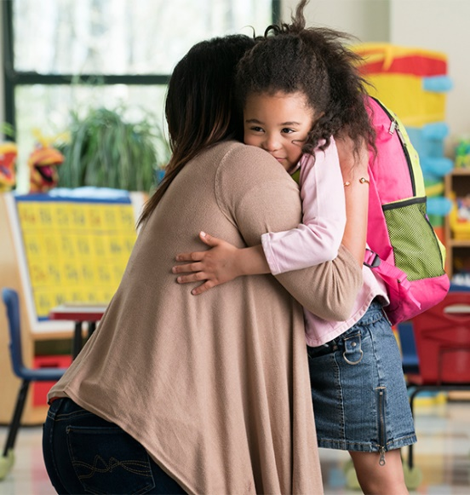
Tempest (2016) says that adults must be consistently responsive towards children’s needs by making sure that the child knows that they are loved, understood and respected. By doing this, the adult can strengthen a crucial relationship with the child and such actions increase their self-esteem which will ultimately result in them having the confidence to move forward in their transition journey. Primary caregivers, key workers and other secondary figures that successfully create secure attachment relationships with children will also see positive development and learning patterns materialise. John Bowlby’s (1907 – 1990) attachment theory is based on the idea that secure and insecure attachments are naturally programmed into children from birth (Wonderful Minds 2020). It cannot be denied that from looking at Bowlby’s theory, the most (Source: What to Expect 2019) intense attachment bond is created between the primary caregiver and the child. So, when a child is presented with new surroundings and people, they are likely to feel scared and anxious. This means that practitioners will need to pay close attention to these children and provide them with care and guidance for them to settle in and feel safe (Lerner and Parlakian 2016). As these children acknowledge the safe and comfortable environment created by practitioners, they will be more trusting of their secondary figures and are more likely to transition onto the next stage competently.
Aiding children
Children who attend nursery settings will be working on strengthening different aspects of their development including their social, emotional, physical and fine motor skills. There are some skills (such as running, jumping or using crayons) that children at pre-school age can do without the help of an adult (Centers for Disease Control and Prevention 2020). However, there are some skills that children cannot do unless aided by a key worker or another adult. Vygotsky (1896 – 1934) developed the zone of proximal development. This is the zone in which children begin learning and developing their skills.
“Vygotsky consistently defines the zone of proximal development as the difference between the current level of cognitive development and the potential level of cognitive development.” He believes that children cannot accomplish their learning targets without the help of their teacher or parent. This is supported by Educational Technology (2020).
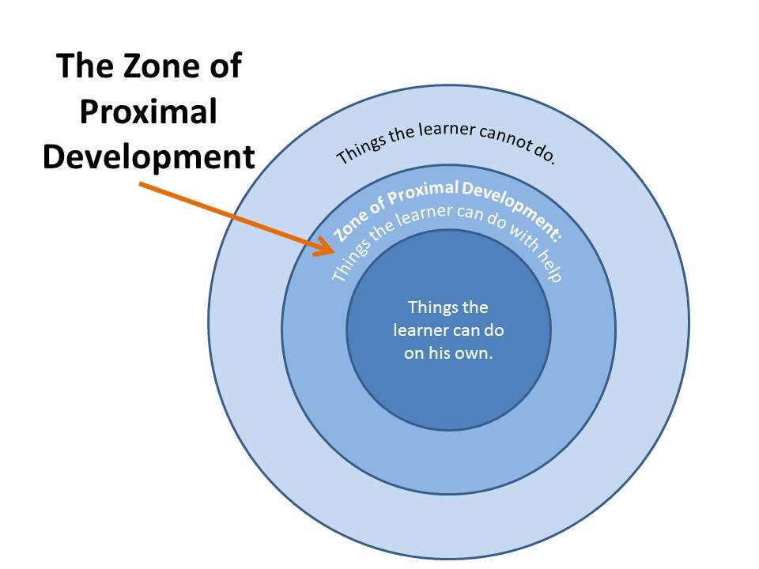

(Source: Cuppa Cocoa 2014)
Therefore, it is important that key workers aid children’s learning and development in nursery settings so that they can transition into a reception class environment smoothly, as they will have been able to build on vital skills that set the foundation for transitions.

The needs of the child
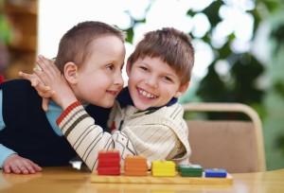
Inclusive Education
As well as needing a safe and loving environment, UNICEF (2020) states that ‘inclusive education allows students of all backgrounds to learn and grow side by side, to the benefit of all’. This supports the view that no matter a child’s disability, gender, additional learning needs or even the language they speak (all of which could be potential barriers to children’s development and learning), children are entitled (Source: Brookes Publishing 2015)
to the best education possible and their voices matter. In addition to this, UNICEF (2020) further suggests that inclusive education is the best way for all children to have an equal chance at learning and developing to successfully transition into the next stages.
Maria Montessori (1870 – 1952) believed that inclusion is vital in child development and that all settings should be child-focussed. She believed that children should be given the appropriate tools, not only to learn and develop at their own individual rates, but to also spark children’s imaginations to help them excel neurologically. Montessori uses the idea of providing basic materials such as cardboard, letters and wooden blocks to all children - regardless of disability - to see what they could do with them. Montessori would further ensure that children were able to feel that sense of inclusion by changing standard sized furniture in settings to child sized tables and chairs. This is still used in settings today. Additionally, toys and materials were stored in cupboards and units lower to the ground so that children could access them for themselves (Zanazzi, 2018, p. 79-82). To summarise, Montessori suggests that all children’s individual needs should be considered and the environment in which they learn and develop should be tailored to include them. By taking this inclusive approach, pre-school children will find it easier to settle in and adapt to changes and transitions.

The United Nations Convention on the Rights of the Child (UNCRC)
“The United Nations Convention on the Rights of the Child (UNCRC) is a legally-binding international agreement setting out the civil, political, economic, social and cultural rights of every child, regardless of their race, religion or abilities.” (Save the Children 2020a).
Children’s rights are incredibly important when taking into consideration the needs of the child. Key workers should look at the 54 articles set out under the international agreement and consider how they can meet these requirements within their settings. For example, Article 3 sets out the best interests of the child and Article 12 states that all children have a voice that must be respected (Save the Children 2020b).
In approaching this, Early Years Practitioners can assess the best way to guide children through transitions by listening to what each child needs. This will hopefully cause as little stress and disturbance as possible, as they will feel valued by being listened to. One might add that Article 31 states the child’s right to play. According to The National Literacy Trust (2017), play allows children to learn and develop and take risks as well as giving them a choice and a voice. Play is an exceedingly valuable need for children as without it they cannot thrive. It is further stated that play is fun and engaging and as a result children will interact with others which will help them relax and build friendships with children who will also be going through a transition. Therefore, they will feel a sense of reassurance as they will not be alone in a fragile time.
Abraham Maslow’s Hierarchy of Needs
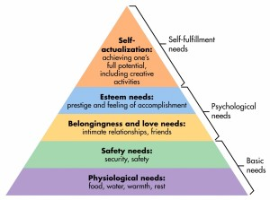
Key workers can fully understand a child’s needs by looking at Maslow’s (1908 – 1970) hierarchy of needs.

(Source: Ferris 2015)
Ferris (2015) suggests that the bottom three tiers of the pyramid are the most basic needs of the child that need to be met by key workers. Children need food, water, trusting relationships and a safe place. By meeting these basic needs, practitioners can build the foundations to guide these children through their transitions.
Partnerships
Parent and family partnerships
Key workers in early years settings must deliver the Early Years Foundation Stage (EYFS) published by the Department for Education (2017). Part of the requirements of this is working in partnership and involving parents in their child’s learning. Having a good relationship with children’s parents and families will allow practitioners a deeper understanding of the child and will help them reach the principles set out by the EYFS. Key workers must provide the following information to parents as stated by the Department for Education (2017):
- The different types of activities and experiences their children will be involved in.
- How the setting can accommodate children with additional learning needs.
- What food and drink will be made available to their children.
- Details of the settings policies and procedures.
- Provide details of their complaint’s procedure.
Parents and key workers can effectively communicate with each other when everyone has access to all the relevant information. This allows parents to understand the pre-school setting their child is attending and how they carry out their policies to ensure the safety and wellbeing of their children. Transitions for children are more likely to progress fluently if key workers and parents communicate advantageously.
Multi-agencies
Urie Bronfenbrenner (1917 – 2005) is another theorist of whom supports the importance of partnerships within education. He believed it was the responsibility of key workers to communicate with multi-agencies and other professionals to help guide children in the best direction possible (Hayes, O’Toole and Halpenny 2017). Bronfenbrenner shows within his ecological theory the level of influence family partnerships, school partnerships, media, and government partnerships have on a child’s development and learning.
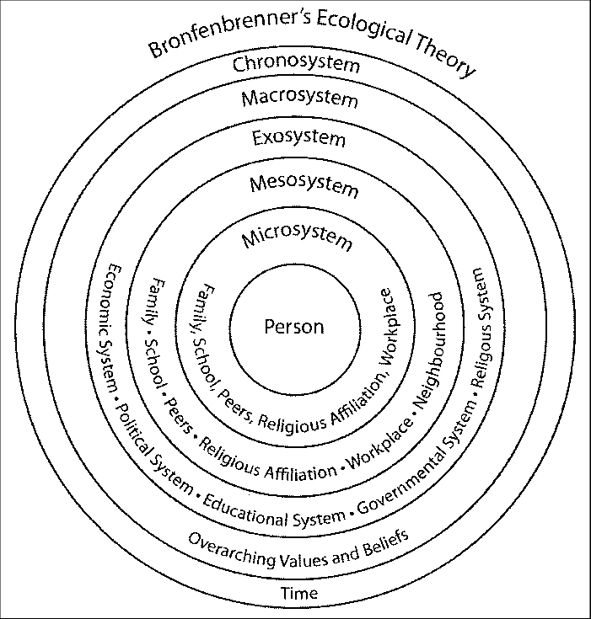

(Source: Stanger, 2011)
From the above source, Bronfenbrenner clearly shows the level of impact different environments and partnerships have on a person. Microsystems, Mesosystems and Exosystems have the greatest influence on a child’s development. Therefore, making sure the partnerships around the child are positive, beneficial and secure will allow the right guidance for the child to be supported through transitions.
Interventions
Studies show that transitions are essential to a child’s development and the way they are managed by key workers in the early years could have a long-lasting impact on how a child adapts to change in their future (The Educator 2017). Moving from a mostly play based environment - such as nursery - into a more educational setting such as reception, can be terrifying for children, especially during current times with the COVID-19 pandemic. Using play is one intervention method to ensure a smooth transition. This is because it breaks down social barriers between adults and children and increases development skills that will help children when they go through changes. Walker (2019) suggests that there are several ways practitioners can soften transitions, for example:
- Introducing reception teachers to children early by allowing them to visit nursery classes.
- Talking to children about starting school so that they can be open about how it makes them feel.
- Beginning to encourage children to become more independent when putting coats and shoes on, and at lunch times and snack times.
By accommodating such activities, children will be more familiar with different key workers and already be prepared for the extra independence starting reception will bring, therefore reducing the stress of a new transition.
‘All about Me’ books
A great intervention method is using ‘All about Me’ books. The purpose of these books is to professionals to get to know each individual child and to help prepare them for transition. Little Swans Day Nursery (No Date) uses this method to help children transition from home to their setting, for transitions within the setting itself and to build information for when they are ready to move on to school. Parents can help fill in all the necessary information so that practitioners can understand what each child will need specifically. Therefore, key workers will be able to guide children successfully through all transitions.
School readiness sessions
Providing parents/primary caregivers access to school readiness sessions will further prepare children for transitions. The sessions allow parents and children to explore different areas and involve themselves in different activities such as learning numbers and trying writing tasks (School Readiness 2020). Keiki Early Learning (2020) suggests that school readiness sessions should not be like a ‘typical’ school day. They say that allowing children to be curious and explore is more valuable for children to discover their love for learning. As children develop these skills and new relationships are built between schools and families, practitioners are giving them ‘the best opportunity to adjust to a school environment and reach their learning potential’.
Proposed outcomes
It is extremely important to understand if the intervention methods for transitions have been successful in the long term as it is suggested not all early years intervention methods are effective (Early Intervention Foundation 2020). The Department for Education (2015) shows that the EPPSE (Effective Pre-school, Primary and Secondary Education) students that attended pre-school settings were more likely to sit their AS level exams at the age of 17. Furthermore, if they had attended a high-quality pre-school setting, ‘they were twice as likely as those who hadn’t attended pre-school to take AS levels.’
Another way to monitor if transitions have been successful is by carrying out a reception baseline assessment. Children who have recently transitioned into reception classes are assessed on their progress to see what their level of development is and what their capabilities are. This evaluation allows key workers and parents to understand where the child’s starting point in education is, but also allows practitioners to see whether their recent efforts to support the child’s transition has been successful (Standards and Testing Agency 2020).
In conclusion, if key workers, parents and multi-agencies communicate effectively and practitioners do everything in their power to support children’s learning and development within their early years, especially during crucial periods, all children (regardless of their needs) have the best chance at adapting to new transitions rewardingly, as well as reaching their greatest potential.

Reference List
Achievement For All (2020) Successful transitions in the early years [image/blog]. Available at: https://afaeducation.org/blog/successful-transitions-in-early-years/successful-transitions-in-early-years/ (Accessed 6th November 2020).
Allingham, S. (2012) Transitions in the early years. London: Andrews UK Limited.
Brookes Publishing (2015) Inclusion Resolutions: 10 Things to do to include all students in the New Year [image]. Available at: https://blog.brookespublishing.com/inclusion-resolutions-10-things-to-do-to-include-all-students-in-the-new-year/ (Accessed: 15th November 2020).
Crain, W. (2015) Theories of Development: Concepts and Applications. Oxfordshire: Taylor and Francis.
Centers for Disease Control and Prevention (2020) Important Milestones: Your Child by Three Years. Available at: https://www.cdc.gov/ncbddd/actearly/milestones/milestones-3yr.html (Accessed 19th November 2020).
Cuppa Cocoa (2014) The Zone of Proximal Development [image]. Available at: http://www.cuppacocoa.com/the-zone-of-proximal-development/ (Accessed 19th November 2020).
Department for Education (2015) Pre-school and early home learning effects on A-Level outcomes. Available at: https://assets.publishing.service.gov.uk/government/uploads/system/uploads/attachment_data/file/472867/RR472A_Pre-school_and_early_home_learning_effects_on_A_level_outcomes.pdf (Accessed: 27th November 2020).
Department for Education (2017) Statutory Framework for the Early Years Foundation Stage Available at: https://assets.publishing.service.gov.uk/government/uploads/system/uploads/attachment_data/file/596629/EYFS_STATUTORY_FRAMEWORK_2017.pdf (Accessed: 22nd November 2020).
Early Education (2012) Development Matters in the Early Years Foundation Stage (EYFS) [image]. Available at: https://www.early-education.org.uk/sites/default/files/Development%20Matters%20in%20the%20Early%20Years%20Foundation%20Stage%20-%20FINAL.pdf (Accessed: 6th November 2020).
Early Intervention Foundation (2020) Why early interventions matter. Available at: https://www.eif.org.uk/why-it-matters/how-do-we-know-it-works (Accessed: 27th November 2020).
Early Years Matters (2020) Transitions. Available at: https://www.earlyyearsmatters.co.uk/eyfs/positive-relationships/transitions/ (Accessed: 7th November 2020).
Educational Technology (2020) Vygotsky’s Zone of Proximal Development and Scaffolding. Available at: https://educationaltechnology.net/vygotskys-zone-of-proximal-development-and-scaffolding/#:~:text=Vygotsky%20created%20the%20concept%20of%20the%20zone%20of,to%20learn%20by%20interacting%20with%20those%20around%20them (Accessed: 19th November 2020).
Essex County Council (2020) Role of the adult. Available at: https://eycp.essex.gov.uk/the-early-years-foundation-stage/how-do-i-become-an-outstanding-practitioner/role-of-the-adult/ (Accessed: 11th November 2020).
Ferris, E. (2015) ‘Hierarchy of Needs’, Penn State University [blog]. 10 April. Available at: https://sites.psu.edu/rclerin/2015/04/10/hierarchy-of-needs/ (Accessed 22nd November 2020).
Hayes, O’Toole and Halpenny (2017) Introducing Bronfenbrenner: A Guide for Practitioners and Students in Early Years Education. Oxfordshire: Taylor and Francis.
John, E. O. (2014) ‘A Philosophical Appraisal of Rousseau’s Child-Centered Education and Its Imports to Nigeria’s Leadership Question’, Journal of Education and Practice, 5(24), pp. 119-123. Available at: https://www.iiste.org/Journals/index.php/JEP/article/viewFile/15266/15632#:~:text=Rousseau%E2%80%99s%20Child-Centered%20Education%20As%20a%20carry-over%20of%20his,his%20needs%2C%20powers%2C%20abilities%2C%20interests%20and%20outlook%20as (Accessed: 13th November 2020).
Keiki Early Learning (2020) What is School Readiness and Why is it Important? Available at: https://keikiearlylearning.com.au/what-is-school-readiness-and-why-is-it-imortant/ (Accessed: 27th November 2020).
Kirklees Council (2019) Kirklees guidance for transitions in the Early Years 2019. Available at: https://www.kirklees.gov.uk/beta/working-with-children/pdf/childcare-providers/transition-guidance.pdf (Accessed: 17th November 2020).
Lerner, C. and Parlakian, R. (2016) ‘Children with Shy or Slow Warm Up Temperaments’ Zero to Three [blog]. 18 February. Available at: https://www.zerotothree.org/resources/198-children-with-shy-or-slow-to-warm-up-temperaments#:~:text=A%20child%E2%80%99s%20approach%20to%20new%20situations%20and%20unfamiliar,caring%20adults%20to%20feel%20safe%20in%20unfamiliar%20situations. (Accessed: 17th November 2020).
Little Swans Day Nursery (No Date) How to use the ‘All about Me’ book. Available at: http://www.littleswans.org.uk/media/other/8087/allaboutme-1.pdf (Accessed: 26th November 2020).
Lynch, L. (2018) ‘Big ideas for Little Learners transitioning to ‘Big School’’, Sensational Tutors [blog]. 30 August. Available at: https://www.sensationaltutors.co.uk/transitioning-from-nurserytoreception/#:~:text=%20Big%20ideas%20for%20Little%20Learners%20transitioning%20to,the%20letters%20in%20their%20name%29%20and...%20More%20 (Accessed: 14th November 2020).
National Literacy Trust (2017) 10 Reasons why play is important. Available at: https://literacytrust.org.uk/resources/10-reasons-why-play-important/#:~:text=Here%20are%2010%20reasons%20why%20it%20is%20so,their%20child%E2%80%99s%20body%20language.%20...%20More%20items...%20 (Accessed 22nd November 2020).
Oxfordshire County Council (2017) Smooth Transitions in the Early Years: A Good Practice Guide. Available at: https://www2.oxfordshire.gov.uk/cms/sites/default/files/folders/documents/childreneducationandfamilies/informationforchildcareproviders/Toolkit/goodpractice/EYTransitionPack.pdf (Accessed: 10th November 2020).
Save the Children (2020a) UN Convention on the Rights of the Child. Available at: https://www.savethechildren.org.uk/what-we-do/childrens-rights/united-nations-convention-of-the-rights-of-the-child (Accessed: 22nd November 2020).
Save the Children (2020b) A Summary Of The United Nations Convention On The Rights Of The Child. Available at: https://www.savethechildren.org.uk/content/dam/gb/reports/humanitarian/uncrc19-summary2.pdf (Accessed: 22nd November 2020).
School Readiness (2020) What We Do. Available at: https://www.schoolreadiness.co.uk/about_us (Accessed: 26th November 2020).
Standards and Testing Agency (2020) Assessment Framework: reception baseline assessment. Available at: https://assets.publishing.service.gov.uk/government/uploads/system/uploads/attachment_data/file/868099/2020_Assessment_Framework_Reception_Baseline_Assessment.pdf (Accessed 27th November 2020).
Stanger, N. (2011) Research Gate [Image]. Available at: https://www.researchgate.net/figure/An-adapted-illustrated-model-of-a-Bronfenbrenners-Ecological-Theory-Adapted-from_fig1_285232380 (Accessed: 23rd November 2020)
Tempest, M. (2016) ‘Secure Attachment: The importance of responsive relationships in childcare’, Professional Association for Childcare and Early Years [blog]. 24 March. Available at: https://www.pacey.org.uk/news-and-views/pacey-blog/2016/march-2016/secure-attachment-the-importance-of-responsive-re/#:~:text=Providing%20secure%20attachment%20for%20a%20child%20involves%20responding,self-esteem%20and%20emotional%20resilience%20as%20they%20grow%20older. (Accessed: 16th November 2020).
The Educator (2017) ‘Managing Transitions in Early Years’ The Educator [blog]. 13 June. Available at: https://www.the-educator.org/managing-transitions-early-years/ (Accessed: 25th November 2020).
UNICEF (2020) Inclusive education. Available at: https://www.unicef.org/education/inclusive-education (Accessed: 14th November 2020).
Walker, E. (2019) ‘Managing transitions in Early Years provisions’ Croner-i, 9th May. Available at: https://app.croneri.co.uk/feature-articles/managing-transitions-early-years-provisions#:~:text=Developing%20a%20secure%20attachment%20with%20a%20key%20worker,nursery%2C%20can%20help%20to%20reduce%20a%20child%27s%20anxiety. (Accessed 25th November 2020).
What to expect (2019) 8 Smart Ways to Easy Day-care and Preschool Separation Anxiety [image] Available at: https://www.whattoexpect.com/toddler/photo-gallery/ease-daycare-and-preschool-separation-anxiety.aspx (Accessed: 17th November 2020).
Wonderful Minds (2020) John Bowlby’s Attachment Theory. Available at: https://wonderfulmind.net/john-bowlbys-attachment-theory/ (Accessed: 17th November 2020).
Zanazzi, S. (2018) Inclusive Education: A Critical View on Italian Policies. Italy: Nuova Cultura.

