Student Name: Delwar Hussain
Student ID: 1813780
Assignment Title: Strategic Management for SMEs
Lecturer: Paul Bocij
Submission Date: 14th April 2022



Contents
Introduction 3
Strategy 4
Use PESTLE and SWOT 6
Stakeholder Analysis 9
Strategic Growth Options 11
Strategic Recommendations 12
Competitors 13
Conclusion 14
References 15

Introduction

Strategic management is the constant planning, tracking, research, and review of all the resources required by a business to accomplish its goals. Strategic management is one of the key components for the success of a business, focusing on strategic planning and management methods that assist organisations with the future plans and action (Jain and Bala, 2017). The industry always looks for ways to advance in order to improve organizational profit and productivity. This report will be based on the (SME) small and medium sized enterprise and the challenges they are faced with in the UK market. The SME that this report will be based on is a company called Big Guyz fast food.
Brief over view of the company
Big Guyz began its adventure in 2017 as a small company ran by 4 brothers in the Saltley area of Birmingham. The business has expanded to 5 other locations in Birmingham. This business is an independent fast-food restaurant that specialises on burgers and pizza. The organization's objective and vision are to work on a market expansion plan and to build a reputation in the fast-food market. The organisation ‘s objectives are to create a brand name by giving the best customer service, customer satisfaction and customer loyalty.

Strategy
When it comes to the establishment of a strategic management and business strategy, the organisation must evaluate various market aspects and their implications for the firm (Li et al., 2019). Big Guyz current approach is to focus on product quality and originality. The business has also concentrated on the product's development and diversification strategy in order to improve their market growth options.

Competitive strategies can provide opportunities and challenges to organisations in the United Kingdom. The organisation must examine the ability of buyers, rivals, suppliers, and others to understand their own competences. Big Guyz has been considering market expansion and strategic planning, as well as assessing competition pressures. Big Guyz used the Porter's five force model to evaluate its business strategy in relation to market competitive factors

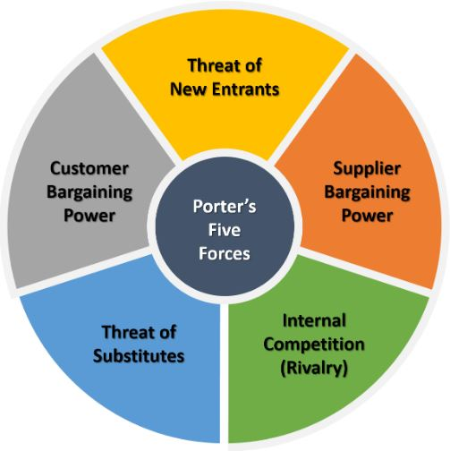

Figure 1 Porter’s Five Forces model
Source: (Jones, 2021)

- Threat of new entrants
The threat of new businesses opening in the fast-food industry is quite high due to the capital investment required is cheaper that other businesses. An individual can easily get the funds required to start up a restaurant as it is affordable. It’s the experience that the individual has in running the business that holds pivotal importance not just the food. So, it is important to focus on any new businesses opening as they can be a threat in the future. (Restaurant owner.com). Big Guyz has guaranteed that the items are of high quality, original, and varied in order to restrict the power of new entrants.

- Suppliers bargaining power
The bargaining power of suppliers is the price given for products and services (Quick MBA 2019). Restaurants food source equipment and foods from external sources as they do not make their own. For example, meat and chicken is sold in most restaurants who it’s purchased from will be according to the price the company is selling it at, for example Prices vary depending on weather you buy organic meat or not. To stay ahead of the competition, Big Guyz have prioritised product development and quality control, aside from that, Big Guyz manage their professional relationships with suppliers in order to exert control over their actions and influence.

- Competition (Rivalry)
Generally, the competition in the food industry is quite high. Businesses prioritise on gaining advantages over rivals by using Ways that could change prices or improve the products to be make them better than the competitors. Big Guyz has also observed that current rivals are developing marketing and product innovation strategies in order to manage the marketplaces. An organisation with a bad business and competitive strategy will be unable to compete. Rivalry is something that automatically happens when businesses are competing for the same customers however revenues can increase through market expansion (Quick MBA, 2019).

- Threat of substitutes
In the United Kingdom there is a concern of substitution since the government proposed in 2018 to reduce calorie consumption to half the rates of paediatric obesity by 2030 (Caddy, 2019). As a result of becoming health conscious, fast food customers may change their eating habits. Eating healthy at a fast-food restaurant, on the other hand, may be more expensive than eating unhealthily. As a result of the financial circumstances, some customers have avoided dining out. As a result, consumers choose to make meals at home because the components are less expensive. This is demonstrated by the fact that in 2018, 93 percent of customers were financially 'OK' to dine out, but this figure fell by 2 percent in 2019. (Caddy, 2019). However, as previously stated, there are various established organisations from whom a client may simply move due to the zero sum of switching. As a result, the danger of replacements is strong, as is competitiveness among rivals.

- Customer Bargaining power
Customer bargaining power in the fast-food market is high due to a few reasons. Generally, external factor such as competition make it easier for customers to migrate from one restaurant to another; as a result, consumers may easily enforce demands such as forcing price reductions, increased quality, or services. As a result, customers are price conscious. As previously stated, consumers' financial situations in the UK contribute to buyers' price sensitivity. The business must bear in mind that the buyer's bargaining power must be appropriately managed. Big Guyz product quality, originality, brand value, customer service, customer satisfaction and customer loyalty. have all contributed to the product's sale.

Use PESTLE and SWOT

Political
Political factors that affect business in the UK have been stable up until Brexit. Brexit has affected the import and export service with the UK meaning it has become more expensive to buy the produce due to import and export regulations changing. How every because Big Guyz sauce their products locally so it has not affected them much.
Economic
Inflation increases impact everyone from customer to businesses, the increase of inflation means that prices go up meaning customer have a smaller disposable income in turn it means because businesses are affected due to customer not spending. After the Brexit and the covid 19 pandemic on top added a big risk for the sustainability of businesses. Because Big Guyz are a Birmingham based business they managed to keep a float during these are times by reducing the number of employees and rotating them around the different locations.
Social Factors

Awareness level of healthy lifestyles is on the increasing, putting more pressure on many fast-food businesses to include healthier options on their menus (BBC, 2011). This involves providing low-calorie alternatives like salads beside burgers, as well as clearly showing nutritional information. On the hand there has been an increase of fast food take aways due the pandemic where people where just ordering food from the online platforms like Just eat, uber eats, Deliveroo and many more. Big Guyz took advantage of the situation like that and worked on originality, customer relations, and quality management to handle changes in consumer buying behaviour and expectations.

Technological

Fast-food businesses are engaging with customers through outlets such as social media websites as consumer awareness with new technologies grows. Furthermore, point of sale and digital ordering systems enable outlets to effectively adjust their menu to suit them and self-service ordering stations have boosted service speed and lowered labour expenses. Food delivery services such as Just Eat and Deliveroo have also made a big impact on the revenue of the business they no longer need to hire delivery staff these companies promote your business and also collect and deliver your product.

Legal

Businesses in the marketplace may face strict regulations. The laws, regulations, and legislation have helped businesses and expand in the UK (Jain and Bala, 2017). Big Guyz have been adhering to consumer rights, business regulations, and other laws that govern business performance.

Environmental
Big Guyz employees have received the appropriate training to ensure compliance with the environmental regulations in place. This might be through charging for plastic shopping bags or following the recycling method in place for products such as electrical goods.

SWOT analysis for Big Guyz

Strengths | Weaknesses
- Strong local presence (Birmingham)  - Good brand name  - Unique products  - Highly enthusiastic team  - Very good customer service  - Experienced management team  - Well recognised among the customers | - poor marketing  - promotional strategies  - serves unhealthy foods
Opportunities | Threats
- Own Application (App)  - Digital ordering system  - Expand in to other towns and cities  - Loyal customer base | - Employee retention  - global trends  - other competitors  - customer demands  - changes in business environment

Big Guyz are in a good situation, according to the pestle analysis. Big Guyz has capitalised on the epidemic to meet customers’ demands during the challenging times. As the SWOT analysis indicates that Big Guyz are doing well, but there are still possibilities and dangers that might threaten the business. There are options that may be used to assist overcome any difficulties.

Stakeholder Analysis

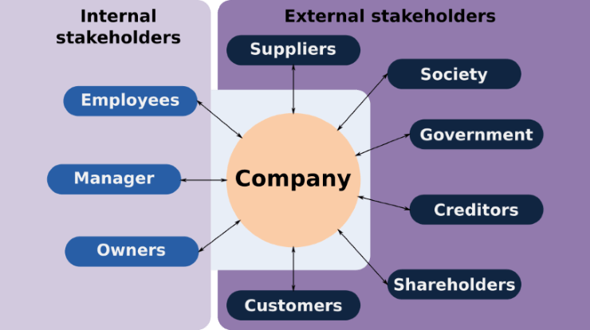

Figure 2 Stakeholder’s of a business Sauce: (pmtips.xyz, n.d.)

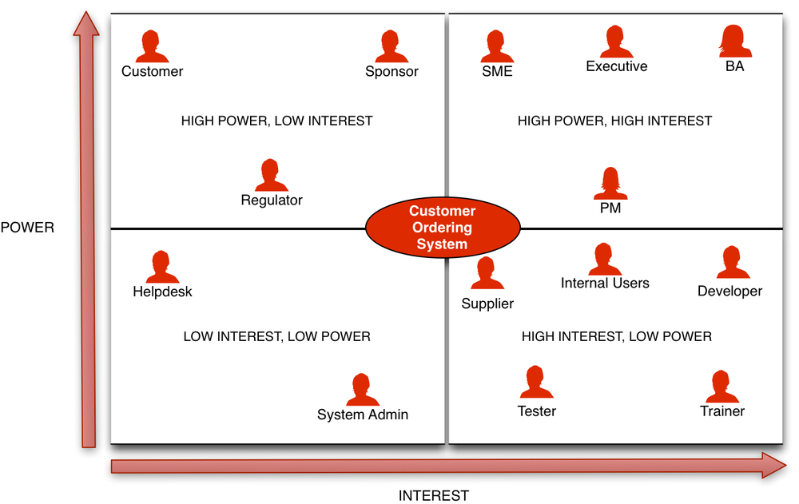
This diagram above shows the different types of stakeholders involved in a business Individuals and groups having a real stake in the company are referred to as stakeholders. These stakeholders can be direct or indirectly linked to the business and they have the potential to affect the company's decision-making process based on their role and involvement in the business. This is why companies do stakeholder analyses: it allows them to evaluate each stakeholder based on their amount of influence and power.

Figure 3 Stakeholder’s power grid Sauce: (Business Analyst Learnings, n.d.)
The stakeholder power-grid above reflects stakeholders and their classifications based on interests, such as the power, and abilities they have over a business (Li et al., 2019). The organisation must analyse the power and position of the stakeholders in order to make business decisions. Big Guyz examined the stakeholder's position and influence, as well as their expectations of the business. Big Guyz has also focused on maintaining stakeholders based on power and interests.
Using the grid matrix, Big Guyz reviewed their key stakeholders and the effect they have on the business. Customers are the most prominent stakeholders in the business, while having little interest in it (Ray Gehani, 2013). The business can investigate how the purchasing power of its customers influences the company's success. the management team at Big Guyz have been working with them to monitor and customer behaviour, power, and interests toward Big Guyz. Big Guyz manages customer connection, relationship management, and communication while adhering to a flexible business strategy. Big Guyz have committed to ensure that the are constantly developing their management systems so that customers have the best experience.
According to the grid, the supplier has higher interests with least amount of power (Surono et al., 2020). In this case the suppliers have higher interests for the business, but they have less control over the organisation. Big Guyz has determined that its suppliers have a greater incentive to be linked with management. The organisation has been operating its own supply chain management using methodologies and assistance for product quality development (Islami et al., 2020). Big Guyz has also ensured that professional relationships are maintained at all times in the workplace.
The management team and the employees at Big Guyz have the higher power and interest towards the business. Big Guyz has observed that management and employees have distinct interests, power, and abilities.

Strategic Growth Options

For long-term adaptation, the corporation would evolve its business strategy and management approaches (Bassi et al., 2015). Companies place a high emphasis on the creation of business strategy in order to increase profitability, diversity, and revenue. Different business market expansion alternatives might open up new possibilities and prospects for the company. Big Guyz has been operating as a small business, and the firm has been attempting to expand its market in the United Kingdom. Different business growth strategies can help the company to think about their strategic capabilities and power in the business markets (Schierstedt et al., 2020).
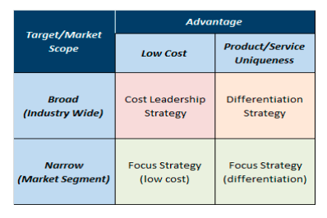

Big Guyz has experienced how the changing business climate and competition have decreased profitability and sales volume. As a result, the company has concentrated on business expansion methods. The following are some of Big Guyz strategic options: Porter's Generic Strategy: The company can make judgments based on client preferences and market concentration (Li et al., 2019). Porter's generic strategy depicts the three options accessible to a corporation to value its success in a competitive environment. For use in the growth option, the offered tactics may have varied strengths and limits. This technique has been used by Big Guyz to obtain a strategic choice for business expansion and growth. Porter's general method is seen in Figure 3.(Li et al., 2019) The cost leadership approach is one that almost all businesses employ (Jain and Bala, 2017). The company tends to follow broad market segmentation as part of this growth strategy in order to produce higher products at lower costs. The application of leadership, cost cutting techniques, technology, communication, production techniques, supply chain management and communication are used for the development of this strategy (Surono et al., 2020). Big Guyz, on the other hand, have not chosen this as their growth choice. With manufacturing investment, the cost-leadership approach might lead to additional consumers. Big Guyz has been considering introducing new items while also expanding its consumer base. The corporation has not considered cutting its costs for the sake of the business or its success. As a result, they have not chosen this choice. On the other side, the organisation can pursue further growth options. The differentiation strategy is one of them (Islami et al., 2020). In this case, the corporation will be able to sell items with more variety in larger markets.
Big Guyz has been considering introducing new items in order to distinguish their image and brand value. Their distinctness and product quality have already aided in the building of a competitive advantage. Thus, Big Guyz has selected this option which can also bring long-term effectiveness. Within this growth model, the company can see the available option for the focus cost strategy and focused differentiation strategy (Schierstedt et al., 2020). Each of them is managed within the concentrated market. However, Big Guyz has not selected this option due to its limitations such as a concentrated market, poor option for getting diversified customers, lack of expansion opportunity, and limitation of the business performance. Hence, a differentiation strategy has been adopted for the company’s reputation and competitive advantages. Ansoff Growth vector: There are different strategies available for the companies to gain the long-term facilities and opportunities (Surono et al., 2020). Ansoff growth vector represents the different types of strategies for business growth. The available 4 strategies can allow the company to gain the opportunities in different situations. Big Guyz has focused on assessing each of them for analysing their potential options for business growth.

Strategic Recommendations
The business might look for a better variety while also putting out new items and services for the organisation (Heino et al., 2020). Big Guyz has opted a diverse approach in order to expand and progress in the market, as well as to target more clients and sell their products. In a competitive industry, a varied service plan might assist the business in bringing forth more resources (Eskerod et al., 2015). According to the Ansoff Growth matrix, Big Guyz's product diversification approach can provide long-term effectiveness.
Big Guyz can implement some of the strategic recommendations under the product diversification plan. These are the following:

When diversifying products, the business must maintain strong research and development (Li et al., 2019). This might help the organisation offer a wider range of items and alternatives to attract the market. Big Guyz has promised to deliver greater product diversity in order to increase the customer base. In this case, Big Guyz must continue to do market research and data analysis in order to categorise the possible business opportunities. Aside from that, Big Guyz may focus on profitability while providing customers with specialised menu. This can assist Big Guyz in researching customer preferences and purchasing behaviour in order to make any business-related decision making.

The scope demands the manufacture of more items (Jain and Bala, 2017). In addition, the business is looking for ways to introduce new items to markets as part of its diversification plan. Big Guyz can minimised their costs and expenditure by combining the product diversification strategy and the market development strategy.

Under the diversified service strategy businesses will develop technological capability and bring new and more improved products. Big Guyz have already made the effort to keep up with the technological advancements which has helped the to grow in the market. Communication and collaboration are very important in the diversification strategy as it would need when it comes to introducing a new product Into and old market.

Competitors

It cannot be ignored competition will provide a range of barriers (Bassi et al., 2015). Businesses must deal with changes in the market and customer experiences. Big Guyz has decided to focus on their company strategy through a diverse product approach. in turn Big Guyz rivals may respond differently and adjust their approach. Big Guyz rivals' most typical reactions would be modifications in business strategy and product development or try to match the changes that Big Guyz have made if they if they are successful.
Because big Guyz are a Birmingham based business their main competitors are the other fast-food establishments around the local areas to the branches. When opening the branches, they did market research to compare the footfall of the location, the types of customers they will get, they looked to the demographic of the area and many more advantages and disadvantage point that encouraged them to open a branch. So, looking to see if there are other establishments in the same industry would have been one of the main priorities for the market research team. Competition is healthy as it brings in customer if they see that they have options.

Conclusion

The industry's business growth is influenced by a variety of elements, ranging from internal management to the external environment. Big Guyz has been considering expanding the business with more new items in order to increase diversity and diversification. offering the new and improve menu to the customers will attract them as they will stand out compare to the competitors. Big Guyz has also seen that the external business environment has brought about changes, problems, dangers, and a variety of scopes. Big Guyz strengths and talents, on the other hand, have contributed to their market expansion plan and capabilities.

References

Abosede, A.J., Obasan, K.A. and Alese, O.J., 2016. Strategic management and Small and Medium Enterprises (SMEs) development: A review of literature. International Review of Management and Business Research, 5(1), p.315.
Bassi, M., Pagnozzi, M. and Piccolo, S., 2015. Product Differentiation by Competing Vertical Hierarchies. Journal of Economics & Management Strategy, 24(4), pp.904-933.
Barboza, D (3rd August 2003), The New York Times, “If You Pitch It, They Will Eat It”. Available at: http://www.nytimes.com/2003/08/03/business/if-you-pitch-it-they-willeat.html?pagewanted=all&src=pm

Business Analyst Learnings. (n.d.). Stakeholder Matrix: A Practical Guide. [online] Available at: https://www.businessanalystlearnings.com/ba-techniques/2013/1/23/how-to-draw-a-stakeholder-matrix.

Ray Gehani, R., 2013. Innovative Strategic Leader Transforming From a Low-Cost Strategy to Product Differentiation Strategy. Journal of technology management & innovation, 8(2), pp.144- 155.

Jain, A. and Bala, R., 2017. Service Differentiation and Capacity Strategy for Joint ProductService Offerings. SSRN Electronic Journal,.

Jones, S. (2021). Five Forces Model Automobile Industry. [online] Sample Dissertations. Available at: https://study-aids.co.uk/dissertation-blog/five-forces-model-automobile-industry/.
‌ Caddy, T., 2019. Eating Out Review -UK- December 2019, London: Mintel .
CGMA, 2013. Porter’s Five Forces of Competitive Position Analysis. [Online]
Available at: https://www.cgma.org/resources/tools/essential-tools/porters-five-
forces.htm
Caddy, T., 2019. Eating Out Review -UK- December 2019, London: Mintel .
CGMA, 2013. Porter’s Five Forces of Competitive Position Analysis. [Online]
Available at: https://www.cgma.org/resources/tools/essential-tools/porters-five-
forces.htm
Caddy, T., 2019. Eating Out Review -UK- December 2019, London: Mintel .
CGMA, 2013. Porter’s Five Forces of Competitive Position Analysis. [Online]
Available at: https://www.cgma.org/resources/tools/essential-tools/porters-five-
forces.htm
Caddy, T., 2019. Eating Out Review -UK- December 2019, London: Mintel .
CGMA, 2013. Porter’s Five Forces of Competitive Position Analysis. [Online]
Available at: https://www.cgma.org/resources/tools/essential-tools/porters-five-
forces.html
Caddy, T., 2019. Eating Out Review -UK- December 2019, London: Mintel .
CGMA, 2013. Porter’s Five Forces of Competitive Position Analysis. [Online]
Available at: https://www.cgma.org/resources/tools/essential-tools/porters-five-
forces.html
CGMA (2017). Porter’s Five Forces of Competitive Position Analysis. [online] CGMA. Available at: https://www.cgma.org/resources/tools/essential-tools/porters-five-forces.html.

Perera, R., 2017. The PESTLE analysis. Nerdynaut.

Quickmba (2019). Porter’s Five Forces. [online] Quickmba.com. Available at: http://www.quickmba.com/strategy/porter.shtml.

pmtips.xyz. (n.d.). Stakeholder Analysis | Project Mangement Tips. [online] Available at: https://pmtips.xyz/2020/05/03/stakeholder-analysis/ [Accessed 14 Apr. 2022].
‌

