Name : Damian Golina
Student number : 2210589

E-portfolio report
Learning in the Digital Era – BMPL4007/BMPS4009

Table of Contents

Task 1 – Written summary 2
Task 2 – Mind map 3
Task 3 – Presentation 4
Task 4 – Reflection 5
Reference list 6

Task 1 – Written summary
“Preparing for Higher Education”
Preparing for higher education is largely based on our approach to the matter, that is, how we organize our time, place of work and how we adapt to the conditions we need to study efficiently. From my own experience as a person actively studying. I know that much depends on the proper organization of time and place where I can study in peace, somewhere where no one will distract me, somewhere where my head will be free from various things that can only distract me, to my studies and learning I approach one hundred percent seriously, because I am a person who is characterized as a perfectionist.

To be better prepare to higher education may help us such a things like prioritize our tasks and things to do , by that I mean put the very important things in first place , don’t wait with finish your tasks till the end of deadline , think about the resources you need to complete the task , be flexible , arrange the space and the time you will need , very helpful to do that might be “Eisenhower’s Principle”. According to Eisenhower, D.D (1954) Speech to the Second Assembly of the world Council of Churches. 19th August 1954. Evanston Illinois “I have to kinds of problems : the urgent and the important. The urgent are not important, and the important are never urgent” . I’m personally understand these words by prioritize our most important tasks , for example writing essay should be more important then going out with friends , once again prioritize. Another good tip to prepare yourself for higher education is to ask yourself a three very important questions , : what do I need to learn ? , why do I need to learn it ? and how should I learn it ?

References :
Burkeman, O. (2018) “ Focus on whats important , not just urgent” , The Guardian 27th July . available at : https://www.theguardian.com/lifeandstyle/2018/jul/27/oliver-burkeman-eisenhower-matrix-urgent-versus-important (accessed 27th July 2018).
Cleeve, R. (2018) “ 5 academic skills to prepare your students for higher education” Available at : https://www.english.com/blog/academic-skills-for-higher-education/ (accessed 22th October 2018)
Pryjmachuk, S. Wright, M. and Bottomley, J. (2019) “Studying for your Policing Degree” . 1st edn. St Albans: Critical Publishing.
Sarah, M. (2010) “The ultimate study skills handbook”. 1st edn. (UK) : Open University Press

.

Task 2 – Mind map
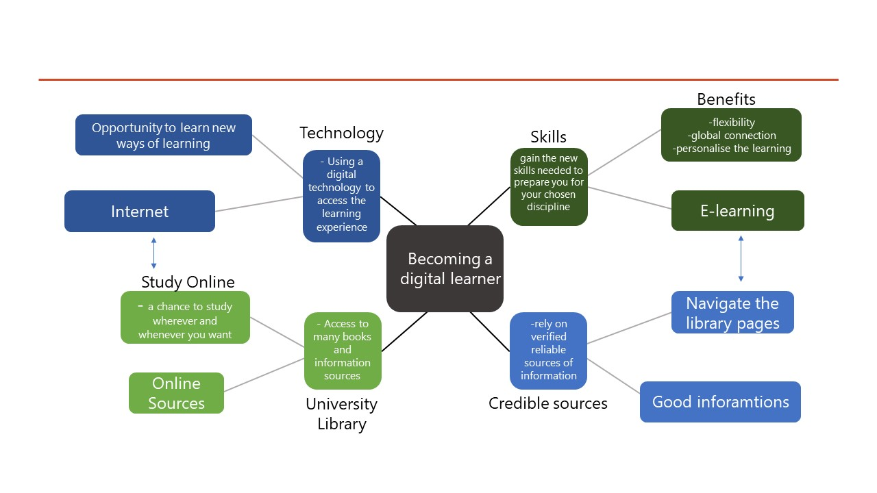
References :
Kohl, K. (2017) “The Digital learner : a new breed of learner in the digital age” : Developing for “Trainingzone”. Available at: https://www.trainingzone.co.uk/deliver/training/the-digital-learner-a-new-breed-of-learner-in-the-digital-age (accessed 26th July 2017)
Razavi, L. (2020) “Students like the flexibility : why online universities are here to stay “, The Guardian. 27th May . Available at : https://www.theguardian.com/education/2020/may/27/students-like-the-flexibility-why-online-universities-are-here-to-stay (accessed 27th may 2020)

Task 3 – Presentation
Please follow this link to view my presentation:

Task 4 – Reflection
Since month I have been studying Police Studies at the University of Wales Trinity St David. As I have always been interested in law enforcement thats why I chose this degree. I have never experienced online learning before, so this is new to me. It seemed challenging at first because I couldn't imagine the lessons that are taught there. I also felt excited it’s something new. At that moment i was thinkig of the words Stibel, J. (2017) from the book: How to motivate yourself and others : ''If you want to inspire someone, use their inner motivations'' . I then reflected on my intrinsic motivations, which are the desire for education and self-improvement. I am always quite quick to adapt. The amount of material available at the university impressed me positively such as the physical and online libraries. When it came time to write my first assesment ideas started popping up in my head as soon as I started writing and searching for information. Online classes I took with my lecturers, who guided us through the process step-by-step, and the information resources I have access to through the university were very helpful. Through the online training, I learned how to effectively search for credible information, how to distinguish between credible and unreliable sources, and how to cite book authors. All this proved important in composing my first assessment. I am quite pleased with how I have developed so far and how I have adapted to the new environment of aspiring police officers. In The Study Skills Book, Mc Millan & Weyers, J. (2021) write: "The transition from university experience to achieving your career goals are challenging and exciting steps." I agree with these statements and can relate to them because university offers us the chance to achieve our goals and is an exciting experience.

Reference list
Burkeman, O. (2018) “ Focus on whats important , not just urgent” , The Guardian 27th July . available at : https://www.theguardian.com/lifeandstyle/2018/jul/27/oliver-burkeman-eisenhower-matrix-urgent-versus-important (accessed 27th July 2018).
Cleeve, R. (2018) “ 5 academic skills to prepare your students for higher education” Available at : https://www.english.com/blog/academic-skills-for-higher-education/ (accessed 22th October 2018)
Kohl, K. (2017) “The Digital learner : a new breed of learner in the digital age” : Developing for “Trainingzone”. Available at: https://www.trainingzone.co.uk/deliver/training/the-digital-learner-a-new-breed-of-learner-in-the-digital-age (accessed 26th July 2017)
Mc Millan, & Weyers , J. (2021) ‘’The Study Skills Book’’ . (4th edn). Pearson Education, Limited , (2021)
Pryjmachuk, S. Wright, M. and Bottomley, J. (2019) “Studying for your Policing Degree” . 1st edn. St Albans: Critical Publishing.
Razavi, L. (2020) “Students like the flexibility : why online universities are here to stay “, The Guardian. 27th May . Available at : https://www.theguardian.com/education/2020/may/27/students-like-the-flexibility-why-online-universities-are-here-to-stay (accessed 27th may 2020)
Sarah, M. (2010) “The ultimate study skills handbook”. 1st edn. (UK) : Open University Press
Stibel , J. (2017) ‘’How to motivate yourself and others ‘’ . USA today.com. Arlington (2017).]

