Component 2 – reflective report

Student Name: Samir Mhanna
Student Number: 2119514
Lecturer Name: Md Nazmul Hasan
BMSW 4001
Academic and Employability Skills

2022

Contents
1. Introduction 3
2. Task 1 – Academic report 4
3. Task 2 – Teamwork – group presentation 6
4. Conclusion 9
5. References 10
6. Appendices 11
6.1. Appendices1 - task 1 assignment draft evaluation form 11
6.2. Appendices2 – the presentation feedback template 12

1. Introduction
The purpose of this assignment is to write a reflective report on my experiences and learning during the Academic and Employability Skills modules. Employability is “A concurrence of capability, preparedness for employment and the relevance of these to the current job market. The term can be used: in general terms, to mean that you have the abilities needed to gain a job and keep it” (Cottrell, 2015, p.250). In this report, I will talk and discuss two different tasks I already had done during the module which I think they are cover most skills I have got and learnt from the lecturer: task 1 – Academic Report, task 2 – team working - group presentation and in the end conclusion. I will use the Gibbs circle to reflect on my experience.

figure 1: Gibb’s reflective cycle. (Gibbs, 1988)
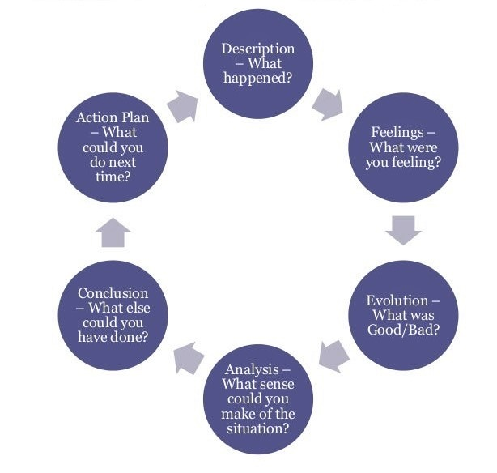

2. Task 1 – Academic report
After 5 weeks of learning different academic skills in class such as note-taking, time management, understanding assessment, finding information, plagiarism, referencing, structuring, and writing academic the time was coming to be ready for real practice and use all these skills to write an academic report about “what is the most effective way to motivate staff?”. So, I must write an academic report - 2000 words discussing different techniques and challenges of motivating employees at work staff. University assignments require you to write in a variety of styles. It guides you through a step-by-step process that will assist you in planning the structure of your submission. Topics of importance: Realistic time management, recognizing task elements, Exploring the topic, Locating and selecting relevant material, using an analytic approach Important terms Analyse, Argue, and Describe the Restriction Topic. (Weyers and McMillan, 2010, p.29).
When I decided to get a start, I backed to week 2 and used a timeline for completing an assignment that which lecture recommended. So, I started with reading the four sources that all students need to use within their assignment, then I began searching for different relevant sours more using digital tools available like google scholar and the online library of the university to find the right research, articles, books, etc. I was taking notes during reading and finding information to start writing. after I collected data and before writing I had to structure my report starting with the introduction where I describe the purpose of the report and give an overview of the different techniques of motivation I will discuss in the body and a brief description of the report structure, and in the main body I divided it to 3 headlines: money as motivational factor, recognition, and good working condition. And in conclusion, I show the main points that have been discussed and mentioned the most important points that have been made in the report. Then I reviewed my writing and did some editing for the final version of the report, in the end, I designed the report title page, table of content, and references list using the Harvard Referencing method.
TABLE 1- TIMELINE FOR COMPLETING AN ASSIGNMENT. (DAY,2018, P.15)

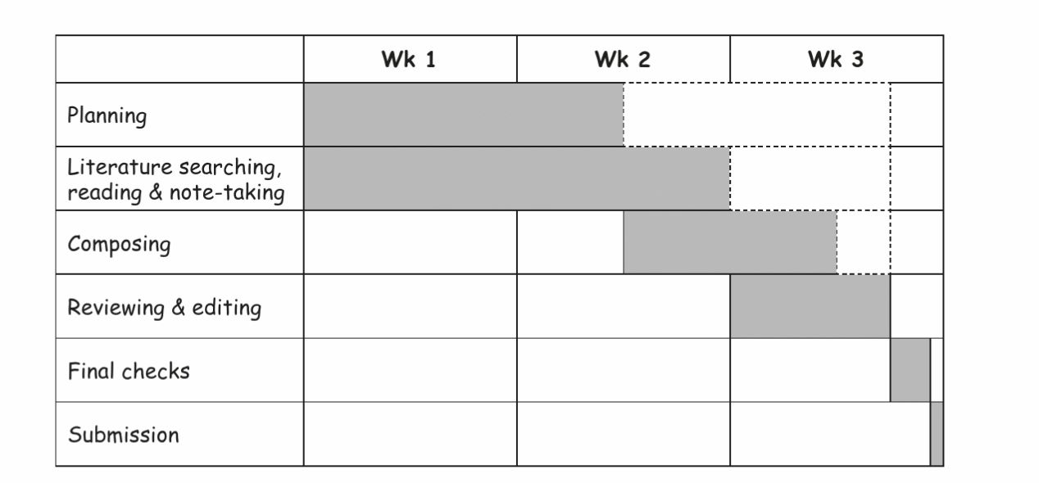

Frankly, being a student at a university in the United Kingdom is difficult. To put it mildly, the pressure associated with tasks or assessments is stressful. In overall, I'm grateful for this opportunity to improve my academic and employability abilities. This is my first term studying the English language. something I've never done before. It was quite interesting and new for me, and I gained numerous abilities as a result of this module. I think still have the courage to keep working and try do my best. Actually, there is such good energy in the classroom. My lecturer is a great teacher. He is always there to support and gives you the advice to calm you and makes things look easier. I like his way of teaching. Finally, I would like to mention that before studying this module I did not feel confident I feel now to start looking for a new job-related management field.
I really want to focus this reflective report on my personal assessment of academic report writing throughout the last ten weeks of learning and working diligently to complete my assignment -1. To begin with, it was an enjoyable task. I read and wrote more than ever before; I read in class and had a reading workshop in week 5, but I also read for extended periods of time at home by myself and then took notes based on what I read and what I needed. Even though it was difficult and time-consuming, I know it was beneficial to my health. I completed an academic report on employee motivation at work in which I applied all of the skills and knowledge I gained from the module's lecturer: how to write an academic report. I discovered that I could do so with a thorough understanding of the process and that there were no difficulties in designing the report and following the Harvard referencing guidelines. On the other hand, I may discuss negative experiences that occurred while I was conducting research. I realised that I spent more time than anticipated reading, taking notes, and writing, which meant that the report took longer hours and days to complete. Additionally, at times, I lost control of my ability to communicate concepts clearly without confounding readers. Finally, I'm proud that I completed an academic report - 2000 words in English.
Following up on what I've mentioned, I can see that the strength in academic writing is that I can be open-minded about the subject I write about. When I read a text, about the subject matter. I have taken on the challenge of delving into a text and analysing it thoroughly in order to improve my ability to write in a variety of styles. Considering this, I would like to make the following observation. I need to enhance my reading and writing skills in order to succeed in university, and this is the logical conclusion. You should always give yourself some wiggle room in your schedule if you want to do your best work. To answer your question, if you ask me about my upcoming academic report, I will tell you that I will immediately begin working on it and study every single book or article that the lecturer provides, such as the reading list on the Module's website. although I am aware of my tardiness, I am certain that I will be able to complete my reading list by the time I return to the classroom on May 23, 2022 and be ready and prepared. (Please see task 1 assignment draft evaluation form in appendices 1).

3. Task 2 – Teamwork – group presentation
From week 6 we moved to the next part of the module "employability skills" which is "A set of achievements, understandings and personal attributes that make individuals more likely to gain employment and to be successful in their chosen occupations". (Knight and Yorke. 2003). teamwork is one of the top skills employers look for. (AACU, 2021). time work is "A group of people who join together to accomplish a specific task". In order for a group to be considered a team, Hackman (2009) has outlined five key requirements: 1- the team must be real. 2- the team needs a compelling direction. 3- the team needs enabling structure. 4- the team needs a supportive organization. 5- the team needs coaching. During class weeks 6 and 7 we had different activities focused on teamwork and preparing students to get ready for task – 2 group presentation. The first activity – skills audit was 30 minutes to complete the skills audit for verbal communication and team working and identify my strengths and areas for development. The lecturer mentioned that the skills audit will highlight the skills needed to be successful in task2.
After finishing this activity and learnt about communication and teamwork skills. We were ready to task 2 – Group Presentation. The title of the presentation was time management- study case. There were three main questions we should answer then great PowerPoint slides and present them in the class in week 8. So, the lecturer divided the students into seven groups each group has five members, and my group was the only one consisting of three members. Unfortunately, no one on my team replied to me back after I sent them emails and text messages on Ms team trying to communicate to achieve good work as a team. Next week when I back to class another activity to work on as a team – creating a job advertisement. The goal as a team works together to choose a specific job role and then design a job advertisement including all the key information required as we learnt last week. But again, no groups no teams, it is just individual work. The last topic in the module was The Evaluation Form which each group will use this form to evaluate their peers and use this evaluation as feedback in a reflective report
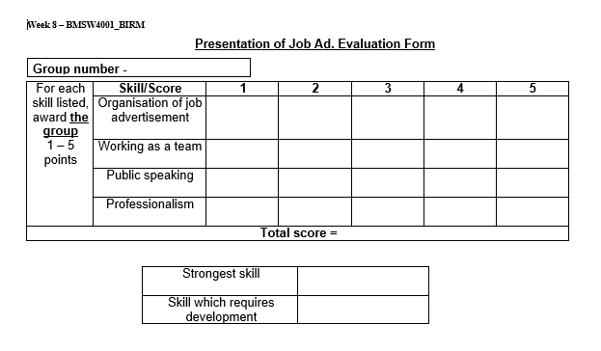
F inger2- Evaluation Form. Week 8

At the end of class, I expressed my concern to the lecturer about my inability to communicate with the group members, and he advised me to do it alone. However, the presentation is divided into two parts: the first is theoretical and discusses the concept of time management and time management skills. The second part is the case of Donna. I did Identify and outline Donna's time management issues in the first slice. The next slide demonstrated how Donna may use the 4D (Do, Dump, Delay, Delegate) time management strategy. Finally, I recommend another technique called 168 hours a week and developing a weekly time management chart to assist her in managing her time and never losing control.
TABLE 2- DEVELOPING THE 4D STRATEGY- DONNA’S CASE
the 4D strategy
Do | Dump | Delay | Delegate
- Planning  - Clean table  - Prepare: pencil and notes…etc. | - Go out with boyfriend  - Go out with friends | - Visit aunt and uncle | - call tutor early  - Ask classmates

I felt quite nervous and worried about standing in front of the students for 15 to 20 minutes and speaking to them. I had no anxiety about collecting material or developing the presentation, but I did have a worry about running out of time after spending a week attempting to interact with the group members. Another reason was that I was dissatisfied with my performance in a previous assignment in a different module, which was just 4 minutes long. So, in order to have more time to practice and prepare me to stand up and speak comfortably, I planned to work harder to complete answering the questions and create the presentation, but that never occurred. There were many positive and negative things that occurred as a result of this work; I'll start with the bad things that happened or the errors I made. One of the major issues I had was that I did not work in a team, which upset me and caused me to waste a lot of time waiting for a response from one of them. Another flaw I realised after grading the speaker was that I had misunderstood the definition of time management in the dictionary. I should've gone with a more scholarly definition. To be honest, there was no additional effort made to rehearse the presentation, which was obvious to both the lecturer and the students. I was jittery and talked rapidly, particularly while clarifying the arguments. I also didn't provide enough time to explain the final slide. On the plus side, I can stand for 20 minutes and converse. I moved about in the area that was open to me. During the talk, I attempted to engage with the students by establishing eye contact or asking questions. The presentation was well-designed. I was pleased to learn that a colleague thought my material was nice and valuable and that it offered fresh knowledge to him. (Please check the feedback template in appendices 2).

4. Conclusion
In conclusion, Academic skills are essential since they may help you be more productive and successful in education. Developing and increasing your academic skill set may assist prepare you for a future job and help you perform better overall. One of the most important skills you need to learn is how to write a report. There are different types of reports like academic reports, essays, and reflective reports. Etc, and in order to do it perfectly, there are many skills you must understand well such as note-taking, time management, understanding assessment, finding information, plagiarism, referencing, and structuring. while Employability skills are defined as a collection of accomplishments, interpretations, and personal characteristics that increase an individual's likelihood of obtaining work and achieving success in their chosen vocations. teamwork is one of the most searched skills among employers. In the end, Effective presentation skills are vital to business success, marketing, advertising, selling, and being willing to talk in front of a set of people.

5. References

Cottrell, S 2015, Skills for Success : Personal Development and Employability, Macmillan Education UK, London. Available from: ProQuest Ebook Central. [5 April 2022].
Gibbs, G. (1998) Learning By Doing : A guide to teaching and learning methods, Oxford: Further Education Unit, Oxford Polytechnic
Weyers, J. and McMillan, C. (2010) How to Write Essays and Assignments. Place of publication not identified: Pearson Education Limited.
Knight, P.T. and Yorke, M. (2003) ‘Employability and Good Learning in Higher Education’, Teaching in higher education, 8(1), pp. 3–16. doi:10.1080/1356251032000052294. Knight, P.T. and Yorke, M. (2003) ‘Employability and Good Learning in Higher Education’, Teaching in higher education, 8(1), pp. 3–16. doi:10.1080/1356251032000052294.
Hackman, J.R. (2009) ‘The perils of positivity’, Journal of organizational behavior, 30(2), pp. 309–319. doi:10.1002/job.587.

6. Appendices

6.1. Appendices1 - task 1 assignment draft evaluation form

Skill/score | Poor | Needs to improve | Acceptable | Good | Excellent
Understanding assessment |  |  |  |  | /
Time management |  |  | /
Note-taking |  |  |  | /
Finding information |  |  |  | /
Structuring |  |  |  | /
Referencing |  |  |  |  | /
Writing |  | /
Reading |  | /

6.2. Appendices2 – the presentation feedback template

Evaluation Form
For each skill listed, award the group 1 -5 points | Skill/Score | 1 | 2 | 3 | 4 | 5
For each skill listed, award the group 1 -5 points | Working as a team | /
For each skill listed, award the group 1 -5 points | Public speaking |  | /
For each skill listed, award the group 1 -5 points | Organization and structuring of presentation |  |  |  |  | /
For each skill listed, award the group 1 -5 points | Well prepared |  | /
For each skill listed, award the group 1 -5 points | Interaction with audience |  |  |  | /

Strongest skills | - Organising and structuring the presentation was almost perfect.  - interaction with the audience and use the space I have.
Skills that require development | - I need to prepare well and practice before doing a presentation.  - communication skills with team members

