Sylwia Brylewicz
2112267

Module Code: BMHP5014

Lecturer: Eleni Koutsogeorgou

Assessment 1
Online portfolio of set exercises (e-portfolio)

ASSIGNMENT 1: E-PORTFOLIO

INTRODUCTION

For this assignment I have chosen to develop my own campaign that promotes and advocates stopping smoking. I have chosen this cause because I am passionate about healthy living. Also, having grown up in a household with smokers, this is a cause I am very passionate about and resonates with me closely.

There are currently about 6.9 million smokers in the UK. (Smokefreeworld.org, 2022) In 2020 it was recorded about 77,600 deaths were related to smoking and over 506,100 hospital admissions related to smoking. (NHS Digital, 2020) Looking at this research I find it hard to ignore the fact that people are causing their own possibly unnecessary deaths and are using valuable NHS resources through fault of their own. Not only does smoking effect those who chose to do it, but it affects those around them. Passive smoking puts people at higher risk of smoking-related diseases. It’s clear that second-hand smoke can cause lung cancer, heart disease and stroke. (Cancer Research UK, 2021) Passive smoking is especially dangerous to children and to unborn children being carried by a pregnant woman. Not only is making damaging to the health of many people but it’s also uses up a large amount of the average household s disposable income. The average smoker is spending just under £2,000 a year on tobacco costing England smokers a total of £12 billion. (Ash.org.uk, 2022) With everything happening in today economy I feel it would be a beneficial change if households were about to save the amount the spend on cigarettes instead.

The target audience for this campaign is all smokers nationally. Although this targeted at smokers, I also intend for the campaign to educational for everyone including non-smokers who may be able to pass the information learnt from the campaign on to friends and family that are smokers.

I have named my campaign “stop smoking, start living”. This name reflects the idea of a journey. Not only are they going to stop smoking, but they will be starting this new life of better health.

To reach my target audience effectively I have chosen to create an elevated pitch for the first artefact. I felt this seemed an appropriate way to reach the audience constructively, as with a pitch I’m able to put in enough information to inform about the cause I am encouraging. A pitch can be read in context too, as I want the campaign to mainly depict a positive journey rather than the negatives of smoking. For the second artefact I have created a flyer that showcases the same information given in the elevated pitch. I’ve kept the facts short and concise to give the needed information about my campaign and making it quick and easy to read. I used bright bold colours to capture the attention of readers and make it stand out wherever it is read.

ARTEFACT 1: ELIVATED PITCH

Hi everyone, I am happy to see so many of you here today. I am from the organisation Stop Smoking, Start Living. Yes, I'm sure you guessed it, I am here to talk to you about your journey to better health, by stopping smoking. My passion for this cause comes from my interest of healthy living and from having the ability to improve your own quality of life. I just need no more than two minutes of your time today to share my knowledge about the benefits of stopping smoking.
Smoking is the main cause of avoidable deaths in the UK. Between 2016 and 2018, 77,600 deaths were attributable to smoking per year in England. (Horton & Windsor-Shellard, 2020). Over 500,000 people in the UK were admitted to hospital. This means 77,600 deaths may have been preventable if they had quit smoking and hundreds of thousands of pounds could have been used elsewhere in the NHS.

If you had a chance to stop your death, would you? Of course, you would. Well good news, you do have that chance. This is that chance. In fact, you can start right now.
Did you know just Twenty minutes after your last cigarette, your blood pressure and pulse will go back down to normal levels. Eight hours after your last cigarette your carbon monoxide levels will also decrease. Twenty-four hours after your last cigarette, your risk of having a heart attack has already decreased, that's only one day after your last cigarette and you're already improving your health dramatically. Let us skip one month down the journey to stopping smoking. Your lung function has increased by thirty per cent, making it easier for you to breathe and making exercise a lot easier. After 6 months to one year of stopping smoking, your fertility will have improved and pregnancy complications will have decreased. Oh, and that dreaded smoker's cough will have gone. Wow, all this after just 1 year of non-smoking. If we now jump five years down the timeline of stopping smoking, your risk of death by lung cancer and dropped by half of what it was from when you did smoke. fast forward another five years to ten years down the timeline that risk of death by lung cancer is now the same as the risk of a non-smoker. Not only has your risk of lung cancer decreased, but all smoking-related illnesses have decreased. Your chances of developing heart disease, having a heart attack or having a stroke are now the same chance as someone who has never smoked a day in their life. (Nall, 2018)
Now you can see the impact of quitting smoking can have on your health and life, don't you want to start your own journey to better health? I know stopping smoking isn't as simple as just stopping. However, here at Stop Smoking, Start Living there's all the help and guidance you need to succeed in the process. From online webinars, step-by-step plans, one-to-one check-ins with health professionals and your very own stop-smoking starter kit. You can also include your friends and family in the process, whether you want to stop smoking together or if you just need them along for moral support. I
If you would like more information about our approach and services, be sure to look online at stopsmoking.co.uk. I've also given each of you a leaflet where you can find all the relevant information about everything, I've spoken about with you today. Thank you for listening.

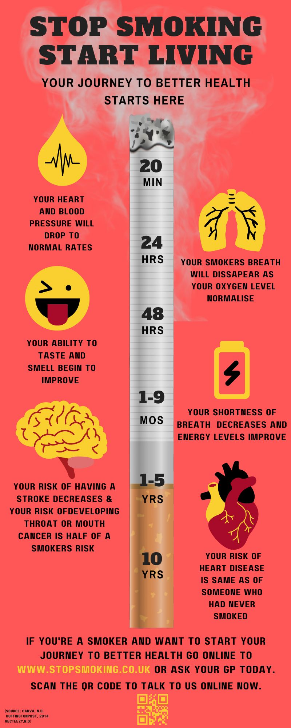
ARTEFACT 2: FLYER/LEAFLET

For artefact 2 I designed a flyer (above). I came up with the idea of a timeline showing the benefits of stopping smoking. By keeping the context of the flyer in a more positive nature I felt it would be more gripping to the target audience than a flyer about the negatives of smoking, which most people may tend to ignore as they don’t want to be reminded of the damages they're doing to their bodies.

The flyer focuses on the benefits and the journey of quitting smoking laid out in chronological order by the amount of time since the last cigarette. I wanted to make sure the flyer gave enough information about these benefits but also wanted to make sure that the flyer wasn’t overloaded with words making it less attractive to read for the target audience. All facts included in the poster were information gathered from an online article The Huffingtonpost.co.uk about the national event “Stoptober”, I felt this was in line with the cause I’m advocating.

For imagery on the flyer, I used a digital illustration of a cigarette (Vecteezy.com, N.d) which is centrally located and is used as the line for the timeline, I felt this was appropriate as the main image for the flyer as it shows that the flyer is related to smoking before reading anything, therefore attracting the attention of the target audience. I preferred to use an illustration of a cigarette instead of a real image because it was bolder against the background I had chosen. Next to each fact on the timeline I added small digital illustrations (Canva.com, N.d) relevant to the fact given. I also edited these Images to match the colour scheme of my flyer which is red and yellow. I chose red as the main background colour as it’s a colour that is used for warning signs and stop signs, both of which my flyer is trying to portray. For the illustrations, I chose a bright yellow, because it’s on the opposite side of the colour wheel to red contrasting the colours to stand out and captivate the eye. Also, yellow signifies hope and positivity which I feel I’m also trying to communicate in the flyer.

Underneath the title of the flyer, I added a subheading “your journey to better health starts here” strategically positioned at the beginning of the timeline to suggest it literally starts at the first step of the timeline. At the bottom of the flyer, I added a small brief statement repeating the subheading line but this time asking the reader. I added the website address and a QR code to take the reader directly to the help they need to get started with their journey. I used both the website address and QR code and recommended asking their GP, instead of just one or the other, because the target audience is such a broad scale of people, I wanted to make sure everyone knows how to proceed after reading the flyer.

CONCLUSION

Overall, I feel I have delivered a successful campaign which demonstrates my passion to the benefits of stopping smoking. My passion which has come from my own belief to live a healthy life as much as I can. Looking into the statistics around smoking within the UK, I quickly became aware of the amount of NHS recourses used by smokers being admitted to hospital from smoking related illnesses. Having looked into other national campaigns for quitting smoking, I found a lot of information that supported my cause, this helped me put together this campaign. The evidence I discovered to support my cause was the key facts that showed the benefits of stopping smoking in a chronological order. In the campaign I’ve used a mixture of facts about how stopping can change the way the target audience live and potentially save their lives, I wanted to add in some shocking information that will stick with the reader or listener.

Both artefacts link together to inform and provide knowledgeable Information to the target audience. For artefact one I designed a 2-minute pitch to a room full of smokers or people who wanting to stop smoking to or those who know a smoker. Pact with short facts about the positive benefits of stopping smoking is enough to cover the main concept behind my cause. This pitched is designed to speak to the listener directly, I have used rhetorical questions throughout to interact with them and give them something to think about and ask themselves after listening. I felt the pitch would be the best way to get all the information to the listener in the correct tone. For Artefact two I created a bold and striking flyer, deigned to capture the attention of the target audience. I felt the layout of the flyer was inviting and made the reader likely to read all the information provided. Although the flyer gives serious and informative facts, I kept the design fun with the digital illustrations and the mix of bold contrasting colours, which will keep the reader engaged. To summarise, I feel the campaign has overall validates my cause to why the target audience should get on board with the cause.

REFERENCE LIST
Ash.org.uk (2022) A third of smoking households in England are living in poverty with rates highest in the North. Ash.org.uk. Available at: https://ash.org.uk/media-centre/news/press-releases/a-third-of-smoking-households-in-england-are-living-in-poverty-with-rates-highest-in-the-north
Cancer Research UK (2021) What is passive smoking? Cancer Research UK. Available at: https://www.cancerresearchuk.org/about-cancer/causes-of-cancer/smoking-and-cancer/what-is-passive-smoking
Canva.com (no date) Free design tool: Presentations, video, social media | CANVA canva.com. Available at: https://www.canva.com/ (Accessed: November 21, 2022).
Horton, M. and Ben Windsor-Shellard, B. (2020) Adult smoking habits in the UK: 2019, Adult smoking habits in the UK - Office for National Statistics. Office for National Statistics. Available at: https://www.ons.gov.uk/peoplepopulationandcommunity/healthandsocialcare/healthandlifeexpectancies/bulletins/adultsmokinghabitsingreatbritain/2019
UK, T.H.P. (2014) What happens to your body when you stop smoking, HuffPost UK. HuffPost UK. Available at: https://www.huffingtonpost.co.uk/2014/10/06/stoptober-stop-smoking-affects-body_n_3960096.html
Nall, R. (2018) What happens when you quit smoking: A timeline of health effects, Healthline. Healthline Media. Available at: https://www.healthline.com/health/what-happens-when-you-quit-smoking#15-years
NHS Digital (no date) Statistics on Smoking, England 2020, NHS choices. NHS. Available at: https://digital.nhs.uk/data-and-information/publications/statistical/statistics-on-smoking/statistics-on-smoking-england-2020
Smokefreeworld.org 2022) State of smoking in the United Kingdom, Foundation for a Smoke-Free World. Available at: https://www.smokefreeworld.org/health-science-research-2/health-science-technology-agenda/data-analytics/global-state-of-smoking-landscape/state-smoking-united-kingdom
Vecteezy.com (no date) Download free vectors, clipart graphics, Vector Art & design templates, Vecteezy. Available at: https://www.vecteezy.com/free-vector/cigarette

