Effective Team Working


Module code: BMSW4002
Lecturer’s name: Malani Gunaratnam
Student’s Name:
Team Leader Marigklen Chotza (1906498) Team roles
Nadezhda Hristova Yaneva (1908346) Benefits of team working
Neli Todorova (1909068) Stages of team development

Vasela Kyurchieva (1908344) Managing conflict

Plamen Penchev (1910023) Successful team development
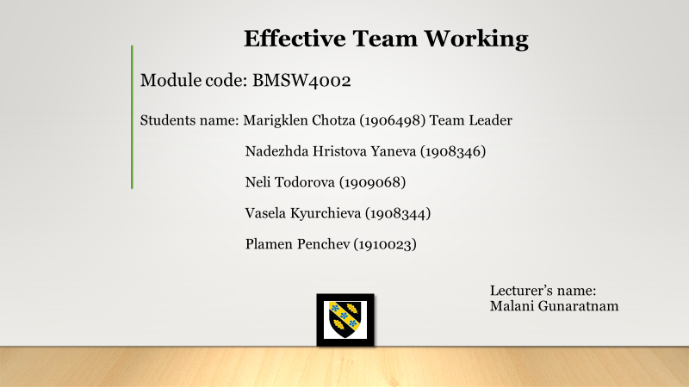

Table of Contents
1
Introduction 2
Benefits of team working 3
Stages of Team Development 4
Team roles R. Meredith Belbin 6
Successful team development 8
References 11
13
14
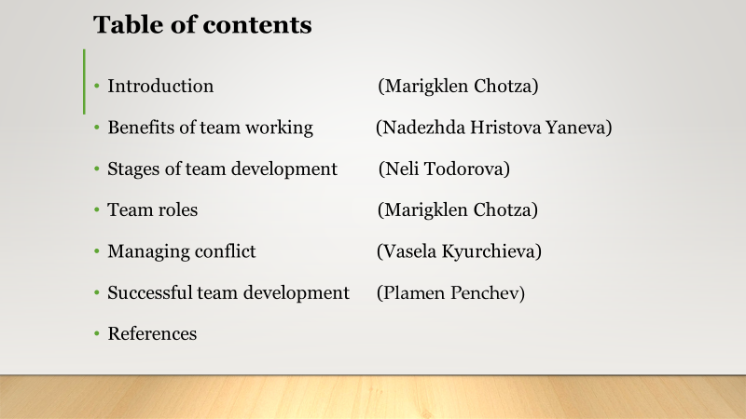
Appendices 15

Introduction

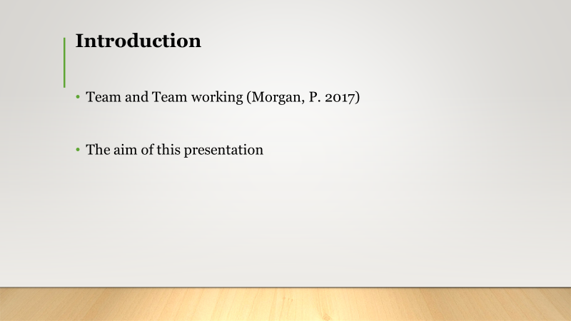
The team is a total of different individuals who have a common goal. Units build from a particular task where skills and abilities are needed. Team’s behaviour is that which makes the difference in consequences on team working. On this presentation, my team and I are going to show the steps and consideration need for an effective team working. My colleague Nadezhda will continue with the Benefits of team working.

Benefits of team working
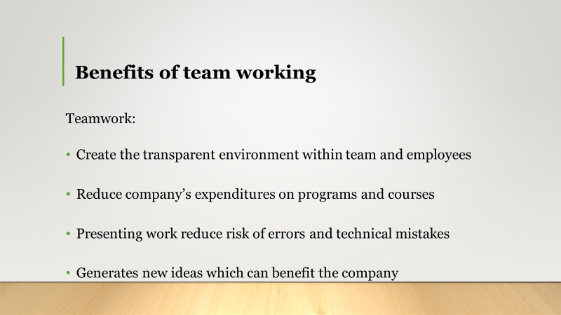

The reasonably applied team working approach brings numerous benefits for modern companies.
First, teamwork creates a transparent environment within a team, and the employees tend to be more open and more creative when they feel that the work is disrupted. (Shuffler et al. 2018, p. 692). Moreover, teamwork reduces the level of stress within a team since some employees associate a team with a family and, therefore, tend to be happier and less stressed than when they work individually (Kashyap 2019). Consequently, the lower level of stress reduces the possibility of making technical errors or serious mistakes. Thereby, teamwork accelerates the time required to compete with a complete task and ensures transparency.

Second, teamwork reduces the company’s expenditures on educational programs and courses because team members are more likely to share their knowledge and skills with other members to troubleshoot and more rapidly find the final solutions. Consequently, companies do not need to spend a huge amount of corporate budget on various training programs, workshops or lectures. Therefore, teamwork is one of the most suitable ways for modern companies to reduce their staff expenditures without firing employees.
Third, the possibility to present your work to other team members constitutes a form of internal accountability that reduces the risks of errors or technical mistakes. Moreover, during this process, the other team members are likely to notice the problem sides and organise a brainstorming session to troubleshoot. Furthermore, the possibility to share their results with other team members increases the level of trust within a team. Also, the opportunity to share personal concerns, ideas, and feelings with other team members reduce the emotional pressure that results in increased productivity and creativity (McDaniel & Salas 2018, p.306). Therefore, teamwork minimises the level of internal risks and errors within a company that leads to higher profits and higher efficiency.
Teamwork fosters the processes of conflicts resolution without external interference that is vital to preserve the team and achieve the prescribed goals. Although working in a team can and should be accompanied by various conflicts regarding the formulation or execution of tasks to find the best options and allocate resources efficiently (Hwand 2018, p.158). Therefore, teamwork reduces the risks of internal conflicts and disputes not related to job activities.
Finally, teamwork generates new ideas and insights that can become the company unique competitive advantages. Partnership encourages team member to take risks and propose ground-breaking ideas that an individual cannot realise individually due to the fear to assume all risks on himself. Furthermore, the possibility to take risks promotes the higher rate of personal development due to the feeling of satisfaction and sense of personal importance. Therefore, teamwork creates new and strengthen the existing company’s competitive advantages.
Overall, team working constitutes the modern form of organising, the operations of a company aimed at increasing, the efficiency and the results of both a company and employee. Moreover, teamwork enables the processes of self-development and growth that saves the company’s resources and time and constitutes its competitive advantages. Although every team needs to improve itself and continuously experiment to be able to achieve higher targets and ensure the employees’ job satisfaction and emotional stability.

Thank you for your attention now I will pass the world to my colleague Neli. She will talk about Stages of Team Development.

Stages of Team Development

To introduce effective team working in an organisation, this company needs to consider what has been successfully used for many years. One of the most famous models of team development is Tuckman’s Team Development Model. Dr Bruce Tuckman created the model in 1965. He claimed that there are four general phases of team development. Those are ‘forming’, ‘storming’, ‘norming’ and ‘performing’ (Morgan, 2017, p.210-211). They are the stages of team formation, disagreement, establishing norms, and working together. The first stage, forming, is the time at which team members have a lot of questions ‘reflecting (...) the uncertainty or anxiety they might be feeling about their place on the team’ (Stein, 2020). This is the stage at which group members are getting to know each other and start to decide how to proceed with the work. The second stage, storming, ‘is characterised by conflict’ – this can affect the team’s productivity negatively (Egolf and Chester, 2013, p.170). There is a disagreement between group members because of differences in opinions on how the work should be done. The third stage, norming, is that of group members accepting ‘that difference of opinion is inevitable’ and addressing ‘ground rules or values’ (Dickson, 1999, p.39). This is when the team learns how to manage conflict, and the members make norms to use for their work together, for example, not talking over each other and listening to others. The fourth stage, performing, is of ‘clear vision and purpose, focus on goal achievement and delegation’ (Nelson and Quick, 2011, p.298). As team members made rules and solved disagreements, in the last stage, they work together to finish the task.
In 1977, Tuckman and Mary Ann C. Jensen added a fifth stage to the model – adjourning (Myers and Anderson, 2008, p.94). Adjourning explains the final stage of teamwork. When a team reaches this phase, it ‘has achieved its purpose’ and ‘team members feel good about what they have achieved’ (Williams and Curtis, 2007, p.81). The team has finished the task and can stop working together. Tuckman’s Team Development Model has been criticised for its accuracy. Critics have said that ‘what makes a workgroup effective is more complex than this model acknowledges’ (Bratton et al., 2008, p.60). Even with Tuckman’s criticisms, his model is still used in many companies. This shows that it is a useful model of team development and should continue to be used for effective team working.
Marigklen will continue now with the Team roles. Thank you.

Team roles R. Meredith Belbin
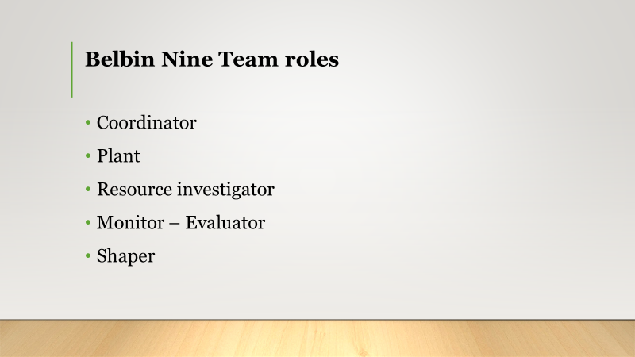

Thank you Neli.On this part I will analyse the theory of R. Meredith Belbin Raymond for Team roles. Meredith Belbin is a Researcher. He was born on 4th June 1926. His origin is from Sevenoaks, Kent, England, and he has studied in Clare College, which is a constituent college of the University of Cambridge in Cambridge (Toolshero, 2020).
To create a successful working team effectiveness must be achieved, which depends on viability and performance. Viability means the participation and satisfaction of the team to work together. Performance is the efficacy of productive effort. (Henry, 1999)
According to Belbin, to be a team with high performing, a team must have nine Belbin’s Team Role behaviours. That does not mean that it must be a team of nine persons. Everyone might have more than one Role in the team. Each role has strengths and weaknesses.
According to the University of Cambridge (2016), the nine-team roles are the following:
Coordinator: is the person who makes the decisions. He is a responsible, confident, and capable person. He defines roles and assigns well. However, he uses people to his advantage and delegates to others his work.

Plant: a person who solves the problems. He is creative and innovative, although he lacks communication skills.

Resource Investigator: his role is to explore opportunities and make new contacts. He is a demonstrative and friendly person. His main weaknesses are that he is extremely positive, and he loses his interest when his enthusiasm passes.

Monitor-Evaluator: he checks all the options and judges. He is observant and strategic, but he is not able to motivate others.

Shaper: he gets difficulties under control. He is a demanding person, and he is capable of prospering under difficult circumstances. He has reactionary behaviour and hurtful towards others.

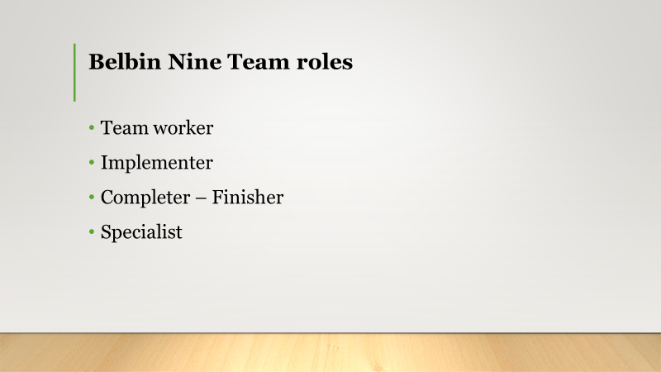
Team worker: is the person who helps the mission of the team and deters conflicts. He is a diplomatic and quiescent individual, but hesitant.
Implementer: his role is to implement the ideas. He is a trustworthy person with discipline and productivity but stubborn and inactive to chances.
Completer-finisher: he must eliminate errors and exclusions. Also, he is consistent with deadlines. A meticulous and conscientious person but stressful and unwilling to assign.
Specialist: He provides knowledge and abilities in uncommon issues. His strengths are determination and commitment. However, he contributes to the team only in necessary circumstances. Speak notes: According Smith (2016), Hersey’s and Blanchard’s model of situational leadership matches on 4 leadership styles which are Telling, Selling, Participating and Delegating. Whole team is being benefiting when the leader can figure out quick with new conditions.
My colleague Vasela will continue with the managing conflict. Thank you.
.

Managing conflict
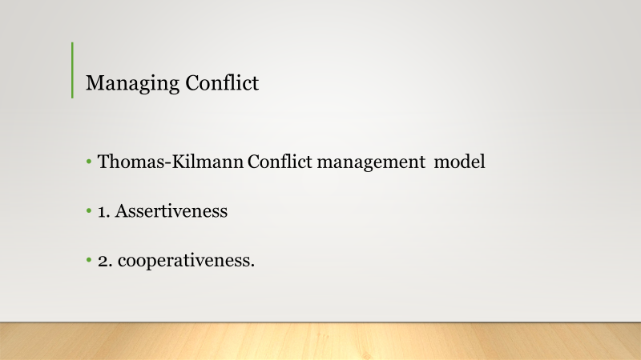
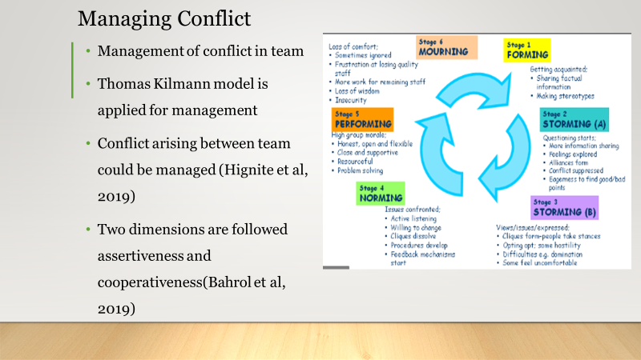
Thank you Marigklen. Hello everyone. On this part I will be talking about managing conflict. According to Hasting et al (2019), two dimensions are identified in the Thomas Kilmann model. They are the assertiveness and cooperativeness. Assertiveness is the degree to which ones try to satisfy one’s own needs. Cooperativeness is the degree to which ones trying to satisfy the other person’s concerns.

These are the 5 options in conflict resolution in the Thomas-Kilmann model.

Competing. The Competing option is at the top left of the model which means you take a wholly assertive and unco-operative approach to resolving the conflict. It means standing up for your rights, defending a position which you believe is correct, or simply trying to beat the other side.

Accommodating. The Accommodating option is at the bottom right of the model which means you take a wholly unassertive and co-operative approach. This might take the form of selfless generosity or charity, giving in to another person's orders when you would prefer not to, or yielding to another's point of view.

Avoiding. The Avoiding option is at the bottom left of the model which means you take an unassertive and unco-operative approach to the conflict

Compromising. The Compromising option is at the centre of the model because it is both assertive and co-operative but only to some extent. It's the approach of "half a sixpence is better than none". Both sides get something but not everything. It might mean splitting the difference between the two positions, some give and take, or seeking a quick solution in the middle ground.

Collaborating. The Collaborating option is at the top right of the model and is at the opposite extreme of avoiding. It means being willing to believe that when two parties are at loggerheads, it is possible for both sides to come out with what they want. Collaborating requires developed conflict resolution skills based on mutual respect, a willingness to listen to others, and creativity in finding solutions.

Now my colleague Plamen will analyse the Successful team development.

Successful team development

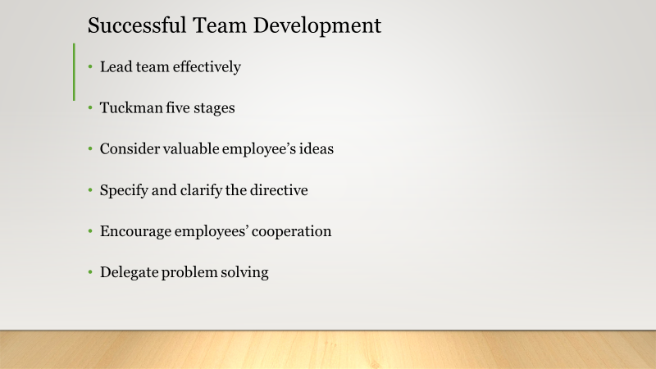

Thank you Vasela.
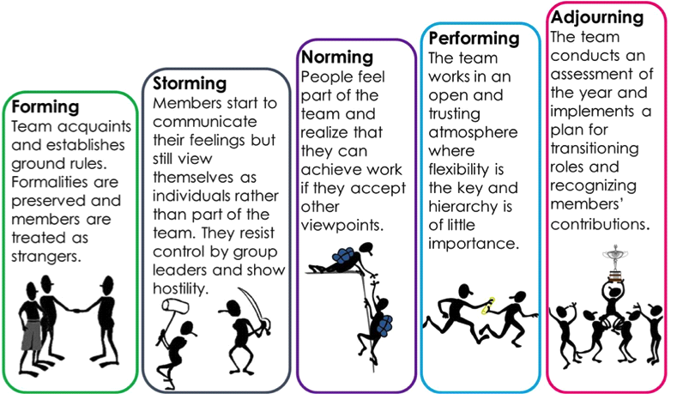
The first rule of team building is obvious - to lead a team effectively, one must first establish her/his leadership with each team member. The most effective team leaders build their relationships of trust and loyalty, rather than fear or the power of their positions.
TUCKMAN’S STAGES OF GROUP DEVELOPMENT
Tuckman’s 1965 five stages of development is still one of the best models to use in order to develop a successful team.

Combined with the following strategies one will achieve a strong, purpose build and creative team with an exceeding expectations team.

Value all the employees’ ideas. There are no bad ideas it is all an opportunity
Be clear when communicating. Be careful to clarify directives.
Promote cooperation among the team. Remember that the relationships team members establish between themselves are as important as those you establish with them. As the team begins to take shape, pay close attention to the ways in which team members work together and take steps to improve communication, cooperation, trust, and respect in those relationships.
Create problem-solving tasks and activities to the team on which they must work out solutions together.

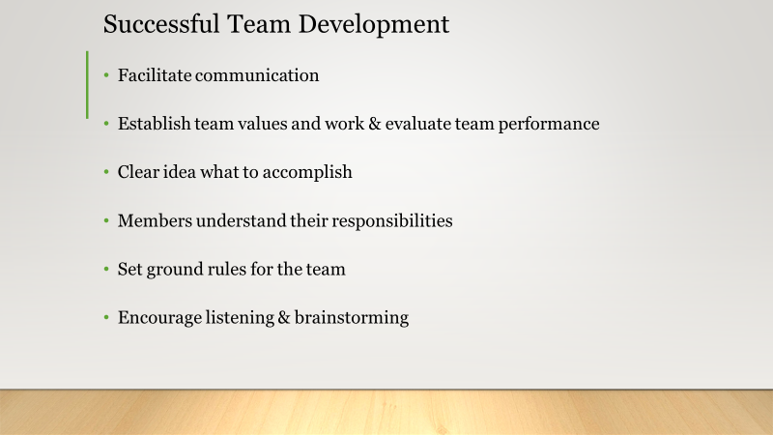
Promote communication. The communication is the most important factor in successful teamwork. Facilitating communication does not mean holding meetings all the time. it means setting an example by remaining open to suggestions, by asking questions and offering help, try to avoid confusion in your own communication.
Establish team values and goals and evaluate team performance. Talk with members about the progress they are making toward established goals so that employees make sense of their success and of the challenges that are to come. Stress teamwork in performance.
One must have a clear idea of what you need to accomplish and make sure you know what your key elements for success are going to be.
That you have set clear time frames, that team members understand their responsibilities.
Set ground rules for the team. These are the norms that the team must establish to ensure efficiency and success. They are simple directives, but you should make sure that the team creates these ground rules by consensus and commits to them, as a group and as individually.
Inspire listening and brainstorming. The team leader or a supervisor’s priority in creating consensus is to encourage debate. Keep in mind employees are often afraid to disagree with each other and this fear can lead your team to make bad decisions. When you motivate debate, you inspire creativity and that's how you'll motivate a team to achieve the best results possible.
That was all from me now I will pass the word to our team leader Marigklen. Thank you.

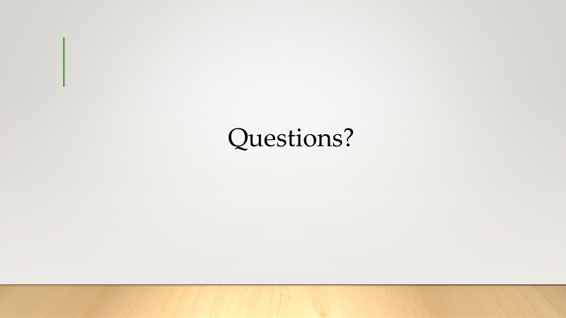
Thank you, Plamen. On this part, I would like to thank you for your time and if you have any questions, we will be happy to answer.

References
Bahrol, K.M., Md Yusoff, R., Amin, M., Dina, N., Abdul Hamid, M. and Ismail, F., 2019. Model of conflict management.

Belbin (2020) The Nine Belbin Team Roles Available at: https://www.belbin.com/about/belbin-team-roles/ (Accessed 6 April 2020)
Berkeley People&Culture Steps to Building an Effective Team Available at: https://hr.berkeley.edu/hr-network/central-guide-managing-hr/managing-hr/interaction/team-building/steps (Accessed 6 May 2020)

Bratton, J., Mills, J. H., Pyrch, T. and Sawchuk, P. (2008) Workplace Learning: A Critical Introduction. Ontario: Higher Education University of Toronto Press Incorporated.

Dickson, A. (1999) ‘High performing teams’, in Landale, A. (ed.) Gower Handbook of Training and Development (3rd ed.). Hampshire: Gower Publishing Limited.

Egolf, D. B. and Chester, S. L. (2013) Forming, Storming, Norming, Performing: Successful Communication in Groups and Teams (3rd ed.). Bloomington: iUniverse.

Hastings, T.J., Kavookjian, J. and Ekong, G., 2019. Associations among student conflict management style and attitudes toward empathy. Currents in Pharmacy Teaching and Learning, 11(1), pp.25-32.

Hignite, M.A., Margavio, T.M. and Chin, J.M., 2020. Assessing the conflict resolution profiles of emerging information systems professionals. Journal of Information Systems Education, 13(4), p.6.

Hwand, M 2018, Relationship between Teamwork and Team Performance: Experiences from an ERPsim Competition, Journal of Information Systems Education, viewed 16 April 2020, < http://www.jise.org/Volume29/n3/JISEv29n3p157.pdf>

Kashyap, S 2019, Importance of teamwork and tips to become a team player, Proofhub
Blog, viewed 16 April 2020, < https://blog.proofhub.com/10-reasons-that-define-the-importance-of-teamwork-at-workplace-b1cbfca4a2aa>

McDaniel, S & Salas, E 2018, ‘The science of teamwork: Introduction to the special issue’. American Psychologist, 73(4), pp. 305-307, http://dx.doi.org/10.1037/amp0000337

Morgan, P. (2017) The Business Student’s Guide to Study and Employability. London: Sage Publications Ltd.

Myers, S. A. and Anderson, C. M. (2008) The Fundamentals of Small Group Communication. London: Sage Publications Ltd.

Nelson, D. L. and Quick, J. C. (2011) Organizational Behavior: Science, the Real World and You (7th ed.). Mason: Cengage Learning.

Shuffler, M, Diazgranados, D, Maynard, T & Salas, E 2018, ‘Developing, sustaining, and maximizing team effectiveness: An integrative, dynamic perspective of team development interventions. ANNALS, 12, pp. 688–724.

Smith (2016) ‘Hersey and Blanchard Leadership Model’ Law & Order 61 (7) pp.61-62 ProQuest [Online] Available at: https://search-proquest-com.ezproxy.uwtsd.ac.uk/docview/1470784183/fulltextPDF/BBB0F7E0B71D4331PQ/1?accountid=130472 (Accessed 8 April 2020)

Stein, J. (2020) Using the Stages of Team Development. Available at: https://hr.mit.edu/learning-topics/teams/articles/stages-development (Accessed: 8th April 2020)

Toolshero (2020) Meredith Belbin Available at: https://www.toolshero.com/toolsheroes/meredith-belbin/ (Accessed 4 April 2020)

Tuckman, Bruce W (1965). "Developmental sequence in small groups". Psychological Bulletin. 63 (6) Available at: https://en.wikipedia.org/wiki/Tuckman%27s_stages_of_group_development#cite_note-1 (Accessed 6 May 2020)

University of Cambridge (2016) Belbin Team Role Available at: https://www.ifm.eng.cam.ac.uk/research/dmg/tools-and-techniques/belbins-team-roles/ (Accessed 5 April 2020)
Williams, J. and Curtis, T. (2007) The Official CIM Coursebook: Marketing Management in Practice. Oxford: Butterworth-Heinemann Publications.
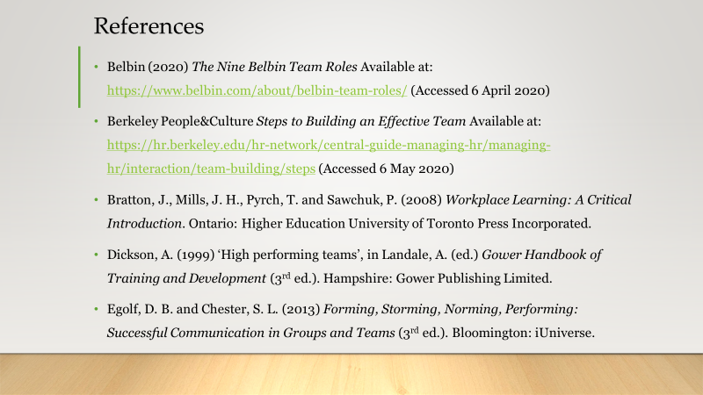

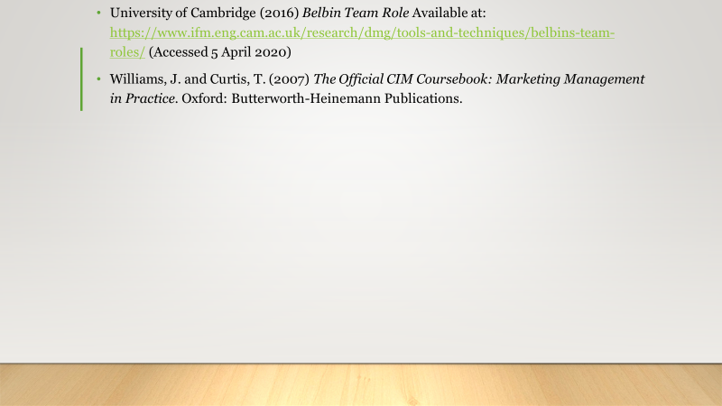
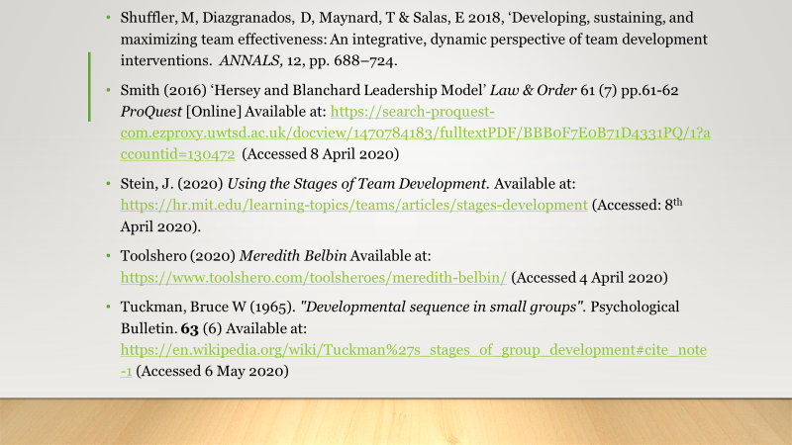

Appendices

Model of situational leadership from Hersey and Blanchard. This theory is for individuals who have the maturity to led and for individuals who have been working as Team Leader before. Maturity is very important to find the right leadership style. On the table below will be showed for each leadership style the Task and Relationship Behaviours according their importance.

^{HIGH}  SUPPORTIVE RELATIONSHIP BEHAVIOUR  ^{LOW} | PARTICIPATING  SUPPORTING  CONSULTING | SELLING  COACHING  ADVISING
^{HIGH}  SUPPORTIVE RELATIONSHIP BEHAVIOUR  ^{LOW} | DELEGATING  EMPOWERING | TELLING  DIRECTING  INSTRUCTING/ TRAINING
LOW HIGH
TASK (DIRECTIVE/GUIDANCE) BEHAVIOR
Table made by the author

