The Chronicle of Richard I (1192)
Richard of Devizes
Time was pressing King Richard to start his pilgrimage, for he who had been the first of all the princes on this side of the Alps to take the Cross did not want to be the last to set out. The king was indeed worthy of the name of king, for in the very first year of his reign, for Christ’s sake he left the realm of England almost as if he were going away and would not return. So great was this man’s devotion and thus quickly, thus speedily and hastily he ran or, rather, flew to avenge Christ’s injuries Although he had more important matters on his mind, he took thought for the realm, and, since the supreme pontiff had given him power of releasing from the Cross and of his subjects he wanted to, in order to govern the affairs of the realm, he wisely, as many men thought, made Hugh of Le Puiset, bishop of Durham, chief justiciar over all the kingdom After he had thus made a new earl of Northumbria out of an old bishop and had given him custody of as any castles as he wanted, he diligently extracted 10,000 pounds of silver from the bishop’s chests.

Raphael Holinshed, The Chronicles of England, Scotland and Ireland 1577
At length king Richard by force of sicknesse (increased with anguish of his incurable wound) departed this life, on the tuesdaie before Palmesundaie, being the ninth of Aprill, and the xj. daie after he was hurt, in the yeare after the birth of our Sauiour 1199. in the 44 yeare of his age, and after he had reigned nine yeares, nine moneths, and od .daies: he left no issue behind him. He was tall of stature, and well proportioned, faire and comelie of face, so as in his countenance appeared much fauour and grauitie, of haire bright aborne, as it were betwixt red and yellow, with long armes, and nimble in all his ioints his thighes and legs were of due proportion, and answerable to the other parts of his bodie.
As he was comelie of personage, so was he of stomach more couragious and fierce, so that not without cause, he obteined the surname of Cueur de lion, that is to saie, The lions hart. Moreouer he was courteous to his souldiors, and towards his fréends and strangers that resorted vnto him verie liberall, but to his enimies hard and not to be intreated, desirous of battell, an enimie to rest and quietnesse, verie eloquent of speech and wise, but readie to enter into ieopardies, and that without feare or forecast in time of greatest perils.
.These were his vertuous qualities, but his vices (if his vertues, his age, and the wars which he mainteined were throughlie weied) were either none at all, or else few in number, and not verie notorious. He was noted of the common people to be partlie subiect vnto pride, which surelie for the most part foloweth stoutnesse of mind: of incontinencie, to the which his youth might happilie be somewhat bent: and of couetousnesse, into the which infamie most captieins and such princes as commonlie follow the warres doo oftentimes fall, when of the necessitie they are driuen to exact monie, as well of fréends as enimies, to mainteine the infinit charges of their wars.
John Foxe Acts and monuments 1563
¶ King Ihon.
AFter the death of Kyng Richard called cure de Lyon, reigned his brother Ihon Earle of Moreton. Afterward the Archbishop put the crowne on his head, and sware him to defēd the church, and to maintayne the same and hir good lawes, and to destroy the euill. And except he though not in his minde to do this, the archbishop charged him, not to presume to take on him this dignity. And on S. Iohn Baptistes day next followyng, Kyng Ihon sayled into Normandy and came to Roane: where he was royally receiued, & truce cōcluded betwen him & the French king for a time. And thether came to him the Erle of Flaunders, & all other Lordes of Fraunce that were of Kyng Richards band and frendship, and were sworne vnto him.
…
The yeare folowyng, Historiographers write þ^{t} Kyng Ihon for lacke of reschue, loste all hys holdes and possessiōs in Normandy, through þ^{e} force of the Frēchking.
After these losses, came other troubles vpon him: with other as great or more greater enemies (that is with the pope & his popelings) by occasion of chusing of the archbishop of Cāterbury, as in hystory followeth by Christe his grace, to be declared.
…
Vpon this occasion, kyng Iohn conceyued an exceedyng displeasure against the cleargye, and monkes of Canterburye (as he had good cause) they doing so many euils against his princely prerogatiue. Without hys lycence thei elected their archbishop, and put by the bishop of Norwiche whome he had appointed. They wasted a great part of his treasure for the warres: and to bryng al to the Deuil, they made Stephan Langton their high metroplitane, whome he tooke for a greuous enemy vnto the whole realme, beyng always so familiar with the French kyng. Wherfore in hys anger he banished them out of the land, to the number of 64. for this their contumacie and contempt of his regall power.
…
And in the selfe same yere, as kyng Iohn was come to Swinestead Abbey, not farre from Lincolne: he rested there two dayes: where as moste writers testifie, he was most traiterouslye poysoned by a monke of þ^{e} abbey, of þ^{e} sect of þ^{e} Cicistercians or S. Bernards brethrē called Simō of Swinsted. As cōcerning þ^{e} noble personage of this prince: this witnes geueth Roger Houeden therin: princeps quidem magnus erat sed minus felix: atque vt Marius vtramque fortunam expertus. Doubtles (saith he) kyng Iohn was a mighty prince, but not so fortunate as many were. Not altogether vnlike to Marius the noble Romaine: he tasted of fortune both wayes: bountiful in mercy: in warres sometyme he wanne, sometyme againe he lost.Munificus ac liberalis in exteros fuit, sed proditionis causa suorum depredator, plus aduenis quam suis confidēs. He was also verye bounteous and liberall vnto straungers but of hys owne people (for theyr dailye treasons sake) he was a great oppressour, so that he trusted more to foreiners thē to them.

Seal of King John
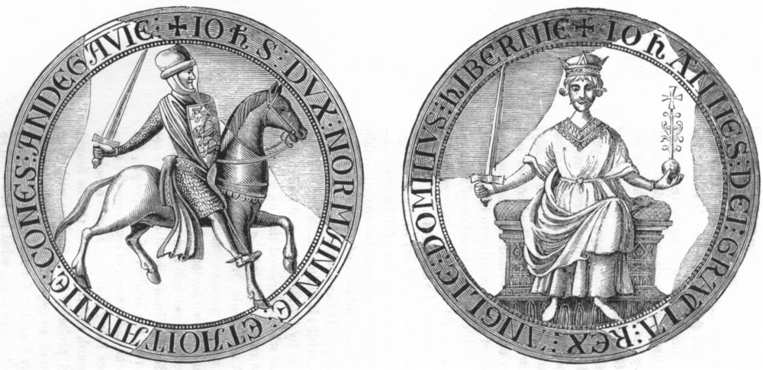
Seal of Richard I


