Hotel Placement Research Project

Impacts of staff shortage on service quality at Holiday Inn.

BMIH6008

Syeda Shafna Begum
2128508
Ben Ka Po Chong

Executive summary
This research project aimed to understand the influence of staff shortage on the service quality of Holiday Inn. In the project, it has been stated that the current literature goes over the challenges, issues and their impacts on service quality from An industry point of view, but it lacks research on a specific level that this project addresses. A wide range of strategically chosen methodologies including qualitative data, secondary collection technique, deductive approach, case study strategy and content analysis has been utilised. It has been stated that the research showed staff shortage at Holiday Inn creates overall operational inefficacy due to employee burnout and turnover which also led to inconsistency of quality and customer dissatisfaction. The situation affected the make value and reputation of the company. It has been also stated that the company is actively integrating coping strategies such as the streamlining process, training employees and so on which are proving to be effective as employee turnover has decreased and customer retention has increased. Despite that, the project has stated a few recommendations including the implication of a guest feedback system, sustainability practices and so on to ensure service quality and improve the overall performance of the company.

Table of Contents
Chapter 1: Introduction 1
1.1 Introduction 1
1.2 Research background 1
1.3 Research aim 1
1.4 Research objectives 1
1.5 Research questions 1
1.6 Company overview 2
1.7 Summary 2
Chapter 2: Literature Review 3
2.1 Introduction 3
2.2 Review of literature 3
2.3 Literature gap 6
2.4 Summary 7
Chapter 3: Methods 8
3.1 Introduction 8
3.2 Research approach 8
3.3 Research strategy 8
3.4 Research method 9
3.5 Data Collection Technique 9
3.6 Data analysis 9
3.7 Ethical considerations 9
3.8 Summary 9
Chapter 4: Case Study Hotel Overview and Findings 10
4.1 Introduction 10
4.2 Overview of Holiday Inn case study 10
4.3 SWOT analysis 11
4.4 PEST analysis 13
4.5 Competitor analysis 15
4.6 Summary 16
Chapter 5: Discussion 17
5.1 Introduction 17
5.2 Discussion 17
5.3 Summary 20
Chapter 6: Conclusion and Recommendations 22
6.1 Introduction 22
6.2 Conclusion 22
6.3 Recommendations and practical strategies 22
6.4 Summary 24
Chapter 7: Reference List 25

Chapter 1: Introduction

1.1 Introduction
The topic of the research is the Impacts of staff shortage on service quality at Holiday Inn. To get started, in this chapter of the research project, the aim, objective and questions of the research will be specified. Furthermore, the background about employee shortage will also be discussed along with a brief company overview discussion about the placement organisation and the issue it is facing.

1.2 Research background
Employees or staff are the core element of an organisation as they are the ones responsible for fulfilling the activities of a company (Arthur, 2020). Due to the potential influence of employees, a company goes through a comprehensive process of selection, hiring and training which is resource-intensive. Shortage of staff on the other hand can severely limit the capabilities of a company to operate effectively (Melissen and Sauer, 2019). One of those companies that is currently facing this issue is Holiday Inn, specifically the Sunderland branch. This is affecting the performance, market value and profitability of the company. This research will allow to understand the key challenges that the company faces, the impacts of those challenges, the mitigation strategies used by the company and their effectiveness (Smith et al., 2021). So, this research will not only be for Holiday Inn Sunderland but also for other companies facing similar issues in the hospitality industry of the UK.

1.3 Research aim
The research aims to analyse the impact of staff shortage on service quality at Holiday Inn.

1.4 Research objectives
The objectives of the research are:
- To identify the key operational challenges caused by Staff shortage at Holiday Inn Hotel.
- To analyse the impacts of the operational challenges on service quality at Holiday Inn Hotel.
- To analyse the coping strategies used by Holiday Inn hotels to reduce the impacts of Staff shortage.

1.5 Research questions
The questions that will be addressed via the research are:
- What are the key operational challenges caused by staff shortages at Holiday Inn Hotel?
- How do these operational challenges impact service quality at Holiday Inn Hotel?
- What coping strategies does Holiday Inn Hotel use to reduce the impacts of staff shortages?
- How effective are these coping strategies in maintaining service quality at Holiday Inn Hotel?

1.6 Company overview
Holiday Inn is a hotel chain based in Atlanta founded in 1952 via Kemmons Wilson. The company belongs to IHG Hotels & Resorts parent company (aedifion.com, 2024).

Figure 1: Holiday Inn.
Source: (Holiday Inn, 2025).
The journey at Holiday Inn started with Wilson taking a road trip to Washington, D.C. and being disappointed by the quality of motels there. After that, he established his first four hotels currently the company has hotels in over 1,100 different locations. The company operates in 100 different countries offering quality experience to customers (Holiday Inn, 2025). It has been operating with great profitability over the years, however, it has only 10,000 employees which indicates an issue of employee shortage (ivypanda.com, 2025).

1.7 Summary
To summarise, Holiday Inn is not one of the top hotel chains internationally. With an operational experience of over 70 years, the company sustained its profitability. However, a shortage of staff can be considered a problem in the company. That is why the research will highlight the issue they are facing, its effect on its customers and the effectiveness of the mitigation strategies used by the company which will not only be for Holiday Inn but also similar companies in the hospitality industry of the UK.

Chapter 2: Literature Review

2.1 Introduction
A literature review is a process of going over and analysing existing literature in order to find relevant information on the chosen topic (Booth et al., 2021). It can be an effective way of gathering information for research, however, it can be time-consuming. In this chapter, an extensive review of existing literature and the implication of possible theoretical frameworks will be done in the context of research objectives and questions. Furthermore, after the review discussion about the literature gap will also be done.

2.2 Review of literature

Key operational challenges caused by staff shortages in the hospitality industry
Employees or staff are the core assets of any organisation, the reason being a company invests in the employees as they fulfil different responsibilities that keep an organisation operational. That is why Morosan and Bowen (2022), stated that ensuring an adequate quantity of employees with relevant skills is the key to operational sustainability. However, many companies in the hospitality industry of the UK are facing the issue of staff shortage (Kaushal and Srivastava, 2020). It is the phenomenon of an organisation not having an adequate level of employees. According to the survey by Thams et al. (2020), of 100 different organisations of the industry in Sunderland around 35% of them face the issue of staff shortage.
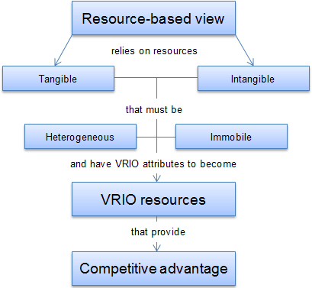
Figure 1: Resource-Based View Framework.
Source: (El Nemar et al., 2022).
The RBV framework states that skilled and appropriate levels of staff are tangible assets to a company which allows it to ensure sustainable performance and gain a competitive advantage in the market (Morosan and Bowen, 2022). However, if a company suffers from a shortage of staff it can lead to different operational challenges such as increased workload on the exiting employees leading to low satisfaction, longer response time affecting customer experience negatively, high turnover rates and employee burnout which can reduce the overall performance of the company. According to Kaushal and Srivastava (2020), the issue of staff shortage can reduce the overall operational efficiency of a company by up to 40%.

The impact of operational challenges on service quality in the hospitality industry
The hospitality industry of the UK is one of the biggest and most contributing to the GDP. According to the research of Kokkranikal, Calinaud and Baum (2024), the hospitality industry of the UK is currently valued at over £93 billion. The valuation of the industry depends on the performance of the companies in it. However, the performance of those companies is decreasing as customers are getting increasingly dissatisfied due to the loss of service quality over the years.
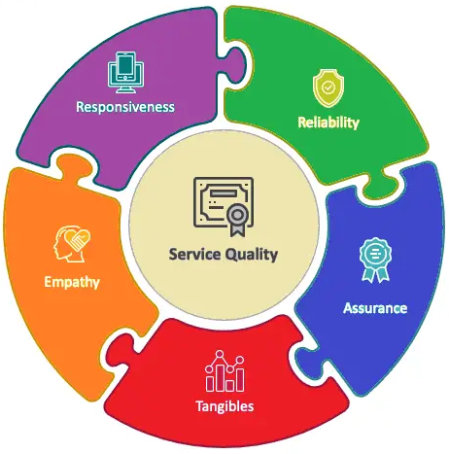
Figure 2: Service Quality (SERVQUAL) Framework.
Source: (Berry, 1988).
According to the Service Quality (SERVQUAL) framework, the quality of service depends on 5 different factors which are reliability, assurance, responsiveness, empathy and tangibles. Research by Ali et al. (2021), stated that the operational challenges can slow down the delivery of service, increase customer dissatisfaction, lead to high amounts of complaints, inconsistency of delivery across shits and create errors. This violates factors of the framework which include reliability, assurance, responsiveness and empathy. Indicating that the operational challenges faced by the companies in the hospitality industry of the UK lead to poor service quality. This decreases customer retention and the performance of a company leading to profitability degradation and a reduction of the overall contribution of the national GDP (Chiang and Trimi, 2020).

Strategies used in the hospitality industry to reduce the impacts of staff shortages
The negative influence or impacts of operational challenges created via staff shortage is clearly visible in the service quality of companies operating in the hospitality industry of the UK. According to Kwok (2022), poor service quality leads to many issues such as reduced brand value, customer retention, engagement and profitability. Such influences not only impact the organisations within the industry but also the overall economy. That is why many organisations within the industry have implicated different strategies to cope with the issue of staff shortage. They seem to utilise situational leadership there which is referred to as adapting to the situation by changing approaches (Rodriguez-Anton and Alonso-Almeida, 2020). So, based on the situation that the company is in using tactics or strategies such as offering facilities overtime, and bonuses depending on the contribution of employees. Many companies also develop and implement training programs for employees which address their overall competency. According to the research by Liu-Lastres, Wen and Huang (2022), companies such as Bloc Hotels, Snoozbox, Umi Hotels and so on have been able to mitigate the issue of staff shortage via the implication of these strategies. These coping strategies address the needs and wants of exiting employees creating satisfaction to improve retention. Furthermore, it also encourages new employees and top talents to join the companies leading to the mitigation of staff shortage issues.

Effectiveness of the implicated strategies in maintaining service quality in the hospitality industry
The issue of staff shortage is huge and it creates many operational challenges and problems with service quality (Greetham, 2014). The primary factors that create those issues via exiting employees are motivation loss. An employee with low motivation will not be able to operate and fulfil their responsibilities effectively. So, Sanabria-Diaz, Aguiar-Quintana and Araujo-Cabrera (2021), stated that employee motivation can lead to effective enhancement of the service quality of the hospitality industry of the UK. The reason is, that a highly motivated individual will be able to operate more effectively leading to the enhancement of service quality.
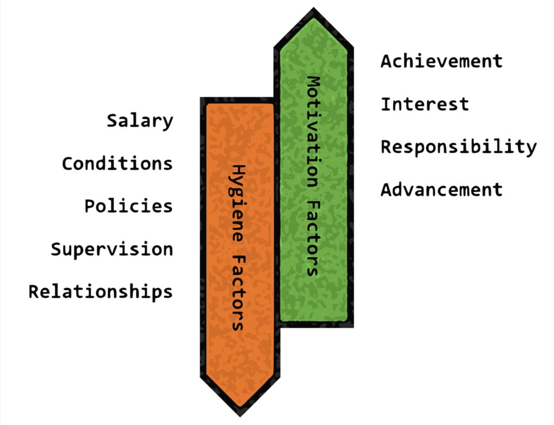
Figure 3: Herzberg’s Two Factor Theory.
Source: (Herzberg, 1964).
The Two Factor Theory of Herzberg showed that there are two different factors to employee motivation which are hygiene factors and motivational factors (Cottrel, 2014). Hygiene factors include salary, conditions, policies, supervision and so on that do not offer additional motivation but ensure no motivation loss. On the other hand, motivation factors such as requests, interest, achievement and so on can make employees more engaged. So, motivated employees will be able to execute activities with greater efficiency and accuracy indicating the effectiveness of the initiatives that are implicated by companies in the hospitality industry of the UK. Research by Diplacido (2022), shows employee motivation can lead to 20%-30% operational efficiency which can effectively improve service quality.

2.3 Literature gap
There is a lot of literature available on the subject of staff shortage in organisations operating in the hospitality industry of the UK. They effectively discuss different challenges in the operational context faced by organising in the hospitality industry due to staff shortage (McGiven, 2006). It also identifies all the impacts including the possible impacts of those challenges that can have on the service quality of the company. On top of that, different strategies used by companies in the hospitality industry of the UK and their effectiveness are also accurately specified. However, all of the information that is presented and analysed is based on a wider context (Richter et al., 2020). There is a lack of studies on a specified organisation or location which can have different influences on companies, their challenges and implicated strategies (Ghani et al., 2022). Furthermore, there is limited research done on the long-term impact of staff shortage on service quality on the companies in the industry. This creates a research or literature gap which this particular research will address.

2.4 Summary
In summary, there is plenty of industry-centric literature available on the topic of staff shortage's influence on service quality. It has been found through the review that staff shortage creates challenges such as increased workload, longer response time, employee burnout and so on. Those challenges can lead to slower service delivery, reduced guest dissatisfaction and many other negative factors on the quality of service. The strategies that current companies in the hospitality industry use such as offering bonuses and training have been proven to be highly effective in mitigating the issue of staff shortage. However, the is a gap that persists in the current literature regarding limited studies on a specific organisation or location and limited research on the long-term impact of the issue.

Chapter 3: Methods

3.1 Introduction
The term methodology refers to the system of methods that are used to complete a particular study (Cottrell, 2014). Selecting the right methods can inflate the quality and possibility of success of a research project. In this chapter, all of the selected methods including the approach, strategy, data type, collection technique, analysis method and others will be critically evaluated.

Figure 1: Research Onion.
Source: (Saunders, Lewis and Thornhill, 2012).

3.2 Research approach
The research approach is the general plan or process of conducting research for which the deductive research approach has been utilised. It allowed the utilisation of hypotheses or theories regulating staff shortage and service quality and ensured a structured study (Collis and Hussey, 2014). Due to its ability to enhance quality and relevancy, encouraged to use it over the inductive approach. However, it creates limitations in terms of theoretical implications the amount of information portrayed may be limited.

3.3 Research strategy
There are a variety of strategies which can be used for research about certain scenarios, however, for this research project, the case study research strategy has been used. It is a method that includes analysis of specified individuals, groups, events, industries or organisations with a real-life context from multiple sources (Yin, 2003). The use of a case study research approach allowed for gaining deep insights, rich and relevant data and real-world context. On the other hand, it can sometimes limit generalisability and create bias in the study (Robson, 2016).

3.4 Research method
A mono method has been utilised for this reach from qualitative, quantitative and mixed available methods. Qualitative methods have been used to collect non-numerical data such as text, images, videos and audio (Marshall, 2015). A wide range of routes such as books, journals, articles, reports and so on has been used to obtain data. The use of this method and a wide range of resources allowed to gain a huge quantity of data with minimum strain on the resources.

3.5 Data Collection Technique
The data collection technique that has been used to collect the required data for this research is the secondary data collection method. This method allows to utilise the existing literature or contributions of the author to collect data relevant to staff shortage and its impact on service quality (Denscombe, 2010). The use of this method along with netnography, the method of using the internet to collect data from databases such as Google Scholar which allowed the research to be executed cost-effectively. However, it made the data collection process time-consuming creating a risk of failing to complete the research within the specified timeline (Bryman, 2008).

3.6 Data analysis
The method that has been used to analyse all the collected data is content analysis. Content analysis refers to a systematic method which uses themes, words and concepts in qualitative data to fulfil research objectives (Grbich, 2006). This method is known to be cost-effective, structured and able to generate historical insights. However, it is also a very time-intensive method and creates subjectivity as well as bias (Diamantopoulos and Schlegelmilch, 2002).

3.7 Ethical considerations
Ethics has been prioritised during the research ensuring no human, animal or trees are harmed during the research. The collected data were secured with limited assets to only the researchers ensuring adherence to data protection law. However, issues with managing and accessing all the information were witnessed which was mitigated by using secured cloud systems (Silverman, 2011).

3.8 Summary
In summary, the carefully selected methods for the research allow to ensure a balance of quality and cost-effectiveness. The use of a deductive approach, case study strategy, qualitative data, secondary collection method and content analysis allowed to gain accurate and relevant results however it was time-consuming due to certain activities.

Chapter 4: Case Study Hotel Overview and Findings

4.1 Introduction
The hospitality industry of the UK which is currently valued at over £90 billion (Ntounis et al., 2024). According to the research of Ali et al. (2024), there are currently over 9,800 hotels in the UK actively serving guests. It has been found via research that each year over 30 million people use accommodation services from some sort of hotel (Statista, 2021). However, over the years the number of hotels has decreased due to loss of profitability as a decrease of 0.9% can be seen compared to 2022. The primary cause is the organisation in the hospitality industry of the UK is facing the issue of staff shortage (Pallant, 2010). Holiday Inn being one of such hotels will be discussed in depth in this chapter in the context of the issue. Furthermore, SWOT, PEST and Competition analysis will also be done to provide a critical overview of the company and its situation.

4.2 Overview of Holiday Inn case study

Company overview
As there are over 9,800 there are only a few hotels that are top of the industry, one of those hotels is Holiday Inn (Ali et al., 2024). Holiday Inn is a chain of hotels based in Atlanta, Georgia it is owned by the parent company IHG Hotels & Resorts. The company was founded in the year 1952 via Kemmons Wilson. It currently operates in over 1,173 locations in around 100 different countries of the world making it an international business (Holiday Inn, 2025). The company has hotels in many different major nations including the UK. Especially Sunderland which is a port city creating thousands of footsteps of new individuals from overseas. The Holiday Inn Hotel Sunderland creates a statement of comfort homely feel and modern ambitions ensuring high customer satisfaction and retention over the years (Zhang et al., 2020). The establishment has been situated in such a location that makes it an ideal choice for leisure as well as business travellers. It offers high-quality services with a modern touch that not only satisfies the customers but also attracts new customers.

Figure 1: Holiday Inn.
Source: (Holiday Inn, 2025).

Descriptive information
Holiday Inn has been operating effectively for over 74 years now ensuring excellent service with greater profitability. The company’s average annual turnover is considered to be from £2 to £3 million which reflects the capabilities and financial stability of the company (Bi et al., 2022). The current client base of the company is very strong as they have a good market reputation, valuation and retention levels. Specifically, the establishment at Sunderland is booked for corporate events, parties and also individual booking. A total of a little over 10,000 employees currently work at Holiday Inn and only 60 staff at the outlet in Sunderland (Holiday Inn, 2025). The management, housekeeping, front desk personnel, food service staff and so on are all included in the 60 staff. This indicates that not only the hotel of Sunderland but also the entire Holiday Inn company is suffering from employee shortages. However, the employees are motivated to ensure a high standard of service quality and operational efficiency (Veal, 2006).

4.3 SWOT analysis
The issue of staff shortage is not something that can be taken lightly as recent literature has indicated that it not only affects the overall profitability of a company but also negatively affects the entire economy (Cottrell, 2011). However, the current literature lacks specified information on a company or location. That is why to understand the impacts of employee shortage it is crucial to first understand the capabilities of the chosen company (States, 2020). That is why the SWOT framework has been selected to analyse the influence of internal factors on Holiday Inn. SWOT is a framework that allows to identify the strengths, weaknesses, opportunities and threats. Implications of the framework are given below.
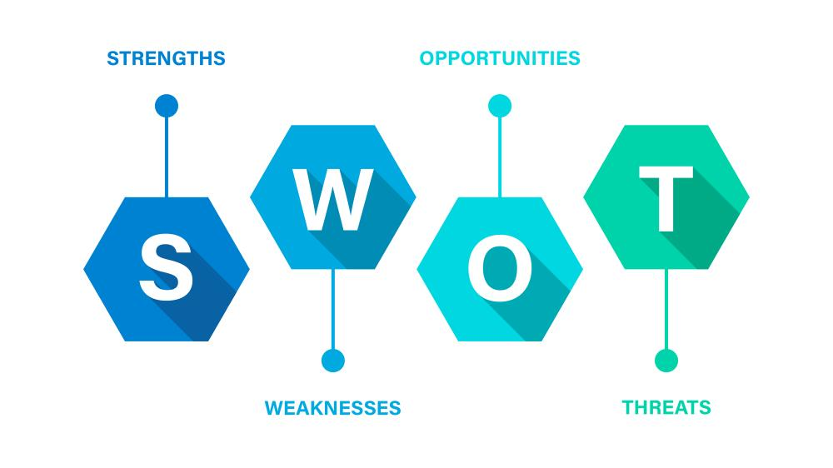
Figure 2: SWOT Framework.
Source: (Vanek, 2022).

Strengths
Holiday Inn has been operating for over 70 years now so they have adequate experience, knowledge and understanding of the market which allows it to overcome many threats and grasp opportunities effectively (Permata Putri, Liauw and Mutiara, 2021). Over the years, the company has ensured excellent customer service and unpetalled quality which has allowed it to gain a high brand presence which can also be considered one of its strengths. The company has segmented its offering into different categories from economic to luxury which ensures something for everyone allowing it to grasp more customers (Hussain et al., 2023). The presence of the company in over 100 countries creates a high reputation as an international brand and establishes brand value in the market (Holiday Inn, 2025). Holiday Inn is actively implicating many coping strategies such as training, enhancement of the hiring process, rewarding and so on to ensure employee attraction as well as retention.

Weaknesses
There are undeniably many strengths of Holiday Inn, but there are some weaknesses as well. The primary weakness of Holiday Inn is increased competition which is offering accommodation services for cheaper prices which is affecting the possible sales of the company. The company is heavily dependent on the local economy as an economic downshift can affect the purchasing power of customers leading to a sales and profitability fall for the company (Mahan and Nelms, 2020). However, the major weakness of the company is the shortage of staff. The company is heavily understaffed compared to its scale as it only has around 10,000 staff (Holiday Inn, 2025). This is affecting the overall operational capabilities as well as service quality. That is why in recent years, the company has faced negative reviews.

Opportunities
Over the years due to the shift of consumer preference changes the trend in the hospitality industry has also changed. This created many opportunities for Holiday Inn one of which is the possible use of sustainable practices such as bio-degradable material, renewable energy sources, waste management and so on which can lead to company valuation growth and higher customer retention (Ozen et al., 2024). Over the years, the unemployment rate in the UK has increased by 1.4% which can be an opportunity for the company as it will be able to gain new employees with minimum effort and resources (Mayhew and Anand, 2020). The company can also partner up with local establishments and businesses to promote their business and ensure better awareness as well as sales.

Threats
The hospitality industry of the UK is considered to be one of the highly sustaining industries with no sudden change (Zhang et al., 2020). However, the company Holiday Inn faces the threat of consumer preference changes which can render the offerings and activities taken by the company useless creating financial losses. There are currently over 9,800 hotel activities operating in the UK and the number of hotels is slowly but steadily rising (Li, Yao and Chen, 2021). This is a threat to the company as the competition is rising each year making more threats such as loss of customer base.

4.4 PEST analysis
Holiday Inn is one of the major hotel chains in the UK operating for over 70 years. The company has been able to develop its assets and resources over the years, however different external environmental factors still have influence over the company (Hossain, Kannan and Raman Nair, 2020). This can also be related to the core issues of staff shortage that the company is facing. So, to understand the causes of its influence on the company, an external environmental analysis is done below with the help of the PEST framework (Perera, 2021). This particular framework goes over 4 different environmental factors including political, economic, social and technological.
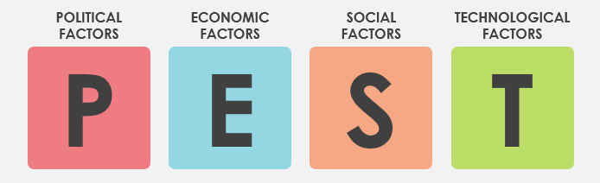
Figure 3: PEST Framework.
Source: (Roy and Chowdhury, 2021).

Political
The government of the UK has initiated various policies in favour of companies in the hospitality industry which makes obtaining investment and attracting investors easy and effective. The reason is, that this industry contributes a lot to the overall economy. So, Holiday Inn also gets to gain more investment faster allowing it to take necessary measures to fulfil goals (Wszendybyl and Panasiuk, 2024). The government of the UK is very strict about its labour law regarding employment and the working class. The government ensures policies of offering fair wages, extra facilities, bonuses, a safe working environment and so on for the employees (Holiday Inn, 2025). Making sure of all those requirements can be sometimes difficult for Holiday Inn which can lead to a shortage of employees.

Economic
The UK is considered to have one of the strongest economies which can be proven by the positive growth rate of its economy. This indicates the individual incomes of people are also rising allowing them to enhance their purchasing power (Khan, 2023). This means Holiday Inn has more chances to have reservations now compared to other years. On the other hand, the rate of unemployment has greatly lowered over the years, which can be positive from an economic point of view (Statista, 2024). However, from the point of view of Holiday Inn, it has made the activity of hiring competent and skilled employees harder. This can also be one of the causes of employee shortage for the company.

Social
The lifestyle of the people in the UK and around the globe is changing rapidly especially after COVID-19 were people had to stay at their homes and avoided travelling to places. Now, more people each year are travelling to different places including the UK (Bi et al., 2020). This has greatly increased the chances for Holiday Inn to ensure full reservation of their accommodation services around the globe and gain greater profitability. On the contrary, another cause of staff shortage at Holiday Inn can be the change of career attitude of individuals (Ali et al., 2021). Similar to consumer preference, the preference of employees regarding careers is changing as well, as they now want to be a part of a desk job which is comfortable. This is making it harder for Holiday Inn to find competent employees for their establishment.

Technological
One of the factors that was revolutionised the most over the years is the technological environment of the UK. Over the years more and more useful and beneficial technology has been developed which can be interesting in the operation of Holiday Inn. This will allow the business to ensure greater customer service quality while mitigating possible operational issues (Ghani et al., 2022). This can help the business to gain better performance sustainability, market position and even competitive advantage.

4.5 Competitor analysis
Holiday Inn is one of the major hotel chains in the globe it has been operating in the UK for several decades now. However, the company has to face competitors from various brands within the industry which includes Hampton Inn, Fairfield Inn, Comfort Inn, La Quinta Inn & Suites, Premier Inn and Travelodge (Guerra-Montenegro et al., 2021). A perceptual map portraying the market position of each of those companies is given below.
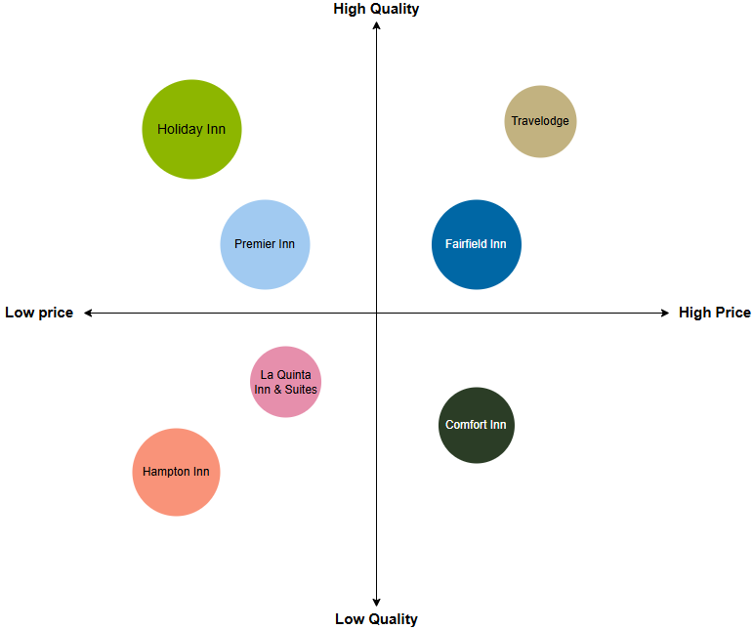
Figure 4: Perceptual map.
Source: Own.
The company Holiday Inn uses a value-centric approach via which they offer the highest possible quality services at the lowest possible price (Holiday Inn, 2025). They include a modern touch; comfortable stay and excellent services make Holiday Inn a default choice for the travellers. However, the company Premier Inn has a similar value-centric approach making it a direct competitor of Holiday Inn. However, the quality and price of Premier Inn are not similar to Holiday Inn making the company fall behind (Melissen and Sauer, 2019). There are other companies such as Travelodge and Fairfield Inn that use a luxury pricing strategy offering high-quality services for a premium price creating a royal impression for the customers. The service price at Holiday Inn may be low, but the quality of those services is similar to the top luxury companies such as Travelodge (Wszendybyl and Panasiuk, 2024). Other companies such as Hampton Inn and La Quinta Inn & Suites have an economic approach of offering low-quality services at a low price which is suitable for individuals with specific needs. On the other hand, the company Comfort Inn is losing market position as they are trying to sell low-quality services to customers at a higher price.

4.6 Summary
To summarise, Holiday Inn has been operating for over 70 years and in that period of time, the company has been able to develop a good market reputation, brand value and customer base ensuring quality and comfort. These attributes of the company now act as its strengths along with the value-centric approaches that set it apart from competitors such as Premier Inn, Hampton Inn and so on, making it the obvious choice for customers. The company has many weaknesses however the primary weakness is staff shortage which can be related to strict labour laws, reduced unemployment rates and changes in career attitudes. Although the company faces the threat of high market competition due to the increasing number of competitors it has the opportunity to attract new customers, obtain required investments more easily and have possible more occupancy for accommodation leading to greater profitability.

Chapter 5: Discussion

5.1 Introduction
Business operation is the concept of creating value for the customers can gaining value in return. However, unlike the definition operating a business is not simple as the inclusion and management of different elements make it difficult (Christiansen and Branch, 2022). A business has to effectively manage all of its assets, most importantly employees to ensure effective performance as well as growth. However, if a company faces issues with employee or staff shortage it not only affects the operational capabilities of the business but also the quality of their service leading to profitability losses (Butler, 2020). So, in this chapter, the literature review and findings will be discussed aligning with the research aim, objectives and questions to understand the impact of staff shortage on the service quality of Holiday Inn.

5.2 Discussion

What are the key operational challenges caused by staff shortages at Holiday Inn Hotel?
As mentioned earlier, business operation is a complex subject but it is more complicated to operate a hotel business in the hospitality industry of the UK due to its need of employees. Employees are the primary asset and element of a business. In the case of Holiday Inn, employees directly engage with the customers to fulfil their needs and requests which indicates that the operational performance of the company depends on the employees of the company (David, Joshua and Peggy, 2021). However, the research showed that Holiday Inn has only 10,000 which indicates a shortage of staff in the company. The issue of labour shortage can create many different issues, however, the issues regarding operation such as operational challenges are most concerning. The literature review showed that staff shortage can drive a company to increase the workload on the exiting employees which can lead to increased response times for the customers (Walker, 2021). Such a situation can lead to employee burnout and high employee turnover making the operational execution of the company inefficient. The findings about Holiday Inn also showed that the company is facing issues or challenges with operational efficiency. This indicates that the company is facing several challenges which are causing operational delays in the company. The primary operational challenge that Holiday Inn is facing is decreased morale of the employees leading to productivity losses (Holiday Inn, 2025). Due to being understaffed, the exiting employees at Holiday Inn have to work longer hours which is affecting their job satisfaction and reduces productivity so the operation of Holiday Inn is now more resource intensive. There are peak times in the day when the company has to manage a lot of customers at the same time, for being understaffed especially the Sunderland with only 60 staff, the establishment struggles to keep the management pace and ensure smooth check-ins (John, 2022). The overall rate of turnover has also increased in the company which can be considered as a cause of staff shortage all of which is negatively affecting the overall operational efficiency of the company.

How do these operational challenges impact service quality at Holiday Inn Hotel?
The value that a company offers to a customer can be divided into two parts products and services. Comparatively offering maintained quality of service is more difficult than maintaining the quality of a product due to its dynamic nature (Malik et al., 2023). Ensuring high quality of service is mandatory for companies, especially in the hospitality industry of the UK where the satisfaction of the customers depends on the experience they have with a company. The Service Quality framework indicates that there are five factors to service quality which include responsiveness, reliability, assurance, empathy and tangibles. However, the existing literature indicates that the issue of operational challenges due to staff shortage creates degradation of service quality of companies in the hospitality industry which has also been identified for the company Holiday Inn through the findings (Mouzaek et al., 2021). Exiting literature showed that operational challenges can effectively lower the efficiency of service delivery making the customer wait for a while to obtain the requested service. This leads to customer dissatisfaction and they usually register companies which affects the reputation of the company as well as reduces the future possible occupancies. Furthermore, inconsistency in the level of quality across different shifts can also be seen due to operational inefficacy caused by staff shortages (Alzoubi et al., 2021). All of these do not fulfil the requirements such as responsiveness, reliability, empathy and assurance mandated by the Service Quality model indicating poor service quality. The finding also showed that Holiday Inn’s service quality has been degrading recently. The reason is, that the likelihood of operational errors has increased in the company which can lead to unexpected scenarios and create the risk of customer dissatisfaction. Due to the primary issue, Holiday Inn struggles to maintain proper cleanliness in the place which creates an unhygienic and unhealthy environment for the guests also contributing to their dissatisfaction (Chiang and Trimi, 2020). The increased pressure on the existing staff affects their performance, willingness and loyalty affecting reliability, responsiveness, assurance and empathy negatively which indicates a degradation of service quality via the Service Quality framework.

What coping strategies does Holiday Inn Hotel use to reduce the impacts of staff shortages?
The issue of staff shortage undoubtedly affects the service quality of companies leading to customer base loss and dissatisfaction which can also have a negative impact on the overall profitability of the company. With the help of existing literature, it has been found that the industry has become aware of the impacts that staff shortage has on service quality which is why different coping strategies are being implicated by different companies (Winter, Schreyogg and Thiel, 2020). One of those strategies is offering bonuses as well as overtime facilities to the employees, it allows the employees to earn more for their hard work which contributes to improving their job satisfaction leading to improved willingness to work efficiently and performance assurance. Existing literature also shows that companies create and implement comprehensive training programs which identify and address the skill and knowledge gap of the employee. This is done to enhance the overall competency of the employees which can lead to improved efficiency and performance of employees leading to faster service delivery and improvement of service quality (Griffiths et al., 2021). Research shows that Holiday Inn is also actively implicating certain strategies to mitigate issues related to staff shortages. The company offers rewards to the employees based on their dedication and hard work which motivates them to work more effectively. The company also offer training facilities to its employees which is not only beneficial for the company in this hard time but also for the employees themselves improving chances of retention. On top of that, Holiday Inn has been enhancing its hiring and recruitment process by making it more streamlined yet accurate allowing the business to hire the most suitable candidates without straining the resources (Holiday Inn, 2025). There are other strategic implications which can be seen in Holiday Inn as well including technological integration, rescheduling of shifts and fostering a positive work environment. These mitigation strategies address the key issues that the company is suffering from that negatively affect the quality of service at the establishment. The succession, sustainability and growth of the company depend heavily on these coping strategies (Hofmeyer, Taylor and Kennedy, 2020).

How effective are these coping strategies in maintaining service quality at Holiday Inn Hotel?
The issue of staff shortage is increasing in the hospitality industry of the UK, which is why many organisations are incorporating different coping strategies addressing each of the issues they are facing. The success or failure of those organisations heavily depends on the effectiveness of the mitigation strategies that are being implicated in the industry (Murphy, 2020). With the help of a literature review, it was found that the majority of the coping strategies target the motivation level of the employees. Motivation is the concept of the willingness that an individual or employee has to fulfil their duties. So, the more motivated an employee is, they will be able to perform that better (Wu, Wang and Ling, 2021). The hospitality industry of the UK uses achievement, interest, responsibility and rewards to motivate employees which can be considered effective as proven by Herzberg’s Two Factory theory which states that motivational factors such as rewards, responsibilities, interests and so on motivate employees (Herzberg, 1964). Meaning, that the implementation of these strategies can effectively improve the performance and willingness of employees leading to operational effectiveness and efficiency growth thus improving service quality. According to the findings, the company Holiday Inn also implicates certain coping strategies to reduce the negative impacts of operational challenges created due to staff shortage. Those strategies not only address the level of employee motivation but also their level of job satisfaction as well. Improvement of employee motivation addresses the performance and productivity issues of the company which could lead to delays in addressing customer needs, inconsistency in shifts and so on (Nikolskaya et al., 2020). On top of that, addressing the level of employee satisfaction allows Holiday Inn to keep the employees in the company, prevent them from leaving and effortlessly attract new employees which addresses the issue of staff shortage as well. The company has been able to improve the employability rates and reduce the employee turnover rates. Furthermore, the satisfaction of customers has increased over the years well as all of which indicates the improvement of service quality at Holiday Inn.

5.3 Summary
In summary, despite years of experience operating in the hospitality industry of the UK, Holiday Inn is currently facing the issue of staff shortage. Research indicates that his issue is affecting more than half of the organisations in the industry creating operational challenges which impact the service quality negatively. This has also been the case for Holiday Inn, as the company is facing inefficacy in operation due to employee burnout, high turnover rates and so on leading to degradation of service quality and customer dissatisfaction. However, similarly to other companies in the industry, Holiday Inn is actively incorporating coping strategies including training, streamlining the recruitment process and so on which not only affect employee motivation but also job satisfaction. Theoretical framework and recent data show that the issue of staff shortage and all the related issues are decreasing for the company, proving the effectiveness of the implemented strategies.

Chapter 6: Conclusion and Recommendations

6.1 Introduction
Holiday Inn has been operating for over 70 years now, still, currently they are still facing the issue of staff shortage after COVID-19 and Brexit (Holiday Inn, 2025). Though the company is actively implementing different coping strategies, there are certain other strategic initiatives that they can take for further improvement of the company. Some recommendations for further improvement and a conclusion of the research report are discussed below.

6.2 Conclusion
To conclude, the issue of staff shortage is rising each year which leads to operational challenges and loss of service quality. There is current literature supporting the claim and portraying different challenges such as employee burnout, efficiency loss and so on faced by companies in the hospitality industry of the UK and it leads to service quality loss due to longer response time, inconsistency and so on. However, companies use different mitigation strategies as well which address the motivation of employees leading to effective performance growth. However, the literature gaps any specific insights of companies or locations which makes it not acceptable universally. With the help of qualitative data collected via secondary data collection methods from a variety of different sources and analysed by content data analysis technique, allowed to gained insight into the challenges, issues and higher impact of service quality on a specific organisation of the industry called Holiday Inn. The research showed that Holiday Inn has been actively operating for over a century now however it has a major staff shortage issue, especially at the Sunderland location. This led to different operational challenges such as high employee turnover, loss of productivity, inconsistency in level of service and so on which has been affecting the overall quality of service of the company. However, Holiday Inn has implemented different mitigation strategies such as offering employee training, streamlining the hiring process and offering bonuses which have allowed them to reduce the level of employee turnover and improve talent attraction indicating their effectiveness in ensuring service quality. However, the company should implement strategies such as customer feedback, technological advancement and so on to further enhance the performance of the company.

6.3 Recommendations and practical strategies
Strategic practices are the activities that are created and implicated with logical reasoning in mind often time addressing different issues faced by a company (Chan, Gao and McGinley, 2021). The selected company Holiday Inn is struggling to be consistent with the quality of service as they are facing different challenges and issues. To mitigate those challenges and issues, and to improve the overall performance of the company few recommendations are given below.
Implicate guest feedback system: Ensuring quality of service is crucial for any business, especially for businesses in the hospitality industry where service is provided to the customers. Holiday Inn is facing issues with service quality indicating customer dissatisfaction. So, the company should offer customers the facility of writing or giving feedback to the company on how their experience was staying at the hotel and what could have been better (Narayan et al., 2022). This critical information can help Holiday Inn to identify any possible issues they have and address them leading to the overall improvement of the service quality and performance of the company.
Technological integration: Over the years technological development has been significant around the globe via the innovation of different machinery and new technologies. The innovations made for the hospitality industry are also revolutionary. So, Holiday Inn should implicate technological enhancement in booking, check-in and out, and inventory management. Doing so will allow the company to ensure a unique customer experience reflecting on its commitment to offering high-quality services (Dalgic and Birdir, 2020). This can also aid with ensuring consistency of service quality across shifts and mitigate the issue of service quality loss due to operational inefficiency.
Sustainable practices implication: Sustainability is a new trend and one of the essentials in the hospitality industry of the UK. Customer preference can change at any time, currently, it is shifting towards companies that are aware of the environment and society and take decisions accordingly. So, Holiday Inn should also implement sustainable practices within the organisation such as establishing eco-friendly policies, reducing the use of plastic, effective waste management and use of renewable energy (Prakash et al., 2022). This will not only improve the reputation of the company but also help it to gain and retain more customers leading to a better market position and profitability.
Focus on customer experience: Customers are the core factor of any business; this is especially the case for Holiday Inn as they offer services to the customer which ensures profitability. As the current quality of service at the company is not great indicating uneven customer experience. That is why the company should empathise more with offering a unique and excellent customer experience by tailoring the preferences of guests, offering personalisation options, offering welcome amenities and so on (Chan, Gao and McGinley, 2021). This will help the company to retain customers and attract a new customer base. It can also aid the company in attracting top talents in the industry as well.

6.4 Summary
In summary, Holiday Inn is facing service quality issues due to operational challenges caused by staff shortages. Though the company has been actively implicating effective mitigation strategies, there are some other strategic approaches which can be helpful for them. Holiday Inn should implement customer feedback facilities, make technological integrations, implement sustainable practices and so on which will not only help the company to cope with current issues but also enhance the overall performance and profitability.

Chapter 7: Reference List
aedifion.com (2024). Holiday Inn | Case Study | Success Stories | Aedifion GmbH. [online] Aedifion.com. Available at: https://www.aedifion.com/en/success-stories-en/holiday-inn [Accessed 6 Feb. 2025].
Ali, B., Ahmed, S., Gardi, B., Othman, B. and Burhan, N. (2021). Hotel Service Quality: the Impact of Service Quality on Customer Satisfaction in Hospitality Industry. International Journal of Engineering, Business and Management (IJEBM), 5(3), pp.2456–8678.
Ali, S., Peters, L.D., Khan, I.U., Ali, W. and Saif, N. (2024). Organizational Learning and Hotel Performance: The Role of Capabilities’ Hierarchy. International Journal of Hospitality Management, 85, p.102349.
Alzoubi, H.M., Vij, M., Vij, A. and Hanaysha, J.R. (2021). What Leads Guests to Satisfaction and Loyalty in Uae Five-Star Hotels? Ahp Analysis to Service Quality Dimensions. Enlightening Tourism. A Pathmaking Journal, 11(1), p.102.
Arthur, D. (2020). Recruiting, Interviewing, Selecting, and Orienting New Employees. New York: Harpercollins Leadership.
Berry, L. (1988). SERVQUAL: A Multiple-Item Scale for Measuring Consumer Perceptions of Service Quality. Journal of Retailing, 64(1), pp.12–40.
Bi, J.-W., Han, T., Yao, Y. and Li, H. (2022). Ranking Hotels through multi-dimensional Hotel information: a Method considering Travelers’ Preferences and Expectations. 24(1), pp.127–155.
Bi, J.-W., Liu, Y., Fan, Z.-P. and Zhang, J. (2020). Exploring Asymmetric Effects of Attribute Performance on Customer Satisfaction in the Hotel Industry. Tourism Management, 77, p.104006.
Booth, A., Sutton, A., Clowes, M. and James, M.M.-S. (2021). Systematic Approaches to a Successful Literature Review. SAGE.
Bryman A. (2008). Social Research Methods, 2nd Ed, Oxford University Press
Butler, D. (2020). Business Development. Routledge.
Chan, J., Gao, Y. (Lisa) and McGinley, S. (2021). Updates in Service Standards in Hotels: How COVID-19 Changed Operations. International Journal of Contemporary Hospitality Management, 33(5), pp.1668–1687.
Chiang, A.-H. and Trimi, S. (2020). Impacts of Service Initiative on Service Quality. Service Business, 14(14).
Christiansen, B. and Branch, J.D. (2022). Analyzing International Business Operations in the Post-Pandemic Era. IGI Global.
Collis, J and Hussey, R (2014). Business Research, A Practical Guide for Undergraduate and Post-Graduate Students, Palgrave, London
Cottrel, S. (2014). Dissertation and Project Reports - A Step-by-Step Guide, Palgrave Macmillan: Basingstoke.
Cottrell, S. (2011). Critical Thinking Skills: Developing Effective Analysis and Argument, Palgrave Study Guides, Palgrave Macmillan: Basingstoke
Cottrell, S. (2014). Dissertations and project reports: a step-by-step guide. New York: Pallgrave.
Dalgic, A. and Birdir, K. (2020). Smart Hotels and Technological Applications. Handbook of Research on Smart Technology Applications in the Tourism Industry.
David, K., Joshua, D. and Peggy, A. (2021). Revenue Management for the Hospitality Industry. Google Books.
Denscombe, M., (2010). Ground Rules for Social Research: Guidelines for Good Practice 2nd ed., Maidenhead: Open University Press.
Diamantopoulos, A. and Schlegelmilch, B. B. (2002). Taking the Fear Out of Data Analysis, Dryden, London
Diplacido, P. (2022). Employee Motivation. Columbus: Ohio Distributive Education Materials Lab.
El Nemar, S., El-Chaarani, H., Dandachi, I. and Castellano, S. (2022). Resource-based View and Sustainable advantage: a Framework for SMEs. Journal of Strategic Marketing, pp.1–24.
Ghani, B., Zada, M., Memon, K.R. and Ullah, R. (2022). Challenges and Strategies for Employee Retention in the Hospitality Industry: a Review. Sustainability, 14(5), pp.1–26.
Grbich, C. (2006). Qualitative Data Analysis, Sage Publications Ltd
Greetham, B. (2014). How to Write your Undergraduate Dissertation, Palgrave Macmillan, Basingstoke
Griffiths, P., Saville, C., Ball, J.E., Jones, J. and Monks, T. (2021). Beyond Ratios - Flexible and Resilient Nurse Staffing Options to Deliver cost-effective Hospital Care and Address Staff shortages: a Simulation and Economic Modelling Study. International Journal of Nursing Studies, 117(117), p.103901.
Guerra-Montenegro, J., Sanchez-Medina, J., Lana, I. and Sanchez, D. (2021). Computational Intelligence in the Hospitality Industry: a Systematic Literature Review and a Prospect of Challenges. Applied Soft Computing, 102, p.107082.
Herzberg, F. (1964). The motivation-hygiene Concept and Problems of manpower. psycnet.apa.org.
Hofmeyer, A., Taylor, R. and Kennedy, K. (2020). Fostering Compassion and Reducing burnout: How Can Health System Leaders Respond in the Covid-19 Pandemic and beyond? Nurse Education Today, 94(104502), p.104502.
Holiday Inn (2025). Holiday Inn® Hotels | Book Family Friendly Hotels Worldwide | Official Site. [online] IHG. Available at: https://www.ihg.com/holidayinn/hotels/us/en/reservation.
Hossain, M.S., Kannan, S.N. and Raman Nair, S.K.K. (2020). Factors Influencing Sustainable Competitive Advantage in the Hospitality Industry. Journal of Quality Assurance in Hospitality & Tourism, 22(6), pp.1–32.
Hussain, K., Shi, H., Javed, M. and Junaid, M. (2023). The Psychological Facets of Consumer-brand Relationship in the Digital World. Frontiers Media SA.
ivypanda.com (2025). Holiday Inn Hotels Organizational Development - 2870 Words | Case Study Example. [online] Free Essays. Available at: https://ivypanda.com/essays/holiday-inn-hotels-organizational-development/.
John, R.W. (2022). Exploring the Hospitality Industry, 2/e. Google Books.
Kaushal, V. and Srivastava, S. (2020). Hospitality and Tourism Industry amid COVID-19 Pandemic: Perspectives on Challenges and Learnings from India. International Journal of Hospitality Management, 92(1), p.102707.
Khan, E.U. (2023). The Post-Brexit Paradigm: Investigating the Effects of Foreign Direct Investment on Economic Growth in the United Kingdom. Zenodo (CERN European Organization for Nuclear Research), 2(1).
Kokkranikal, J., Calinaud, V. and Baum, T. (2024). Too Many Barriers to Overcome? Career Challenges of Women in the UK Hospitality Industry. International Journal of Tourism Research, 26(4).
Kwok, L. (2022). Labour shortage: A Critical Reflection and a Call for industry-academia Collaboration. International Journal of Contemporary Hospitality Management, 34(11), pp.3929–3943.
Li, Y., Yao, J. and Chen, J. (2021). The Negative Effect of Scarcity Cues on Consumer Purchase Decisions in the Hospitality Industry during the COVID-19 Pandemic. International Journal of Hospitality Management, 94, p.102815.
Liu-Lastres, B., Wen, H. and Huang, W.-J. (2022). A Reflection on the Great Resignation in the Hospitality and Tourism Industry. International Journal of Contemporary Hospitality Management, 35(1), pp.235–249.
Mahan, T. and Nelms (2020). Employer Engagement. Simon and Schuster.
Malik, S.A., Akhtar, F., Raziq, M.M. and Ahmad, M. (2023). Measuring Service Quality Perceptions of Customers in the Hotel Industry of Pakistan. Total Quality Management & Business Excellence, 31(3-4), pp.263–278.
Marshall, C. (2015). Designing Qualitative Research, 6th Ed, Sage, London.
Mayhew, K. and Anand, P. (2020). COVID-19 and the UK Labour Market. Oxford Review of Economic Policy, 36(1).
McGiven, Y. (2006). The Practice of Market and Social Research, an Introduction, Prentice Hall, Harlow
Melissen, F. and Sauer, L. (2019). Improving Sustainability in the Hospitality Industry. Abingdon, Oxon: Routledge.
Morosan, C. and Bowen, J.T. (2022). Labour Shortage Solution: Redefining Hospitality through Digitization. International Journal of Contemporary Hospitality Management, 34(12).
Mouzaek, E., Marzouqi, A.A., Alaali, N., Salloum, S.A., Aburayya, A. and Suson, R. (2021). An Empirical Investigation of the Impact of Service Quality Dimensions on Guest Satisfaction: a Case Study of Dubai Hotels. The Journal of Contemporary Issues in Business and Government, 27(3), pp.1186–1199.
Murphy, D.J. (2020). Increasing Employee Motivation: a Guide for Supervisors. Round Rock, TX: Professional Training Associates.
Narayan, R., Gehlot, A., Singh, R., Akram, S.V., Priyadarshi, N. and Twala, B. (2022). Hospitality Feedback System 4.0: Digitalization of Feedback System with Integration of Industry 4.0 Enabling Technologies. Sustainability, 14(19), p.12158.
Nikolskaya, E.Y., Lepeshkin, V.A., Kulgachev, I.P., Matveev, A.A. and Llebedeva, O.Y. (2020). Perfection of Quality Management of Hotel Services. Journal of Environmental Management and Tourism, 11(2), p.417.
Ntounis, N., Parker, C., Skinner, H., Steadman, C. and Warnaby, G. (2024). Tourism and Hospitality Industry Resilience during the COVID-19 pandemic: Evidence from England. Current Issues in Tourism, 25(1), pp.1–14.
Ozen, E., Singh, A., Taneja, S. and Rajaram, R. (2024). Sustainability, Innovation, and Consumer Preference. IGI Global.
Pallant, J. (2010). SPSS Survival Manual, Oxford University Press, Buckingham
Perera, R. (2021). The PESTLE Analysis. 2nd ed. Sri Lanka: Nerdynaut.
Permata Putri, A., Liauw, F. and Mutiara, M.W. (2021). The Application of Corporate Image in the Design of the Holiday Inn Express Pluit Citygate Hotel Lobby. Advances in social science, education and humanities research.
Prakash, S., Sharma, V.P., Singh, R. and Vijayvargy, L. (2022). Adopting Green and Sustainable Practices in the Hotel Industry operations- an Analysis of Critical Performance Indicators for Improved Environmental Quality. Management of Environmental Quality: an International Journal, 34(4).
Richter, O., Kerres, M., Bedenlier, S. and Bond, M. (2020). Systematic Reviews in Educational Research Methodology, Perspectives and Application.
Robson, C. (2016). Real World Research, 2nd Ed, Blackwell: Oxford
Rodriguez-Anton, J.M. and Alonso-Almeida, M. del M. (2020). COVID-19 Impacts and Recovery strategies: the Case of the Hospitality Industry in Spain. Sustainability, 12(20), p.8599.
Roy, M. and Chowdhury, S. (2021). Ecotourism and Hospitality: the Application of PESTEL Analysis and Determining the Internal Factors. Tourism Products and Services, pp.181–215.
Sanabria-Diaz, J.M., Aguiar-Quintana, T. and Araujo-Cabrera, Y. (2021). Public Strategies to Rescue the Hospitality Industry following the Impact of Covid-19: a Case Study of the European Union. International Journal of Hospitality Management, 97, p.102988.
Saunders, M., Lewis, P. and Thornhill, A. (2012). Research Methods for Business Students, FT/Prentice Hall: Harlow
Silverman, D. (2011). Qualitative Research Methods, 2nd Ed, Sage: London
Smith, R., Snow, P., Serry, T. and Hammond, L. (2021). The Role of Background Knowledge in Reading Comprehension: a Critical Review. Reading Psychology, 42(3), pp.214–240.
States, U. (2020). SWOT Analysis: a Tool for Making Better Business decisions. Washington, D.C.: U.S. Dept. of Agriculture, Risk Management Agency.
Statista (2021). Hotels Market - Number of Users in the United Kingdom in 2023 | Statista. Statista.
Statista (2024). Unemployment Rate 2023 | Statista. [online] Statista. Available at: https://www.statista.com/statistics/279898/unemployment-rate-in-the-united-kingdom-uk/.
Thams, A., Zech, N., Rempel, D. and Ayia-Koi, A. (2020). An Initial Assessment of Economic Impacts and Operational Challenges for the Tourism & Hospitality Industry Due to COVID-19. www.econstor.eu.
Vanek, M. (2022). Evaluation Methods of Swot Analysis. GeoScience Engineering, 58(2), pp.23–31.
Veal, A J (2006). Research Methods for Leisure and Tourism, 3rd Ed, Financial Times/ Prentice Hall
Walker, J.R. (2021). Introduction to Hospitality. thuvienso.hoasen.edu.vn. Pearson.
Winter, V., Schreyogg, J. and Thiel, A. (2020). Hospital Staff Shortages: Environmental and Organizational Determinants and Implications for Patient Satisfaction. Health Policy, 124(4), pp.380–388.
Wszendybyl, E. and Panasiuk, A. (2024). The Classification of Hotels in the Context of Sustainable Development Factors: a Case Study of Public Policy in the European Union and Poland. Sustainability, 16(19), p.8485.
Wu, X., Wang, J. and Ling, Q. (2021). Managing Internal Service Quality in Hotels: Determinants and Implications. Tourism Management, 86, p.104329.
Yin, R. K. (2003). Case Study Research, 4th Ed, Sage: London
Zhang, F., Xiao, Q., Law, R. and Lee, S. (2020). Mergers and Acquisitions in the Hotel industry: a Comprehensive Review. International Journal of Hospitality Management, 91, p.102418.

