Managing people

(LCBB5004)
Charles Oham

Mariya Mitreva
2011903

Assessment 2

Contents
Introduction 1
Employee engagement 1
Factors affecting employee efficiency and productivity 1
Company value and loyalty 1
Motivation 2
Self-development 3
Lack of engagement 3
Methods and tools measuring employee engagement 3
Effective communication – 360dgree feedback 3
Appraisals 4
Employee value proposition 4
Strategies and tools to increase employee engagement 5
Great management and leadership attitude performance 5
Training and development 5
Company benefits 6
Recommendation 7
Conclusion 7
References 8

Introduction
Flexible working arrangements, such as the flexibility to choose one's own working hours, the opportunity to work from home, a desire for uniform clothes, and so on, may affect employee engagement. These practises may also have a positive influence on staff performance, which contributes to a firm's success. Given the importance of this topic, particularly in light of the Covid-19 epidemic's influence on working conditions, this study explores flexible working practises and their impact on employee engagement and enjoyment in the workplace.
This study, will examine the notion of employee engagement and the factors that influence staff efficiency and productivity. It will be also assessed diagnostic techniques for measuring staff engagement. Although it will examine employees’ value proposition including methods to increase levels of engagement, as well as company benefits of staff engagement.

Employee engagement

Factors affecting employee efficiency and productivity

Company value and loyalty
Employee happiness is a critical aspect in determining a firm's productivity. Worker affective response to how an employee feels about his or her employment based on his or her experience (like or dislike). Prior research suggests that it has determinants such as self-efficacy, commitment, and support networks. It can also be linked to outcomes such as employee loyalty and organisational citizenship behaviour.
Although, Factors like as self-efficacy, engagement, and social support all have an impact on employee satisfaction. Work engagement may be classified into three types: energy, dedication, and absorption. It refers to people's good emotional attachment to their employment. Employee retention may be measured using four indicators, such as "my job inspires me." (Bhattacharya, 2015)
Moreover, employee engagement has a direct effect on employee loyalty (H1) and is a substantial and positive predictor of employee loyalty. When a person is engaged with his or her job in the organization, he or she will have a higher level of job embeddedness; nevertheless, job embeddedness is connected to employee loyalty (H2). Shahpouriet al. (2016) investigated the function of work engagement in moderating the relationship between job resources and turnover intention. They discovered that work engagement has a substantial influence on intention to turnover.

Motivation
Employees, according to Taylor, are motivated solely by money and income, and they do not love their jobs in overall. Managers can assist by decomposing each employee's behavior into small, more doable tasks. Training will be provided in a manner in which all employees do particular tasks in a consistent manner. Careers are driven to perform harder in order to earn more money, and firm growth is as efficient as it is profitable (Taylor & May, 1996).
Mayo Elton Mayo (1880-1949) argued that people should be encouraged to fulfil their society requirements while at work rather than only their earnings (which Taylor ignored). He founded the Human Connection School of Thought, which advocated for managers to be more interested in their employees, to see them as persons with vital assessments, and to recognise that employees love connecting with one another. Employee efficiency rose or remained constant regardless of improvements in lighting or working surroundings. Mayo argued that enhanced communication between managers and staff (where feedback is frequently accessible) is the most motivating factor for employees (Bruce & Nyland, 2011).
Employee motivation seems to have become a critical requirement for a firm to flourish in today's competitive market. It is the process of motivating people to perform productively in order to propel the firm forward (Taylor & Westover, 2011). According to Quratul-Ain, the incentives ideology includes Abraham Maslow's Hierarchy of Demands, which depicts the many needs of an individual by depicting the separation of demands within shape of a pyramid. In theory, the employee considers first on the necessity displayed at the bottom, which is food, shelter, and a place to live. Then he progresses to the next higher rung of the ladder if the workers' immediate demands are addressed. The need is at the pyramid's highest tier (Manzoor, 2012).
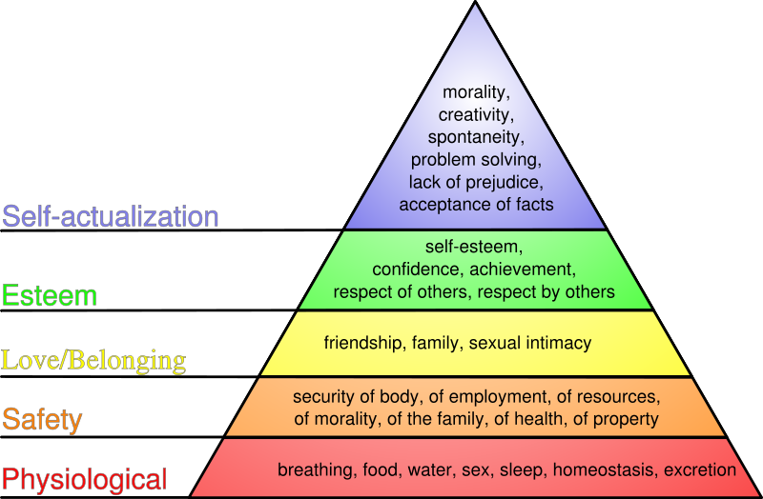
Fifure.1 Maslow Hierarchical needs

Source: Maslow, 1987

Self-development
Organizational commitment is an important positive idea since it is related with a greater care for execution results and adds to the significance that employees attribute to their employment. However, it should be noted that in some instances (e.g., a lack of sufficient assets, job excess), involvement in work could have a detrimental impact on the individual (Britt, et al., 2001). As a result, under certain conditions, most strong positive constructs have the potential for negative consequences, and it should be advised and encourage investigate the things that lead to these implications to gain a comprehensive profile of how positive mental factors at work make a contribution to adaptive behavior (Kahn, 1990).

Lack of engagement
Because engaged employees sense of personal accountability for their job performing, the results at work has good influence on their individuality. As a result, working includes caring about and being committed to achieving well. Brittet al. (2005) enhanced this method by using a political analogy to define work engagement. Similarly, our approach to job engagement emphasises individuals sense directly accountable for and concerned about the outcomes of their employee productivity (Britt, et al., 2005).

Methods and tools measuring employee engagement

Effective communication – 360dgree feedback
360-degree feedback is a comprehensive leadership development asset that capitalises on employees' understanding inside one's own sphere of influence: supervisors, coworkers, and program outcomes. This is most commonly utilised development, although it is still utilised for administrative reasons by a number of organisations. One of the most useful methods for employees to learn is to get feedback on their performance from their coworkers – employers, superiors, supervisors, and others. This practise, known as 360-degree evaluations, is also extensively used by hr leaders and in leadership programs. 360-degree assessments give multiple perspectives for assessing an individual's abilities, behaviours, ability, or outcomes, since 360-degree exams incorporate insight from new and diverse encounters, and the assessment provide a picture of the person's ability and capabilities (Fleenor & Prince, 2017).
Although, according to Carter and colleagues (2005), the reasons for implementing 360 degree feedback include self improvement, emphasising training requirements, team-building, performance assessment, implementation of strategic, and pay (Carter & Silverman, 2005). According to Lepsinger and Lucia (1997), the goals of the 360-degree feedback feedback method are to achieve company strategy, promote cultural change, nurture personal growth, enhance performance, and highlight development and recruitment needs (Lepsinger & Lucia, 1997). Rao and colleagues (2002) advocate multi-rater feedback for team building and monitoring, talent management, right placement, helping to promote identified organisational values, strategic planning, improving communications through out organisation, systems awareness and thoughts, incentive, and also as a complement to the yearly performance assessment system (Rao, et al., 2002).

Appraisals
Performance evaluation is a collaborative technique in which both the workers and employers set priorities connected to the business mission. This strategy resulted in the creation of formal modifications to standards that are frequently utilised as input and standards assessment methods (Brown, 1988).
Although, performance appraisal (PA) is critical in human resource management in enterprises. The fundamental goal of a PA in a corporation is to promote employee effectiveness. This goal might be achieved by either of three processes: (1) the data supplied by the PA would be used for executive matters connecting the analysed efficiency to organisational positive and negative reinforcement including a salary increase, promotion, or release; (2) the PA procedure includes offering valuable feedback (i.e., details concerning the standard of ability) to the employees we examined; and (3) the PA is a procedure that increases worker understanding of the fact that they might be becoming evaluated (Dobbins, et al., 1988).
Moreover, most firms make it a practise to provide employees with feedback on their performance. If done correctly, performance feedback may be a powerful source of incentive for employees. Employees want to realise how lucky they are to achieving their job tasks, thus they are interested in performance feedback. Performance appraisal should help the receiver focus on the degree of job performance, especially the precise ways for improving his or her achievement (Kluger & DeNisi, 1996).

Employee value proposition
The Employee Value Proposition refers to the perceived entire contract between a corporation and an employee (EVP). The employer makes an offer to the employee and expects the employee to repay the favour. Inducements are widely utilised to encourage professional progress, organisational support, fair and transparent performance management, and more tangible objects such as remuneration and vacation time. Contributions include working hours, being an advocate for the employer within and outside of the organisation, and bringing abilities, energy, and entrepreneurship to productive work (Black, 2009).

Strategies and tools to increase employee engagement

Great management and leadership attitude performance
Independently, the development of staff leadership traits has a significant positive impact on work-related attitudes. Executive leadership, in particular, has a significant significant effects on organizational dedication, professional fulfillment, and work happiness, whereas innovation has a significant positive impact on organisational dedication and work satisfaction (Karia & Asaari, 2019).
Furthermore, credibility, insightful personality, understanding, abilities, and knowledge to lead others, willingness to learn something new and adjust to different, recognition of atmosphere, self-sacrifice, adaptability, acceptance in sharing evaluating information when necessary are all leadership characteristics of employee’s leaders. Yang and Wei (2017) describe themselves as serious, ethical, trustworthy, and caring about others (Yang & Wei, 2017)
Also, great management leadership styles have a favourable and substantial association with organizational commitment. Although, leadership may have an influence on job happiness both directly and indirectly. Moreover, leadership can influence work happiness (Yiing & Ahmad, 2009)

Training and development
Workers will be more involved if they had been educated and promoted in a fair manner that aligned both ends' expectations. Training programs are meant to address people' desires for self-actualization, and if they think they have a chance to live a fulfilling life, they will put up their best efforts in their work performance. The significance of IT in the office demonstrates that an owner's coworker has a considerable influence on IT usage, whereas individual base aspects have relatively little influence. A well-planned training programme has a significant influence on service inaccuracy, resulting in increased customer effectiveness and employee participation. The better a person handles defects that arise throughout his task, the more successful he will be.

Company benefits
To create a stronger Employee Value Proposition (EVP), it is necessary to give a healthy corporate culture, employee engagement, and a more employee-friendly HR approach. Employee and company brand development is aided by a positive internal culture and a favourable HR strategy. Also, hiring has an effect on an employee vision statement as well. By placing the right individual in the right location at the right time. i.e. manpower planning, contribution to the organisation, and effectiveness are all improved if the employer is required to supply stronger EVP (Pawar & Charak, 2014).

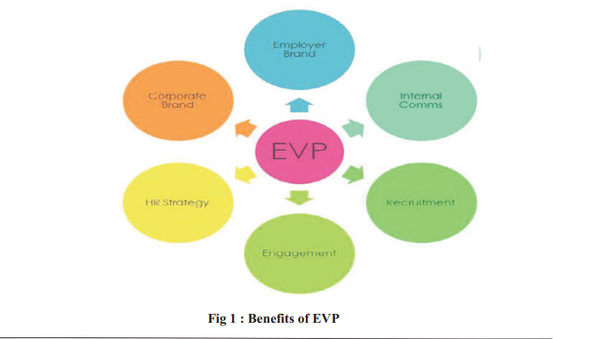
Figure 2. Benefits of Employee Value Proposition
When utilised and communicated correctly, an Employee Value Proposition (EVP) may be a powerful administrative tool. Organizations that effectively communicate their competitive overall rewards programmes via an EVP may have a significant impact on employee happiness, increasing engagement and decreasing investment in larger prizes. An EVP can also help to connect the staff with organisational productivity goals and the company's brand promise. The principal face of a corporation is its employees. They are far more likely to produce on the brand – whether it be customer service, creativity, or anything else – if they are engaged and committed to the company. A company that keeps its brand promise receives more favourable consumer feedback and has a higher degree of reputation and revenue than a company that breaks its pledges (Hiltrop, 2006).
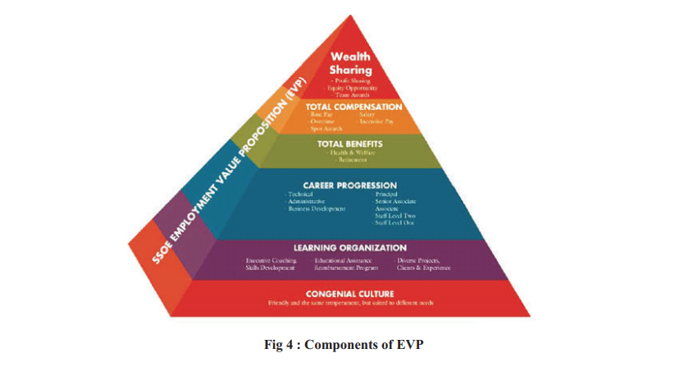
Figure. 3 Component of Employee Value Proposition
Robinson et al., 2004

Recommendation
Recruiting and retaining employees has grown increasingly challenging in today's environment. People today have more access to information and resources that can help them locate new jobs than ever before. Employees may begin to contemplate leaving their current firm after being exposed to cost-cutting efforts and layoffs, especially if a new position offered increased employment security, higher pay earnings, and a better working environment that improved work-life balance. Businesses must offer an enticing Employee Value Proposition in order to retain the best and brightest workers (EVP). Despite the fact that the concept of an EVP has been around for decades, many organisations have yet to see the importance of having a strong EVP. This might be a costly mistake, especially given the. This may be an expensive error, especially given the ongoing high demand for skill in many areas (Harter & Hayes, 2002).

Conclusion
This article looked at employee happiness as well as the elements that influence staff productivity and efficiency. Diagnostic strategies for assessing work satisfaction were also examined and evaluated. Even though business incentives are dependent on workers' value propositions, including strategies to improve engagement levels. Having review the above it can be concluded that HR play vital roles in increasing staff engagement which is connection with company benefits of this.

References

Bibliography
Bhattacharya, Y., 2015. Employee engagement as a predictor of seafarer retention: A study among indian officers. The Asian Journal of Shipping and Logistics, Volume 31, pp. 295-318.
Black, S., 2009. “The employee value proposition: How to be an employer of choice.. s.l.:INSEAD.
Britt, T. W., Castro, C. A. & Adler, A. B., 2005. ‘Self engagement, stressors, and health: A longitudinal study’. Personality and Social Psychology Bulletin, Volume 31, p. 1475–86.
Britt, T. W., Adler, A. B. & Bartone, P. T., 2001. Deriving benefits from stressful events: The role of engagement in meaningful work and hardiness’. Journal of Occupational Health Psychology, Volume 6, pp. 53-63.
Brown, R., 1988. Brown, R.D. (1988). Performance appraisal as a tool for staff development. New Directions for Student Services. San Francisco: Jossey-Bass.
Bruce, K. & Nyland, C., 2011. Elton Mayo and the Deification of Human Relations. 32(3), pp. 383-405.
Carter, A. & Silverman, M., 2005. 360 Degree Feedback:. Brighton:: Beyond the Spin.
Dobbins, G. H., Cardy, R. L. & Truxillo, D. M., 1988. The effects of purpose of appraisal and individual differences in stereotypes of women on sex differences in performance ratings: a laboratory and field study. Journal of Applied Psychology , 73(3), pp. 551-558.
Fleenor, J. W. & Prince, J., 2017. John W. Fleenor Jeffrey Michael Prince. s.l.:s.n.
Harter, J. K. & Hayes, T. L., 2002. Business-unit-level relationship between employee satisfaction, employee engagement, and business outcomes: a meta-analysis.. Journal of applied psychology, 87(2), p. 268–279.
Hiltrop, J. M., 2006. A diagnostic framework for building HR capability in organizations.. Strategic Change , 15(7/8), pp. 341-356.
Kahn, W. A., 1990. ‘Psychological conditions of personal engagement and disengagement at work’,. Academy of Management Journal, Volume 33, pp. 692-724.
Karia, N. & Asaari, M., 2019. Leadership attributes and their impact on work-related attitudes. International Journal of Productivity and Performance Management, 68(2).
Kluger, A. N. & DeNisi, A., 1996. The effects of feedback intervention on performance:a historical review, a meta-analysis and a preliminary feedback intervention theory. Psychological Bulletin, 119(2), pp. 254-284.
Lepsinger, R. & Lucia, A. D., 1997. The Art and Science of 360 Degree Feedback.. San Francisco,: Pfeiffer/ Jossey-Bass.
Manzoor, Q. A., 2012. Impact of employees motivation on organizational effectiveness. Business management and strategy,, Volume 3, pp. 1-12.
Pawar, A. & Charak, K., 2014. A Study and Review of Employee Value Proposition: A Tool of Human Resource Management. Review of reserchech, 3(6).
Rao, V. T., Mahapatra, G., Rao, R. & Chawla, N., 2002. 360 Degree Feedback.. New Delhi: Excel Books.
Taylor, A. & May, S., 1996. Threat and coping appraisal as determinants of compliance with sports injury rehabilitation: An application of protection motivation theory. Journal of sport sciences, 14(6).
Taylor, J. & Westover, J., 2011. The Effects of Public Service Motivation, Workplace Attributes and Work Relations’, Public Management Review. Job Satisfaction in the Public Service, 4(13), pp. 731-751.
Yang, Q. & Wei, H., 2017. Ethical leadership and employee task performance: examining moderated mediation process. , Management Decision, 55(7), pp. 1506-1520.
Yiing, L. H. & Ahmad, K. Z., 2009. Yiing, L.H.The moderating effects of organizational culture on the relationships between leadership behaviour and organizational commitment and betweenorganizational commitment and job satisfaction and performance. Leadership & OrganizationDevelopment Journal, 30(1), pp. 53-86.

