
problem solving report
[Document subtitle]

Zoltan Balog
(2028534)
July 8, 2022
University of Wales Trinity Saint David

Contents
0
Introduction – 2
Findings 3
Conclusion (average of 10% of word count) 4
References 4
Appendices 4

Introduction

In this report we will analyse, why Lloyd’s banking groups, including Halifax and Bank of Scotland they are closing their branches across the UK. What was the nature of the problem to make these decisions? The nature of the problem is that more people are using online banking instead of going to their branches. Bank closures directly affect people who are working for the bank. Because of this they lost their jobs. What is the scope of problems? The families of these people who lost their jobs will also be affected, including financial damage. The problem is going much further than we think. For example, the elderly people who haven’t got the skills of using the mobile bank services. Another example the small local businesses who depending on cash payments. But that's not the end the problem. The impact, much wider and deeper than we thought. The impact can change social morale, cities, and towns economy, health and wellbeing of the elderly and vulnerable people, global economy etc (Jolly, J. 2022).

Main Findings
SWOT Analysis.
SWOT analysis is a businesses strategy tools from Albert Humphrey (1960s), we can use it to evaluate Strengths, Weaknesses, Opportunities and Threats to analyse and identify the internal and external problems, that will help to recognise the positive and negative impacts of a business (Teoli, D. and An, J. 2019).
The closure of the Lloyd’s banking groups branches can be traced back to the covid-19 law that came in 2019. Due to state regulations, people did not have the opportunity to physically visit their banks. That's why people had to do banking online, which led to a 12% to 27% increase in the use of mobile applications (Maycock, S. 2022). Taking advantage of this opportunity, banks began to close their offices because there were not enough people to visit their offices. This decision prevented them from being unprofitable and diverted them in a new direction to the digital currency revolution. This is given them opportunities to alternatives solutions and support for their customers. Such as mobile banking vans, partnership agreement with the Post Office, Community bankers. However, it can be a threat to the bank by spawning new regulatory actions from the government with a carefully considered policy response (Bennett, O. 2021). Another threat to loosing stakeholders who’s choosing to use different banks.
Lloyd’s Banks - SWOT analysis
Strength: increasing the online banking customer and mobile app users | Weakness: keeping up with fast growing technology, data protection
Opportunity: invest money to open a new call centre and create new jobs | Threat: government new regulation plans, cybercrime, viruses

PESTLE Analysis.
The PESTLE framework is a tool that helps organizations see what external factors (POLITICAL, ECONOMIC, SOCIAL, TECHNOLOGICAL, LEGAL AND ENVIRONMENTAL) affect their business. This analysis can identify potential threats and vulnerabilities to companies that can also be used with the S.W.O.T Analysis framework (CIPD, 2021). With this framework we can identify any strengths, opportunities, weaknesses, and threats to an organization.
Political/Technological impact: One of the biggest Macro impacts on the banking system was from the government regulations, one of which required the closure of several banks, and the regulation was due to the covid-19 virus. Due to government regulations, people could not go to their banks, but at the same time they opened a new opportunity for banks to force people to use online banking. Another such problem has entered the banking system precisely in connection with this new possibility, the government regulation banks must improve the online banking system to make it easier and safer for people who decided to use it. They had to invest a lot of money in the Financial Technology (Fintech) to improve and develop their software system (Kagan, J. 2020).
Environmental impact: Another Macro impact on the banking sector is climate change-related developments. “More importantly, however, banking and finance has a crucial role to play in allocating capital and investment if climate change is to be addressed” (Mullan, H. 2021). To do this, banks need to respond to the consequences of climate change, which could bring changes to economy and the society. A wide range of laws and regulations relating to climate change have an impact on the banking sector. Some of these regulations can be come from the Prudential Regulatory Authority (PRA) or the Task Force on Climate-related Financial Disclosure (TCFD) (Rachmaninov, E. 2021). The extensive support and investment required to assist communities in making the transition to a sustainable future play a significant role in the financial services industry.

Decision Making Matrix
The decision matrix is a decision-making technique that evaluates and ranks choices. You must first share a set of weighted criteria before comparing each election with the list. This is an L-shaped matrix variant (Peek, S. 2021). Principles of MCDM Multicriteria Decision-Making (MCDM) techniques can be used to deconstruct complex issues into more manageable parts (Khan, S.A., Chaabane, A. and Dweiri, F.T. 2018). The MCDM process generally consists of the following steps:
Specify the overall goal ("Goal") for the decision-making process. Splitting the goal into multiple more specific, lower-level objectives that detail various aspects necessary for achieving the goal. Defining the standards by which the alternatives' success in each chosen criterion is measured. Outlining the decision options and gathering information on their attributes and performance. Developing a matrix that details how the alternatives perform against each of the chosen criteria. The actual decision-making process, which includes ranking the decision alternatives and weighting the criteria by the participating decision-makers.
BANKS CLOSURES
CRITERIA | WEIGHTING | SOLUTIONS
 |  | OPTION A | OPTION B | OPTION C | OPTION D
 |  | Mobile banking | New local call centre
INTERNAL IMPACT | 5 | 5 | 3
STAKEHOLDER INVOLVEMENT | 1 | 4 | 4
COST TO IMPLEMENT | 4 | 4 | 5
TIME TO IMPLEMENT | 3 | 3 | 2
LONG-TERM BENEFITS
SHORT-TERM BENEFITS
TOTALS |  | 54 | 45
Recommendation and Options
The reduction of carbon emissions will depend heavily on the banking and finance industries. To encourage industry toward less carbon-intensive activities and to promote sustainable energy solutions and technology, it will be essential to attract investment and allocate money. The banking and finance sector is crucial in providing funds to environmentally friendly technologies. Firms will need to collaborate, work independently, and obey government and regulatory guidelines to accomplish this (Mullan, H. 2021).
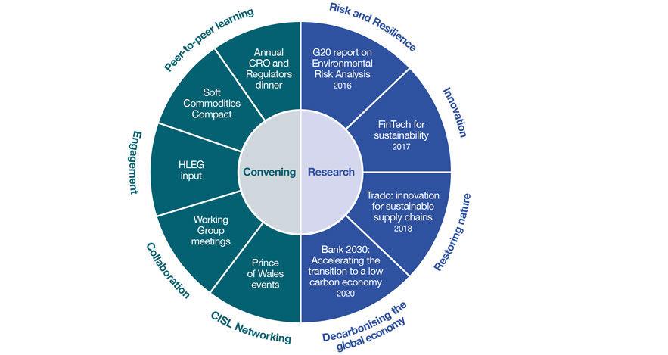

Significant amounts of funding are needed for adaptive technology, renewable energy, and plant renovation (Hutton, H. 2020). With these upgrades, carbon emissions will be reduced, atmospheric carbon will be captured and stored, and the switch away from fossil fuels will happen faster. Significant green investment prospects exist in the fields of oil and gas, energy production, real estate, automobiles, and agriculture. Banks should choose a leader who will oversee managing climate risk, implement thorough internal reporting systems, and ensure that the board can monitor risks and act quickly (Nelson, M. 2020). Prior to creating physical and conversion scenarios, they should first identify the most significant climatic problems and major risk factors by industry. Banks are under pressure to take decisive action because stakeholders demand it. The best approach is thorough planning, and a bank may do this by developing a value-focused road map that lays out a schedule customised to its situation and considers both the current physical and regulatory environment. A green strategy will enable the banks to make financial savings. Since green banking greatly reduces financial documents, invoices, and other papers, stakeholders will pay reduced utility costs and incur less expenses. Green banking can result in cost savings for the banks, but it will undoubtedly increase client convenience, benefiting both parties (Larduinat, X. 2021). Banks and financial services firms, meanwhile, might lend a hand by supplying customers with more information about how their spending habits are impacting the environment.

Monitoring, reviewing, and communicating a decision.
It is very important for banks to monitor the number of online users, as this allows them to identify their effectiveness and what additional services may need to be developed. For this to be successful, the financial service company that help them to process the incoming data traffic are needed. In connection with this, banks need to develop a secure software system, through which their services can be accessed more quickly and easily by their users. The key is that the users want to access every single service that they have been able to physically implement so far, so further development is necessary. The goal is for online banking to take over the role of the physical banking system and thereby create a new banking service. For the people to trust this service, there will be a need for skilled developers, which must be repeated on a frequent schedule. This is a new and simpler use of the modern bank, with which people can manage their accounts more conveniently and save time. The banks can benefit with lower infrastructure cost, better customer insights, large outreach, customer loyalty and competency (Technavio, 2013). To achieve this, it is necessary to establish a communication with the users, which can be done by email, newspaper, tv channel or by mail. With this, the banks must agree with the government on further solutions. Banks must adapt to a detailed set of government legislation.

Conclusion
During the reformation of the banking system, all that is evident from the fact that physical means of payment are replaced by digital ones. For this situation, however, banks must play a major role as well as pay attention to their stakeholders, government and the environmental. Of course, better methods must be implemented so that those affected feel safe. Another agreement must be concluded with the government on how to provide the stakeholders with secure access to their money and its accountability. Data protection must be improved, their systems must be made more secure, and those in charge must be assisted with new alternatives. In addition, banks must be reformed as soon as possible so that they can offer environmentally friendly options to those concerned, for example reducing paper consumption and postage, recycling end of life products and using alternative eco-friendly materials. These things have already begun, but we still have a long way to go before we can feel the qualities that it brings.

Reference list
Teoli, D. and An, J. (2019). SWOT Analysis. [online] Nih.gov. Available at: https://www.ncbi.nlm.nih.gov/books/NBK537302/.[Accessed on 20/06/2022]

Maycock, S. (2022). Which Lloyds banks are closing down? The branches affected. [online] GoodtoKnow. Available at: https://www.goodto.com/family/family-news/which-lloyds-banks-are-closing-down-657896.[Accessed on 21/06/2022]

Bennett, O. (2021). Bank branches: why are they closing and what is the impact? commonslibrary.parliament.uk, [online] CBP-9453(867-KB). Available at: https://commonslibrary.parliament.uk/research-briefings/cbp-8740/.[Accessed on 21/06/2022)

Jolly, J. (2022). Lloyds, Halifax and Bank of Scotland to shut 60 branches. [online] The Guardian. Available at: https://www.theguardian.com/business/2022/mar/23/lloyds-halifax-bank-of-scotland-shut-branches-england-wales-jobs-lost.

CIPD (2021). PESTLE Analysis. [online] CIPD. Available at: https://www.cipd.co.uk/knowledge/strategy/organisational-development/pestle-analysis-factsheet#gref.

Kagan, J. (2020). Financial Technology – FintechDefinition. [online] Investopedia. Available at: https://www.investopedia.com/terms/f/fintech.asp.

Mullan, H. (2021). Banking, climate and competition. [online] FCA Insight. Available at: https://www.fca.org.uk/insight/banking-climate-and-competition.

Rachmaninov, E., Bowater, A., Conyers, H., Parmar, R., Bruckhaus, F. and Llp, D. (2021). Climate change and the banking industry. [online] Available at: https://www.freshfields.com/4a53da/globalassets/what-we-do/sustainability/climate-change-and-the-banking-industry.pdf.

Peek, S. (2021). What Is a Decision Matrix? Definition and Examples. [online] Business News Daily. Available at: https://www.businessnewsdaily.com/6146-decision-matrix.html.

Khan, S.A., Chaabane, A. and Dweiri, F.T. (2018). Multi-Criteria Decision-Making Methods Application in Supply Chain Management: A Systematic Literature Review. [online] www.intechopen.com. IntechOpen. Available at: https://www.intechopen.com/chapters/59664.

Hutton, H. (2020). Banking Environment Initiative. [online] www.cisl.cam.ac.uk. Available at: https://www.cisl.cam.ac.uk/business-action/sustainable-finance/banking-environment-initiative.

Nelson, M. (2020). How banks lead on climate-related disclosures. [online] www.ey.com. Available at: https://www.ey.com/en_gl/assurance/how-banks-are-adopting-recommendations-on-climate-related-disclosures [Accessed 6 Jul. 2022].

Larduinat, X. (2021). Five ways to make customer banking more sustainable. [online] Thales blog. Available at: https://dis-blog.thalesgroup.com/financial-services/2021/09/15/five-ways-to-make-customer-banking%E2%80%AFmore-sustainable/.

technavio (2013). How Mobile Banking is Affecting the Banking Industry. [online] Technavio. Available at: https://blog.technavio.org/blog/how-mobile-banking-is-affecting-the-banking-industry#:~:text=Mobile%20banking%20has%20proved%20to [Accessed 6 Jul. 2022].

