Module: Introduction to Computer Systems
Module Code: ACCA4021
Assignment Title: OS Install and Setup
Student Name: Aleksandr Badger
Student ID Number: 2308404

Table of Contents
Part 1: A working Windows operating system installed on a virtual machine. 2
Part 2: A short report (approx. 1000 words) showing the driver setup for two of the interfaces (e.g. the sound card and the network card). Explain any important setup parameters and include screengrabs from the control panel>system pages. 28
Driver Setup: Network Interference Card 28
Driver Setup: Sound Card 33
Software Installation: Chrome 42
Software Installation: LibreOffice (Office Suite) 48
References 67

Part 1: A working Windows operating system installed on a virtual machine.

In this section I will be demonstrating how to install a Windows Virtual Machine using Oracle Virtual Box VM.
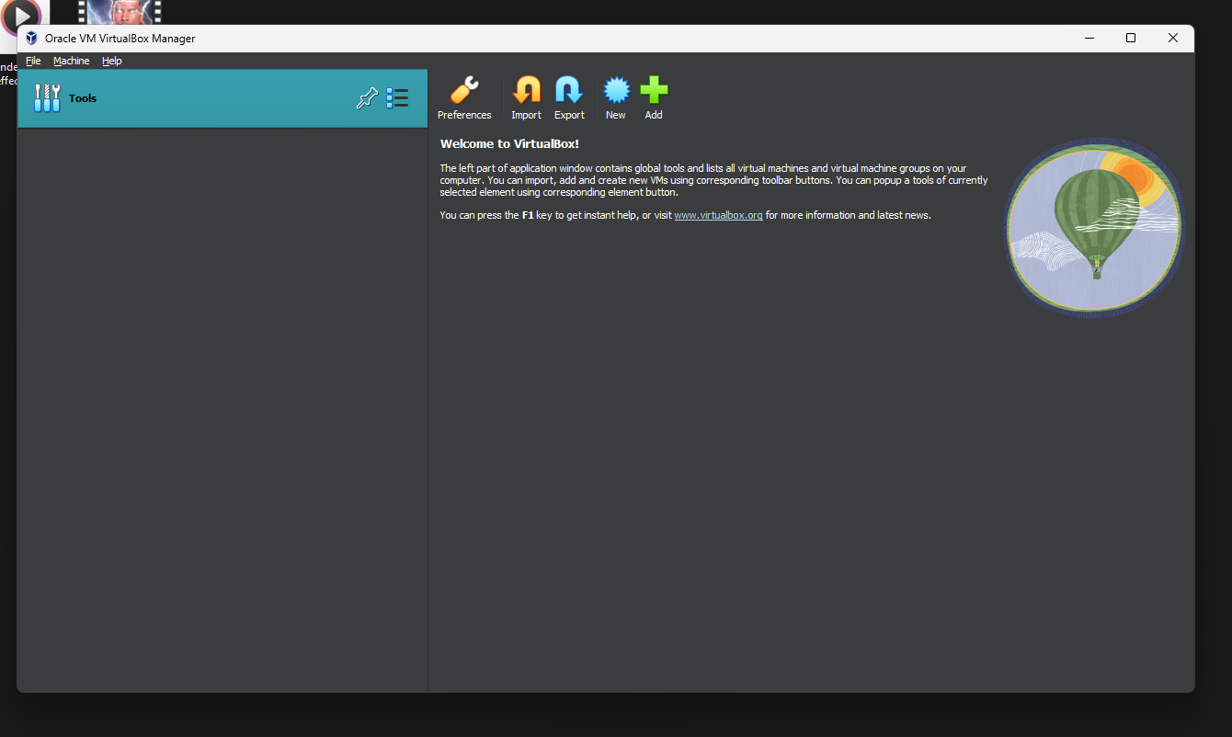
After installing Virtual Box, click “new”, which will present the screen to create a virtual machine. Before this, you will need the ISO file of the Operating System you want to use, in this case I will be using a Windows 7 ISO.
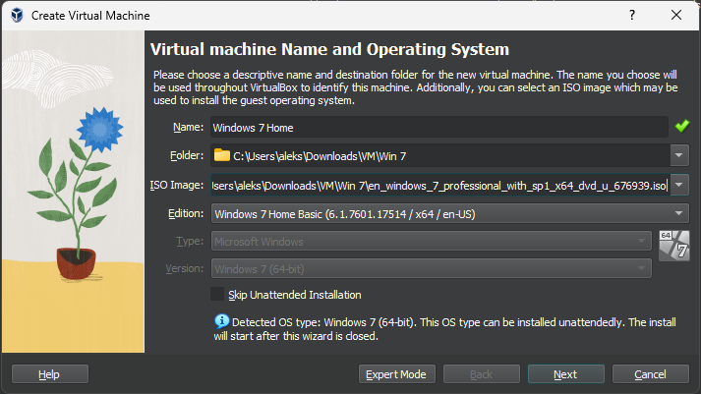
Create a suitable location for the Virtual Machine (VM), in this case I have created a folder in my Downloads Folder called VM in “C:\Users\Aleks\Downloads\VM\Win 7”.
Give your VM an appropriate name, I have called mine Windows 7 Home, which denotes the version and edition of its OS.
Make sure to store your ISO in an appropriate location too, in this case I have used the same folder to store both ISO and VM.
Click next.

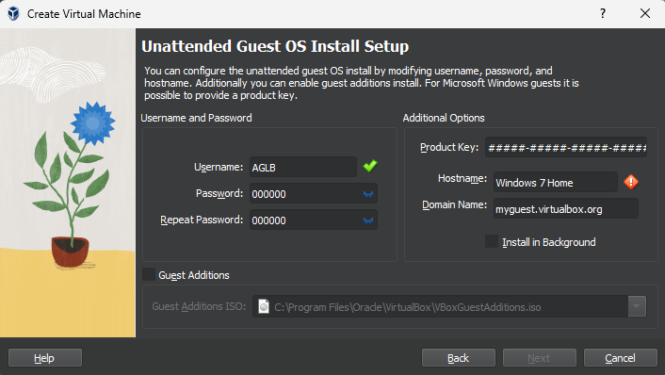
Change the username and password to something easy to remember, and ensure the Hostname is valid (no spaces allowed).
After this we can choose the amount of RAM and CPU cores, we can allocate to our VM.
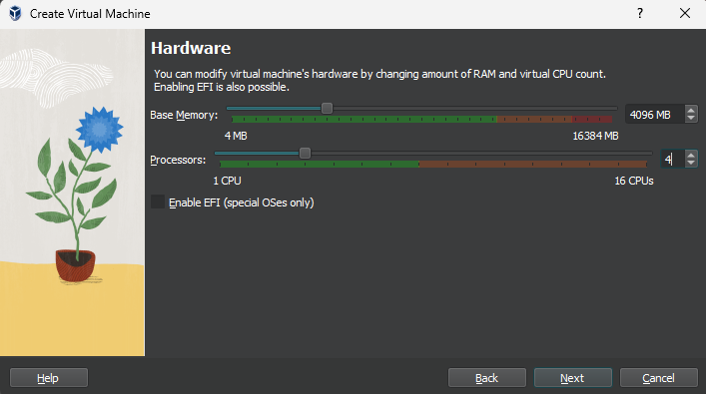
As my computer has 16gb of RAM and 8 cores, I will allocate the VM 4gb of RAM and 4 cores.
I have chosen this as Windows 7 is an older operating system and is less resource intensive, so this much will suffice. This also is well over the minimum requirements to run Windows 7, to ensure it will run smoothly [1] .
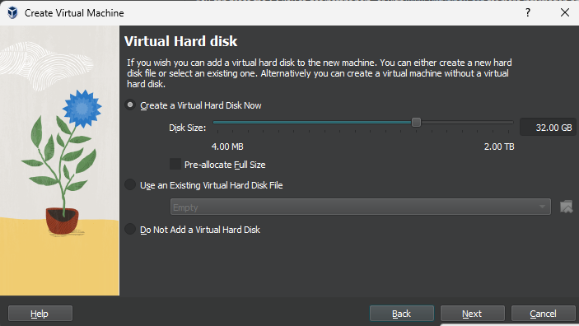
As Windows 7 requirements only dictate that 20gb of Storage is needed for the 64bit version, I will allocate 32gb of storage [1].
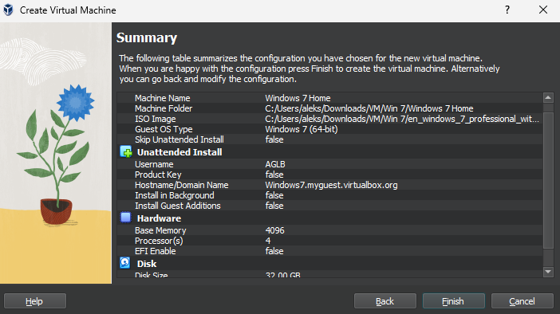
Next, the summary table will appear, where I have double checked my configuration is correct.
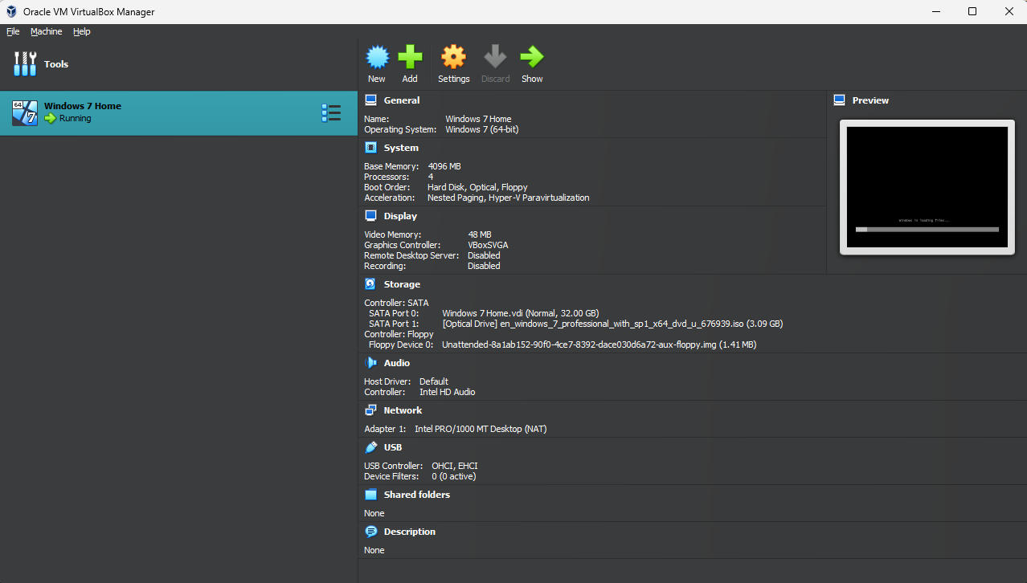
When you click finish, you will be met with a completed VM, which will need to be powered on and then go through the Windows installation.
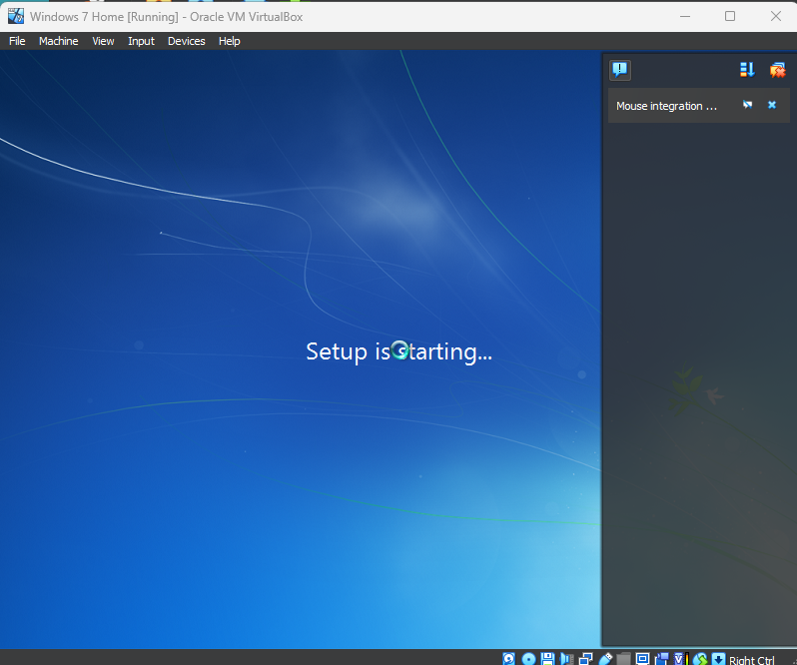
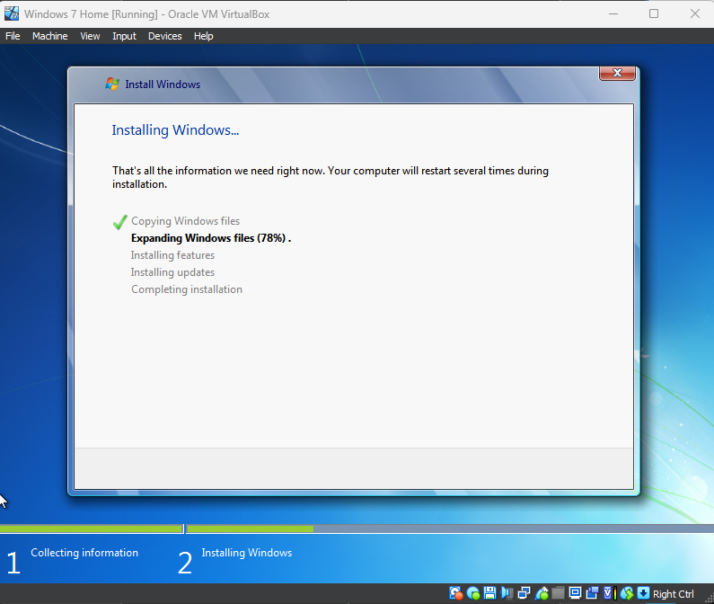
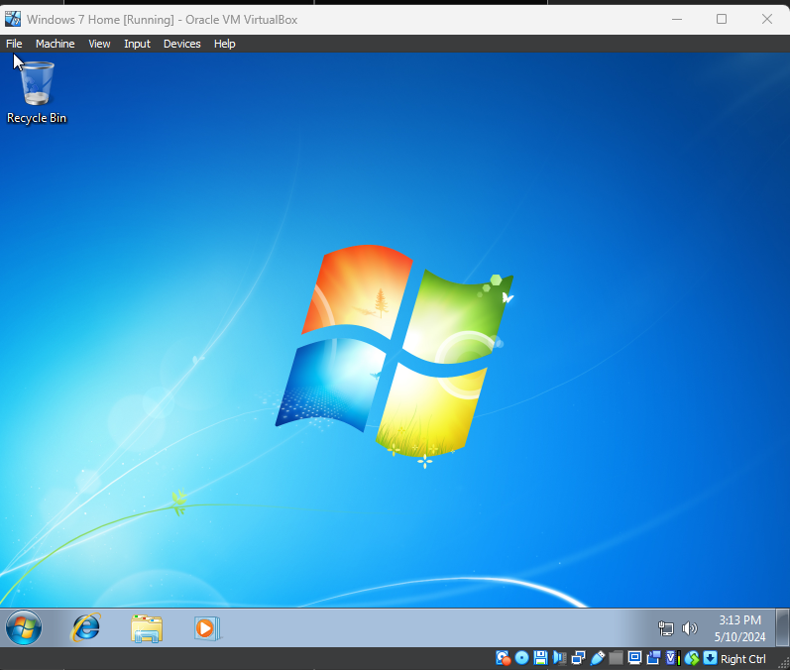After the installation is finished, you will be presented with a clean version of Windows 7, within a VM.
Even though this is a fresh install, it is best to ensure all drivers are up-to-date and working and to check the system specifications are as set.
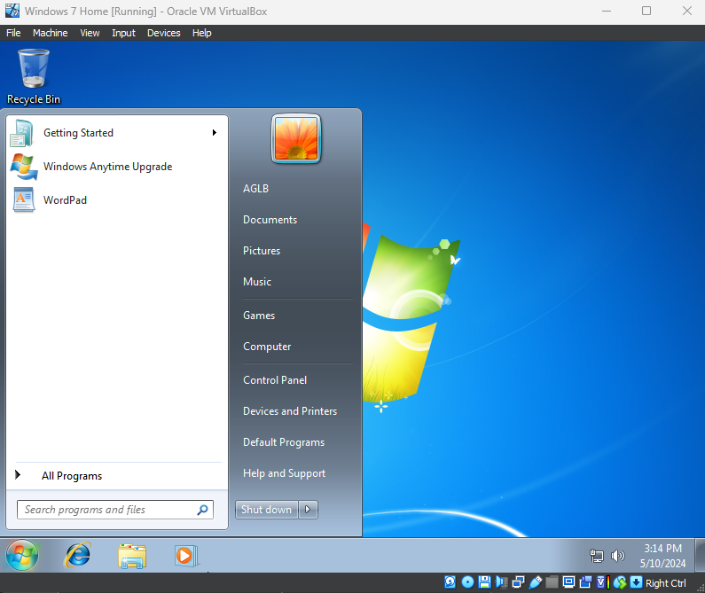
First, open up the control panel.
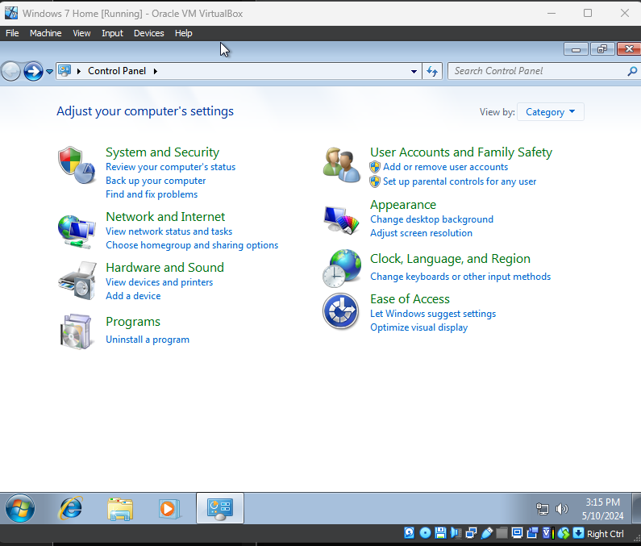Then set the view type in the top left corner to “Small Icons”, as this will display a more detailed Control Panel.
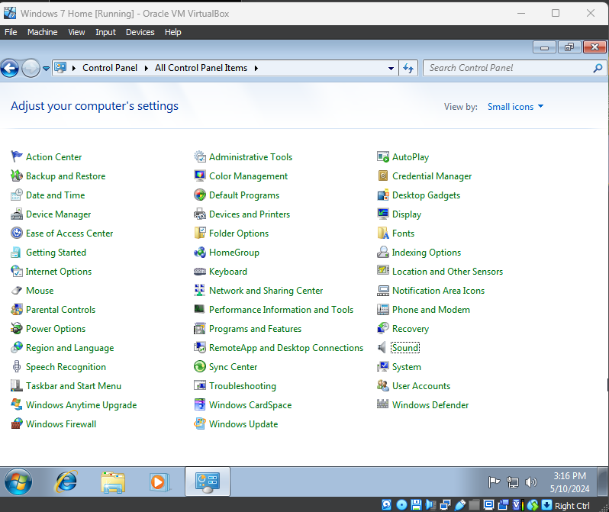
Select system.
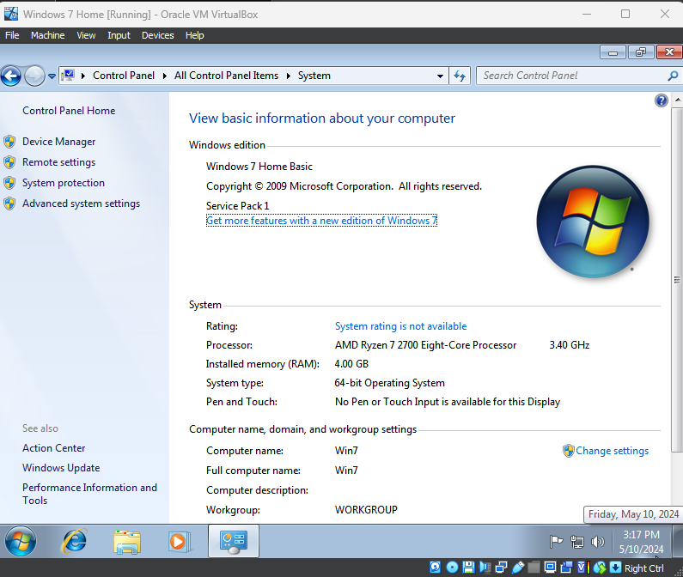
And here we can see our System Information, including our RAM, Computer Name and CPU, which we set earlier and can verify is correct.
Then click on Device Manager.
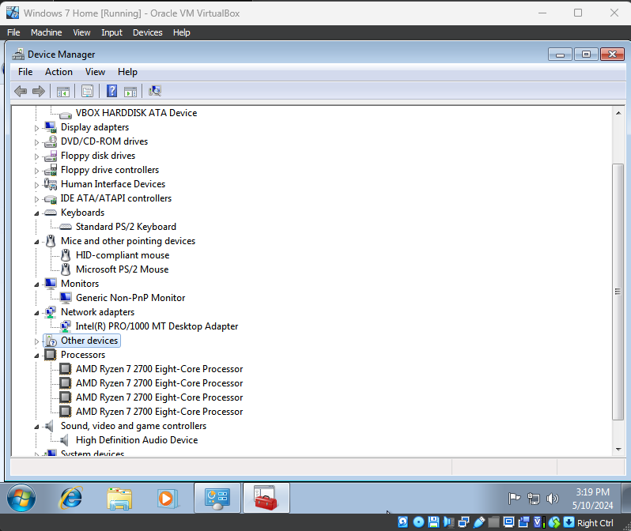
Here, we can see that all devices are working properly and as expected, including audio, video and network drivers.
Now, we will separate the storage device into two separate partitions, partition C: and partition E:.
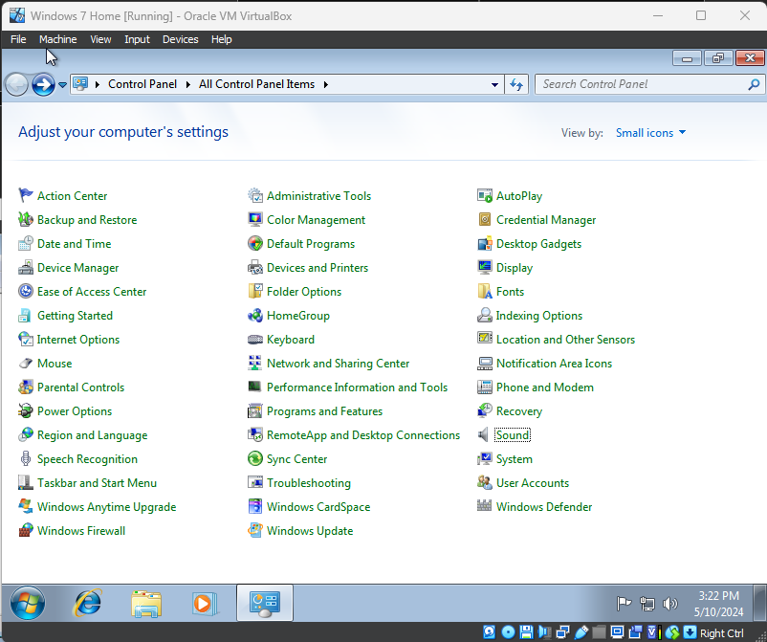
Return back to the Control Panel Window and select “Administrative Tools”.
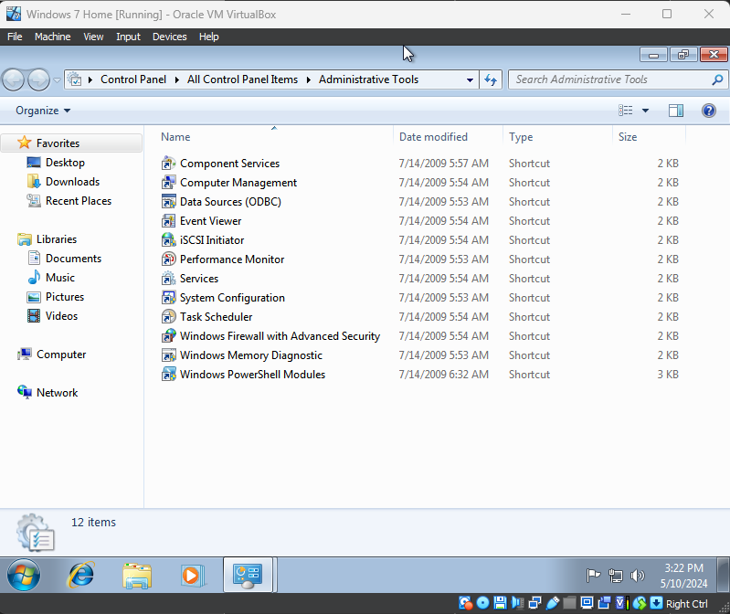
Here we are presented with a few administrative tools, and we are going to use select “Computer Management”.
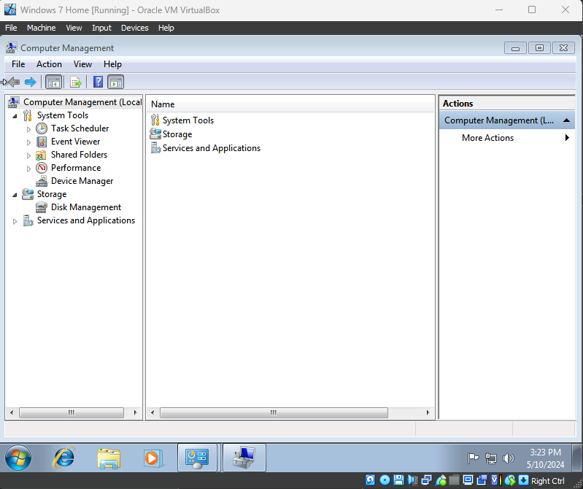
And finally, select “Disk Management”.
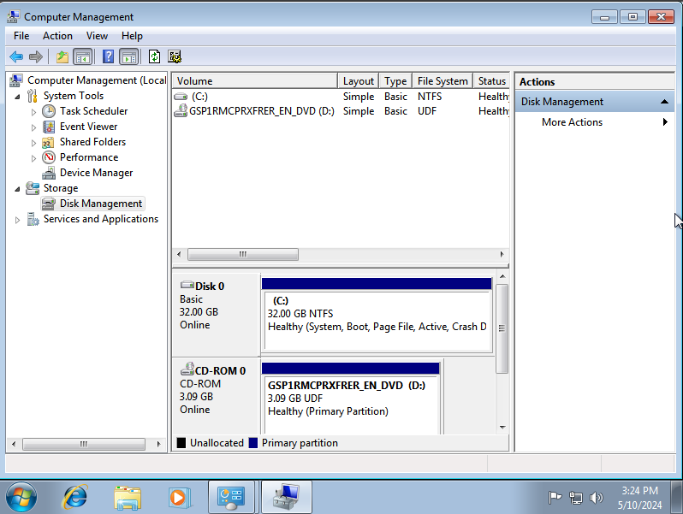
Here we can see all the system drives, such as our virtual hard drive and the CD Drive, and can manage them accordingly.
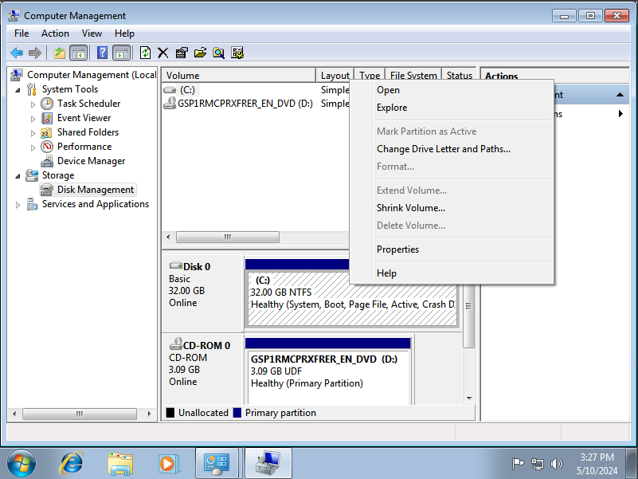
Right click on the C: Drive, and select “Shrink Volume”.
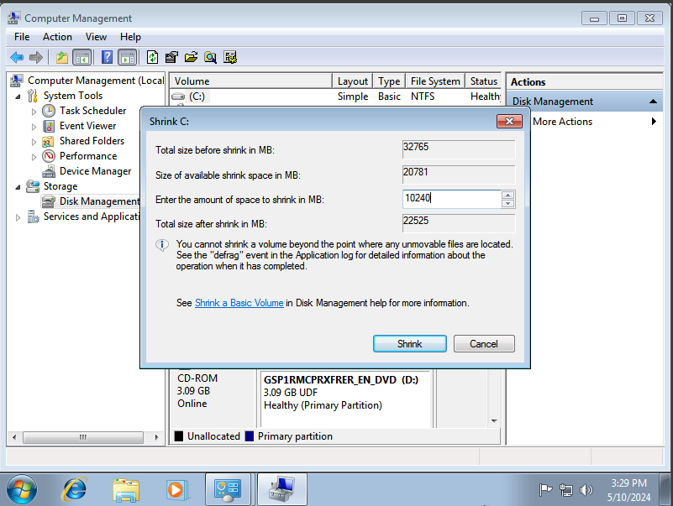
Then, we are presented with the option to choose how much we would like to shrink our hard disk space by. I have chosen 10240MB, or 10GB, as it will leave the minimum required storage for the Operating System [1].
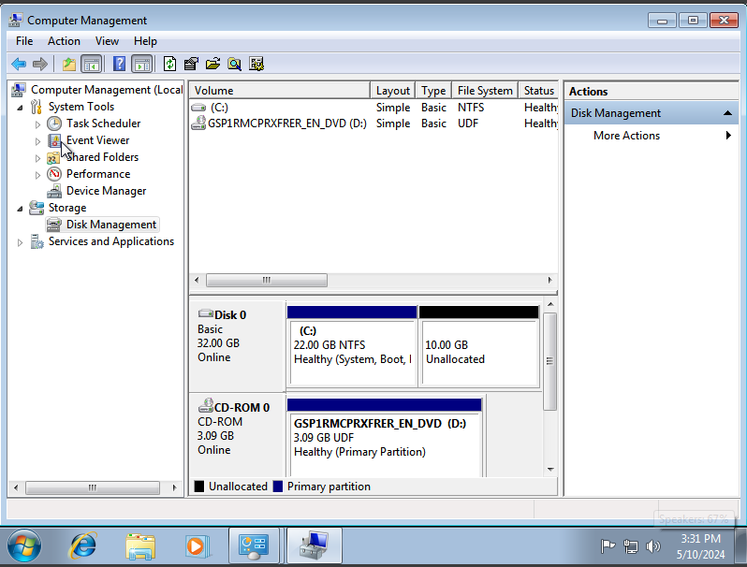
Finally, click “Shrink” and it will shrink the hard drive space by the amount we specified and will display a new “Unallocated” space on the drive.
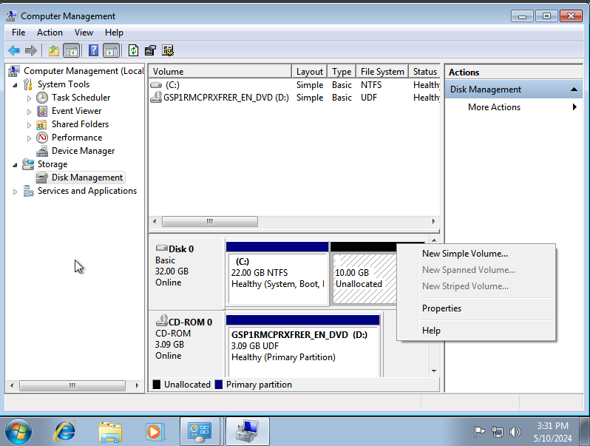
Right click the “Unallocated” space, and select the “New Simple Volume” option, to create a new drive and click next.
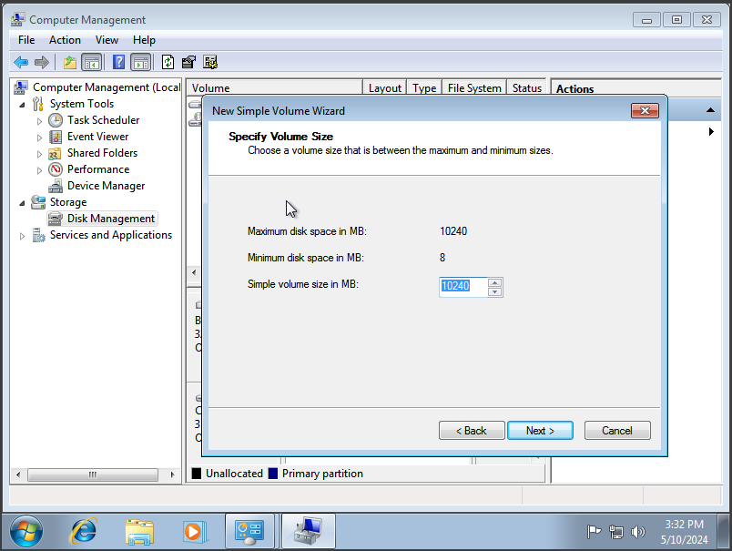

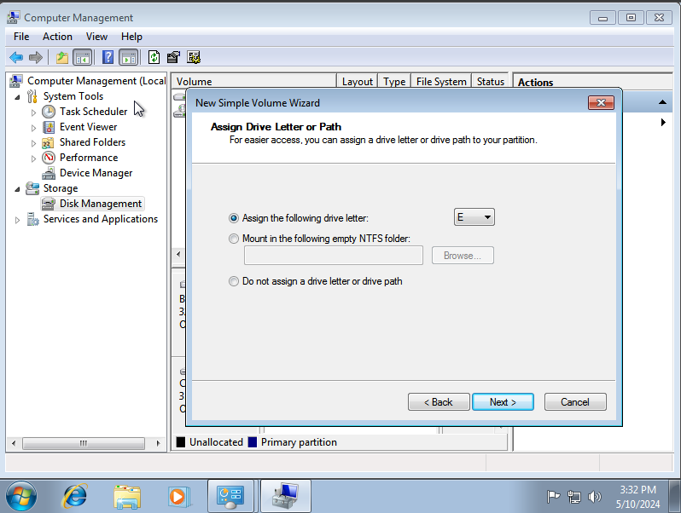
I am going to assign the drive the letter “E:”, however this does not make any real difference, purely user preference.
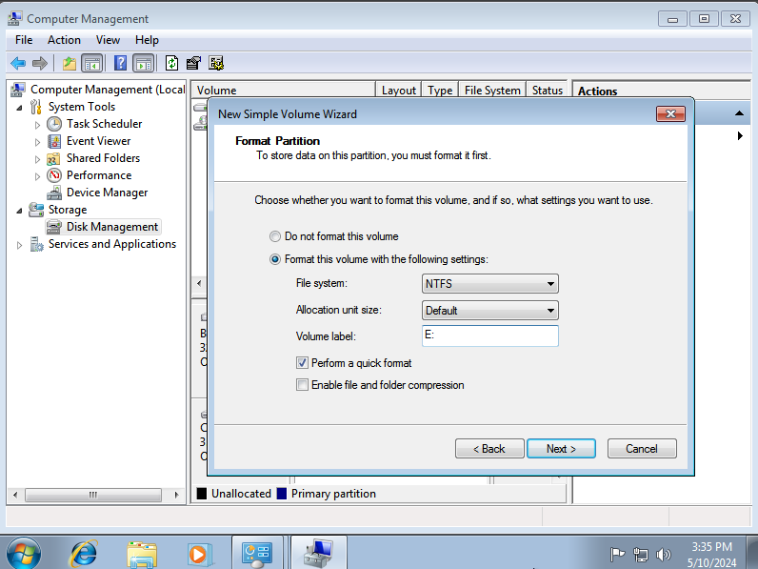
We will choose NTFS, as this is the standard Windows format for hard disks, allow it to format and give it an appropriate name.
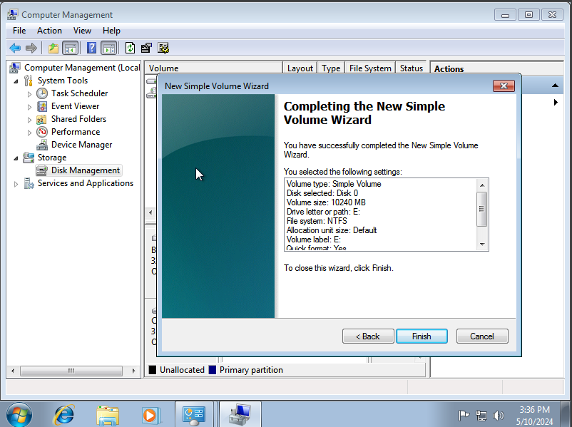Then, click next and finish to initialise the new volume.
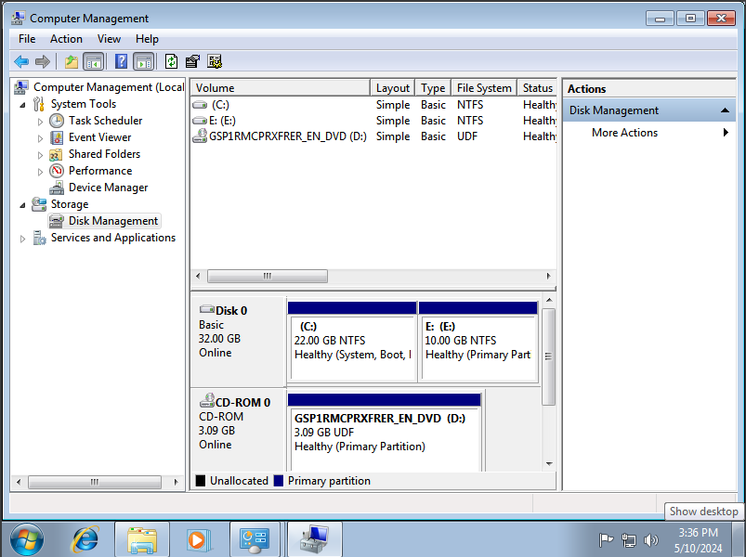
Here is the new volume in Disk Management.
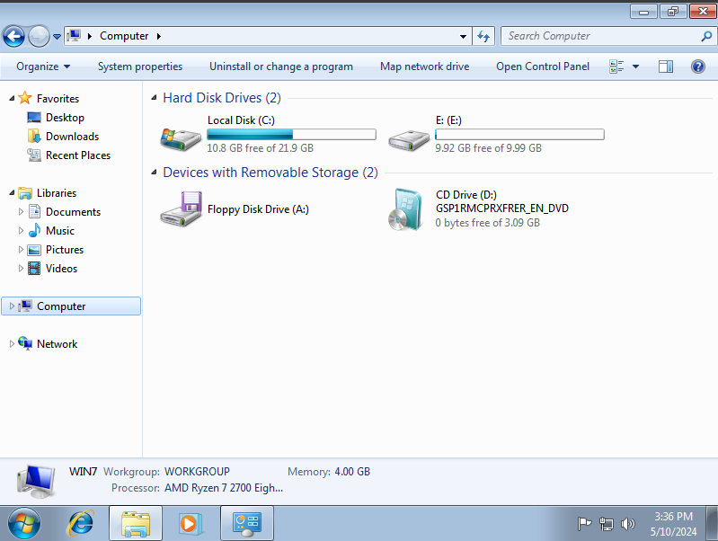
Here is the new volume “E:” in Windows Explorer

Part 2: A short report (approx. 1000 words) showing the driver setup for two of the interfaces (e.g. the sound card and the network card). Explain any important setup parameters and include screengrabs from the control panel>system pages.

Driver Setup: Network Interference Card
Close down the VM and open the settings tab and go to the Network tab.
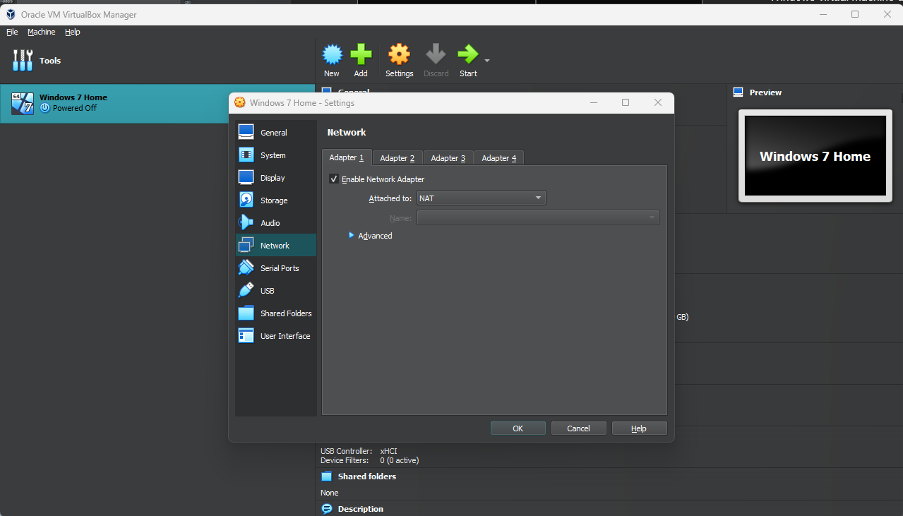
By default “Enable Network Adapter” is enabled, and you can choose which NIC you would like to use.
It may not work by default, however this was not the case for me, so I chose to use NAT.
As computer’s have progressed the need to manually install drivers has faded, as generic default drivers now exist built-in to the Windows Operating System, which was introduced in Windows 7 [2].
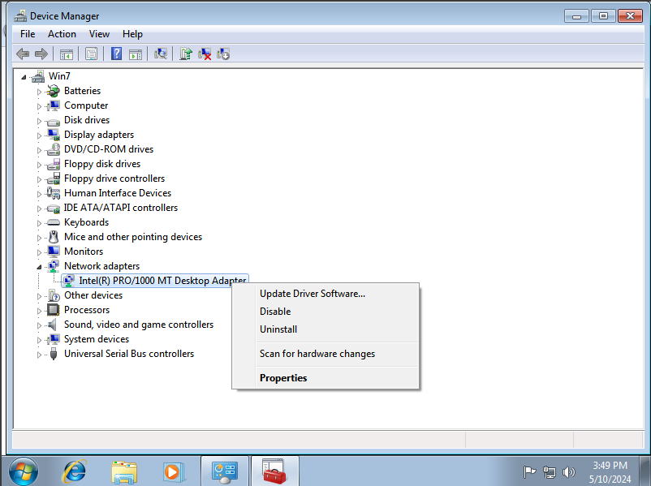
However, in device management, we can manually update any drivers. First, right click the device you want to update, in this case the Network Card, and select update driver software.
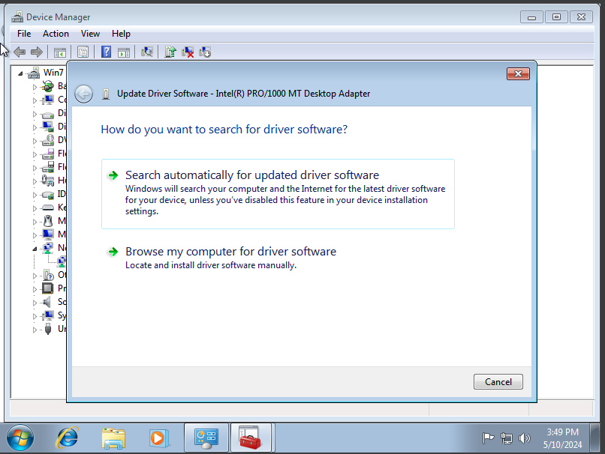
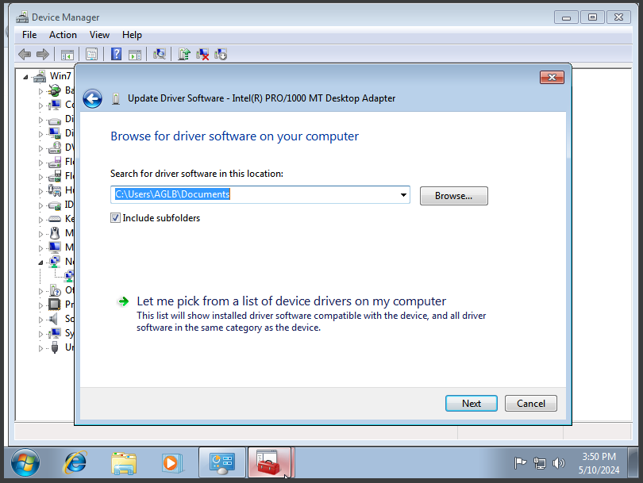
Select, “Browse my computer for driver software”, and “Let me pick from a list of device drivers available on my computer”.
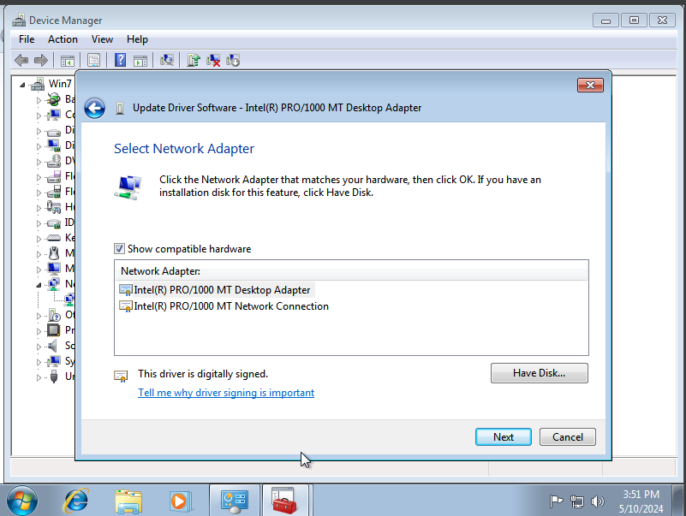
Then, we are given a list of network drivers available, in this case we will be using the Desktop Adapter, as that is what the device is, and selecting next.
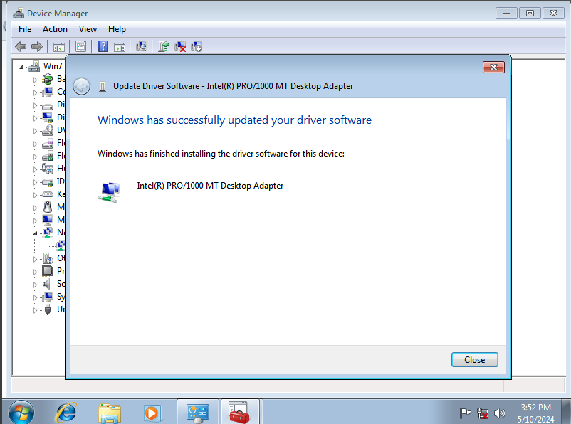
Then it will install the driver and give you a prompt if it is successful.

Driver Setup: Sound Card
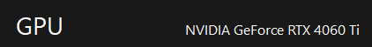
The graphics card on our system is an Nvidia Card, so we will need to install their proprietary drivers from their website.
First, we’ll go to their website and download the driver installation software, as we are running Windows 7, we will have to download an older version of the software.
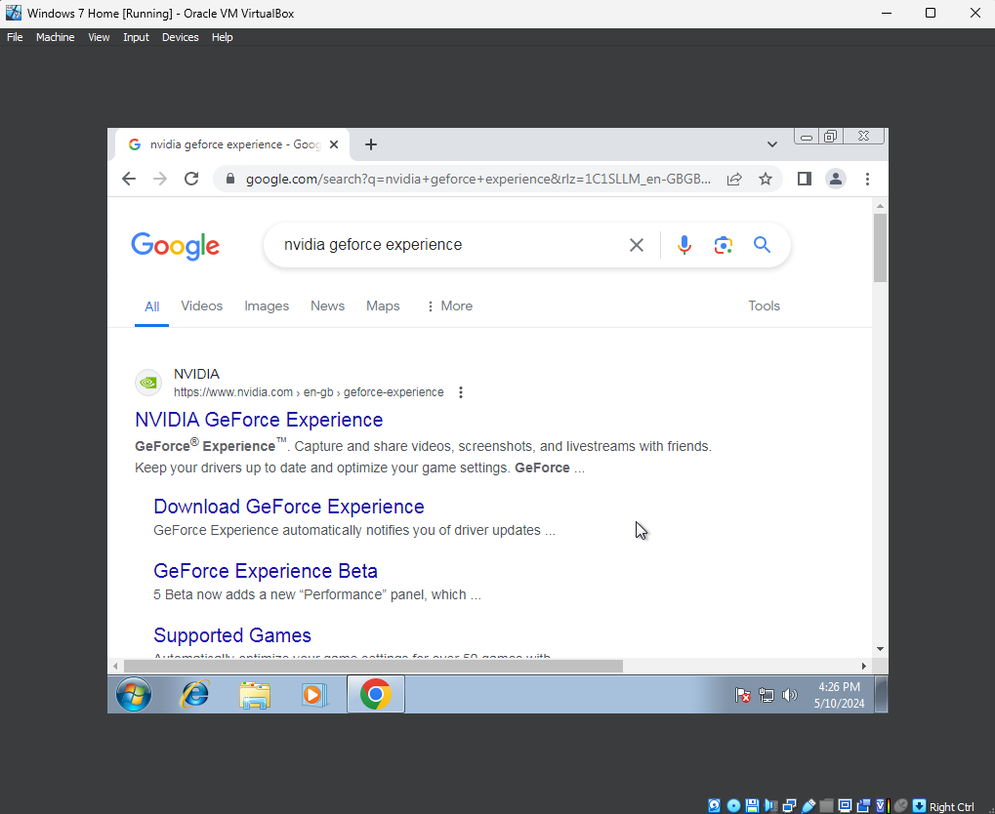
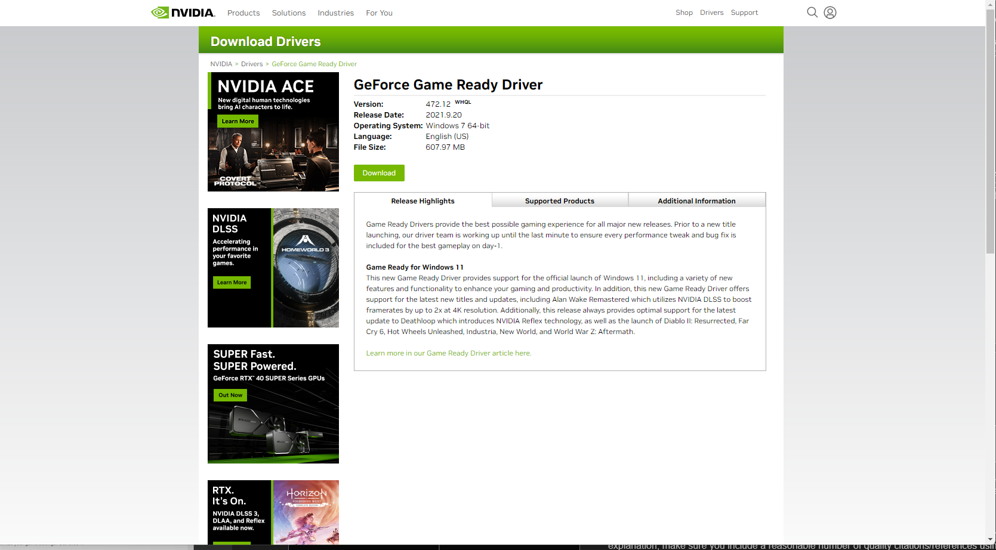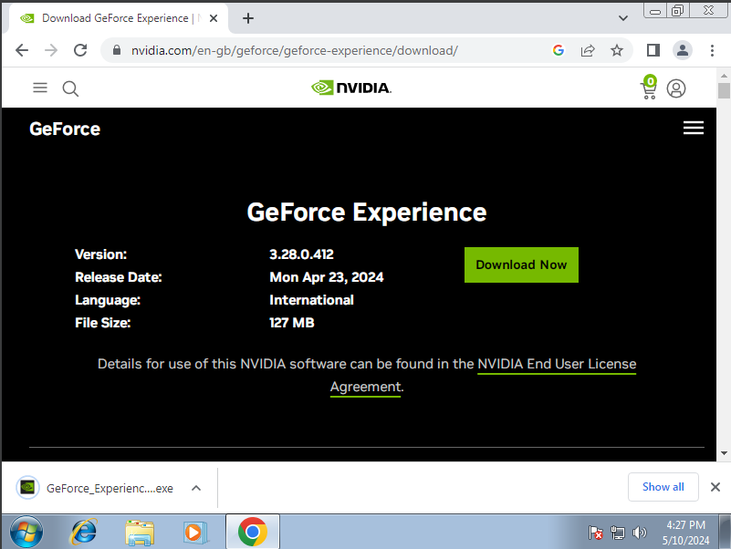
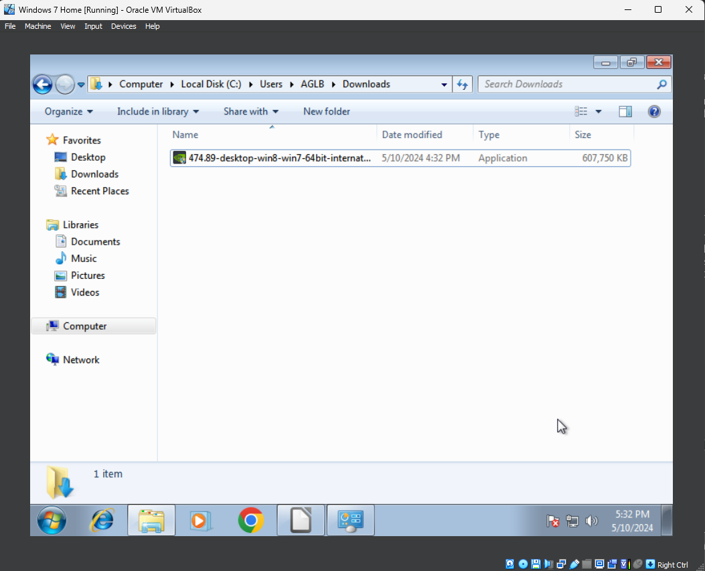 This EXE. file will be downloaded to the “Downloads” folder in C:\Users\AGLB\Downloads
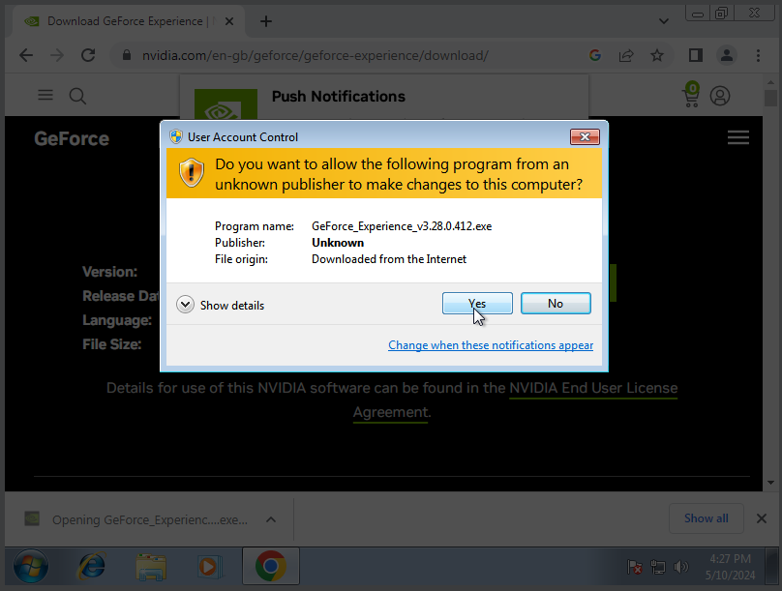
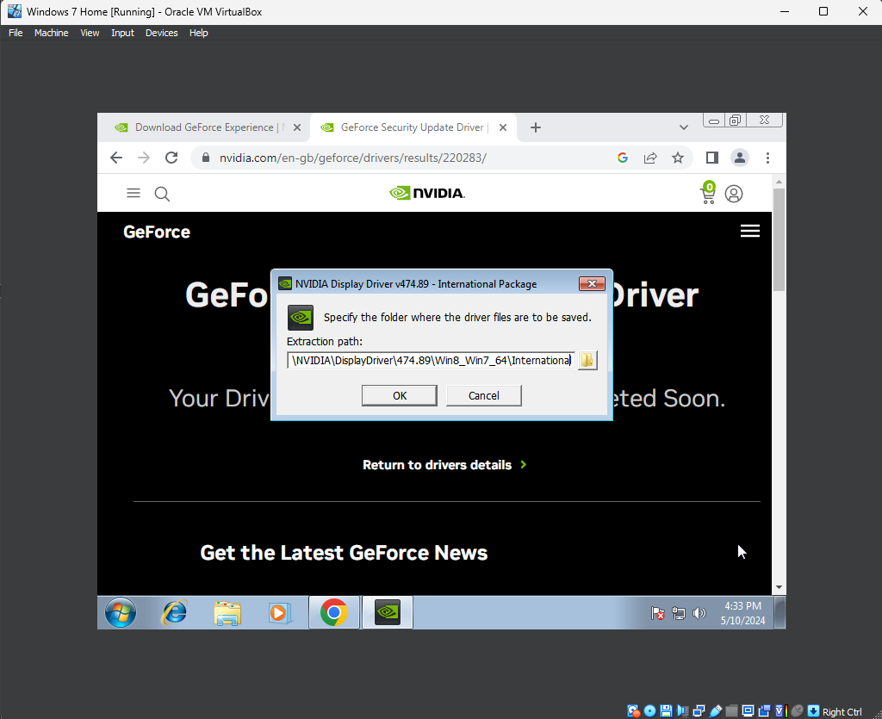When opened, it will ask you to specify a folder, in this case it will create a folder in the C: drive, which we will go with.
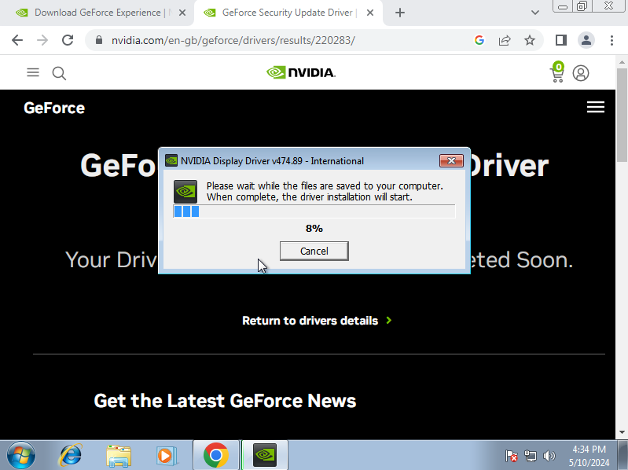
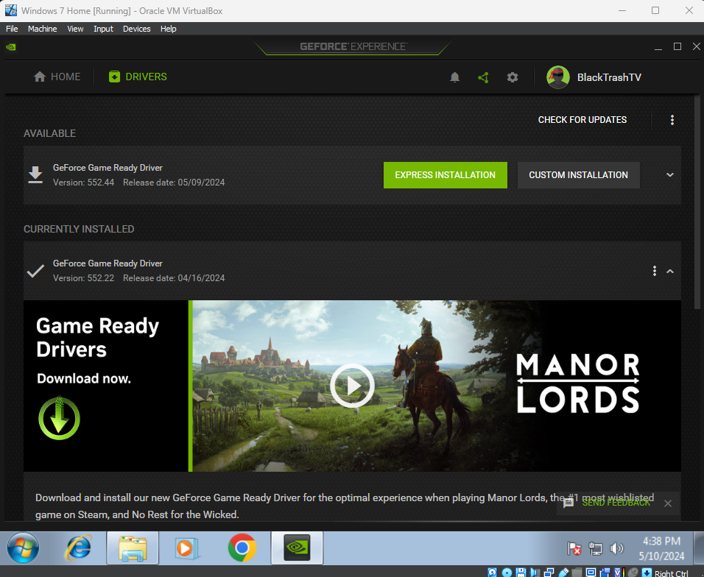
Once installed it will give you the option to do either an express installation, which has no input, and a custom installation. In this case we are going to be doing a custom installation.
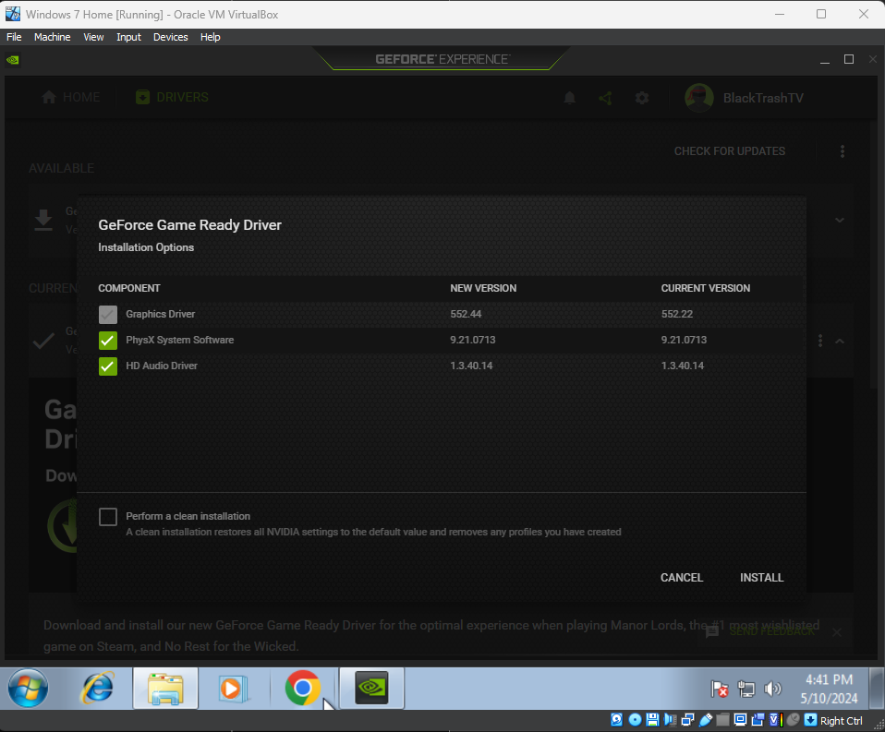
This gives us the option to choose which drivers we want to update, in our case we want to update all. It also gives us the option for a clean installation, if there are any issues.
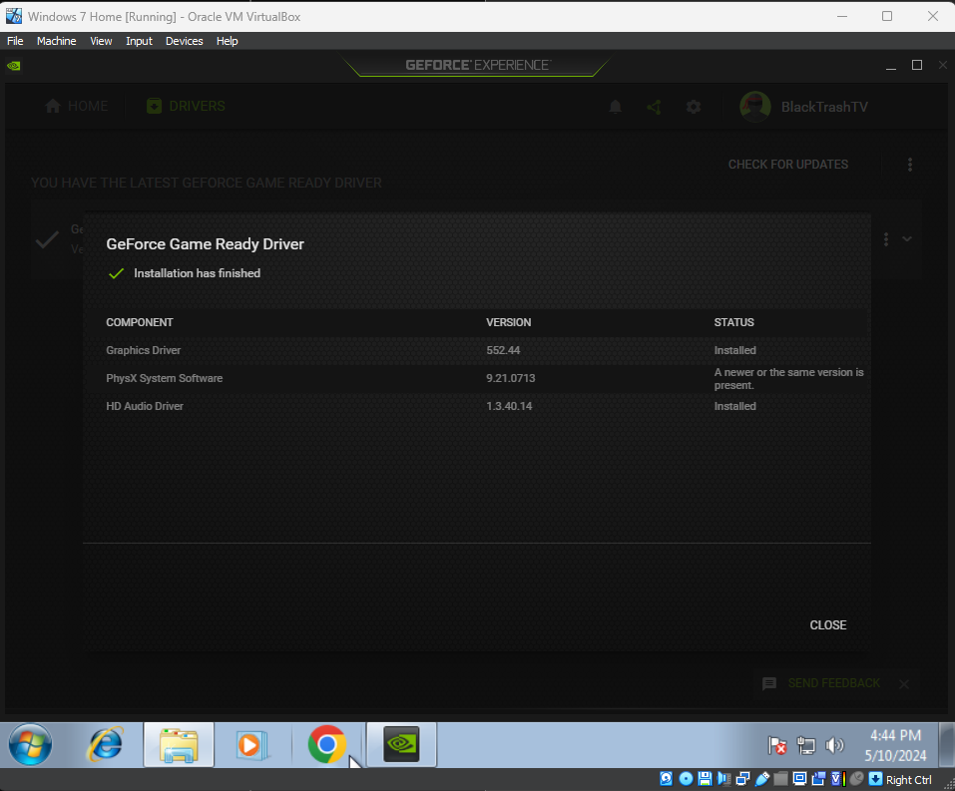
Once finished, it will present you with this screen.

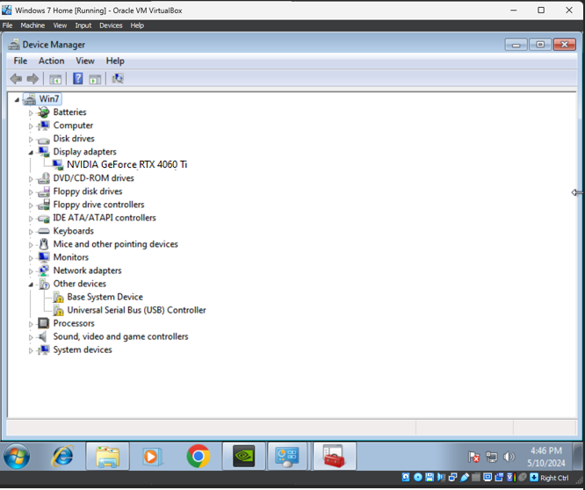And here we can check that the graphics card is functioning under “Display Adapter”.

Software Installation: Chrome

As Internet Explorer is outdated, we will be installing Chrome, a chromium-based web browser.
The minimum requirements for Chrome is to be on Windows 10 [3], however, we can still install it despite this, but there may be security issues and bugs due to lack of updates. It is also free, which makes it good for our purposes or web browsing.
First, we will open Internet Explorer and go to the Google Chrome website to download the installer.
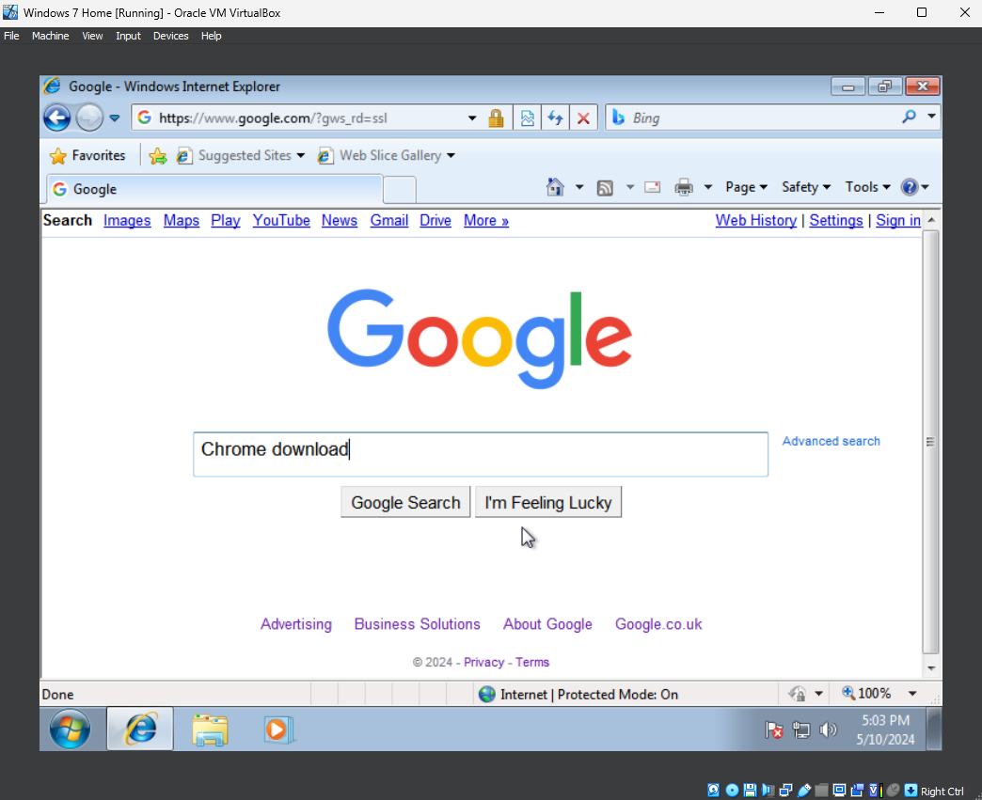
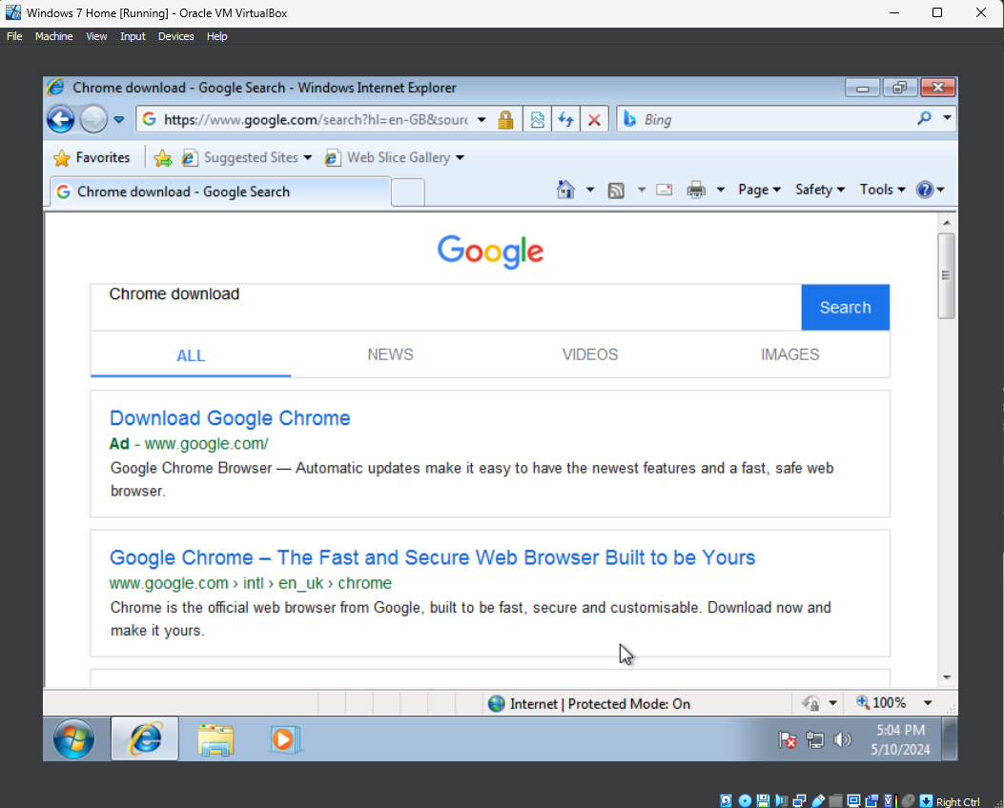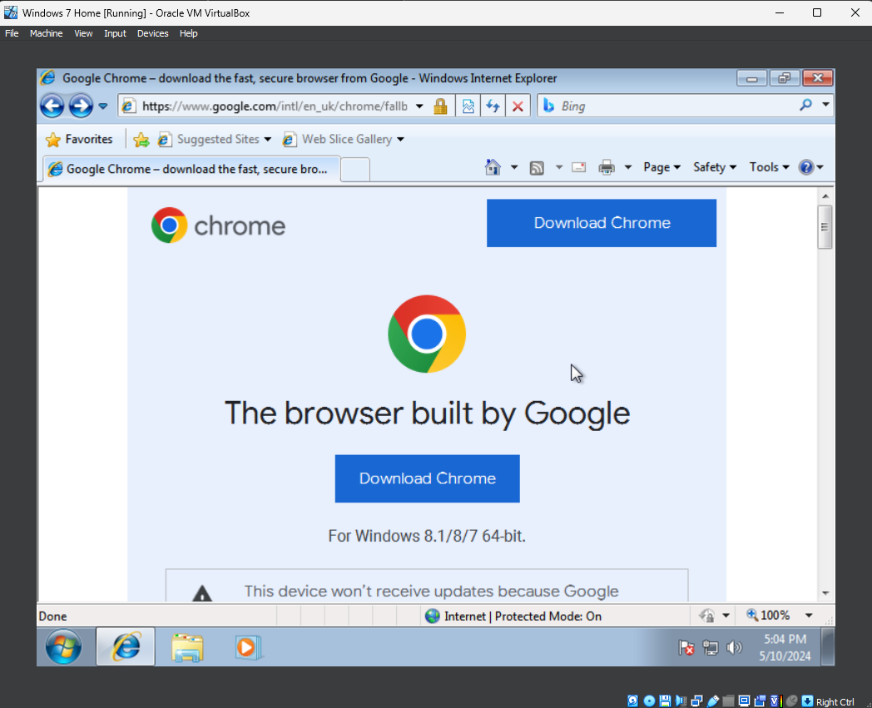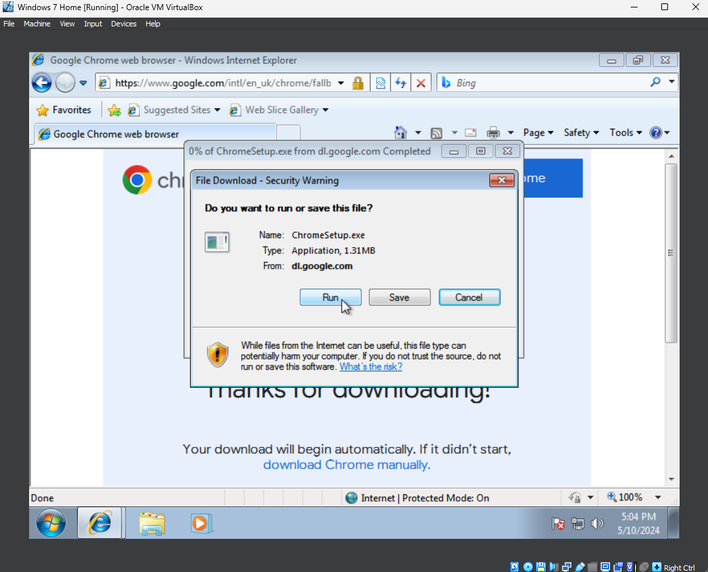
Once downloaded, we run the setup file and let the installer run.
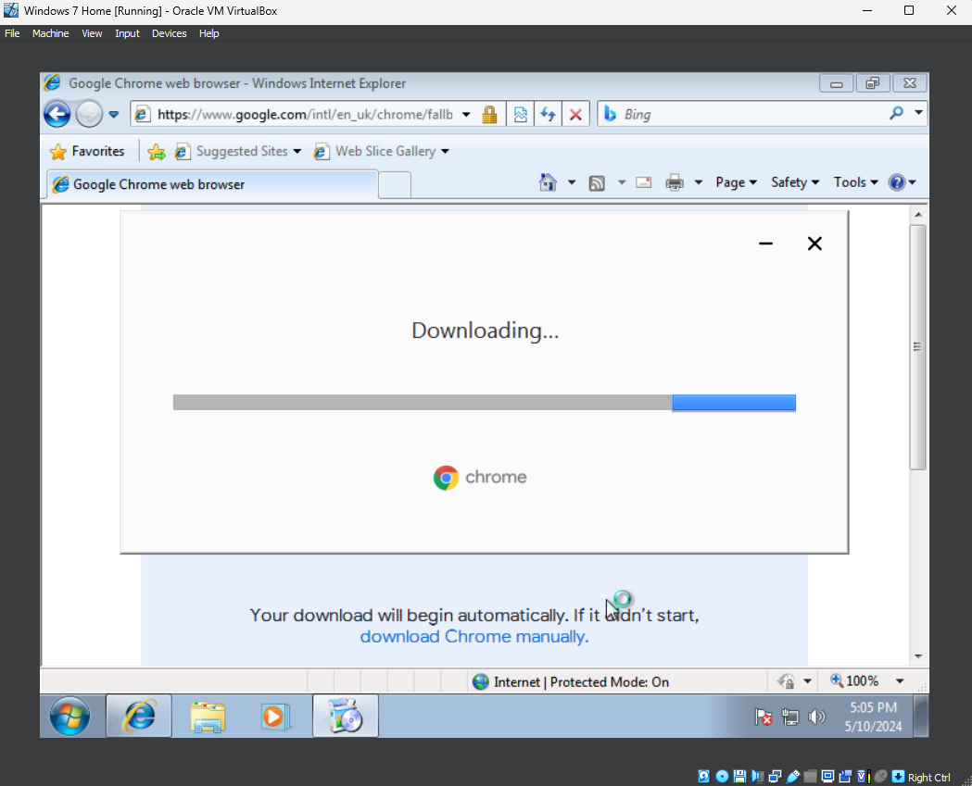
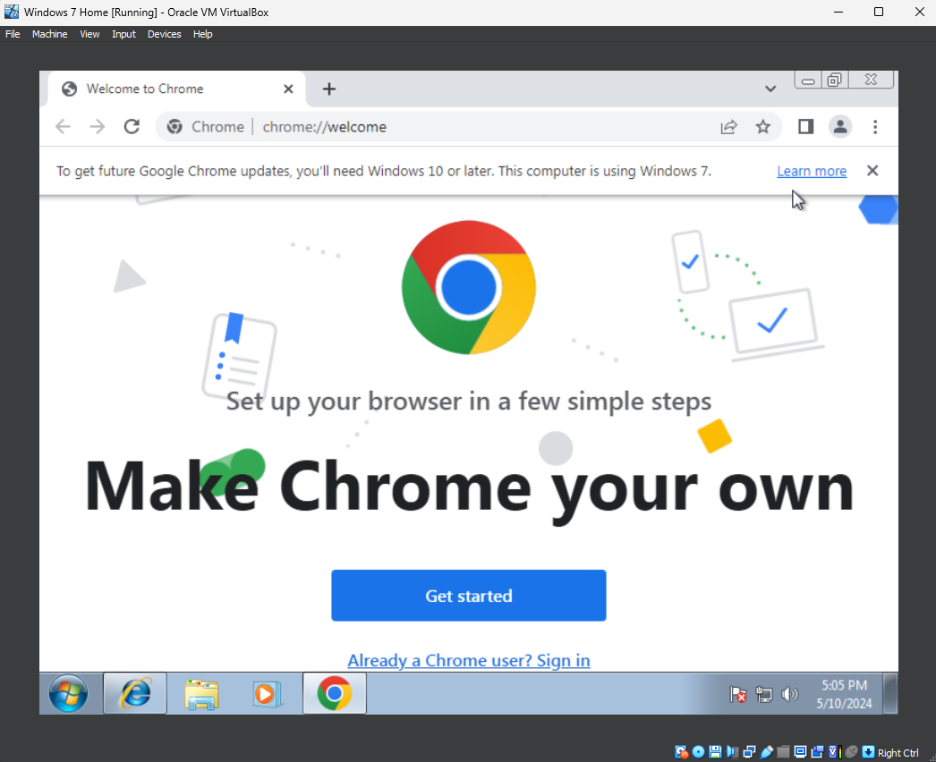
When it is done, it will display this screen and automatically open the application.

Software Installation: LibreOffice (Office Suite)

For the office suit I have chosen LibreOffice. This is because LibreOffice is supported on Windows 7 and meets our system requirements [4]. It is also a free and open source program [5], which makes it perfect for our use in a VM.
Another option we could have chosen is Microsoft Office, however we would have to use an older version, as the latest version is not supported by Windows 7 [6], it is a paid product and not open source.
First, open Chrome and search for Libre Office, and go to their download link.
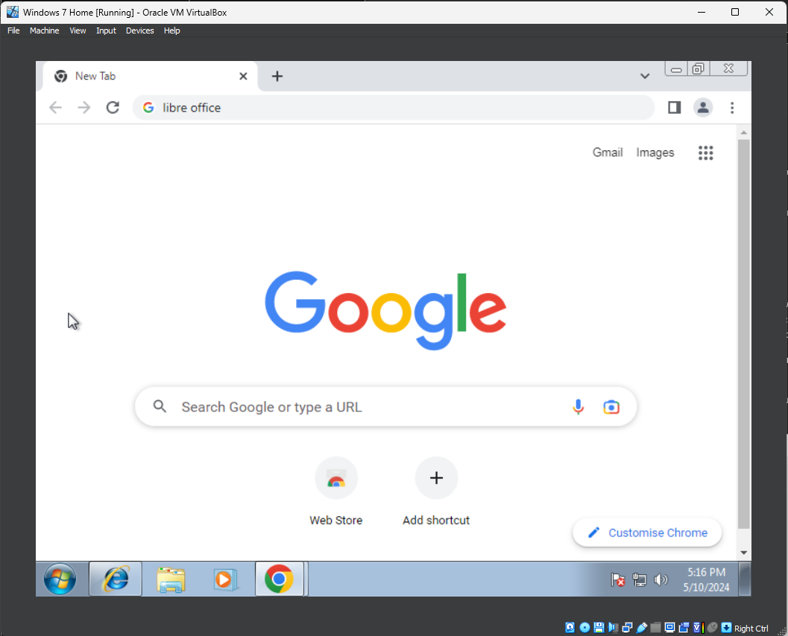
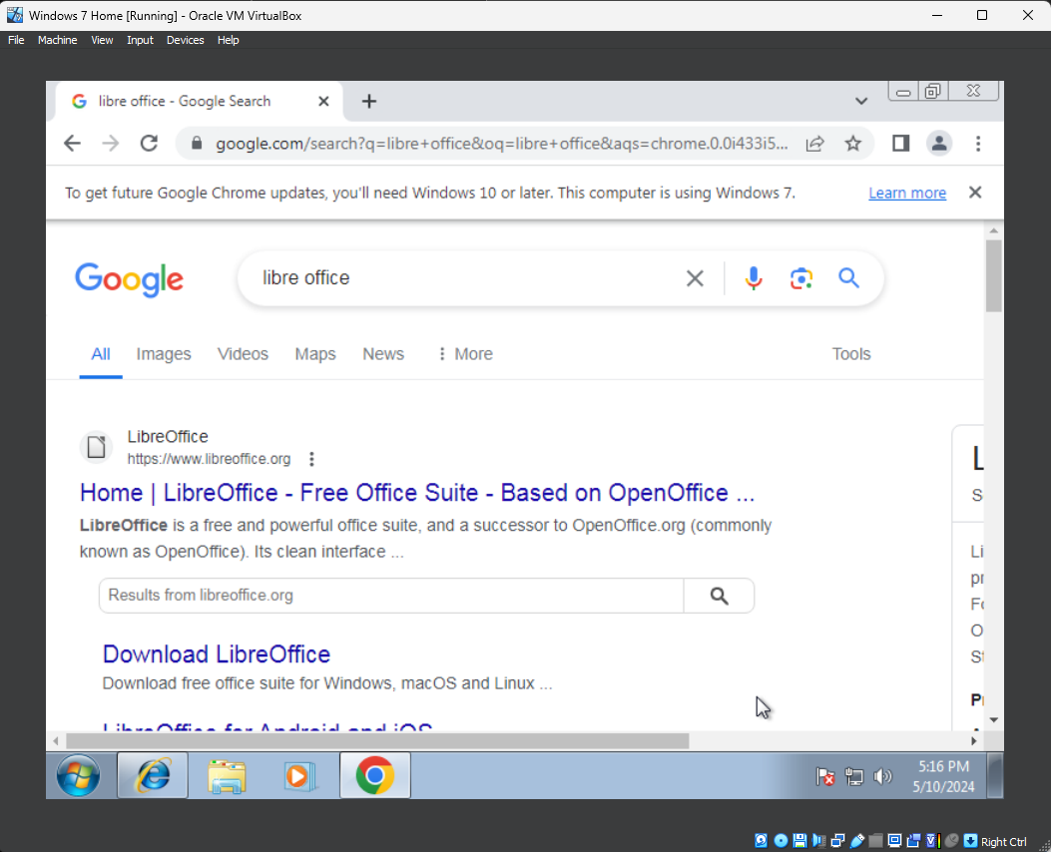
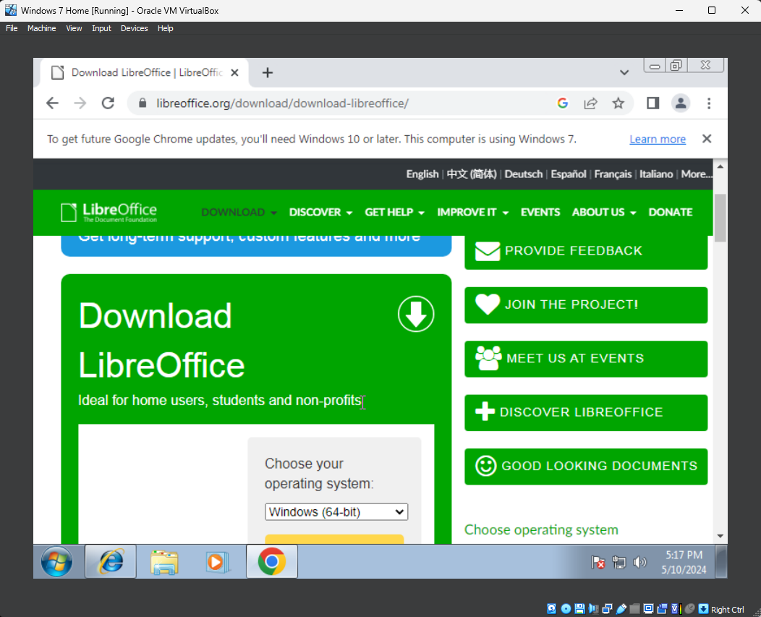
It will download a .MSI file to install the suite, run this and follow the installation wizard. This MSI. file will be downloaded to the “Downloads” folder in C:\Users\AGLB\Downloads
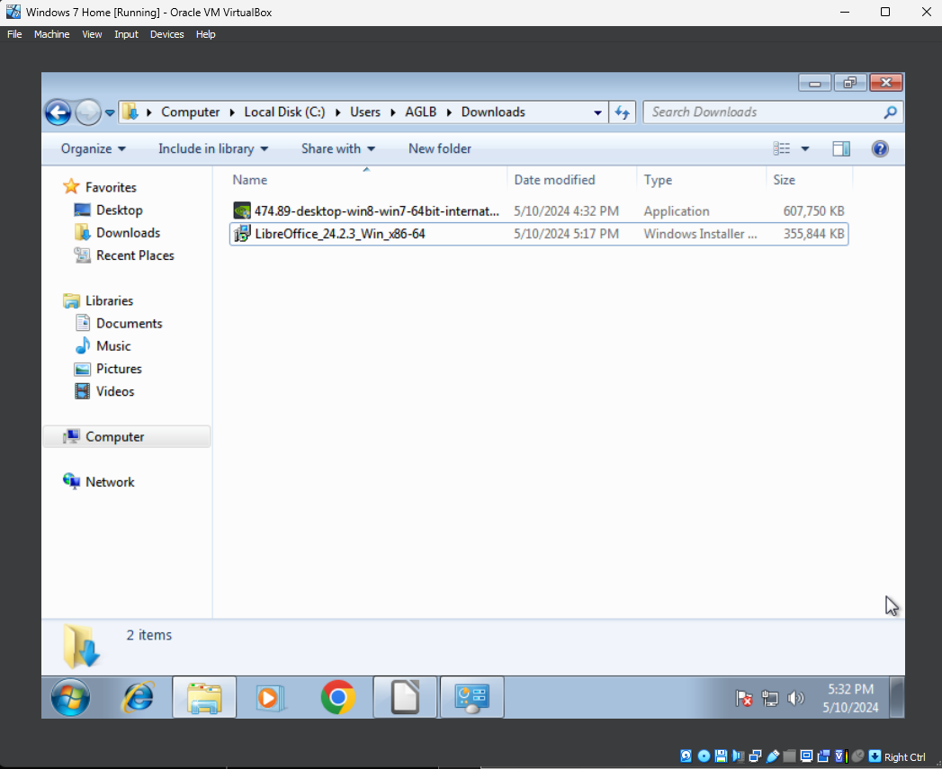
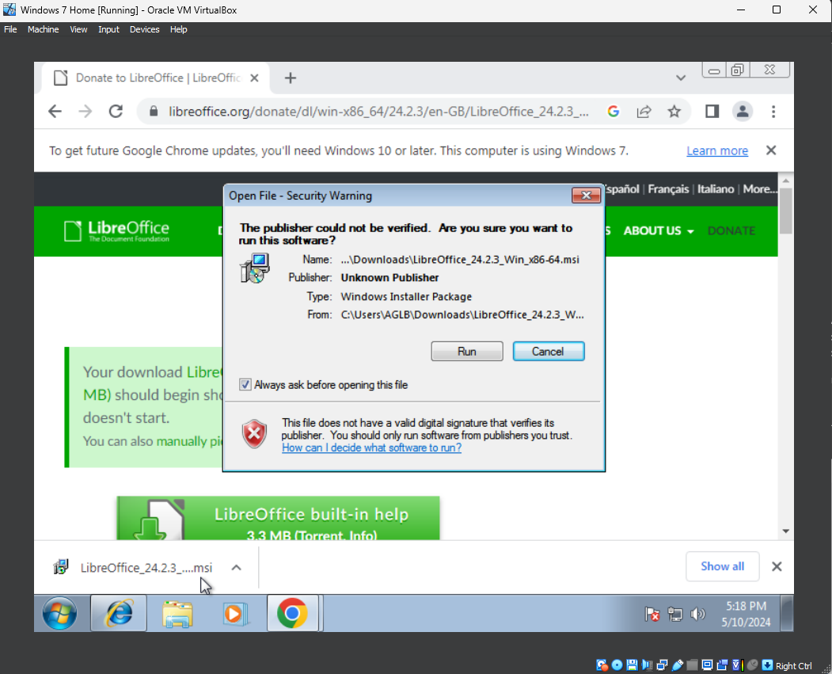
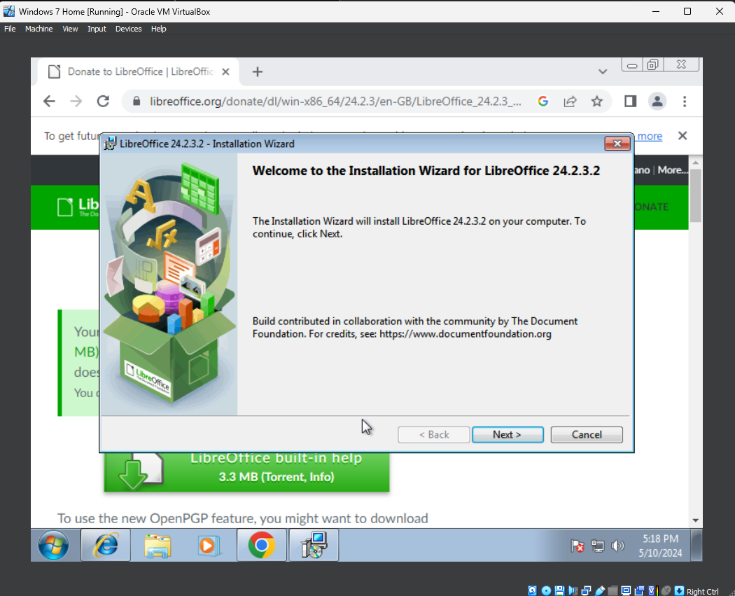
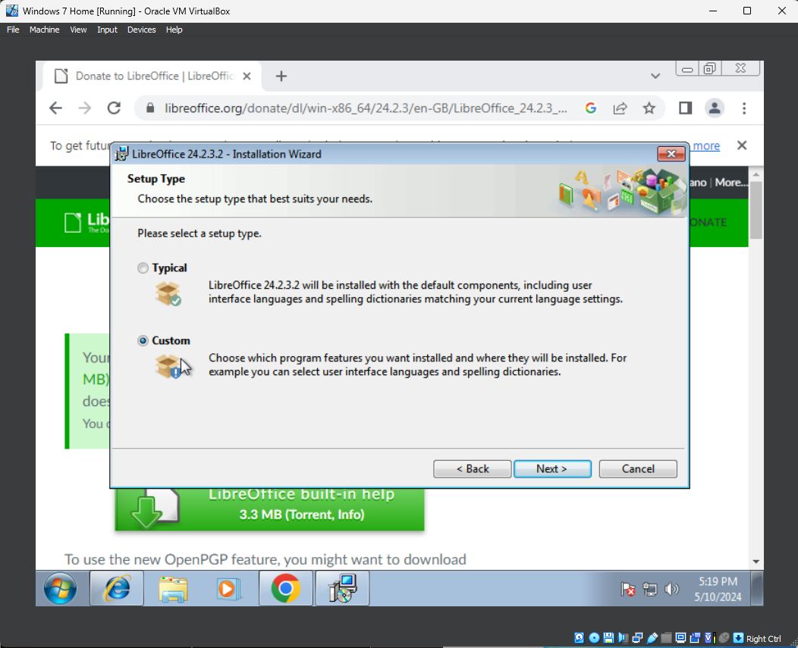
It presents the option for a “Typical” install or a “Custom” install, in this case we will be using the custom install.
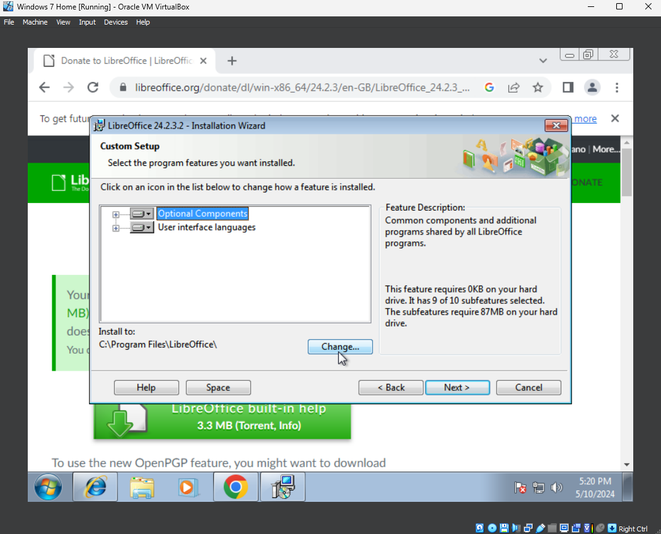
It gives us the option to add optional components and languages, as well as change the installation directory. It automatically selects C:\Program Files\LibreOffice as the installation directory, so we will leave it as that, as it is an appropriate place for it.
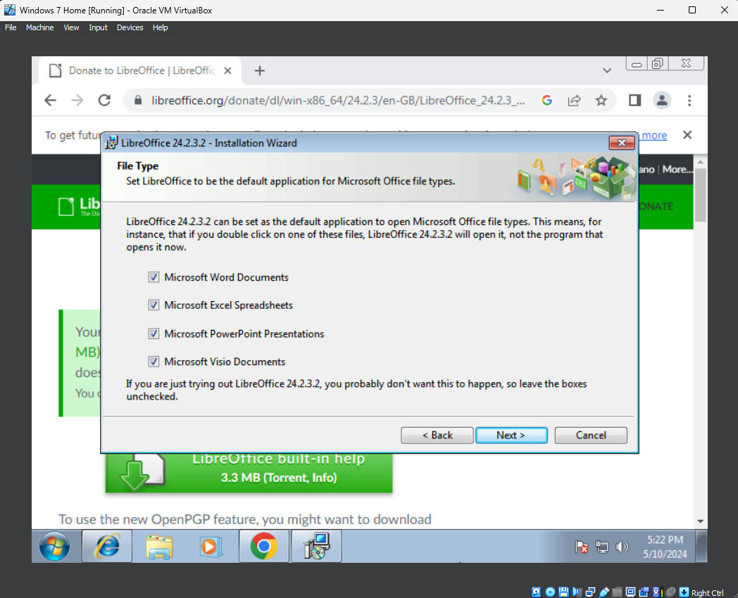
It also automatically sets the default for Microsoft Office files, such as a docx. File, to be opened by LibreOffice, which we will enable, as these are the default file types used by most people.
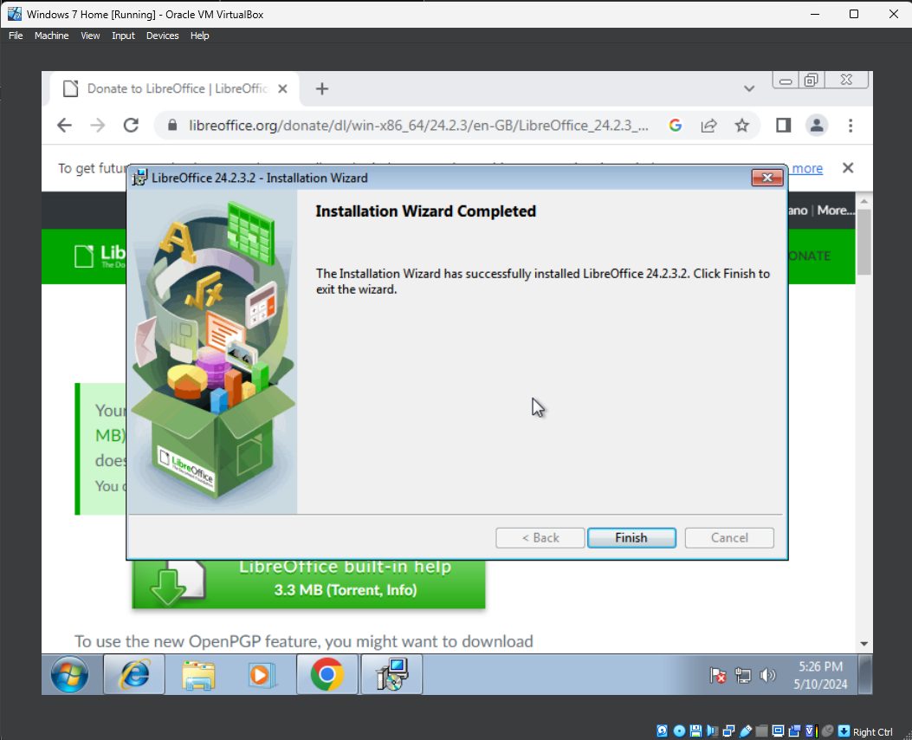
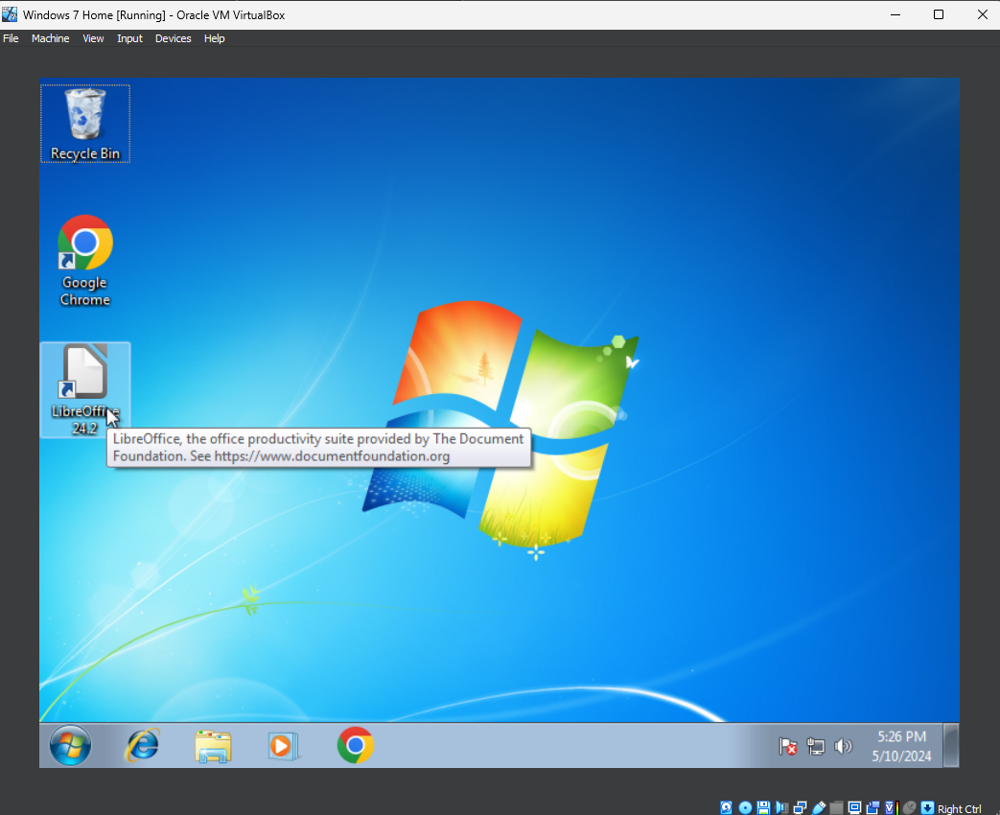
Once you click finish, it will close the Wizard and a LibreOffice shortcut will appear on the desktop.
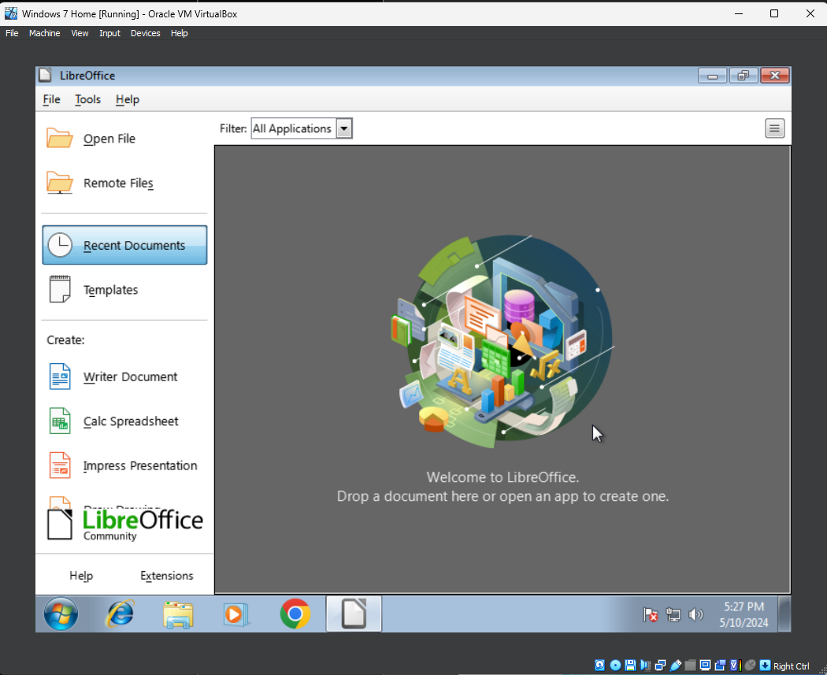
When opened it will display the full suite of office tools.
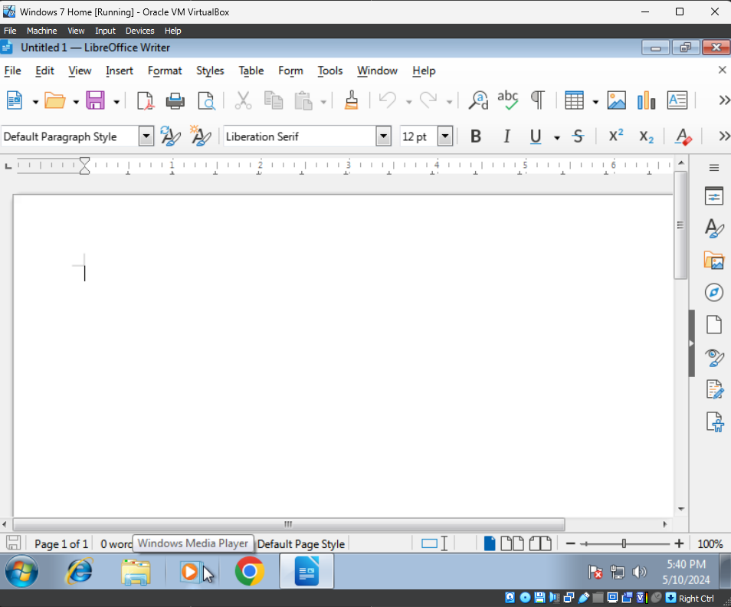
This is the display for the word processor, to save a file click the file in the top left and click “Save As” or “Save”.
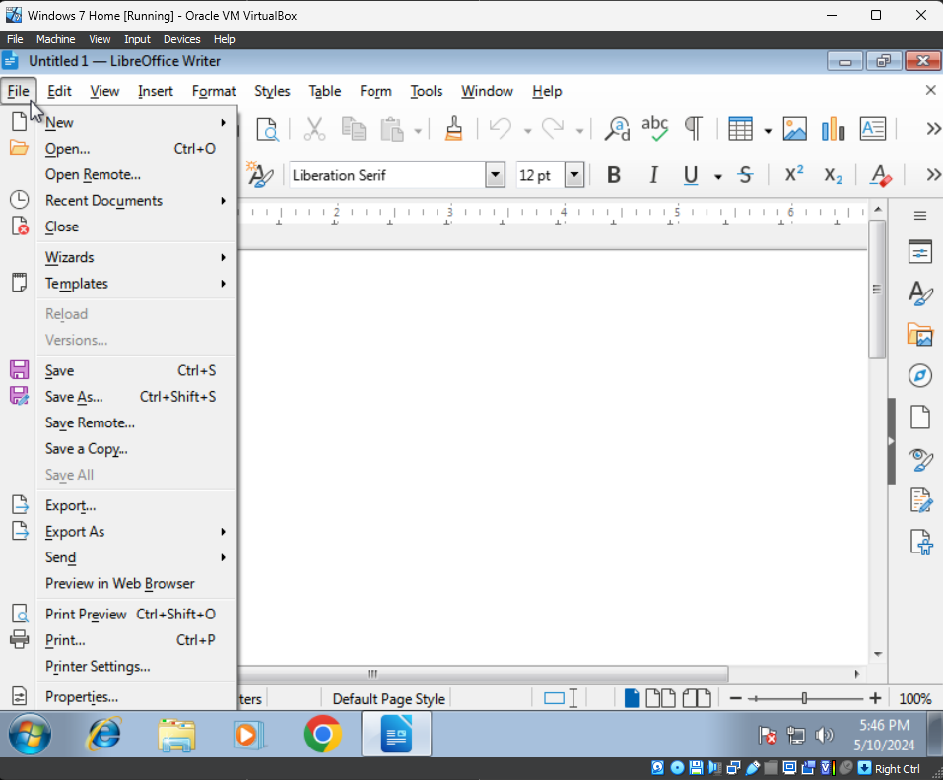
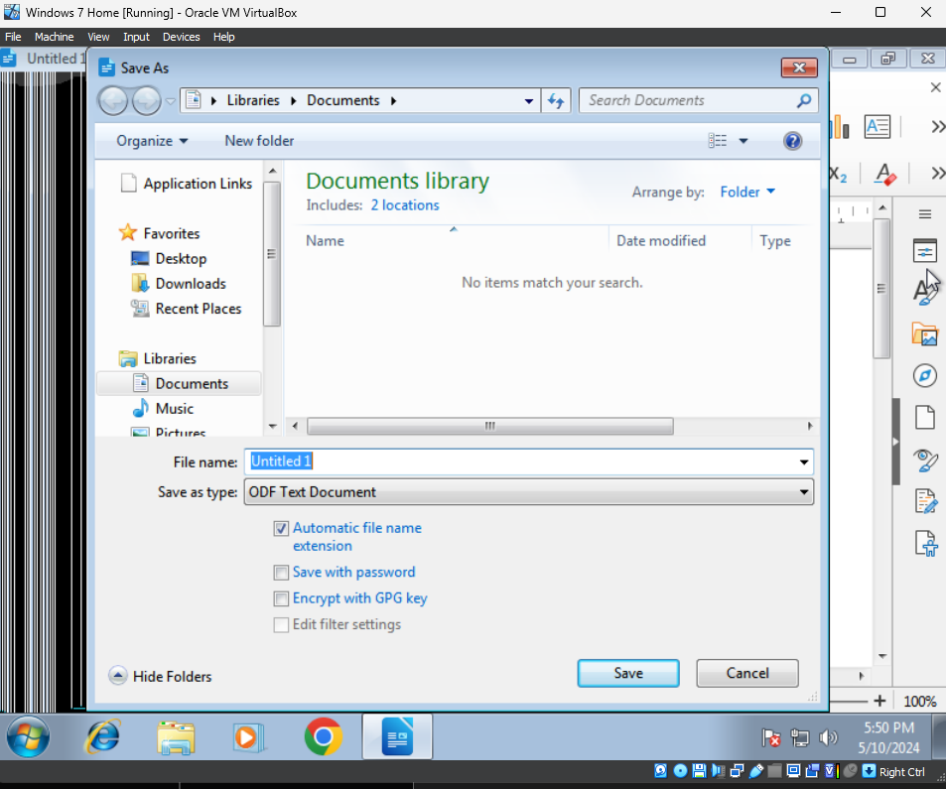
By default, is will be called “Untitled” and will try to save it in the documents folder, however we can rename it and save it in another folder, such as the desktop.
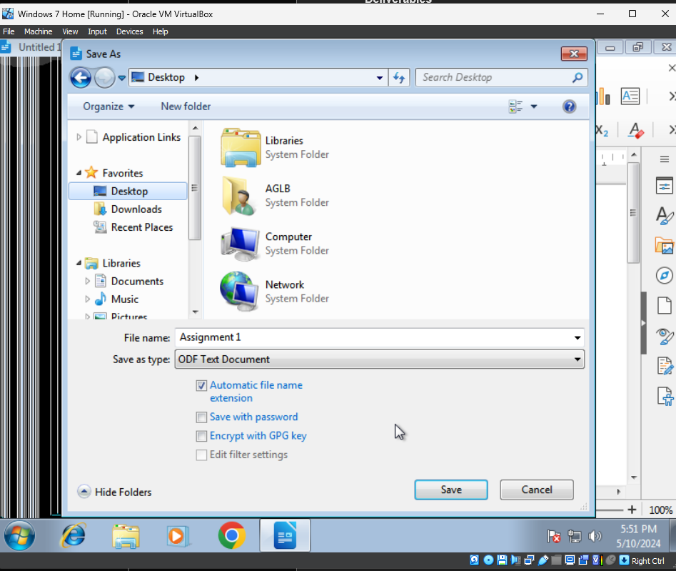
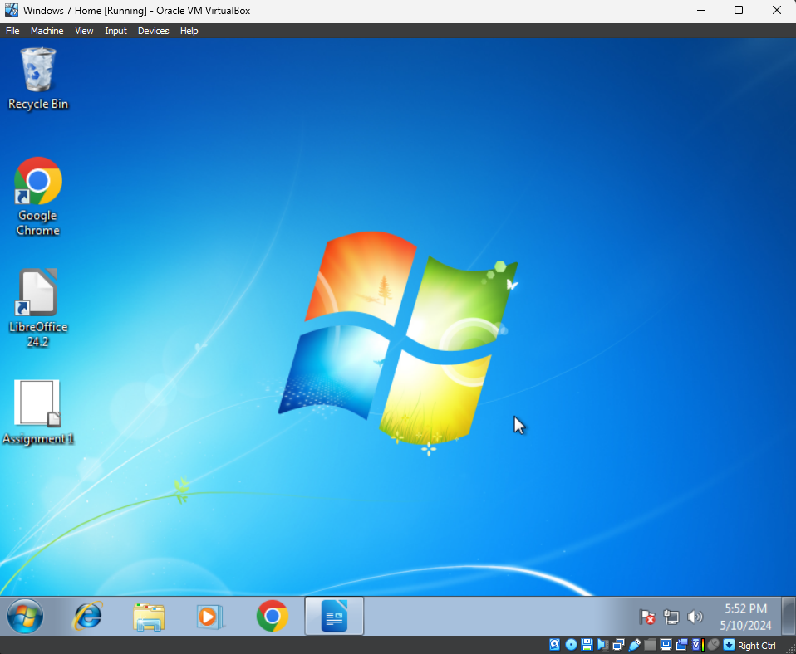
We can also check the Programs and Features application in Windows 7 to confirm that it installed the software without fail.

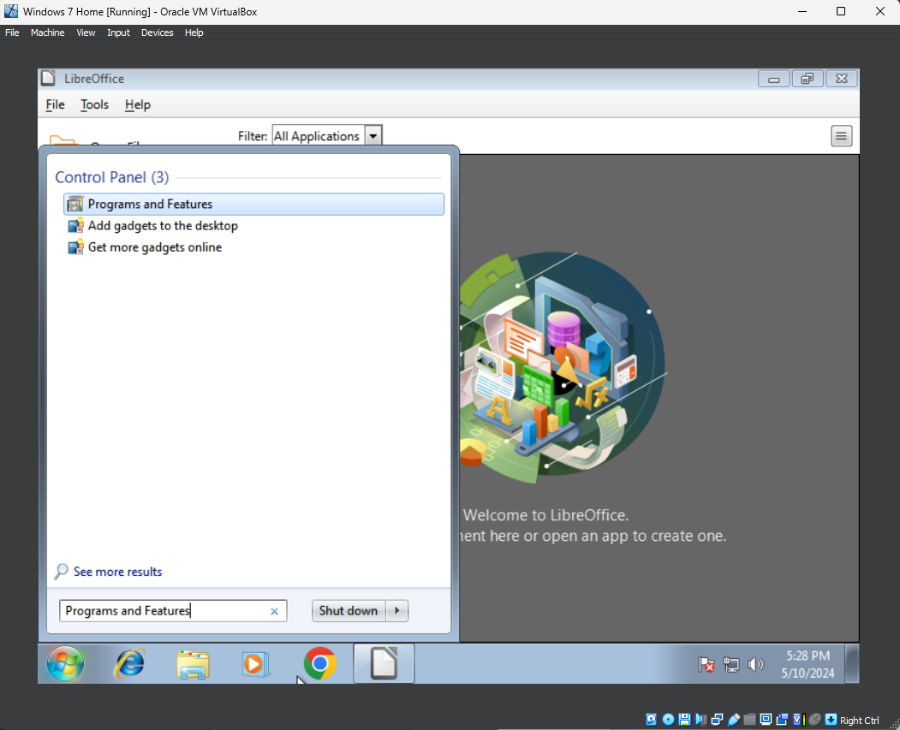
First, type in Program and Features in the search bar and open it.
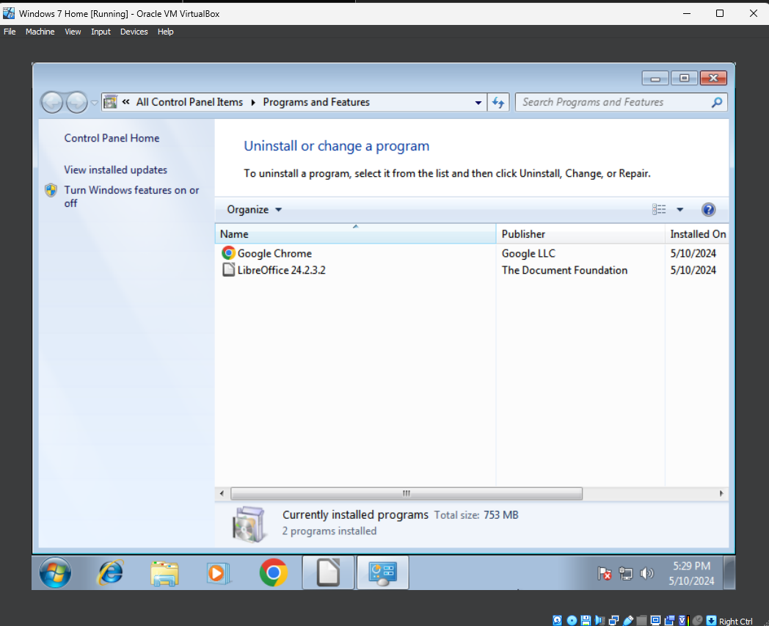
It will then display all installed software application, in our case Google Chrome and LibreOffice.

References

[1] | “Microsoft Support,” 22 10 2009. [Online]. Available: https://support.microsoft.com/en-gb/windows/windows-7-system-requirements-df0900f2-3513-a851-13e7-0d50bc24e15f.
[2] | “Drivers and information,” Microsoft, 22 10 2009. [Online]. Available: https://support.microsoft.com/en-gb/windows/automatically-get-recommended-drivers-and-updates-for-your-hardware-0549a8d9-4842-8acb-75fa-a6faadb62507#:~:text=Windows%20can%20automatically%20check%20if,drivers%20aren't%20installed%20automatically.. [Accessed 10 05 2024].
[3] | Google, “Chrome Enterprise Education and Help,” Google, 01 2020. [Online]. Available: https://support.google.com/chrome/a/answer/7100626?hl=en#:~:text=Windows,or%20later%20that's%20SSE3%20capable. [Accessed 10 05 2024].
[4] | LibreOffice, “System Requirements,” [Online]. Available: https://www.libreoffice.org/get-help/system-requirements/. [Accessed 10 05 2024].
[5] | O. Source, “Open Source,” [Online]. Available: https://opensource.com/tags/libreoffice. [Accessed 10 05 2024].
[6] | Microsoft, “Microsoft Support,” [Online]. Available: https://support.microsoft.com/en-gb/office/system-requirements-and-supported-accounts-46a8d501-0d1f-4145-ab0f-286bc7dcf780. [Accessed 10 05 2024].

