Design and implementation of smart home
Sam Wattis (1804612)

School of Applied Computing
Computing (Computer Networks and Cyber Security)

Introduction
The idea of automating home appliances has been around since the 1970s. X10 was developed by a Scottish company in 1975 and allowed devices to talk to each other over already existing electrical wires. This technology is still in use today, but more reliable means of communication now use radio waves to connect. ZigBee and Z-Wave are 2 of the most prominently used radio networks. They provide the protocols and work in tandem with electronics companies who produce the products needed for a Smart Home such as CCTV, door security and heating and lighting controls. The problem is there is no standard system for automating home devices so there is a compatibility issue for ensuring a single network controlled through one hub. In addition, there are security issues many of which exist because there is a huge demand for this technology which means it has been marketed in some cases before it has been adequately tested. This report investigates the technologies that are on the market and their possible security issues.
ZigBee
Zigbee is an open communication standard that operates wirelessly making use of radio frequencies to communicate. It functions using a ‘mesh network’ which means that it can communicate with multiple devices using wireless points known as ‘nodes’. The nodes act as small transmitters and are able to transmit data over a wide area. Its main advantage over other protocols is speed.
ZigBee created the ZigBee Alliance in 2002 which now consists of over 400 members who are manufacturing devices using the ZigBee protocol. These include Amazon Echo Plus, Samsung SmartThings, Belkin WeMo, Hive Active Heating, Phillips Hue and Honeywell thermostats. Such devices will need to be controlled by a central hub such as Amazon Echo Plus [1].
Z-Wave
Z-Wave operates on a different radio frequency to ZigBee which shares its frequency with Wi-Fi and so it suffers less interference issues. It offers far fewer nodes on its mesh network than ZigBee but enough for any Smart Home and operates on a very low power providing energy saving benefits.
Z-Wave also has an alliance which has more than 700 members and over 70% of the smart home market has Z-Wave technology inside it [2].
All Z-Wave devices work with other Z-Wave devices and will find each other in the home and create a strong mesh network which will work with or without an app or hub to control the network. However, the drawback of Z-Wave is because it operates on very low power, it will not work for security cameras or HD video [3].
Near Field Communication
Near Field Communication (NFC) protocol is used for wirelessly communicating data between a maximum of a maximum of 4cm, Android beam is feature that allows 2 android devices to share data using NFC.
There are other communication networks used in the Smart Home including Wi-Fi and Bluetooth, but each has drawbacks and cannot be used exclusively. Wi-Fi requires devices to have their own power source or long-lasting battery. It is mainly used for streaming and browsing the internet – both of which are power intensive. Bluetooth used for linking your phone to your computer, car or headphones has a short distance range so can only make connections with devices close by.
An Amazon Alexa device such as an echo or echo dot work as a smart controller. They can be used to operate smart tv’s, thermostats and speakers etc by connecting to the home Wi-Fi network or Bluetooth. Alexa’s are compatible with Phillips hue light bulbs and the lights are able to be turned on and off with voice commands.
Security in IoT
In addition to considering compatibility issues when setting up a Smart Home it is important to look at security issues. In connecting a network of devices that were previously standalone vulnerabilities are introduced and the network is subject to attacks from hackers. Sometimes it is the most basic security measure of using strong passwords and double authentication sign ins that are overlooked.
The common security risks are:
- An attack that interrupts or sends a fake communication between 2 systems which could have catastrophic results e.g. a fake temperature reading could shut down a heating/cooling system.
- An attacker can breach the network to gain personal data to use for identity theft and fraudulent purposes.
- An attacker can hijack and assume control of a device. If one device is compromised in this way other devices can be accessed including door locks leaving the home vulnerable to burglars.
- A Distributed Denial of Service (DDoS) attack attempts to make a network resource unavailable either temporarily or indefinitely. The attack comes from multiple sources making it difficult to block and is becoming increasingly common. An example of a DDoS attack is the 2016 U.S. Mirai botnet attack [4] via baby monitors that left much of the internet unavailable to a large area of northern America and Europe.
- A Permanent Denial of Service (PDoS) attack damages the device so badly that it will be scrapped or require re-installation of hardware [5].

Security measures that should be taken to mitigate attacks [6]:
- Authentication and encryption
- Access control
- Device identification
- Security lifecycle management
- Security monitoring and analysis
- Application level DDoS protection

Architecture of IoT
There is no set standard of architecture for IoT that has been agreed on so researchers have proposed different solutions.

Three- and five-layer architectures
One of the main fundamental architectures as shown by P. Sethi [7] in Figure 1 is called the three-layer architecture. Since the emergence of IoT research this architecture has been around. The 3 layers of this architecture are the Application layer, Network layer and the Perception Layer.
(i)The application layer is in control of transporting application particular resources to the user. This layer determines where applications in the IoT are positioned within their perspective categories such as smart homes, smart health and smart cities.

(ii)The network layer is accountable for connecting to further smart devices, servers, and networked devices. The utilisation of the network layers features are used to process and transmit sensor data.
(iii)The perception layer has sensors that detect and collect information on the surrounding conditions, as it is a physical layer. It can recognise other smart devices within range and sense various physical parameters.

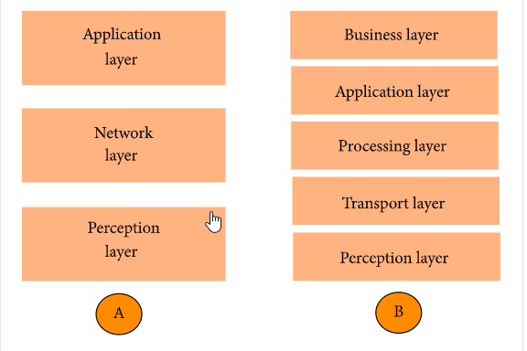
FIGURE 1
The five-layer architecture proposes an addition 3 layers the perception layer and the application layer remaining the same, to the main idea of the IoT and expands upon the network layer and the three-layer architecture. This is because the three-layer is not adequate for research purposes. The function of the remaining three layers are defined below.
(i) The business layer oversees the complete IoT structure, this includes the privacy of users, applications and profit and business models.
(ii)The processing layer is alternatively called the middlewear layer. This layer processes, analyses, and stores a extensive amount of data originating from the transport layer. It supplies and controls various sets of resources to the lower levels. This layer incorporates numerous technologies such as big data processing modules, databases, and cloud computing.
(iii)The transport layer transfers sensor data to the processing layer from the perception layer interchangeably through the use of 3/4/5G, Bluetooth, lan, RFID, NFC and wireless networks
Smart home design implication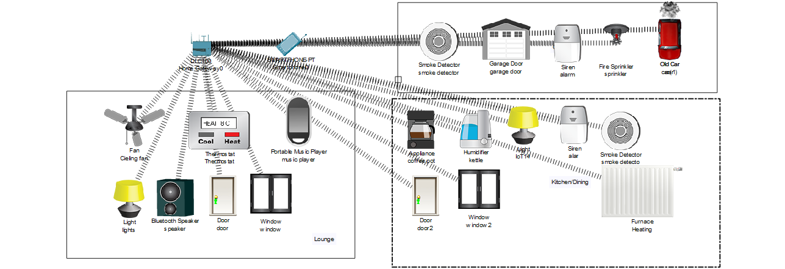
Figure 2
First thing to be added to the Cisco packet tracer was to design a lounge as shown in figure 2, where a home gateway device also known as a router to connect and be the control point to other IoT devices from the network. From here on out all wireless devices mentioned have been connected wirelessly to the home gateway and the network wireless card selected. A smartphone has been added to control wireless devices and the same SSID as the home gateway has been selected. Access to the home gateway can be tested by using the IoE monitor app inside packet tracer where once IoT devices have been registered to the network they will be listed. In the living room a ceiling fan has been added along with a thermostat. There is a rule set on the home gateway that if the temperature is set to above 15°C the fan will turn on and below that will turn off. Inside the lounge are more IoT devices which can be controlled remotely such as the opening and closing of doors, switching on and from lights and wireless speakers.
The second room to be designed is the garage. The following IoT devices have been added: smoke detector, sprinkler, alarm, garage door that can be opened and closed remotely and a old car. There has been a rule set that if the smoke detector detects a smoke level of 10 or above the alarm will go off, also if the smoke detector find a level of smoke above 10.5 the sprinkler will go off. This was tested using smoke from the old car.
The third room designed being the lounge/diner. IoT devices such as a window, kettle, coffee pot, light, alarm, smoke detector and a door where deployed. All these devices could be accessed and used remotely from anywhere to make life easier such as boiling the kettle when on the return from ones workplace.
The author intended to apply the WPA2-PSK security standard for wireless networks based on the Advanced Encryption Standard technology (AES) to all devices implemented in the Smart Home design as a form of network access protection. This protocol stops the security risks of shared passwords enables additional controls.

Conclusion
The research carried out on smart home devices, security and technologies is an occurring event as new technology continues to emerge. These devices will define the way we live life in the future. This research was carried out with the purpose to design a Smart Home in Packet Tracer. Some of the devices that may have been proposed that were unable to be used in the Packet tracer design would have been devices such as smart washing machines, where you could set your washing machine to turn on while your at work. Smart toasters and fridges where the fridge can order food on the internet when you are running out and the possibilities are endless.

Bibliography

[1] | "zigbee alliance," about, [Online]. Available: https://zigbeealliance.org/about/. [Accessed Mon 18 May 2020].
[2] | C. Allison, "The Ambient," 01 April 2020. [Online]. Available: https://www.the-ambient.com/guides/zigbee-vs-z-wave-298. [Accessed Mon 18 May 2020].
[3] | Anon, "Smart-Home Adoption Hinges Upon Consumer Education, Says Z-Wave's Klein," Twice, vol. 33, no. 7, 2018.
[4] | N. Woolf, “Mirai botnet,” The Guardian, wed 26 October 2016. [Online]. Available: https://www.theguardian.com/technology/2016/oct/26/ddos-attack-dyn-mirai-botnet. [Accessed Monday 18 May 2020].
[5] | S. Sicari, "Securing the smart home: A real case study," Internet technology letters, vol. 1, no. 3, 2018.
[6] | "Smart Home: Threats and Countermeasures," Rambus, [Online]. Available: https://www.rambus.com/iot/smart-home/. [Accessed Mon 18 May 2020].
[7] | S. R. S. Pallavi Sethi, "Internet of Things: Architectures, Protocols, and Applications," Journal of Electronic and Compter Engineering, vol. 2017, p. 25, 2017.

