Effectiveness of Agile in the Workplace
Jamie Davies (1302337)
Managing Work-based Projects (BMPF7315D)
13/09/2024

Contents
1.0 Introduction 1
2.0 Main Findings 3
2.1 Agile 3
2.2 Agile v2 3
2.3 Agile v3 6
3.0 Conclusion 9
Bibliography 10

1.0 Introduction
From the evaluation of various methodologies, it was recommended that for my role in the information technology (IT) department, an Agile approach would be the most effective management process for application development projects. This is due to its approach to continuous improvement, which helps mitigate potential risks. In their journal article, Făgărășan et al. (2021) presented the mitigation of risk overtime in comparison to the Waterfall methodology, a linear model that was concluded to be not as effective in software development projects.

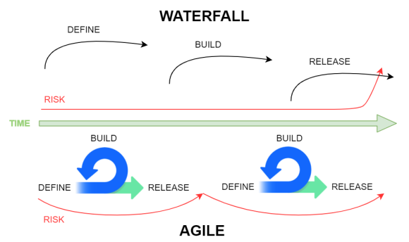
Figure 1: Risk mitigation in Agile compared to Waterfall (Făgărășan et al., 2021, p. 5).

In Agile, the risk in application development is lower towards the end of a project because the iterative nature of Agile lends itself well to continuous improvement. Feedback is incorporated at each iteration, unlike in Waterfall, where the risk accumulates and becomes only apparent upon release of the application.
However, software development environments vary, and several factors can influence the effectiveness of Agile, depending on the workplace. In my workplace, software development occurs across multiple platforms, and for the current project of developing a knowledge management system for leisure centre staff, I will be using the Power Platform. Thus, multiple frameworks, such as Scrum and Kanban, have been established to optimise application development.

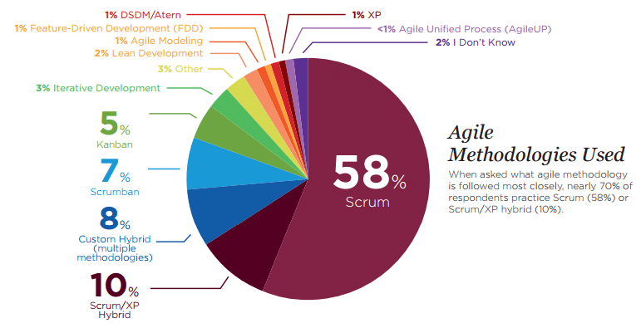
Figure 2: Most popular Agile frameworks used by software developers (Budiman and Suroso, 2017).

The results above show that no single framework fits all situations; notably, 8% of responses came from developers using multiple methodologies, likely due to the diverse requirements of software development teams. In my case, the traditional Agile framework is viable, as recommended. However, it could be improved to be more effective for Power Platform development projects in my workplace. This report will discuss the design of this project management process.

2.0 Main Findings
The findings of this report compile different variations of Agile, specifically in relation to the Power Platform, which will be used in my current project to develop the knowledge management system for leisure centre staff.

2.1 Agile
As a project that revolves around the development of software, it is recommended to utilise Agile, which has proven to be effective in delivering meaningful developments at the different phases of the project, that are flexible and collaborative (Alexander, 2023). Additionally, from this communication, Agile accounts for potential developments to the app that may come from the requests of the leisure centre staff over time. Whilst it is not a direct correlation for its success, research conducted by Serrador and Pinto (2015, p. 1046) emphasises the popularity of the methodology, in which 65% of the total projects completed by respondents included iterative aspects such as Agile.
The key aspect of this project is that app development will be done through Power Apps, a Power Platform developed by Microsoft that is intended to produce low-code solutions. The newly developed technology would allow integration with Office 365 services, which the organisation uses for its current services and solutions.

2.2 Agile v2
With this development, Microsoft has devised a project management methodology that enhances the current Agile development methodology commonly used in software development. Named “Agile v2” by Yoshida, Vivek and Osborne (2022), this methodology incorporates a familiar flow to Agile development and has similarities to the Waterfall methodology. However, the intention of this model is to enable end users to access the minimum viable product (MVP) at the earliest stage of development through Power Apps; what you see is what you get (WYSIWYG) development solution.
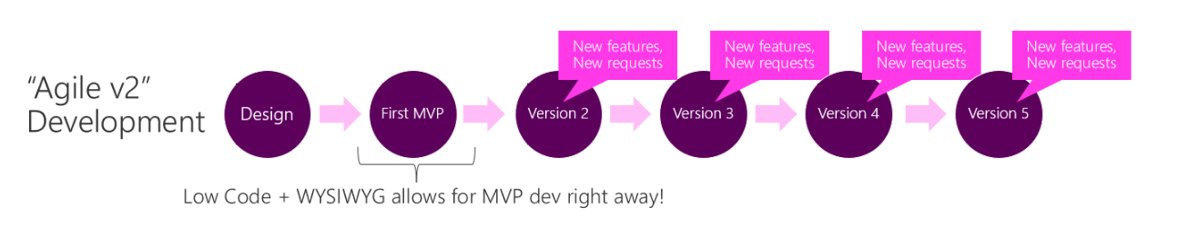
Figure 3: Methodology developed by Microsoft, dedicated to Power App development (Yoshida, Vivek and Osborne, 2022).

Having the opportunity to present software at the earliest stage of development has the benefit of allowing the end user to provide feedback throughout the entirety of the project and at each version of the app. This feedback is then incorporated as new features and requests, with the additional benefit of seamless rollback to previous versions of the application should any issues arise. Additionally, through MVPs, this improves communication and results in effective development activities (Duc and Abrahamsson, 2016). In this scenario, having constant contact with the users at each version of the application development ensures that the project meets its objectives and matches the needs of the stakeholders.
In my organisation and within the software development role, project management and particularly communication have often been an afterthought. Agile v2 is a feasible methodology because it encourages continuous user engagement throughout the project's lifecycle. In contrast, previous projects followed the Waterfall methodology, where engagement and testing occurred only in the last phase before publishing the application. This approach often extended project timelines, as feedback during these late stages could require significant changes or even lead to the project's dismissal.
Although Microsoft presents the advantages of this kind of delivery, the rollout of an MVP does have negatives that should be considered, especially in this organisation. Firstly, being a new technology that hasn’t yet been fully tested in the organisation means that first impressions are essential. If the MVP does not match the expectations of the end users, then there is a possibility that the app could be rejected at the first phase. Lastly, Agile v2 is only suitable for solutions that revolve around WYSIWYG. App development that requires extensive periods of time to return an MVP would not benefit from this methodology because the turnaround time for an MVP is substantially greater.
Despite being named Agile v2, the methodology is less iterative than its predecessor. Each version of the application is its own stage, and any updates from the feedback are carried over to the next version. Like the Waterfall cycle, Agile v2 steps are not repeated, and reverting to previous versions of the application development simply adds an additional version/step to the lifecycle of the methodology. Unfortunately, as a result, project planning and scoping are more difficult because the application could have many requests and feedback, leading to a constantly ongoing project. Moreover, in relation to each version, there is no clarity as to what the next step entails, which can result in not only miscommunication but scope creep (NineFeetTall, 2023).
Many projects in the organisation have fallen to scope creep, whereby the requirements for that application have exceeded the initial scope of the project. Consequently, the timeline for these projects was increased, leading to delays in other work priorities. Additionally, having no project end essentially means that there is no end for the project, which could affect other commitments. To ensure that Agile v2 reflects the size and complexity of a Managed Work Project (University of Waterloo, 2024), it is vital to update this methodology with a concrete end.
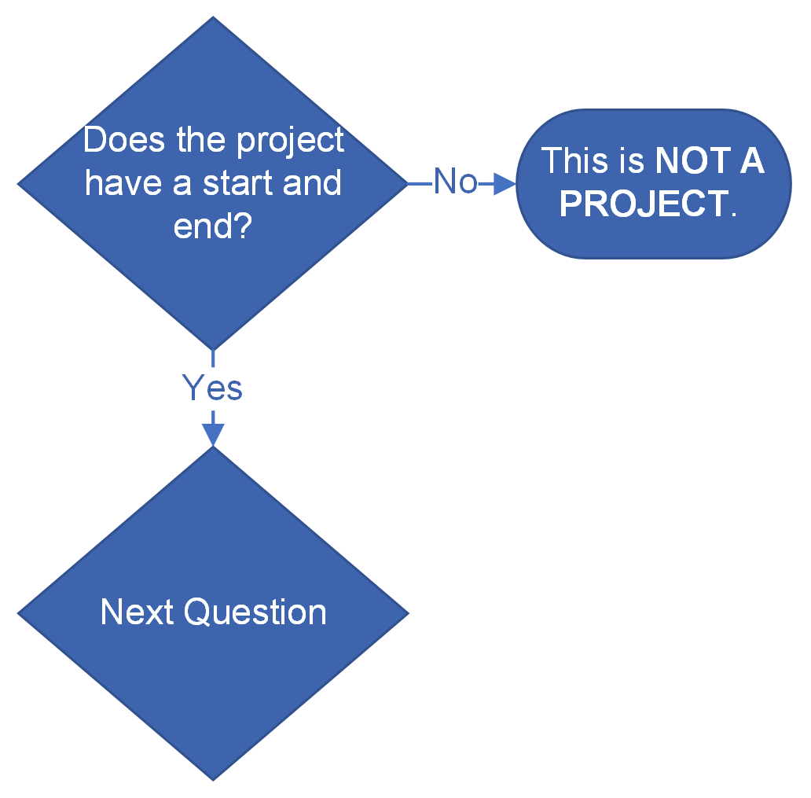
Figure 4: The first question used by the University of Waterloo (2024) to determine project sizing and complexity asks if the project has a start and end.

According to the University of Waterloo (2024), a task without a defined start and end is not considered a project. Instead, it is viewed as a commitment that can be completed without the need for the methodologies or processes highlighted.

2.3 Agile v3
To meet the needs of the current project, below is the development of a custom methodology tailored to the requirements of Power Apps. The methodology will be called Agile v3. With this methodology, when collecting the requirements of the project, it is critical to limit the requirements so that an MVP can be delivered.
In this methodology, the MVP is the end of the project. After collecting the requirements to produce the MVP, the application is developed through Power Apps, and once the requirements from the first stage are achieved, the app is demonstrated to the end users. From the demonstration, users are then asked to present feedback on the current build. If users are not satisfied with the product in relation to the requirements set out in the scoping step, then the process is repeated until users are satisfied with the app. The application reaches the end phase once the app has been published and staff are able to use the application as scoped in the requirements phase. It is important to incorporate the feedback stage into the methodology because it ensures that communication is maintained between myself and the customers. Moreover, it ensures the highest quality MVP by meeting the requirements to the highest standards possible.

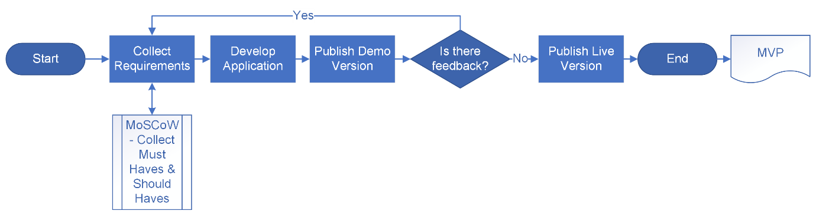
Figure 5: The structure of the Agile v3 methodology.

When we follow the above methodology, the issue of scope creep will be mostly mitigated because when collecting requirements, they are limited to providing the MVP. Thus, during the collect requirements stage, I will need to create a list of essential features that the application will need to effectively function for the leisure centre staff. This clarity will allow me to understand what needs to be developed. Furthermore, it would allow me to understand that new requests and features that would further enhance the application must come after the MVP has been delivered and the closure of the project. Therefore, instead of waiting until further development cycles (Komodo, 2024), these features would be classified as separate projects.
To determine the requirements of my current project, I will utilise the Must-Have, Should-Have, Could-Have, and Won’t-Have (MoSCoW) method (Miranda, 2022) with the aim of “helping to understand and manage priorities” (Agile Business Consortium, 2024) of the project. As the name suggests, it will allow me to categorise potential features and requests into the four different categories, making the project more manageable, but more importantly, determining the collected requirements of the MVP in the Agile v3 methodology. This will enable the project delivery and completion. Therefore, as Power Apps is a new technology used within the organisation, it is important to leave a good first impression; thus, features and requests listed as must-haves and should-haves will be accounted for as the MVP for the application. In common Agile practices such as sprint, MoSCoW is implemented through prioritisation and backlogging.

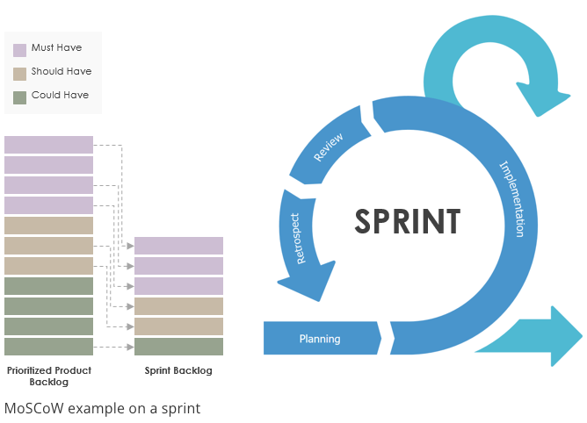
Figure 6: An example of how MoSCoW is implemented in sprint (Visual Paradigm, 2018).

Agile v3 enables streamlined processing because could-haves are ignored, in which these features will need to be implemented in future projects. When it comes to publishing a demo version for feedback, access will be given to only the client who requested the application. This ensures that feedback is only relevant to the collected must-haves and should-haves from the Collect Requirements stage. Lastly, if no feedback is given relating to those requirements, then the application is published and then the project is closed.

3.0 Conclusion
In my previous essay, I concluded that in my current IT role, the Agile methodology is most suitable for managing application development. Unlike linear models, Agile enables continuous improvement, which is essential to improving an application throughout its development and reducing risks. Multiple Agile frameworks have been developed through recognition that each project is unique; thus, establishing the correct framework enables the optimisation of software development. In my role, I work with multiple systems; currently, I am working with the Power Platform, and while a traditional Agile framework is suitable, it could be further tailored to my workplace.
Under the Power Platform is Power Apps, which is a low-code solution by Microsoft for developing applications with the intention of delivering the MVP after designing the application. Microsoft has developed a framework called Agile v2. It is structured similarly to the Waterfall methodology but maintains the continuous improvement of Agile by accommodating additional features and requests at each stage after the MVP is delivered, thereby mitigating risk buildup. Unfortunately, this approach can lead to scope creep, as leisure centre staff may continue providing requests and feedback, leading to a project that never ends.
To address the drawbacks and improve the applicability of Agile v2, I have developed a new model called Agile v3. This version aligns with the needs of a current managed work project. Agile v3 retains the Waterfall structure and continuous improvement of Agile v2, but also includes a defined project closure upon the publication of the MVP. It also mitigates scope creep by limiting the collected requirements down to must-haves and should-haves from the MoSCoW model; could-haves would be implemented in potential future projects. By implementing Agile v3 in the workplace, I can effectively prioritise and streamline the development of a Power App application, ensuring that development efforts are concentrated on the features that deliver the most value to the organisation.

Bibliography
Agile Business Consortium (2024) Chapter 10: MoSCoW prioritisation. Available at: https://www.agilebusiness.org/dsdm-project-framework/moscow-prioririsation.html (Accessed: 6 August 2024).
Alexander, M. (2023) Agile project management: principles, benefits, tools, tips, and when to make the switch. Available at: https://www.cio.com/article/237027/agile-project-management-a-beginners-guide.html (Accessed: 24 July 2024).
Budiman, T. and Suroso, J.S. (2017) 'Optimizing IT infrastructure by virtualization approach', IOP Conference Series: Materials Science and Engineering, 190(1), p. 12012. Available at: https://doi.org/10.1088/1757-899X/190/1/012012.
Duc, A.N. and Abrahamsson, P. (2016) Minimum viable product or multiple facet product? The role of MVP in software startups. Edinburgh, 2016. Cham: Springer International Publishing, pp. 118–130.
Făgărășan, C., Popa, O., Pisla, A. and Cristea, C. (2021) 'Agile, waterfall and iterative approach in information technology projects', IOP Conference Series: Materials Science and Engineering, 1169(1), pp. 4–6. Available at: https://doi.org/10.1088/1757-899X/1169/1/012025.
Komodo (2024) What is scope creep and how to address it. Available at: https://www.komododigital.co.uk/insights/what-is-scope-creep-and-how-to-address-it/ (Accessed: 6 August 2024).
Miranda, E. (2022) 'MoSCoW rules: A quantitative exposé', in Stray, V., Stol, K., Paasivaara, M. and Kruchten, P. (eds.) Agile Processes in Software Engineering and Extreme Programming. Switzerland: Springer International Publishing, pp. 19–34.
NineFeetTall (2023) Importance of clarity and scope of projects. Available at: https://www.ninefeettall.com/the-importance-of-clarity-and-scope-of-projects/ (Accessed: 1 May 2024).
Serrador, P. and Pinto, J.K. (2015) 'Does agile work? — A quantitative analysis of agile project success', International Journal of Project Management, 33(5), pp. 1040–1051. Available at: https://doi.org/10.1016/j.ijproman.2015.01.006.
University of Waterloo (2024) Project sizing and complexity. Available at: https://uwaterloo.ca/vpaf-project-management-office/methodologies/project-sizing-and-complexity (Accessed: 1 May 2024).
Visual Paradigm (2018) How to prioritize product backlog using MoSCoW method. Available at: https://www.visual-paradigm.com/scrum/prioritize-backlog-with-moscow/ (Accessed: 6 August 2024).
Yoshida, T., Vivek, K. and Osborne, K. (2022) Differences between Power Apps and traditional app development approaches. Available at: https://learn.microsoft.com/en-us/power-apps/guidance/planning/app-development-approaches (Accessed: 1 May 2024).

