

Applied Computing
Wales Institute of Science and Art (WISA)

ACCA6023

Design, Configure and Troubleshoot Multiarea OSFP

Objectives:
Part 1
- Design network as per the topology stated
- Configure Basic security and connectivity Tasks
Part 2
- Configure Multiarea OSPFv2
- Verify and Examine Multiarea OSPFv2

Part 1
- Create a topology and assign IP Address as stated in the below design.
- Configure Hostnames, Line, passwords, banner, security and activate the network.
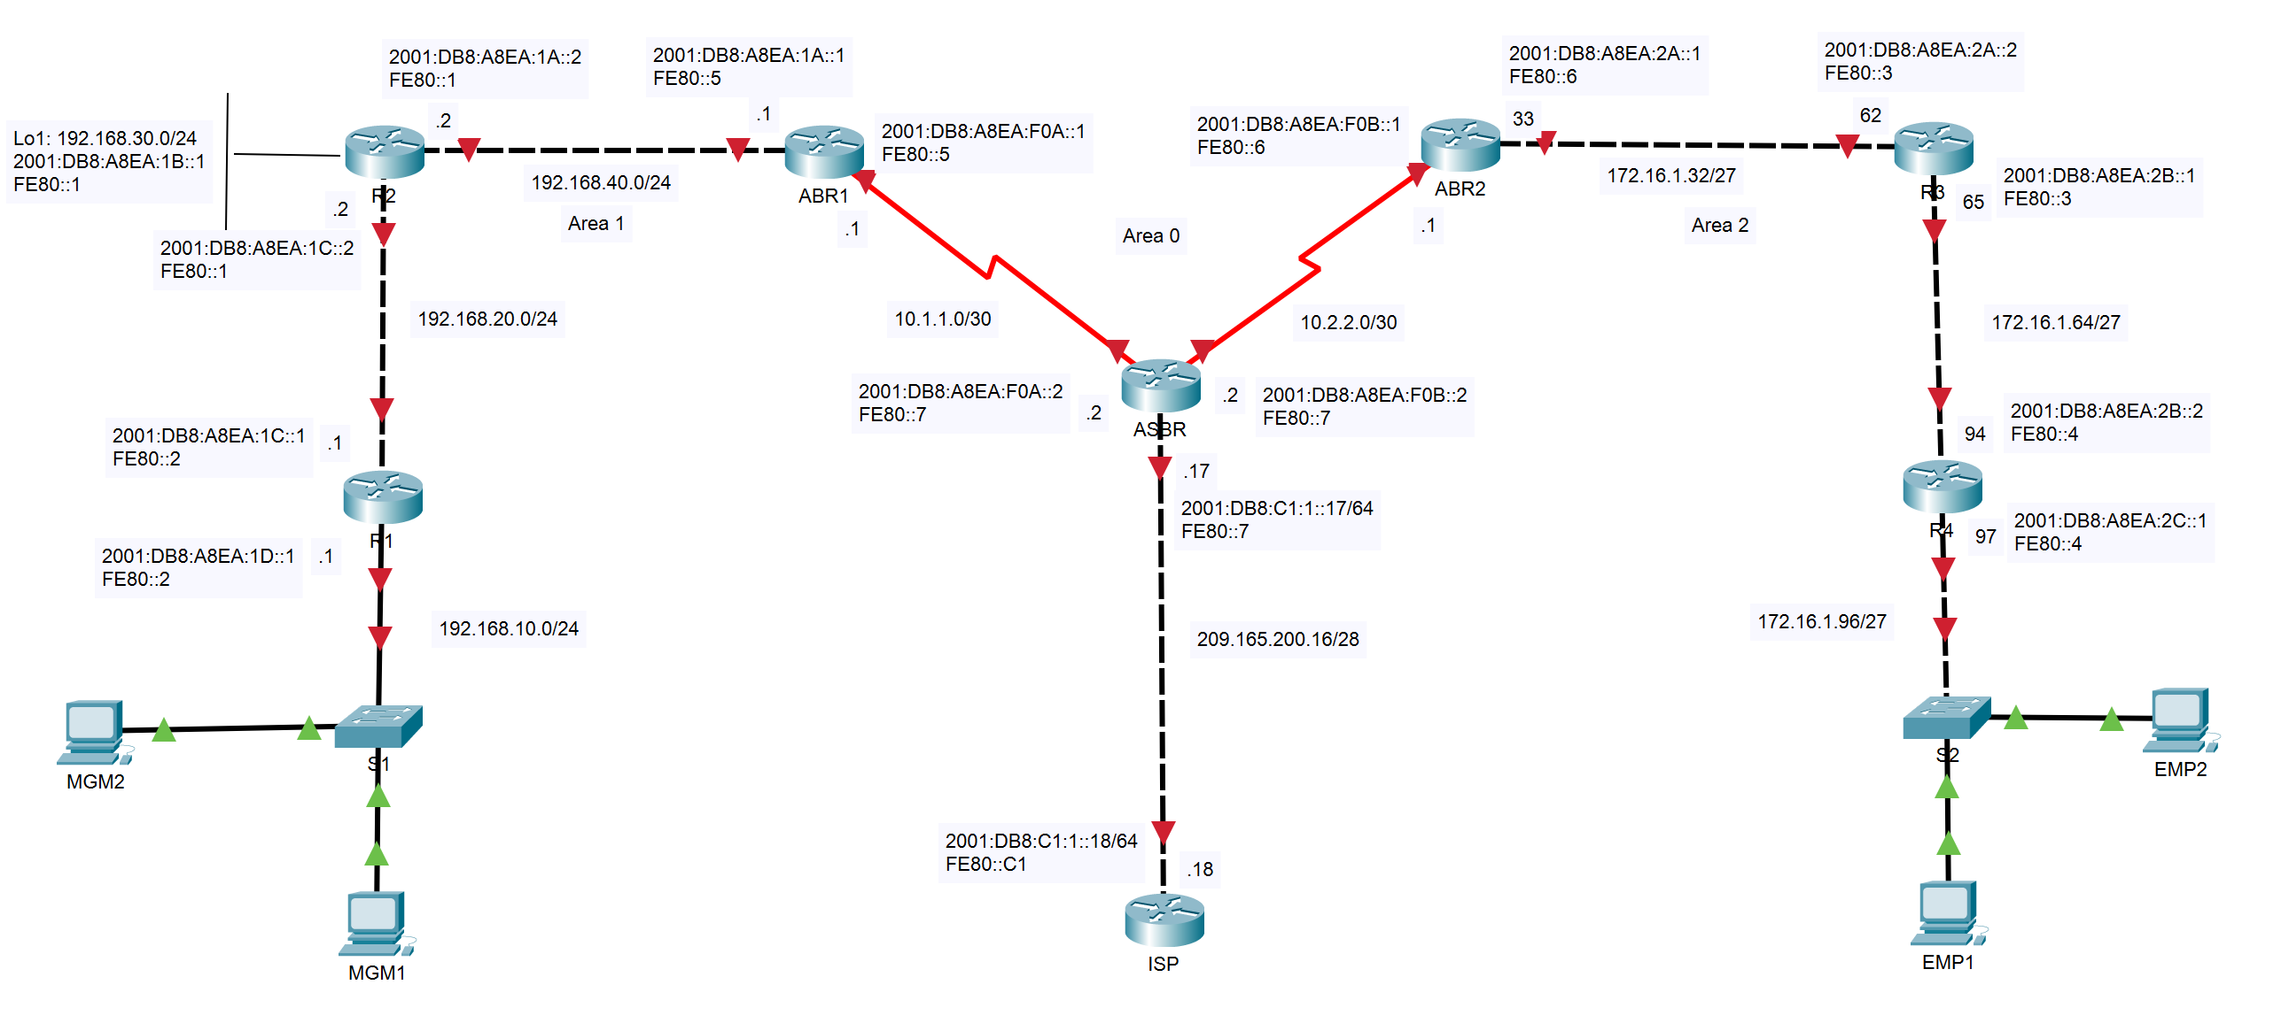
Part 2
- Configure OSPFv2
Use the following requirements to configure OSPF routing on all routers:
- Process ID (as required)
- Router ID for each router (as required)
- Network address for each interface
- LAN interface set to passive (do not use the default keyword)
- Advertise each directly connected network in OSPFv2 (as required).
- Verify connectivity to each of the OSPFv2 areas.
- Record the command used to configure and verify the connectivity.
- Repeat the step from 4 to 7 and configure OSPF v3.

OSPFv2 Configuration
router ospf 1
router-id 1.1.1.1 (Must be unique – 32 Bit)
network Network Address Wildcard Mask area Area Number
default-information originate (For a Default Route – External Network ASBR)
passive-interface Gi0/0/0
interface GigabitEthernet0/0
ip ospf hello-interval 5
ip ospf dead-interval 20
ip ospf priority 150

OSPFv3 Configuration
ipv6 unicast-routing
ipv6 router ospf 1
router-id 2.2.2.2
interface GigabitEthernet0/0
ipv6 ospf 1 area 0
interface Serial0/0/0
ipv6 ospf 1 area 0
Troubleshooting Commands
OSPF v2
show ip ospf neighbor
show ip protocols
show ip ospf
show ip ospf interface
OSPF v3
show ipv6 interface brief
show ipv6 protocols
show ipv6 ospf interfaces brief
show ipv6 ospf neighbor
clear ipv6 ospf process
show ipv6 route
show ipv6 route ospf
show ipv6 ospf database

