Changemakers: Creativity and Value Creation

Thomas Sellwood (2215661)
bsc computing (data and information systems)
2023

Contents
Contents 1
E-Portfolio Link 1
E-Portfolio Screenshots 2
 2
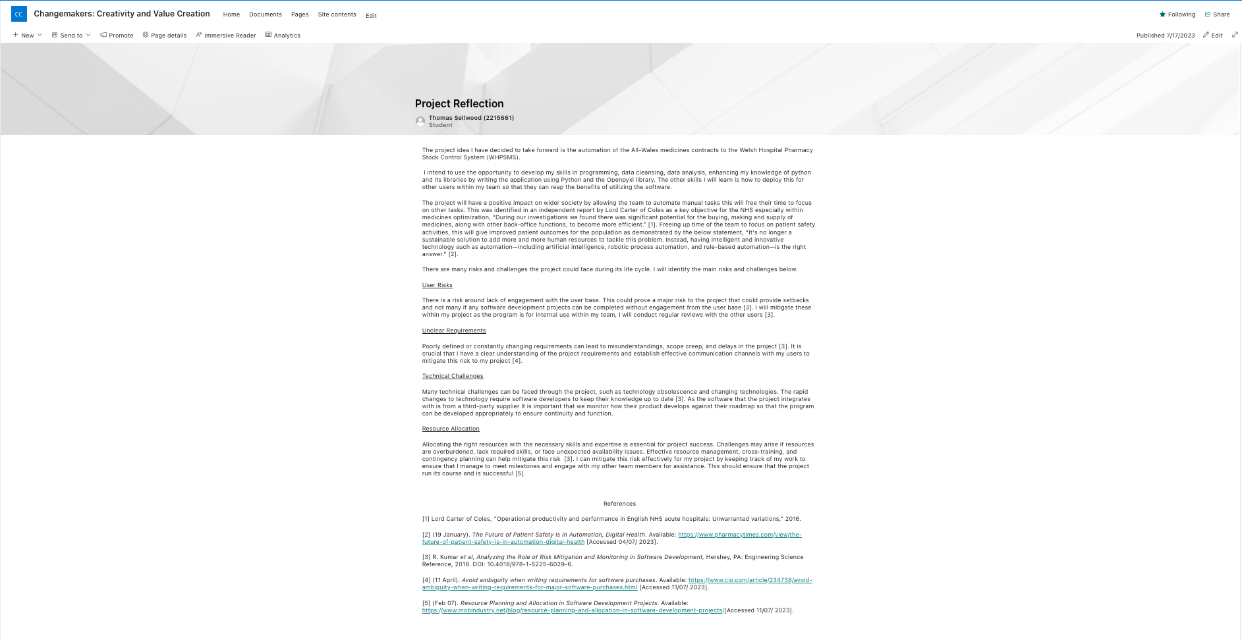 3

E-Portfolio Link
https://uowtsd.sharepoint.com/sites/ChangemakersCreativityandValueCreation

E-Portfolio Screenshots



