
Skills for the Workplace
Module Assignment Submission
Student Name: | LARISA LEPARDA
Student Number: | 1808629
Module No: | BMSK4003
Module Title: | Digital skills and research method
Lecturer: | Anupam Mazumdar

Statement of Confirmation of Authenticity
By the act of making this submission, the student declares that this is the work of the student named above. The work has not, in whole or in part, been knowingly presented elsewhere for assessment, or where assessment has been built on a previous assessment, this has been identified. Where materials have been used from other sources it has been properly acknowledged. If this statement is untrue, the student acknowledges that an assessment offence has been committed.
Attention is drawn to the plagiarism and unfair practice policies of both the University and of ILM.

Table of contents

• Introduction
• Definition and example of modern technology
• Effectiveness of the use of modern technologies at workplace
• Social media as a tool for marketing
• Creating their own professional online presence
• Conclusion
• References

INTRODUCTION
Modern technology is simply an advancement of old practical applications. The effect of technology in modern life is immeasurable that utilize in various ways. People utilize these applications on regular basis to achieve specific tasks or interests. Due to increased benefits and newfound popularity, modern and developed practical applications replace past utilized technology (Drummond and et.al., 2015). This study is based on the effectiveness of the use of modern technologies in the context of health and social care. This report will explain the definition and example of modern technology as well as its effectiveness in health and social care. It will state that social media as a tool of marketing for health and social care.
Definition and example of modern technology
Modern Technology:
Modern technology is the promotion of old technology with new additions and alteration. Any type of device is the good of modern technology. The impact of technology is modern life is immeasurable that utilize practical applications in various ways and implement different technologies for damage than products (Ramey, 2012). On regular basis, people utilize practical applications to achieve particular activity or interests. Due to increase benefits or new found popularity, modern and developed technology regenerate past utilized practically. Modern technology utilized by not only students but also health and social care to the safety and welfare of people.
Example of modern technology:
There are many examples such as cloud, dropbox, idrive etc. used in health and social care.
Dropbox: It is one of the most identifiable names when it comes to determining cloud services providers. It is utilized at the business around the nation as a mode to gain access and edit files from one central user-friendly place. Healthcare professional has long identified the possibilities for improving the level of patient care. In future days, file sharing is likely to raise non-affiliated hospitals (Fremonti, 2017). Dropbox is attached to keep the public's information safe, health care organizations still require to be careful.
Cloud Technology: It is essential to health and social care to change the way of doctors, nurses, as well as hospitals, deliver quality and cost-effective services to their patients. The cloud has capacities to revolution healthcare for improving patients experience by giving services equal to those offered by internal information technology companies yet at significantly lower costs. Healthcare providers implement cloud solution includes important modifications in the processes (Wherton and et.al., 2015). Due to lack of funds, healthcare providers incline to avoid capital expenses on new technology. Cloud technology is beneficial for transforming services delivery in relation to decrease capital expenses and leveraging existence assets. It is advantageous to control the cost of operation, ongoing development, delivery services.
IDrive: Healthcare installation is under rising pressure to develop their operation strategy such as switching of electronic medicine, creating an online appointment, executing removed medicines and storing a huge number of records of patients that are important to sustain in the modern medical area. Healthcare professional is under continual pressure to safeguard their essential files. Idrive assists with a reliable online backup solution to protect information with compliance attachment. Healthcare providers utilize this modern technology to physical safeguard, control, and measures technical security unauthorized utilization and revealing information.
Health Information Technology (HIT): It is information technology implement health and social care. This technology helps to improve quality and effectiveness, raising productivity or efficiencies as well as costs of healthcare. Healthcare providers utilize HIT to increase efficiencies of management and procedures of well-being work. It helps well-being information administration across processed systems and secure exchange data relating to health between customers, providers as well as a quality monitor.
The effectiveness of the use of modern technology
Health and social care provider utilize various modern technologies such as cloud technology, dropbox, idrive, health information technology(HIT) for improving efficiencies and productiveness of health and social care services. It also helps to prevent medical mistakes and raising accuracy and procedurals correctness healthcare. These technologies expand access to affordable care and reduce paperwork and unproductive work time. All these technologies are more beneficial in an effective manner.
Cloud Technology: It is an example of modern technology that is more beneficial to health and social care. Because of, it increases speed and flexibility of evolving and giving new services to patients. It is managing customer relationship over the cloud that is billing efficiently. Cloud technology reduce capital expenses and leveraging existence assets. It is the key to transform and delivery of health and social care services (Yonker and et.al., 2015). Cloud technology increase the agility of business, improve information management as well as decrease operating risks. Cloud brings powerful information technology resources to healthcare providers. By optimize availability of resources with minimum delay and waste, cloud technologies help to increase business agility.
Health Information Technology: HIT is also more beneficial to health and social care. Because of, it shares health info between patients and providers aids to better diagnosis, promote self-care. It is also good for detection of infected disease outbreak across the nation, improve tracking of degenerative disease administration. HIT is more beneficial for improving the quality and effectiveness of health and social care (Beard and Bloom, 2015). For reducing healthcare events and improve quality of care, providers implement healthcare information technology. It is extended real-time communication of well-being information processing among healthcare professionals.
IDrive: It is also more beneficial to health and social care in relation to protecting information and records to patients. It helps with a reliable online backup solution to protect data with compliance supports. Idrive is more advantageous because of, healthcare providers set private key encoding, control and measures technical security of unofficial utilization and disclosure of consumer information.
Dropbox: It is also good for health and social care in relation to sharing the information of health between patients. It is also a perfect platform for backing up data. Dropbox is committed to keeping information on the safety of public and healthcare organizations. This technology helps to secure info about health because of, average patients are more concerned about their overall well-being. It is beneficial for identifying possible for improving the level of healthcare of patients.
Therefore, these technologies help to improve the quality and efficiencies of health and social care services (Hollis and et.al., 2015). These practical applications aid to protect information about the health of people. These technologies assist to increase productiveness and effectiveness of well-being.
Social media as a tool for marketing
Every individual uses social media in their business as a tool for marketing. Therefore, social media also utilized in health and social care. Social media help to engage patients, providers and public with relevant and timely data as well as communicate the value and credibility of the health system for the healthcare industry. There are many ways to social media works as a tool for marketing of well-being and societal care.
Engage with patients: Social media marketing is more beneficial in healthcare to communicate and engage with existing patients. Health systems assist patients empowerment be allowing and engaging in patients forums and research network online. It allows patients to manage their well-being conditions be discussing treatment with whom have similar situations. Healthcare provider can develop their social media platforms that allow patients to share their experience and receive help from the same individual (Girardi, 2017). Therefore, healthcare firms make sure that monitor these platforms to respond to patients in a timely manner to successfully engage patients on social media networking sites. Healthcare providers utilize social media networking pages along with a forum to promote patients discussions. With the help of it, healthcare providers more utilize social media network to engage more people.
Facilitate physician collaboration: Healthcare providers also utilize social media channels to encourage physician alignment and cooperation. Social media is a simple way for physicians to discovery and link with other health professionals as well as external of their own health system. The medical practitioner also shares their knowledge or research to benefit other providers. These practices improve the physician's knowledge and disposition to work as a team. Educate medical practitioner are provided their experience and quality of care to the patient so that they feel happier towards their services (Glasby, 2017). Therefore, healthcare professional utilizes social media networks for promoting physicians collaboration to give better experiences in relation to foster loyalty and retention to patients. Thus, social media channels improve physicians involvement and alignment for giving better health and social care to patients.
Preventative health initiatives: Many social media websites are public communications platforms which are reached broad intelligence of individuals. Healthcare companies utilize this marketing actions to help wider population well-being and preventative health edge. Social media help to communicate educational data relating to health cases and crises. Healthcare firms utilize social media to deal with time-sensitive well-being and promote data sharing to advance behavioral changes. This allows the public to give useful data and feedback about healthcare services. Social media is a useful platform for communication between offices and laws to exchange information about healthcare facilities. Healthcare companies also utilize social media as a platform to deal with data about common well-being conditions, diseases and other issues in promises of preventing these happen.
Creating professional online presences
Healthcare organizations make efforts to create their online presences for increasing productivity and quality of healthcare. For creating online presences, organizations adopt many ways in the workplace.
Understand what's out there: It makes sense that they had gone online to get some answer when a person gets sick. If an illness happens outside of office hours, so that, this especially true. Patients have issues with their health insurance while the person is traveling. But this study makes patients psychotic and lead to reside with self-diagnosis. By this way, it is essential to create online presences by healthcare providers.
Start with care: When patients do their own research before contacting healthcare professional so that it occurs misinformation. Therefore, healthcare providers able to steer patients towards coming in their office at least contacting with a question (Hansson, Höög and Nyström, 2017). After the individual leaves office, so they need to direct on giving the best experience possible while negative reviews occur. Through this, it is necessary to create online presences by healthcare providers.
Update social network: It is necessary to update social network for creating online presences. Not only a social network but also update LinkedIn by healthcare providers. This also helps to know about education and experience as well as thoughts of patients. Therefore, companies provide this information on LinkedIn.
Build a personal website: It is the best way to create online presences is to build personal website proactively that can function as a web-friendly resume. This website put a name for any healthcare facility considering hiring people (Nelson and Staggers, 2016). Healthcare providers utilize platforms like Squarespace and Weebly as well as physicians particular site such as iHealthSpot.
Claim profiles: It is needed to claim profiles on Yelp, ZocDoc and other sites by the healthcare organization. So that, patients are reviewing their doctors online. Healthcare providers are promoted to claim their profiles on Yelp. By this way, providers add correct information involving hours, specialties and other. Thus, healthcare organizations also claim profile on Google, ZocDoc and other review sites.
Proactive Online: most of the work happens in person that are patients as healthcare providers. Thus, they are going online to research before step into office and writing reviews. Therefore, healthcare providers want to take stock of what's out there, check their social media profiles, build website and claim profile on review websites (Beard and Bloom, 2015).
Therefore, healthcare providers need to create their online presences, so that people are aware of their organizations and its facilities. By this way, people know information about treatment and medicines as well as company reviews online.
https://www.facebook.com/Health-and-happy-368057850621094/?ref=bookmarks
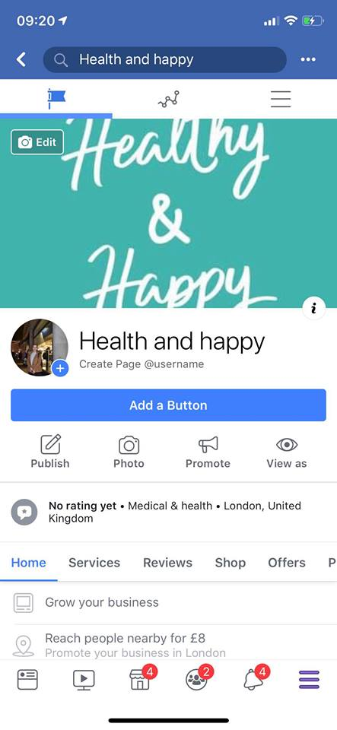https://www.linkedin.com/feed/?trk=hb_signin
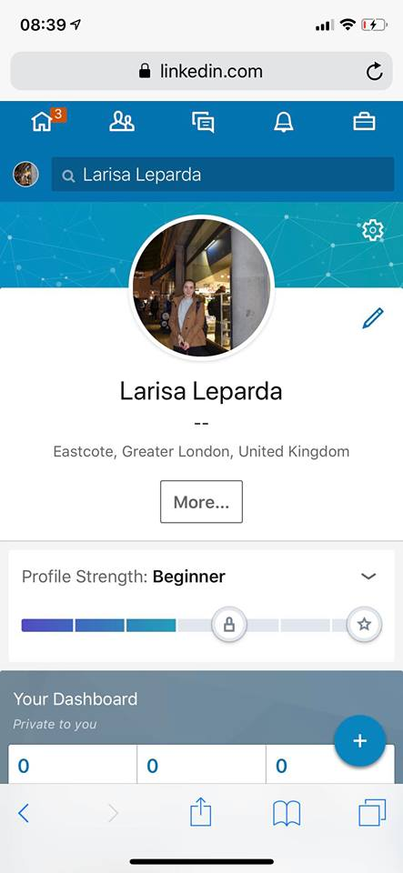

CONCLUSION
This report has summarised that meaning of modern technology and its various examples such as Dropbox, Cloud Technology, Idrive, Health Information Technology (HIT) that have utilized in health and social care. It can be concluded that the benefits of these technologies in health and social care organizations. It can be discussed that different ways such as Engage with patients, Facilitate physician collaboration, Preventative health initiatives to use social media as a tool for marketing in healthcare. Furthermore, a report has completed that various techniques that include Understand what's out there, Start with care, Update social network, Build a personal website, Claim profiles, Proactive Online for creating online presences utilized by healthcare providers in the workplace.

REFERENCES
Books and Journals
Beard, H. P. J. R. and Bloom, D. E., 2015. Towards a comprehensive public health response to population ageing. Lancet (London, England). 385(9968). p.658.
Drummond, M. F. and et.al., 2015. Methods for the economic evaluation of health care programmes. Oxford university press.
Glasby, J., 2017. Understanding health and social care. Policy Press.
Hansson, J., Höög, E. and Nyström, M., 2017. Action research for multi-level facilitation of improvement in health and social care: Development of a change facilitation approach for a local R&D unit. Action Research. 15(4). pp.339-356.
Hollis, C. and et.al., 2015. Technological innovations in mental healthcare: harnessing the digital revolution. The British Journal of Psychiatry. 206(4). pp.263-265.
Nelson, R. and Staggers, N., 2016. Health Informatics-E-Book: An Interprofessional Approach. Elsevier Health Sciences.
Wherton, J. and et.al., 2015. Co-production in practice: how people with assisted living needs can help design and evolve technologies and services. Implementation Science. 10(1). p.75.
Yonker, L.M. and et.al., 2015. “Friending” teens: systematic review of social media in adolescent and young adult health care. Journal of medical Internet research. 17(1).
Online
Fremonti, G., 2017. Dropbox in Healthcare: What File Sharing Means for Patients [ONLINE]. Available technology. : <https://blog.primefactors.com/dropbox-in-healthcare-what-file-sharing-means-for-patients> [ACCESED 5 DICEMBER 2018].
Girardi, C., 2017. 3 Ways Social Media Can Improve Healthcare Marketing Efforts. [ONLINE]. Available technology. : <https://www.evariant.com/blog/best-practices-social-media-healthcare-marketing/> [ACCESED 5 DICEMBER 2018].
Ramey, K., 2012. Modern Technology. [ONLINE]. Available technology. : <https://www.useoftechnology.com/modern-technology-advantages-disadvantages/> [ACCESED 5 DICEMBER 2018].

