Niamh Thomas
2204956
BA Musical Theatre
Material

Cabaret Material

First sessions: Building a brand for our group and deciding what’s suitable for our brand and how we promote it best.

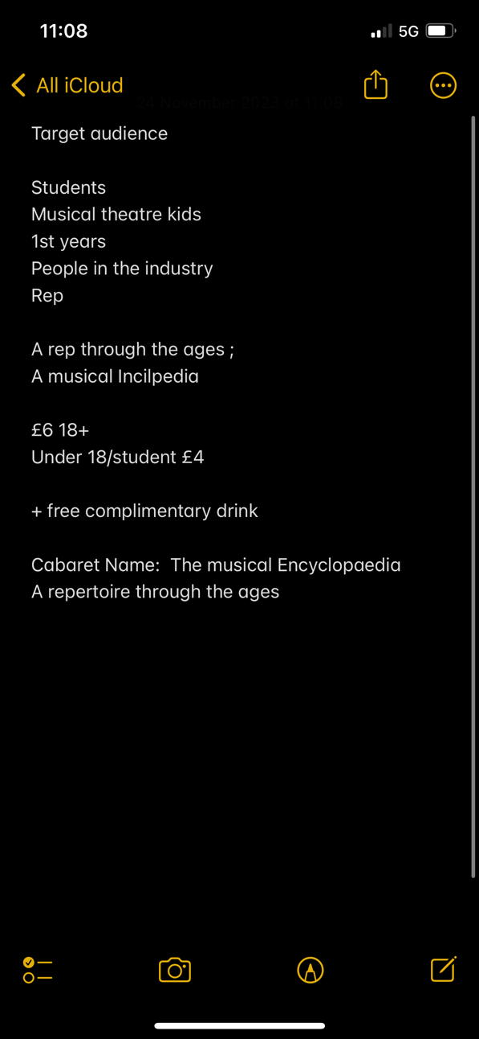

Soon after deciding details and information regarding our event, we quickly decided on our poster and how we were going to present our brand. The following images are our ideas and the final poster which was created by our group.

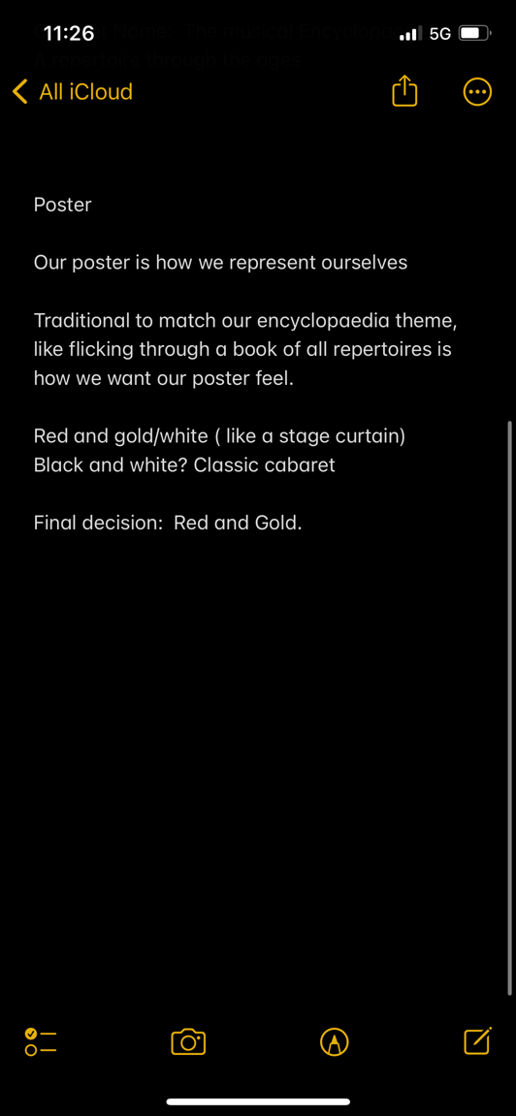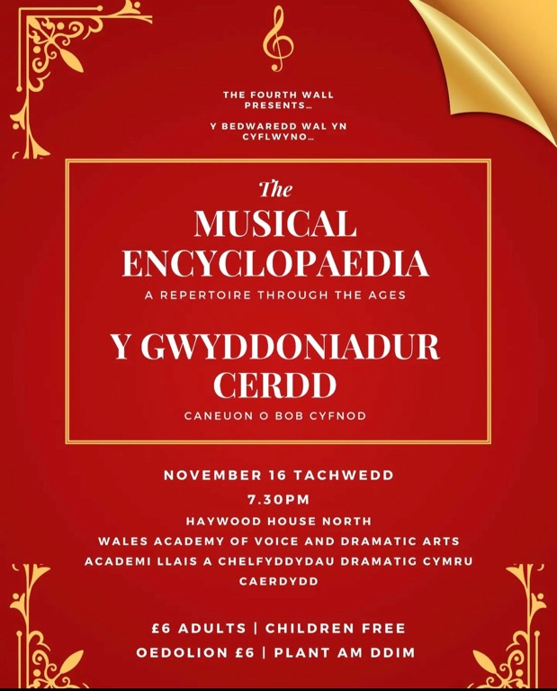

Promoting our brand
Here’s some ideas of how we decided to promote our event in the most professional way, we decided that we would reach our target audience through Instagram, therefore we created an account. With our brand name and our poster as our logo, representing us professionally as a team. Here’s the link to our Instagram account.
https://instagram.com/the4thwall_wavda_?igshid=MzMyNGUyNmU2YQ==

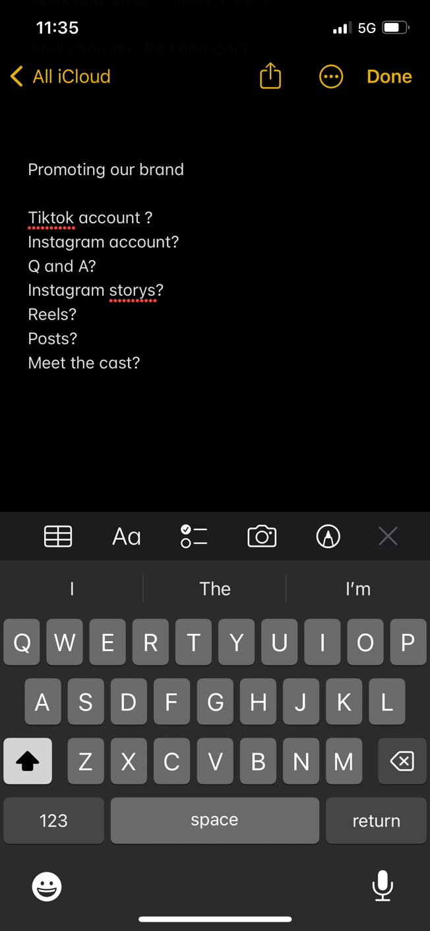

Our first post, which we collectively decided on as a team.
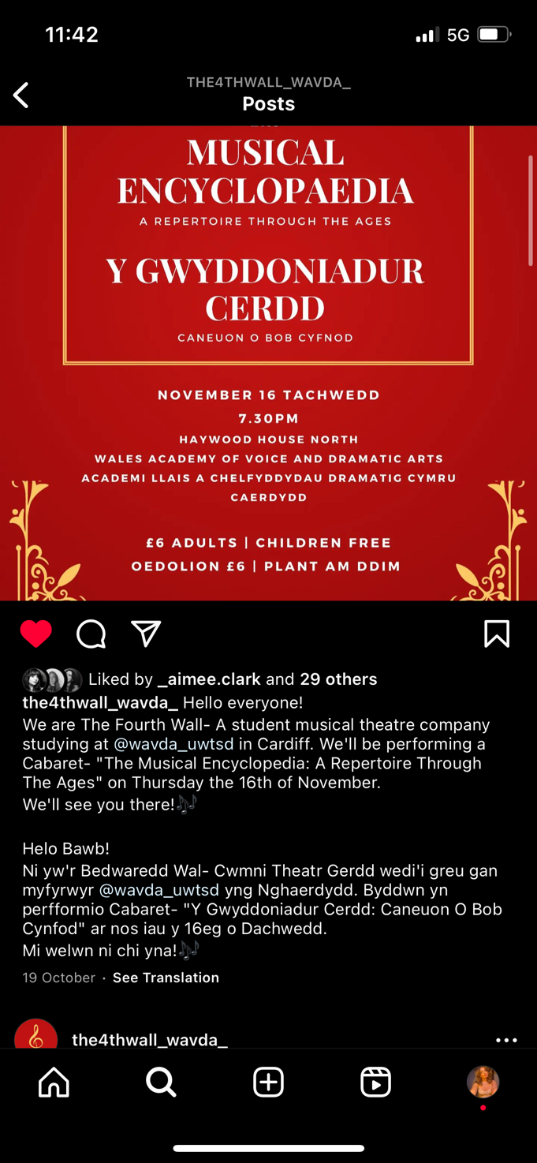

Here’s some rehearsal photos which we shared on Instagram, to encourage and make people feel excited about our coming project. Presenting our names, and sneak peaks of what we’re working on to present to our audience.

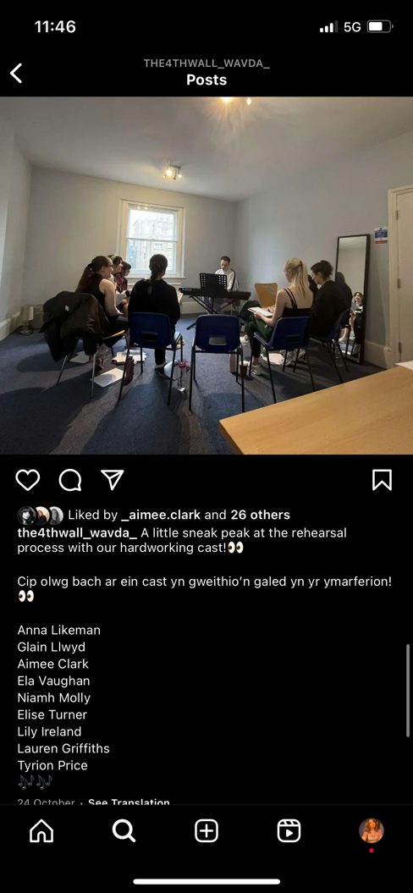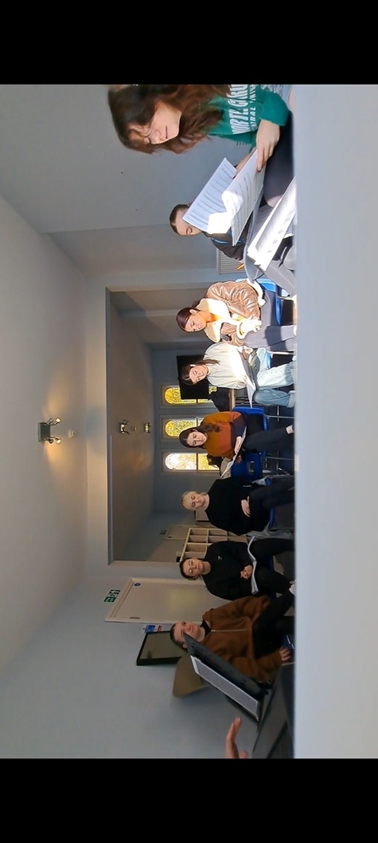

Meet the Cast

9 days before showcasing our work, as a team, we decided to introduce the cast on our Instagram, as a bit of information about ourselves and a hint of what we were performing, we decided to do 1 person today as a countdown from our performance.
Here’s my post and the questions I answered. All of the ‘Meet ‘the Cast’ posts are on our Instagram account.

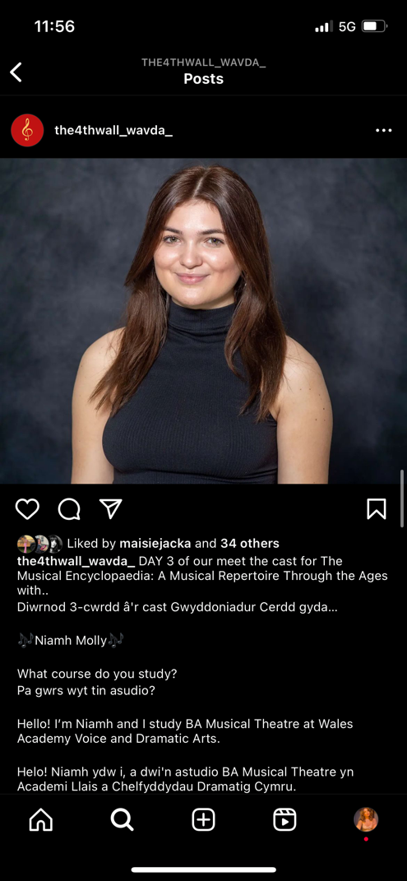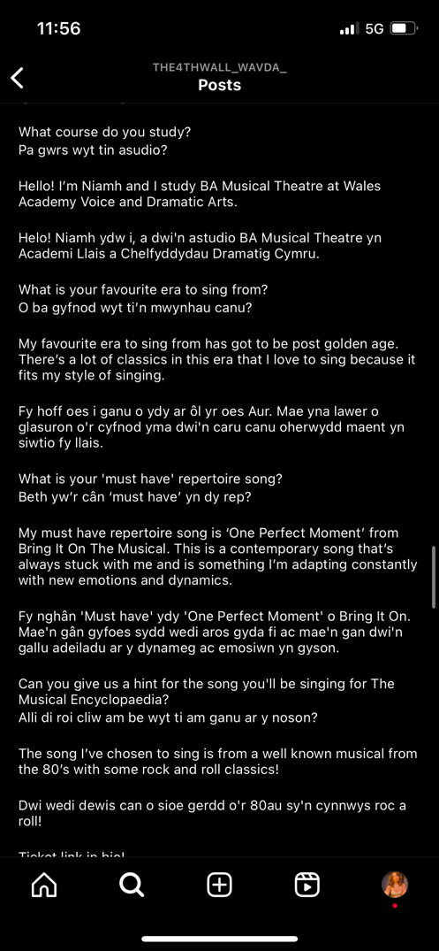

Programme
We decided to write a bit about ourselves in our programme, telling the audience about our chosen song and all our company numbers. That our programme looked more striking if our writing was red as it was matching our cover and our poster. Here’s my written section in the programme.
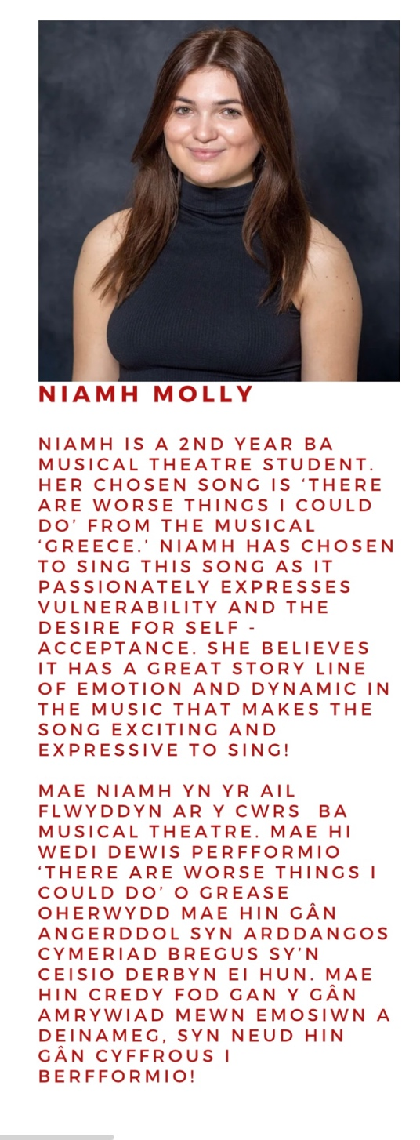

Here’s the cover and the running order which is in the programme, all created and decided by our group
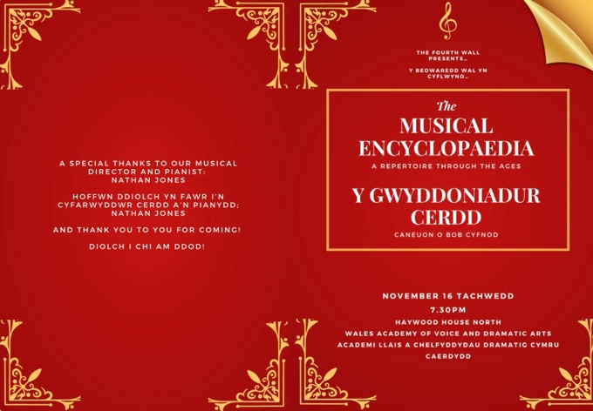
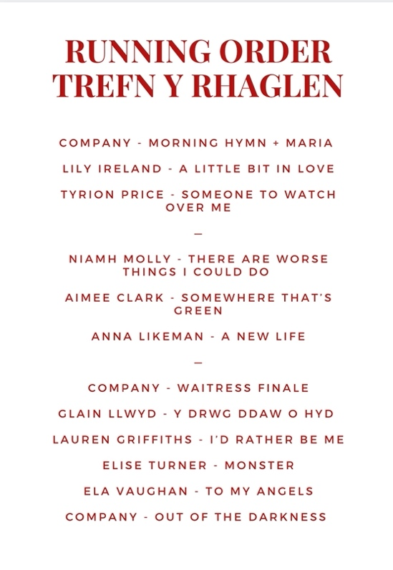

The Performance

Here’s a photo of us before our performance and our last post on our Instagram account.



