MOCK INTERVIEW

Student name: Magdalena Siemiatkowska

Student number: 2110059

Module name: Professional Career Development

Module code: BMSW4005

Assignment title: Portfolio of work

Lecturer’s name: Md Nazmul Hasan

Date: 10TH of July 2022.
JOB ADVERTISEMENT

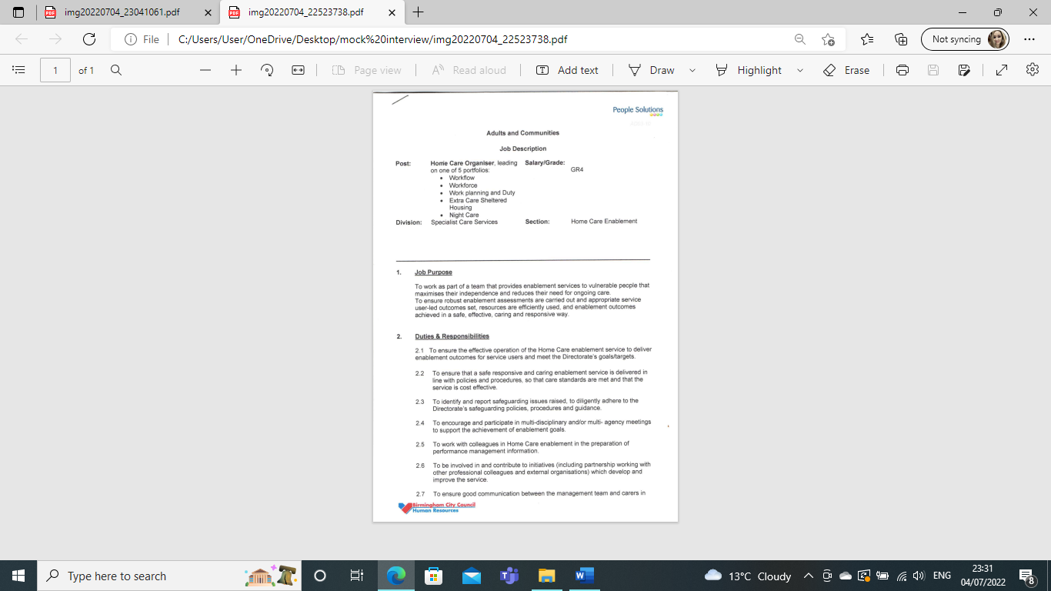

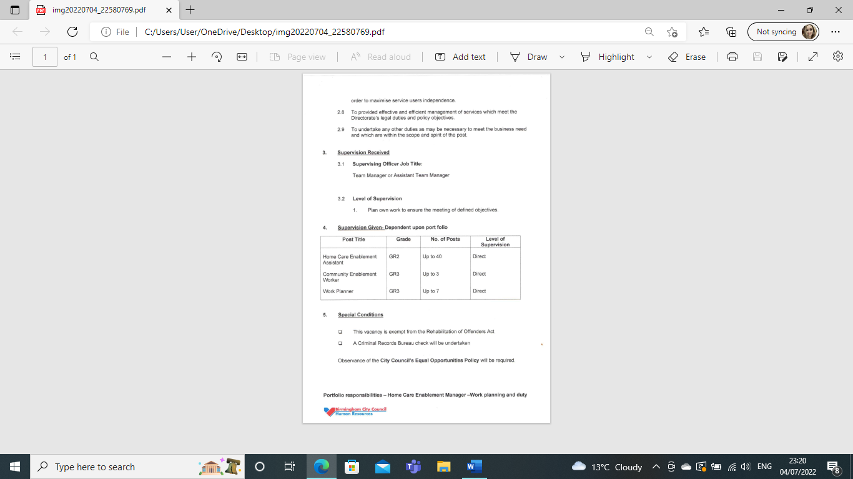

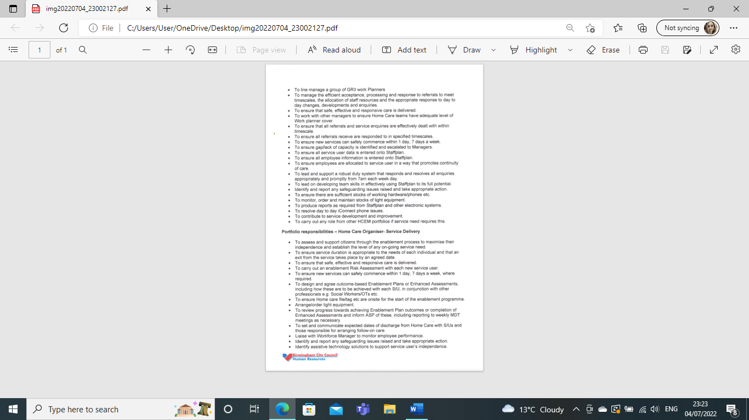

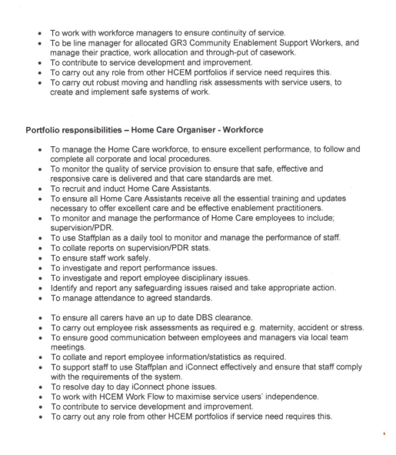
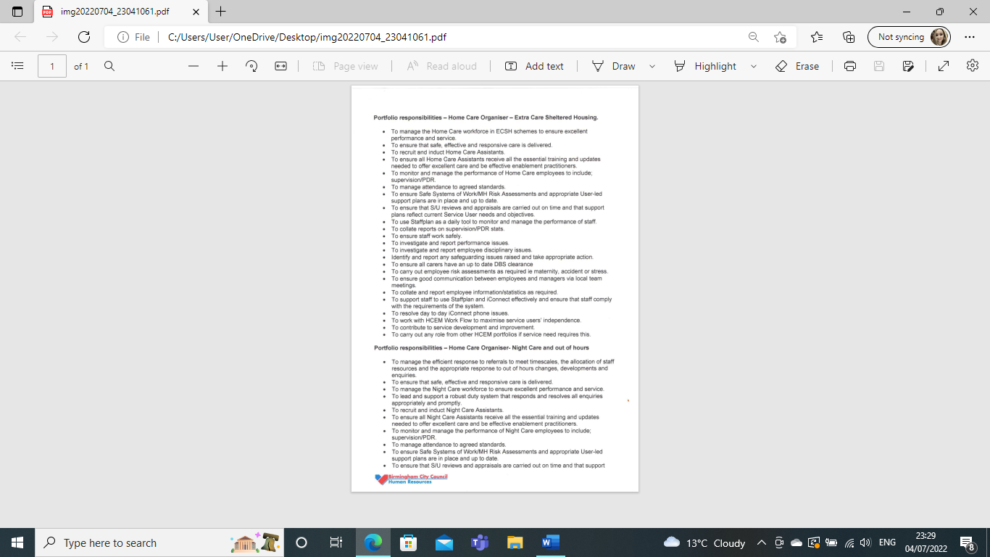
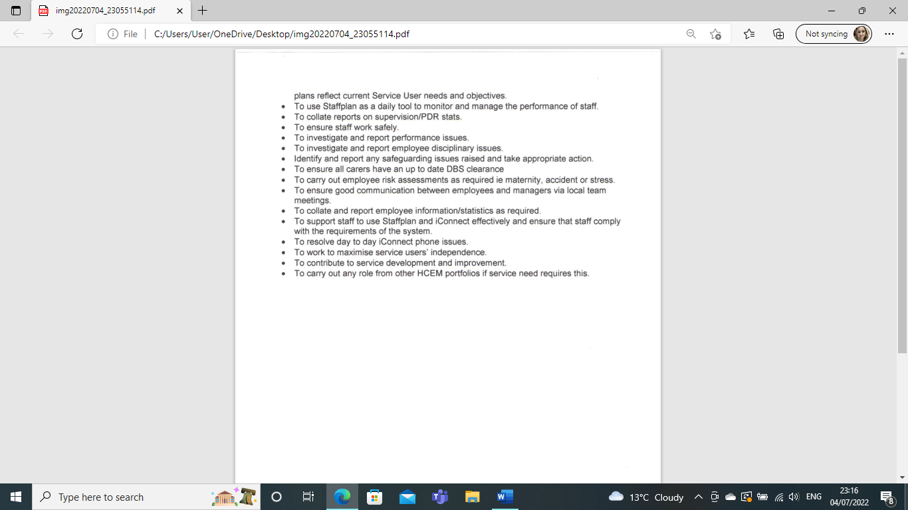

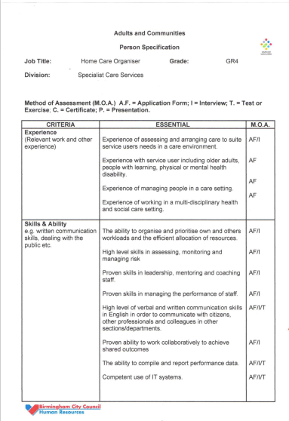

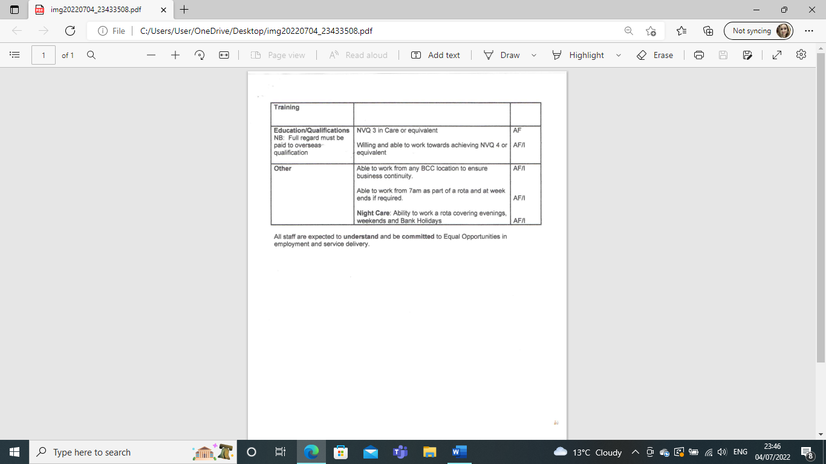

COVER LETTER

Birmingham, UK
July 10th, 2022
Recruitment team
Birmingham City Council
10 Woodcock St
Birmingham
B7 4BL

Dear Madam/Sir,
I am writing to apply for the Home Care Organiser role and therefore I am attaching my resume.
Over the past year, I have been working as an Enablement Assistant for Adult Social Care and Disability Facility Grant at Birmingham City Council.
I am applying for this vacancy for three main reasons. Firstly, I believe I possess the relevant skills, experience, and knowledge to excellently execute this role for the betterment of the council and the public that it serves. Secondly, working for Birmingham City Council has enabled me to gain a wealth of knowledge on policies and procedures, stakeholder management and service improvement and I would feel proud to take on this opportunity. I am mindful that you respect and promote effort, encourage professional growth at employment, and enhance learning while employed and I embrace these ethics. I'm confident that my strong professional history qualifies me for the position. Additionally, I am motivated by my career since I believe in assisting people. Finally, it is my passion to help others and great desire to progress in the field of Adult Social Care.
I am native Polish and multilingual. I can speak two languages fluently: English and Russian and basic Portuguese.
Currently, I am completing my Level 4 Skills for the Workplace Certificate. I also hold a Master Degree in the Faculty of Tourism, Recreation and Health Care and Level 3 Diploma in Custodial Care.
I presently work as a DFG Champion/recovery coordinator where my role is to support services with their recovery from substance misuse, approve and direct grants across Birmingham, and do additional work with a wide range of diverse data for clients who come under the 9 characteristics age of the equality act 2010.
I work with clients that fall into all of the following groups: Disability, I ensure fair treatment and opportunity for all. I aim to eradicate prejudice and discrimination based on an individual or group of individuals' protected characteristics.
I am incredibly passionate about managing Adults and Communities to ensure we fulfil not only the statutory and business obligations but also the social justice agenda. My deep interest, passion and commitment to Adults and Communities led me to embark on intensive training not only as an Enablement Assistant but also as a Disability Facility Grant team member.
During my Lvl 4 Skills for the Workplace course, I developed a framework to combat employment barriers within organisations with recommendations for the wider labour market. I, therefore, seek a position whereby I can utilise such skills and develop evidence-based solutions to current challenges within Birmingham City Council’s Adult Social Care Directorate.
I aim to always achieve high performance and productivity while working within my team. I have strong time management, organisation and communication skills and confidently enjoy working on my own as well as in a team.
Therefore, I believe that I could contribute to substantially improving the performance of the Adult Social Care department.
I look forward to hearing back from you and if any additional information is needed, please do not hesitate to contact me.
Best regards,

Yours faithfully,

Magdalena Siemiatkowska.

Magdalena Siemiatkowska
Birmingham, UK
magdalenasiemiatkowska70@gmail.com

Profile
CERTHE Level 4 Skills for the Workplace student with over five years of experience gained in Adult Social Care. Highly organized, resourceful, and keen to take on new challenges. Looking for a Home Care Organiser role in a business that utilises strong interpersonal skills and offers an opportunity to work as part of a team and take on high levels of responsibility.
I am multilingual and can speak Polish (native), Russian and English (fluent), and Portuguese (basic).
I have worked in a variety of roles in Adult Social Care and have gained valuable experience in dealing with different types of service users. I have also worked in a number of different settings, including residential care homes, day-care centres and community support services. I have gained a great deal of knowledge and experience in dealing with different types of needs and have developed strong communication and interpersonal skills. Some of my key achievements include: developing strong relationships with clients and their families, supporting clients to live independently in the community, advocating on behalf of clients, liaising with other professionals to ensure that clients receive the best possible care and support, and providing emotional support to service users and their families, working collaboratively with other agencies to promote client wellbeing.
I take service seriously. I am also comfortable taking on new challenges and I am extremely confident when managing inquiries, concerns, and conversations. Additionally, I can meet deadlines and manage numerous workloads successfully.

Work Experience

Employer name: Birmingham City Council
Notice period (if applicable):4 weeks
From May 2021 – Ongoing
- Disability Facility Grant Champion & Enablement Assistant
- Promoting the physical, emotional and intellectual wellbeing and rights of service users
- Providing direct support when required and independence by developing an extensive knowledge of, and links with community resources, supporting service users by making use of these opportunities and promoting social inclusion and Self-Directed Care.
- Implementing an appropriate person-centred support plan through partnerships with service users and the care coordinator
- Gained influencing skills by teaching individuals with learning disabilities and showed the ability to motivate and bring out the best in adult service users through individual lessons

Employer name: HMP Birmingham
Notice period (if applicable):4 weeks
From May 2019 – May 2021

- Prison Custody Officer
- I was chosen from hundreds of available candidates during the recruitment process to take part in very intensive training which I have completed as one of few participants with a score of 86%. Gained experience in training and development, reward, and recognition. Performed a variety of roles from being a key worker to the supervisor of prisoner's activities and their work assignments by preventing disturbances, assault, and breakouts
- Gained experience in dealing with individuals in a busy, specialist environment and was allocated the responsibility of the prisoner's wing with the most challenging behaviors

Employer name: St Catherine’s Residential Care Home, Birmingham
Notice period (if applicable):4 weeks
From February 2017- May 2019
- Healthcare assistant

- Provided personal care and support to Clients with a wide range of needs, illnesses, and disabilities
- Undertaken the tasks detailed in the Client’s care and support plan using a person-centred approach and in the least intrusive way
- Ensured as safe as possible the living environment for the Client, as whilst respecting the Client’s choice and rights
- Maintained detailed accurate records in respect of care and medication support given and tasks undertaken

Education
September 2021-2022
- CERTHE Skills for the Workplace, Level 4 Diploma at University of Wales Trinity Saint David, Birmingham
November 2018-February 2018
- Level 3 Diploma in Prison Custodial Care at HMP Birmingham, UK 2018
September 2009-2011
- Master in Tourism, Recreation and Health Care, in the field of Tourism and Recreation, majoring in Tourism in Regional, National and Global Economy at Higher School of Tourism and Hotel Industry in Gdansk, Poland
September 2006-2009
- Bachelor's Degree in the field of Tourism and Recreation, majoring in European Tourism and Health Care at Pultusk Academy of Humanities Faculty of Tourism in Ciechanow, Poland

September 2003-2006
- A level at Henryk Dobrzanski High School

Polish language and literature, Russian, English, History.

Additional training

-University of Wales Trinity Saint David:
- Learning to lead, 2nd July 2022.

-Birmingham City Council:
- Continuing Professional Development, 27th June 2022.
- Autism Awareness, 25th May 2022
- Anti-Racism, 15th May 2022
- Gender Identity, 15th May 2021
- Working Collaboratively Online, 25th February 2022
- Customer Service Suite: Part 1-Introduction, February 2022
- Data Protection, GDPR and Information Security (Level 2), January 2022
- Data Protection, GDPR and Information Security (Level 1), January 2022
- Emotional Abuse, December 2021
- Equality in the Workplace, November 2021
- Fire Safety Awareness, October 2021
- Focus on Fraud Awareness, September 2021
- Working Collaboratively Online, September 2021
- Gender Identity, August 2021
- Prevent, August 2021
- Safeguarding People, July 2021
- This is Birmingham, July 2021
- Health and Wellbeing: Stress Awareness, July 2021
- Manager Health and Safety Awareness, June 2021
- Modern Slavery & Human Trafficking, June 2021
- Mandatory Learning 2021, May 2021
- Employee Health and Safety Awareness, May 2021

-Chatsfield Training:
- Food Safety, June 2018
- Diabetes Awareness, June 2018
- Infection Control, June 2018
- Health & Safety, May 2018
- Fire Safety Awareness, April 2018
- Moving and Handling, April 2018
- AoFAQ Level 3-Emergency First Aid At Work (RQF), March 2018
- EFAW First Aider, March 2018

- Pultusk Academy of Humanities, Ciechanow, Poland
- Anti-defence training, May 2009.

Personal Skills

- Communication skills.
- Leadership Skills
- Multitask
- Digital skills
- Office 365.

Leisure activities:

- Walking, Running, Keeping fit.

Languages:

- Polish (native), English (fluent). Russian (fluent), Portuguese (basic).

Volunteer activities:

- Feeding the homeless in the City Center

Ambitions:

- Good secure employment, be happy and enjoy life with my family, and travel the world.
References
- References are available upon request.

