
APPENDIX GA36c

LEVEL 6 ASSESSMENT SPECIFICATION

Student name: | Ellie Rhodes | Student ID number:
Programme: | Applied Computing
Module: | Usability Engineering
Module code: | ACCB6017 | Contribution to Overall Module Assessment (%): | 50%
Lecturer: | Pauline Greenaway | Internal Verifier | Gaynor Thomas
Assignment Title: | Cluedo Part 2 | Word count (or equivalent): | 3000
Submission deadline: | 14/5/23 | Return date of provisional marks & written feedback: | TBA
Submission method: | All written assessments, where practical and possible, must be submitted via Turnitin unless otherwise instructed by the Lecturer. (Please DO NOT put this assessment specification into Turnitin or it will match many similarities with other students’ submissions.)  Alternative submission method (if applicable):  Late submission of the assessment will result in a late penalty mark. Penalties for late submission: Up to one week late, maximum mark of 40%. Over one week late, 0%. Only the Extenuating Circumstances Panel may approve a change to submission dates.
Academic honesty / referencing: | Academic honesty is required. In the main body of your submission you must give credit to authors on whose research and ideas your work is based. Append to your submission a reference list that indicates the books, articles, etc. that you have used, cited or quoted in order to complete this assessment.

Module Learning Outcomes
(from module syllabus)
Upon the successful completion of this module, the student should be able to:
- Research and evaluate cognitive and social information processing
- Select, apply and analyse critically techniques of interface evaluation
- Synthesize a solution to a complex design problem from the concepts and principles of usability engineering and software development
- Critically analyse, individually and as part of a team exercise, input and output hardware appropriate for specialised applications, for example for use by disabled people, and for three-dimensional modelling applications

TASK DESCRIPTION

Task
The boardgame CLUEDO is familiar to many as one that requires players to move their pieces around a board that represents a country mansion, finding clues that will help them solve the murder of Dr Black.
You are to design a UWTSD version of this as a computer game.

“Oh no! The Vice-Chancellor has been murdered! Who did it?”

You may set the game on any or all of the university campuses, and may include up to 8 players who should represent different parts of the university.

You should submit a report containing the following:
- A complete set of full-colour storyboards with appropriate example content together with a short discussion of the changes made due to the feedback collected on the wireframe storyboards, together with evidence of usability testing of these changes.
- A description of the process used to collect feedback on your final storyboard prototypes and a summary of the positive and negative feedback elicited
- A discussion of what data would be gathered if a working version were to be build and released, and how that data could be used to influence the next version of the app.
- A reflective summary of the overall design process and how it has been informed by both usability theory and by the inclusion of the potential users in the design process
The report should include appropriate illustrations and references to research literature (at least two thirds of these should be books/journal papers).

Your submission should be presented in the form of a report that includes the following sections:
- (30%) Full colour design storyboards (not hand-drawn and scanned). They should show all of the major functionality of the app at a size appropriate for a mobile phone, and should take all of the usual aspects of interaction design theory into account in the design. Where the design differs from that of the wireframe model the reasons for this should be documented and justified. The complete set of storyboards should be presented in an appendix but significant elements such as the main screen designs should be discussed in the main body of the report. These can be created using any suitable software; Adobe XD is a good choice for this, but other packages are fine provided that you remember to show not only the screens but how the user moves between the screens.
- (20%) How did you collect feedback on your prototypes? How did you ensure that your test subjects covered the range of personas you defined earlier? What feedback did you get, both in terms of usability and of emotional response? Were these what you expected and, if not, why not?
- (20%) What information are you going to collect from you users in the working version? Why do you need it and how will you collect it? Can data be collected automatically or will you need to continue to interact directly with your users to get the data you need? Are there differences between collecting usage data and emotional response data?
- (20%) How would your storyboards have differed if you had approached the app purely from a usability viewpoint? Were there any conflicts between usability and user experience that you had to resolve? Use examples from your design process to explain these.

The final 10% will be awarded for document presentation and appropriate references to the research literature. The report should be submitted through Turnitin. Do not submit the assignment brief document with this.

GUIDANCE FOR Students IN THE COMPLETION OF TASKS

NOTE: The guidance offered below is linked to the five generic assessment criteria overleaf.

- Engagement with Literature Skills
Your work must be informed and supported by scholarly material that is relevant to and focused on the task(s) set; you should make use of scholarly reviews and primary sources, where appropriate (for example, refereed research articles and/or original materials appropriate to the discipline). You should provide evidence that you have accessed a wide range of sources, which may be academic, governmental and industrial; these sources may include academic journal articles, textbooks, current news articles, organisational documents, and websites. You should consider the credibility of your sources; academic journals are normally highly credible sources while websites require careful consideration/selection and should be used sparingly. Any sources you use should be current and up-to-date, mostly published within the last five years or so, though seminal/important works in the field may be older. You must provide evidence of your research/own reading throughout your work, using a suitable referencing system, including in-text citations in the main body of your work and a reference list at the end of your work.

Guidance specific to this assessment: You need to justify your decisions related to good design and poor design by suitable reference to the literature.

- Knowledge and Understanding Skills
At level 6, you should be able to demonstrate coherent and detailed knowledge and a systematic understanding of the subject area, at least some of which is informed by the latest research and/or advanced scholarship within the discipline. You should be aware of the uncertainty, ambiguity and limits of knowledge. Your work must demonstrate the growing extent of your knowledge and systematic understanding of concepts and underlying principles associated with the subject area. Knowledge relates to the facts, information and skills you have acquired through your learning. You demonstrate your understanding by interpreting the meaning of the facts and information (knowledge). This means that you need to select and include in your work the concepts, techniques, models, theories, etc. appropriate to the task(s) set. You should be able to explain the theories, concepts, etc. meaningfully to show your understanding. Your mark/grade will also depend upon the extent to which you demonstrate your knowledge and understanding; ideally each should be complete and detailed, with comprehensive coverage.

Guidance specific to this assessment: Consider how you could collect data in a real-world situation. This will involve identifying and selecting potential commercial data collection services as well as bespoke data collection options..

- Cognitive and Intellectual Skills
You should be able to: critically evaluate evidence, arguments, assumptions, abstract concepts and data some of which are at the forefront of a discipline (and that may be incomplete) to devise and sustain arguments, to make judgements and/or solve problems; describe and comment upon particular aspects of current research, or equivalent advanced scholarship, in the discipline Your work must contain evidence of logical, analytical thinking, evaluation and synthesis. For example, to examine and break information down into parts, make inferences, compile, compare and contrast information. This means not just describing what! But also justifying: Why? How? When? Who? Where? At what cost? At all times, you must provide justification for your arguments and judgements. Evidence that you have reflected upon the ideas of others within the subject area is crucial to you providing a reasoned and informed debate within your work. Furthermore, you should provide evidence that you are able to make sound judgements and convincing arguments using data and concepts. Sound, valid conclusions are necessary and must be derived from the content of your work. Where relevant, alternative solutions and recommendations may be proposed.

Guidance specific to this assessment: What changes did you make to the design as a result of the test carried out in the previous assignment? How will these solve your problems?

- Practical Skills
At level 6, you should be able to apply the methods and techniques that you have learned to review, consolidate, extend and apply your knowledge and understanding, and to initiate and carry out projects. You will deploy accurately established techniques of analysis and enquiry relevant to the discipline, and apply them in complex and unpredictable contexts, to devise and sustain arguments and/or to solve problems. You should be able to frame appropriate questions to achieve a solution - or identify a range of solutions. You should be able to demonstrate how the subject-related concepts and ideas relate to real world situations and/or a particular context. How do they work in practice? You will deploy models, methods, techniques, and/or theories, in that context or circumstances, to assess current situations, perhaps to formulate plans or solutions to solve problems, or to create artefacts, some of which may be innovative and creative. This is likely to involve, for instance, the use of real world artefacts, examples and cases, the application of a model within an organisation and/or benchmarking one theory or organisation against others based on stated criteria. You should show awareness of the limitations of concepts and theories when applied in particular contexts.

Guidance specific to this assessment: You should produce a full updated interface for this prototype design, using an appropriate workplace tool. This should be tested with real users rather than simply relying upon designer tests.

- Transferable Skills for Life and Professional Practice
Your work must provide evidence of the qualities and transferable skills necessary for graduate-level employment requiring the exercise of initiative and personal responsibility and decision-making in complex and unpredictable circumstances. This includes demonstrating: the learning ability for professional development to advance existing skills and acquire new competences of a professional nature that will enable you to assume significant responsibility within organisations; that you can initiate and complete tasks and procedures, whether individually and/or collaboratively; that you can use appropriate media to effectively communicate information, arguments and analysis in a variety of forms to specialist and non-specialist audiences; fluency of expression; clarity and effectiveness in presentation and organisation. Work should be coherent and well-structured in presentation and organisation.

Guidance specific to this assessment: This is a report, not a paper, so no abstract is needed. Ensure that your report looks professional. Document presentation is important. Remember to use technical English, to stick to the numerical referencing method, and to caption all of your illustrations.

Student FEEDBACK FORM

This section details the extent to which the assessment criteria are demonstrated by you, which in turn determines your mark. The marks available for each category of skill are shown. Lecturers will use the space provided to comment on the achievement of the task(s), including those areas in which you have performed well and areas that would benefit from development/improvement.

Generic Assessment Criteria | Marks available | Marks  awarded
1. Engagement with Literature Skills
.
Very good engagement with literature in terms of supporting discussion throughout. This is particularly well-applied in the explanation of the full-colour story board. However, more could have been applied in the reflective summary. |  | 21
 | 30 | 21
2. Knowledge and Understanding Skills

Different data collection methods have been discussed although more specific analysis of the different methods and the value they provide could have been included. |  | 21
 | 30 | 21
3. Cognitive and Intellectual Skills

Very good quality final full-colour storyboard produced as a result of feedback although the background colour could have been changed.. Full and comprehensive discussion of amendments made with full reference to interaction design rules/principles. Final evaluative testing completed using Nielsen’s Heuristics. However, screenshots should have been provided rather than including a link to the survey. Summary of evaluation provided and discussed with observation also completed for qualitative responses and this was obtained from two potential users. Reflective summary refers back to design rules/principles but should have been more detailed. |  | 20
 | 30 | 20
4. Practical Application Skills

 | 0
5. Transferable Skills for Life and Professional Practice

Report format applied. However, contents page should have been included. Well-expressed throughout | 10 | 7

Assessment Mark (Assessment marks are subject to ratification at the Exam Board. These comments and marks are to give feedback on module work and are for guidance only until they are confirmed. ) | Late Submission Penalties (tick if appropriate) |  | 69%
 | Up to 1 week late (40% Max) |  | 69%
 | Over 1 week late (0%) |  | 69%

GENERIC ASSESSMENT CRITERIA

Level 6
In accordance with the Framework for Higher Education Qualifications, at the end of Level 6 students should have coherent and detailed knowledge and a systematic understanding of their subject area, at least some of which is informed by the latest research and/or advanced scholarship within the discipline. They will be able to accurately deploy established techniques of analysis and enquiry within a discipline, using their conceptual understanding to devise and sustain arguments and/or to solve problems. They should be aware of the uncertainty, ambiguity and limits of knowledge. They should be able to critically evaluate evidence, arguments, assumptions, abstract concepts and data (that may be incomplete), to make judgements, and to frame appropriate questions to achieve a solution - or identify a range of solutions. They will apply the methods and techniques that they have learned to review, consolidate, extend and apply their knowledge and understanding, and to initiate and carry out projects. They will have the ability to manage their own learning, and to make use of scholarly reviews and primary sources (for example, refereed research articles and/or original materials appropriate to the discipline). They will demonstrate the qualities and transferable skills necessary for employment requiring: the exercise of initiative and personal responsibility; decision-making in complex and unpredictable contexts; the learning ability needed to undertake appropriate further training of a professional or equivalent nature.

Level 6 | FAIL | MARGINAL FAIL | SATISFACTORY  (3rd / Pass) | GOOD  (2.2 / Pass) | VERY GOOD  (2.1 / Merit) | EXCELLENT  (1st / Distinction) | EXCEPTIONAL  (1st / Distinction)
Category | 0-29% | 30-39% | 40-49% | 50-59% | 60-69% | 70-84% | 85-100%
Engagement with literature (including reading, referencing,  academic conventions and  academic honesty) | Little or no evidence of reading and/or reliance on inappropriate sources.  Views and findings mostly unsupported and non-authoritative.  Referencing conventions used incoherently or largely absent. | Poor engagement with essential reading. No evidence of wider reading. Reliance on inappropriate sources, and/or indiscriminate use of sources. Heavily reliant on information gained through class contact. Inconsistent and weak use of referencing. | Engagement with a limited range of mostly relevant and credible sources. Some omissions and minor errors.  Referencing conventions evident though not always applied accurately or consistently. | Engagement with an appropriate range of research-informed literature, including sources retrieved independently. Some over-reliance on texts. Referencing may show minor inaccuracies or inconsistencies. | Engagement with a wide range of research-informed literature, including sources retrieved independently.  Selection of relevant and credible sources. Very good use of referencing, with no/very few inaccuracies or inconsistencies. | Engagement with an extensive range of relevant and credible literature, informed by the latest research. Consistently accurate application of referencing. | Exceptional engagement with an extensive range of relevant and credible literature, informed by the latest research. High-level referencing skills consistently and professionally applied.
Knowledge and understanding (Coherent and detailed knowledge and systematic understanding of the subject area, at least some of which is informed by the latest research and/or advanced scholarship within the discipline.) | Major gaps in knowledge and systematic understanding of the subject matter. Substantial inaccuracies. No awareness of knowledge of the latest research and/or advanced scholarship within the discipline. | Gaps in knowledge, with only superficial systematic understanding. Some significant inaccuracies and/or irrelevant material. No awareness of knowledge of the latest research and/or advanced scholarship within the discipline. | Limited knowledge and systematic understanding of the relevant concepts and principles within the subject area which to some limited extent, is informed by current research and scholarship. | Knowledge is reasonably detailed, accurate with a good systematic understanding of the field of study and to some extent, current research and scholarship. | Knowledge is reasonably extensive coherent and detailed. Exhibits very good understanding of the breadth and depth of established views, and the work is, at least in part, well-informed by current research and scholarship. | Excellent coherent and detailed knowledge and systematic understanding of the principles and theories of current research and scholarship. Clear awareness of challenges to established views and the limitations of the knowledge base. | Exceptionally coherent and detailed knowledge and systematic understanding of the principles and theories of the subject, well-informed by current research and scholarship. A critical, sophisticated and nuanced awareness of the ambiguities and limitations of knowledge.
Cognitive and intellectual skills  (Conceptual and critical thinking, analysis, synthesis and evaluation of research, assumptions, abstract concepts and data (that may be incomplete); logic, argument and judgement.) | Wholly or almost wholly descriptive work. Little or no analysis, synthesis or evaluation.  Failure to develop arguments, leading to illogical or invalid judgements. Unsubstantiated generalisations, made without use of any credible evidence. | Largely descriptive work, with superficial use of critical evaluation. Weak development of arguments and judgements. Information accepted uncritically, uses generalised statements made with scant evidence and unsubstantiated opinions. Ideas sometimes illogical and contradictory. | Limited attempt at critical thinking, analysis, synthesis and evaluation, tending towards description.  Some evidence to support emerging arguments and judgements but these may be underdeveloped or with a little inconsistency / mis-interpretation.  Asserts rather than argues a case. | Some critical thinking, analysis, synthesis and evaluation. Can analyse new and/or abstract concepts and data without guidance.  An emerging awareness of different stances and ability to use evidence (that may be incomplete) to support the argument.  Mostly valid arguments and logical judgements. Some tendency to assert/state opinion rather than argue on the basis of reason and evidence. | Sound critical thinking, analysis, synthesis and evaluation demonstrating critical thinking. Ability to devise and sustain persuasive arguments, and to review the reliability, validity and significance of evidence (that may be incomplete) to make mostly appropriate and valid judgements. | Excellent critical thinking, analysis, synthesis and evaluation. Ability to investigate contradictory or incomplete information and make strong, persuasive, arguments and sophisticated judgements. Some evidence of independent thought and ability to ‘see beyond the question’, suggesting a grasp of the broader field and wider concepts. | Exceptional critical thinking, analysis, synthesis and evaluation based on judiciously selected evidence.  Ability to investigate contradictory or incomplete information and make strong, persuasive, arguments and sophisticated, nuanced, judgements. Evidence of independent thought and ability to ‘see beyond the question’, suggesting an outstanding grasp of the broader field and wider concepts.
Practical skills  (Apply/deploy accurately established tools and techniques; initiate and carry out projects; formulate solutions to solve problems in complex and unpredictable contexts.) | Limited or no use of methods, materials, tools and/or techniques.  Little or no appreciation of the context of the application.  Limited understanding of the application of theory to practice or making appropriate links between the two.  Very weak problem-solving skills in complex and unpredictable contexts. | Rudimentary application of methods, materials, tools and/or techniques but without consideration and competence. Flawed appreciation of the context of the application.  Weak understanding of the application of theory to practice, with only occasional evidence of making appropriate links between the two. Weak problem-solving skills in complex and unpredictable contexts. | An adequate awareness and mostly appropriate application of well-established methods, materials, tools and/or techniques.  Basic appreciation of the context of the application. Theoretical knowledge and understanding applied in practice, but not always making logical links between the two.  Can identify problems and propose basic solutions in complex and unpredictable contexts without fully appreciating the complexity. | A good and appropriate application of standard methods, materials, tools and/or techniques.  Clear appreciation of the context of the application. Mainly consistent, accurate and logical application of theory to practice, making appropriate links between the two  Can identify problems and propose mostly appropriate solutions in complex and unpredictable contexts. | A very good application of a range of methods, materials, tools and/or techniques.  Very good consideration of the context of the application, with perceptive insights. Can identify problems and propose appropriate solutions in complex and unpredictable contexts.  Evidence of some innovation and creativity. | An advanced application of a range of methods, materials, tools and/or techniques.  The context of the application is well considered, and insightful.  Application and deployment extend beyond established conventions. Can identify complex problems and propose excellent solutions. Innovation and creativity evident. | Exceptional levels of application and deployment skills in unpredictable, practical contexts, drawing skilfully on the latest research within the discipline. Can identify complex problems and propose sophisticated solutions. Assimilation and development of cutting edge processes and techniques.
Transferable skills for life and professional practice  (Exercise of initiative and personal responsibility; professional development; initiate and complete tasks and procedures: individually and/or collaboratively; use appropriate media to communicate effectively; fluency of expression; clarity and effectiveness in presentation and organisation.) | Communication medium is inappropriate or misapplied.  Work is poorly structured, disorganised and/or confusingly expressed. Very weak use of language and/or very inappropriate style. Little or no evidence of autonomy (or collaboration, where relevant) in the completion of tasks. Little or no evidence of the skills required in graduate employment. | Communication medium is poorly designed and/or not suitable for the audience.  Work is poorly presented in a disjointed manner. It is loosely, and at times incoherently, structured, with information and ideas often poorly expressed. Weak use of language and/or inappropriate style. Weak independent initiative (or collaboration, if relevant). Limited evidence of the skills required in graduate employment. | Can communicate in a suitable medium but with some room for improvement.  Mostly ordered presentation and structure in which relevant ideas / concepts are reasonably expressed. Work may lack coherence in places. Can work as part of a team, but with limited involvement in group activities.  Demonstrates the basic skills required in graduate employment, with some areas of minor weakness. | Can communicate effectively in a suitable format, but may have minor errors.  Mostly coherent, organised work, in a suitable structure and is for the most part clearly expressed. Can work effectively independently and/or as part of a team, with clear contribution to group activities.  Demonstrates the skills required in graduate employment, with some areas of strength and some of minor weakness. | Can communicate well, confidently and consistently in a suitable format.  Work is coherent, fluent, well-structured and organised. Can work very well autonomously and/or as part of a team, with very good contribution to group activities.  Demonstrates very good graduate employment skills, with just occasional minor weakness. | Can communicate professionally confidently and consistently in a suitable format.  Work is coherent, very fluent and is presented professionally. Can work autonomously with initiative. Where relevant can work professionally within a team, showing leadership skills as appropriate, managing conflict and meeting obligations. Demonstrates excellent graduate employment skills and an appetite for further development. | Can communicate with an exceptionally high level of professionalism.  Work is exceptionally coherent, very fluent and is presented professionally. Can work exceptionally well and professionally within a team, showing advanced leadership skills. Demonstrates exceptional graduate employment skills and an appetite for further development.

THIS DOCUMENT IS ALSO AVAILABLE IN WELSH

Usability Engineering
Contents
Useability Engineering 1
Introduction 1
Updated Designs 1
Feedback Alterations 1
Following Theory 4
Final Feedback 6
Heuristic Evaluation 6
Observation 7
Summery 9
Data Collection 9
Reflection & Summery of Design 10
Conclusions 11
Bibliography 11
Appendix 12

Introduction
Cluedo is a classic murder mystery game, originally created in 1943. In accordance with the brief, a Cluedo reboot will be designed, with six weapons, six suspects and nine rooms based on Neath Port Talbot College. Following previous, basic wireframes have been improved- complying with previous intended user feedback, then re-tested and future recommendations made. Additionally, data collection is considered with methods of utilising user information to better develop the game.

Updated Designs
Formerly, feedback in the format of cognitive walkthroughs have been implemented to decipher design flaws and strong points. Originally, concept frames were made to display how menus would be included, navigation and main user actions. After noted feedback, alternations were identified to better the wireframes and changes have been made accordingly. Although useful, the cognitive method picked few issues, which have all been resolved. Therefore, additional improvements have been made in relation to theorist opinion for a final representation of how the application game will appear.

Feedback Alterations
Firstly, an issue brought by testing found confusion of how to change the sign in within the main menu as there were two mentions- a switch login and who is currently signed in. Within the first draft, the top left ‘Signed in as: Ells_23’ was for display and feedback to the user whereas now it has been made as a button, so when clicked it navigates the user to the switch sign in page. This has also been improved to reiterate the same feedback, as illustrated below and now states the current user and methods to change it.
This follows Dix’s (1) theory of flexibility and customisation within an application to amend details to make personal to the user and their own account. Moreover, customisation is shown through menu selection, with the user choosing difficulty level, character and solo play or online with friends.

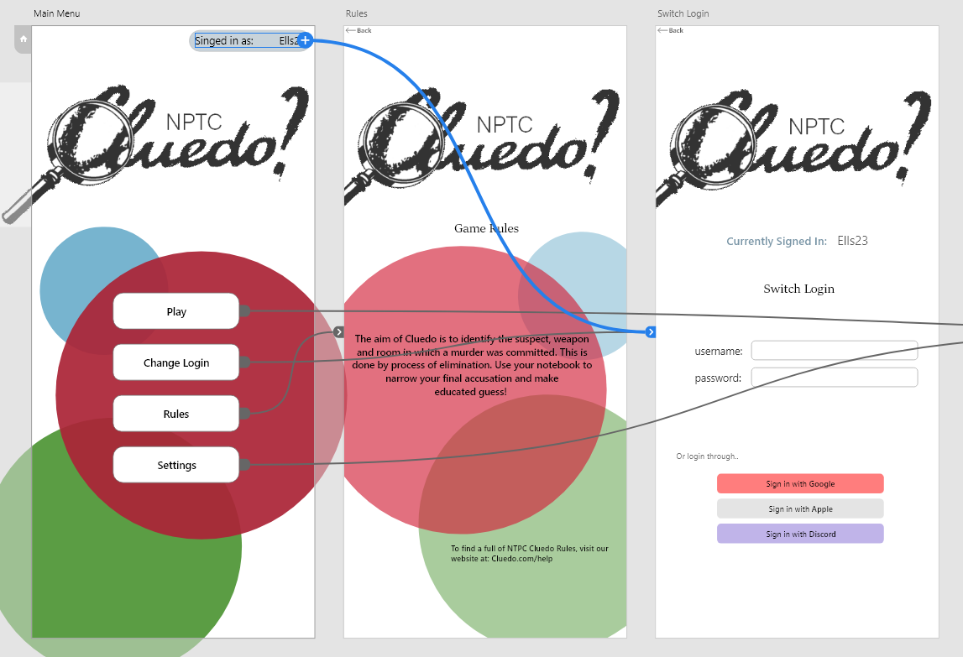
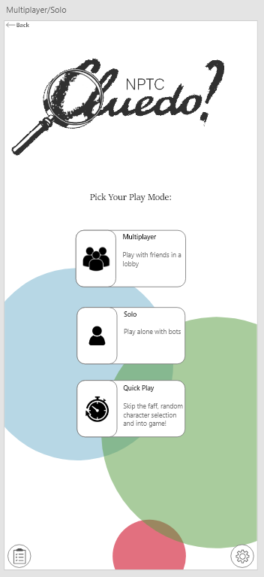
Moreover, it arose that the menu process was too long winded, and they expected less screens to be able to get into a game. This process has been provided a shortcut alternative in the format of a game mode, ‘quick play’, removing selection screens, randomly generating character and puts the user in a game, as shown on the left. Doing so, removes 5 screens and follows Schneiderman’s theory of enabling shortcuts (2). Shortcuts are ideal for quicker use, mainly users that are familiar with the application. However, Nielson (3) continues flexibility of use should cater to experience and non-experienced to reap the same benefits. In this instance, the ‘quick play’ alternative is a clear shortcut, well-explained for users not wanting multiple customisations.

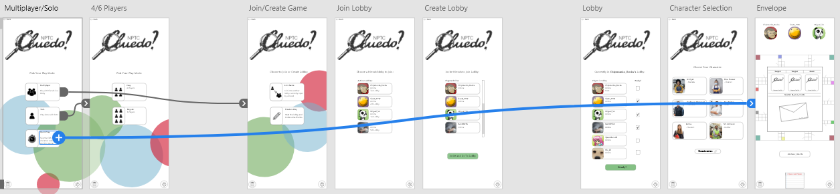
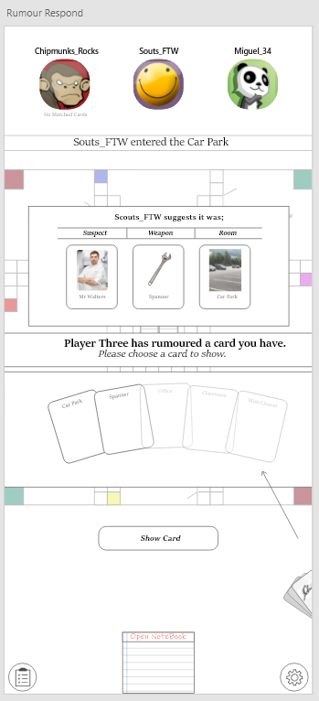
Another flaw was the need for progression notes. As stated by Schneiderman (2), an application design should offer informative feedback. Doing so allows the user to understand what the current situation is and provide incentive about what will happen. To resolve this, as displayed more prompt messages have been littered within the application as a reminder of how to progress and additional buttons on specific screens where the user was unsure on how to pass through story screens. For example, the user is meant to watch but not necessarily interact, like screen showing 3 cards going into envelope. Neilson (3) concurs suggesting visibility of system status should allow choices to become predictable and informed of any consequence to the action.
Stated previously, another solve of the feedback is to create more buttons to illustrate prompts of progress. Similar to buttons prior, the user is able to understand purpose and recognition over recall (3), by visually picking options, reducing cognitive load and memory.
As suggested by Nielson (3), help and documentation has been implemented also to increase understanding of how to perform tasks by clearly identifying what the application requires of the user and allowing faster decisions instead of analysing. This is shown on the above left slide.

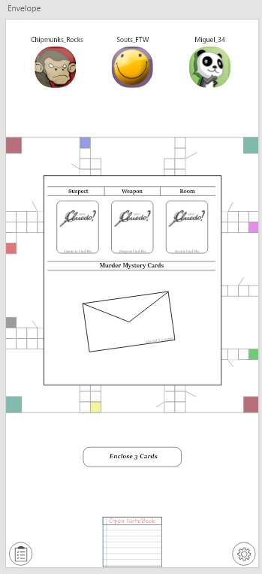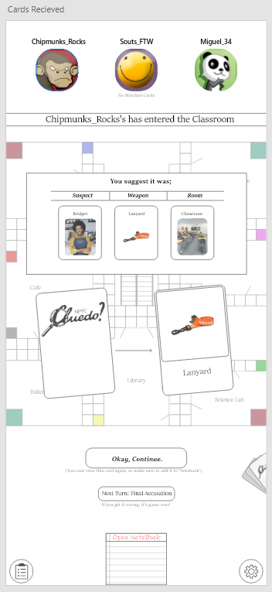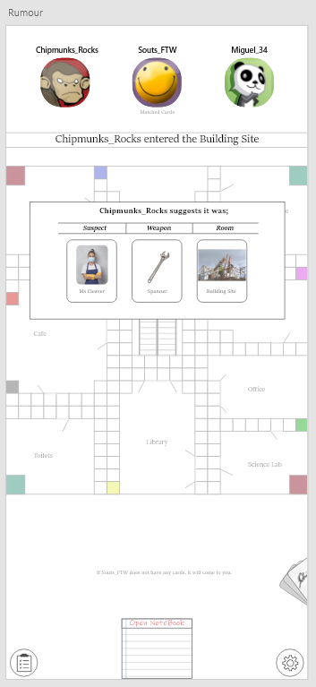
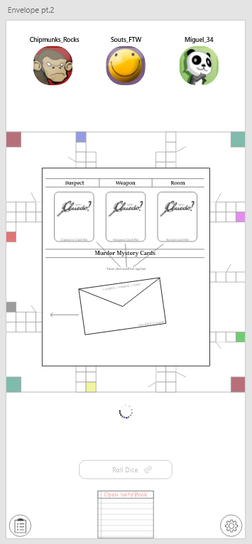
Finally, feedback of loading screens was suggested to create a visual perception of a common application task- loading between screens. Like many other apps, a loading circle has been introduced to convey to the user a process is taking place and the application is working, just loading and not paused or crashed. This is displayed below after the envelope has been created, but it is loading into the main body of the game. Following Dix (1), game status should be observable, and a user should be able to see the state of the application from perceivable representations. The choice of logo links with Nielson’s (3) recognition over recall as the icon chosen identifies with similar icons as loading or saving. Using common illustrations furthers learnability and understanding.

Following Theory
Moreover, a great quantity of images has been added within the wireframes, including logo vectors. As a result, it increases overall visual attraction and psychological abilities to interact. Firstly, it follows Nielson’s (3) match between system and real world. As previously suggested, familiar icons have been used, especially within initial menus, discrete menus within the game and for settings. As similar icons are used within similar applications, it brings a learnable nature and prior knowledge of what it will do with no real experience of the application. Gestalt (4) supports this suggesting theory of past experience, for example seeing similar or same icons used within many games brings unconscious knowledge. Also, system and real world is implemented through terminology. Despite being game lingo, it is comprehensible to novice and frequent user. Like Multiplayer, Join Lobby.
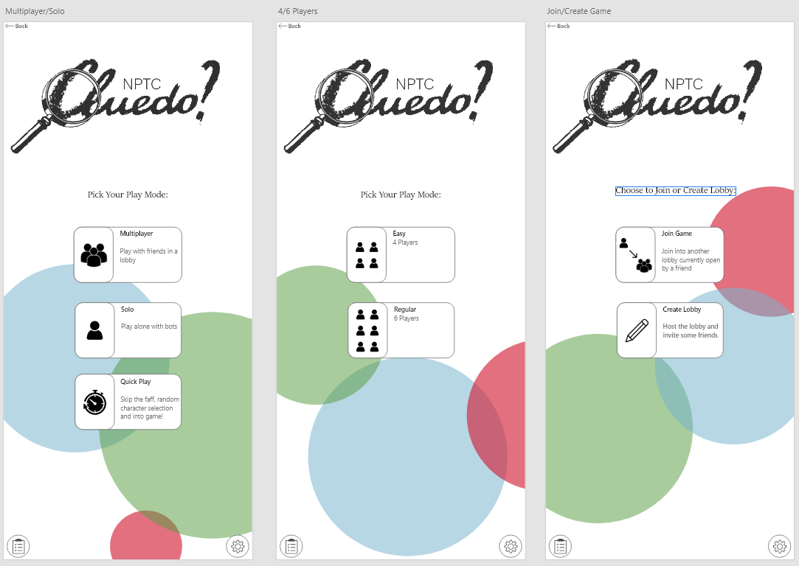
Colour is also required to make an application appearance attractive and interactive. By adding colour, it brings a theme and brand to the application. As executed within the final draft, NPTC logo colours are used as background colours. Following this, Gestalt (4) implies the figure/ground theory meaning the use of contrast guide the user to a specific task or options while lessening the cognitive load. This is facilitated within the initial menus whereby options are white, and the background is lively.
Exaggeration on aspects of the page were made to highlight key areas of data and navigation. In comparison to previously, semi-bold and darker fonts have been used to manipulate attention and provide necessary information. This is shown on buttons, headings, and the back button. As suggested by Schneiderman (2), application design should permit easy reversal of actions and Dix (1) agrees recoverability is necessary to take corrective measures. By making the back button more prominent, it enables knowledge of reversal if wrong option selected, or user has changed decision.
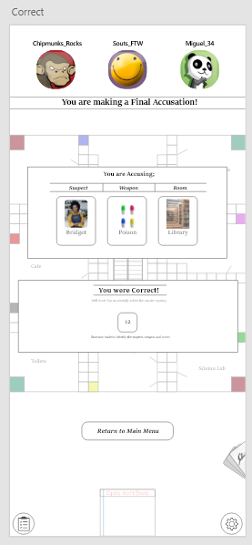
Continuing, Gestalts law of proximity has been facilitated within screens to display buttons solely (4). Doing so allows users to recognise it as one entity and bring attention by singling out one option conversely to competing with elements close by. By removing it from anything else on screen, it becomes distinct and easily findable. Nielson’s theory of consistency and standards also apply (3). The placement of the button and the same formatting is kept throughout to ensure the user feels familiar and begins to predict and associate the button with the next stage of the game. This is supported by Schneiderman (2) strive for consistency and Dix (1) learnability of consistency.

Within the new design, certain features have been un-blocked. For example, within the first draft, the notebook and player cards were faded, showing they were un-clickable. This was predictive of when a user would interact with features. However, in the final version, these features remain accessible for user control and freedom, Nielson (3). From this, it does not impose actions or make decisions for the user and enables them to navigate through the features as desired. Additionally, it is never certain to know what a user will want to do; therefore, paths should not be blocked. Schneiderman (2) supports displaying support internal locus of control is essential- if the user wants to pull up notebook at any given time, they should be able to.

Final Feedback
After the final iteration of prototypes were complete, testing is required to analyse if the changes were a success and to decipher if there are any other issues or strong points that the development has. To do this, a heuristic evaluation and observation was carried out.

Heuristic Evaluation
Heuristic testing, suggests Tan (5), acts as a quantitative and qualitive method of extracting data, highlighting points and reasoning. This was carried on 4 intended users to get a broader understanding and overview. All users were able to experience the run through of the application wireframes and answered a heuristic evaluation on Microsoft forms. This meant results could be anonymous, and more likely to be authentic. Like previous feedback testing, the 4 users selected were from focus groups carried out, therefore suited a specific persona, also helping the reliability of the target audience response.

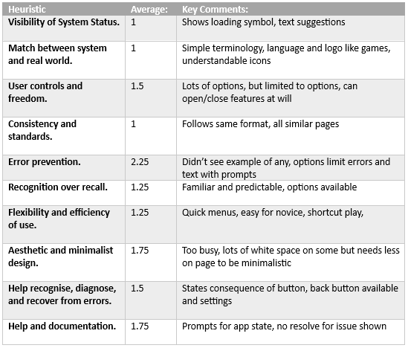
View responses here: https://forms.office.com/Pages/DesignPageV2.aspx?subpage=design&FormId=cYpHzTswzE6x6k40RHNiVDyDxxPHAY5Mi3lpZZw58PpUQkhKRFhHQUc3TzVYNUxaNVoyODg4TTJZVS4u&Token=24bb7cceedd6428d92820a3c8fd5d963
From evaluation testing, mixed responses were retrieved. Although overall it was a positive set of feedback, there were few high averages, indicating there are still areas of improvement. These included error prevention with the worst score of 2.25. Users suggested there was a lack of prevention methods in place after the player joined the game, which is understood. But it was highlighted options lacked the ability to go too wrong. Aesthetic and minimalistic design also scored negatively 1.75, with suggestions the screens held too much and were busy. This could be reduced by creating additional pages for processes like creating a rumour. Despite this, many aspects were praised, for example consistency scored he best possible as well as visibility of status, match between real world and system and comments like familiar, simple terminology, set format of pages, loading symbol clear and commonly used menu as games meant the wireframes followed most of Nielson’s principles.

Observation
Alternatively, an observation is a qualitive format of user testing, identifying struggles and successes from analysing a user. Baker (6) states doing so, physical data can be extracted to find feedback emotionally. This method allows a depth of realism and raw data from the user, rather than answers they manufacture, real useability mishaps are clear and provide otherwise unknown insights. Unlike previous, observations were only carried out on 2 users. 26-year-old female student and 42-year-old male lecturer. This was due to time limitations, however, still does cover 2 areas of the personas defined prior. Each user was provided the same specific tasks and observed doing so, resulting in the following:
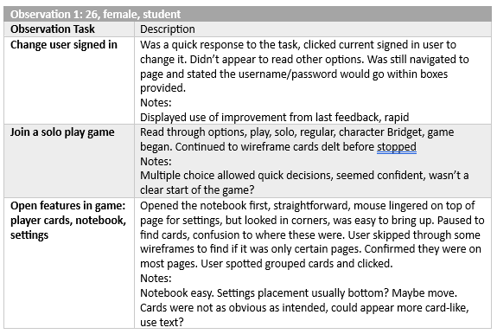
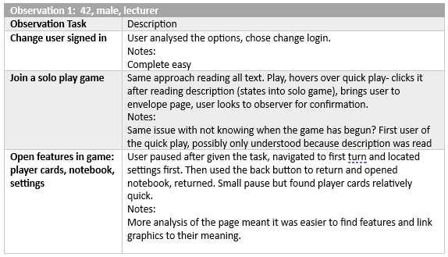
From both users’ differences were spotted. Firstly, the pace and understanding were different levels. With the 26 female, placement of logins for social sites was used quick, there was a lack of time for reading the entire screen, whereas 42 male analysed more text and chose based on that. Additionally, starting a game seemed simple for both users, the use of few option buttons rapidly decided game structure and didn’t cause contemplation. However, it was noticed with both users there was a lack of clarity of when the game started, one user moved more wireframes in, while the other wanted confirmation the task was complete. To resolve this, a clear button of start game could be used after character selection so it feeds back. With the final task, it did require analysis and understanding to link graphics to their meaning, therefore it did take 26 female significantly longer to find their set of cards. Nevertheless, to identify features text could be shown when they are first introduced like a tour of what is on the page, enabling better useability.

Summery
Overall, a range of feedback was collected from intended users. From the heuristic evaluation, an overview of the application was analysed, focused on Nielson’s heuristics. This was mainly positive, as expected as they were consulted throughout the design process, but few issues were identified, like a need of decluttering and error prevention. Alternatively, observations brought a narrow viewpoint of specific tasks and would benefit from additional observations or a complete observation of the wireframes. Although mainly positive, it did highlight few unexpected flaws. This could be due to bias developer opinion or assuming a user would be more observant than the observed users.

Data Collection
Defined by Ellis (7), user experience is an overall experience of a person using a product, such as website or application and creating a perception based on how easy or pleasing it was to use. This design concept is widely used to increase user satisfaction by extracting data, analysing it, deciphering trends and emotional responses and making improvements to the product based on them. The same concept can be implemented for NPTC Cluedo.
Various types of data can be collected from users; however, developers need to be transparent about what they collect, usually formatted in a privacy policy that outlines what data and purpose it has. This would need to be added within the settings of the game. Examples of types of information include:
- Device Information: Including details about the user's device such as device model, operating system version, unique device identifiers, IP address, and network information.
- Personal Information: Information provided by the user, such as usernames, email addresses, and profile pictures.
- Location Information: If the game incorporates location-based features, it may collect the user's GPS coordinates or approximate location.
- Game Activity and Progress: Information related to the user's gameplay, levels reached, achievements, in-game purchases, and interactions with other players.
- Analytics Data: Game developers may collect usage data and analytics to understand user behaviour, gameplay patterns, session duration, and performance metrics to improve the game and enhance the user experience.

Furthermore, there are many purposes for collecting data, for example: improving user experience to understand how users interact with their games. This information helps them identify areas for improvement, optimize gameplay mechanics, fix bugs, and enhance overall user experience. Analytics and performance monitoring allowing developers to analyse gameplay patterns, session duration, and metrics to gain insights into player behaviour and assist developers making data-driven decisions to refine games and introduce features. Another reason is personalisation by offering tailored recommendations, in-game rewards, targeted advertisements, all based on a user's preferences, gameplay history, or demographics.
Moreover, suggested by Llan (8) methods to collect these variations of data vary, but commonly they use user account registration, whereby users are asked to create an account with personal information like email and username, in-game tracking where it is integrated within the game to collect data on gameplay activities, progress, achievements, and interactions, and analytics and SDKs by implementing analytics services or software development kits (SDKs) provided by third-party providers. Tools included collect and analyse user data, including gameplay metrics and user behaviour.
Google (9) conveys data collection can occur automatically without requiring continued interaction. As users install and launch the game, certain data can be collected automatically in the background while users engage with the game. Similarly, game analytics and performance data like in-game actions and session duration can be auto collected- typically by tracking mechanisms and integrated analytics services. Conversely, there are some types of data that require direct interaction with users. Like the registration process, whereby users may need to provide personal information like email addresses, usernames, or profile pictures and location where users will be prompted to grant access to their device's location information.
Finally, Diaz (10) suggests there is a significant difference between collecting usage and emotional response data. Usage data refers to the information collected about how users interact with the game and their gameplay behaviour. It is primarily focused on understanding player behaviour, improving the game mechanics, and optimising user experience. Examples of this include session duration, in-game purchases, achievements unlocked, and gameplay patterns.
Alternatively, emotional response data pertains to capturing and analysing the emotional reactions and responses of players while they engage with the game. This data aims to measure aspects like joy, frustration, excitement, engagement, or boredom experienced by players. It is collected through methods, like surveys, questionnaires, facial expression recognition, physiological sensors, or sentiment analysis among others. This format of data is valuable in understanding how players feel about the game, identifying areas for improvement, and designing more engaging and immersive experiences.
Concluding, both types of data can complement each other to provide a holistic understanding of the user experience in game design. Collecting and analysing both types of data allow developers to make data-driven decisions, enhance gameplay, and create satisfying and emotionally resonant gaming experiences.

Reflection & Summery of Design
Within the current wireframes, the main focus point has been design theory and useability, ensuring users were able to understand the process and link design theories to their useability. Throughout this, Dix, Schneiderman and Nielson, among others have provided insight of how design effects users interactivity. If the wireframes were designed solely from a useability standpoint there would be more emphasis on the effectiveness of features, efficiency of use, learnability of the navigation, features and general theme of the application as well as memorability and error prevention. Although this is fundamental to application design a sense of emotion and good satisfactory user experience should be considered to increase enjoyment and value of playing a game.
Another focus of design was the intended user including an age range, gender and possible interests. Although this helped with narrowed feedback and design choices like multiple choice, a broader understanding of target audience could increase useability, from technological level, navigation methods and ease of use with functions and features but also user experience to understand what aspects they enjoy, behaviours, social data to understand what parts of the application require improvement and what is enjoyed.
Throughout the design process a variety of useability and user experience has been considered to add into the design. Despite both needing to be added, they worked together well, with functionality and design coexisting. For many aspects, it was thought what would be simplistic and not time consuming yet understandable and interactive. This was the concept for most design elements, like the menu screens, use of graphics for functions and freedom within the game.

Conclusions
To conclude, overall, the project has been a success. Final wireframes brought feedback, suggesting future recommendations and improvement, research into useability theories and user experience has been carried out and ideas have been created in relation to making a real mobile application from NPTC Cluedo. The process was smoother than expected, with fewer errors and improvements than anticipated, however that is positive. Moreover, if the wireframes were to become part of a game development process they would require far more fine-tuning, taking into consideration the feedback and looking at how data can be collected, analysed and used to better the application- usability and experience wise.

Bibliography

- Dix.A. Designing for Appropriation. [2007] (accessed May 9) Available at: https://www.scienceopen.com/hosted-document?doi=10.14236/ewic/HCI2007.53
- Schneiderman. 8 Golden Rules- IEEE. [2022] (accessed May 9) Available at: https://ieeexplore.ieee.org/abstract/document/9932115
- Nielson. Nielsen’s 10 design heuristics. [2007] (accessed May 9) Available at: https://pdfs.semanticscholar.org/5f03/b251093aee730ab9772db2e1a8a7eb8522cb.pdf.
- Gestalt, Moore. Gestalt Theory and Design. [1993] (accessed May 9) Available at: https://journals.sagepub.com/doi/abs/10.2190/G748-BY68-L83T-X02J?journalCode=jtwa
- Tan.W. Heuristic evaluation and user testing. [2009] (accessed May 10) Available at: https://www.sciencedirect.com/science/article/abs/pii/S016981410800053X
- Baker.L. Observation: a complex research method. [2006] (accessed May 10) Available at: https://muse.jhu.edu/article/202353/summary
- Ellis.K. Data collection of user interfaces. [2018] (accessed May 11) Available at: https://dl.acm.org/doi/abs/10.1145/3173574.3174128
- Llan.J. Data collection methods for web. [2001] (accessed May 12) Available at: https://link.springer.com/article/10.1023/A:1005682102768
- Google. Google data disclosed. [2023] (accessed May 12) Available at: https://developers.google.com/games/services/data-collection
- Diaz.H. Multimodal data: emotional, cognitive, usage. [2020] (accessed May 13) Available at: https://link.springer.com/article/10.1007/s10639-020-10229-w

Appendix
All screens in order of appearance- some optional
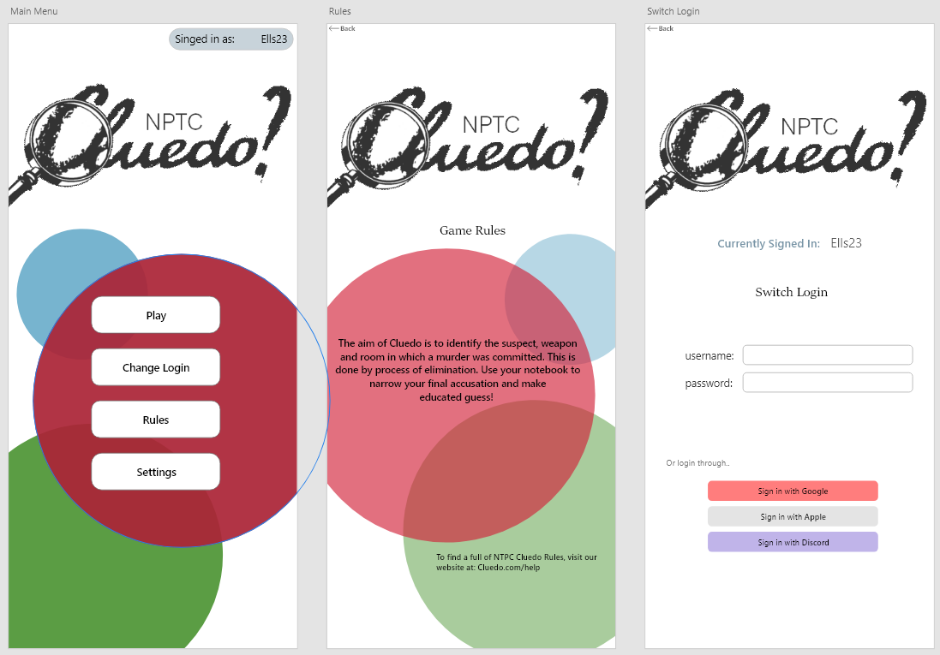
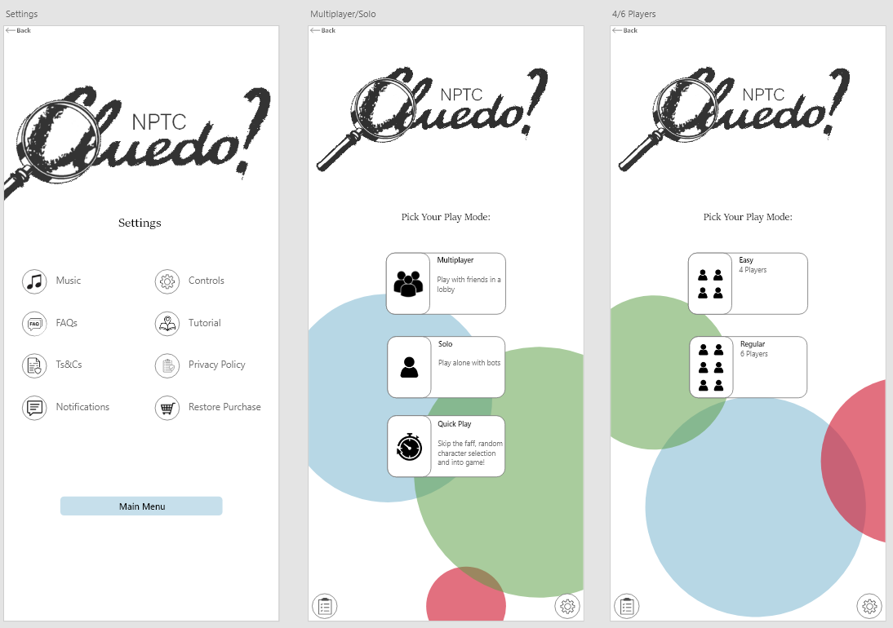
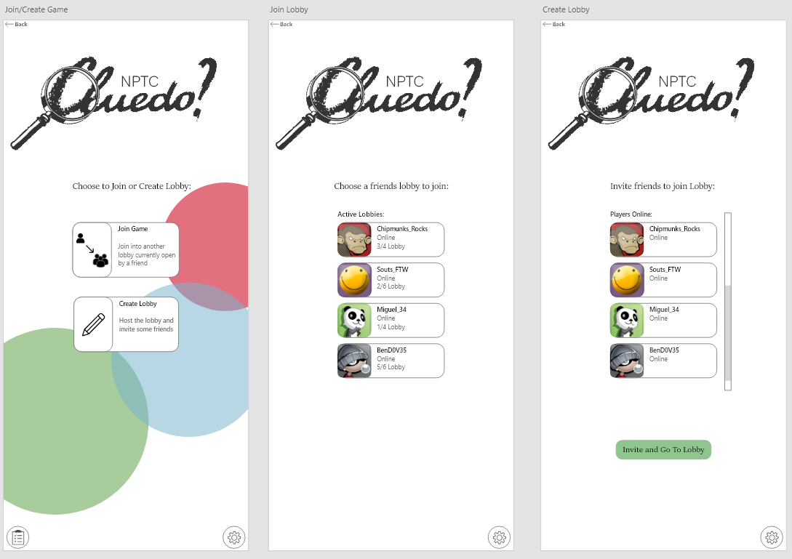
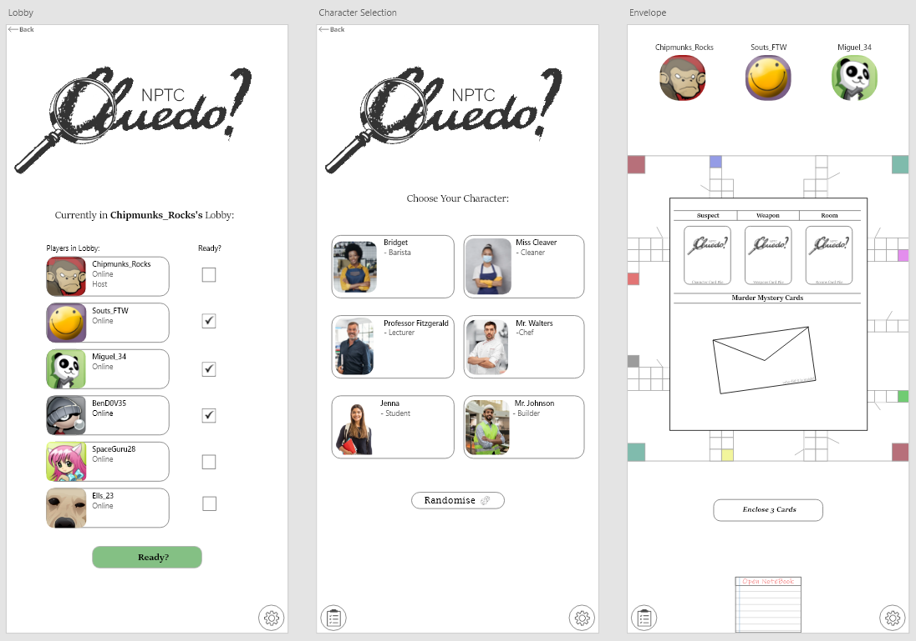
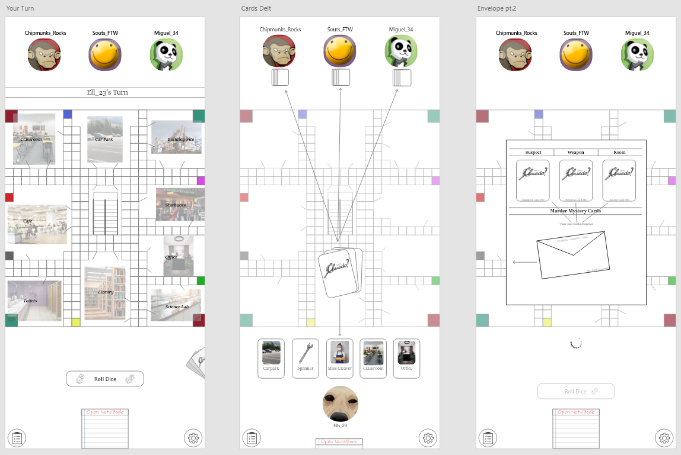
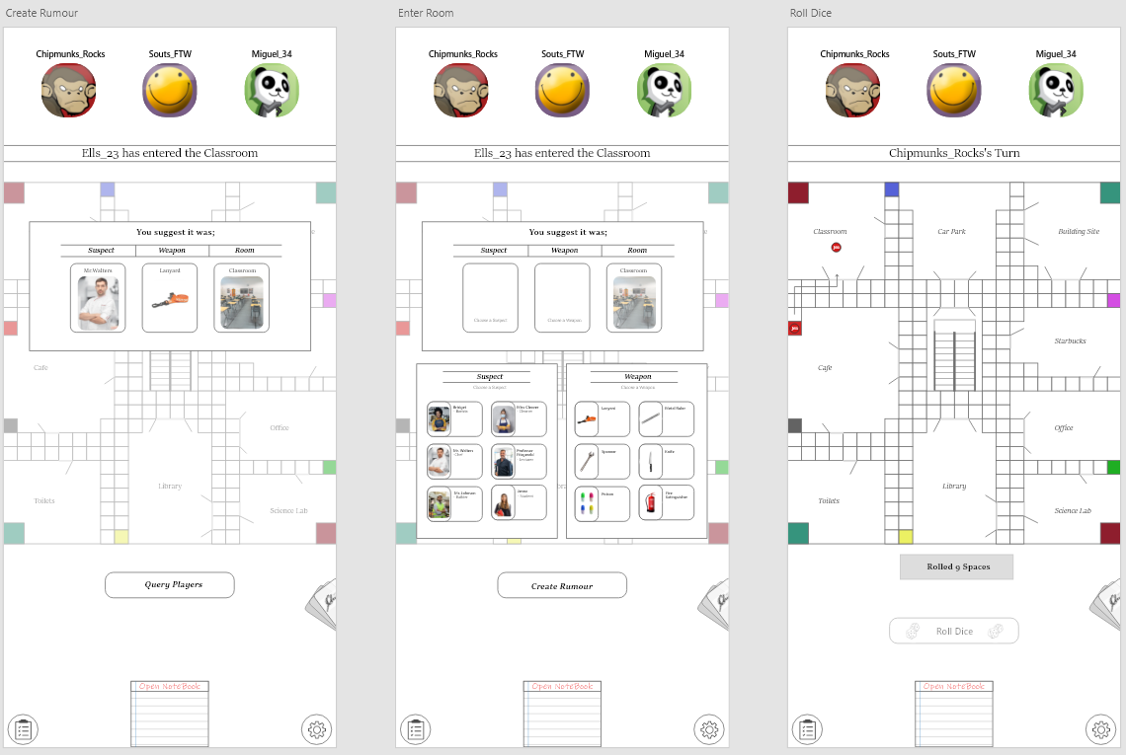

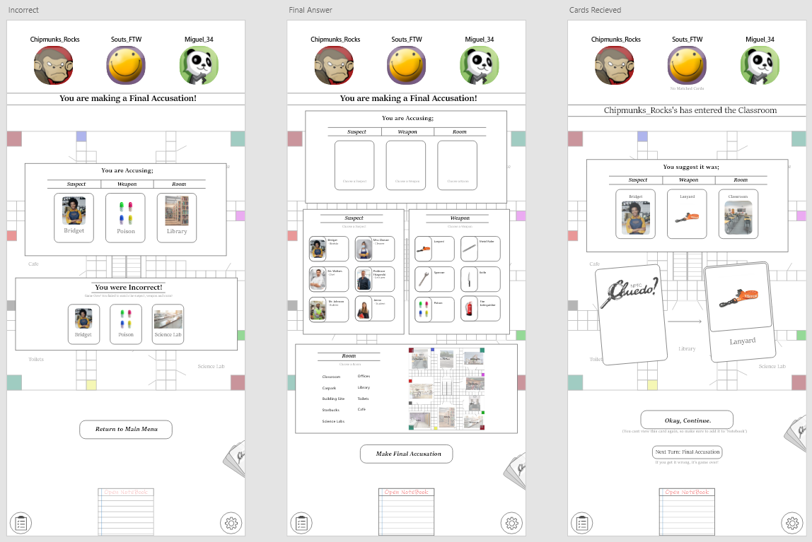
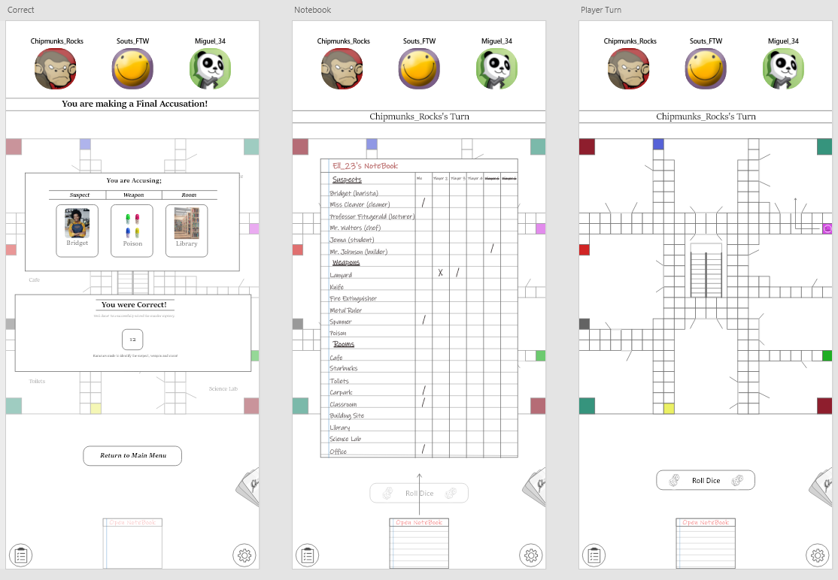
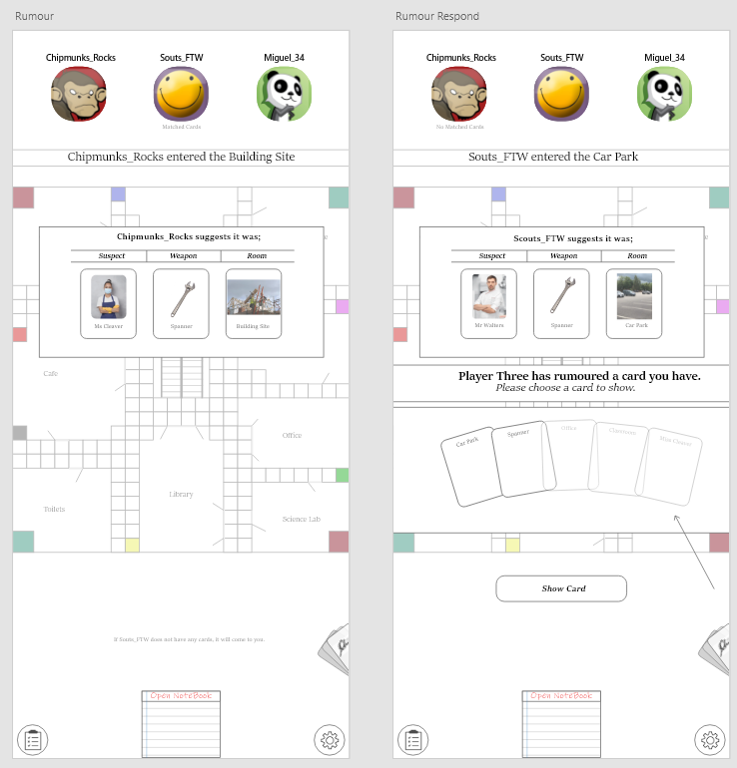
Display of the navigation between screens


