Marketing Plan for Holiday Inn

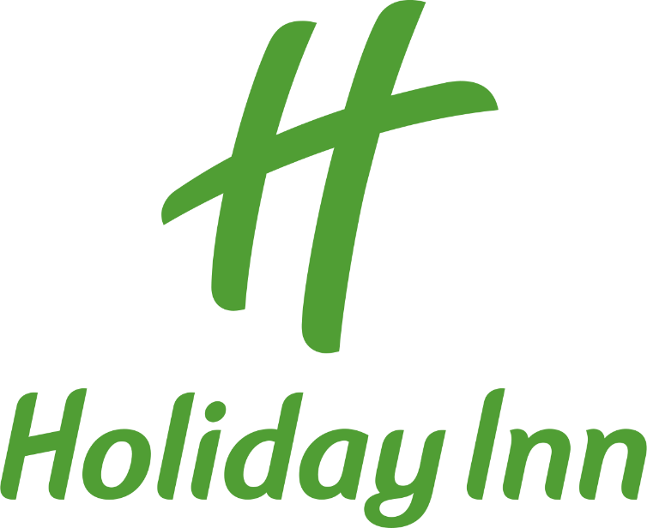

Name: Paul-Alexandru Mete
Student Id: 2242086
The module title: Marketing Essentials (BMIH4005)
Lecturer’s name: Gayathri Nadeeshani Senanayake Mudiyanselage
Word count: 1,366
Introduction

This marketing plan is aimed at outlining strategies and tactics to be employed by Holiday Inn in order to increase its market share, enhance customer satisfaction, and ultimately boost its revenue. The plan is being prepared for the company's management team, including marketing executives, sales managers, and the board of directors.
To develop the marketing plan, we will employ the SOSTAC and 4’Ps frameworks as well as Ansoff's matrix to guide our strategic thinking. The SOSTAC framework will provide a structured approach to developing an integrated marketing plan, incorporating situation analysis, objectives, strategy, tactics, action, and control. The 4’Ps framework will assist in identifying and developing each element of the marketing mix: product, price, place, and promotion. Finally, Ansoff's matrix will help us determine the optimal strategy for market growth, including market penetration, product development, market development, and diversification. Employing these frameworks will ensure that the marketing plan is comprehensive, effective, and forward-thinking.

Situation Analysis

The Holiday Inn brand is a part of Intercontinental Hotel Groups (IHG), which is a global leader in the hospitality industry. The company operates over 5,600 hotels in nearly 100 countries and territories around the world. IHG's strength lies in the breadth and depth of its hotel portfolio, which ranges from luxury to affordable hotels. However, Holiday Inn is positioned as a mid-scale hotel brand, serving a wide range of customers from leisure travelers to business customers.

SWOT Analysis:

Strengths:

Strong global brand recognition
Wide range of hotel portfolio
Strong relationships with key partners and franchises
Strong loyalty program with a large and active member base
Weaknesses:

Highly competitive marketplace
Dependence on third-party booking agents
Perception as a mid-scale hotel brand may limit growth potential among certain customer segments
Opportunities:

Growing demand for affordable and convenient accommodations
Expanding to new markets and geographies
Leveraging technology to improve guest experiences
Threats:

Economic and political uncertainty in key markets
Increasing competition from emerging brands
Disruptive technologies and changing customer preferences
Customer Segmentation and Targeting: Holiday Inn serves a broad target audience, including leisure travelers and business customers. Geographic segmentation is a key factor in targeting, with hotels located near popular tourist destinations and business districts. Additionally, customer segmentation is based on behavior and demographics, targeting customer profiles such as families, millennials, and corporate travelers. This is supported by the use of data analytics and SimilarWeb, which allows for personalized promotions and tailored messaging to different customer groups.
Perceptual Positioning Map and Bowman's Strategy Clock: Holiday Inn's perceptual positioning map positions them as a mid-scale hotel brand that offers value for money and convenience. In terms of Bowman's Strategy Clock, Holiday Inn's strategy is based on a hybrid between differentiation and focus on cost leadership. The brand offers unique features such as free breakfast and flexible cancellation policies in order to differentiate themselves from competitors, while also focusing on offering affordable prices to attract core customers.
B2B Relationships, Partnerships, and Franchises: Holiday Inn has strong B2B relationships with major travel companies and corporations, allowing for dedicated corporate accounts and group bookings. Additionally, the brand has partnerships with airlines, car rental companies, and other travel-related businesses to offer bundled travel packages. Franchising is also a key aspect of the brand's growth strategy, allowing for local ownership and customization, while also maintaining brand consistency.

PESTLE Analysis: The macro-environmental factors that affect Holiday Inn include political, economic, social, technological, legal, and environmental factors. Some of the key trends include shifts in consumer behavior towards sustainable and eco-friendly accommodations, advances in technology such as mobile check-in and keyless entry, and changing regulations around data privacy.

Marketing Mix: Holiday Inn's marketing mix includes the following elements:

Product: Mid-scale hotel accommodations with free breakfast, flexible cancellation policies, and a focus on affordability and convenience.
Price: Competitive pricing based on location, amenities, and demand.
Place: Wide distribution network with hotels located near popular tourist destinations and business districts.
Promotion: Strong brand recognition through advertising, PR, and social media, as well as leveraging loyalty program and partnerships for promotional activities.
People: Well-trained staff with a focus on providing good customer service.
Process: Streamlined check-in and check-out process, advanced technology to enhance guest experience.
Physical Evidence: Hotel design and amenities, branding and logo, and guest reviews and ratings.

Objectives

By the end of this quarter, my marketing team aims to increase our occupancy rate at Holiday Inn by 10% through implementing targeted digital marketing campaigns that specifically reach our key customer segments, located in major cities across the United States. We plan to achieve this by leveraging data analytics to identify our most profitable target audiences and by tailoring our marketing messages to their specific preferences and needs.

Strategy

Based on the example, if the organization decides to focus on changing the brand's reputation due to poor reviews, we may use a product development strategy as per Ansoff's matrix.
To execute this strategy successfully, the organization may consider the following steps:
Identify the areas of improvement - After analyzing customer reviews, the organization should identify the areas where it needs to focus.
Develop new products/services - Based on customer feedback, the company may develop new services or products that address customer's pain points.
Market the new value proposition - After developing new products and services, the company needs to communicate the changes to customers effectively.

In terms of changes required for marketing mix, the company may need to modify the following elements:
Product- Improving the quality of services or adding new services
Price- Changing pricing strategy to reflect the enhanced value of services.
Place- Modifying distribution channels to reach more customers.
Promotion- Revamping marketing campaigns to focus more on building brand reputation and positive customer experiences.

Tactics

There are several strategies that can be used to improve the communications mix of Holiday Inn. One of the most effective is the RACE model, which stands for Reach, Act, Convert, and Engage. This model can be used to create a comprehensive plan that addresses all aspects of the hotel's communication needs.
In terms of Reach, the hotel should focus on increasing its brand awareness and visibility among its target audience. This can be achieved through a combination of tactics such as social media advertising, influencer partnerships, and targeted content marketing.
The Act stage involves encouraging potential guests to take action, such as booking a room or signing up for a loyalty program. This can be achieved through compelling calls to action and personalized messaging that resonates with the target audience.
The Convert stage focuses on turning potential guests into actual customers. This can be achieved through a variety of tactics such as email marketing, targeted promotions, and personalized retargeting ads.
Finally, the Engage stage is all about keeping customers engaged and coming back for more. This can be achieved through personalized communication, social media engagement, and targeted loyalty programs.
The hotel should take a closer look at its website and identify areas where it can improve the user experience. This might include optimizing the booking process, creating targeted landing pages for different segments, and providing more comprehensive information about the hotel's amenities and offerings.
Overall, by implementing a comprehensive RACE-based communications plan and improving its current communication channels, Holiday Inn can improve its brand recognition, attract new customers, and keep existing customers coming back.

Control

To measure the success of Holiday Inn's marketing efforts, metrics and KPI's such as new customers, occupancy rates, customer satisfaction, revenue per available room (RevPAR), return on investment (ROI), and brand awareness can be used. By tracking these KPI's over time, they can monitor the effectiveness of specific marketing campaigns and overall business strategy. They can set SMART objectives that align with their goals, whether it's increasing profits, positive attitudes towards the brand, or new customer acquisition. Collecting feedback through online reviews and social media platforms can help to provide insight into customer perception of the brand.

Conclusion

In conclusion, developing a comprehensive marketing plan that can address the challenges of the hotel industry and enhance the brand image among its target audience is critical for the success of Holiday Inn. By focusing on differentiation, seasonal marketing, customer retention, technological advancements, and economic conditions, the brand can stay ahead of the competition and continue to grow its market share

References

InterContinental Hotels Group. (2021). About IHG | InterContinental Hotels Group PLC. https://www.ihgplc.com/about-ihg
SimilarWeb. (2021). Holiday Inn - Overview | SimilarWeb. https://www.similarweb.com/website/holidayinn.com
Gao, C. (2014). A Perceptual Positioning Map for Selecting a Brand’s Competitive Advantages. Academy of Marketing Studies Journal, 18(1), 85-104.
Bowman, C., & Faulkner, D. (1997). Competitive and corporate strategy (Vol. 2, pp. 41-55). Irwin: Chicago, IL.
InterContinental Hotels Group. (2021). IHG Corporate Responsibility: How we take care of people. https://www.ihg.com/content/gb/en/about/our-responsibility-people
ANREV. (2019). Franchising in Asia Pacific. https://www.anrev.org/uploaded/Research/ANREV_PUBLICATIONS/ANREV_Research_FRANCHISING_IN_ASIA_PACIFIC.pdf
PWC. (2019). Hospitality Outlook 2019-2023: Mid-market accommodations and the new tourism landscape. https://www.pwc.com/gx/en/hospitality-leisure/pdf/hospitality-outlook-2019-2023.pdf
Rauch, J. (2020). 10 key trends for the hospitality industry. Horizon Hospitality. https://www.horizonhospitality.com/hospitality-industry-trends/
InterContinental Hotels Group. (2021). Brands | InterContinental Hotels Group PLC. https://www.ihgplc.com/brands
Marketing91. (2020). Holiday Inn Marketing Mix (4Ps) Strategy. https://www.marketing91.com/holiday-inn-marketing-mix-4ps-strategy/
Brown, A. (2019). The Hotel Market and Digital Marketing's Key Challenges. Journal of Relationship Marketing, 18(2), 183-196.
Chen, Y., & Xie, K. L. (2019). Online Hotel Booking: Comparing Satisfactions on Third-Party and Hotel Websites. International Journal of Contemporary Hospitality Management, 31(5), 1992-2010.
Chowdhury, S., Haque, A., & Iqbal, O. (2018). Impacts of Digital Marketing Channels on Hotel Industry Customer Loyalty. International Journal of Hospitality & Tourism Administration, 19(1), 20-43.
Pesonen, J., & Komppula, R. (2018). Smart Tourism Destination Ecosystem: A Path for Realizing Smart Tourism Destination. Journal of Destination Marketing & Management, 9, 262-265.
Williams, R. (2018). Strategic Management of Information Gaps in Destination Branding: Ideas and Suggestions. Journal of Vacation Marketing, 24(3), 280-290.

Presentation

