
APPENDIX GA36b

LEVEL 5 ASSESSMENT SPECIFICATION

Student name: |  | Student ID number:
Programme:
Module: | Advanced Software Development
Module code: | ACCB5011 | Contribution to Overall Module Assessment (%): | 50%
Lecturer: | Dr Tim Bashford | Internal Verifier: | Dr Mike Dacey
Assignment Title: | Maze Pathfinding implementation | Word count (or equivalent): | 3000-word equivalent
Submission deadline: | 13/01/22 | Return date of provisional marks & written feedback: | 10/02/22
Submission method: | All written assessments, where practical and possible, must be submitted via Turnitin unless otherwise instructed by the Lecturer. (Please DO NOT put this assessment specification into Turnitin or it will match many similarities with other students’ submissions.)  Alternative submission method (if applicable):  Late submission of the assessment will result in a late penalty mark. Penalties for late submission: Up to one week late, maximum mark of 40%. Over one week late, 0%. Only the Extenuating Circumstances Panel may approve a change to submission dates.
Academic honesty / referencing: | Academic honesty is required. In the main body of your submission you must give credit to authors on whose research and ideas your work is based. Append to your submission a reference list that indicates the books, articles, etc. that you have used, cited or quoted in order to complete this assessment.

Module Learning Outcomes
(from module syllabus)

TASK DESCRIPTION

You are required to write a report, then complete an implementation which allows automatic navigation through a maze.

Section | Marks
Report | 40%
Implementation | 60%

Report

Write a report of 1250 words which:

- Describes Dijkstra's Algorithm, the A* Algorithm and performs a comparison between the two (approx. 750 words).
- Reflects on the developing process of the implementation, details results obtained and discusses the interesting portions of their code, with snippets (approx. 500 words).

Implementation

Please read this brief carefully – it will clarify several key aspects of the implementation.

Download the Pathfinding Assignment code from Moodle. Import it into Visual Studio and ensure it runs. It will require a compiler supporting at least C++17.

When this code is run, it will generate a maze, which comprises:
- A “player” which must be moved through the maze.
- A “target” which the player aims to reach. The target does not move.
- Walls, which the player cannot move through.
- Empty space, which the player can move into.
The maze is plotted on a 2D grid of size 20x20. Walls encompass the entire maze. The player always starts in the bottom left, the target always starts in the top right. Internal walls are randomly generated each time a maze is created; however, the maze is guaranteed to be solvable, i.e., it will always be possible for the player to reach the target.

The player may only move one square at a time in cardinal directions, i.e., up, down, left, and right. Here is an example maze when first created:

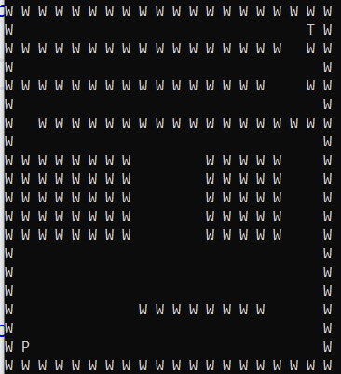
Note that in this, ‘W’ represents a wall, ‘P’ (bottom left) represents the player, ‘T’ (top right) represents the target and blanks are space into which the player can move.

Your goal is to write code to automatically solve any randomly generated maze as efficiently as possible – more detail on the precise meaning of this will be given later in this document.

First, you can try to run this code in “manual” mode. Start the code and at this menu:

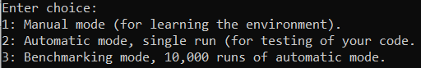

Enter ‘1’.

This will generate a maze through which you can move in the manner described. However, every operation you perform is added up – every move, every time you view a square, every time you hit a wall.

Navigating the maze blind will be difficult, so you might first like to hit ‘v’ to see your randomly generated maze:

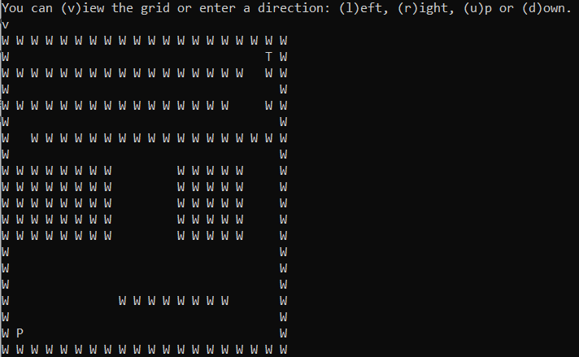

From here, you can theoretically solve the maze using l, r, u, d. Try moving around a little, e.g.:

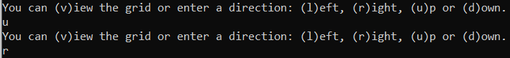

Now, if you hit ‘v’ again:

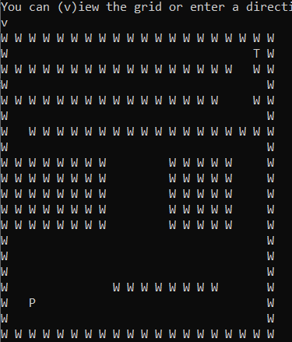

Note that the ‘P’ player icon has moved up and right. Continue in this fashion to try to solve the maze manually. The goal here is to do so while:
- Not hitting any walls
- Avoiding using ‘v’ unnecessarily.
Once the maze is complete, you’ll see an output similar to:

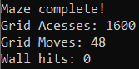

What this means is that I entered a direction 48 times to complete the maze. I did well (if I say so myself) and avoided hitting any walls – but I did have to view the entire grid 4 times in order to complete it. This says “1600” accesses, because it counts how many times a square was viewed – the grid is 20x20, so every time I view the entire grid it construes 400 accesses.

Your goal is to write an automatic solution which:

- Completes any randomly generated maze successfully.
- Keeps the number of moves made to a minimum. This will vary slightly from maze-to-maze.
- Keeps the number of grid accesses (views) to a minimum.
- Avoids hitting any walls.

You should not change any of the existing code to achieve this, i.e., no tampering with the counters, maze generation, etc!

The only method you can change is GridNavigatorAutomatic::Navigate() which is the method which will be called by the code when trying to solve the maze automatically. Currently, it is a comment and a cout:

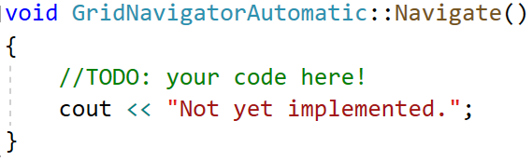
These can be erased, and your own code added. You can (and likely should) add your own classes and methods called from this method – but may not change any other code in the existing program.

The parent class has a protected attribute called “grid” which you should access through the GridNavigatorAutomatic::Navigate() method.

The following methods are available to you:

grid->CheckComplete() - this returns true when the grid has been successfully c-+ompleted (i.e. the player reaches the target), but false in all other situations.

grid->GetGrid() – this obtains the entire grid as a 2D array. This will increase the “access” counter by 400.

grid->GetGridSquare(x, y) – this obtains a single square in the 2D array. Parameters x and y are integers, which should be in the range 0 – 19. This will increase the “access” counter by 1.

Note: both GetGrid methods return an enum called “griditem” – you may not have previously encountered enums. Enums are a computationally efficient way of referring to a restricted range of things. In this case:

empty, wall, player, target

You can refer to any of these using the notation griditem::type, e.g. griditem::wall. So if I wanted to test if a square was a wall, I could write the code:

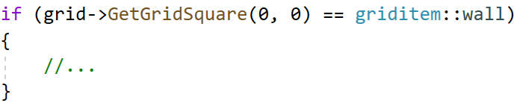

grid->PrintGrid() – prints the entire grid to console. This effectively calls grid->GetGrid() so will correspondingly increase the “access” counter by 400. I recommend that this method shouldn’t be used in your actual solution – an automatic solution shouldn’t need to print to console, but it may nonetheless be useful to you as the developer for debugging.

grid->MovePlayer(direction) – moves the player in a direction you specify. This both takes and returns an enum.

The parameter for this method is an enum called movedirection, with the enumerators up, down, left, right. So, if you wanted to move the player up, you should call:

This method also returns an enum called moveresults with the enumerators ok, complete, wall.
- “ok” implies a successful move, i.e., the player moved into blank space.
- “complete” implies that the move was successful, and the player has reached the target, i.e., the maze can be considered complete.
Either “ok” or “complete” will result in the “move” counter increasing by 1.
- “wall” implies that the player tried to move into a wall – this move will not result in the player moving but will cause the “wall” counter to increase by 1 (the “move” counter will not change).

So for example:

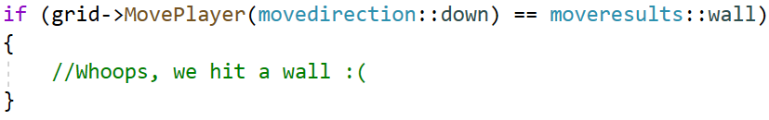

Note, you can use enums like any other type, e.g.:

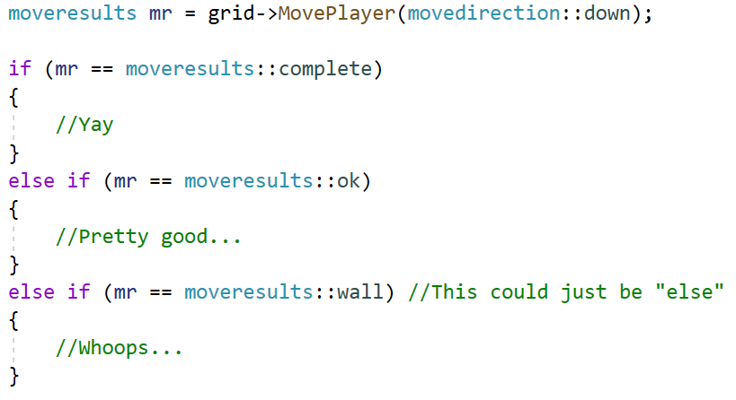

Once you have written your solution, you can test it by running the program then hitting ‘2’. This will run through your GridNavigatorAutomatic::Navigate() method, then, assuming it completes correctly, print out the number of moves, accesses and will hits – which should make it possible to track whether your solution is improving as it evolves (though remember that certain mazes will allow an easier solution than others).

For a more robust but time-consuming test, hit ‘3’ when the program starts – this will run your solution 10,000 times and tell you the minimum, maximum and mean for the 3 counters. The mean should allow you to track whether your solution has improved, because 10,000 iterations should be sufficient to iron out any variance in the difficulty of the randomly generated mazes.

Tips

Your goal is efficiency, but you should focus on a coherent, working solution first. A significant portion of marks are available for a well-considered, working solution, even if the route is not optimal.

More advanced students should implement the A* pathfinding algorithm or Dijkstra's Algorithm, as researched in part 1. Anyone with a surplus of time could even consider implementing both and comparing the two – but this would be above and beyond the expectations for this assignment!

Don’t worry about over-optimising the “access” counter. I.E., it would theoretically be possible to use your knowledge of the maze (like the static positions of the player, target and outside walls – or even to deconstruct the internal wall generation code) to avoid accessing these positions; this level of optimisation is unnecessary. It is expected that most implementations will access every square in the maze at least once (400 accesses total), but a good implementation probably won’t have much more than that.

A very naïve example

As an example, not to be copied, this code will solve the problem:

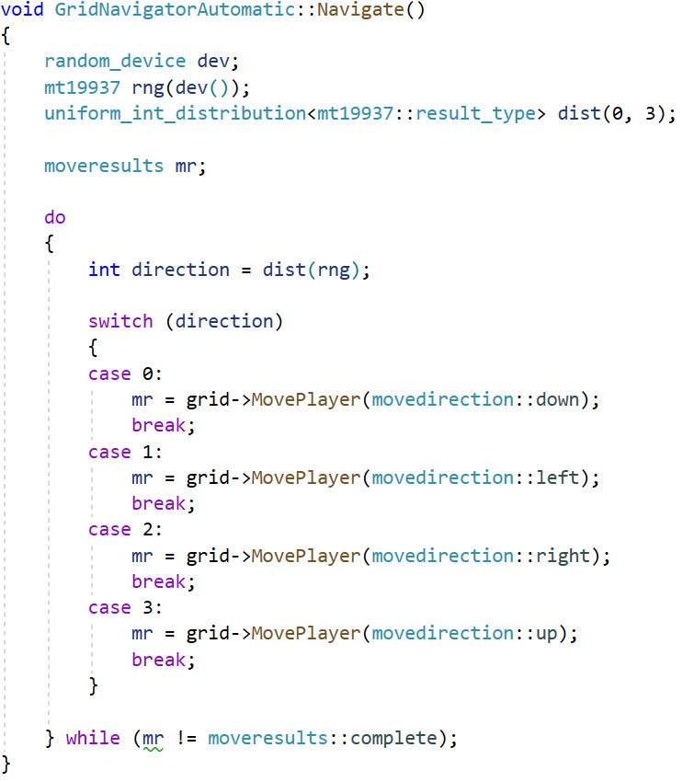

This simply moves the player in a random direction indefinitely, until we luck into reaching the end. This gives statistics like:

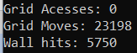

Which is not good. Interestingly, this approach has 0 accesses, because it never actually looks at the maze – and doesn’t need to(!)

Just for fun, I let this run 10,000 times (which took a few seconds), which gave:

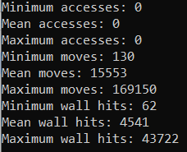

Of course, your solution should be considerably better than this…

GUIDANCE FOR Students IN THE COMPLETION OF TASKS

NOTE: The guidance offered below is linked to the five generic assessment criteria overleaf.

- Engagement with Literature Skills
Your work must be informed and supported by scholarly material that is relevant to and focused on the task(s) set. You should provide evidence that you have accessed an appropriate range of sources, which may be academic, governmental and industrial; these sources may include academic journal articles, textbooks, current news articles, organisational documents, and websites. You should consider the credibility of your sources; academic journals are normally highly credible sources while websites require careful consideration/selection and should be used sparingly. Any sources you use should be current and up-to-date, mostly published within the last five years or so, though seminal/important works in the field may be older. You must provide evidence of your research/own reading throughout your work, using a suitable referencing system, including in-text citations in the main body of your work and a reference list at the end of your work.

Guidance specific to this assessment: For good use of referencing in the pathfinding algorithms comparison in the written report.

- Knowledge and Understanding Skills
At level 5, you should be able to demonstrate: sound knowledge and critical understanding of the well-established concepts and principles of the subject area and the way in which those principles have developed; knowledge of the main methods of enquiry in the discipline. Knowledge relates to the facts, information and skills you have acquired through your learning. You demonstrate your understanding by interpreting the meaning of the facts and information (knowledge). This means that you need to select and include in your work the concepts, techniques, models, theories, etc. appropriate to the task(s) set. You should be able to explain the theories, concepts, etc. meaningfully to show your understanding. Your mark/grade will also depend upon the extent to which you demonstrate your knowledge and understanding.

Guidance specific to this assessment: For your explanation and comparison of the pathfinding algorithms in the rewritten report.

- Cognitive and Intellectual Skills
You should be able to critically analyse information, and propose solutions to problems arising from that analysis, including the critical evaluation of the appropriateness of different approaches to solving problems. Your work must contain evidence of logical, analytical thinking, evaluation and synthesis. For example, to examine and break information down into parts, make inferences, compile, compare and contrast information. This means not just describing what! But also justifying: Why? How? When? Who? Where? At what cost? At all times, you must provide justification/evidence for your arguments and judgements. Evidence that you have reflected upon the ideas of others within the subject area is crucial to you providing a reasoned and informed debate within your work. Furthermore, you should provide evidence that you are able to make sound judgements and convincing arguments using data and concepts, with an understanding of the limits of knowledge, and how this influences analyses and interpretations. Sound, valid conclusions are necessary and must be derived from the content of your work. Where relevant, alternative solutions and recommendations may be proposed.

Guidance specific to this assessment: For the reflective portion of the written report.

- Practical Skills
At level 5, you should be able to use/deploy a range of established techniques within the discipline, and apply underlying concepts and principles outside the context in which they were first studied, including, where appropriate, the application of those principles in an employment context. You should be able to demonstrate how the subject-related concepts and ideas relate to real world situations and/or a particular context. How do they work in practice? You will deploy models, methods, techniques, and/or theories, in that context, to assess current situations, perhaps to formulate plans or solutions to solve problems, or to create artefacts, some of which may be creative. This is likely to involve, for instance, the use of real world artefacts, examples and cases, the application of a model within an organisation and/or benchmarking one theory or organisation against others based on stated criteria. You should show awareness of the limitations of concepts and theories when applied in particular contexts.

Guidance specific to this assessment: For the implementation in code.

- Transferable Skills for Life and Professional Practice
Your work must provide evidence of the qualities and transferable skills necessary for employment requiring the exercise of personal responsibility and decision-making. This includes demonstrating: professional development to advance existing skills and acquire new competences that will enable you to assume significant responsibility within organisations; that you can initiate and complete tasks and procedures, whether individually and/or collaboratively; that you can use appropriate media to effectively communicate information, arguments and analysis in a variety of forms to specialist and non-specialist audiences; fluency of expression; clarity and effectiveness in presentation and organisation. Work should be coherent and well-structured in presentation and organisation.

Guidance specific to this assessment: For good spelling, punctuation, grammar and presentation in the written report.

Student FEEDBACK FORM

This section details the extent to which the assessment criteria are demonstrated by you, which in turn determines your mark. The marks available for each category of skill are shown. Lecturers will use the space provided to comment on the achievement of the task(s), including those areas in which you have performed well and areas that would benefit from development/improvement.

Generic Assessment Criteria | Marks available | Marks  awarded
1. Engagement with Literature Skills
.
 |  | 5
2. Knowledge and Understanding Skills

 |  | 20
3. Cognitive and Intellectual Skills

 |  | 10
4. Practical Application Skills

 |  | 60
5. Transferable Skills for Life and Professional Practice

 |  | 5

Assessment Mark (Assessment marks are subject to ratification at the Exam Board. These comments and marks are to give feedback on module work and are for guidance only until they are confirmed. ) | Late Submission Penalties (tick if appropriate) |  | %
 | Up to 1 week late (40% Max) |  | %
 | Over 1 week late (0%) |  | %

GENERIC ASSESSMENT CRITERIA

Level 5
In accordance with the Framework for Higher Education Qualifications, at the end of Level 5 students will be expected to have developed sound knowledge and critical understanding of the well-established concepts and principles in their field of study, and of the way in which those principles have developed. They will have learned to apply those concepts and principles more widely outside the context in which they were first studied, including, where appropriate, the application of those principles in an employment context. They will have knowledge of the main methods of enquiry in the subject area, and ability to evaluate critically different approaches to problem solving. They will possess an understanding of the limits of their knowledge, and how this influences their analyses and interpretations. They will be able to use a range of established techniques to initiate and undertake critical analysis of information, and to propose solutions to problems arising from that analysis. They will be able to effectively communicate information, arguments and analysis in a variety of forms to specialist and non-specialist audiences, and deploy key techniques of the discipline effectively. They will be able to undertake further training, develop existing skills and acquire new competences that will enable them to assume significant responsibility within organisations. They will have the qualities and transferable skills necessary for employment requiring the exercise of personal responsibility and decision-making.

Level 5 | FAIL | MARGINAL FAIL | SATISFACTORY  (3rd / Pass) | GOOD  (2.2 / Pass) | VERY GOOD  (2.1 / Merit) | EXCELLENT  (1st / Distinction) | EXCEPTIONAL  (1st / Distinction)
Category | 0-29% | 30-39% | 40-49% | 50-59% | 60-69% | 70-84% | 85-100%
Engagement with literature (including reading, referencing,  academic conventions and  academic honesty) | Little or no evidence of reading and/or reliance on inappropriate sources.  Views and findings mostly unsupported and non-authoritative.  Referencing conventions used incoherently or largely absent. | Poor engagement with essential reading. No evidence of wider reading. Reliance on inappropriate sources, and/or indiscriminate use of sources. Heavily reliant on information gained through class contact. Inconsistent and weak use of referencing. | Engagement with a limited range of mostly relevant and credible sources. Some omissions and minor errors.  Referencing conventions evident though not always applied accurately or consistently. | Engagement with an appropriate range of literature, including sources retrieved independently. Some over-reliance on texts. Referencing may show minor inaccuracies or inconsistencies. | Engagement with a wide range of literature, including sources retrieved independently.  Selection of relevant and credible sources. Very good use of referencing, with no/very few inaccuracies or inconsistencies. | Engagement with an extensive range of relevant and credible literature. Consistently accurate application of referencing. | Exceptional engagement with an extensive range of relevant and credible literature. High-level referencing skills consistently applied.
Knowledge and understanding (Sound knowledge and critical understanding of the well-established concepts and principles in their field of study; knowledge of the main methods of enquiry in the discipline.) | Major gaps in knowledge with unsatisfactory, uncritical understanding of the subject matter. Much irrelevant material. Substantial inaccuracies. Significantly flawed understanding of the main methods of enquiry in the discipline. | Fragmentary knowledge, with only superficial critical understanding. Some significant inaccuracies and/or irrelevant material. Incomplete or partially flawed understanding of the main methods of enquiry in the discipline. | Limited but adequate knowledge and critical understanding of the well-established concepts and principles within the subject area, with a few gaps in the selection of material. A narrow critical understanding of the main methods of enquiry. | Knowledge is reasonably detailed and accurate. A good critical understanding of the well-established concepts and principles and the main methods of enquiry, with minor gaps in the selection of material. | Knowledge is reasonably extensive. Exhibits very competent critical understanding of the well-established concepts and principles of the subject and the main methods of enquiry. Breadth and depth of knowledge. | Excellent, detailed knowledge and highly critical understanding of the well-established concepts and principles of the subject and the main methods of enquiry. | Exceptionally detailed knowledge and outstanding critical understanding of the well-established concepts and principles of the subject and the main methods of enquiry. May go beyond established theories.
Cognitive and intellectual skills  (Critical evaluation and analysis of concepts and principles; argument and judgement; the limits of their knowledge, and how this influences their analyses and interpretations.) | Wholly or almost wholly descriptive work. Little or no critical evaluation and analysis of concepts and principles.  Failure to develop arguments, leading to illogical or invalid judgements. Unsubstantiated generalisations or opinion, made without use of any credible evidence. | Largely descriptive work, with superficial use of critical evaluation and analysis of concepts and principles. Weak development of arguments and judgements. Information accepted uncritically, uses generalised statements made with scant evidence and unsubstantiated opinions. Ideas sometimes illogical and contradictory. | Limited attempt at critical evaluation and analysis of concepts and principles, tending towards description.  Some evidence to support arguments and judgements but these may be underdeveloped, with a little inconsistency / mis-interpretation or failure to fully recognise limits of knowledge. | Some critical evaluation and analysis of concepts and principles, though descriptive in parts.  An emerging awareness the limits of their knowledge and ability to use evidence to support the argument though with some tendency to assert/state opinion rather than argue on the basis of reason and evidence.  Mostly valid arguments and logical judgements. | Sound critical evaluation and analysis of concepts. Is selective in the range of evidence used and synthesises rather than describes. Ability to devise arguments that show awareness of different stances, and use evidence convincingly, to support appropriate and valid judgements. | Excellent critical evaluation and analysis of concepts and principles leading to logical, evidence-based, reasoned arguments and judgements. Explicit recognition of other stances and a strong awareness of the limits of their knowledge.  A capacity for independent thought and ability to ‘see beyond the question’, suggesting some grasp of the broader field and wider concepts. | Outstanding critical evaluation and analysis of concepts and principles. Uses evidence exceptionally well to connect ideas, and support highly logical and persuasive, arguments and judgements. Evidence of independent thought and ability to ‘see beyond the question’, suggesting a clear grasp of the broader field and wider concepts. Perceptive recognition of the limits of their knowledge, and how this influences their analyses and interpretations.
Practical skills  (Apply underlying concepts and principles more widely outside the context in which they were first studied; use a range of established techniques; propose solutions to problems arising from analysis.) | Limited or no use of established methods, materials, tools and/or techniques.  Little or no appreciation of the context of the application.  Limited understanding of the application of theory to practice or making appropriate links between the two.  Very weak problem-solving skills outside the context in which they were first studied. | Rudimentary application of established methods, materials, tools and/or techniques but without consideration and competence. Flawed appreciation of the context of the application.  Weak understanding of the application of theory to practice, with only occasional evidence of making appropriate links between the two. Weak problem-solving skills outside the context in which they were first studied. | An adequate awareness and mostly appropriate application of established methods, materials, tools and/or techniques.  Basic appreciation of the context of the application. Theoretical knowledge and understanding applied in practice, but not always making logical links between the two.  Can identify problems and propose basic solutions outside the context in which they were first studied. | A good and appropriate application of established methods, materials, tools and/or techniques.  Clear appreciation of the context of the application. Mainly consistent, accurate and logical application of theory to practice, making appropriate links between the two.  Can identify problems and propose mostly appropriate solutions outside the context in which they were first studied. | A very good application of a range of established methods, materials, tools and/or techniques.  Very good consideration of the context of the application, with perceptive insights. Consistent, accurate and logical application of theory to practice, making appropriate links between the two. Can identify problems and propose appropriate solutions outside the context in which they were first studied.  Evidence of some creativity. | An advanced application of a range of established methods, materials, tools and/or techniques.  The context of the application is well considered, and insightful.  Consistent, accurate and logical application of theory to practice, making well-developed links between the two. Can identify problems and propose excellent, creative solutions outside the context in which they were first studied. | Exceptional levels of application and deployment skills using established methods, materials, tools and/or techniques. Consistent, accurate and logical application of theory to practice, making highly developed links between the two. Can identify routine and non-routine problems and propose quite sophisticated, creative solutions outside the context in which they were first studied.
Transferable skills for life and professional practice  (Effectively communicate in a variety of forms  to specialist and non-specialist audiences; the qualities and transferable skills necessary for employment requiring the exercise of personal responsibility and decision-making.) | Communication medium is inappropriate or misapplied.  Work is poorly structured, disorganised and/or confusingly expressed. Very weak use of language and/or very inappropriate style. Failure to work effectively as part of a group. Little or no evidence of the skills for employment requiring the exercise of personal responsibility and decision-making. | Communication medium is poorly designed and/or not suitable for the audience.  Work is poorly presented in a disjointed manner. It is loosely, and at times incoherently, structured, with information and ideas often poorly expressed. Weak use of language and/or inappropriate style. Flawed approach to group work, meeting only partial obligations to others. Limited evidence of the skills for employment requiring the exercise of personal responsibility and decision-making. | Can communicate in a suitable medium for the audience but with some room for improvement.  Mostly ordered presentation and structure in which relevant ideas / concepts are reasonably expressed. Work may lack coherence in places. Can work as part of a group, meeting most obligations to others but perhaps with limited involvement in group activities.  Demonstrates the basic skills for employment requiring the exercise of personal responsibility and decision-making, with some areas of minor weakness. | Can communicate effectively in a suitable medium for the audience, but may have minor errors.  Mostly coherent, organised work, in a suitable structure and is for the most part clearly expressed. Can work effectively independently and/or as part of a team, with clear contribution to group activities.  Demonstrates the skills for employment requiring the exercise of personal responsibility and decision-making, with some areas of strength and some of minor weakness. | Can communicate well, confidently and consistently in a suitable medium for the audience.  Work is coherent, fluent, well-structured and organised. Can work very well autonomously and/or as part of a team, with very good contribution to group activities.  Demonstrates very good skills for employment requiring the exercise of personal responsibility and decision-making, with just occasional minor weakness. | Can communicate professionally confidently and consistently in a suitable medium for the audience.  Work is coherent, very fluent and is presented proficiently. Can work autonomously with initiative. Where relevant can work professionally within a team, showing leadership skills as appropriate, and meeting obligations. Demonstrates excellent skills for employment requiring the exercise of personal responsibility and decision-making and an appetite for further development. | Can communicate with an exceptionally high level of professionalism, highly suitable for the audience.  Work is exceptionally coherent, very fluent and is presented professionally. Can work exceptionally well within a team, showing leadership skills. Demonstrates exceptional skills for employment requiring the exercise of personal responsibility and decision-making and an appetite for further development.

THIS DOCUMENT IS ALSO AVAILABLE IN WELSH

