 APPENDIX GA36d

LEVEL 7 ASSESSMENT SPECIFICATION
Student name: | Lee, Tak Man Anna Lisa | Student ID number: | 2124401
Programme: | DBA
Module: | Qualitative Research Methods
Module code: | HKBM7003 | Contribution to Overall Module Assessment (%): | 100%
Lecturer: | Dr. Tamara Savelyeva | Internal Verifier:
Assignment Title: | Research Article | Word count (or equivalent): | 8,230 words
Submission deadline: | 31st October, 2022 | Return date of provisional marks & written feedback:

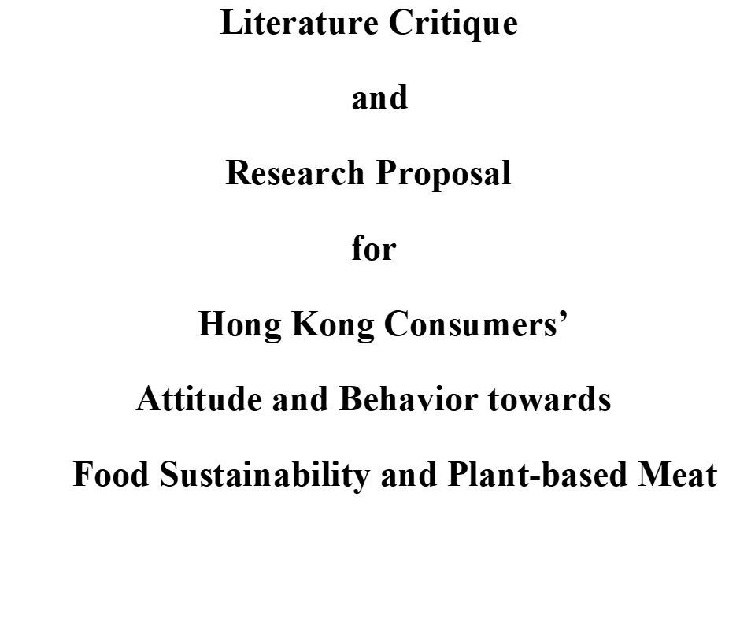

Table of Contents

List of Tables and Figures

1. Overall Abstract

Food sustainability is a global challenge affecting human race, so world leaders are desperate to look for solutions to maintain a healthy and sustainable food system (Berry et al., 2015). Major threats come from climate change that affects crop yields and livestock agriculture, political instability brings breakage to food supply chain, and the outbreak of epidemic diseases gives rise to devastating effect on food security. Humans have long been declared to be the primary culprits for destroying environment by releasing excessive greenhouse gas that gave rise to disasters such as droughts and floods, resulting in species extinction and biodiversity loss (Garnett, 2013). The rise of meat-alternatives becomes the “life-saving straw” to reduce utilization of resources and farm land for planting crops to feed livestock for meat (Gastaldello et al., 2022; Lusk et al., 2022), and also easing the stress of demand for irrigating water (Zhai, Y. et al., 2022). Consuming meat-alternative diets becomes a sensible and humane solution to eliminate the degree of impacts induced by food insecurity and unsustainability.
Hong Kong is a prosperous city, so Hongkongers are not in a state to feel anxious about inadequacy of food; however, food unsustainability problems had already triggered the world alarm. The food sustainability issue is significantly prominent to Hongkongers, since Hong Kong’s food supply is over 90% imported, and mainly from China. China’s self-sufficiency rate of food had a direct impact on Hong Kong’s food security. World population climbs drastically, and by 2050, it will reach nine billion people and there will be insufficient food to feed all (Chan, 2016). Awareness should be activated to start considering how the world can produce enough food to feed everyone. Scientists have been working in full strength to innovate meat substitutes by simulating the texture, flavour and aroma of conventional meat. The invention of meat-alternatives, such as plant-based meat, could be traced back in history; contrarily, cultured meat is a novel technological lab-made product growing in bioreactors. Besides these two common alternatives, there are also algae-based and insect-based meat, from which proteins can be transited (van der Weele, C. et al., 2019).
Eating greens in Hong Kong is not a contemporary issue as the city has a religious culture and culinary heritage of Buddhism and vegetarianism, but Hong Kong’s meat-alternative industry is not functioning in full swing, as Chinese people believes that the main source of nutrition comes from meat. Despite the warnings from United Nation, Hong Kong people’s meat consumption rate is on rise, proportionately eating more meat than the rest of the world. There is an imperative need to raise their awareness and alert them of the insecure food system. As earth dwellers, Hongkongers have the responsibilities to maintain a sustainable food system by making efficient use of natural resources to protect the environment. The current researcher will conduct a qualitative study by adopting the grounded theory approach, for the purpose to establish a theory to interpret Hong Kong people’s social behaviour in response to food shortage and environmental problems, and to identify knowledge gaps which had not discovered in previous researches.

Grounded theory is a research approach driven by data obtained directly from the field. Basing on inductive reasoning, patterns of paradigm appear and a new theory will emerge from the grounded data. The theory can be used to interpret Hong Kong consumers’ attitude and behaviour towards plant-based meat, a product perceived by scientists as solvable remedy to lessen the impact of climate change. Marketers can use these findings and theory application to develop their promotional campaign. The researcher will collect data from focus group interviews by use of theoretical sampling to recruit participants; but for the initial interview before theoretical categories occur, purposive and convenient sampling method will be used for recruiting participants who are older than 18 years of age, ones who can make independent decisions for purchasing plant-based meat. When initial data are under analyses, the researcher has to frequently ask questions about these data, to justify if they fit with the researcher’s original idea or there are uncertainties exist. When more information is needed for solving the puzzles, theoretical sampling will come into place by inviting more participants to join in extra rounds of focus group interviews for clarification and refinement of problems emerged from theoretical categories. Comparing data constantly across groups will place disparities and complexities into analyses, other secondary data retrieved from literatures reviewed or from researcher’s personal experiences can also be examined and checked against the data collected. The process will help to examine the correctness or biases of the researcher’s early assumptions and to decide whether more information is needed, or the researcher has to alter her original idea. The theoretical sampling process will continue until data saturates and a factual conclusion is reached. If necessary, the researcher will further conduct one-on-one interviews with experts to acquire more in-depth insights. The researcher will construct a new theory – a theory that will be emerged during the process and was grounded in the data.
A pilot test will be conducted before the full-scale study takes place, for the purpose to evaluate the functionality of data collection and analysing methods, and to test the feasibility of research and appropriateness of sample size. Pre-defined and open-ended questions will be asked during the semi-structured focus group interviews at both the pilot run and major study, interviewees can freely express their opinions but guided by the questions when formulating their thoughts and ideas. Analyses of data will be done immediately after each session by doing open coding, memo-writing, themes-generating, thematic coding and categorizing, and much attention has to be placed in recognizing the emergence of new theory.
Grounded theory approach tends not to provide the researcher with predetermined ideas about what she will discover in the exploratory study; however, by basing on the researcher’s experiential knowledge about the social phenomena of meat-alternative consumption in Hong Kong, a new theory is anticipated to emerge. If the new theory does appear, the researcher would like to name it as the “Theory of Purposive and Motivational Consumption Behaviour”, which is adapted from the Theory of Reasoned Action (Ajzen, 2015). Complemented by Edward Tolman’s Purposive Behaviourism Theory, and Dean Pruitt and Peter Carnevale’s Dual Concern Theory. This newly-recognized motivational behaviour will be supported by a novel three-level model constructed by the researcher, and be named the “Hierarchy of Needs for Food Sustainability”. The new theory and model will help the researcher to explain in a more comprehensive manner about Hong Kong consumers’ attitude and behaviour towards plant-based meat.

Key words:
Plant-based meat, grounded theory approach, theoretical sampling, semi-structured focus group interviews

2. Evaluation of Research Article

For the purpose to enhance critical thinking skills and exceling to a level of higher cognitive mindset, the current researcher will critique on a qualitative research article to gain more understanding about the social conditions of meat-alternatives in the context of Brazil. The chosen paper has to meet certain criteria and standards proposed by Forchuk and Roberts (2016) for critique. The selected topic should be appropriate for qualitative inquiry, the methodology adopted fit with the topic, and the research method stayed consistent throughout the paper. The paradigm of research must be clear and participants involved in the in-depth interview should be well-introduced. Data collection and analyses of findings should be conducted by adopting appropriate methods. Conclusion must be sound and the research should show significance. An article was chosen from the Food Policy journal for the purpose of critique, it was published by Elsevier BV, with an overall ranking of 1332 and a SCImago Journal Rank (SJR) of 1.926. The full citation of the research article is as follow:

“Morais-da-Silva, R. L. et al. (2022) ‘The social impacts of a transition from conventional to cultivated and plant-based meats: Evidence from Brazil’. Food Policy 111 (2022) 102337. Online. Available: The social impacts of a transition from conventional to cultivated and plant-based meats: Evidence from Brazil | Elsevier Enhanced Reader “

The reason for choosing this specific literature is due to its empirical research nature that the conclusions will be derived from concrete and valid evidences revealed by the participants of research. Among the four philosophical assumptions of ontology, epistemology, axiology and methodology, the authors undertook the epistemological assumption to collect subjective evidence from participants, basing on their individual views in the conventional meat and meat-alternatives fields. The authors tended to shorten the distances between researchers and the participants being studied, they held one-on-one in-depth interviews with field experts, and relied on their quotes for evidence assembling. Among various interpretive frameworks, Morais-da-Silva et al.’s study was linked to social constructivism. Research participants provided complex viewpoints about the meat industries, and reality is discovered by answering open-ended questions. Reality is shaped according to interviewees’ individual experiences and personal background, then interpretation of findings can be co-structured through various ways of knowledge understanding (Creswell and Poth, 2012).
The article is interesting to be conducted in Brazil, a country with meat-alternatives’ adaptation and acceptance level distinctly different from that of Hong Kong – a city which the current researcher will propose to study on. These two places vary greatly in their self-sufficiency rate of food – Hong Kong imports over 90% of its food (AFCD, 2022), whereas Brazil is one of the world leaders in meat productions with highest food security rate among the BRICS , accounting for over 50% of the global food supplies (Ren et al., 2020). Brazil is having a high self-sufficiency rate, not only able to feed its own population adequately, but capable to earn foreign exchange by exporting overseas, mostly exported to Hong Kong and China (Silva, 2019; Nogueira, 2021). With these diversities, it is interesting to study about their differences from contrary angles. The current researcher will also adopt a qualitative research method similar to that of Morais-da-Silva et al. This methodology can help the researcher to get hold of the thoughts, experiences and feelings of interviewed participants, to understand how and why certain behaviors would occur (Austin, 2015). Qualitative research is a mindset, and researchers made it grow (Savelyeva, 2022).

2.1 Summary of the Critique Article
The research of Morais-da-Silva et al. (2022) aimed to explore the social impacts accentuated in Brazil during the country’s transitional process from conventional meat to meat-alternatives. The authors conducted an empirical study by collecting data via semi-structured in-depth interviews with 35 experts related to the field of food production; consequently, nine opportunities and five challenges were identified as social impacts. This knowledge gap contributed significance to their studies, since social implications were scarcely studied and had never been explored under current contexts. In view of the identified research gap, Morais-da-Silva et al. formulated the research question as: “What would the social impacts be if there is a transition from conventional meat to cultivated and plant-based meat?”. They explained the term “transition” as “by reducing the proportion of conventional meat consumption and increasing the share of alternative-protein’s intake, there will be potential changes in worldwide meat productions and variations in consumption chains”. The authors referred to the assumption of Gerhardt et al. (2020), assuming that by 2040, the world meat market will be proportionated by 40% of real meat, 35% of cultured meat and 25% of plant-based meat. The authors introduced different kinds of conventional meat and meat-alternatives, but focus was put on cultured meat and plant-based meat. Related problems such as environmental disruption, animal welfare and human health issues were also discussed in the study.
Morais-da-Silva et al. adopted the qualitative research strategy of in-depth interviews for their exploratory study. Their study was grounded on the Theory of Social Impact, and the research is dominated by social constructivism to reveal multiple evidences of opportunities and challenges during the process of transition from conventional meat to meat-alternatives. The authors clearly explained why expert participants were invited for the research, mainly because little information was available publicly in Brazil, so they intended to obtain primary insights and first-hand information from experts about this innovative market of alternative-meat. Most participants were met by the authors at a field conference and invitations were extended after the meeting, further recruitments were done by snowball sampling. The authors set up the interview meetings by following the “guide for semi-structured interviews”, open-ended questions were asked for revealing the social impacts.
The authors adopted the Content Analysis approach by first transcribing interview data, familiarities were then identified in the transcripts. These data were coded by ATLAS.ti for generating first-order concepts and second-order themes to aggregate two categories composed of nine social opportunities and five social challenges. The authors discussed about the generated results and uncovered the new opportunities for agricultural producers, including new jobs would be created for workers at different educational levels, meat-alternative technologies would raise workers’ educational qualifications, average salaries would be increased as the gap between rural and urban workers narrowed, working conditions would be improved by comparing manufacturing plants with slaughter houses, opportunities for meat-alternative ingredients entrepreneurs would also be increased, poor people might gain easier access to proteins, healthiness would be improved, and animal welfare would be benefited. Regarding social challenges, the reduction of conventional meat demand would bring assault to real meat producers, unemployment rate would increase in the real meat sector, livestock workers’ low educational qualification needed time to be advanced, price of meat-alternatives was high and not affordable by general public, and Brazilians might find hard to accept meat alternatives as Brazil is a cultural “barbecue country”.
The research findings emphasized the importance of joint effort by all stakeholders, especially by the Brazilian government. The authors proposed the concept of “stakeholder engagement” for addressing the challenges of social impacts, the more Brazilians engage with meat-alternatives, the higher the chance to achieve the opportunities. The authors concluded that cultured meat and plant-based meat showed significant differences in perceived social opportunities and challenges, but they are both playing roles in changing the world’s conventional meat supply chain. Changes in food system might bring both positive and negative social impacts, but will show differences at dissimilar geographical locations; therefore, the authors suggested that future studies should be conducted at other regions and quantitative research approach can be adopted for obtaining closed-system perspectives. Moreover, animal benefits might seem to be enhanced when meat-alternatives came into focus, but more studies have to be conducted since animals are still involved in the production of cultivated-meat.

2.2 Literature Critique
The title of research was clear to show the purpose and intention of the study. In the abstract, purpose, significance of study, research design, methodology adopted, findings, conclusion and recommendations for future studies were all briefly described. The research problems regarding social impacts were stated explicitly, and the research question was clearly defined with the research problem building in. The study adopted the Content Analysis approach for analyses of findings, therefore the use of ATLAS.ti for analyzing the complex and unstructured textual data was appropriate. The overall research design fulfilled the basic requirement of data collection, data measurement and analyses of findings. Critically speaking, the evidences obtained in the research were not generalized enough to address the research problem, since the selection of samples were choice-based and were chosen purposively. Their provided answers exhibited only the attributes and choice behavior favorable to their predetermined positions in the meat-alternative industry.

Choice of Sampling
The critique falls on the choice of samples for in-depth interviews. The authors adopted a choice-based sampling technique with intention to recruit field experts for the study and interview them on one-on-one basis. The authors and 50 experts attended a conference meeting organized by the Brazilian Federal Government’s Ministry of Agriculture, Livestock and Supply. The experts became targets for recruitment, and invitation letters were sent right after the meeting. With help of snowball sampling, 35 experts were recruited. The authors listed out all participants with titles and organizations they were in, but the current researcher discovered that among all 35 participants, 17 of them were from the meat-alternatives industry or related. The current researcher relisted their job titles, types of organization and fields they were from in Table 1.

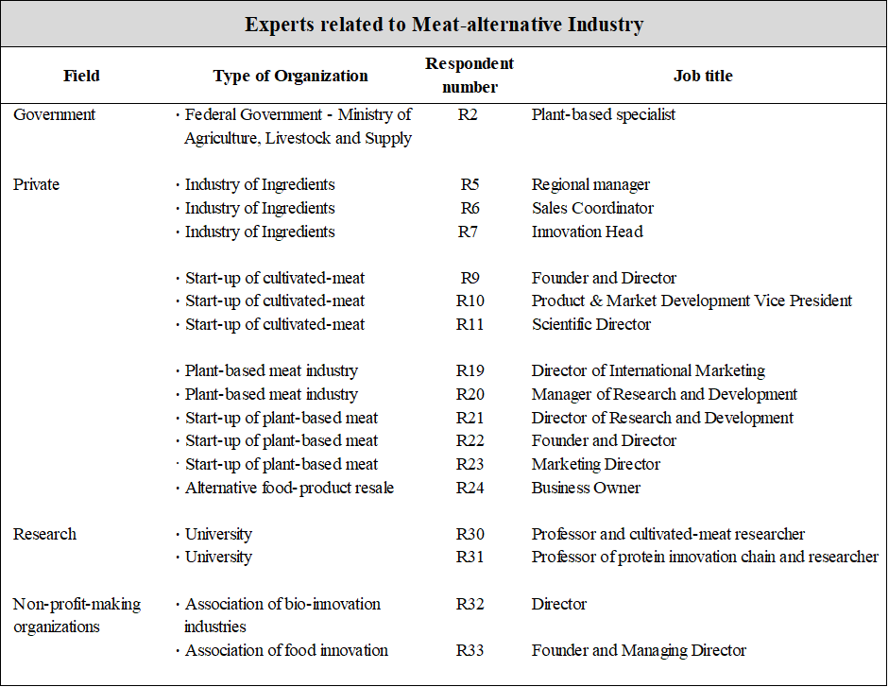
Table 1 List of expert participants related to the meat-alternative fields. Information was retrieved from the study of Morais-da-Silva et al. (2022) and the table was reconstructed by the current researcher.

By looking at the jobs of participants which were highly related to the industries of meat-alternatives, there is a possibility that they would provide opinions which were advantageous and in favor of their belonged field or government sector. For instance, the participants claimed that “there are health problems in conventional meat, so meat-alternatives may be healthier”; however, the current researcher did not totally agree with this opinion, since there were numerous analytical reports and studies indicating that meat-alternatives are in lack of certain nutrients as found in real meat, and intensive processing will lead to nutrient loss (Fraeye et al., 2020; van Vliet et al., 2021; Kolodziejczak et al., 2022). As a result, these contradictive views required further studies to examine the nutritional facts about conventional meat and meat-alternatives. On the other hand, the current researcher agreed with Morais-da-Silva et al. that “engagement of stakeholders seemed crucial” in section 5.3.1 of their paper. Recruitment of participants should be in a wider scope to cover more stakeholders from broader dimensions, so they would provide diversified perspectives in holistic views. Farmers and rangers of both crop and animal agriculture, conventional meat and meat-alternatives marketers should all be included; but most importantly, consumers should not be missed out. Social opportunities should belong to all stakeholders and social challenges should be embraced by all.

Sample Size
A sample with 35 experts in size is appropriate for collecting insights, too large a size might induce saturation of data. Normally, the common themes will be identified after 10 to 15 interviews, information will start to repeat after that. Sample size is partially determined by the scientific paradigm under which the study is taken place and the size is contextual (Boddy, 2016)

Social Impact, social opportunities and social challenges
For the key domain of “social impact”, Morais-da-Silva et al. did try to give an explicit explanation of the terminology by citing the quotations of seven past researchers. For instance, the quotation of Dietz (1987) stated that “social impact is recognized as improvement or deteriorations in the welfare of people”. Tello (2020) indicated that “social impact can be sensed by individual person, family units, social groups, or the whole society, direct or indirect impacts may be realized”. Morais-da-Silva et al. further cited that “social impact can be assessed on scales ranging from positive to negative, with neutrality in the center” (Barrow, 2010); but “social impacts are difficult to be assessed since there are no direct causal relationships” (Vanclay, 2002). As a fact, the authors did not instrumentally assess social impacts in their study and even the term “social impacts” was seldomly mentioned throughout their research. The current researcher had gone through literatures to search for more comprehensible explanation of “social impact” and some definitions brought greater inspirations: “social impacts are positive changes that people intentionally make to create a better world for all living beings” (The Impactful, 2022), and “social impact is how the community is affected by actions of organizations” (Woodson, 2013). Furthermore, the authors did not explain the meanings of “social opportunities” and “social challenges” within the realm of their research, and these terminologies were even not included in the list of keywords, but they occupied almost the whole Chapter 5 for interpretation. The current researcher started to search for better descriptions of social opportunities and social challenges, in order to find out more about how they would create social impacts. Zahra et al. (2008) explained that social opportunity is a vague concept, as it involves economic and non-economic aims, and if conceptualizations become global, definitions are more complex. Nevertheless, in order to make the term more explicit, Zahra et al. tried to break the barriers of understanding, they suggested to “look at opportunities through the lens of behavioral theory within the social realm”. For social challenges, Morais-da-Silva et al. did not clearly explain the actual meaning of social challenges. The current researcher reviewed numerous past literatures and not be able to obtain a precise explanation of the terminology, but discovered that they came in different forms when related to meat-alternatives, such as “sustainability challenges of animal agricultural” (Newton and Blaustein-Rejto, 2021), “social challenges change meat-alternatives into practical business products” (Post et al., 2020) and the like. On the web, there were different definitions about “social challenges”, but most of them related to psychological challenges that people experienced in society, such as people having problems to interact socially or to behave in common social behaviors, and very often the term was linked with emotional and behavioral challenges; therefore, if more precise and concise terminologies were used or explained, Morais-da-Silva et al. would make the research paper more comprehensible.

Topic Title and Sub-titles for Discussions
The title of Morais-da-Silva et al.’s paper did provide the basic idea and purpose of the research, but it gives readers a misconception at first glance that “meat” had been transited successfully from conventional to cultured or plant-based meat. In the Chapter of Introduction, the authors defined the meaning of “transition” as “a potential change in worldwide meat-manufacturing and consumption chains, while the proportion of conventional meat reduces, there is a significant increase in the share of alternative meat”. As readers understand, the term “transition” simply means “the process of change from one state to another”. The authors highlighted the forecast studies of Gerhardt et al. (2020) and Tubb and Seba (2021) to indicate that meat consumption at 2040 will have a dispersion of 35% for cultured meat, 25% for plant-based meat, and 45% for conventional meat. Obviously, the transition passage was not completed to change from one state to another by 2040; therefore, the term “transition” in the title brought misconception. Consumers’ acceptance and adaptation of meat-alternatives is not yet ascertained. Lee et al. (2020) expected that “meat-alternatives will maintain a complementary relationship with real meat”.

The subtitles of different sections were also not clearly written so they brought contrasting meanings when social opportunities and social challenges were discussed. Table 2 showed the subtitles of Chapter 5.

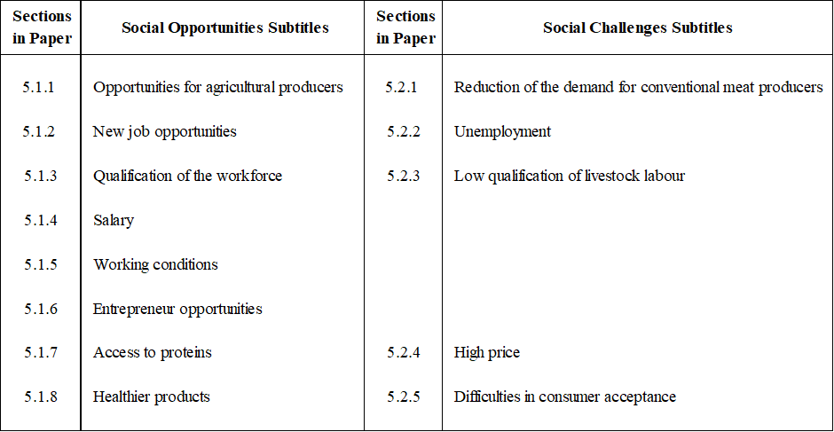
Table 2 Subtitles of social opportunities and social challenges discussions. The table is constructed by current researcher.

The subtitles for sections 5.1.1 and 5.2.1 were well-set, as they reflected the cause-and-effect relationship between opportunities bringing growth to agricultural producers and challenges bringing decrease in demand to real meat producers. For sections 5.1.2 and 5.2.2, if the titles were more explicitly written by stating who the targets were for new job opportunities, and which social class would be affected by unemployment, the titles would become more reasonable. In the paper, the authors actually meant new job opportunities for people with higher technological qualifications, and lower qualification jobs refer to packaging, distributing and marketing. But in reality, manpower for packaging and distributing was already existed in conventional meat industry and they are not new posts created for man-made meat. There was a confusing phrase in section 5.1.2: “bringing job opportunities to people with lower and higher qualifications are expected, mainly in the fields of agronomy, biotechnology, food engineering and chemical engineering”. It’s a known fact that schools of agronomy, engineering and biotechnology required people with higher educational qualification to be enrolled in, so the word “lower” should not be phrased in the same sentence ended with a full-stop. The authors explained later that “lower” applied to jobs such as packaging and distributing, but the phrase had already confused readers.

For section 5.1.7 “Access to proteins”, the authors mainly interpret the phenomena of poverty that gave rise to starvation in Brazil, and Brazilians were not able to purchase meat-alternatives since the price parity between man-made meat and real-meat was high, so why did the authors mention “access to proteins” if this man-made protein is unaffordable. Access to proteins is not difficult as “protein sources from plant and animals are abundant and they were available in different forms (Berkheiser and Brown, 2022). If the authors rename the title as “Access to alternative proteins”, the whole section would become more meaningful. Disparate meanings and usage of terminologies will bring misinterpretations.

At the end of discussion about opportunities and challenges, the authors did not summarize the findings, and jumped directly to implications and contributions. If a summary is entailed, the interpretation of results will be more structured and systematic.

Contribution to Previous Literature
The authors emphasized that they had made “contribution to previous literature” since social impacts were not studied by previous researchers, and only one paper was found discussing social and economic issues. If the sub-title is rewritten as “contribution to literature” or “contribution to future”, that will be more sensible.

Conclusion of the Critique
Morais-da-Silva et al. followed the ethical issues in social study research and the University’s ethics committee had granted them approval to conduct their study in a quality way, without showing misrepresentation on data collected. The authors had made detailed description of new knowledge obtained from research and had also made numerous suggestions for future studies in multiple aspects. Their study can be concluded as knowledge acquired was confirmable, since recurrent patterning was found with consistency, so knowledge could be transferred over dissimilar settings with credibility for validity, and dependability for acceptance by external auditors.

3. Research Proposal

A research proposal will be conducted according to the topic introduced in the long abstract. Approaches and methodologies will be carefully planned and structured, and the adoption of tools and instruments are also rigorously considered, for the purpose to confirm that the research is feasible and worth working on.

3.1. Introduction and Background Overview

Insecurity and unsustainability of the food system are bringing alarm to world leaders to arouse their awareness of the instability of global food supply chain. Agriculture of conventional meat is accused of being the major culprit to bringing environmental disruptions by emitting greenhouse gas, hence causing climate change. The increase of droughts and floods leads to animal species extinction and biodiversity loss. Furthermore, 77% of total agriculture land were occupied for livestock farming but only producing 17% of total food. Eighty percent of water is wasted and being polluted for farm-animal rearing, and large amount of antibiotics was also used for curing farm animal disease thus bringing health concerns to humans as antibiotic resistance rate is driven up. Green food lovers have been actively promoting the belief to eat less meat for loving our planet, and taking up plant-based diets were perceived as a responsible and humane solution to eliminate the menace of food unsustainability. Hong Kong is a small city of having only seven million in population, but Hongkongers consume most meat in the world. Although 90% of food is imported, Hongkongers are living in heck and manger, affluent supply of food does not make them aware and realize of threats approaching. Food insecurity and unsustainability may also be caused by social, economic and political unrest, and impacts can as well be enormous.

3.2 Objective of Research

The research’s major objective is to investigate whether Hong Kong consumers will be willing to undertake a dietary change from conventional meat to plant-based meat if they were aware that the current world food system is insecure and unsustainable. Researched studies had confirmed that Hongkongers eat most meat in the world but live longest life, this sarcasm might reflect that Hong Kong people will not feel the necessity to switch from pro-meat diets to vegetarian or vegan diets. For the sake of protecting environment from the destruction by climate change, the motivators for encouraging Hongkongers to totally or partially give up their established meat-eating habits will be explored.

3.2.1 Problem Statement

For a prosperous city like Hong Kong, Hongkongers are not at all be aware of the food sustainability problems uprising in the rest of the world. Hong Kong consumers’ attitude and resistance towards plant-based meat is the greatest challenge facing marketers when they launch the new products in Hong Kong, heart-touching marketing tactics are needed for raising consumers’ acceptance rate. Arousing consumers’ awareness is the initial step, and moving them to love the planet and mankind is the second step for sustaining plant-based meat. Previous researches focused mainly on the practicality of meat alternatives’ marketing methods, for the purpose to locate where the target group is, how old they are, how much they made, to see if consumers are willing to pay an extra premium for meat-alternatives; but the underlying reasons leading to consumers’ willingness to pay a price that is two to three times more are not thoroughly investigated. Moreover, researches conducted at different countries had identified different demographic groups of customers who were willing to transform to plant-based diets, but what caused the differences and what the innate motivations were, reasons were not disclosed. Cultural, social, psychological and economic factors play major roles in formulating consumers’ decision-making process, but they were not thoroughly studied around the world, especially not in Hong Kong. Basing on these problems observed, the current researcher will conduct an exploratory study by using grounded theory and theoretical sampling approaches to explore the unknowns in the context of Hong Kong. A preliminary literature review had been undertaken and the summary is exhibited in Appendix 1. The review showed that most studies were conducted deductively by adopting the quantitative research method, so the current researcher believed that by using an inductive qualitative approach is suitable for gaining more exploratory insights from the experiences of participants. Three research questions were established for guiding the research process.

3.2.2 Research Questions
In grounded theory study, the designs of research questions will be dissimilar to those in experimental researches, as they are on exploratory nature. The scope of questions asked should be wide enough for allowing researchers to explore a topic liberally in depth but not being off focus. The questions to be asked in the initial round of interviews should illustrate the scope of research and provide guidelines for collecting data. Questions in later rounds will be adjusted for the purpose to refine theoretical categories that might emerge.

Question 1:
Does Hong Kong people know about the food sustainability problems and will their awareness of the problems affect their humanistic love for the environment?

Question 2:
Will Hong Kong people’s humanistic love for the environment have an effect on their purchase intention of plant-based meat?

Question 3:
What other determinants will affect Hong Kong people’s choice of plant-based meat and why?

3.3 Qualitative Insight and Significance of Study

Gathering qualitative insights from interviews can serve as a powerful tool to collect non-numerical in-depth data for understanding problems or generating novel ideas for research. For the current research, by asking “why and how” questions, qualitative insights can be gathered from Hong Kong consumers to reveal their purchase motivation behind their perceptions, and opinions about plant-based meat. Further supplemented by reviewing and reflecting on literatures and anecdotal evidences, a knowledge gap will be discovered with regards to Hong Kong people’s awareness of food unsustainability and remedies that can be undertaken to reduce the impact of climate change. There might be multiple reasons that led to the awakenings or attitudes remain unchanged, these factors are what the researcher is interested in for gaining knowledge about the nuances of Hong Kong people’s thoughts. By adopting focus group interviews and grounded theory approach, a new theory is expected to be emerged during the process, assuming that Hong Kong people might be awakened by their psychological anticipation to maintain a sustainable food system for the well-being of environment, human health and animal welfare.

3.4 Research Epistemology and Philosophical Assumptions

Among the well-defined inquiry fields of epistemology, ontology, philosophy and methodology, epistemology allows researchers to inquire the questions of “what” they want to know about the originality, extent and certainty of propositional knowledge that they are interested in, complemented with personal beliefs and knowledge of researchers, the strategic approach of “how” would fit into the investigation of new knowledge (Locke, 2010). The process starts by asking reflexive questions, and reflexivity helps to establish research questions for provoking awareness to explain and answer the inquiries, epistemology will be the research philosophy applied for the present research. The research is guided by a qualitative paradigm to build up the system of thinking; using concepts, theories and models to set assumptions and to shape the investigative framework, and then incorporated with research methodologies to listen and observe closely at participants’ words, actions and body languages to discover the recurring patterns of their experiences. This process forms the philosophic underpinning of the qualitative research approach.

By using grounded theory approach, the current research will be grounded in assumptions of objectivist and positivist, with emergence of social constructivism and interpretivism paradigms. The researcher tended to gain a better understanding of how Hong Kong people will address to the problems of food sustainability, aimed to develop subjective meanings about consumers’ behavior if they realize of the essentiality to reduce meat consumption. The thinking of positivity implies that the researcher is going to discover the truth about Hong Kong people’s plant-based meat purchase behavior and their underlying motivations. Participants’ backgrounds and historical experiences formulated their beliefs and opinions, thus shaping their own interpretations about their perceptions towards plant-based meat diets. By visiting participants in their fields to collect data inductively, that helps researchers to generate meanings for developing a theory which is able to interpret the missing parts of knowledge that were not identified by past researchers (Creswell & Creswell, 2018; Crotty, 1998).

3.5 Review of Literatures

For the study, the researcher will review existing literature as an inquirer to identify gaps in the areas of food sustainability and plant-based meat, and will rework the study in the setting of Hong Kong, targeting Asian people. But by using grounded theory, literatures would not be used to set the platform for the research, instead knowledge will be obtained and learned from participants of focus groups (Creswell and Creswell, 2018). There were arguments regarding the appropriate timing for doing literature review in qualitative research, most researchers claimed that literature review should be done before data collection, so the fundamental grounds of research problems could be identified. This rationale was commonly found in quantitative studies. Conversely, researchers such as Frankel and Devers (2000), they claimed that “literature review at initial stage would block the inquirer’s true listening, observant and receptiveness to new concepts, knowledge and ideas”. The researcher agreed with the standpoints of Frankel and Devers, so the thorough literature review will be done after the findings are analyzed, for the aims to look for alternatives or to reassure views from past researchers for refinement of conclusion. At the early stage, the researcher will collect anecdotal evidences about the topic from online texts, digital evidences from videos, books, newspapers and magazines. A preliminary literature review will only be done on the key aspects of plant-based meat to gain better understanding of the product and to identify knowledge gaps.

3.6 Theory Application in Qualitative Research

Adoption of theory in qualitative study is both complex and controversial (Bradbury-Jones, Taylor and Herber, 2014). In qualitative study, theories serve two purposes – they serve as the lens for inquiries, or for generation of new theory by using grounded theory approach (Creswell and Creswell, 2018). These perspectives provide guidelines on what issues are necessary to be examined and why they have to be studied. The current research will adapt the Theory of Reasoned Action (Ajzen, 2015) for grounding the research base. The belief of Purposive Behaviorism Theory of Edward Tolman (MacCorquodale and Meehl, 1954) will be used to assist in explaining consumers’ intentional change in consumption behavior resulted from their cognitions and perceptions towards protecting the environment. A purposive and goal-directed behavior will be formed by consuming more green food for the purpose to loving the Earth. But on the other hand, consumers’ mentalistic transformation in consumption behavior had the possibility to be conflicted by their consciousness of double concerns. There are two phenomena of concerns - consumers might eat by concerning their own interest, or they enact to eat by concerning others as there is a social norm for protecting the environment; therefore, the Dual Concern Theory by Dena Pruitt and Peter Carnevale will also be applied to explain the conflicted consideration processes of consumers when they consider buying plant-based meat (Jang and Cho, 2022).

3.7 Research Design
The current research will adopt an exploratory approach to reveal the unknown mindset of Hong Kong people, to study how they will react to the food sustainability problems, or they will just ignore the issues. A qualitative research strategy of semi-structured focus group interviews will be adopted together with a methodological approach of grounded theory. Exploratory areas of interest will be centered around environmental impact, nutritional health concern, animal welfare concern, effect of subjective norm and price of plant-based meat.

3.7.1 Research Methodology: Grounded Theory Approach

The grounded theory approach is an inductive reasoning research strategy focuses on generating a new theory to explain a process, course of actions, or interactive phenomena shaped by the perceptions of participants, instead of focusing on existing theories. The approach begins with data collected via qualitative sampling, and then after data transcription, memo-writing, qualitative coding, categorizing, and theming, patterns and concepts will be identified. Refinement might be needed for clarification, so more information will be gathered from extra focus group interviews, by means of theoretical sampling and sorting. Consequently, the researcher might be able to construct a substantive theory emerged from data collected. Creswell (2007) introduced two most popular genres of grounded theory qualitative design:
- Barney Glaser and Anselm Strauss proposed in 1967 that when existing theories were improper and was ill-fitted for participants under study, theories should be “developed and grounded in field data, specifically through social interactive processes of people”. Researchers adopting grounded theory has no pre-existing knowledge about the data and they performed as neutral observers, they established theories by “inductive data collection and systematic analysis”.
- Kathy Charmaz proposed the “constructivist grounded theory” in 2006, the theory has a high degree of similarity with the traditional ones except for the relationship between researcher and participants. Charmaz argued that researchers are not in the neutral observer positions, but they are co-participants involved in the study, so research topic investigation is recommended before data gathering. When new ideas came out, the researcher could always return to the field to collect more information, thus multiple rounds of interviews will be taken place. The current researcher will employ Charmaz’s constructivist grounded theory approach and adopt the theoretical sampling technique for the study. Figure 1 illustrates the process.

Figure 1 The grounded theory approach research process. The figure was constructed by the researcher and was adapted from researcher’s previous work
3.7.2 Sampling Method and Sample Size

The researcher will adopt a theoretical sampling method to recruit participants for the main study; but for the initial interview, purposive convenient sampling method will be used. Theoretical sampling is commonly used in grounded theory research, the approach is similar to purposive sampling in a way that criteria of participants are set to fit with the research objectives. Purposive sampling is done before research starts, whereas theoretical sampling is done continuously during the data-collection process A small handful of participants will be first selected as purposive samples, they are interviewed and data will be analyzed right away. Based on the analytical result of the initial interview, the researcher will realize what additional information is needed and what extra kinds of theoretical samples are required for obtaining needed information. This supplementary information may give confirmation to previous findings, or the researcher will purposefully look for participants who will disconfirm the previous findings. The researcher will go back and forth between rounds of interviews with newly recruited participants, collecting data and doing analyses until saturation of data reached and no more new information evolved. The current researcher will purposefully recruit Hong Kong residents of at least 18 years of age to participate in focus group interviews of 6 persons in sample size.

3.7.3 Pilot Study

Before actual data collection, it is necessary to conduct a pilot study for finalizing and confirming the methodological approaches of major study, in order to trial-test the “applicability, viability and practicality” of research (Mortell, Ahmad and Abdullah, 2018). The pilot study will follow the same strategies as planned for the actual research, but will use purposive convenience sampling instead of theoretical sampling at this stage. A semi-structured interview will be held for testing the data collection and analyzing methods, any unexpected issues can be identified before the actual study takes place. Ethical approval will also be sought and informed consent forms will also be signed by participants. After transcription and theme identification, if the initial pilot study has identified problems and clarifications are in need, then the purposive sampling method will be interchanged with theoretical sampling for pilot testing a second group of participants. The purpose is to validate the qualitative rigor of the study that is has credibility of trust-worthiness, transferability of application, dependability of consistency, and confirmation of neutrality. The test is to verify that the constructivist grounded-theory approach and theoretical sampling method are the right methodologies for the study, and occurring problems can be averted at early stage.

3.7.4 Data Collection and Analysis Method

In order to obtain interpretivist subjective views from participants regarding their own perceived realities about food sustainability and plant-based meat, semi-structured focus group interviews will be held by asking pre-defined and open-ended questions for revealing information for building up theoretical categories. Participants of the first focus group were chosen purposively and brief inquires will be made for gathering core information to define theoretical categories after memo-writing and coding. Theoretical sampling occurs when the researcher has identified theoretical categories which is relevant to the theory that is going to emerge, then more participants will be recruited for additional data for developing, refining and checking on causes and consequence of the emerged categories (Charmaz, 2001; Khan, 2014). The data collection method and procedures will be more or less the same as those of pilot test. In case of necessity, in-depth one-on-one interviews may also be held. Interviews and reflections will generate concepts. The transcribed data will be carefully examined and common themes will be identified in the constant comparison process. Themes include theoretical or descriptive ideas, with patterns of meanings recur constantly. These repeated passages will then be linked together by different “codes”. Coding is a categorization of thoughts found in the transcript. The current researcher will use the concept-driven coding method to build up in advance a list of prime thematic ideas; since the researcher is part of the social world, she will have fundamental sensitivity and awareness of theoretical ideas and potential codes. A color-coding method will be used by categorizing same codes into one color, and then the categories will be put into the codebook for constructing a framework of thematic schema, on which the new theory will emerge. The new theory come to light from the factual data provided by participants, it is supported and can be explained, so the theory is said to be grounded.

The researcher will adopt a thematic analysis approach for analyzing data inductively. The method allows the researcher to approach data with preconceived themes, basing on the Theory of Reasoned Action, Purposive Behaviorism Theory, Dual Concern Theory and the researcher’s existing knowledge. The researcher is anticipated to discover reflections in the data as she is having strong ideas on the themes that will be revealed.
3.7.5 Emergence of New Theory

By basing on current researcher’s personal experiences, literature reviewed, evidences studied, assumptions, and results expected, a novel theory is expected to be evolved from the themes and categories grounded in the information of interview participants. The grounded theory refrains from predetermined assumptions, so the researcher will not know in advance what new theoretical categories will be emerged to form a new theory. In case a theory comes into view aligning with the researcher’s expectation, she would like to name it the “Theory of Purposive and Motivational Consumption Behavior”, shortly abbreviated as PMCB. The theory implies to explain behaviors that is driven by purposive intentions to perform courses of actions which are motivated by individuals’ personal views, beliefs, and are driven by social norms to bring betterment to the environment. The theory will interpret the actions that Hong Kong people might be able to undertake if they were made aware of the global food unsustainability problems, and further explain why they will be motivated to make dietary change by replacing their conventional meat diets with plant-based meals. The motivation is supported by Hongkongers’ basic physiological need for food and safety need for food sustainability, but with higher ideality to establish the need for protecting the world with humanistic love. This novel theoretical concept borrows the bottom three levels of Maslow’s model of “Hierarchy of Need”, and the new conceptual model will be renamed by the researcher as “Hierarchy of Needs for Food Sustainability”. On top of the new hierarchy is the Need of Humanistic Love for safe-guarding the environment and mankind, which serves as the major propellent for humans to work out ways to maintain food sustainability. Figure 2 exhibited the newly developed model to assist in explaining the purposive and motivational consumption behavior of Hong Kong people when consider buying plant-based meat.
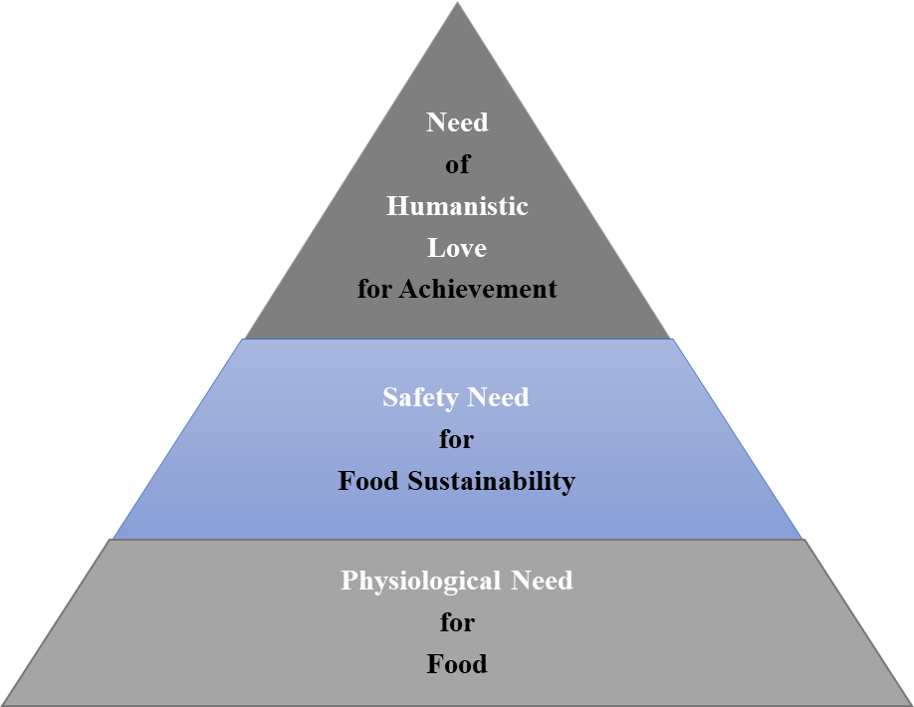

Figure 2 Hierarchy of Needs for Food Sustainability. The hierarchy was adapted from the researcher’s previous work.
3.8 Expected Findings, Recommendations for Further Studies
Analyses of findings, interpretation of results, and conclusions drawn from studies may have been shaped by experience of the researcher (Savelyeva, 2022). The researcher expected that conventional meat will not be totally replaced by plant-based meat in Hong Kong, the view was supported by the study of He et al. (2020). The estimated findings will be similar to those of Gerhardt et al. (2020), Tubb and Seba, (2021) and Morach et al. (2021) mentioned in the Literature Critique. The forecast by these past researchers predicted that dispersion of consumption at 2040 will be 35% for cultured meat, 25% for plant-based meat, and 40% for conventional meat; but the researcher estimated that the proportion of favorability will be slightly different, as plant-based meat is currently perceived as more acceptable by consumers than cultured meat (Gomez-Luciano et al., 2019). Stollar et al. (2022) also indicated in their study that only 10% of consumers will buy cultured meat as it is laboratory-made. The study of Carfora, Morandi and Catellani (2022) conducted in Italy further provided a discouraged view showing that Italian consumers had very low intention to purchase man-made meat, although they had already been educated by promotional messages about the benefits of meat-alternatives, and they were also aware of the impacts of climate change. In view of this, it is interesting for the current researcher to conduct research on this topic in an Asian context to investigate the cultural, social, economic and psychological differentiations in purchase behavior between Hong Kong and the rest of the world.

For further studies, the researcher would like to employ a mixed research methodology to look for answers from a larger population to explain the evidences surprisingly emerged from the current research. A mixed integration of inductive and deductive reasonings will bring more comprehensive views to the matter and can be generalized to larger social contexts.

3.9 Limitations
The current researcher is keen to propose the adoption of grounded theory approach; however, she is an amateur to the method. This methodology is challenging and requires the researcher to have a lot of knowledge and skills to implement the approach well. Identification and location of appropriate theoretical samples will also test the researcher’s ability; and as well, sampling techniques needed to be changed from time to time to cope with the demanding need of data. Newness can be a limitation, but with well-preparedness, consciousness and an inclination to embrace with the complexity of grounded theory, the study can turn out to be a fruitful experiential learning journey.

3.10 Dissertation Research Time Frame
A final dissertation time frame is developed with activities scheduled to serve as guidelines for the study. The research time frame is exhibited in Table 2.

Table 3 The Qualitative Dissertation Research Time Frame. The time frame was constructed by the researcher.

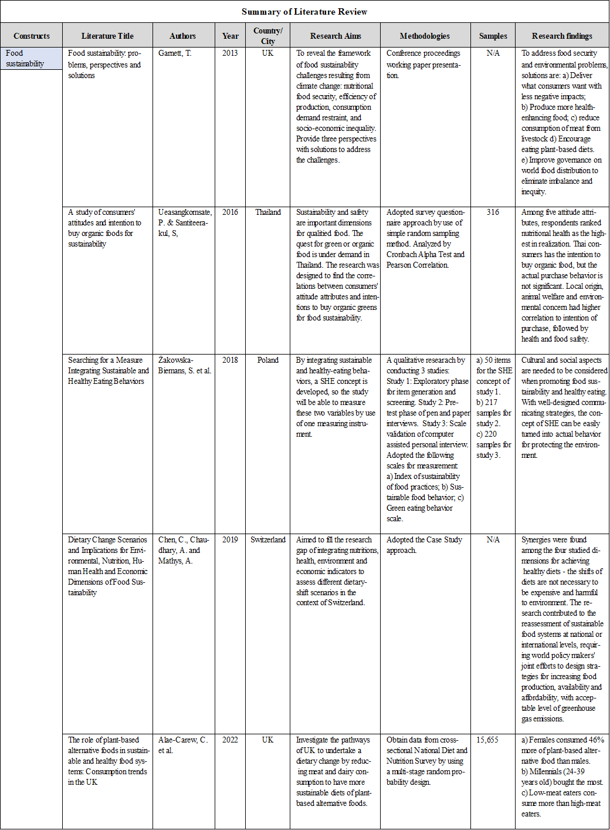
Appendix 1 Summary of Preliminary Literature Review

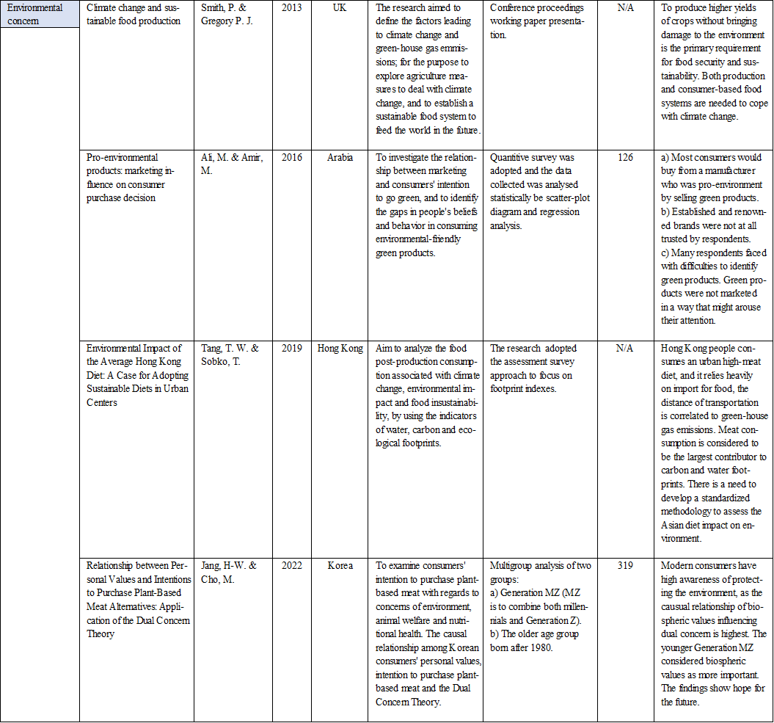

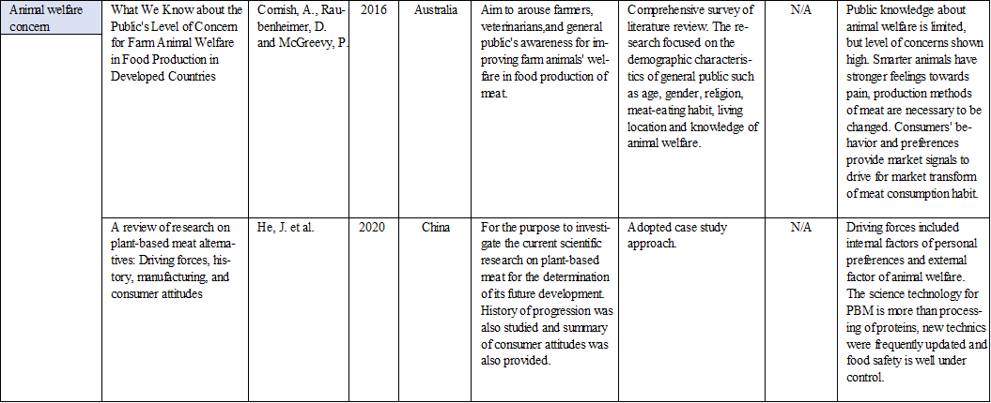

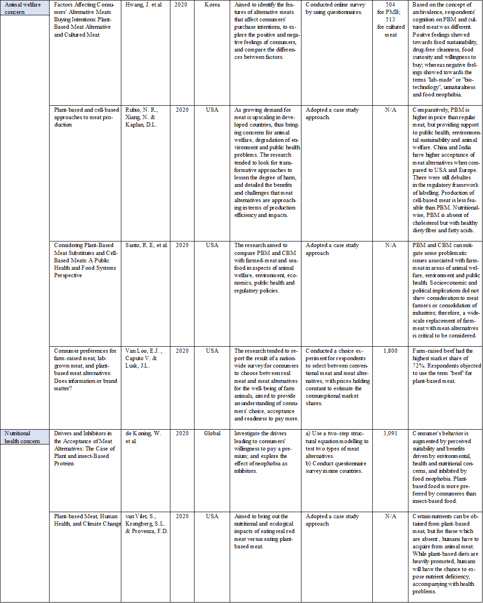

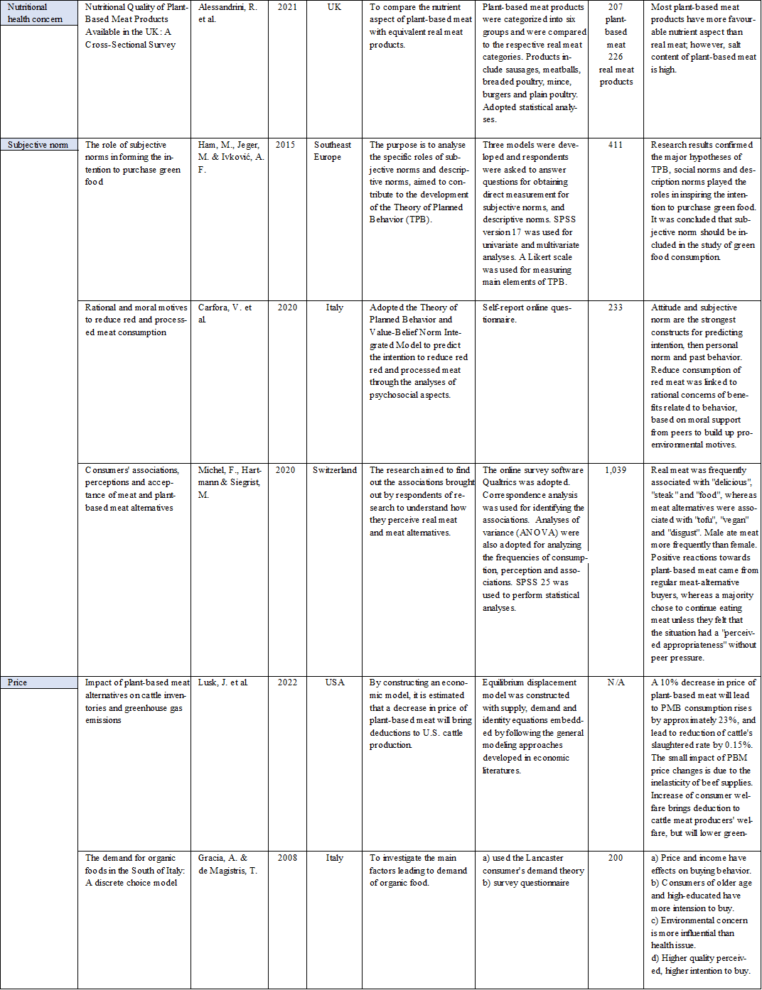

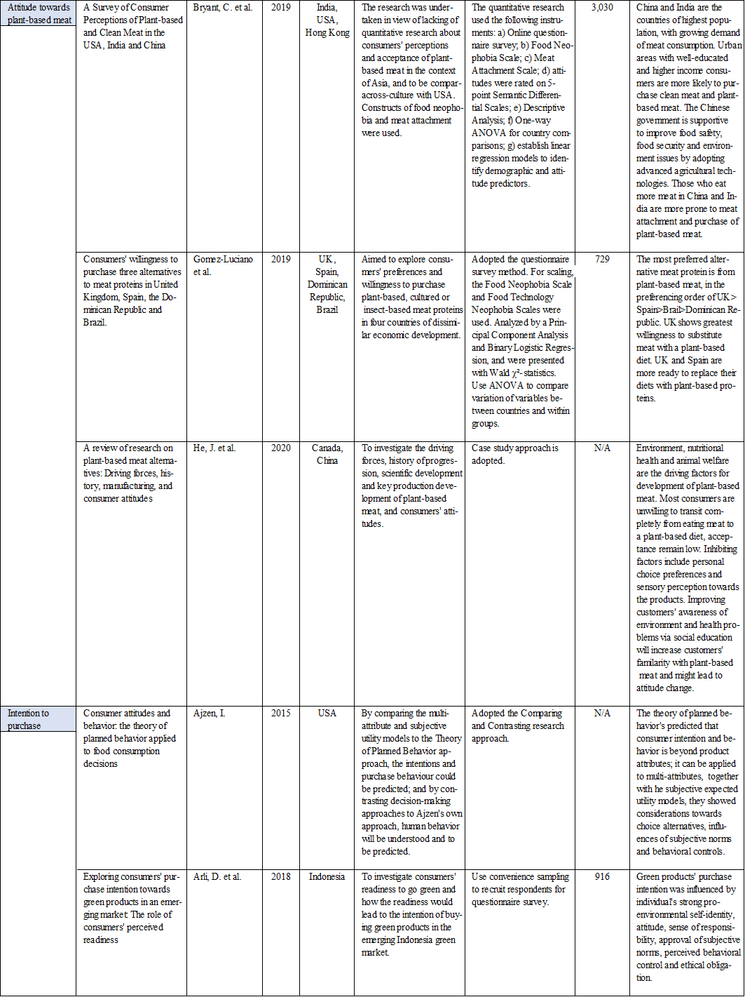

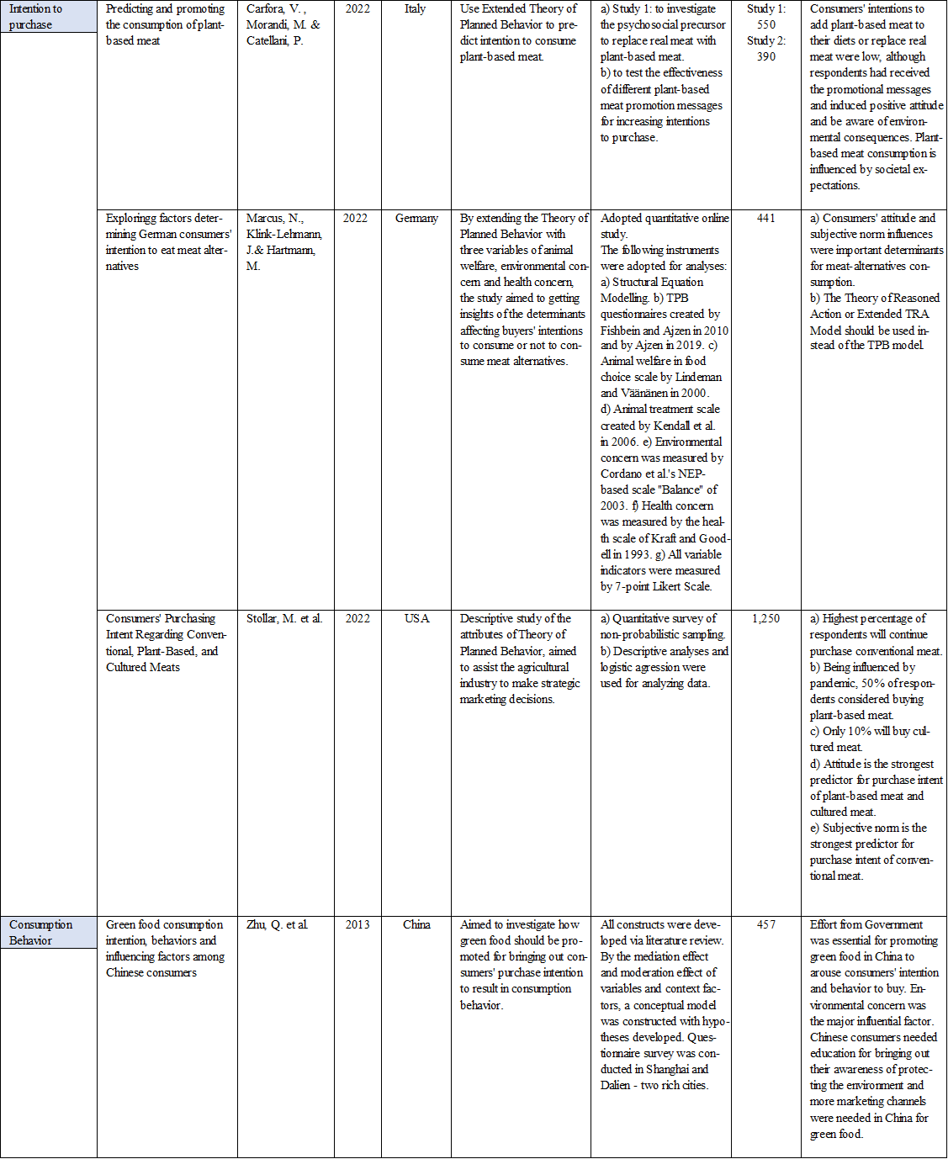

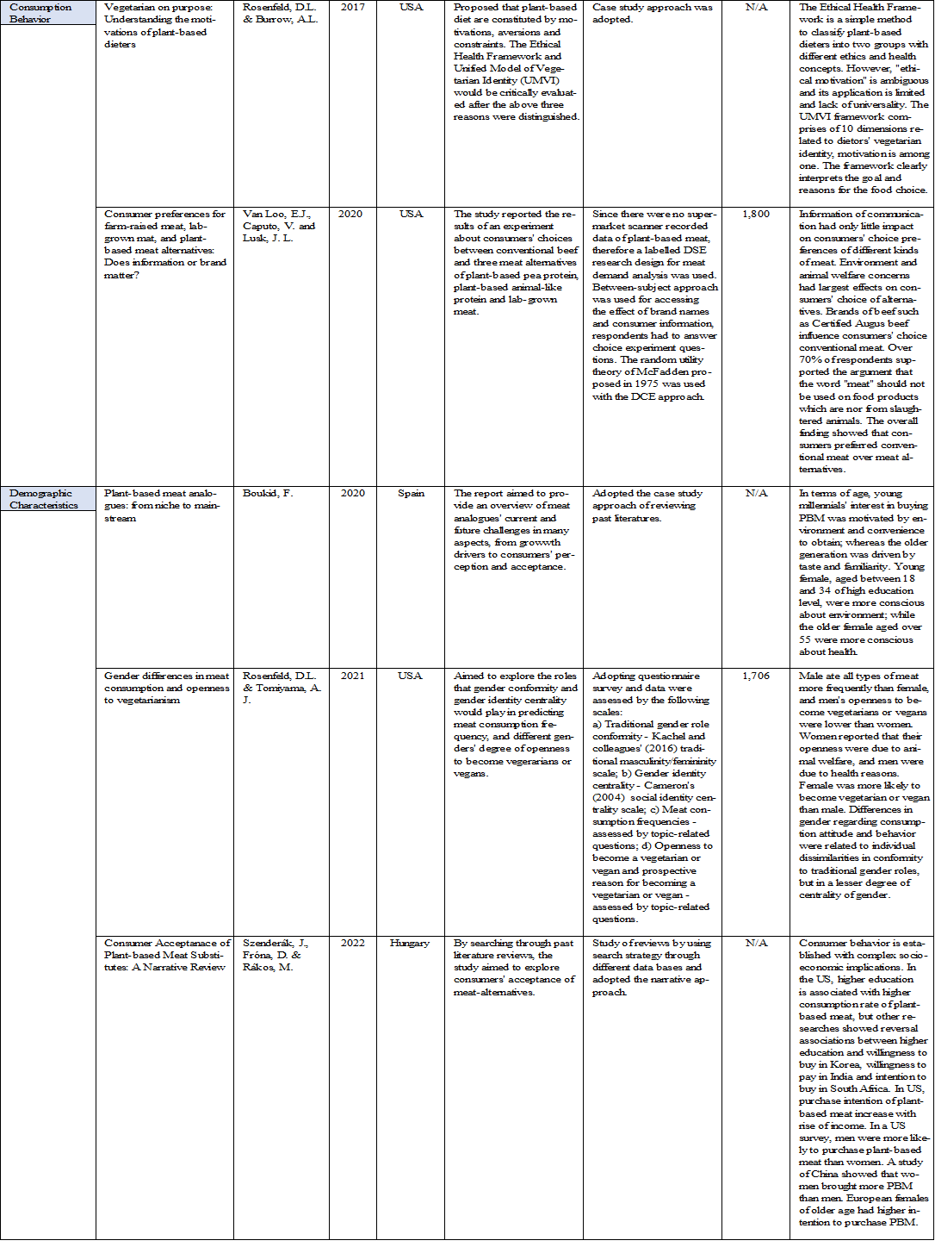

The new model borrowed the concept of Maslow’s Hierarchy of Need.
AFCD stands for Agriculture, Fisheries and Conservation Department.
BRICS stands for Brazil, Russia, India, China and South Africa.
Retrieved from The Impactful (2022) at What is Social Impact? Definition, Types, & Examples — The Impactful
Retrieved from Woodson, E. (2013) at What is Social Impact? | The Stanford Daily
The meaning was retrieved from Microsoft Bing Dictionary @ definition of transition - Search (bing.com)
The Summary of Literature Review was adapted from the researcher’s past work of similar topic.

