

Fast Fashion Fad: The Influencer Impact.

AN ANALYSIS INTO THE IMPACT SOCIAL MEDIA INFLUENCERS HAVE ON FAST FASHION WITH A FOCUS ON SUSTAINABILITY.

By Lucy Patterson (1801506)

Dissertation submitted as part of the requirements for the award BA (Hons) Business Management with Human Resources 2021.

Covid-19 Statement

In light of the continuing impact of the global pandemic, it is important to include a statement at the start of my dissertation which outlines the effects that COVID-19 has had on the research that I have undertaken towards your undergraduate degree.
The University of Wales Trinity Saint David recognises that the COVID-19 pandemic, and consequent closures of our campus (18th March 2020) and national and international lockdowns, has directly or indirectly impacted the work of many of our undergraduate researchers. Although the campus had periods of re-opening in 2020 and 2021, some research will have been disrupted and some personal circumstances difficult to manage. Teaching was arranged via suitable meeting software and documents shared electronically. All research data collection was designed to utilise digital data collection.
The inclusion of this statement is to facilitate the reader’s awareness, both now and in the future, that the pandemic may have had an effect on the scope, direction and presentation of the research.
The academic standards and quality threshold for the award remains unchanged. I wish to reassure readers that this statement is not evidencing a lack of original research or quality.

Declaration

This work has not previously been accepted in substance for any degree and is not being concurrently submitted in candidature for any degree.
Signed: Lucy Patterson
Date: 21/05/21
STATEMENT 1
This dissertation is being submitted in partial fulfilment of the requirements for the degree of BA.
Signed: Lucy Patterson
Date: 21/05/21
STATEMENT 2
This dissertation is the result of my own independent work/investigation, except where otherwise stated.
Other sources are acknowledged by references. A bibliography is appended.
Signed: Lucy Patterson
Date: 21/05/21
STATEMENT 3
I hereby give connect for my dissertation, if accepted, to be available for photocopying and for interlibrary loan, and for the title and summary to be made available to outside organisations.
Signed: Lucy Patterson
Date: 21/05/21
STATEMENT 4
I hereby give connect for my dissertation, if accepted, to be available on the university’s IT system to those who have consent to use the system.
Signed: Lucy Patterson
Date: 21/05/21

Acknowledgements

I would like to thank my friends, partner and family for supporting me throughout this dissertation. The continued support from my parents from embarking on my university journey to present day has truly motivated me to do the best I can. I would like to make a special thank you to my friend Sophie Maley who has provided much needed emotional support this year.
I would also like to thank Caroline Jawad, my dissertation supervisor who has helped around the clock with the development of this dissertation.

Abstract

The aim of the dissertation was to analyse the impact social media influencers had on the fast fashion industry, honing in on the need for greater sustainability. The effects of fast fashion and rising consumer consumption due to an increase in influencer marketing has been delved into in great depth allowing a focus for how sustainability could be achieved across the industry.
The researcher conducted an extensive literature regarding the three main themes of the research topic; fast fashion, influencer marketing and sustainability. This enabled in-depth knowledge and understanding of the behaviours of social media influencers and how this contributes to the fast fashion problem, opening avenues for ways to improve sustainability. Such literature enabled the researcher to justify the interview design.
The primary research was conducted through interviews via email with ten participating interviewees. The research results generally supported that of the literature review conducted. Results found that interviewees are heavily influenced by personalities online, leading to unplanned purchases. Additionally, interviewees were aware of the environmental impacts generated through fast fashion consumption, however remained regular shoppers for fast fashion companies, supporting the attitude behaviour gap in the literature review. Methods sustainable companies could use were highlighted, allowing for recommendations to be made to improve sustainability within the fashion industry.

Contents
Declaration II
Acknowledgements III
Abstract IV
1.0 Chapter One: Introduction 1
1.1 Introduction 1
1.2 Background 1
1.3 Rationale 2
1.4 Aims and Objectives 3
1.5 Structure 4
1.6 Conclusion 5
2.0 Chapter Two: Literature Review 6
2.1 Introduction 6
2.2 Understanding Influencer Marketing 7
2.2.1 Use of Influencer Marketing 7
2.2.2 Trust in the online environment 7
2.3 Understanding Fast Fashion and its Consumers 8
2.3.1 Fast Fashion Consumer Characteristics 8
2.3.2 Long Term Effects of Fast Fashion 9
2.3.3 The Attitude-Behaviour Gap 10
2.4 The Impact of Influencers on Purchasing Habits 10
2.4.1 Buying Behaviour 10
2.4.2 Impulse Buying 11
2.4.3 Disposable Nature of Clothing 12
2.5 Conclusion 14
3.0 Chapter Three: Methodology 15
3.1 Introduction 15
3.2 Research onion 15
3.2.1 Philosophy 16
3.2.2 Research approach 17
3.2.3 Research Method & Strategy 17
3.2.4 Time Horizon 18
3.2.5 Techniques for Data Collection, Processes and Analysis 18
3.2.5.1 Pilot Study 18
3.2.5.2 Analysis 19
3.2.5.3 Sample 19
3.3 Limitations 20
3.4 Ethical Considerations 20
3.5 Reliability and Validity 21
3.6 Conclusion 21
4.0 Chapter Four: Analysis 22
4.1 Introduction 22
4.2 Methods 23
4.3 Demographics 23
4.4 Themes 24
4.4.1 Theme 1: Fast Fashion 24
4.4.1.1 Understanding of Fast Fashion 24
4.4.1.2 Why Purchase Fast Fashion? 25
4.4.1.3 Reasons for Low Cost 26
4.4.1.4 Interviewee Purchasing Frequency 27
4.4.2 Theme 2: Influencer Marketing 28
4.4.2.1 Buying Behaviour 28
4.4.2.2 Fast Fashion Responsibility 30
4.4.3 Theme 3: Sustainability 32
4.4.3.1: Understanding Sustainable Influencers 32
4.4.3.2 Sustainable Fashion Purchases 33
4.5 Conclusion 35
5.0 Chapter Five: Conclusion and Recommendations 36
5.1 Introduction 36
5.2 Main Findings 36
5.3 Future Recommendations 37
5.4 Limitations 38
5.5 Self Reflection 38
5.6 Conclusion 39
6.0 References 40
Appendices 50
Appendix 1 – Literature Review Matrix 50
Appendix 2 – Interview Question Sheet 54
Appendix 3 – Interviewee Responses 58

List of Figures

Figure 3.1: The Research Onion | 16
Figure 4.1: Description of Fast fashion | 24
Figure 4.2: Reasons for Purchasing Fast Fashion | 25
Figure 4.3: Interviewee Purchasing Frequency per month | 26
Figure 4.4: Impulse Buying Behaviour | 28
Figure 4.5: Fuelling Fast Fashion Consumption | 30
Figure 4.6: Influencer Responsibility | 30
Figure 4.7: Sustainable Purchases | 32
Figure 4.8: Transition to Sustainable Fashion | 33

1.0 Chapter One: Introduction

Introduction

This dissertation aims to understand the impact influencer marketing has on the fast fashion industry and the need for sustainability. While there is a multitude of research on the power of influencers and fast fashion consumerism, there is a gap regarding the interest in sustainability and sustainable influencers for fast fashion consumers.

In 2019 the fast fashion industry was worth $36 billion, compared to $22 billion in 2009 (Sabanoglu, 2021). Additionally, Instagram has the highest engagement rate across all social media for the fashion industry (Marketing Expert, 2020). Therefore, the link between using Instagram for fashion and the fast-fashion problem should be investigated to understand the current strains and how greater sustainability can reduce the harmful effects.

Background
Samani, Sandin & Peters (2017) explains how the fast fashion model is based upon the rapid production times of garments inspired by the latest trends, at the expense of poorer quality and shorter lifespans. Fast fashion began to emerge in the 1990s when brands began to create 'fashion focussed' clothing creating more styles and new trends (Strahle & Erhardt, 2016). This has led to the present-day whereby consumer lifestyles demand constant new fashion, straining production processes (ibid). O’Neill (2020) discusses how globalisation has enabled fashion companies to move production to LMICs, however, this often exploits workers through poor wages and working conditions. However, packed factories and overworked employees are the only way for fast fashion companies to keep up with high demands and constant new trends (ibid).

The demand for fast fashion has only got stronger as a rise in social media marketing via social media influencers who encourage people to buy more (Symington, 2020). Social media influencers are classed as people who boast a large following online and are therefore able to use this position to promote products sent to them from businesses (Veirman, Cauberghe & Huddersfield, 2017). Instagram is the most used social media platform for influencers (Casaló, Flavián & Ibáñez-Sánchez, 2018). Johnson (2020) states that Instagram has 27.25 million Instagram users in the UK with 24-35-year olds making up 30.5% of users. Furthermore, those aged 20-29 tend to hold higher levels of purchasing power (Glucksman, 2017).

As a result of fast fashion and influencer persuasion, consumers are purchasing clothing 400% more than in the 1990s due to increasing demand and trends (Morgan, 2015). Additionally, Revlon-Chion, Bolat & Liang (2020) conducted a survey whereby it was discovered that 57% of respondents are likely to buy something impulsively if they see it on social media. Indulging in overconsumption in this way has resulted in 80 billion clothing garments being produced annually with 75% ending up in landfill (Chung, 2016). This fashion-driven attitude creates a need for greater sustainability within the industry, however, increased social media presence makes this more difficult. Sustainability is about incorporating environmental, social and economic impacts into the decision-making process (Farley & Smith, 2020). Within fashion, sustainability is about slow fashion, whereby production times are realistic, working conditions are good and clothing is ethical (Henninger, Alevizou & Oates, 2016).

Rationale
The fashion industry is being called out for its unsustainable nature. Bramley (2020) discusses how fashion trade bodies in the UK and the US are demanding changes including limiting the number of collections designed per year and becoming more environmentally and socially sustainable to reduce their negative impact and create better relationships with consumers. However, as social media grows, the blame for overconsumption has shifted from consumers to social media influencers with 73% of 18-24-year-olds blaming the fast fashion rise on influencers (Jahsan, 2019). The fashion problem has gained attention with academics with literature aiming to understand the current problem, working towards sustainability. Sterns (1962) impulse buying theory gains an insight into the phycology behind why consumers are purchasing rapidly and without consideration. However, academics have argued that even with greater sustainability amongst influencers that if consumption continues at the current high rates, sustainability will not be achieved.

Research has found that fast fashion consumers are conscious of the environment with 52% of fashion consumer wanting a more sustainable industry, however, only 29% would pay more for an ethical piece (Moore, 2019). Further research has been conducted on the need for more sustainable influencers with academics believing it could make a difference (McKewon & Shearer, 2019).

However, there is still a gap regarding whether fast fashion consumers are interested in sustainable influencers and the factors fast fashion consumers require to transition to more sustainable consumption. This enables trends to be created and recommendations to be made to aid the fashion industry in their change to sustainability.

Aims and Objectives

The overarching aim of the dissertation is to analyse the impact social media influencers have on fast fashion consumption with a focus on aiming for greater sustainability within the industry. To achieve this aim, the research will consist of four objectives:

- To conduct an extensive literature review on how influencer marketing contributes to fast fashion.
- To conduct primary research to understand whether fast fashion customers are interested in greater sustainability within the fashion industry.
- To analyse data collected to understand the behaviour of fast-fashion consumers and whether they believe there is a need for sustainability within the fashion industry.
- To summarise findings, make recommendations and understand the limitations of the study.

Structure
To achieve the stated objectives, the research will consist of five chapters.
Chapter one is the background section providing a backstory to the themes of the dissertation. This also includes a rationale as to why the research is necessary and an outline of the researcher's aims and objectives.
Chapter two is a literature review on the topics of influencer marketing, fast fashion and the need for sustainability. This will provide the researcher with relevant information regarding the topics allowing for an in-depth analysis of the current problems within the fashion industry alongside the identification of research gaps. This sets up the methodology discussed in chapter three which aims to address the gap.
Chapter three sets out the research design and methodology, justifying the primary technique selected by the researcher to contribute to the gap found, enabling analysis for the following chapter.
Chapter four will use the methodology discussed in the prior chapter to analyse the primary data collected allowing for trends and themes to emerge using qualitative data analysis software.
Chapter five will conclude the research, providing an overview of the main findings collected, future recommendations, limitations of the study and a self-reflection for the researcher.

Conclusion

Chapter one has introduced the research, supplying background to the research topics and a rationale justifying how the study can help to mitigate the trends within the fashion industry aiming for greater sustainability. Additionally, aims and objectives have been stated.

The next chapter will discuss and analyse existing literature to provide a greater understanding of the topics discussed in chapter one.

2.0 Chapter Two: Literature Review

2.1 Introduction
The role of this chapter is to analyse academic literature surrounding the link between influencer marketing and fast fashion through changing buyer behaviour. This will be achieved by reviewing literature from academic journals, textbooks and online articles to further knowledge on how consumer’s consumption is and the problems created regarding fast fashion. This will help to underpin the research chapter for this dissertation. The literature review will satisfy the following research objective:

Objective one: To conduct an extensive literature review on how influencer marketing contributes to fast fashion.

This chapter will focus on understanding what influencer marketing is including its use and how it is effective to understand techniques required for persuasion. The fast-fashion problem including the fast fashion target market will be explored to understand why fast fashion appeals to these consumers alongside environmental and human impacts of fast fashion to highlight the need for sustainability. The attitude-behaviour gap for fast fashion consumers will be explained to show that there is an understanding of the negative impacts of fast fashion, providing hope for sustainability. Finally, the effect of influencer marketing on fast fashion will be explored, looking at buying behaviour including impulse buying the disposable nature of clothing to show the power of influencers and how they feed the current fashion dilemma.

2.2 Understanding Influencer Marketing

2.2.1 Use of Influencer Marketing
Balaban & Mustatea (2019) found that for influencer marketing to be successful, the influencer and follower must share similarities to feel connected. Therefore, influencers need to be relatable to their followers so that a relationship can be built to increase purchase intention. Kapitan & Silvera (2015) support this, stating that characteristics such as similarity and likability allow greater persuasion onto the consumer. Influencers appear relatable by emerging as normal, approachable people on their profiles, connecting with followers through shared experiences making their lifestyle appear more achievable than a-class celebrities (Schaefer, 2019: McRae, 2017). Chae (2017) found that such relatable and similar characteristics between the two parties result in the followers aspiring to be like the influencer which (Ki & Kim, 2019) believe creates a desire to mimic, generating in the purchase of products.

2.2.2 Trust in the online environment
Bock et al (2012) state that trust is important for e-commerce businesses to gain sales and increase purchase intention. Gefen & Straub (2004) explain that trust can be achieved by creating a social presence to achieve personal and human contact. Therefore, an influencer who acts as a middleman between businesses and consumers (Gustavsson, Nasir & Ishonova, 2018) is an ideal approach to give an online store a personal touch to improve trust. Influencers are paid to promote products from a brand (Oliveira, Barbosa & Sousa, 2020) questioning the credibility of their opinions, however, by regularly creating content and focusing on a relationship with followers, influencers can gain their trust (Woods, 2016). Additionally, there is an increased trust for influencers compared to high ranking celebrities as influencers incorporate products into their daily life making their opinions appear more authentic to the consumer improving trust (Schouten, Janseen & Verspaget, 2019). Forrester (2019) states that the target market for influencer marketing is 18-25, with 58% trusting influencers more than friend’s opinions, demonstrating their power (Forrester, 2019). Russel & Rasolofoarison (2017) conclude that this perceived trust is due to influencers demonstrating how to use the products rather than promotion through commercial environments creating a positive impression for the consumer.

2.3 Understanding Fast Fashion and its Consumers

2.3.1 Fast Fashion Consumer Characteristics
Tapping (2014) states that fast fashion is aimed at younger age groups with lower income due to the cheap nature of the clothing. Bhradwaj and Fairhurst (2010) support this as they discovered that younger consumers prefer cheap and fashionable clothes whereas older consumers are drawn towards high-quality products and are less concerned about trends. Michaela (2015) believes that fast fashion is ideal for those who are fashion conscious and eager to try new products. Therefore, fast fashion is arguably ideal for the fashion conscious as it allows for quick production and design timeframes, exploiting upcoming trends and customer demands (Cachon & Swinney (2010). Furthermore, fast fashion companies are heavily inspired by designer fashion runways for the creation of their new lines to be sold to the larger population (Chakraborty, Hoque & Kabir, 2020). This enables consumers to get designed inspired items for a fraction of the price while remaining on-trend. Pacheco (2018) states that fast fashion companies heavily rely on influencers to promote their products, means that consumers who admire influencers are more exposed to fast-fashion pieces, increasing fast fashion consumption.

2.3.2 Long Term Effects of Fast Fashion
The fashion industry is the second largest cause of pollution in the world due to poor environmental awareness after shifting production to LMICs (Abdulgadir & Abdulagadir, 2020). While some argue that fast fashion is beneficial as it has allowed stylish clothes to become accessible to all social classes, this is often at the expense of the environment (Bick, Halsey & Ekenga, 2018). The fast production of clothing results in hazardous environmental conditions. Khan & Malik (2014) state that dyes used on fabric are often released into local water systems creating a toxic water source that can harm wildlife and the local community. This environmental damage often occurs in LMICs where large corporations manufacture to exploit profits by lowering costs (Arrigo, 2013). Thorisdottir & Johannsdottir (2019) explain that due to fashion brands marketing strategies, clothing is often thrown away despite being in good condition. Such disposal due to increased consumption is also proving hazardous for the environment as ends up clogging rivers in LMICs with insufficient waste disposal (Bick, Halsey & Ekenga, 2018). Ferrer & Katanich (2020) discuss how fast fashion sells cheap due to workers working below minimum wage, estimated at £3.50 per hour. Furthermore, workers often work 10-14 hours per day in poor conditions leading to injuries without access to trade unions (Labour Behind the Label, 2021). These factors enable fast fashion companies to keep costs minimal, allowing for cheap prices. This demonstrates the need for sustainability. This knowledge could be used by influencers to educate their followers on the effects of high fast fashion consumption to move towards change. Henninger, Alevizou & Oates (2016) argue that upcycling fashion should be promoted by brands to encourage greater sustainability. Sustainability can be improved by using the cradle to cradle whereby a product has multiple lives, instead of being wasted, materials can be reused (Braungart & McDonough, 2008). Furthermore, lists for materials should be made including ‘X’ for toxic materials, ‘grey’ for materials that are not desirable but can be worked with until a better alternative and ‘p’ which is for the good, preferred materials to help become more sustainable (ibid).

2.3.3 The Attitude-Behaviour Gap
Kim & Oh (2020) state that there is an increasing interest in sustainable fashion brands due to the negative connotations associated with fast fashion. Bertram & Chi (2017) explain that consumers are not as educated on the effects of fast fashion production compared to unnecessary product packaging, proving limited awareness of the problem. Joergens (2006) draws attention to the gap between consumer’s concerns and the actions they exhibit, stating that they do not always correlate. This difference in belief and action is known as the attitude-behaviour gap whereby a consumer claims to have strong ethical and environmental values, however, their purchase history does not match this (Perry & Chung, 2016). White, Hardisty & Habib (2019) provided data supporting this gap, with 65% of respondents wanting to buy from brands that promote sustainability, however, only 26% have this attitude when purchasing. Lee et al. (2020) also found a large attitude behaviour gap concluding that fashion consumers do not alter their fashion demands for the sake of being sustainable. However, over the coronavirus pandemic, 18-25-year-olds; the same demographic responsible for fast fashion sales, have adopted a ‘buyer less, buy better’ attitude showing the gap can close. (Yang, Song & Tong, 2017; Elan, 2020) McKewon & Shearer (2019) argue the gap could be closed through the use of influencers promoting sustainable fashion, explaining that if the influencer enforced trust with followers that they could create a positive attitude regarding sustainability.

2.4 The Impact of Influencers on Purchasing Habits

2.4.1 Buying Behaviour
Consumer buying behaviour is described as the mental, emotional and physical characteristics exhibited by consumers when choosing, buying and disposing of a product (Schifman & Kunak, 2009). Marketing strategies have evolved to entice consumers to purchase products from traditional television advertisements to a social media presence (Putter, 2017). Furthermore, the use of social media marketing is viewed as a competitive advantage compared to businesses not using this strategy (ibid). Therefore, influencers are an ideal candidate for social media marketing. Sudha & Sheena (2017) state that influencer marketing has increased the number of online purchases as it can take consumers directly to the product almost instantaneously. Sheth & Kim (2017) found that 67% of people would consider buying a product recommended on social media, proving the power influencers have on purchase intention. Yodi, Widyastuti & Noor (2020) found a 78.8% increase in purchase intention if brand marketing comes from a credible influencer. Bognar, Puljic & Kadezabec (2019) researched how influencer marketing affects consumer behaviour, and while participants believed influencers did not directly make them purchase an item, 87% did agree that when purchasing an item, they would choose those promoted by influencers supporting their high impact on consumer purchasing behaviour.

2.4.2 Impulse Buying
Vonkeman, Verhagen & Van Dolen (2017) define impulse buying as the outcome of an exposure to stimuli whereby the customer makes an unplanned purchase of a product that they previously had no desire or intention to buy. Styvén, Foster & Wallström (2017) argue promotions such as free, fast delivery and a range of payment options encourage impulse buying. Yin et al (2014) state that online impulse buying can be simulated by the availability of reviews which reduce uncertainty of consumers. While influencers do not provide a typical review on a website, they showcase products that can be seen in real life, encouraging consumer purchases. As discussed above, smaller influencers are seen to have greater trust than celebrities. Gunawan & Iskander (2020) discovered that smaller influencers have a positive correlation with impulse buying, especially during the early adopter stage whereby a product or trend is relatively new, allowing consumers to become trendsetters. This finding is more relevant to smaller influencers as celebrities will often create a massive demand for a product and Gunawan and Iskander discovered that consumers do not want to wear something that everyone else has.

Stern (1962) created an impulse buying theory that can be applied to influencer marketing and impulse buying. Stern’s model divides impulse buying into four categories; pure, whereby the consumer has had no intention to purchase and broke normal shopping behaviour, reminder; whereby a consumer recalls an advertisement for the product and wants to try it, suggestion; whereby a customer sees an item and creates an idea for its use and finally planned; whereby a customer intends to purchase particular products as well as unplanned purchases depending on the offers available. From previous research, pure impulse buying correlates to the effect of influencers, for example, Gunawan and Iskander’s discovery of consumers wanting to buy a product to become a trendsetter. Additionally, suggestion impulse buying could be a result of influencer marketing as consumers may see an item they recall a personality of theirs had, pushing them to purchase.

With influencers having a strong impact on consumer impulse buying, there is a concern for overconsumption. Liu, Lee & Lien (2020) state that people are more likely to impulsively purchase cheap fast fashion compared to higher ticket items. Cook and Yurichisin (2017) also argue that those who favour fast fashion items often promoted by influencers, are more likely to buy impulsively creating a barrier for reducing fast fashion consumption.

2.4.3 Disposable Nature of Clothing
Yang, Song & Tong (2017) state that fast fashion is associated with disposable fashion which is a current problem within the UK. Fashion consumption in the UK is causing an increasing waste problem with one million tonnes of textiles being wasted every year as a result of 1,130,000 tonnes of clothing purchased in 2016 (UK Parliament, 2020). Influencers that impact purchase intention could result in consumers purchasing and subsequently wasting clothing. Marroncelli & Braithwaite (2020) state the ease of purchasing clothing from influencers via direct links creates instant gratification for consumers. However, such fulfilment is adding to the disposable nature of clothing and fast fashion, causing concern for sustainability.
Agbebo (2020) states that with increased purchasing and fashion trends being produced at rapid rates that people are viewing clothing as disposable through engaging in overconsumption. Tjandrawibawa (2020) support Agebo's statement, finding that fast fashion is often low-quality garments leading to a throwaway mentality, reinforcing the importance of creating durable fashion. Lea, Paulina & Lisa (2018) conducted a study and found that consumers often feel pressured by influencers to keep up with trends and buy new clothes. This promotion of short-lived clothing and constant demand for new items creates a throwaway culture that is associated with and supports fast fashion (Green, 2020).

As previously discussed there is a strong correlation between influencer marketing and fast fashion as these pieces often appeal to the younger demographic following influencers who are looking for on-trend fashion pieces, which has led to a greater need for sustainability within the industry. Brewer (2019) discusses how sustainable fashion businesses must advertise the negative effects of fast fashion and promote their contributions to sustainability via sourcing and production processes to encourage consumers to purchase. Research has been conducted on sustainable influencers with McKewon and Shearer (2019) believing that sustainable influencers could encourage sustainability. However, Kuvshinova (2018) argues that even if influencers promote less polluting materials, due to buying power, they will be bought in such large quantities that pollution will not stop. Additionally, Kuvshinova argues that influencers do not care about sustainability, but rather they promote it to gain popularity and visibility. However, little research has been conducted on whether fast fashion customers would be interested in sustainable influencers. Fast fashion attracts younger people with less disposable income and sustainable fashion is often more expensive (Chan, 2020) and therefore there is a gap to investigate whether influencer marketing can increase sustainable fashion consumption through greater responsibility for buying behaviour.

2.5 Conclusion
This chapter achieved the first objective:
To conduct an extensive literature review on how influencer marketing contributes to fast fashion.
The literature review revealed that influencers can persuade consumers to purchase items through relatability and likability by appearing more normal than A-class celebrity (Kapitan & Silvera, 2015; Shaefer, 2019). The perceived trust for influencers was also found important as they appear more authentic by using products in daily life shown online (Woods, 2016). Research has discovered that fast fashion consumers who tend to be young with lower incomes are heavily persuaded by influencers with 67% agreeing they would purchase an item recommended by influencers (Tapping, 2014; Sheth & Kim, 2017). This buying behaviour has led to greater impulse buying as younger consumers want to become trendsetters as they often buy products they had no intention to purchase before seeing it worn by influencers (Gunawan & Iskander, 2020; Stern, 1962). The need for clothing that influencers have has led to a constant demand for new items creating a throwaway culture, responsible for hazardous environmental conditions including clogged rivers in LMICs (Green, 2020; Bick, Halsey & Ekenga, 2018). There has been research on the use of influencers to promote sustainability within fashion (McKewon & Sheraer, 2019; Kushinova, 2018). However, there is limited literature on whether fast fashion consumers would follow sustainable influencers to help reduce the fast-fashion problem due to their lower spending limits, which is the area this research aims to investigate.

The next chapter will identify the research methods used to fill the literature gap discovered in this chapter.

3.0 Chapter Three: Methodology

3.1 Introduction
The purpose of this chapter is to achieve the second objective of the dissertation.
Objective two: To conduct primary research to understand whether fast fashion customers are interested in greater sustainability within the fashion industry.

To achieve this objective, the researcher has identified the appropriate method, data collection and analysis to conduct primary research. The Research Onion will be used to guide the researcher through the research process alongside the reliability and validity of the study.

3.2 Research onion
Saunders et al. (2007) define research as a process whereby people can discover and increase their knowledge using a structured approach. Bertrand & Hughes (2017). define research as the process of asking questions and finding answers. To ensure thorough research is conduction it is important to plan the research process. One model that can aid this is the Research Onion, created by Saunders et al. (2007).

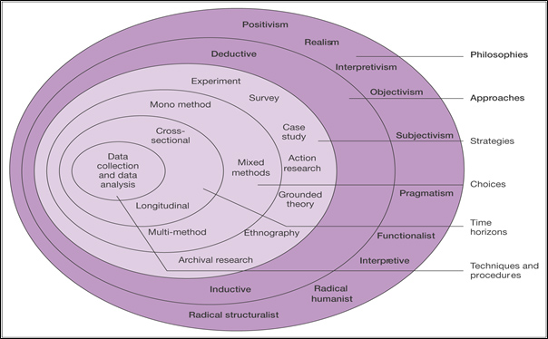

Figure 3.1: The Research Onion. (Source: Saunders et al., 2007).

Figure 3.1 displays the research onion which consists of several layers whereby you peel each layer of the onion, outside to inside until you reach the core to create a well-developed research design that is in line with the research objectives and questions (Sahay, 2016).

3.2.1 Philosophy
Interpretivism will be used which takes a human approach and allows that humans will interpret things differently based on their meanings (Saunders et al, 2009). This philosophy is relying upon a social reality whereby a person's understanding of something is based on interactions and experiences which helps them to create their meanings (Ryan, 2018). For this, the researcher aims to understand interviewees experiences with fast fashion and influencer marketing to understand if fast fashion consumers need or want greater sustainability within the industry. This approach is beneficial for this qualitative study as Thanh & Thanh (2015) state that interpretivism is inclusive as it allows for different viewpoints among different people and therefore this can be achieved through open-ended questions. Additionally, this approach allows the data collected to be compared and analysed to aid a conclusion.

3.2.2 Research approach
The research approach is inductive which enables the researcher to identify patterns from observations thus allowing the development of theories later in the research process (Bernard, 2011). The researcher uses observations in the first instance and then analyses these to create a consensus for the topic area (Blackstone, 2012). For this study, observations will be collected from data within the interviews to develop theories surrounding 18-25-year-olds shopping habits prompted by fast fashion tactics and social media influencers to understand their interest in sustainability. This approach is appropriate as there is currently little literature on the links between fast fashion consumers and sustainability, allowing the researcher to generate theories.

3.2.3 Research Method & Strategy
The researcher will use mono method for data collection as an interview will be created and used as the primary form of data collection for research. With no time constraints, a mixed-method approach would be used as this can provide a better understanding of the problem (Guest, Namey & Mitchell, 2013). However, given time restrictions, a mono approach will be effective as the researcher can go into the data in greater depth, rather than analysing a greater amount of data to a lesser degree. Interviews will be conducted via email primarily due to COVID-19 regulations which currently prohibit meeting in person. Despite in-person interviews not being possible, there are still benefits to e-interviews. Hawkins (2018) discusses the time effectiveness of these as interviewees can respond in their own time, allowing for more detailed responses as the interviewee will not feel rushed as could be the case for a time scheduled interview. Additionally, an e-interview can save time as interview sheets can be sent together rather than face-to-face interviews taking up numerous days and time can be saved transcribing data as answers are already written by interviewees, aiding the analysis process (ibid).
As interviews are being conducted, qualitative data will be collected. Sutton & Austin (2015) state that qualitative data is useful for researchers as it allows for an understanding of the participant's thoughts and feelings attributed to a certain scenario. This will help draw more detailed conclusions compared to 'yes' or 'no' responses. Another benefit of an interview is that follow up questions can be asked to provide further scope.

3.2.4 Time Horizon

Cross-sectional research is most suitable for this study. This gathers data from individuals at one point in time (Allen, 2017). This is most suitable for the research as it is quicker to complete than a longitudinal study, so it can be achieved in the time frame for the dissertation. However, as it is only a snapshot at a particular time, results may not be as accurate as observations over longer periods.

3.2.5 Techniques for Data Collection, Processes and Analysis

3.2.5.1 Pilot Study
A pilot study allows the researcher to understand if something can be carried out and how it should be executed (In, 2017). This takes place on a smaller scale so that modifications and adjustments can be made before the main research method goes live (ibid). The researcher sent the interview questions to a supervisor to ensure the questions were valid and appropriate.

3.2.5.2 Analysis
As interviews are being conducted, the research will be qualitative with many open-ended questions asked. Wong (2008) states that analysing qualitative data consists of reading transcripts to find similarities, differences and themes. Richie & Lewis (2003) suggest the framework approach whereby tables are used to structure responses. NVivo is a software used to analyse qualitative data. Bazeley & Jackson (2013) state that for smaller projects this is easy to use without the need for learning complex procedures. NVivo can manage data, manage ideas and report from data (ibid). This will ensure data is analysed correctly so that trends made are an accurate representation. Another analysis method is word clouds which are a basic method to analyse qualitative data by putting the most common words in larger writing, aiding comparison of information (Cidell, 2010).

3.2.5.3 Sample
A purposive sample will be used as many questions are focused on fast fashion and influencers meaning people who have little knowledge are unlikely to provide valuable insight. This enables the researcher to lay out what needs to be discovered and involves those with knowledge and experience in the area to help find this out (Bernard, 2011). Purposive sampling can be more beneficial than random sampling as the researcher can select participants that hold certain characteristics which are beneficial to the study (Etikan, Musa & Alkassim, 2015).

The sample size will be ten participants. Braun & Clarke (2013 pp 50) state that for smaller projects a sample size of six to ten is sufficient for saturation. Due to the nature of the project, there is likely to be a higher number of female than male participants. It is assumed that due to terms included such as 'influencers' and 'fast fashion' that the survey will include younger, fashion-conscious females.

3.3 Limitations
The research has to be completed by a strict deadline limiting the amount of data that can be collected. A restricted time frame limits the number of interviewees as preparing, conducting and analysing each one is a lengthy process. However, to overcome these, time management is key and preparation work must start early to ensure a true reflection.

In addition to time, there are also limitations with the interview method. As interviews were conducted, the sample size was smaller and also only contained those in the 18-25 age bracket. Vasileiou et al. (2018) found that generalisability was impacted by smaller sample size as findings could not be applied to everyone within the research area, for this study, fast fashion consumers. Therefore, this could mean that results do not provide the ‘bigger picture’ as there are fewer responses as compared to a quantitative survey.

3.4 Ethical Considerations
The University of Cambridge (2020) state that to be ethical during research, the researcher must respect autonomy, maximise benefits, minimise harm and be fair. The research conducted for this project is low risk to those involved. To ensure this, an ethics form will be completed and the research process will follow this. Participants will receive and fill out a consent form so they are aware of what will take place and feel comfortable throughout the process. All data collected will be held in confidence for data protection but also to ensure participants feel comfortable giving honest opinions.

3.5 Reliability and Validity
Carmines & Zeller (1979) define reliability as how consistent the results are over time and validity as the success of achieving the research objectives and the truthfulness of the results. To ensure reliability for the methods chosen the sample ensured that interviewees were between 18 and 25 meaning they were within the target market for fast fashion. The sample also ensured that interviewees were consumers of fast fashion so they knew to answer the questions in depth.
To ensure validity, interviewees were given a declaration for reassurance that all responses would be kept confidential, to encourage honest answers. Additionally, the sample size was within the required saturation limit of between six and ten as researched by Braun & Clarke (2015) to ensure a range of responses for analysis. Furthermore, as the questionnaire was underpinned with literature, the relevance and appropriateness of the questions can be ensured.

3.6 Conclusion

To conclude this chapter has successfully explained the methodology which will be used for the research. This has included the use of a model; The Research Onion to systematically justify each stage of the research process to achieve objective 2:
To conduct primary research to understand whether fast fashion customers are interested in greater sustainability within the fashion industry.
The following chapter will analyse the data collected to create trends, using the methods discussed in this chapter

4.0 Chapter Four: Analysis

4.1 Introduction

Chapter three discussed the methods for the primary research. This chapter will present the findings collected by the researcher alongside an analysis of how these findings relate to the literature discussed in chapter two.
This chapter meets the requirements to fulfil objective three:
Objective Three: To analyse data collected to understand the behaviour of fast-fashion consumers and whether they believe there is a need for sustainability within the fashion industry.
The data collected was received through E-interviews conducted with ten participants who were knowledgeable and passionate about the topic area. The participants were 90% female and 100% fell within the 18-25 age category. Due to the nature of the method; qualitative e-interview, the analysis is based upon small data. Dworkin (2012) discusses how small data is beneficial for in-depth research as it helps to answer ‘hows’ and ‘whys’ within a research area. This is beneficial for this research as it aims to understand interviewees experiences with fast fashion and influencer marketing.

4.2 Methods
The purpose of this data is to analyse the data collected and to achieve these different software packages were used. Bazeley (2017) states that using qualitative data analysis software is beneficial as it enables the researcher to organise from different sources and the use of coding enables themes to be developed leading to improved data management. Firstly, Microsoft Excel was used to create graphs for less in-depth analysis and closed questions. For open-ended answers to qualitative questions, NVivo software package was used. NVivo allows for the grouping of keywords and themes to enable the researcher to gain a better context for data collected (Dollah, Abduh & Rosmaladewi, 2017). Firstly, data was input into Nvivo, then nodes were created helping to group answers for each question and enabling the key points within answers to be highlighted. After this was completed, the researcher was able to create word clouds and mind maps to visualise the data. The interview response sheets can be found in the appendix except for interviewees signatures to keep confidentiality.

4.3 Demographics
Within the interview questions, there were two basic demographic questions; gender and age to help link respondent answers to previous research discussed in chapter two. Due to a purposive sample selected, 100% of respondents were aged 18-25 due to this age category being most responsible for fast fashion sales, allowing the results found to be applied to the target fast fashion market (Cavender & Lee, 2018). In addition to fast fashion, the 18-25 age group was also said to be most influenced by those on social media with 58% trusting influencers more than family (Forrester, 2019). While it appears this demographic is fuelling the fast fashion issue, there is a paradox as Generation Z also seem to be driving a sustainability movement with a 90% increase in a second-hand shopping app and an 18.1% decrease in retail sales during the coronavirus pandemic (Elan, 2019). Therefore, analysing the answers within this sample should help to understand how 18-25-year-olds are thinking regarding fast fashion and sustainability. 90% of respondents identified as ‘female’ while 10% identified as male. It was expected that the sample would be predominately female due to the nature of the topic. Horton (2019) discusses how fast-fashion retailers aim their products at ‘young women’ and therefore, a majority female interview base can gain improved validity.

4.4 Themes

4.4.1 Theme 1: Fast Fashion

4.4.1.1 Understanding of Fast Fashion

This chapter is divided into three themes; fast fashion, influencer marketing and sustainability based upon the findings. For the research, a purposive sample was chosen to ensure knowledge on the topic area to create meaningful results. Therefore, participants were asked to describe the term fast fashion based on their knowledge. Previous research on fast fashion as supported by Michaela (2015) showed that fast fashion is popular among its younger target audience due to its cheap nature, fast production and imitation of trends.
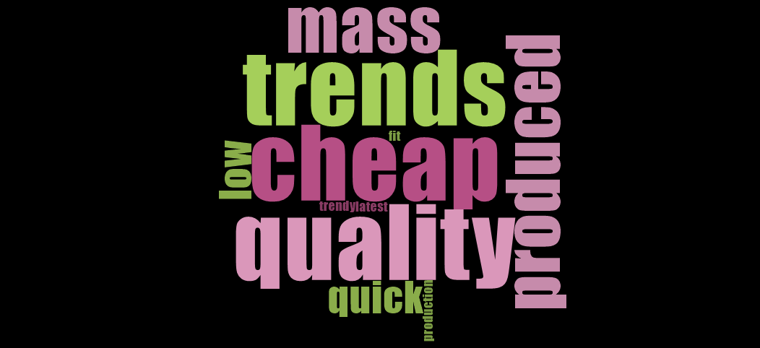
Figure 4.1: Description of Fast Fashion
Figure 4.1 displays a word cloud generated on NVivo showing the key terms used by interviewees when asked to describe the term ‘fast fashion’. Responses correlated with previous literature on the topic which was expected as interviewees were experienced in terms of purchasing fast fashion. Descriptions correlated with (Agbebo, 2020) including trendy, low price and low quality. Much of these descriptions for fast fashion also doubled as reasons for purchasing fast fashion, shown in the figure below.

4.4.1.2 Why Purchase Fast Fashion?

Figure 4.2: Reasons for Purchasing Fast Fashion
Figure 4.2 shows the main reasons given to the researcher for fast fashion consumption. Half of the interviewees gave influencer marketing and the availability of discounts as the main reasons for purchasing fast fashion. Based on previous research these results are expected as Pacheco (2018) explained how fast fashion companies rely on influencers for promotion and Tapping (2014) discusses the cheap nature of fast fashion clothing.

4.4.1.3 Reasons for Low Cost

Khan & Malik’s (2014) research stated that the environmental reasons behind low prices. This can be attributed to poor fabrics and dyes being used that often end up polluting the surrounding environment. This knowledge, however, is not unknown to the fast fashion consumer with 100% of respondents stating negative connotations when asked about how they feel fast fashion affects the environment which participant 9 stating:

“I think it has a horrible effect on the environment not in just the waste caused by the physical items themselves but through its factories, its methods, etc”.

While the interviewee was asked about environmental impacts; fast fashion ‘factories’ and ‘methods’ were mentioned. This could be attributed to the human cost of fast fashion which is also a reason the clothing is so cheap. Employees at fast fashion factories are often paid well below minimum wage with little access to working rights and poor working conditions (Ferrer & Katanick, 2020; Labour Behind the Label, 2021). This enables clothes to produced cheaply, enabling the companies to offer low prices and big discounts. This shows that respondent attitudes are aware of the dangerous effects of fast fashion, however interviewees remain fast fashion consumers with monthly purchases ranging from one to eight times a month as shown in figure 4.3.

4.4.1.4 Interviewee Purchasing Frequency

Figure 4.3 Interviewee Purchasing Frequency Per Month
THIS links to the attitude behaviour gap discussed in chapter two. Research conducted by Perry & Chung (2016) found that despite concerns people have regarding the environmental impacts of fast fashion that often their actions do not correlate. Therefore, this study supports this as regular purchasing still occurs despite the level of awareness towards the environment and human costs. However, it is important to note that every respondent was aged 18-25 and therefore disposable income could be a barrier for purchasing more expensive, sustainable fashion.

4.4.2 Theme 2: Influencer Marketing

4.4.2.1 Buying Behaviour
Theme two looks at influencer marketing, understanding what impacts influencers have on their followers purchasing habits, how consumers view influencers in terms of inspiration and the effects these have on fast fashion and sustainability. As displayed in figure 4.2, influencer marketing is a key tool used by fast fashion companies to promote their items. Ki & Kim (2019) stated that influencer marketing is successful as consumers can relate to them making them mimic their purchases and style. Ki & Kim’s theory proves to be the case for the interviewees as 100% of respondents follow influencers on social media. Additionally, 90% of respondents stated that they followed influencers for fashion-related reasons including inspiration or trend predictions. Therefore, influencer marketing proves successful for the target audience. However, as influencers are heavily used by fast fashion brands and many target consumers follow them, a question was raised regarding how these influencers affect buying behaviour. 100% of respondents claimed that an influencer had made them purchase an item before with participant 6 stating the reason that
"An influencer encourages you as they produce better content than the fast-fashion retailer".

While increased sales are to be expected with marketing tactics, the is that people often impulse buy items they did not previously want due to seeing them worn by an influencer. Figure 4.4 displays this showing that 70% of interviewees had bought items they did not previously desire due to influencer marketing. Participant 9 explained how the influencer had worn a pair of shoes online that they wanted, encouraging the purchase. Therefore, while the item was previously desired, the influencer was the deciding factor, for the purchase.

Figure 4.4 Impulse Buying Behaviour
Gunawan & Iskander (2020) support this finding as they discovered a link between influencers and impulse buying behaviour. However, Green (2020) states that the promotion of fast fashion items and impulse buying feeds the fast-fashion problem, leading to a throwaway culture with the UK Parliament (2020) finding one million tonnes of textiles being wasted annually in the UK. Increased buying and impulse behaviour generate an interesting argument for sustainability for the future. Kuvshinova (2018) argues that if any type of clothing is bought in large quantities, pollution will not cease. Therefore, it could be argued that even if influencers promote sustainable clothing, followers will likely be persuaded as shown from this research, to purchase, meaning consumption levels will remain high.
However, participant 5 generated an interesting point that could contribute to the percentage of impulse buying being high, stating that

“I may have not seen the piece before seeing it on the influencer as I don’t check online shops often”

Therefore, people may use influencers for inspiration rather than scrolling through websites meaning it is not a matter of not wanting the items before the influencer but rather the items had not been seen before. Using influencers for inspiration supports Ki and Kim’s theory of consumers wanting to mimic influencers, leading to Peltoa’s (2019) theory of influencers playing a role in consumer self-identify as fast fashion shoppers can duplicate their image to that of the influencer. This questions future sustainability as if consumers are buying purely to be like the online persona they follow, their purchase intentions are not sustainable.

4.4.2.2 Fast Fashion Responsibility

As the researcher has found that consumers are being targeted by influencers to purchase items that may have never bought before, it is important to understand where consumers think responsibility lies for fuelling the fast-fashion problem so that requirements for sustainability can be identified.

When asked, 100% of respondents believed that influencers do increase fast fashion consumption. Figure 4.5 shows the reasons why interviewees believe this to be the case with the main beliefs being through increased inspiration and brand deal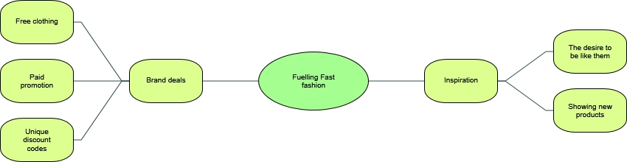
Figure 4.5: Fuelling Fast Fashion Consumption
As this research found that influencers have a strong impact on consumer buying behaviour alongside fast fashion consumers believing that influencers are fuelling the industry, it should be considered if whether influencers should hold greater responsibility for promoting fashion that is bought at alarming rates and has negative impacts.

Figure 4.6: Influencer Responsibility
With 100% of interviewees believing that influencers contribute to fast fashion, they were asked how influencers could take greater responsibility. 80% of respondents claimed that influencers should support sustainable brands whether it be through shopping local or researching the company's ethics. This, however, indicates a problem as 'influencing' is often considered a full-time job from some and therefore they are simply a middleman looking for income who are controlled, giving them little say. Participant 3 begins to draw on this stating:
"Ultimately it shouldn't be up to influencers or people buying clothes, I think it needs to be put on the manufacturers and the companies selling the clothes"

This provides an interesting argument as while consumer’s purchases are persuaded by influencers, fast fashion companies are engaging in unethical practices such as low pay. Therefore, for true sustainability, fast fashion companies need to improve or engage with better practices. However, despite participant three stating that consumers are also not to blame, they are purchasing items despite this prior research finding their high level of awareness for the problems. With this, it can therefore not be expected for influencers to take full responsibility.

4.4.3 Theme 3: Sustainability
The third theme is sustainability, which the biggest theme for the research as it aims to understand if sustainability for fast fashion consumers is truly possible.

4.4.3.1: Understanding Sustainable Influencers
When asked about sustainable influencers, only 50% of interviewees followed at least one online. Compare this to a 100% follow rate for ‘normal’ influencers, there is a lack of interest for sustainable influencers. This could however be attributed to the fact sustainability is becoming a recent concern with many only acting upon it in the past year (Elan, 2020).

4.4.3.2 Sustainable Fashion Purchases

Figure 4.7: Sustainable Purchases
Figure 4.7 shows 70% of interviewees have previously purchased sustainable fashion. This is arguably surprising as only 50% follow sustainable influencers.
To gain an understanding of this unexpected percentage, interviewees were asked for their reasoning for purchasing sustainably. 20% of interviewees claimed it was environmental-related to 'reduce landfill waste' and to 'feel less guilty'. This is to be expected due to participant’s prior knowledge on fast fashion impacts in theme one. Participant 5 generated an interesting perspective stating when asked about fast fashion purchases:
“Yes as I liked the pieces, not because it was sustainable”
Therefore, the level of sustainability of clothes for some is not the main priority but rather how much the piece is liked. This can potentially make sustainability harder to achieve as Zhang & Dong (2020) argue that consumers need a mindset for a commitment to the environment for sustainable social development, a mindset many fast fashion consumers probably do not hold.
Of the 20% who had not purchased sustainable, both highlighted expense as the reason. Higher prices remain an obvious barrier for fast fashion consumers as 50% of respondents claimed lower prices within sustainable fashion would help them to transition from fast to sustainable. This barrier is problematic as sustainable fashion prices are high due to better quality fabrics, rigorous quality checks and smaller-scale production (Davis, 2019). Therefore, it is unlikely sustainable brands would be able to offer low prices that fast fashion consumers are used to. In addition to price, 70% of respondents mentioned an increase in social media presence, whether through influencers or advertising as a factor to help a transition to sustainable fashion. This solidifies the power influencers have in the eye of fashion consumers with interviewees and shows that they can make a difference regarding consumers making more conscious decisions. This links with the argument of whether influencers should hold more responsibility and demonstrates that if they did, fast fashion consumers may trust influencers and follow a more sustainable path.

Figure 4.8: Transition to Sustainable Fashion
If the barriers above were overcome, 80% of fast fashion consumers interviewed stated that they would transition to sustainable fashion as shown in figure 4.8. While some issues are easier to overcome than others such as sustainable brands using influencers compared to price, it is positive that fast fashion consumers are willing to transition. This proves that fast fashion consumers are interested in sustainable fashion and are demanding a greater presence of sustainable influencers despite being predominately fast fashion consumers, showing there is room in the influencer market for greater sustainability.

4.5 Conclusion

This chapter has achieved the following objective:

To analyse data collected to understand the behaviour of fast-fashion consumers and whether they believe there is a need for sustainability within the fashion industry.
Based on responses, three themes were identified; fast fashion, influencer marketing and sustainability. From these, the gap in the literature found in chapter two, regarding fast fashion consumers interest in sustainability was met. Results found that 80% of fast fashion consumers would transition to sustainable fashion, with 7 respondents providing improve social media presence including influencer marketing as a reason to help achieve this.
The next chapter will provide recommendations and explain the limitations of the study and areas for future research.

5.0 Chapter Five: Conclusion and Recommendations

5.1 Introduction
Chapter 5 seeks to achieve the following objective:
Objective Four: To summarise findings, make recommendations and understand the limitations of the study.
The chapter will highlight key findings of the study and provide recommendations and limitations including potential areas for future research in addition to a self-reflection section for the researcher.

5.2 Main Findings
The main findings of this research mostly support the literature presented in chapter two. While interviewees were aware of the negative fast fashion impacts, with 100% agreeing that fast fashion is harmful to the environment, most of their actions did not correlate with fast fashion purchases averaging four times per month. This supported the attitude behaviour gap theory often found amongst fashion consumers whereby the intentions to be sustainable are present but the actions do not follow through. This highlights whether fashion consumers will be able to transition to sustainable fashion.

The research found that there is an interest in sustainable fashion with 70% of interviewees previously bought sustainable fashion items and 80% willing to transition to sustainable fashion. The literature gap identified in chapter two regarded the potential interest in sustainable influencers amongst fast fashion consumers. While only 50% of respondents currently follow a sustainable influencer, 70% wanted to see more social media coverage including influencer advertising from sustainable fashion companies to encourage them to purchase.

However potential barriers to sustainability were identified. 70% of interviewees admitted that an influencer made them purchase an item not desired beforehand, which creates an argument on the viability of sustainable influencers as literature argued that to achieve sustainability a 'buy less buy better' attitude was required. Therefore, even if influencers promote sustainability, there is still the potential for consumers to indulge in overconsumption creating a paradox. Another barrier identified by interviewees was the higher cost of sustainable items compared to fast fashion. However, it was found unlikely that sustainable companies can change this due to better quality and higher standard production process.

While aware, consumers may need better education regarding the fashion industry to adopt a green mindset found by literature. Influencers could work towards this, educating their followers rather than simply promoting particular products.

5.3 Future Recommendations

The first recommendation would be for sustainable fashion companies to show greater transparency in their production process. This would help consumers understand their pricing structure and prove a justification for higher price points, allowing consumers to see the bigger picture beyond expense.

To educate on greater sustainability, sustainable fashion companies should invest in greater influencer marketing. Evidence in the study demonstrates the level of trust influencers have on consumers. Therefore, consumers may be more likely to engage with what influencers are teaching compared to a traditional advertisement to encourage sustainability.

It is difficult to recommend fast fashion companies to become sustainable as it is not their model. However, fast fashion companies could improve recycling processes. As overconsumption has led to mass landfill waste, fast fashion companies provide recycling clothing bags to customers whereby clothing can be donated to charities or recycled properly to avoid landfill.

5.4 Limitations
One limitation regards the sample. Interviewees were all within the 18-25 age category and 90% were female. While this fits the target market for fast fashion and influencer marketing, it is not representative of the industries as a whole. Additionally, those of different demographics could have offered different insights as many responses were similar.

While sustainability emerged as a theme and the literature gap was contributed to, the research could have included more on what fast fashion consumers demand from sustainable influencers. This could include preferences for sustainable brand deals, education or second-hand consumption. This would have gained a better understanding of what could encourage the transition, aiding the recommendations.

Additionally, Covid-19 has been a limitation for the interview research method. Due to social distancing rules, interviews were conducted online via email. This reduced the opportunity to ask follow up questions and obtain greater depth from answers. However, the researcher structured questions in such a way, mostly through open-ended questions to extract maximum information.

5.5 Self Reflection

The researcher aimed to understand how influencer marketing contributed to fast fashion focusing on a need for sustainability. This was a personal interest for the researcher which developed throughout digital marketing and ethics modules throughout the BA Business Management degree.

A range of skills was developed throughout the process including IT skills using software packages for analysis and the ability to plan and conduct interviews which were able to contribute to a growing problem within the fashion industry.

If the recommendations were conducted, the researcher is optimistic about the possibility for greater sustainability among fast fashion consumers and a reduction in consumption.

5.6 Conclusion
This chapter has achieved the following objective:
To summarise findings, make recommendations and understand the limitations of the study.
The dissertation understands the power held by influencers that are contributing to fast fashion through overconsumption and impulse buying. Additionally, the need for sustainability has been identified through the impacts of fast fashion consumption. The research concluded that fast fashion consumers are concerned about the environment and are open to becoming more sustainable so long as barriers including greater promotion and cheaper prices are presented. Potential avenues for future research include understanding what fast fashion consumers want from sustainable influencers and understanding other demographics opinions to grasp insights from fashion consumers as a whole. Recommendations provided a pathway to a more sustainable industry.

6.0 References

Abdulgadir, A. & Abdulgadir, I. (2020) ‘Strategic Proposals for Sustainable Supply Chains in the Fast Fashion Industry: Exploring ways to incorporate concepts and methods to confront the damaging effects of the industry’, Master of Science Thesis, KTH, Stockholm.

Agbebo, V. (2020) ‘What about disposition? Exploring millennials’ clothing disposal behaviours in fashion-oriented impulse buying’, Master’s Thesis, Lund University, Lund.

Allen, M. (2017) The SAGE encyclopaedia of communication research methods. Thousand Oaks: Sage Publications.

Arrigo, E. (2013) ‘Corporate responsibility management in fast fashion companies: The Gap inc case’, Journal of fashion marketing and management: An International Journal, 17(2), pp.175-189.

Balaban, D. & Mustățea, M. (2019) ‘Users’ perspective on the credibility of social media influencers in Romania and Germany’, Romanian Journal of Communication and Public Relations, 21(1), pp.31-46.

Barely, P.& Jackson, K. (2012) Qualitative data analysis with NVivo. 2nd ed. London: Sage.
Bazeley, P. (2017) Handbook of Research Methods in Health Social Sciences. Singapore: Springer.

Bernard, H. R. (2011) Research Methods in Anthropology: Qualitative and Quantitative Approaches. Maryland: Rowman & Littlefield.

Bernard, H.R. (2017) Research methods in anthropology: Qualitative and quantitative approaches. 6th ed. Maryland: Rowman & Littlefield.

Bertram, R. F. & Chi, T. (2017) ‘A study of companies’ business responses to fashion e-commerce’s environmental impact’, International Journal of Fashion Design, Technology and Education, 11(2), pp.254–264.

Bertrand, I. & Hughes, P. (2017) Media research methods: Audiences, institutions, texts. London: Macmillan International Higher Education.

Bhardwaj, V. & Fairhurst, A. (2010) ‘Fast fashion: response to changes in the fashion industry’, The international review of retail, distribution and consumer research, 20(1), pp.165-173.

Bick, R., Halsey, E. & Ekenga, C.C. (2018) ‘The global environmental injustice of fast fashion’, Environmental Health, 17(1), pp.1-4.

Blackstone, A. (2012) Principles of Sociological Inquiry- Qualitative and Quantitative Methods. Maine: Saylor Foundation.

Bock, G. W., Lee, J., Kuan, H.-H. & Kim, J.H. (2012) ‘The progression of online trust in the multi-channel retailer context and the role of product uncertainty’, Decision Support Systems, 53(1), pp. 97–107.

Bognar, Z. B., Puljic, N.P. & Kadezabec, D. (2019) ‘Impact of influencer marketing on consumer behaviour. In Economic and Social Development- book of proceedings. pp. 301-309.
Bramley, E. V. (2020) 'The fashion system must change': BFC and CFDA call for an industry reset. Available at: https://www.theguardian.com/fashion/2020/may/21/the-fashion-system-must-change-bfc-and-cfda-call-for-an-industry-reset (Accessed: 20th May 2021).

Braun, V. & Clarke, V. (2013) Successful qualitative research: A practical guide for beginners. London: Sage.

Braungart, M. & McDonough, W. (2008) Cradle to Cradle. London: Jonathon Cape.

Brewer, M.K. (2019) ‘Slow Fashion in a Fast Fashion World: Promoting Sustainability and Responsibility’, Laws, 8(4), p.24.

Cachon, G.P. & Swinney, R. (2011) ‘The value of fast fashion: Quick response, enhanced design, and strategic consumer behavior’, Management science, 57(4), pp.778-795.

Carmines, E.G. & Zeller, R.A. (1979) Reliability and validity assessment. Newbury Park: Sage publications.

Casaló, L.V., Flavián, C. & Ibáñez-Sánchez, S. (2018) ‘Influencers on Instagram: Antecedents and consequences of opinion leadership.’, Journal of Business Research, (117), pp. 510-519.

Cavender, R. C. & Lee, M. Y. (2018) ‘Exploring the Influence of Sustainability Knowledge and Orientation to Slow Consumption on Fashion Leaders’ Drivers of Fast Fashion Avoidance’, American Journal of Theoretical and Applied Business, 4(3), pp. 90-101.

Chae, J. (2017) ‘Explaining Females’ Envy Toward Social Media Influencers’, Media Psychology, 21(2), pp. 246–262.

Chakraborty, S., Hoque, S.A. & Kabir, S.F. (2020) ‘Predicting fashion trend using runway images: application of logistic regression in trend forecasting’, International Journal of Fashion Design, Technology and Education, 13(3), pp.376-386.

Chung, S-W. (2016) Fast fashion is drowning the world. We need a fashion revolution. Available at: https://www.greenpeace.org/international/story/7539/fast-fashion-is-drowning-the-world-we-need-a-fashion-revolution/ (Accessed: 20th May 2021).

Cidell, J. (2010) ‘Content clouds as exploratory qualitative data analysis’, Area, 42(4), pp.514-523.

Cook, S.C. & Yurchisin, J. (2017) ‘Fast fashion environments: consumer’s heaven or retailer’s nightmare?’, International Journal of Retail & Distribution Management, 45(2), pp. 143-157.

Davis, J. (2019) How can you make sustainable fashion more affordable? Available at: https://www.harpersbazaar.com/uk/fashion/fashion-news/a28609044/sustainable-fashion-expensive-why/ (Accessed: 20th May 2021).

De Veirman, M., Cauberghe, V. & Hudders, L. (2017) ‘Marketing through Instagram influencers: the impact of number of followers and product divergence on brand attitude’, International Journal of Advertising, 36(5), pp.798-828.

Dollah, S., Abduh, A. & Rosmaladewi, M. (2017) ‘Benefits and drawbacks of NVivo QSR application’, 2nd International Conference on Education, Science, and Technology, 149, pp. 61-63.

Dworkin, S. L. (2012) ‘Sample Size Policy for Qualitative Studies Using In-Depth Interviews’, Archives of Sexual Behaviour, 41, pp. 1319-1320.

Ek Styvén, M., Foster, T. & Wallström, Å. (2017) ‘Impulse buying tendencies among online shoppers in Sweden’, Journal of Research in Interactive Marketing, 11(4), pp.416–431.

Elan, P. (2020) Shopping habits of generation Z could spell end of fast fashion. Available at: https://www.theguardian.com/fashion/2020/may/25/shopping-habits-of-generation-z-could-spell-end-of-fast-fashion (Accessed: 18th May 2021).

Etikan, I., Musa, S. A. & Alkassim, R. S. (2016) ‘Comparison of convenience sampling and purposive sampling’, American Journal of Theoretical and Applied Statistics, 5(1), pp. 1-4.

Farley, H.M. & Smith, Z.A. (2020) Sustainability: if it's everything, is it nothing? 2nd ed. Oxon: Routledge.

Ferrer & Katanich (2020) Inside the Leicester sweatshops accused of modern slavery. Available at: https://www.euronews.com/green/2020/07/09/inside-the-leicester-sweatshops-accused-of-modern-slavery (Accessed: 16th May 2021).

Forrester, J. (2019) 18-25 Year Olds Influenced More by Social Media Influencers Than Family and Friends. Available at: https://talkinginfluence.com/2019/04/10/18-25-year-olds-influenced-more-by-social-media-influencers-than-family-and-friends/ (Accessed: 18th May 2021).

Gefen, D. & Straub, D.W. (2004) ‘Consumer trust in B2C e-Commerce and the importance of social presence: experiments in e-Products and e-Services’, Omega, 32(6), pp.407-424.

Glucksman, M. (2019) ‘The rise of social media influencer marketing on lifestyle branding: A case study of Lucy Flank’, Elon Journal of Undergraduate Research in Communications, 8(2), pp. 77-87.
Green, H. (2020) ‘Is ‘Fast-Fashion Feminism’an oxymoron? Critical Reflections:’, A Student Journal on Contemporary Sociological Issues.

Guest, G., Namey, E. & Mitchell, M (2013) ‘Qualitative Research: Defining and Designing’. In: Collecting Qualitative Data: A Field Manual for Applied Research. London: SAGE Publications, Ltd pp. 1-40.

Gunawan, N.P. & Iskandar, I.B.P. (2020) ‘Analyzing the Impact of Fashion Influencer on Online Impulsive Buying Behavior’, KnE Social Sciences, pp.350-363.

Gustavsson, A.S., Suleman Nasir, A. & Ishonova, S. (2018) Towards a world of influencers: Exploring the relationship building dimensions of Influencer Marketing.

Hawkins, J. E. (2018) ‘The practical utility and suitability of email interviews in qualitative research’, The Qualitative Report, 23(2), pp. 493-501.

Henninger, C.E., Alevizou, P.J. & Oates, C.J. (2016) ‘What is sustainable fashion?’, Journal of Fashion Marketing and Management: An International Journal, 20(4), pp. 400-416.

Horton, K. (2019) ‘Just Use What You Have: Ethical Fashion Discourse and the Feminisation of Responsibility’, Australian Feminist Studies, 33(98), pp. 515-529.

In, J. (2017) ‘Introduction of a pilot study’, Korean journal of anesthesiology, 70(6), pp. 601–605.

Jahshan, E. (2019) 54% shoppers believe social media influencers behind rise in fast fashion. Available at: https://www.retailgazette.co.uk/blog/2019/10/54-shoppers-believe-social-media-influencers-behind-rise-fast-fashion/ (Accessed: 20th May 2021).

Joergens, C. (2006) ‘Ethical fashion: myth or future trend?’, Journal of Fashion Marketing and Management: An International Journal, 10(3), pp. 360-371.

Johnson, J. (2020) Distribution of Instagram users in the United Kingdom (UK) as of September 2020, by age of users. Available at: https://www.statista.com/statistics/1018012/instagram-users-united-kingdom/ (Accessed: 23rd November 2020).

Kapitan, S. & Silvera, D.H. (2016) ‘From digital media influencers to celebrity endorsers: attributions drive endorser effectiveness’, Marketing Letters, 27(3), pp.553-567.

Khan, S. & Malik, A. (2014) ‘Environmental and health effects of textile industry wastewater’, In Environmental deterioration and human health (pp. 55-71). Dordrecht: Springer.

Ki, C.W.C. & Kim, Y.K. (2019) ‘The mechanism by which social media influencers persuade consumers: The role of consumers’ desire to mimic’, Psychology & Marketing, 36(10), pp.905-922.

Kim, Y., & Oh, K. W. (2020) ‘Which Consumer Associations Can Build a Sustainable Fashion Brand Image? Evidence from Fast Fashion Brands’, Sustainability, 12(5), pp. 1703.

Kunshinova, D. (2018) ‘Sustainable consumption or green consumerism? A study on Dutch sustainable fashion blogging’, Master’s Thesis, Erasmus University, Rotterdam.

Labour Behind the Label (2021) Working Conditions. Available at: https://labourbehindthelabel.org/our-work/working-conditions/ (Accessed: 16th May 2021).
Lea, C., Paulina, M. & Lisa, R. (2018) Influencers impact on decision making amount Generation Y and Z Swedish females when purchasing fast fashion. Available at: http://hj.diva-portal.org/smash/get/diva2:1214227/FULLTEXT01.pdf (Accessed: 12th February 2021).

Lee, E.J. Et al. (2020) ‘How to “Nudge” your consumers toward sustainable fashion consumption: An fMRI investigation’, Journal of Business Research, 117, pp.642-651.

Liu, S.F., Lee, H.C. & Lien, N.H. (2020) ‘Do fast fashion consumers prefer foreign brands? The moderating roles of sensory perception and consumer personality on purchase intentions’, Asia Pacific Management Review, pp.1-9.

Marketing Expert (2020) Fashion Industry Statistics in the UK and marketing insights. Available at: https://www.marketingexpertus.co.uk/blog/uk-fashion-industry-statistics-marketing-insights/ (Accessed: 20th May 2021).

Marroncelli, R. & Braithwaite, N. (2020) ‘#insta-fashion: How the Digital Revolution Has Affected Celebrity Culture and the British Fashion Retail Landscape’, Fashion Practice, pp. 1–27.

McKeown, C. & Shearer, L. (2019) ‘Taking sustainable fashion mainstream: Social media and the institutional celebrity entrepreneur’, Journal of Consumer Behaviour, 18(5), pp.406-414.

McRae, S. (2017). “Get Off My Internets”: How Anti-Fans Deconstruct Lifestyle Bloggers’ Authenticity Work’, Persona Studies, 3(1), 13-27.

Michaela, E. (2015) ‘Fashion conscious consumers, fast fashion and the impact of social media on purchase intention’, Academic Journal of Interdisciplinary Studies, 4(3 S1), pp.173.
Moore, K. (2019) Report Shows Customers Want Responsible Fashion, But Don’t Want To Pay For It. What Should Brands Do?. Available at: https://www.forbes.com/sites/kaleighmoore/2019/06/05/report-shows-customers-want-responsible-fashion-but-dont-want-to-pay-for-it/?sh=69e013917820 (Accessed: 20th May 2021).

Morgan, A. (2015) A New Future For Fashion. Available at: https://www.huffpost.com/entry/a-new-future-for-fashion_b_7120694 (Accessed: 2nd February 2021).

O’Neill, L. (2020) A five-minute history of fast fashion in the UK. Available at: https://www.vice.com/en/article/v74z9x/fast-fashion-history-zara-topshop-boohoo-missguided (Accessed: 20th May 2021).

Oliveira, M., Barbosa, R. & Sousa, A. (2020) ‘The use of influencers in social media marketing’, In Marketing and Smart Technologies (pp. 112-124). Singapore: Singapore.

Pacheco, D. (2018) How your shopping habits are affecting the environment. Available at: https://organizationaldynamics.wordpress.com/2018/07/24/how-your-shopping-habits-are-affecting-the-environment/ (Accessed: 12th February 2021).

Peltola, L. (2018) ‘Making sense of the relationship between social media influencers on Instagram and the consumers who follow them’, Master’s Thesis, Hanken School of Economics, Helsinki.

Pütter, M. (2017) ‘The impact of social media on consumer buying intention’, Marketing, 3(1), pp.7-13.

Revlon-Chion, E., Bolat, E. & Liang, Y. (2020) Instant Buying of Fast Fashion: Are Influencers to Blame? Working Paper. Poole, England: Bournemouth University.

Ritchie, J. & Lewis. J. (2003) Qualitative Research Practice: A Guide for Social Science Students and Researchers. London: Sage.

Russell, C. A. & Rasolofoarison, D. (2017) ‘Uncovering the power of natural endorsements: a comparison with celebrity-endorsed advertising and product placements’, International Journal of Advertising, 36(5), pp. 761-778.

Ryan, G. (2018) ‘Introduction to positivism, interpretivism and critical theory’, Nurse Researcher, 25(4) pp. 41–49.

Sabanoglu, T. (2021) Fast fashion market value forecast worldwide in 2009 and 2019, with a forecast for 2029 (in billion U.S. dollars). Available at: https://www.statista.com/statistics/1008241/fast-fashion-market-value-forecast-worldwide/ (Accessed: 20th May 2021).

Sahay, A. (2016) ‘Peeling Saunder's Research Onion’, Research Gate, Art, pp.1-5.

Saunders, M. et al. (2007) Research Methods for Business Students. 4th ed. United Kingdom: Financial Times/ Prentice Hall.

Saunders, M. et al. (2009) Research Methods for Business Students. New York: Pearson.

Schaefer, G. (2019) ‘Influencer Marketing: Consumer Responses to Instagram influencers’, Senior Honours Thesis, Liberty University, Lynchburg.

Schiffman, L.G. & Kanuk, L.L. (2009) Consumer Behaviour. New Delhi: Prentice Hall of India.

Schouten, A. P., Janssen, L., & Verspaget, M. (2019) ‘Celebrity vs. Influencer endorsements in advertising: the role of identification, credibility, and Product-Endorser fit’, International Journal of Advertising, pp. 1–24.

Sheth, S. 7 Kim, J. (2017) ‘Social media marketing: The effect of information sharing, entertainment, emotional connection and peer pressure on the attitude and purchase intentions’, GSTF Journal on Business Review (GBR), 5(1), pp. 62-70.

Stern, H. (1962) ‘The significance of impulse buying today’, Journal of marketing, 26(2), pp. 59-62.
Strähle, J. & Erhardt, C. (2017) ‘Collaborative consumption 2.0: an alternative to fast fashion consumption’. In Green Fashion Retail (pp. 135-155). Singapore: Springer.

Sudha, M. & Sheena, K. (2017) ‘Impact of influencers in consumer decision process: the fashion industry’, SCMS Journal of Indian Management, 14(3), pp.14-30.

Sutton, J. & Austin, Z. (2015) ‘Qualitative Research: Data Collection, Analysis, and Management’, The Canadian journal of hospital pharmacy, 68(3), pp. 226–231.

Symington, S. (2020) Social media is fuelling fast fashion fads. Available at: https://www.bbc.co.uk/programmes/articles/44rQcnNMDXz2vyvNzhfhXqf/social-media-is-fuelling-fast-fashion-fads (Accessed: 20th May 2021).

Taplin, M. I. (2014). ‘Who is to blame?’, Critical Perspectives on International Business, 10(1/2), pp. 72–83.
Thanh, N.C. & Thanh, T.T. (2015) ‘The interconnection between interpretivist paradigm and qualitative methods in education’, American Journal of Educational Science, 1(2), pp.24-27.

The University of Cambridge (2020) Applying for ethical approval: basic principles. Available at:https://www.research-integrity.admin.cam.ac.uk/research-ethics/ethics-application-guidance/applying-ethical-approval-basic-principles (Accessed: 24th November 2020).

Thorisdottir, T.S. & Johannsdottir, L. (2019) ‘Sustainability within fashion business models: A systematic literature review’, Sustainability, 11(8), p.2233.

Tjandrawibawa, P. (2020) ‘The Effect of Using Instagram Influencers in Building Conseva’s Brand Awareness’, The Winners, 21(1), pp. 67-73.

UK Parliament (2020) Textile waste and collection. Available at: https://publications.parliament.uk/pa/cm201719/cmselect/cmenvaud/1952/report-files/195207.htm (Accessed: 12th February 2021).

Vasileiou, K. et al. (2018) ‘Characterising and justifying sample size sufficiency in interview-based studies: systematic analysis of qualitative health research over a 15-year period’, BMC Medical Research Methodology, 18(148), pp. 1-18.

Vonkeman, C., Verhagen, T. & van Dolen, W. (2017) ‘Role of local presence in online impulse buying’, Information & Management, 54(8), pp. 1038–1048.

White, K., Hardisty, D. J. & White, R. H. (2019) The elusive green consumer. Available at: https://hbr.org/2019/07/the-elusive-green-consumer (Accessed: 5th February 2021).
Wong L. (2008) ‘Data analysis in qualitative research: a brief guide to using nvivo. Malaysian family physician’, the official journal of the Academy of Family Physicians of Malaysia, 3(1), pp.14–20.

Woods, S. (2016) ‘# Sponsored: The emergence of influencer marketing’, Chancellors Honours Program Project, University of Tennessee, Knoxville.

Yang, S., Song, Y., & Tong, S. (2017) ‘Sustainable Retailing in the Fashion Industry: A Systematic Literature Review’, Sustainability, 9(7), pp. 1266.

Yin, D. Et al. 2014. ‘Anxious or angry? Effects of discrete emotions on the perceived helpfulness of online reviews’, MIS quarterly, 38(2), pp.539-560.

Yodi, H.P., Widyastuti, S. & Noor, L.S. (2020) ‘The Effects of Content and Influencer Marketing on Purchasing Decisions of Fashion Erigo Company’, Dinasti International Journal of Economics, Finance & Accounting, 1(2), pp.345-357.

Zamani, B., Sandin, G. & Peters, G.M. (2017) ‘Life cycle assessment of clothing libraries: can collaborative consumption reduce the environmental impact of fast fashion?’, Journal of cleaner production, 162, pp.1368-1375.

Zhang, X. & Dong, F. (2020) ‘Why Do Consumers Make Green Purchase Decisions? Insights from a Systematic Review’, International Journal of Environmental Research and Public Health, 17(18), pp.6607.

Appendices

Appendix 1 – Literature Review Matrix
Question 1 | The study seeks to find how social media influencers impact fast fashion buying behaviour alongside the need for greater sustainability in the industry. For this, I am keen to understand basic demographic information, therefore, would you be happy to state your gender? | Questions 1 & 2 are standard demographic questions to gain basic information from the interviewees.
Question 2 | What age category are you in?  18-25  26-35  36-45
Question 3 | How would you describe the term ‘fast fashion’? | This question aims to understand interviewees base knowledge. Fast fashion is described as cheap, low quality, trendy clothing for the fashion conscious (Bhardwaj & Fairhurst, 2010; Michaela, 2015).
Question 4 | How do fast fashion companies encourage you to purchase their pieces? | This question aims to understand the tactics used by fast fashion companies to see how sustainable fashion companies could encourage sales. Pacheco (2018) describes how fast fashion companies use influencers for promotion. Chackraborty, Hoque & Kabir (2020) discuss how fast fashion companies mimic runway fashion, ideal for the fashion conscious aiming to keep up with trends.
Question 5 | How often would you say you purchase fast fashion clothing? | This question gets a better understanding of current purchasing habits among interviewees. Morgan (2015) discusses the consumers are purchasing more presently than 1990s.
Question 6 | How would you describe your experiences with fast fashion? | This question gains an insight into whether the interviews enjoyed the fast fashion experience. Tjandrawibawa (2020) states that fast fashion can often be low quality. Tapping (2014) discusses how fast fashion is inexpensive.
Question 7 | How do you think fast fashion affects the environment? | This gains an insight into whether consumers are actually aware of the fast fashion production process Khan & Malik (2014) explain the environmental impact of hazardous dyes.
Question 8 | Do you consider environmental impacts when purchasing clothing?  Why? | If consumers knew more about environmental impacts would this change their mind about fast fashion.
Question 9 | On average, how long would you say you keep fast fashion items?  What factors influence you to dispose of fast fashion items? | To understand interviewees disposal habits. Fast fashion is often quickly thrown away due to trends changing (Thorosdottir & Johannsdottir, 2019). Agbebo (2018) argues that fast fashion clothing is low quality which could be a reason consumers throw items away.
Question 10 | When you do dispose of clothing, how do you do it? | Bick, Halsey & Ekenga (2018) state most waste ends up in LMICs to be wasted or sold in markets
Question 11 | Do you follow any social media influencers on social media?  If yes, why? | This question will validate participant’s responses through gaining an understanding of their knowledge on the topic. Ki & Kim (2019) argue that consumers want to mimic social media influencers.
Question 12 | Has an influencer ever made you purchase an item or make you consider purchasing an item? If yes, did you want this item before seeing it on the influencer? | This question helps to better understand the power influencers have over fast fashion consumers. Sheth & Kim (2017) found 67% of people would buy a recommendation based on influencers opinions.
Question 13 | In your opinion, do you think influencers fuel fast fashion consumption? If yes, how do you think they do this? | Pacheco (2018) states fast fashion brands rely on influencers for advertising.
Question 14 | How could influencers take greater responsibility when promoting fashion items? | McKewon & Shearer (2019) believe influencers would be able to successfully promote sustainability and move consumers away from fast fashion.
Question 15 | What do you know about sustainable fashion? | This question understands the thoughts and knowledge of fashion conscious consumers regarding sustainable fashion.
Question 16 | Are you aware of any sustainable influencers and do you follow any?  Why? | This question can gain understanding as to whether there is a demand for sustainable influencers. The literature gap focuses on whether fast fashion consumers would be interested in sustainability.
Question 17 | Have you purchased from sustainable fashion brands and why? | Kim & Oh (2020) state an increasing interest in sustainable brands. Therefore, this question will help to prove this true within the sample.
Question 18 | As a fast fashion consumer, would you consider transitioning towards sustainable fashion?  Why? | Little literature has focused specifically on fast fashion consumers towards sustainable fashion so this questions aims to fill this gap.
Question 19 | In your opinion, how could sustainable fashion brands encourage more people to purchase? | Fast fashion brands offer low prices, fast production and latest trends (Bhardwaj & Fairhurst, 2010; Cachon & Swinney, 2010). Therefore, this questions aims to see what consumers believe would attract them to greater sustainability.

Appendix 2 – Interview Question Sheet

“THE IMPACT SOCIAL MEDIA INFLUENCERS HAVE ON BUYING BEHAVIOUR WITHIN THE FAST FASHION INDUSTRY CREATING A NEED FOR SUSTAINABILITY”

PARTICPANT INTERVIEW QUESTIONS

Thank you for taking time to display interest in this research project. The research focusses on how social media influencers impact fast fashion purchasing habits alongside how the industry could become more sustainable.
If you are happy to take part, please check the boxes below and sign with your name. Questions begin on the following page.

To take part in this research interviewees must be over the age of 18.

Can you confirm that you are over this age threshold?

I understand that participation in this study is voluntary and I am
able to withdraw at any time throughout without the need to give an explanation.

I also understand that if I do not wish to answer a particular question I am able to decline.

I understand that my information and responses will be kept confidential

and that my name will not be associated with answers given within the research.

Participant Signature: …………………………………………………………………….

Date: _ _/ _ _/ _ _ _ _
Question 1 | The study seeks to find how social media influencers impact fast fashion buying behaviour alongside the need for greater sustainability in the industry. For this, I am keen to understand basic demographic information, therefore, would you be happy to state your gender?
Question 2 | What age category are you in?  18-25  26-35  36-45
Question 3 | How would you describe the term ‘fast fashion’?
Question 4 | How do fast fashion companies encourage you to purchase their pieces?
Question 5 | How often would you say you purchase fast fashion clothing?
Question 6 | How would you describe your experiences with fast fashion?
Question 7 | How do you think fast fashion affects the environment?
Question 8 | Do you consider environmental impacts when purchasing clothing?  Why?
Question 9 | On average, how long would you say you keep fast fashion items?  What factors influence you to dispose of fast fashion items?
Question 10 | When you do dispose of clothing, how do you do it?
Question 11 | Do you follow any social media influencers on social media?  If yes, why?
Question 12 | Has an influencer ever made you purchase an item or make you consider purchasing an item? If yes, did you want this item before seeing it on the influencer?
Question 13 | In your opinion, do you think influencers fuel fast fashion consumption? If yes, how do you think they do this?
Question 14 | How could influencers take greater responsibility when promoting fashion items?
Question 15 | What do you know about sustainable fashion?
Question 16 | Are you aware of any sustainable influencers and do you follow any?  Why?
Question 17 | Have you purchased from sustainable fashion brands and why?
Question 18 | As a fast fashion consumer, would you consider transitioning towards sustainable fashion?  Why?
Question 19 | In your opinion, how could sustainable fashion brands encourage more people to purchase?

Appendix 3 – Interviewee Responses

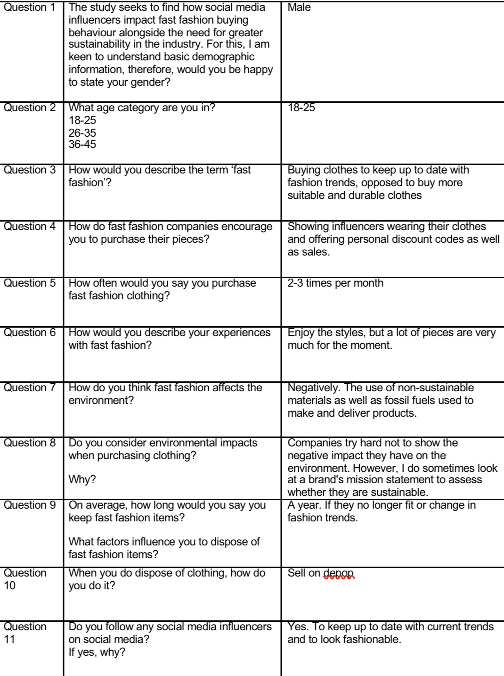
Participant 1

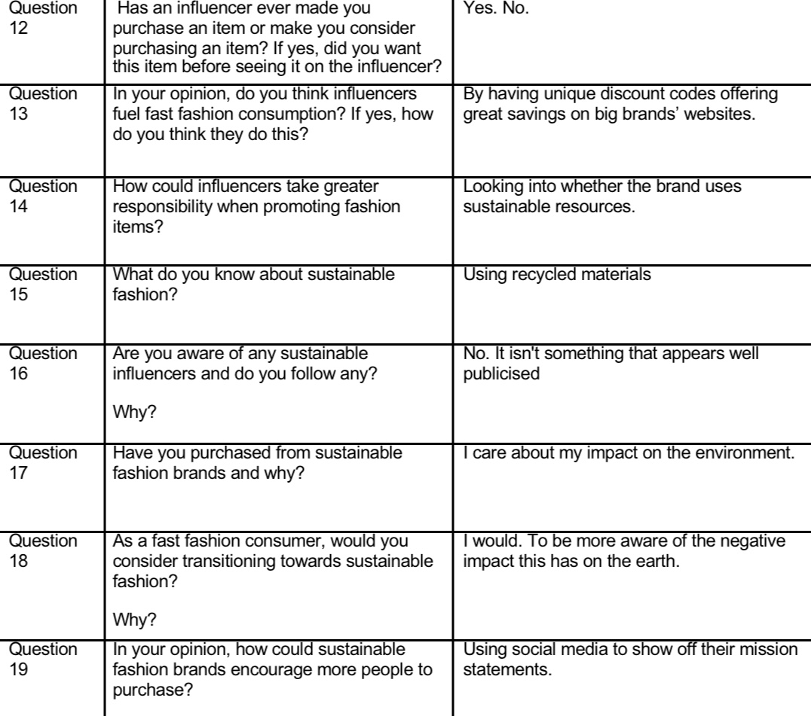

Participant 2

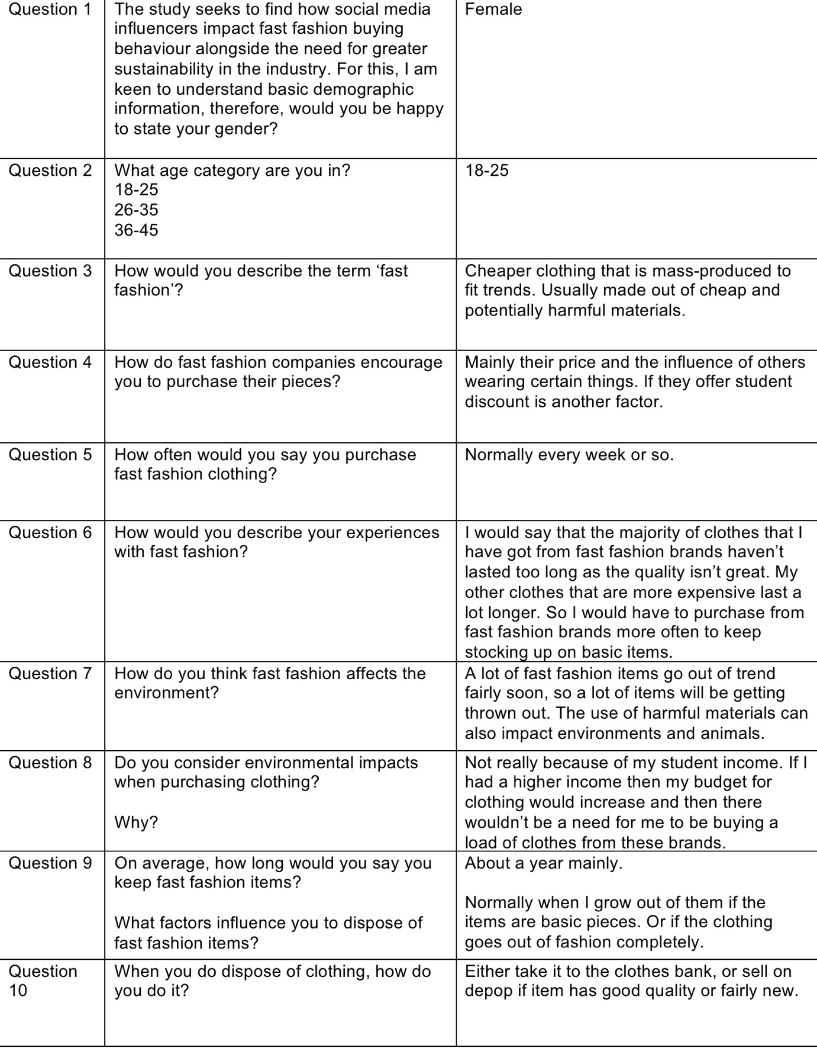

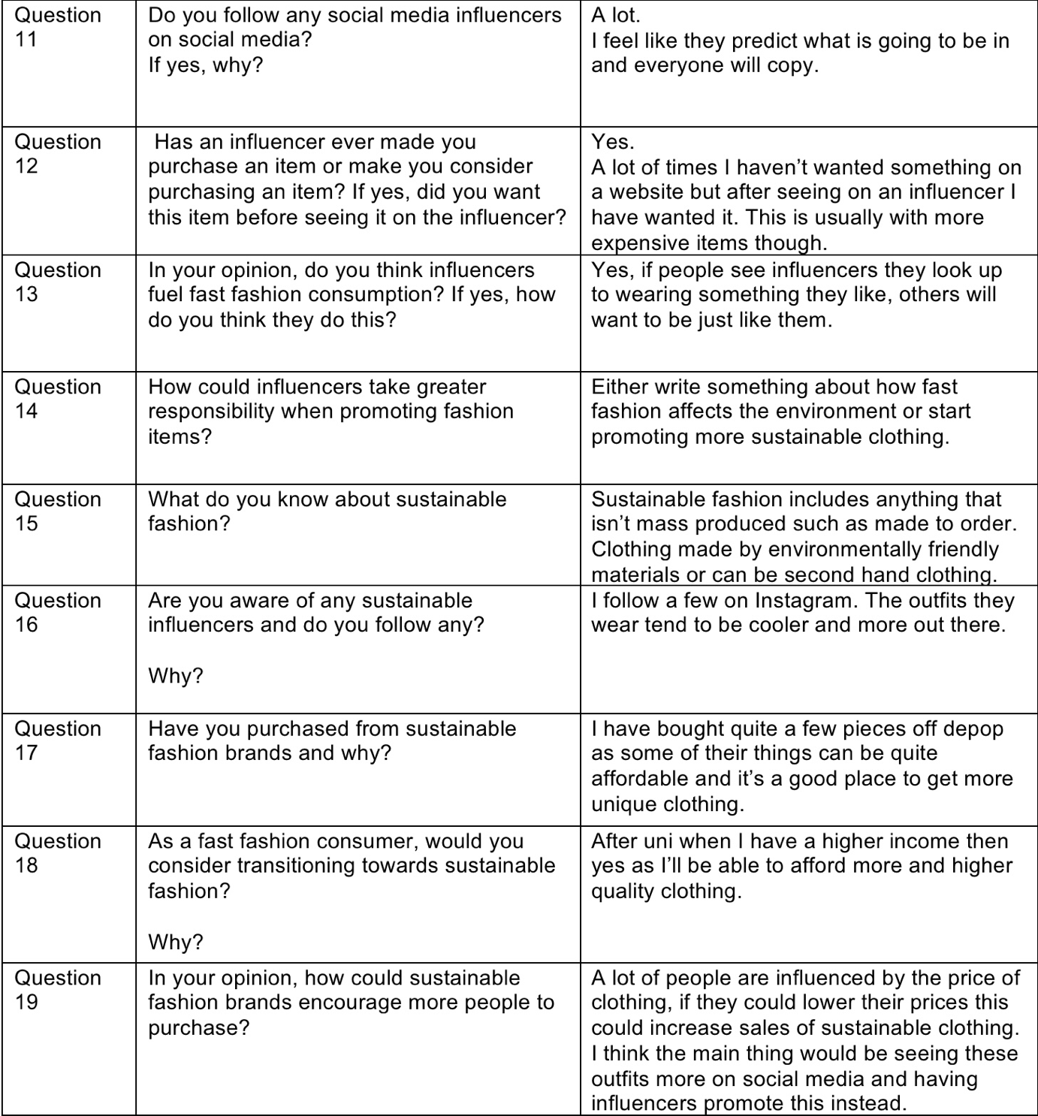

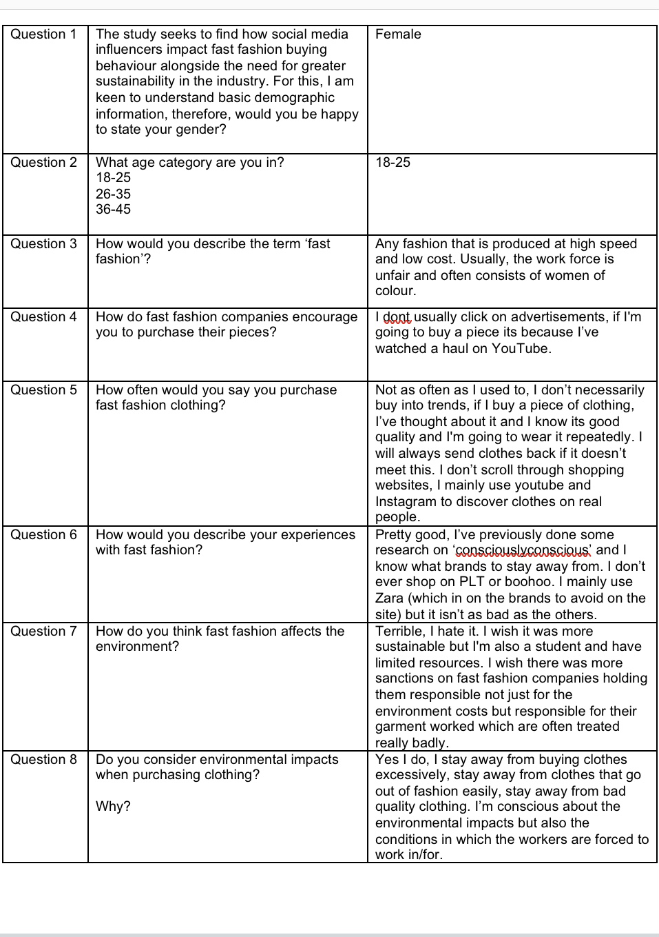
Participant 3

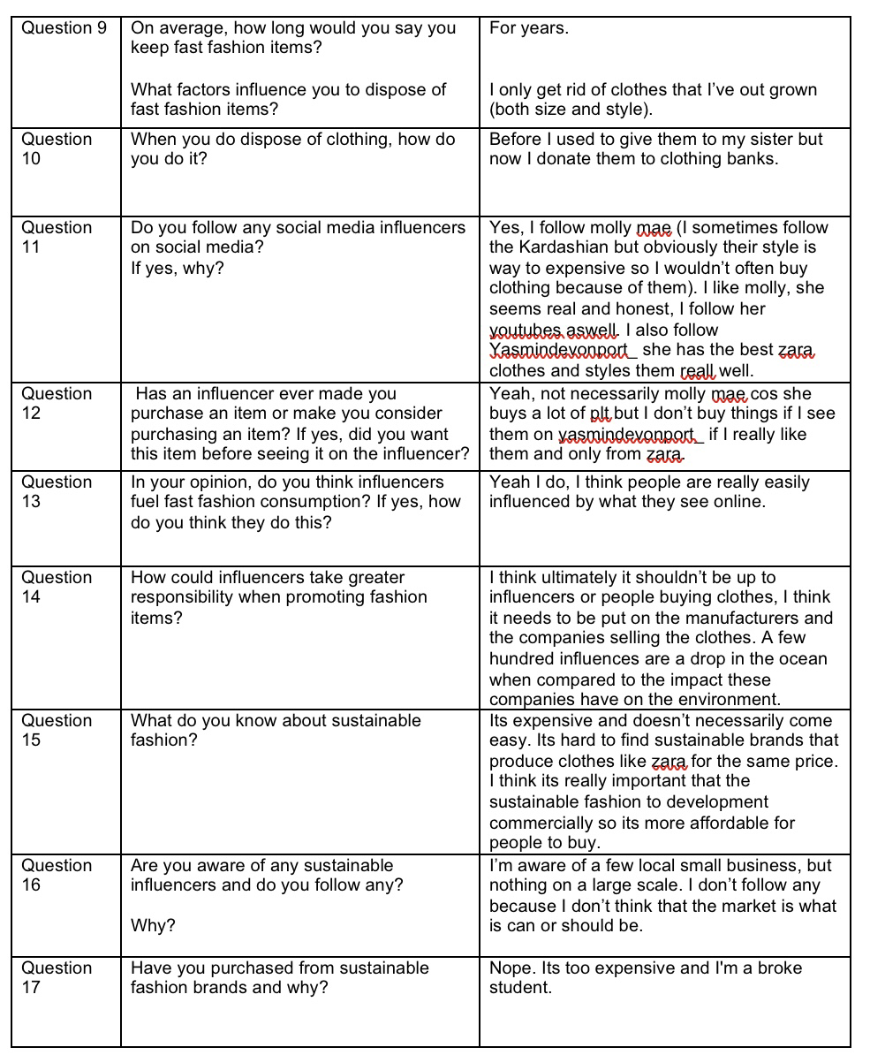
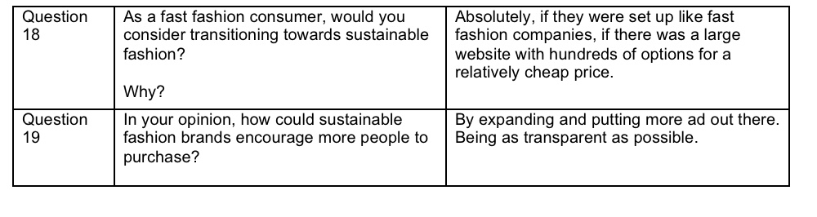

Participant 4

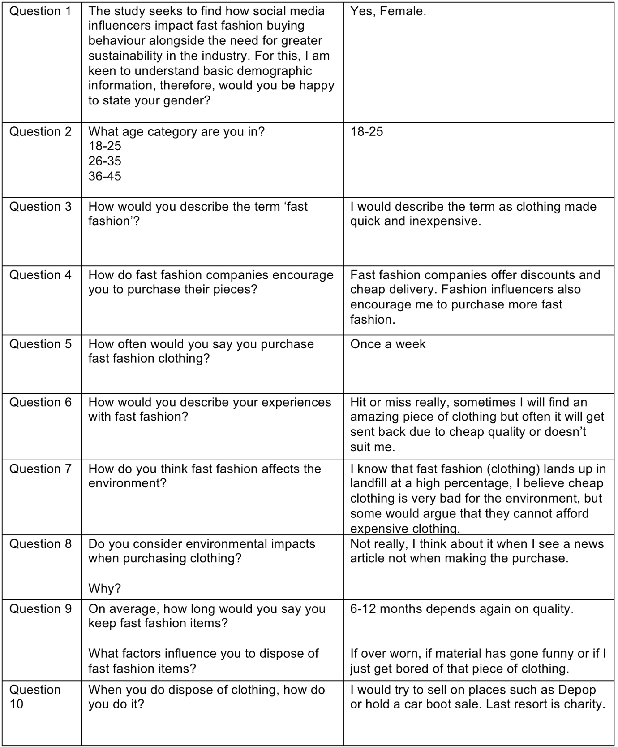

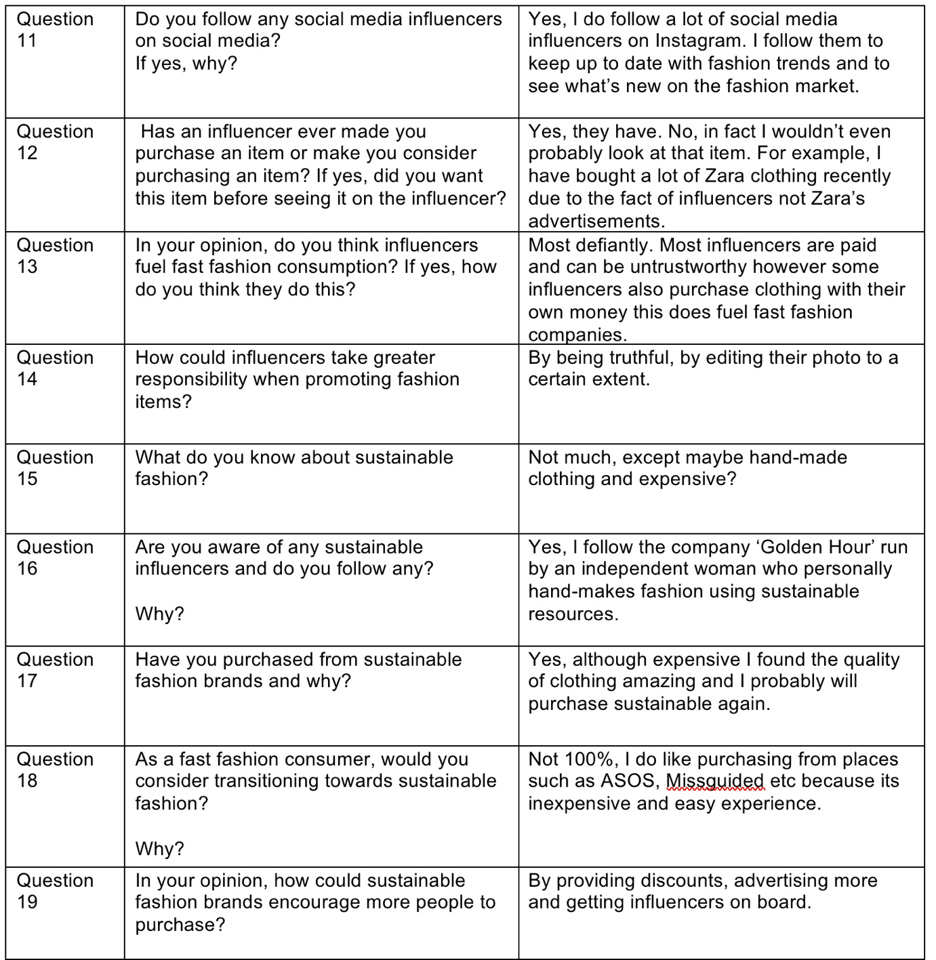

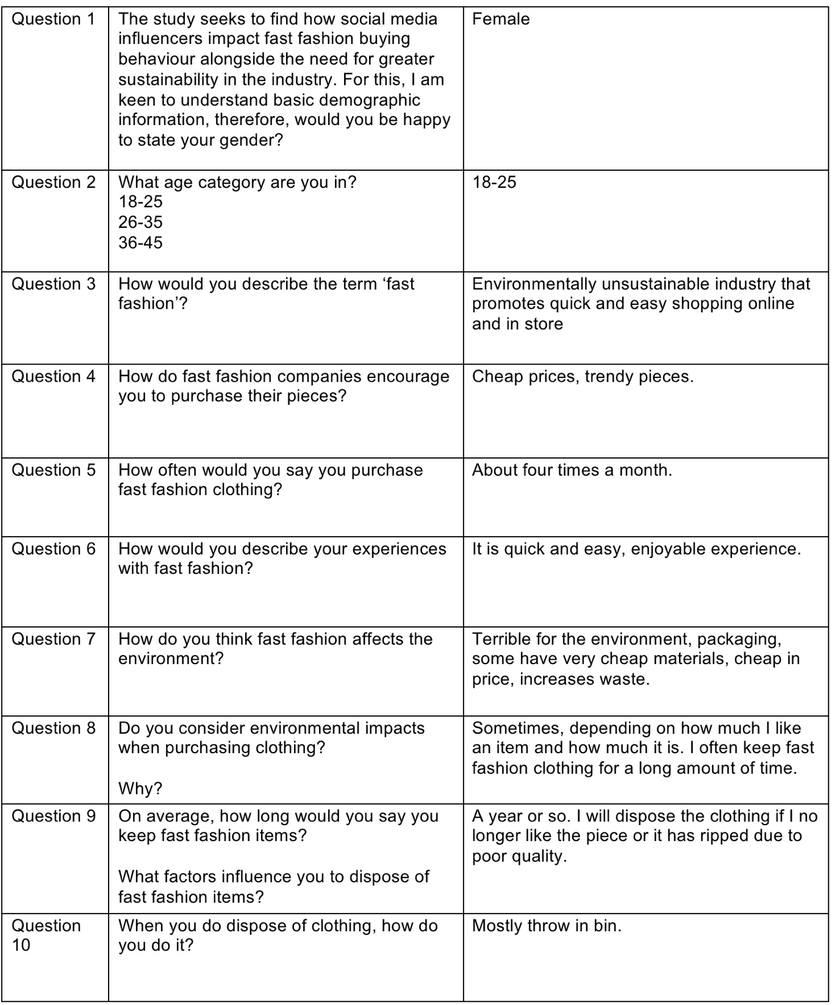
Participant 5

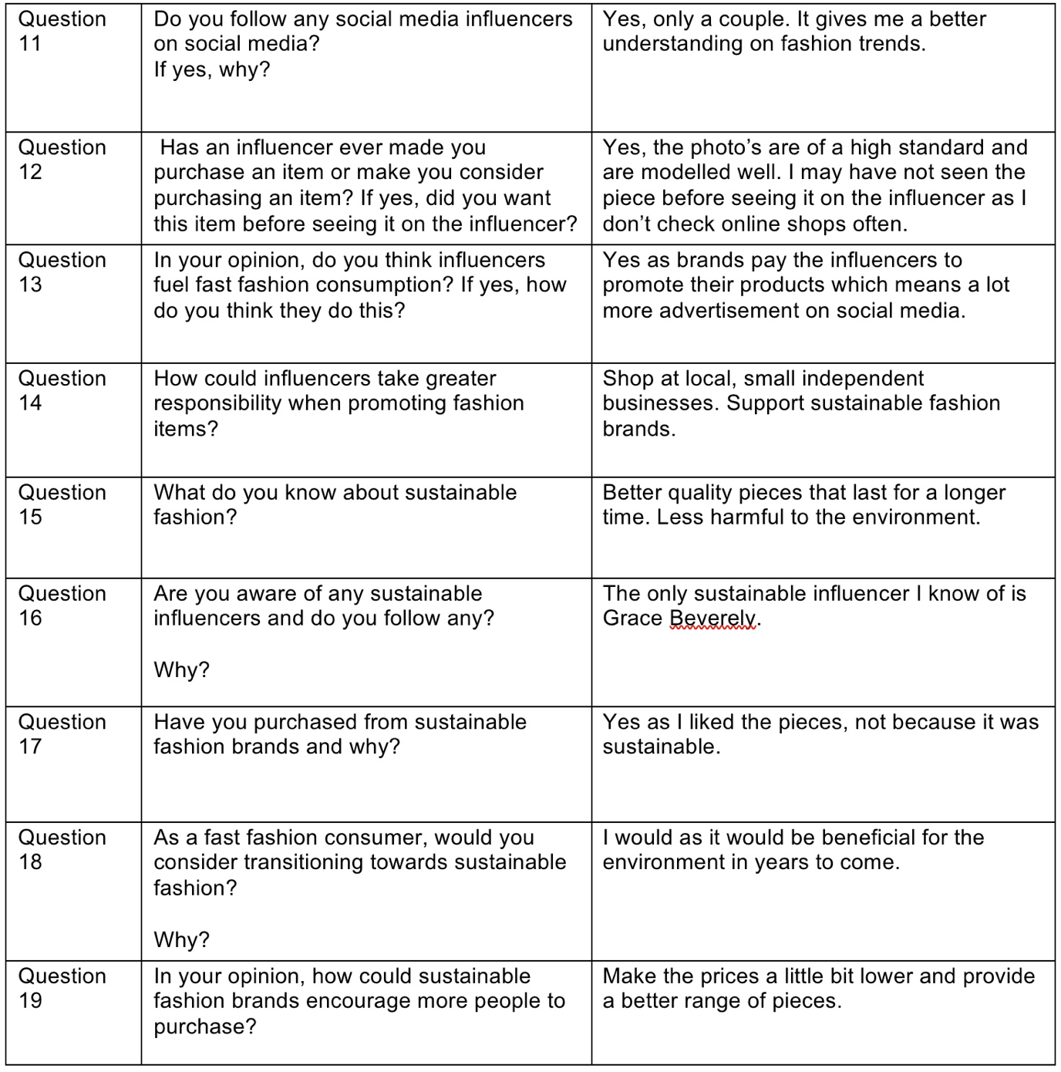

Participant 6

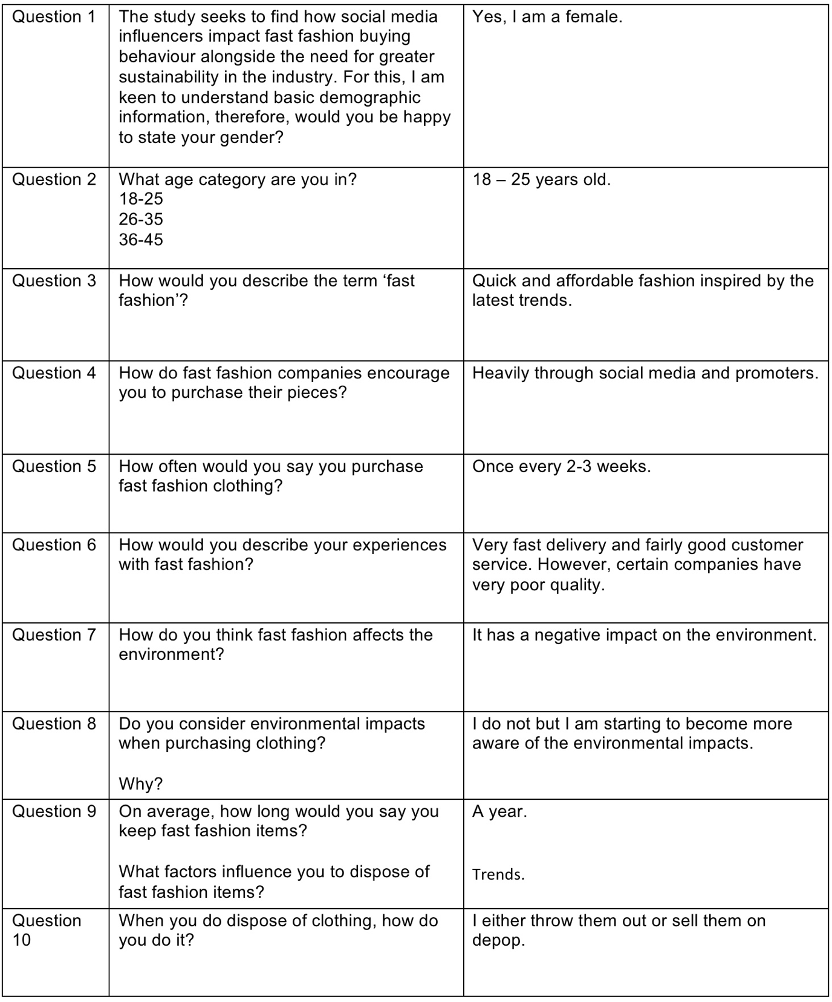

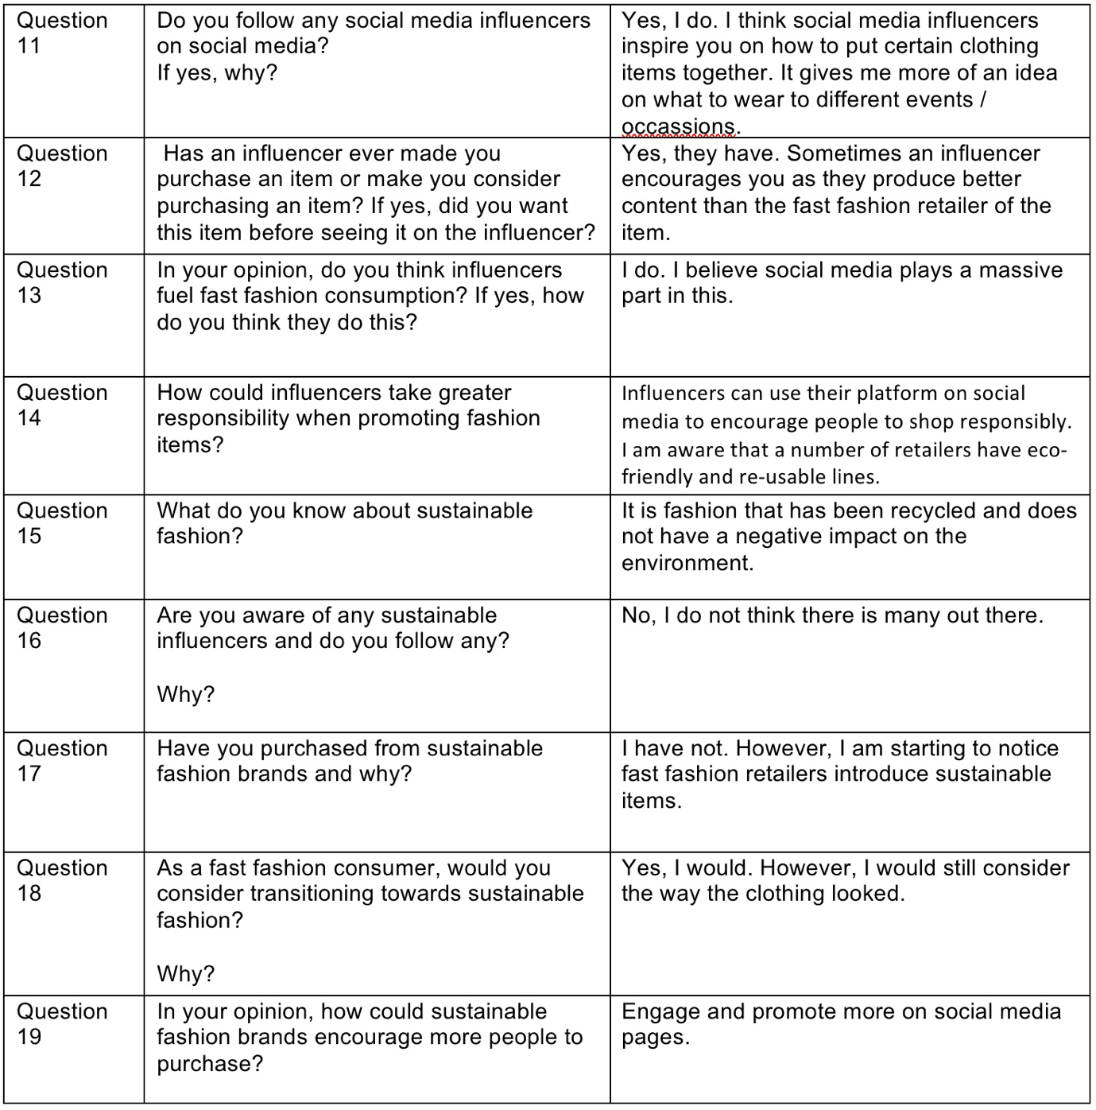

Participant 7

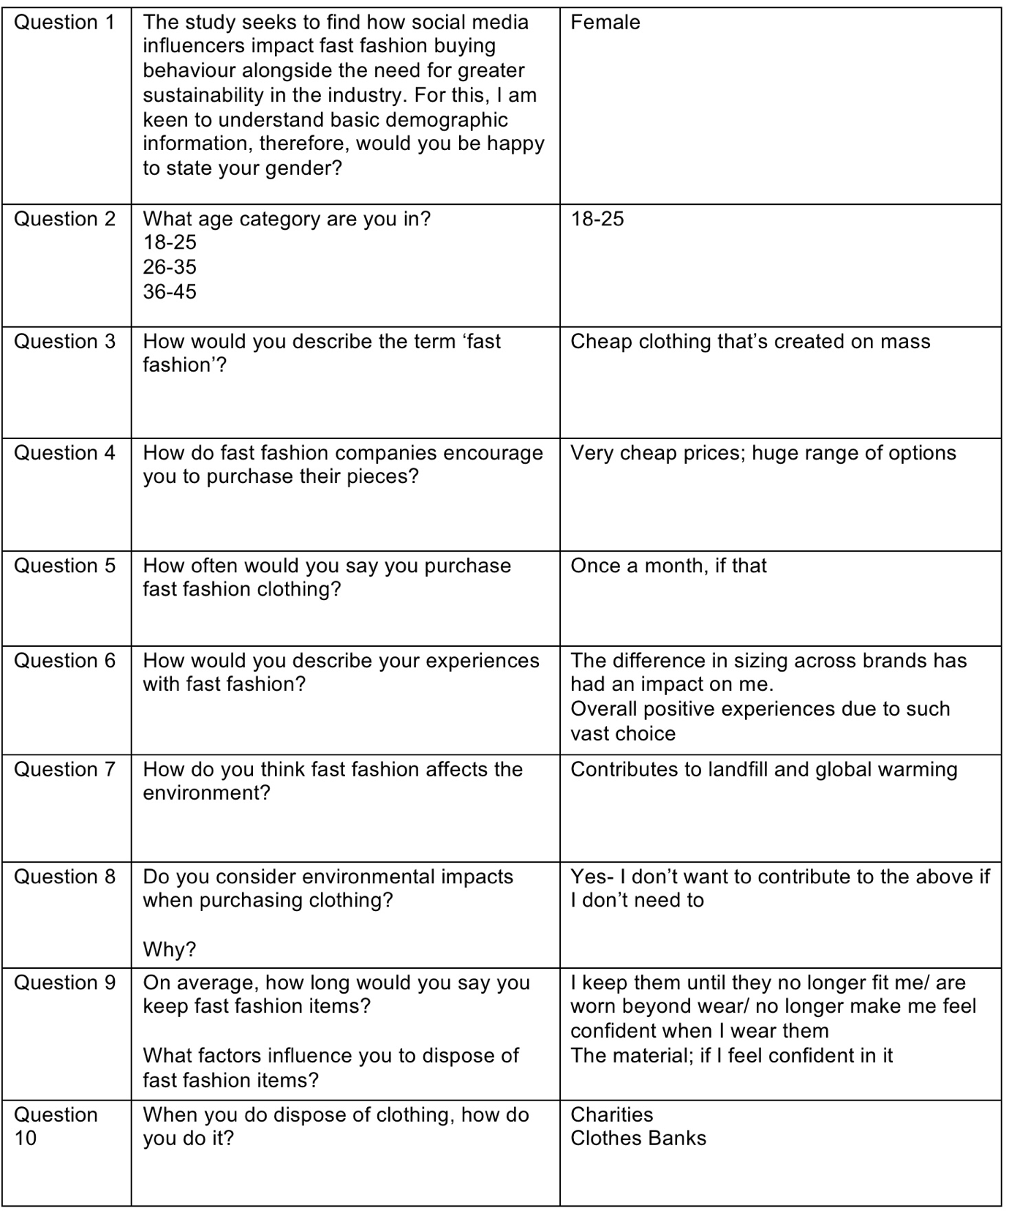

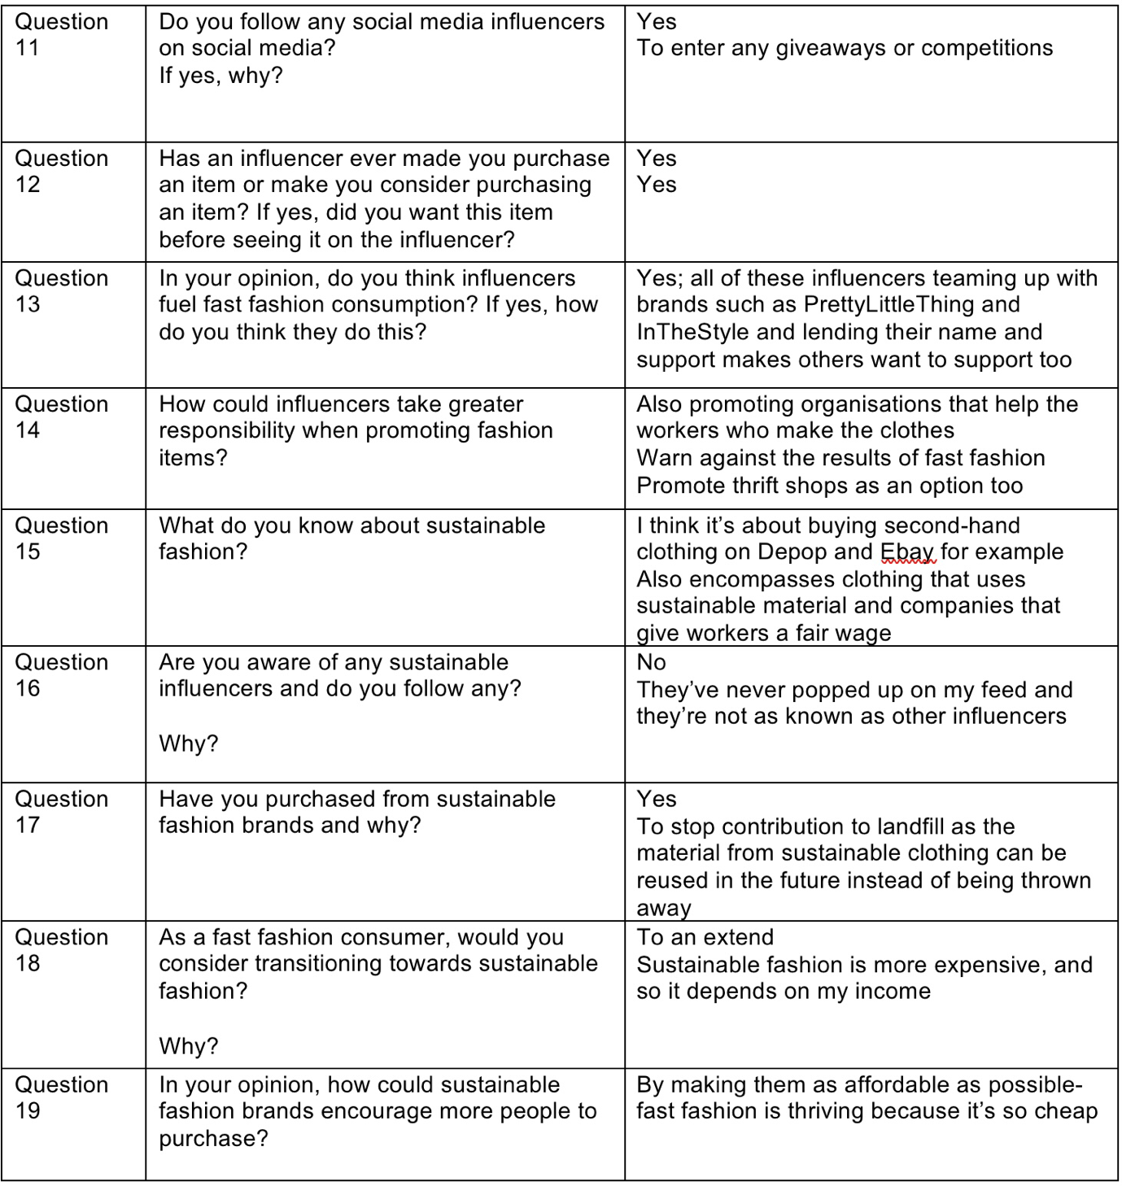

Participant 8

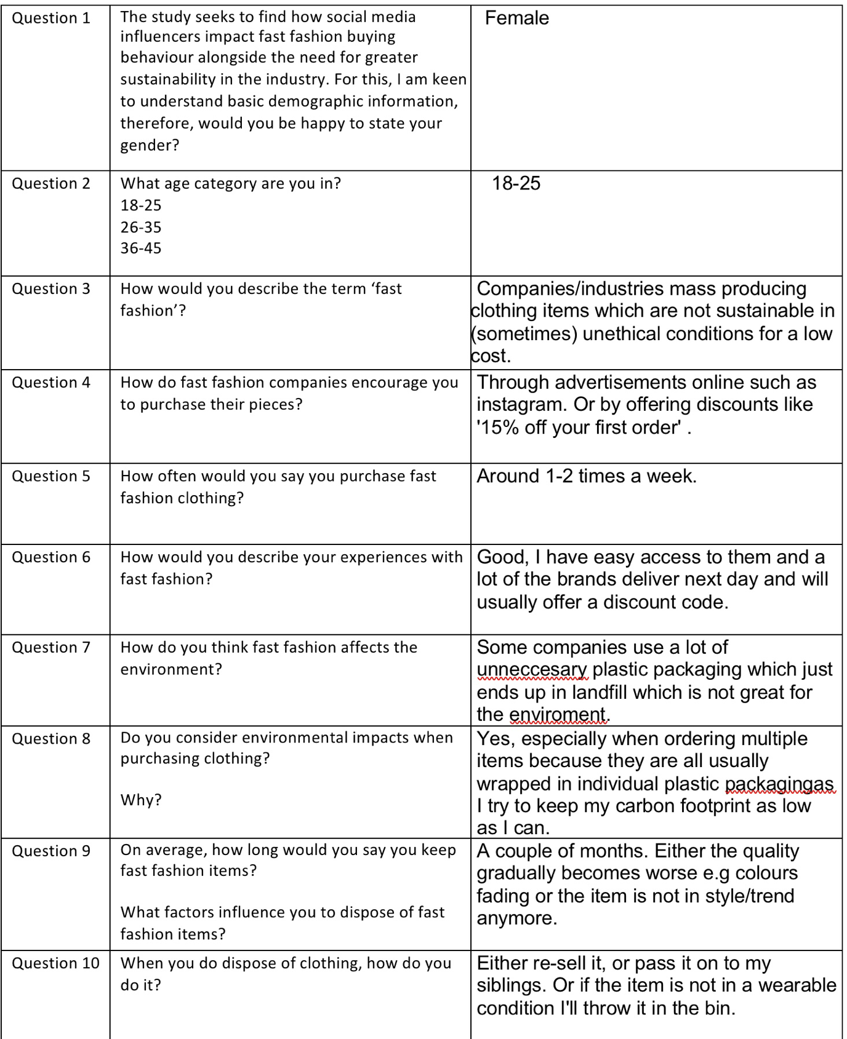

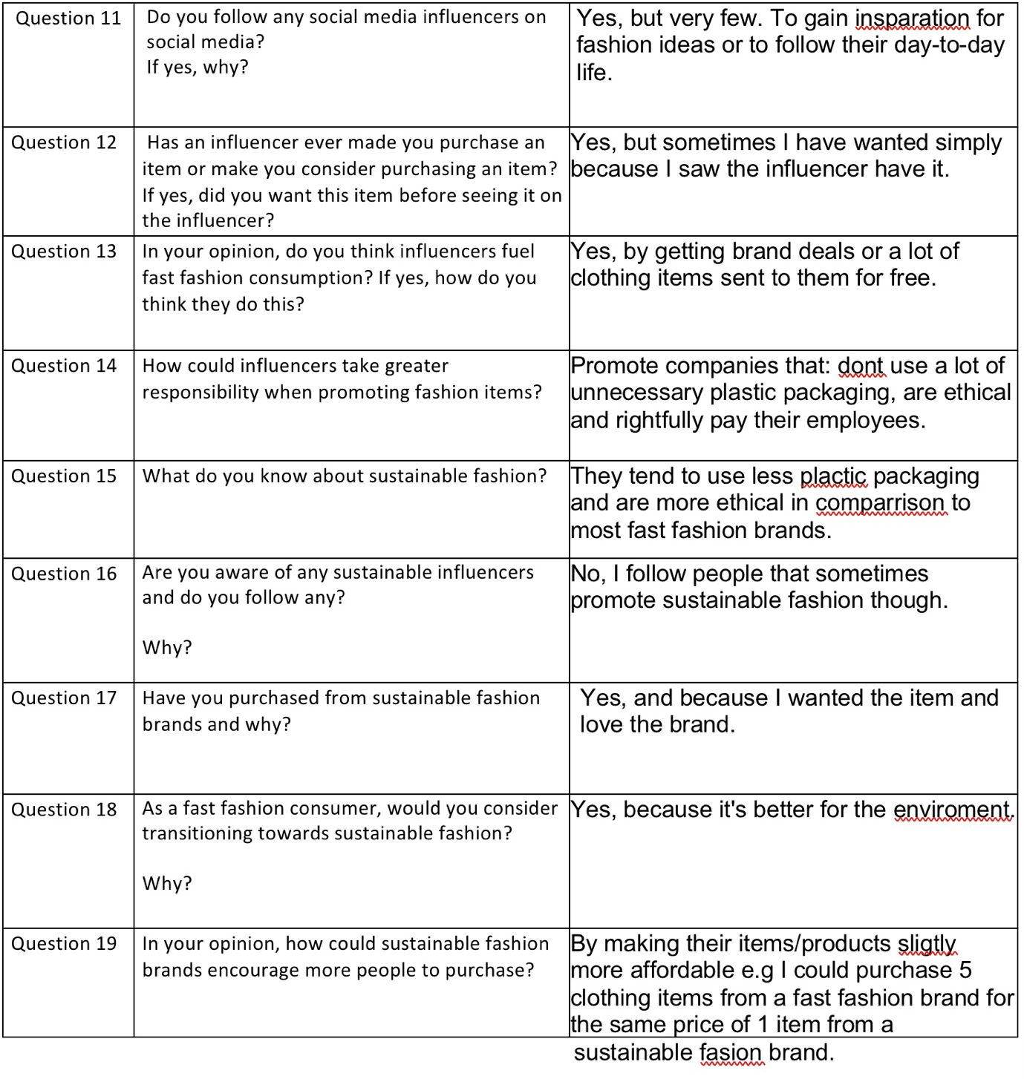

Participant 9
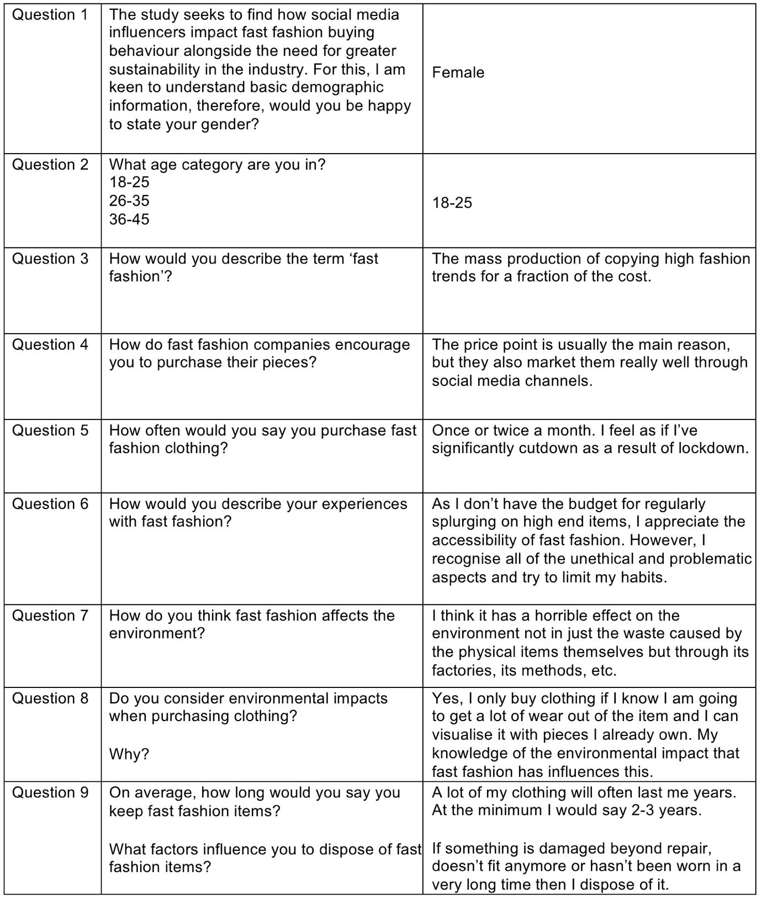

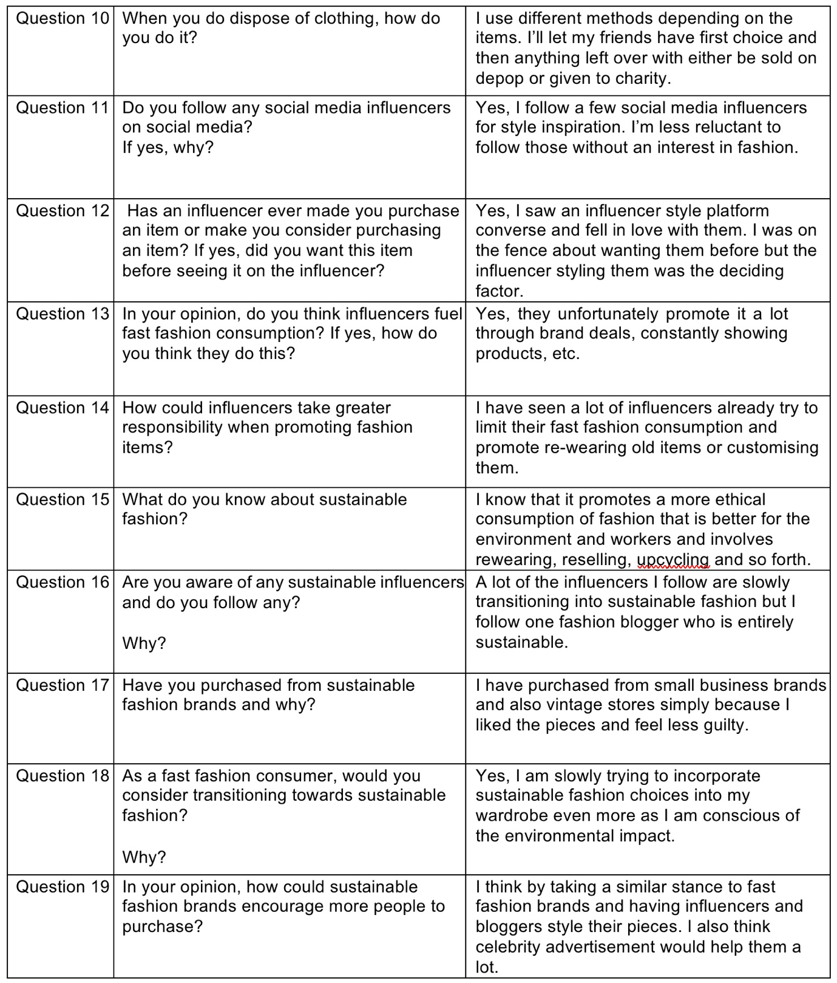

Participant 10


