December 11, 2020
dragos sculeac
University of Wales Trinity Saint David
1913775
problem solving and decision making
the decline of royal mail

Abstract
This report is looking to analyse the problems Royal Mail is facing and to provide recommendations and an action plan meant to help the company and its recovery.
By conducting the research, it was discovered that the problem the Group has been facing for several years is a constant decline in the letter volume and a loss of revenue generated by this. This happened as a result of changing customer’s behaviour and choosing faster communication ways in detriment of traditional correspondence.
Although the trend has been clearly noticed and is not looking to improve, Royal Mail have been slow to adapt to its consumer’s needs and this has caused a loss in the market share to its main competitors.
The company still possesses some important strengths, like a broad service offering and an increase in parcel deliveries, a strong infrastructure and all of these can help the business to modernise and become more focused on the parcel market.
The PESTLE analysis has demonstrated that there are numerous factors that have contributed to the decline of letter volume, particularly social and technological ones. The rapid growth of technology and digital communication tools have led the people to stop sending letters unless they are required to. Also, the introduction of GDPR has negatively impacted the direct mail correspondence.
The action plan proposed will help the company to increase its automation and become a parcel led business in the next two years.

Contents
Abstract 1
Table of Figures 2
Introduction 3
Main Findings 3
Nature 3
Scope 4
Impact 4
SWOT analysis 6
PESTLE analysis 7
Conclusion 8
Options/Recommendations 9
Action Plan 9
Monitored 10
Reviewed/ Evaluated 10
Communicated 11
Appendices 11
SWOT analysis 11
PESTLE analysis 13
Monitoring & Evaluation template 16
Reference List 17

Table of Figures
SWOT analysis of Royal Mail 12
PESTLE analysis of Royal Mail 14
Monitoring & Evaluation template 17

Introduction
The current report has been requested by the lecturer Christian Felices on the 20th of November 2020 and it was compiled by Dragos Sculeac, with the submission deadline of 11th of December 2020. The purpose of the report is to analyse the decline of Royal Mail, by identifying the causes that led to its current problems, using the SWOT and PESTLE analysis. Once the problems are identified, an action plan that provides solutions has to be implemented and monitored. The research methods used are journals, articles, and Royal Mail reports.

Main Findings
Royal Mail is the largest postal and delivery services group in UK. It is one of the oldest organizations in the world and was founded in 1516 (Royal Mail, 2020)
It operates in 44 countries and in the UK provides a six days a week delivery service and a universal price to about 30 million addresses (Marketline, 2020)
Within the group there are two main segments: General Logistics System and UK Parcels, International and Letters.
The first segment provides logistics solutions and parcel and express services and covers 41 European countries, 7 states in USA and 1 state in Canada, with an emphasis on business-to-business deliveries. In 2019 the reported revenue accounted for 27% of the company one.
The second segment provides universal postal services and is represented by the UK and international letter and parcel delivery businesses through the Royal Mail own network and Parcelforce Worldwide. Within this segment there are also some letter related business activities and marketing mail consulting services. Last year its revenue accounted for 73% of the Royal Mail total revenue.
With the letters market in continuous decline, Royal Mail is looking to become a parcel led business. The collection, sorting and delivery of letters has been a loss-making exercise for the Royal Mail for some years now but the parcels business is much more profitable helped by the rapid growth in online shopping and fulfilment. Apart from this major problem, Royal Mail is also facing tensions with its workforce, with employees fearing for their job security, unhappy about pensions and employment conditions (The Guardian, 2020)

Nature
The main problem Royal Mail is facing is the decline in the letter market. Volumes in this market have fallen by 4-6% each year (Royal Mail PLC, 2019) and since the Covid 19 pandemic hit, for the first time in its history, the letters revenue is now lower than the parcel revenue (Post&Parcel, 2020) and is not predicted to change in the future. Although the parcel business is more profitable, Royal Mail haven’t been able to keep up with their competitors and have underinvested in this segment (Financial Times, 2020)
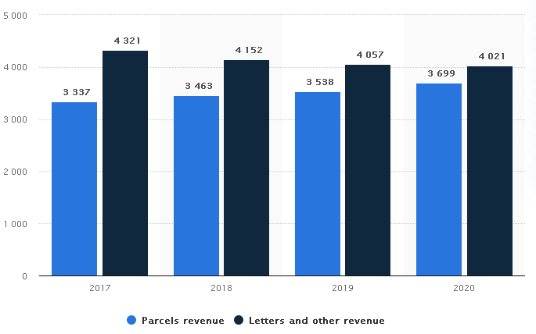
Figure 1. Royal Mail revenue from UK letter and parcel by sector 2017-2020 (Statista, 2020)

Scope
The letter market has seen a constant decline for years and there have been numerous factors that contributed to this problem. The most important one is a change in the customer’s behaviour, the evolution of digital communication tools has driven the people to use faster ways of communication, like email, fax, and messenger apps. Royal Mail have admitted to being slow in adapting to changes and the customer’s needs (Royal Mail Group, 2020) and this led to poor investment in new technology and revenue loses every year. The most affected by the company’s problems are its employees, followed by the shareholders and finally its customers.

Impact
Since privatisation in 2013, the company has cut more than 12000 jobs and closed many mail centres and delivery offices. With Royal Mail looking to become a parcel led business, its main purpose is to reduce its costs by investing in automatization. With staff cost accounting for 60% of the group’s cost, the plan for the next two years is to cut 2000 management jobs, saving £130 million. (The Telegraph, 2020). The pension scheme has suffered changes in the detriment of the employees and with the plan to reduce the costs even further, the dividends were cut last year and will be this year as well. The workplace culture is worse than ever and employees are not happy about their working conditions, nor with the plan of cutting more jobs. The strike actions have impacted the customers as they chose other parcel delivery companies.
Ultimately the customers have been impacted by the company’s inability to adapt to their changing behaviour. The number of complaints has been increasing every year, as seen below.

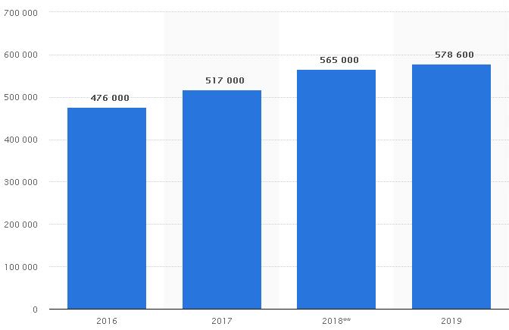
Figure 2. Number of customer complaints receiver by Royal Mail Group 2016-2019 (Statista, 2020)
As a result of this, the group has faced financial loses, in the last financial year had to pay regulatory fines of 51 million pounds (Royal Mail, 2020).
Although the parcel segment has surged due to the pandemic, the Group is still expecting to report a loss this current financial year (Denton, 2020).

SWOT analysis
From the conducted SWOT analysis, it has resulted that Royal Mail has got the resources to overcome the problems its facing and some opportunities that will allow the Group to potentially become a parcel led business.
Strengths
Royal Mail is the largest post operator in UK and offers a large variety of delivery options, to businesses and customers. The Group has a strong market position and operates in several European countries, USA and Canada.
The parcel segment continues to provide profit and the Group is looking to become a parcel led company in the near future. The company has the necessary resources, like the workforce, infrastructure, to achieve its goal but will need to keep up with the changing needs of its consumers and improve customer service. Another strength it benefits from is financial leverage, the company managing to decrease its debt by 8% in the FY2019 (Marketline, 2020).
Weaknesses
Since the privatisation, the shareholders have focused on increasing profits while operating several cuts, which has affected the customer service. In 2018 there has been a 51% increase in customer complaints regarding parcel deliveries (The Telegraph) as not being received. Also the Group is now regulated by Ofcom and has to maintain a set price for second class letters and parcels. The company also has been slow to adapt to the evolving market and hasn’t invested enough in automatization. Royal Mail are also facing with limited cash available for potential opportunities.
Opportunities
The biggest opportunity for the business is to transform into a parcel led business and reduce the B2Bservices. By introducing more sorting machines, they can also reduce their staff costs significantly and can increase productivity and customer satisfaction. Royal Mail will continue to benefit from the rapid growth in online commerce and also air freight market. This segment has shown increases in 2018 on all the markets the Royal Mail Group is operating in.
Threats
When it comes to what threatens the business the most, competition plays a big role and has added great pressure in the logistics and communications markets, resulting in Royal Mail losing a big market share to its competitors.
Along with this the business has been dealing with a decline in the letters market because of increased interest towards digital communication. Introduction of GDPR also negatively impacted the volume of direct mail. It is expected that the letter volume will continue to decline and the Group must be resilient and adapt to the changes quickly, otherwise it will face even higher revenue loses.

PESTLE analysis
The Pestle analysis has demonstrated that there are a lot of factors that have affected the business in the recent years and there are some important challenges it is facing. The letter volume will continue to drop and nothing can be done to change this, but the company can avoid loosing more revenue by adapting to change and modernise.
Political
As Royal Mail Group operates in 44 countries, it is permanently exposed to many political risks and high instability can have negative impacts over its operations. Brexit is also going to have a political impact as there could be new taxes introduced for customs when UK will be leaving the EU.
Economic
In the current year Covid-19 has had a big economic impact over the business. As an essential business, Royal Mail had to keep its door open and the implemented safety measures, along with protective equipment purchases and staff absence have cost the company £85 million in the first half of 2020. (Denton, J.) There has also been a positive impact as the lockdown measures made the customers to increase their online orders, which resulted in a parcel delivery growth three times over the estimated figures.
In the first two months of 2020 however there has been a 33% volume decline in addressed letters and 63% in advertising mail as a result to Covid-19, as seen in the figure below.
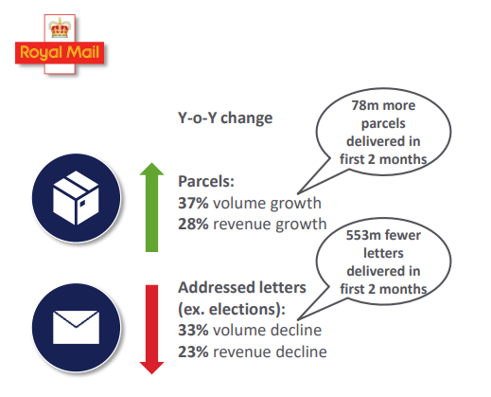
Figure 3. Decline in addressed letters and parcels growth in first two months of 2020 (Royal Mail, 2020)
Social
The social element is the one that has had the biggest impact over the decrease in the volume letters. This is a result of changes in customer’s behaviour and needs, where traditional correspondence has been replaced by the digital one. In a similar way the volume of direct mail has decreased as a result of shift of marketing to social media. (Riley 2015). In 2020 for the first time the parcel segment of the business has generated more revenue than the letter segment.
Technological
With a continuous rise in parcel delivery, Royal Mail had to invest in Parcel Sorting Machines to minimise the operational costs and improve the efficiency. They are now operating 20 machines in 16 sites and they are looking to double the number in the next 3 years, aiming to reach 80% of parcels processed. (Royal Mail Group, 2020)
The access to new technology has allowed customers to chose digital tools over traditional correspondence hence affecting the volume of letters sent.
Legal
The legal factor that had a big impact on the decrease in letter volume is GDPR. Since it has been introduced, the volume of direct mail had a 10% drop and is not looking to improve in the future. Another element that caused loses for the company is Covid-19 pandemic, with new health and safety rules being introduced that costs several millions of pounds.
Environmental
The Royal Mail Group is committed to manage the environmental aspects, like energy consumption, carbon emission, water usage and generated waste (Environmental Policy, 2019)
and how they work with suppliers and customers on environmental issues. They are also implementing the recommendations made by Taskforce on Climate related Financial Disclosures (TCFD).
Failure to comply with their environmental policy would result in increased business costs, taxes and reputational risk.

Conclusion
The problem regarding the decline of letters volume is not one that happened overnight, but as a result of evolution and changing customer’s behaviour towards technology and faster ways of communication.
The reason why it got to the level it is today is because Royal Mail have refused to adapt to these changes and haven’t been investing in modernising the company. Recently they have concluded that they have to benefit from the increase in e-commerce, it is a great opportunity for the business to recover from the loses and become a parcel business. It is clear that with the rapid technology growth, the consumers will never revert to the traditional communication methods and the group must rebrand and focus on parcel deliveries.

Options/Recommendations
The factors that impacted the decline of the letter volume have been outlined in the Ishikawa diagram below.
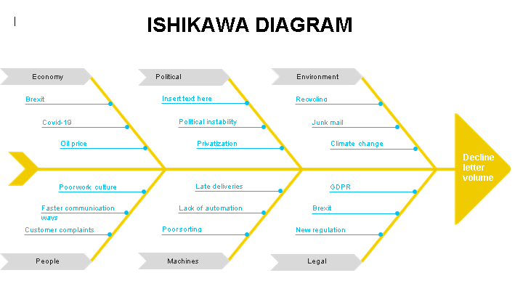
Figure 4. Causes that led to the decrease of letters volume.
Following the micro and macro analysis, it is evident that the problem regarding the letter volume decrease can’t be reversed. There are some options the company could consider to avoid more revenue loses.
A first option would be to modernise the business and introduce automation. This will significantly reduce the fixed costs, increase the performance, time management and customer satisfaction. It would also improve the working conditions and reduce the working hours, which will result in a better workplace culture and low risk of strikes. By sorting the parcels more efficiently, the business could look to provide 2 deliveries per day in most countries.
To become more competitive, Royal Mail could also introduce same day and next day/Sunday delivery.

Action Plan
After identifying the main problem, Royal Mail has to implement a series of actions in order to achieve its goal of modernising and grow its parcel segment.

Monitored
The resources needed for the action plan are money, new equipment and employees. All of the these are essential as they are related to reducing costs and increasing productivity,
The money are necessary to buy the equipment and modernise the mail centres, whilst the employees are the company’s most important asset.
The key indicators are the number of parcels sorted automatically, increase of parcel collection points and same day delivery and Sunday delivery. With the introduction of parcel sorting machines to every mail centre, the productivity can increase and the employees working conditions, by reducing the working hours. The parcel collection points can be installed in every location Royal Mail operates and so it will be easier for Royal Mail to focus on providing same day deliveries for letters and parcels in the near future.
The targets sets will be:
- Increase the number of automated sorted parcels to 1 billion and introduce parcel sorting machines in every mail centre by 2022
- Double the number of existing parcel post-boxes by the end of 2022
- Offer 2 deliveries per day in UK, first to include letters and small parcels and one to include large parcels, by the end of 2022
These are smart goals and can be achieved as a result of an increase in the parcel share market. By achieving these goals, the employee’s performance would increase, and this would have a positive impact on customer satisfaction, with consumers more driven in using Royal Mail’s postal services.

Reviewed/ Evaluated
The action plan will be reviewed at the beginning of 2023 and the questions asked will be:
- Is the number of automated sorting machines increasing?
- Is the productivity increasing?
- Are there parcel sorting machines in every mail centre?
- Is the company able to deliver twice a day, including large parcels ordered a day before?
- What was done right?
- What can be done better next time?
These questions have the role to determine the success of the action plan or the improvements needed in case not all the targets have been met.

Communicated
The action plan will be communicated to both the internal and external stakeholders.
At the internal level, the decisions will need to be communicated to the employees and managers. The first are the ones who will be directly impacted by the automation, as it will improve their working conditions and reduce their hours, and the managers will need to implement the decision and make sure the objectives are achieved.
At an external level the customers will be happy to know about the new technology and increased number of parcel boxes available and the introduction of same day delivery. The accounts will need to be notified as well as it will also impact their business, and the shareholders are the ones who ultimately make these changes possible by investing the profits in modernising the company.

Appendices

SWOT analysis

Strengths | Weaknesses
- National recognised brand  - Largest post operator in UK  - Offers a variety of delivery options  - Business services available  - Owns its own courier network for national and international deliveries  - Low debt | - Royal mail still has to deliver to rural areas where they are facing loses  - Maintaining the one price goes anywhere service  - Staff reductions  - Set price cap by Ofcom for second class letters and parcels  - Increase in customer dissatisfaction regarding parcel deliveries  - Low liquidity  - Poor automation
Opportunities | Threats
- Employee share scheme and working hours reduction can help in increasing productivity and reduce the risk of costly strikes  - Growth opportunities for the courier, express and parcel market  - Increased global air freight | - A constant decline in the letter business  - Emphasis on profits can alter other priorities  - Higher competition from retailers and online retailers, such as Amazon own delivery network, click and collect retailers  - Loss in direct mail volume
SWOT analysis of Royal Mail

PESTLE analysis
Element | Factor | Impact
Political | Privatisation  Political instability in Europe  Brexit | The government has lost 1 billion pounds because it undervalued the company when it was listed on the stock market  Royal mail operates in many countries and is exposed to many political risks  When the UK will leave the EU there could be new taxes introduced for international deliveries
Economical | Privatisation  Covid 19  Brexit  Volatile oil Price | -Introduction of shareholders will allow the company to secure profit and modernize the company  -The postal services market has been opened up to increasing competition in recent years with postal businesses able to apply for a licence to operate in competition to the Royal Mail.  -Implemented safety measures, along with ppe equipment purchases and staff absence have cost the company £85 million in the first half of 2020  - The high number of infections and the continuous restrictions are delaying the economical recovery  -Brexit is going to have a big economical impact over Royal Mail as it is going to affect all businesses. The main reason for it is that UK will have to bear all costs of leaving the EU  - Since the referendum, the economic growth has weakened and so did the investors’ confidence who preferred to move their business to other countries  -With over 48000 delivery vehicles, the oil price plays an important role over the variable costs which then impacts the business’ profits every year
Social | E-commerce  Digital ways of  communication | An increase in online shopping has led the parcels to overcome the letters for the first time and caused huge losses in profit for the business  Increased email access, fax, smartphones has stopped people from sending letters
Technological | Online communication  New technology | A rise in online communication apps has seen the company losing in its letter business  The parcel segment has grown significantly in the recent years and there is a high need for new technology to be implemented that will allow the parcels to be sorted automatically
Environmental | Climate changes  Pollution | Royal Mail has launched Smart Stamp in 2004, Sustainable Mail in 2009 and Click and Drop in 2015  In some European countries Royal Mail is distributing letters and parcels on electric vehicles
Legal | Change of regulator  Health and safety laws  Data protection regulation  Brexit | Royal Mail became free to set its own prices  - Reduction from 3 months notice to 30 days notice for Universal Service Obligation services  - Downstream access from competitors with no specific price cap  - Royal mail must make a profit of 5-10%  New safety measurements to protect against contacting Covid-19  The new GDPR law had a negative impact over marketing mail, that reported a 10% loss in the last financial year (Royal Mail PLC, 2020)  With UK leaving the EU, new laws could be introduced that will affect the custom clearance process
PESTLE analysis of Royal Mail

Monitoring & Evaluation template
Decision implemented:

Transform the company from a letter business to a parcel led business

Monitoring the decision:
Resources:
Employees
New equipment
Money

Key Indicators:
Number of parcels sorted automatically.
Parcel collection points
Same day delivery and Sunday delivery

Targets:
Increase the number of automated sorted parcels to 1 billion and introduce parcel sorting machines in every mail centre by 2022
Double the number of existing parcel post-boxes by the end of 2022
Offer 2 deliveries per day in UK, first to include letters and small parcels and one to include large parcels, by the end of 2022
Data Sources:
The data in this plan will be taken from the yearly reports generated by Royal Mail

Reviewing the decision:
The current action plan will be reviewed at the beginning of 2023.
Is the number of automated sorting machines increasing?
Is the productivity increasing?
Are there parcel sorting machines in every mail centre?
Is the company able to deliver twice a day, including large parcels ordered a day before?
What was done right?
What can be done better next time?

Communicating the Decision:
Internal Stakeholders  Employees  Managers | External Stakeholders  Customers  Accounts  Shareholders
Monitoring & Evaluation template

Reference List
- Denton, J (2020), Royal mail goes from profit to loss, This is Money, available at https://www.thisismoney.co.uk/money/markets/article-8965059/Royal-Mail-revenues-jump-online-shopping-costs-weigh.html accessed 28.11.2020
- Denton, J (2020), Royal Mail warns it's on track to make a loss this year as letters sent fall by 1.1BILLION during lockdown... but shares bounce 25% on parcel increase, available at https://www.thisismoney.co.uk/money/markets/article-8708777/Royal-Mail-track-material-loss-year.html, accessed 9.12.2020
- Foy, S. (2020), Royal Mail cuts 2,000 jobs as Covid costs soar, available at Royal Mail cuts 2,000 jobs as Covid costs soar (telegraph.co.uk), accessed 9.12.2020
- MarketLine Company Profile: Royal Mail plc.: EBSCOhost, accessed 29.11.2020
- Morley, K, (2018), Complaints over disappearing parcels double at Royal Mail, https://www.telegraph.co.uk/news/2018/08/20/complaints-disappearing-parcels-double-royal-mail/ accessed 28.11.2020.
- Post&Parcel (2020) ROYAL MAIL RESULTS: STRONG PARCEL GROWTH ALONGSIDE £20 MILLION OPERATING LOSS. Available at: https://postandparcel.info/129202/news/e-commerce/royal-mail-results-strong-parcel-growth-alongside-20-million-operating-loss/ Accessed 9.12.2020
- Riley, G. (2015) Royal Mail privatisation, A2 Business Economics, available at https://www.tutor2u.net/economics/reference/competition-policy-case-study-royal-mail-privatisation, accessed 08.12.2020
- Royal Mail (2020) About Us. https://www.royalmailgroup.com/en/about-us/our-story/ accessed 29.11.2020
- Royal Mail Group (2019) Environment Policy. Environment%20Policy%20%28April%202019%29.pdf (royalmailpfs.com), accessed 29.11.2020
- Royal Mail PLC (2020), Financial and strategic Analysis review, Marketline, available at https://advantage-marketline-com.ezproxy.uwtsd.ac.uk/Company/Summary/royal-mail-group-ltd , accessed 09.12.2020
- Royal Mail Group (2020) Full year 2019-2020 Results and business update, available at https://www.royalmail.com/sites/royalmail.com/files/2020-06/royal_mail_group_fy2019-20_results_presentation.pdf, accessed 10.12.2020
- Royal Mail Group (2020) In depth: Parcel Sorting Machines https://www.royalmailgroup.com/en/insights-innovation/innovation/in-depth-parcel-sorting-machines/ accessed 29.11.2020
- Royal Mail Plc (2019) Journey 2024. Growing. Efficient. Diversified. https://www.fundslibrary.co.uk/FundsLibrary.DataRetrieval/Documents.aspx/?type=sl.ra.full&id=67c86e96-3502-454d-b7a7-1e674e06c8e7&user=gKMbC9ie2tcNFagfH89gxpH7NdubUnwiOK29H3sCNkSUpf9TEHCKfZkVbYOUf%2bR7&r=1 accessed 29.11.2020
- Statista (2020), Annual revenue from UKPIL (UK parcels, international & letters) segment of the Royal Mail Group from 2017 to 2020, by sector, available at https://www.statista.com/statistics/1006782/royal-mail-revenue-from-letters-and-parcels-uk/, accessed 10.12.2020
- The Financial Times Limited (2020), Royal Mail: Return to sender, Investors Chronicle, London, available at https://search-proquest-com.ezproxy.uwtsd.ac.uk/trade-journals/royal-mail-return-sender/docview/2426309171/se-2?accountid=130472, accessed 9.12.2020
- The Guardian (2020), Royal Mail shares sink to all-time low as strike threat takes toll, available at https://www.theguardian.com/business/2020/feb/06/royal-mail-shares-strike-threat, accessed 10.12.2020

