NEW BUSINESS MODELS AND FORMS OF OPERATIONS IN INDUSTRY 4.0

PRAVEEN R. PILLAI
UNIVERSITY OF WALES TRINITY SAINT DAVIS
Course Number: MADE L7K ACPA7000 ANDVANED MANUFACTURING (INDUSTRY 4.0)

Abstract
The essay explores the new business models based on emerging technologies that are related to Industry 4.0/ Smart Manufacturing initiatives and the influence of these technologies in the current industries. The work is prepared based on the understanding and facts referred from various publications and books.

INDUSTRY 4.0

Industry 4.0— the Fourth Industrial Revolution or 4IR— is a term widely used today to define the advancement of technology in the industrial domain; based on various use cases, this platform may also be referred as SMART Manufacturing or SMART FACTORY. The concept involves adoption of one or more technologies to optimize or/ and improve the efficiency of an industrial process, assets, and people. These digitization or even digital transformation technologies were driven by the advancement in Data handling capability, connectivity of systems from shop floor to cloud, Data analytics capability, robotics to name a few. (MCKINSEY, 2022)
In the words of German Chancellor Angela Merkel, Industry 4.0 is 'the comprehensive transformation of the whole sphere of industrial production through the merging of digital technology and the internet with conventional industry' (European Union, 2015). The term Industry 4.0 originated in Germany, but the concept largely overlaps with Smart factories, the Industrial Internet of Things, Smart industry, or Advanced manufacturing.
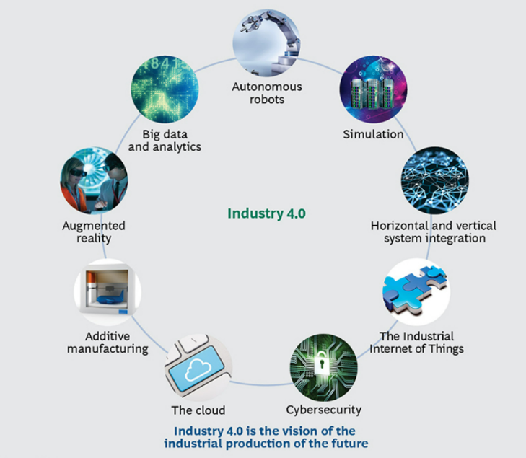
As per the report from the BCG Consulting group there are multiple technology trends that forms the foundation of Industry 4.0, and these technologies can transform business. These include Augmented Reality, Big Data and Analytics, Additive Manufacturing, Autonomous Robots, Simulation, The Industrial Internet of Things, Horizontal and Vertical System Integration, Cybersecurity, The Cloud. (Boston Consulting Group, 2015)

Figure: Nine Technologies are Transforming Industrial Production. (Boston Consulting Group, 2015)
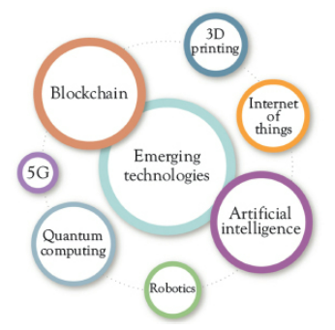
Over the years, the technology advancement contributed to incorporate new emerging technologies into industry 4.0. State of art technologies such as 5G and Quantum computing has been added. As per Stylianos, the following emerging technologies will be key players that define new business models in industry 4.0 (STYLIANOS, 2022)

Figure: Emerging Technologies (Stylianos, 2022)

BUSSINESS MODELS OF INDUSTRY 4.0
As per the industry 4.0 Report from Mckinsey.com, “the industry 4.0 brings four foundation types of disruptive technologies that can be apply all along the value chain. 1. connectivity, data, and computational power: cloud technology, the Internet, blockchain, sensors 2. analytics and intelligence: advanced analytics, machine learning, artificial intelligence 3. human–machine interaction: virtual reality (VR) and augmented reality (AR), robotics and automation, autonomous guided vehicles 4. advanced engineering: additive manufacturing (such as, 3-D printing), renewable energy, nanoparticles” (MCKINSEY 2022).

CONNECTIVITY, DATA, AND COMPUTATIONAL POWER
This is primarily related to handling of large amount of data which include technology such as cloud computing, big data, block chain etc.
The flexibility of handling enterprise level data and managing infrastructure is a technological advancement in the field on industry 4.0. Gartner Research has predicted that by 2026, about 75% of the organization will utilize the cloud platform for modelling their digital transformation journey. (GARTNER RESEARCH, 2023)
Big Data is a concept that refers to very large datasets that traditional computer application for data processing is not designed to deal with them. (FRAN, 2017)
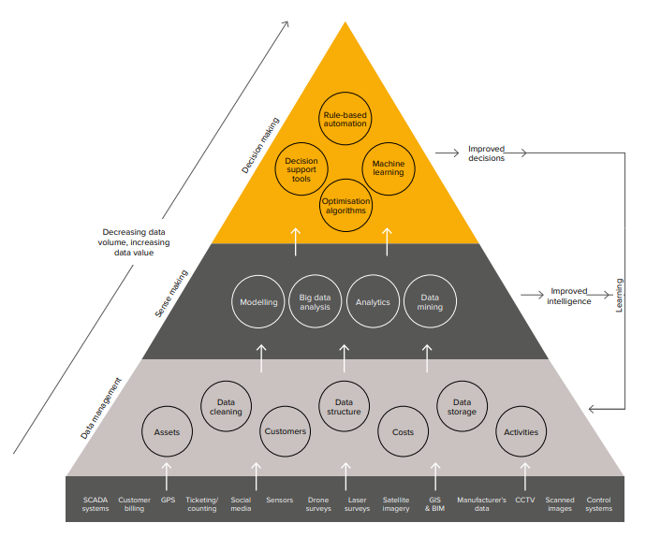
The ability to harvest data and analyze it to optimize and drive the performance from infrastructure assets is critical. The following diagram from the smart infrastructure paper published by Cambridge University provides an overview of how smart infrastructure can help in generating value from data. (Cambridge University, 2023)
Figure: Increasing Data Value from Digital Infrastructure (Cambridge university, 2023)
Digital Twin and Simulation is a key enabler in implementing Industry 4.0 and IIoT projects. The concept of digital twin used in multiple domains are represented differently based on use case. Industrial Internet Consortium has refereed Digital Twin in Manufacturing as follows. In smart manufacturing context, “Digital twins can be used as a means to systematically collect, aggregate and manage data of manufacturing assets of multiple types, such as products, production devices, equipment, cells, plants and supply chains.” as defined in the Architecture Alignment and interoperability between Industrie4.0 and Industrial Internet Consortium (Industry 4.0 & IIC, 2017)
Internet of Things (IoT) primarily refers to connectivity of devise and machines which forms the fundamental component for data enablement on smart manufacturing along with sensors, products, machines, networks, and data repositories. IoT facilitates real-time data to understand user and process behavior based on product usage and product performance. Industrial IoT is an extension of IoT applied on industrial and manufacturing environment. "IIoT technologies are playing an important role in facilitating the integration of IT and IIoT, improving productivity, efficiency, and oversight in manufacturing organizations."
The key technologies involved in Internet of Things include 1. Small, low-power processors 2. Latest generation sensors 3. Low consumption communication. (FRAN, 2017)
As the internet of Things are incredibly distributed system along with the capabilities, comes the securing privacy, security and identify verifications. Block chain technology can be leveraged to secure IoT devices by register and validate themselves on the network as discussed by Errol in his book. (ERROL, 2020)

ANALYTICS AND INTELLIGENCE:
Artificial Intelligence (AI) and Machine Learning helps to analyze large amount of real-time and historic data and predict future outcomes based on patterns. As per Gartner Research, Data and Analytics along with Artificial Intelligence will have a profound effect on most of the industry. Gartner has also predication that by 2027, organizations that are based on data will be significantly using simulation platforms and technologies to manage AI. (GARTNER RESEARCH, 2023)
The adoption of data analytics and intelligence help to gain deep understanding about customer behaviors, market demands and historic trends which help to make informed business decisions. A typical example of taking advantage of Analytics and Intelligence in Supply Chain – some time called as Supply Chain 4.0. The design principles of Industry 4.0 can facilitate deep insights of the people and trends hence helping to make market-driven strategies on a rapidly changing supply/demand environment. (HERMANN, 2016)

HUMAN–MACHINE INTERACTION:
Immersive Technologies can be implemented in diverse sectors from construction to aerospace for designing to prototyping there by reducing the cost of designing and environment friendly with low wastage.
Application of Virtual Reality (VR), Augmented Reality (AR), Data capture and analytics can be utilized for making manufacturing process efficient. By adopting these technologies, organization can directly monetize on time-savings such as reduction in cost of travel, reduction in cost of physical tools. The technology is effective for education and training and facilitate in remote maintenance and repair, making manufacturing process efficient. Data visualization and user engagements are advantages as well.
The content generation of these technology can be implemented inhouse or can be outsourced to a third party. Outsourcing the implementation helps to use existing solution which might be more reliable and risk-free. However, companies will have less control and cost would be higher compared to inhouse development. Whereas inhouse development helps to generate content in house, as smaller task and makes it manageable and low-cost alternative.
The Main barrier of adopting this technology includes financial, skill-based cultural and demography-based challenges. Challenges also include Data Governance, handling of data and Quality of data. Also includes potential issues and risks around data security, application security, IP restrictions etc.

ADVANCED ENGINEERING:
Additive Manufacturing and 3D printing technology has disrupted multiple industries by helping to produce prototypes of products at a fraction of time and fraction of cost with minimal investments compared to expensive infrastructure. This technology has been particularly useful in the fields with prototyping is particularly important such as medical care, as denoted in the report form Stylianos Kampakis - "In healthcare - medical professionals are printing prosthetics and replica of bones, organs, and blood vessels, all tailored to a specific patient. " (STYLIANOS, 2022)

References
- McKinsey, August 2022. What are Industry 4.0, the Fourth Industrial Revolution, and 4IR [https://www.mckinsey.com/featured-insights/mckinsey-explainers/what-are-industry-4-0-the-fourth-industrial-revolution-and-4ir ]
2. Boston Consulting Group, April 09, 2015. Industry 4.0: The Future of Productivity and Growth in Manufacturing Industries (bcg.com) [https://www.bcg.com/publications/2015/engineered_products_project_business_industry_4_future_productivity_growth_manufacturing_industries]
- FRAN YANEZ, 2017. THE GOAL IS Industry 4.0: Technologies and Trends of the Fourth Industrial Revolution
- Cambridge University, 2023 Smart Infrastructure: Getting more from strategic assets https://www-smartinfrastructure.eng.cam.ac.uk/system/files/documents/the-smart-infrastructure-paper.pdf , 2023
- Industrie 4.0, 2017 Architecture Alignment and Interoperability https://www.plattform-i40.de/IP/Redaktion/EN/Downloads/Publikation/whitepaper-iic-pi40.pdf?__blob=publicationFile&v=1
- Errol S, 2020. Emerging Technologies: Blockchain of Intelligent Things to Boost Revenues By: Errol S. van Engelen Publisher: Business Expert Press
- Supply Chain 4.0: Improving Supply Chains with Analytics and Industry 4.0 Technologies By: Ioannis Minis, Vasileios Zeimpekis, Emel Aktas, Michael Bourlakis
- Business Models in Emerging Technologies: Data Science, AI, and Blockchain By: Stylianos Kampakis, Theodosis Mourouzis, Gerard Cardoso, Marialena Zinopoulou - Publisher: Business Expert Press © 2022]
- [Hermann, M et al (2016) Design principles for Industry 4.0 scenarios, 49th Hawaii International Conference on System Sciences]
- Gartner Research, 2023. Over 100 Data and Analytics Predictions through 2028 https://emtemp.gcom.cloud/ngw/globalassets/en/doc/documents/over-100-data-and-analytics-predictions-through-2028-1.pdf
- European Union, 2015. Industry 4.0 Digitalisation for productivity and growth https://www.europarl.europa.eu/RegData/etudes/BRIE/2015/568337/EPRS_BRI(2015)568337_EN.pdf

