
UWTSD
Portfolio Last Term

Module Name: Digital Skills for Personal Development and Business Growth (BMSW4008)
Student: Kevin Guerrero Garcia (2426552)
Module Lead: Muhammad Cassamo
Submission Date: 12/Dec/2025

Contents

Analysis of the Business Plan process in Digital Skills 3
Introduction: 3
Questionnaire: 4
Website: 7
Logo and Marketing: 9
References: 11
Importance of Excel in the digital era 13
Excel in the digital era 13
Conclusion: 15
References: 16

Analysis of the Business Plan process in Digital Skills

Introduction:

Through this document, I will analyze the steps I took to develop my business plan, taking advantage of the digital tools, we have available today.
We will review, step by step, how this benefits the company and why it is necessary to rely on the tools we have. We will understand the purpose behind each of the steps followed in this interesting process of creating a business plan.
Today, the world of computing offers us a wide variety of tools with which we can achieve many things that were previously unthinkable, or at best, extremely difficult to obtain or do. Thanks to advances in computing and technology, we can start a business from the comfort of our own home, promote our company, and develop our business plan to ensure its success and innovation.
Below I show my process for using digital tools in a business plan.

Questionnaire:
One of the many important things I learned in this module is the importance of questionnaires as a tool for collecting data on what we need to know and consider when starting a business. There are many ways to collect data, and one of them is through questionnaires (Saunders, M. and Lewis, P. 2012).
For my purpose, which is to obtain data from people who frequent nightlife venues, we cannot make a very dense questionnaire; a less dense questionnaire has a higher level of response than one that is more extensive (Subar A. 2001).
Thanks to this questionnaire I created using Microsoft Forms, I was able to understand who my potential customers are and how I can meet their expectations by giving them what they expect, thus increasing the flow of customers (Evans V. 2022).

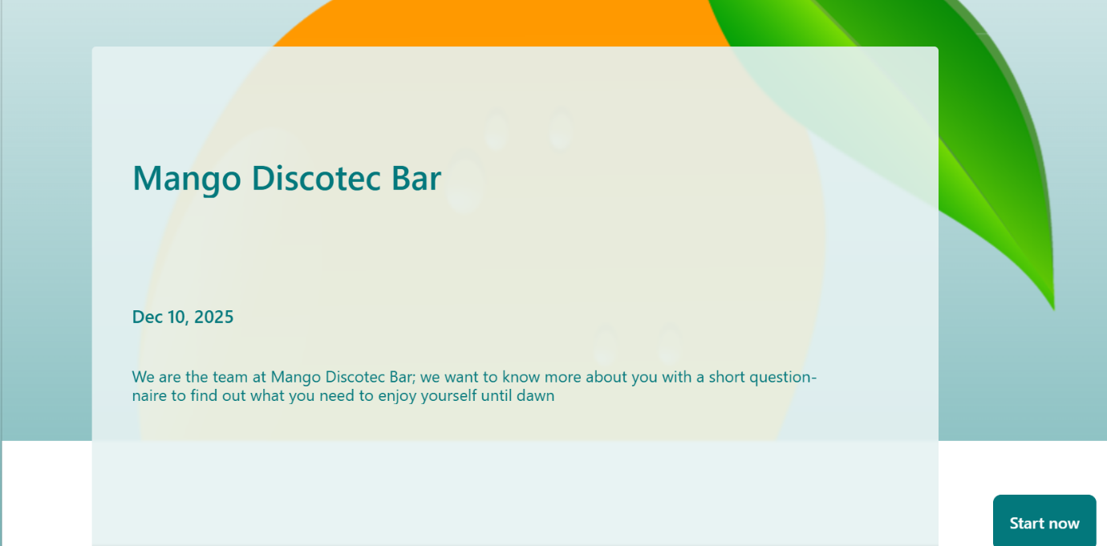

I was able to find many designs to give me an idea to support me in developing my questionnaire and obtaining the necessary information that I can use in my business idea (Brace I. 2008).
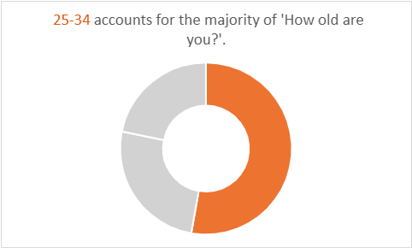

The result of my questionnaire was that the people surveyed are mostly under 30 years old, and that, based on the population to whom I presented the questionnaire, they prefer a place to enjoy nightlife entertainment with a Latin/Tropical atmosphere; I also realized that the type of music they prefer is POP and REGGAETON.

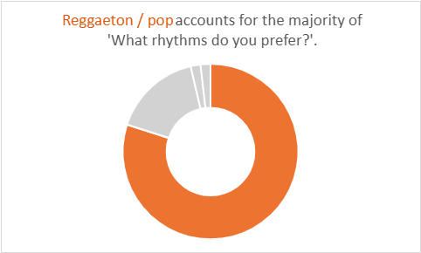
Taking into account the results of my questionnaire, I have a clearer idea of ​​how to approach my nightclub concept. Based on the information I gathered, I decided to develop my business idea: a nightclub with a Latin atmosphere, featuring pop and Latin music (Reggaeton, Salsa, Bachata, etc.), keeping in mind the factors that contribute to a successful business (Morris, M. 2011).

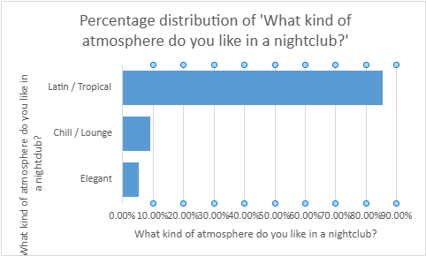

We conducted a survey with 100 people living in Cardiff in groups of friends and Hispanic communities. to find out what people prefer when it comes to nightlife entertainment. To get the most responses in a short time, we gave a small reward to the respondents (a shot of tequila), because this is the easiest way to get answers (Carpenter F. 2023) .
As part of the process, after the questionnaire, I researched everything I could to promote my business, so I needed a website. For this, we need to see how the competition is doing on the web (Alistair L.2014).

Website:
In short, having a website is essential for business success in the digital age. It provides global visibility, creates a positive impression, generates leads and customers, facilitates market expansion, offers detailed information, and strengthens brand identity. Companies that invest in a high-quality website are better positioned to compete, grow, and thrive in the modern business environment (Possible Team, 2023).
After doing some research, I found that there are several ways to create a website, and I discovered that these are the 10 best Website Builders (Cybernews, 2025):
- WIX
- HOSTINGER
- IONOS
- SQUARESPACE
- SITE 123
- GoDaddy
- SHOPIFY
- ELEMENTOR
- BLUEHOST
- Network Solutions
I created my business website with the help of Webador, suggested by my colleagues at UWTSD, because it's a very easy-to-use platform and good for practicing at a reasonable price (£3 per month). Here is my website:
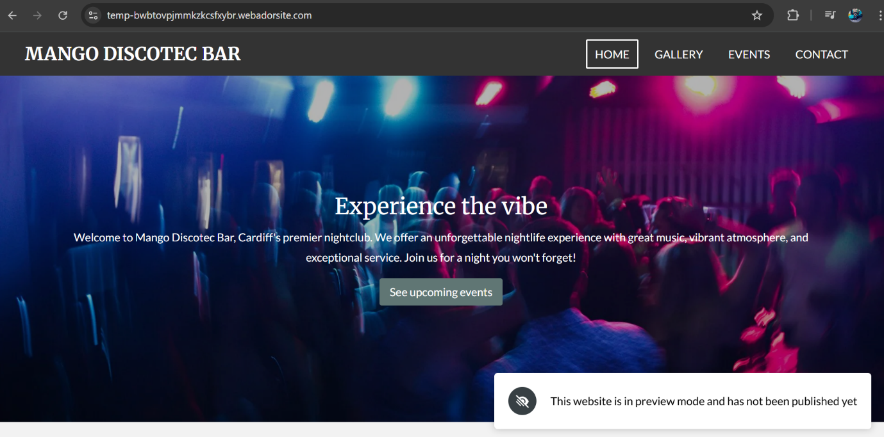

Events allow businesses to connect with their audience in a close, personal, and authentic way. Beyond a simple product or service, an event creates a memory that associates your brand with a positive experience. This gives customers more reasons to return and recommend you (Promotty, 2025); this is why I also promote events on the website.

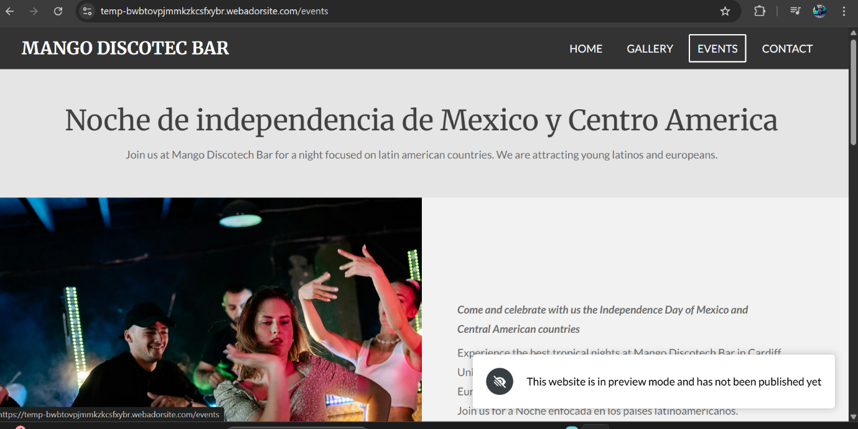

Logo and Marketing:

Besides our website, I also created a logo for the company. I did this with the help of Canva. I used an existing template as a reference for an empanada shop, then changed the images and wrote our company name.

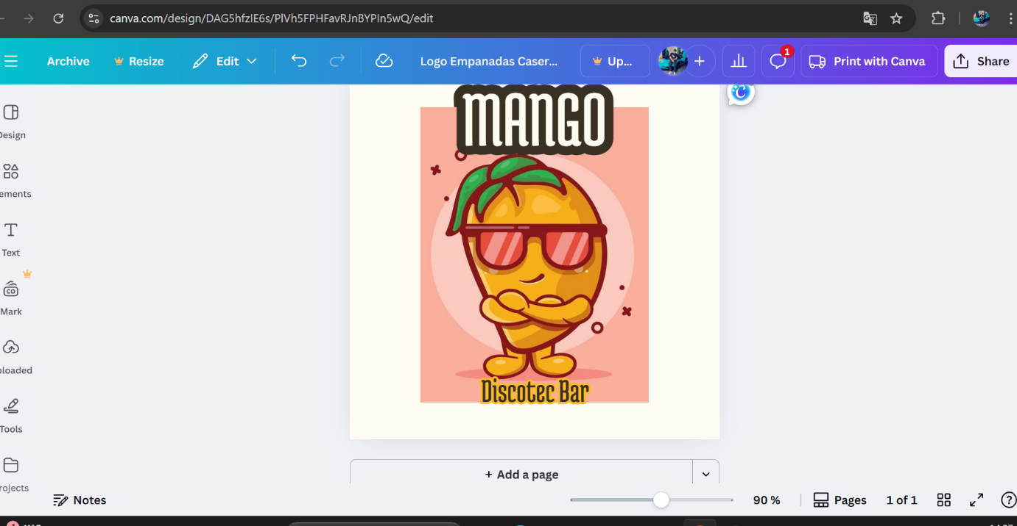

The logo is a fundamental part of a company; it is the first element that people see of a brand, and this can be decisive in whether a potential customer remembers the brand in the future. The logo is a great marketing tool and can convey the personality of the company. A well-designed logo can help us create a strong and consistent visual identity, which can help us gain the trust of customers (PMK. 2022).
Speaking of marketing, I decided to do more to promote our business to the public, such as banners, flyers, and expanding our presence on different social media platforms, because my goal is to attract young people, students, and local residents from the Cardiff area.

Below is a prototype of the flyers:
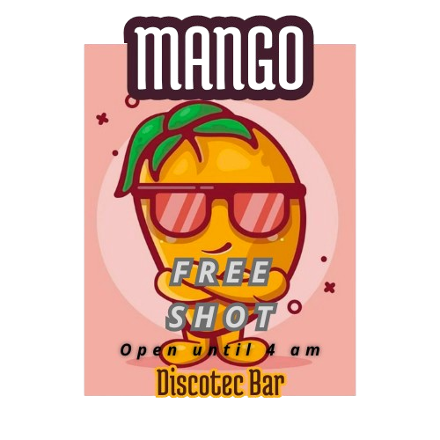
In the presentation we had in the classroom, I gave each of my colleagues a sample, as a sample of my marketing plan.
A flyer, also known as a brochure, is a printed medium used to convey information to people in a precise and visually appealing way. It is generally a small document that combines images, graphics, and text to communicate a clear and specific message. Flyers are commonly used to promote events, special offers, advertising campaigns, and to communicate the message of companies or brands. Flyers are a direct and visually impactful form of communication, allowing messages to be conveyed clearly and attractively (Ignacio S. 2024).
There are many ways to market to attract more customers, and the best part is that we can attract all kinds of people, not just one specific group. We can attract people who want to drink, people who want to dance, people looking for company, people who enjoy the music we offer, in addition to the people our business plan focuses on. And most importantly, if done well, people can remember it and return to our business.
Nightclub marketing stands out as one of the best ways to attract more customers and ensure repeat business at nightlife and entertainment venues (Suarez, 2025).

References:
- Subar, A.F. et al. (2001) ‘Is Shorter Always Better? Relative Importance of Questionnaire Length and Cognitive Ease on Response Rates and Data Quality for Two Dietary Questionnaires’, American journal of epidemiology, 153(4), pp. 404–409. Available at: https://doi.org/10.1093/aje/153.4.404.
- Saunders, M.N.K. and Lewis, P. (2012) Doing research in business and management : an essential guide to planning your project. 1st ed. Harlow, England: Financial Times Prentice Hall.
- Brace, I. (2008) Questionnaire design : how to plan, structure and write survey material for effective market research. 2nd ed. London ; Kogan Page.
- Morris, M.J. (2011) Starting a successful business : choose a business, plan your business, manage operations. 7th ed. London ; Kogan Page.
- Jeffrey Carpenter (2023) Behaviorally-Validated Warm Glow Questionnaire. IZA - Institute of Labor Economics.
- Alistair Lane. (2014). Reasons why a small business should have a website. [Online]. Shopifi. Last Updated: 12 Oct 2014. Available at: https://www.shopify.com/es/blog/15617732-4-razones-por-las-que-un-pequeno-negocio-debe-tener-un-siti [Accessed 10 December 2025].
- Possible Team. (2023). The importance of a website for business success. [Online]. Possible. Last Updated: 24 Oct 2023. Available at: https://www.possibleinc.com/blog/la-importancia-de-una-pagina-web-para-el-exito-empresarial/#:~:text [Accessed 09 December 2025].
- Cybernews. (2025). Best Website Builders. [Online]. CYBERNEWS. Last Updated: 01 Dec 2025. Available at: https://uk.cybernews.com/lp/best-website-builders/?campaignId=22710211897&adgroupId=184539280250&adI [Accessed 10 December 2025].
- Evans, V. (2022) The FT Essential Guide to Writing a Business Plan. Third edition. Harlow, England: Pearson Education, Limited.
- Promotty. (2025). Events to build customer loyalty. [Online]. PROMOTTY. Last Updated: 12 Aug 2025. Available at: https://www.promotty.com/es/blog/eventos-para-fidelizar-clientes [Accessed 10 December 2025].
- PMK. (2022). The importance of the logo for companies and brands: its role in branding, marketing, and advertising. [Online]. PMK. Last Updated: 13 Dec 2022. Available at: https://www.puromarketing.com/146/211144/importancia-logotipo-para-empresas-marcas-papel-branding-ma [Accessed 10 December 2025].

- Ignacio Santiago. (2024). Qué Son Flyers De Marketing, Tipos, Ventajas y Consejos. [Online]. Ignasio Santiago. Last Updated: Dec 2024. Available at: https://ignaciosantiago.com/flyers-de-marketing/ [Accessed 11 December 2025].
- Pablo M. Suarez. (2025). 12 Marketing Strategies for Nightclubs and Discos. [Online]. SEONET. Last Updated: 01 March 2025. Available at: https://www.seonetdigital.com/es/blog/marketing-para-discotecas [Accessed 27 November 2025]

Importance of Excel in the digital era

Excel in the digital era
In this digital era, we have many tools to help us with our tasks and, in a way, with life itself. One of these tools, and one of the most complex, is Microsoft Excel.
We live in the digital age. Today, almost all accounting and production project information is compiled in extensive electronic spreadsheets, easily accessible to production managers, who can extract and analyze the data as needed. In every project, especially long-term production, IT, or manufacturing projects, thorough risk management is essential due to the inherent uncertainty from the planning stage to the final cost of the workflow (Demirova, S. and Antonov, A. 2023)
In the digital age, businesses rely on tools that allow them to organize, analyze, and present information efficiently. Among these, Microsoft Excel stands out for its versatility and functionality. It's not just a spreadsheet; it's a strategic tool that can transform how internal processes are managed, from administration to strategic decision-making. Mastering Excel isn't just a technical skill; it's a competitive advantage. Companies that leverage this tool gain greater control over their data, optimize resources, and reduce errors, thereby strengthening their market position.
Excel has become an indispensable tool for modern businesses. Its ability to manage data, analyze information, automate processes, and facilitate collaboration makes it a strategic ally that directly impacts the efficiency, productivity, and competitiveness of any organization (Claabe. 2025).
Some of the ways Excel can help us are:
- Efficient data management
- Analysis and visualization of information
- Process automation
- Collaboration and communication tool
- Customization according to the company's needs
- Support in strategic decision-making
- Training and skills development

Although Excel is often perceived as a standalone tool, its ability to integrate with more advanced solutions keeps it relevant. For example, it can connect with Business Intelligence tools like Power BI, import and export data from ERP and CRM systems, and interact with SQL databases. This means that even as businesses adopt more advanced solutions, Excel remains an essential bridge between enterprise systems and end users. People who need to manipulate data, create custom reports, or analyze information most often do so in Excel because of its familiarity and functionality (Widigital 2025).
Knowing the importance of Excel in business life, and its applicability even to personal life, it is necessary that we have access to this tool from an early age. Learning fraction in primary school can be helped using VBA for Microsoft excel in supporting the fraction subchapter so that it will be more interesting and easier to understand (Wijaya, T. 2020).
VBA stands for Visual Basic for Applications, a programming language derived from Microsoft's legendary Visual Basic, which is integrated into Microsoft Office applications like Excel. Thanks to VBA, we can write scripts, also called macros, that automate tasks, perform complex calculations, or customize the behavior and interface of spreadsheets or even the application itself. VBA's capabilities are vast, allowing for virtually anything you might need, making Excel capable of doing just about anything you could possibly require (Fernan G. 2025).
In the following example we can see how Microsoft Excel plays a fundamental role in data collection:
(Muh F. 2025) “Therefore, the aim of this study is to identify the impact of LMS on the development of pedagogical content knowledge (TPACK) and the digital skills of pre-service mathematics teachers. This mixed-methods study, with an exploratory approach, included 76 pre-service mathematics teachers (22 men, 54 women). Data were collected through questionnaires and interviews and subsequently compiled using Microsoft Excel and saved in CSV format. Then, data were analyzed with Jamovi software, version 2.4.8.0. Results show that digital skills significantly influence TPACK development (β = 0.63, p < 0.001), more than LMS use (β = 0.49, p < 0.001), with a combined explanatory power of 65% (R² = 0.65)”.
Below is my cash flow statement for a small business, which I created using a pre-existing template. After watching numerous videos and reading about Excel, I've used several examples, but I've also learned that for small businesses, saving time can be achieved by using templates, as they are a feature of this program designed to simplify procedures.

Conclusion:

The importance of Excel in this digital age is immense because it is a very comprehensive tool that allows us to manage our company's data, as well as its accounting and revenue.
Since I was in elementary school, I received Excel classes, but I had no idea of ​​everything we can do in this program.
Today, thanks to everything I've seen in this module, the exercises, and the examples, I realize that I need to learn as much as I can about Excel because, although it may not seem like it, it's a vast world with so many functions and automations that can be done through this program.
For most people, Excel is a powerful data processing tool. Through manual formula entry, chart creation, and the use of pivot tables, users can analyze and visualize data. However, this method requires mastery of Excel's functions and tools, and handling complex datasets can be time-consuming and laborious (Sally, 2025).

References:

- Demirova, S. and Antonov, A. (2023) ‘Accessible risk management using workflow simulation into Microsoft Excel’, E3S web of conferences, 389, p. 9006. Available at: https://doi.org/10.1051/e3sconf/202338909006.
- Claabe. (2025). Why is Excel an indispensable tool in modern businesses?. [Online]. Solucion Claabe. Last Updated: 24/Nov/2025. Available at: https://claabe.com.mx/por-que-excel-es-una-herramienta-indispensable-en-las-empresas-modernas/#:~:te [Accessed 12 December 2025].
- Widigital. (2025). Excel in the digital age: Reasons why it remains indispensable. [Online]. WIDIGITAL. Last Updated: 23/May/2025. Available at: https://widigital.es/excel-indispensable-era-digital/ [Accessed 12 December 2025].
- Wijaya, T.T. et al. (2020) ‘Using VBA for microsoft excel based on 6-questions cognitive theory in teaching fraction’, Journal of physics. Conference series, 1657(1), p. 12078. Available at: https://doi.org/10.1088/1742-6596/1657/1/012078.
- Fernan Garcia. (2025). What is VBA and how does it work in Excel?. [Online]. Arsys. Last Updated: 17/06/2025. Available at: https://www.arsys.es/blog/que-es-vba-y-como-funciona-en-excel#:~:text=VBA%20son%20las%20siglas%20de, [Accessed 12 December 2025].
- Muh Fitrah et al. (2025) ‘Impact of Learning Management Systems and Digital Skills on TPACK Development Among Pre-service Mathematics Teachers’, Qubahan Academic Journal, 5(1). Available at: https://doi.org/10.48161/qaj.v5n1a1392.
- Sally. (2025). AI and Excel: Revolutionizing Data Processing. [Online]. Excelmatic. Last Updated: 16/May/2025. Available at: https://excelmatic.ai/es/blog/ai-and-excel/#heading-0 [Accessed 12 December 2025].

