European Emission Regulations – Will Stringent Emission Regulations Choke Automotive Industry Or Will OEMs Find Their Way Out?

Apr 26, 2016
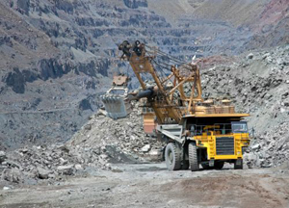Currently, automotive emissions are one of the leading contributors to air pollution. The different exhaust gases from an automobile tailpipe, such as NOx, CO2, and CO are primary reasons for deterioration of the atmosphere and environment and lead to respiratory and skin ailments. Emission regulations were designed to reduce tailpipe emissions to zero over the course of time. European emission regulations came into effect in 1992, with the latest being Euro 6 regulations in effect from September 2015.
Euro 7 Emission Norms – 2020 CO2 Goals
Euro 7 emission norms are expected to be implemented in 2020, with a CO2 emission target of 95 grams per kilometer. The Euro 6 CO2 target of 130 gm/km was met by almost all of the original equipment manufacturers (OEMs) by 2014, and the fleet average emission of new cars in 2014 was 123.4 gm/km. OEMs have to tackle this 2020 target reduction in CO2 by 27% with a slew of technology adoptions and enhancements. The emission limits are based on the mass of the vehicle, using a limit value curve. The Euro 7 CO2 target has a phase-in period of one year that requires that 95% of the OEM cars be compliant by 2020, and by 2021 all cars have to be compliant to the limit value curve. By analyzing the technology adoption roadmaps of major OEMs, we can deduce that OEMs, such as PSA, Renault-Nissan, and Toyota will meet targets before 2020, while heavier OEMs, including Daimler and BMW, will have to introduce more ultra-low emission vehicles (ULEVs) and downsize and electrify their internal combustion (IC) engines to meet targets by 2020/2021. All 3 German OEMs analyzed by Frost & Sullivan will not be compliant in 2022 and, on average, will exceed their target by 3 to 5 gm/km in 2020/2021, while all Asian OEMs will comply with their targets by 2020 and average 2 to 3 gm/km of CO2 below their respective targets.
The majority of OEMs are working on lightening their powertrains as a 100 kg reduction in weight is expected to reduce CO2 emission by 8.5 gm for every 100 km. This has resulted in most OEMs downsizing and electrifying their powertrain portfolio from their existing portfolio without reducing the drivability factor.
OEMs that do not meet the targets by 2020/2021 will have to pay an excess emissions premium of €95 per every gram of CO2 exceedance. This has put all OEMs under tremendous pressure to achieve the target by 2020. The German OEMs are expected to pay over 1.5 to 2.0 billion euros as a fine due to existing technology roadmaps and the relative distance to their 2020 targets. The largest liability will be borne by VW group. This is going to add to vehicle costs and; hence, will be detrimental to sales.
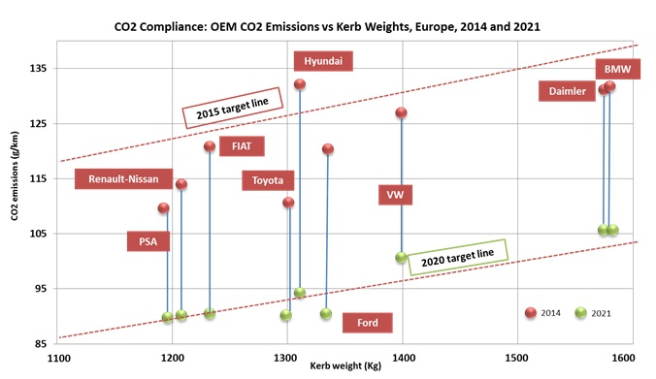
Diesel and Gasoline Technology Trends
The Euro 7 emissions norms, coupled with European city laws to levy additional tax on diesels, will have an impact on the diesel market share. According to Frost & Sullivan analysis, the diesel market share in Western Europe is likely to decline below 50% from an existing 53%. This is likely due to the additional costs of advanced particulate matter-controlling technologies such as selective catalytic reduction systems (SCRs) that are currently expensive, but prices are expected to decrease by 15% to 20% by 2020 with increased adoption rates. This, in conjunction with different European city policies to curb diesel cars from entering central business districts (CBDs) or exclusive ultra-low emission zones with additional taxes, will eventually push the diesel market to shrink. The 3 German OEMs are expected to reduce their dependency on diesel because of the introduction of newer plug–in and full hybrid models in their gasoline powertrain portfolio. Hybridization of their diesel counterparts may witness the same pace owing to the cost differences in hybridizing a diesel powertrain. OEMs will be implementing advanced energy recovery systems, advanced exhaust gas recirculation (EGR), and advanced after treatment in a majority of mass volume segments starting in 2017. The additional cost associated with advanced diesel powertrain is €400 to €900 over base engine.
The implementation of technologies, such as continuously variable valve technology (CVVT), gasoline direct injection (GDI), and downsizing, increases the fuel-saving potential of a gasoline engine over its predecessor by 20% to 25%. The difference in fuel savings is close to 15% over an advanced diesel DI engine. Almost all OEMs are working on introducing downsized engines with GDI and CVVT in every car segment by 2018. This, coupled with technologies such as start stop, lean burn strategy, and advanced transmissions (CVT and DCT), is viewed as helping OEMs reach their 2020 CO2 targets. The additional cost associated with downsizing is approximately €1,700 to €2,000 over its ICE counterparts.
Powertrain Electrification
Powertrain electrification is one of the most important strategies of every OEM in achieving the long-term goal of carbon neutral mobility. OEMs, such as BMW and Renault-Nissan, are using a strategy of having BEVs and eREVs in their portfolio to help them reach their target, while other OEMs, including Daimler and Toyota, have PHEVs and full hybrids to help them achieve the 2020 target. Every OEM is working on powertrain electrification as a main strategy to achieve their CO2 targets, irrespective of the vehicle segment and volume. Frost & Sullivan analysis shows that an OEM with 120 g/km average CO2 emissions could cut down by 8 to 10 g/km by 2020-2021 through electrification alone using the right mix of PHEV, FHEV, and BEV in their fleet. The lack of charging models will keep the uptake of PHEVs and BEVs low in the medium term. By 2020, PHEV and BEV are expected to sell a little more than 600,000 units.
OEMs with ULEV qualify for additional incentives called super credit. Currently, each ULEV is counted as 1.5 cars; this will be revised to be equivalent to 2 cars in 2020, and gradually reduced to 1 car by 2023. The additional cost of hybridizing an existing powertrain is €1,800 to €4,400.
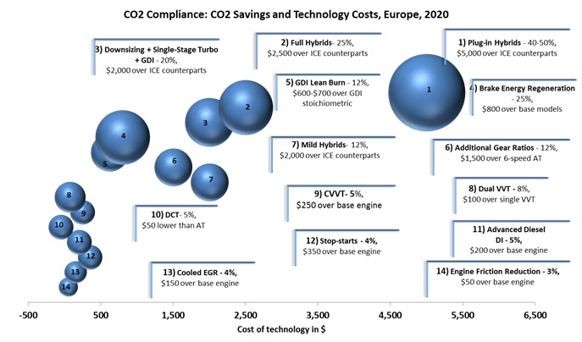

Conclusion
Expansion of lower emission segments and judicial use of powertrain lightweighting and electrification will be indispensable for all OEMs for CO2 compliance towards 2020-2021. While measures will be taken in countries such as France and UK to decrease the number of diesel vehicles on the road, the diesel market share will see a marginal decline from 53% in 2015 to approximately 50% in 2020.

