Supporting Handout
Introduction
Due to the globalised economy, marketing expansion from the west to the east is becoming more and more strategic for business organisations (Sahin and Ergin, 2016). To develop a company on a global scale, international communication is the most important technique to be acquired to communicate with overseas partners. At this stage, a Multi-National Company (MNC), Jewellery Retail Group, aims to expand its market to Asia. Our consulting company has been acquired to guide this market expansion. We are going to offer a comprehensive guidance by evaluating relationship building critically. Therefore, this report intends to tackle the following elements: cultural differences, product strategy, skills of international communication, relationship building and gift giving.
Cultural differences
In general, the key cultural differences are generated by Hofstede’s cultural dimension by purposing a framework of cross-cultural communication between countries. It can also be argued that society’s culture and values can be presented by using this framework. Hofstede purposes six dimensions including “Power Distance” ,”Individualism”, “Masculinity”, “Uncertainty Avoidance”, “Long Term Orientation” and “Indulgence” to analyse cultural differences. At this stage, for Jewellery Retail Group who desires to expand its market into Asia, a provisional cultural dimension has to be depicted to analyse the actual differences for international communication.
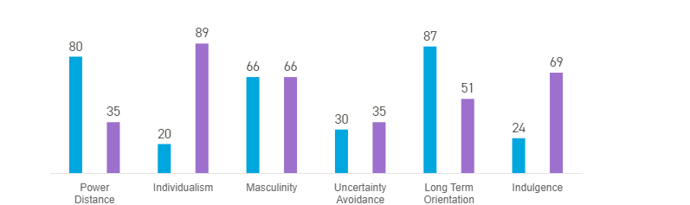
=East Asia =Western Countries
Figure 1: cultural differences between the West and the East
Firstly, the power distance in the west obviously differs from the west significantly. To explain more, the factor of power distance aims to evaluate the power distance between the least powerful group with the most powerful group in a business organisation (Hofstede, 2011). The other vital difference is based on individualism, 20 versus 89, mainly refers to the extent to the people in a society integrated as a group. Therefore, people in the east countries are normally tending to group together. According to the dimension of long-term orientation, people in east Asia have usually emphasised on a specific “long-term plan” or “long-term development” comparing with people in the west (Hofstede and Rorso, 2018). The final difference between east and west is the factor of indulgence, west countries got 69 while east countries got 24 (Hofstede, 2011).
For those proposed differences between China (can be regarded as a representative of East Asia countries) and the UK, to analyse those factors, high power distance allows Chinese leadership enjoying greater power which will speed-up organisation’s decision-making process. However, this can be regarded as a dictatorship in a western view.
In addition, considering individualism versus collectivism, Asian country, South Korea for example, collectivism and corresponding group’s benefit will be placed a significantly higher ground comparing with western countries which only focus on individual’s benefit. This ideology can be applied in a company’s rewarding system. In some business organisations, performance and corresponding salaries will be evaluated on an individual basis in some western countries. In collectivism countries, this evaluation system can simulate individuals better by applying group based system.
Long-term versus short-term orientation is a determining element to decide long-term profit or short-term profit. For example, in Singapore, businessman emphasises on long-term profit. However, in short-term, those Asian businessmen can undertake certain amount of loss. This loss may present some threats on business’s survival.
Therefore, comparing Jewellery Retail Group with Asian companies on cultural dimension basis, there are four major divergences in terms of cultural differences. To mitigate those principal four factors will be the key method to communicate with Asian companies and potential partners in Asia (Stoneman, 1990).
Skills for international communication
Based on the cultural dimension theory, individualism, indulgence, power-distance and long-term orientation are four major differences. This theory is compatible with Hall’s theoretical framework which is purposed to measure how messages are exchanged among individuals in a particular society (David,2019). By referring to Hall's high-and low-context framework, within high-context society, communication highly depends on context (Hollenbeck, 2016). This concept refers that non-verbal communication is emphasised during a communication process (Piechota, 2017). There are many kinds of non-verbal communication including gestures, eye contact, body language and etc (Piechota, 2017). Therefore, within a high-context culture, business negotiators have to focus on their behaviours. Due to the cultural dimension theory (based on those mentioned factors), business negotiators should not show the opposite side of cultural dimension. For example, in Japan, to communicate with businessman from high-context culture, business negotiator should not express very explicit meaning within a communication. However, this method to communicate with partner may arise ambiguity.
For Jewellery Group, a western MNC, has normally engaged low-context communication method which only emphasises on verbal communication with local enterprises (Cavusgil et al., 2018). To mitigate cultural differences in those four aspects, cross-cultural communication presents the best method. Therefore, to meet the requirements in cross-cultural communication context, high-context culture has to be acknowledged at the first stage. Generally, a particular high-context culture, especially in China, people are relational, collectivist, intuitive and contemplative. Firstly, communicating with partners from high-context culture, business negotiators from Jewellery Group should not over emphasis on individualism emphasising on collectivism instead. On the other hand, during the communication process, indulgence and low power-distance should not be focused. Finally, due the cultural attribute, long-term orientation is other important aspect. People within high-context culture, China for example, are normally emphasising on long-term profit which ought to be proposed during communication.

Within the cross-cultural communication process, there are many potential failures and threats, especially between high-context culture and low-context culture. In the given situation, the business partnership between Jewellery Group and Asian partners should acknowledge those threats. Therefore, the skill of international communication should both acknowledge Hofstede’s cultural dimension theory and Hall’s high-context and low-context culture theory. Generally, to avoid conflict based on social hierarchy in high-context culture is the most important issue. For example, an American office director is assigned a similar position in Seoul within a same company. This American officer shows that he is extremely discomfort at the deference from his group members. He says that his unequal deference arises some potential breakdowns based on professionalism’s consideration. He argues that this unnecessary deference even during casual communication has wasting time and productivities. Eventually, this office has lost production and nearly broken down (Cavusgil et al., 2018).

Importance and benefits of relationship building
The cross-cultural communication from high-context to low-context culture is related to the relationship build between two companies. Based on Hall’s theory, members within high-context culture tend to focus on relationship more comparing with low-context culture. This statement can be endorsed by cultural cluster theory (see figure 2).
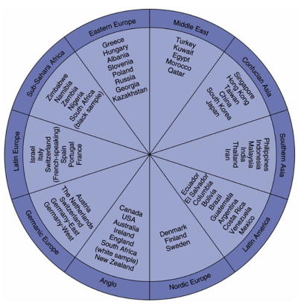
Figure 2: Cultural cluster theory, cultural mapping (Include-Empower, 2019)
Based on this cultural mapping theory which reflects distinct national attribute and cultural speciality for different countries, business relationship and corresponding social networks “Guanxi” are important to communicate with Asian partners in East Asia. To explain more, the boundary between social life and business in East Asia is blurred, formal relations are socially embedded (Jiang, 2012). “Guanxi” allows interaction between individuals to be formally applied on a corporate level. For example, an individual A is privately in favour of other individual B, on a corporate level, A tends to corporate with B based on A’s personal preference and private interpersonal ties. Therefore, “Guanxi” will be a most useful tool to corporate with Asian partners by building a private and international relationship (see table 1.0).
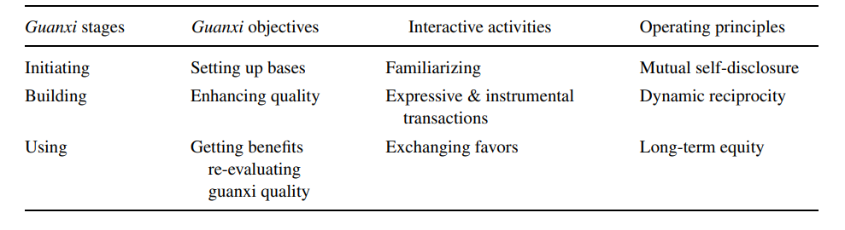
Table 1.0 a process of model of “Guanxi” building (Chen and Chen, 2004)
In China’s business context, “Guanxi” has some specific meanings. This is a term referring to the private relationship between businessmen. To be more specific, doing business with Chinese businessman, “Guanxi” will be a dynamic personalised networks of power (Jiang, 2012). Building relationship in eastern culture is equivalent to a foundation of Confucian doctrine of mutual commitments and reciprocity in a community. In business context, “Guanxi” also plays an essential role in relationship building. Therefore, it is important to build relationship with East Asian partner on “Guanxi” basis by referring two significant domains: a) government administrators can also form social ties with private business, b) it is vital to build social tiers with suppliers, buyers, competitors and other business mid-men (Chen and Chen, 2004). Due to the interrelated social networks, Jewellery Group’s potential business partners are also interrelated with other players in the market. Therefore, building relationship with potential partners is not an adequate method to expand market. Treating all players in the market with good “Guanxi” would be a suggestion to Jewellery Group. By having good “Guanxi” with local enterprises, secret information and highly specialised knowledge can be easily acquired to build Jewellery Group’s competency.
Potential failures and threats are somehow related to the broken down of “Guanxi”. The potential results are mostly negative for relationship building and profit maximisation. This can be exampled by engaging cases studies of Mattel, eBay, Google, Home Depot. Those companies are thrived in all over the world excepting China. This is due to they failed to localise their business by engaging “Guanxi” and relationship building. “It’s a lack of understanding of the legal and cultural environment that leads to most failures,” says Shawn Mahoney, managing director of the EP China consulting group. “The only difference between a success and failure in my experience is that people who are successful are more willing to talk and learn about how things work on the ground (Carlson, 2019).” Therefore, companies must obtain good flexibility and prepare to localise when they doing business globally.

Example and evidence
In 2018, D&G’s event in China market had been described as a “disaster” by mainstream western media. This is a representative example to justify the application of “Guanxi” in China. To warm up D&G’s fashion show in Shanghai, China, D&G released its short videos titled “Eating with Chopsticks” which arose huge humiliation against Chinese people. Only few hours later, many Chinese actors and singers who contracted with D&G showed on Weibo expressing they will not attend this fashion show (Stockholm, 2019).

“The home country is above every material gains. We are proud and confident of our culture and soul, China is the best”. Said by previous D&G’s contractor, a signer and actor Kerry Wang Junkai. He expresses that he will decline the contract and not attend the fashion show organised by D&G in Shanghai. In the next day, all D&G’s luxury products have been removed from shelves (online and offline stores) (Stockholm, 2019).

Reference
Carlson, B. (2019). Why big American businesses fail in China. [online] CNBC. Available at: https://www.cnbc.com/2013/09/26/why-big-american-businesses-fail-in-china.html [Accessed 2 Nov. 2019].
Cavusgil, S., Knight, G., Riesenberger, J., Rammal, H. and Rose, E. (2018). International business. 1st ed. London, pp.127-129.
Chen, X. and Chen, C. (2004). On the Intricacies of the Chinese Guanxi: A Process Model of Guanxi Development. Asia Pacific Journal of Management, 21(3), pp.305-324.
David (2019). Utilizing the U-Curve Model to Assess Cross-Cultural Training Programs for Low Context Expatriates Working in a High Context Culture. Journal of Business Diversity, 19(1).
Hofstede, G. (2011). Dimensionalizing Cultures: The Hofstede Model in Context. Online Readings in Psychology and Culture, 2(1).
Hofstede, G. and Rorso, P. (2018). A Brief Conversation on the Topic of Culture, Happiness and Subjective Well-Being. Journal of Intercultural Management and Ethics, 1(3), pp.39-41.
Hollenbeck, C. (2016). Female Leadership: Context and Culture MatterFemale Leadership: Context and Culture Matter. PsycCRITIQUES, 6161(1212).
Include-Empower (2019). Cultural Clusters: Mapping Cultural Distance | Include-Empower.Com. [online] Include-Empower.Com. Available at: https://cultureplusconsulting.com/2015/03/24/mapping-cultural-distance-cultural-clusters/ [Accessed 2 Nov. 2019].
Jiang (2012). Formation and Trend of Guanxi Practice and Guanxi Phenomenon. International Journal of Criminology and Sociology.
Piechota, G. (2017). Cultural Differences in Network Communication - Analysis on the Basis of Communication Behaviour in a High-Context and Low-Context Culture. Journal of Media Critiques, 3(11), pp.87-95.
Sahin, N. and Ergin, E. (2016). Consumers’ Attitudes towards Brand Extensions: An Analysis on Food and Textile Industries in Turkey. International Journal of Marketing Studies, 8(1), p.72.
Stockholm, M. (2019). China Crisis: What can we learn from the D&G disaster?. [online] Upthereeverywhere.com. Available at: https://www.upthereeverywhere.com/blog/how-to-avoid-a-crisis-like-what-happened-to-dg-in-china [Accessed 30 Oct. 2019].
Stoneman, P. (1990). Technological Diffusion with Horizontal Product Differentiation and Adaptation Costs. Economica, 57(225), p.49.

