Skills for the Workplace
Module Assignment Submission
Student Name: | Sarah Jones
Student Number: | 1911102
Module No: | BMSK4003
Module Title: | Digital Skills and Research Methods

Statement of Confirmation of Authenticity
By the act of making this submission, the student declares that this is the work of the student named above. The work has not, in whole or in part, been knowingly presented elsewhere for assessment, or where assessment has been built on a previous assessment, this has been identified. Where materials have been used from other sources it has been properly acknowledged. If this statement is untrue, the student acknowledges that an assessment offence has been committed.
Attention is drawn to the plagiarism and unfair practice policies of both the University and of ILM.

Table of Contents
Table of Contents
Part 1
Introduction 3
Evaluation of modern technologies used in the 21st century workplace 3,4,5
Technologies used in my workplace 5,6,7,8
Part 2 9
Social media in the workplace 9
How we use social media in my workplace 9,10
Using social media to enhance networking and career prospects 10
LinkedIn Profile 11,12,13,14
Conclusion 14
References 15
Appendix A 16
Appendix B 17

Introduction
In this assignment, I am going to be evaluating modern techniques used in the 21st century workplace and how they are used in my workplace. I intend to demonstrate how I used modern technologies to amend a process at work and evidencing the outcome of this process. I will also be identifying social media in the workplace and how we use it at the Royal College of Nursing. In this assignment, I will also be explaining how we can use social media to enhance networking and career prospects including screenshots from my LinkedIn profile.

Evaluation of modern technologies used in the 21st century workplace.

Several different technologies are used in the modern 21st century workplace. Computers, laptops and tablets are an important part of business. Laptop users can complete the same tasks on the move as they would in an office. There are some disadvantages of laptops and tablets. They present security issues, as they can easily get lost or stolen. When using a laptop or tablet a wireless network is required to access information. This would need to be a secure network, which is not always possible.

Mobile phones are vital in the 21st century workplace. They can improve productivity and customer service and keep businesses and employees connected. Mobiles are used to work remotely away from the office. There are some disadvantages which can include disruption to workflow resulting and a decrease in productivity. It can also compromise work-life balance, as you are available all hours of the day, which can result in receiving calls outside of working hours.

Many businesses are now using smart boards and white boards within their offices. Employees can project information from their desktop so that they can present to clients and employees at meetings. You no longer need to be in the same building for meetings as they have videoconferencing capabilities. The company would save money as they would not be spending on travel costs and paying for the employees travel time. It also means that document management is easier, and time consumed in meetings is reduced. However, like all technology sometimes there are disadvantages. The cost of a smart board/white board is significant and not all businesses are able to purchase.

Printers are a pivotal piece of equipment in today’s workplaces. There are many types of printers used in the 21st century. These can include 3D printers, all-in-one printers, inkjet printers and laser printers to name a few. These are not necessarily modern but I have included as I feel printers have improved immensely in the last 20 years. 3D printing has revolutionised the way we look at printers. Kellner, T. (2013) reports that an Indonesian man, Arie Kurniawan took part in an open invitation challenge hosted by GE. He had to redesign the bracket that attaches a jet engine to an aeroplane wing. Arie’s design beat over 1,000 other entries. He had no experience of industrial manufacturing and he used a new design technique taken from industrial 3D printing technology. The bracket he submitted passed every test for stress and durability and worked perfectly. They noted that his weighed 0.72 grams and the original weighed 4.48 pounds. This equates to 84% difference in weight. This shows how much printing technology has come.

Many businesses in the UK use Microsoft Office 365. This is a variety of software including Word, Excel, PowerPoint and Outlook. You also get access to One Drive cloud storage. Another benefit of Microsoft Office 365 is while connected to the internet you can also use it anywhere as it is entirely cloud-based. It also means that features are continually updating with the latest versions. There is no need for servers as it is run in the cloud, so document storage and emails are saved here instead. It gives access twenty-four hours a day by accessing it from your desktop, laptop, tablet and mobile phone.

If you are connected to your work every hour of the day, it can also have a negative impact on the employee. According to Perlow (2012) research on employees, she reveals a disadvantage of being connected to work 24/7. She also adds that employees that are able to shut down when at home may achieve greater cohesiveness with their colleagues. Perlow (2012) book suggests that it also affects the employees’ colleagues as well as the employee themselves. If we are connected twenty-four hours a day it takes time away from family and friends. A strong commitment to work could also lead to personal relationships suffering. Another issue is if your internet connection is down you are not able to work. Cloud storage can also be susceptible to data breaches via hacking meaning business data would be compromised.

Across the UK, many businesses use Computer Telephony Integration (CTI). A system that allows interaction between computers and telephone systems. This means that you are able to perform all call-related tasks through your desktop. It allows phones, computers, voicemail and mobile phones to communicate with each other. Due to the system being able to field a large volume of calls, it would be beneficial for companies that have call centres to use this type of system, which would also enhance productivity. CTI enables a link between client information and profiles so that their information is visible to the call handler. Everything is tracked on a dashboard display; it keeps a detailed account of each call that comes in which is stored so that you can go back and cross-reference the information.

Companies use several online payment systems throughout the UK. Some include World Pay, Shopify, PayPal and Sage Pay. These companies allow customers to pay for products or services through internet or devices using a payment gateway rather than paying cash in person. It reduces the risk of losing money and it eliminates the risks that come with carrying cash. You can make payments at any time which results in increased sales as they can take immediate payments from the customers. There are many ways that you can pay contactless including bankcards, smart phones and key fobs. However, there are some disadvantages to using contactless payments. If your card is stolen, it is easy to use as no identification is required for this payment option and not every business has contactless payments. Contactless payments, which are used through wallet apps on smart phones, are very common with the younger generation. I think this will be the future of banking and eventually you will not need cards or money. According to Lumsden, E, (2018) she confirms that individuals and companies can have access to payments, savings, and credit products without ever stepping into a bank branch. This is possible through digitization, which can essentially turn a smart phone into an all-in-one wallet, checkbook, bank branch, and accounting ledger. In another article Detrixhe, J. (2019) states that cash usage is shrinking in Britain faster than in most places. However, the UK does not have a plan in place for what happens next. Plastic payment cards are the most popular way to buy things in the UK and only about 30% of transactions use paper notes and coins. That figure is expected to decrease to about 10% in the next 15 years. 3,000 plus bank branches have been shut in Britain in the space of four years.

Wi-Fi is a system that allows computers, smart phones, or other devices to connect to the Internet or communicate wirelessly within different areas. Wi-Fi has become a crucial part of our personal and professional life. It is constantly improving our efficiency and our communication and the capabilities of Wi-Fi are endless.

Technologies used in my workplace
All employees at the Royal College of Nursing (RCN) are provided with Fujitsu desktop computers. We also have access to laptops when needed and these can be booked out for external meetings. We do not have access to tablets. The operating system we use is Microsoft Office 10. We can access Word, PowerPoint, Excel and Office. Servers are still used to store information and tapes are collected weekly. I approached our IT Department to ask why they were not using Windows 365 and whether there were any plans to change this in the future. I collected primary research from the RCN IT department, who advised me that it is something they are looking into as it would be helpful for remote users to access information and stop using servers altogether. IT has submitted a business plan and is hopeful it will be implemented in 2022.

We also use a telephone system called Lync Accountant, which is used alongside Skype for business. We also have access to mobile phones if needed. The calls are monitored and logged. Wi-Fi is available to all staff and visitors that enter the building. They are required to input their email addresses to gain access.

We have recently had two smart boards provided for our meeting rooms. These have been a welcome addition; previously we had a telephone pod and a projector. We found this outdated as we could not edit any information and only the people in the room could view it. We now hold meetings with several other offices around the UK. We have cut down on the costs of travel and saved the employee on time travelling to the office.

We no longer use landlines, so all calls are computer based. We also use a CRM system that has the entire client’s information stored. It is synced with Lync so when a call comes in if the number relates to a client’s account it is loaded on screen automatically. This saves the client time, as they do not need to be on hold for a long period while we search for their details.

At the Royal College of Nursing, we are now not able to accept cash. We have an online payment system set up so that members can pay for courses themselves. As I work on reception, I have spoken with several first-year students that had come into the office to join the RCN. They confirmed that they wanted a quick and easy process for joining rather than having the long drawn out process of attending in person to complete forms. I researched the way that students pay at student recruitment events and realised that many student nurses were leaving without joining, as they did not want to hang around and complete forms after they had heard a half hour presentation. I was surprised to see there was no quick option offered. I spoke with my manager about creating a quick link to an online membership page where the student nurses could join without having to complete paperwork in person. From my findings, they agreed that we should be offering this service. An online page was set up so that the nurses could have that link and complete in their own time. It also meant that they did not have to complete separate standing orders as they could do this online at the same time. I also raised the question about having a QR-code that would link to the website page. Having completed primary research with the student nurses, I understood they wanted the quickest option possible. I then researched if all phones were compatible with QR-codes. I found out that all smart phones are compatible with QR-codes. I approached my manager to ask if I could give the student nurses a quick questionnaire at the next recruitment event to find out if they used smart phones and if they were familiar with using QR-codes. I asked seventy student nurses attending the recruitment event if they owned a smart phone and if they were familiar with QR-codes. Please see pie charts below for results.

I presented my findings to my manager with an example of a QR-code for her to try. My manager shared the information with the Welsh Management Team, and they agreed that we should add this QR-code to our membership forms. This was implemented in May 2019 and then rolled out to every office in the UK in September.

This has made a big improvement in membership numbers in Wales. The evidence below shows an increase in student members since May 2019 (see appendix 1 for figures).

I also added a QR-code to the window at reception so that anyone passing or when the building was closed could get the link quickly and easily if needed. I was awarded a Special Recognition Award by the Royal College of Nursing for this piece of work.

The Royal College of Nursing (RCN) also has a main website, www.rcn.org.uk. Non-members can join and get information about what the RCN can do for them. They can get access to employment advice, pay advice, professional development and clinical advice. Members can also access the Library services. This is an online library where they can access journal articles online and view and order books. Members can also book for online meetings with librarians if they need help. Having this online service means that all members get access to library services even if they are not able to get into a library at one of our UK branches. Students can also find and book onto events and courses that we run throughout the year by using an online payment system so there is no need to speak to anyone and the payment is secure.

I feel that the RCN website is out-dated and not easy to navigate. The search option is not helpful at all and never gives the relevant information. After speaking with my manager, she confirmed there is a plan in place after receiving many complaints about the website to get it changed and updated to make it more user-friendly. She could not confirm when this will be changed. I have compared the RCN website with the Unison website. Unison is our main competitor. Their website front page is not as busy and just has the membership link and costs. Ours is very busy and does shows a small link to joining, it does however show you what we are currently doing for the nurses and I feel this shows that we care. We are a nurse's union whereas Unison have many members within the public service.

Staff at the RCN also have access to an intranet where we can access HR policy documents and forms. We can access OpenHR, which is an online system that we use to book/view annual leave. It also gives us information about what is happening around all the RCN offices and links us with other RCN offices around the UK.

The RCN uses a security system where passes are required to get you into the building and entry to each floor. This pass also gives staff access to printing. Staff can scan documents, copy and print via the machines on each floor. Staff can insert their login information if they forget their security card therefore only members of staff can use these printers.

At our office visitors, staff and contractors can all access free Wi-Fi via an online login system, however this is not secure so poses a risk to users.

Part 2
Social Media in the workplace
Many businesses in the UK are using social media in their workplace. Facebook seems to be the most popular in the UK. It is used for networking and according to the website Social Media, Results driven marketing (2019) (appendix 2) they confirmed Facebook had around 35,000,000 users in the UK. Companies can also advertise their products on Facebook and it has the biggest outreach. YouTube is also used for video uploading and viewing. It has around 23,000,000 users in the UK. Instagram is now very popular, and businesses are using it to advertise and share photos and videos. It has around 14,000,000 UK users. Businesses are also using Twitter, which is a micro-blogging platform. It has around 13,000,000 UK users. It is used for advertising. LinkedIn is also used by business in the UK and can be used for professional networking. It has around 20,000,000 users in the UK. It is a great way to market your business.

You can use social media to promote your business and tell customers about goods and services. It is a good way to find out what customers think of your business. It can attract new customers and build stronger relationships with existing customers. Social Media is normally free or low-cost and could target audiences with a broad reach. There are, however, risks with social media also. Wrong information can spread rapidly. According to Bizzi, L (2018) looks at organisational trends and realised that more companies are allowing employees to use social media to interact with each other. He says that if employees use social media to facilitate work, they are more likely to form new contacts outside the organisation and engage in job search behaviours. This can result in companies losing good staff to competition. On one hand this can have a negative impact on the business, but the same can be used for their business to also do the same, securing skilled employees from other organisations. I feel every organisation should create social media policies to guide employee content so that information is clear to the user.

How we use social media in my workplace
At the Royal College of Nursing (RCN) we use several different social media platforms. Facebook is used to get messages to members and keep them informed about what is going on in the RCN. Each office of the RCN has its own local page, and this is kept up to date by media teams within each office. We share media about events and company values which can help establish a brand and attract applicants and customers. I have noticed that our local Facebook page isn't always kept up to date. This does not help the members. I feel we need to have another member of the media team in Wales that just updates social media as I know the one employee on that team does not have the capacity to commit to this every day. It doesn’t look very professional and could have the potential to put members off joining. I also feel they could be using Facebook more to advertise our courses and events that we run. The cost would be minimal and the income we would generate would be greater. If the page is kept updated, then there would be more members using it which in turn would create more income from events. I have also noticed there are many unhappy members that like to complain on Facebook, so this is then visible to all members. This can have a negative impact on business so this needs to be dealt with in a professional manner to understand why and what they are unhappy about.

We also use Twitter at the RCN. This is to keep members informed about news and activities happening at the RCN. It also helps deliver customer service to the members. It allows direct two-way communication with our members. If we use it well it shows our business in a positive light. Twitter also helps with brand identity by communicating our brand ethos and personality. However, if this page is not kept up-to-date people will ignore it so it needs to be continually updated and relevant. As I stated above, I feel in 2019 we need to have a specialised employee that can continually update Twitter so that it draws members and non-members to the RCN as they can see what the RCN is doing for them. It is difficult to get seen on Twitter if there are not regular posts as there is so much traffic.

RCN Wales has recently added an Instagram page to their social media. This is becoming more popular with the younger generation. Nurses and student nurse members are using social media everyday unlike 20 years ago. The RCN has had to change their online presence in the last few years as the workforce is changing. The RCN has realised that many nurses that qualified over 20 years ago were unable to use computers. Currently every nurse that is coming through their training can use computers and smart phones, so they have had to keep up with that demand. We use Instagram to showcase what RCN Wales has been doing to help Nurses and what is to come. It gets nurses in the workplace talking. I have noticed we do not use it for advertising which I think is something that could be implemented as this would generate income for the RCN and show what RCN Wales is doing for their members. RCN Wales recently held an event at the Welsh Government. The RCN were asking all members to attend so that it would generate an impact that could not be ignored. The event was about safe staffing levels on wards so this would have a huge positive impact for the nurses if this bill was passed by Welsh Government. Altogether there were forty-seven attendees on the day. I feel this could have been double if they used social media correctly. I do not think this was advertised as much as it should have been. After checking Facebook, Twitter and Instagram I have noticed that 1 post a week was going out on all social media platforms. I feel this would not be enough given the amount of traffic on each platform daily, it could have easily been missed on their news feeds. If social media is used correctly it could have a big impact on business and if not adopted correctly can have the opposite effect. Nurse members want to know we are fighting for them and this is the easiest, quickest and most cost-effective way to show them that.

Using social media to enhance networking and career prospects
A social network called LinkedIn can be used to enhance networking and career prospects. It focuses on networking and career development. You can display your CV and search for jobs. It allows you to enhance your professional reputation by interacting with other people and posting updates. LinkedIn is like Facebook, based on connecting to friends/colleagues, sharing and liking content and instant messaging other users but it puts a professional spin on ideas from Facebook. Your profile becomes a CV and includes work experience, accomplishments, recommendations and referrals. Unlike Facebook, you can search and apply for jobs. Facebook is more of a personal page whereas LinkedIn is professional. Some content on your Facebook page can put employers off but LinkedIn is a professional profile that you would be happy for employers to view. It helps employees to develop connections with other employers. McLean, R. (2014) explains how he uses social media to build a professional network. They exposed him to ideas that would be applicable to him by just following certain pages on Facebook or people on Twitter. Mclean uses his Facebook page personally and professionally. I would look at separating the two, as there may be photos or personal information that you do not want everyone to see. You must make sure that you do not offend anyone with posts or comments. If your profile on Facebook is private, it stops prospective employers looking at information that may put them off hiring. According to a new CareerBuilder survey, Salm, L. (2017) seventy percent of employers use social media to screen candidates before hiring. That is a huge number so making sure your online information available is professional, is vital. Social media can be used as an opportunity to stand out and display your personality in a positive way. Salm, L. (2017) claims that forty-four percent of employers found content on social networking that made them hire the candidate. It is better to have some online presence as I feel it would raise more flags as an employer if I could not find you on social media at all.

LinkedIn Profile

Below is the main page of my profile on LinkedIn. It displays where I work and what job I have, where I am from and what school I attended. It also has a paragraph, which tells a bit about me, which I have kept professional unlike on Facebook or Instagram where I would be more casual about what content I add.

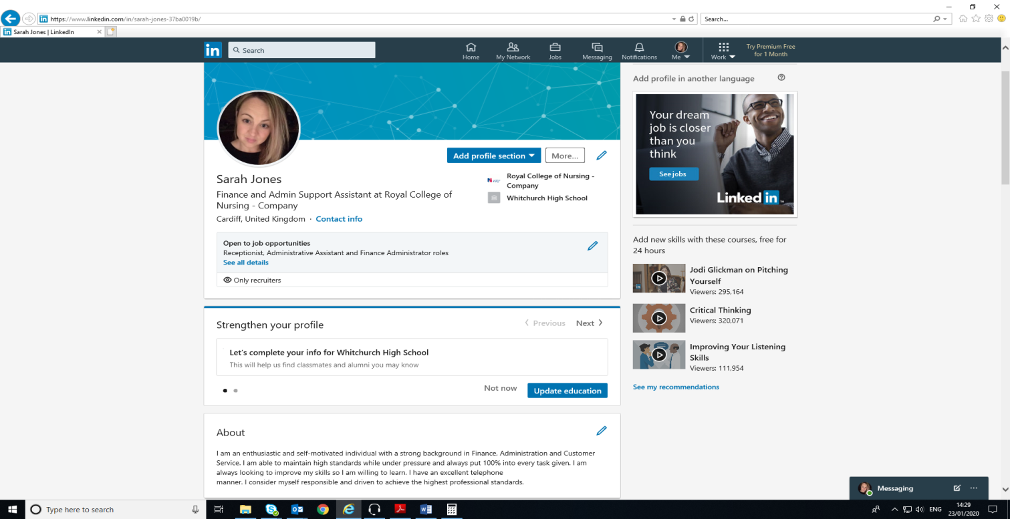

I have updated my LinkedIn account with my work experience. It lists all positions held from last to most recent so that it is easy for employers to read. We do not have this on Facebook, Instagram and Twitter. I would not want these details to be on these social network sites as they are not professional platforms. We can use LinkedIn to locate professional people unlike Facebook where we search for friends. People are ‘connected’ to business contacts on LinkedIn but Facebook friends have very strong personal connections. LinkedIn connections are typically professional people. Facebook connections tend to be people you know quite well or know of.
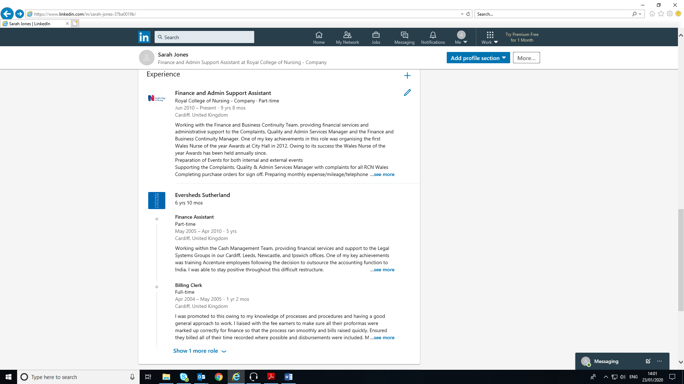

We can also search for specific jobs. There is a news feed that appears on the page, which companies and connections advertise and share information one would not post anything personal on LinkedIn relating to my family or pets etc. I would keep these posts for Facebook or Instagram.
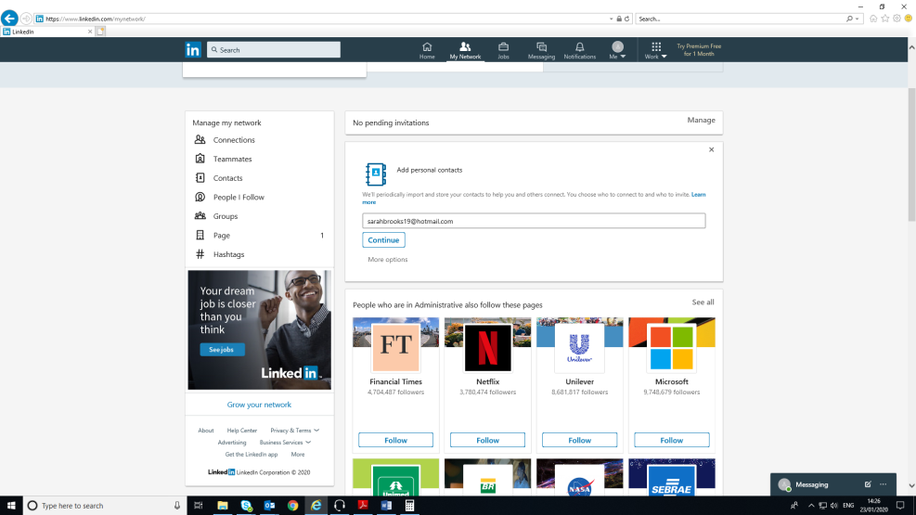
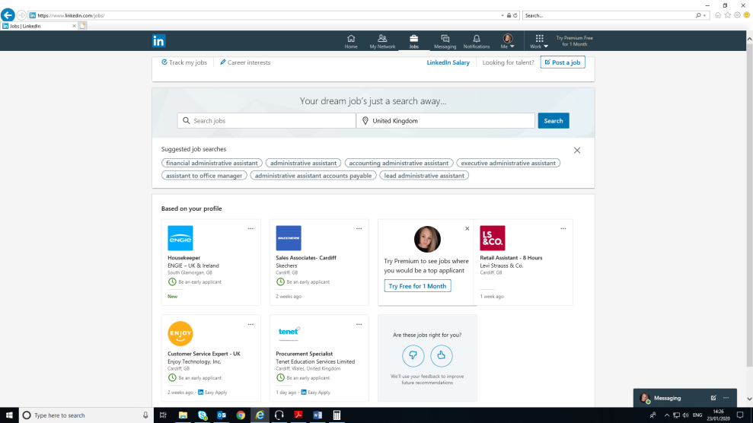
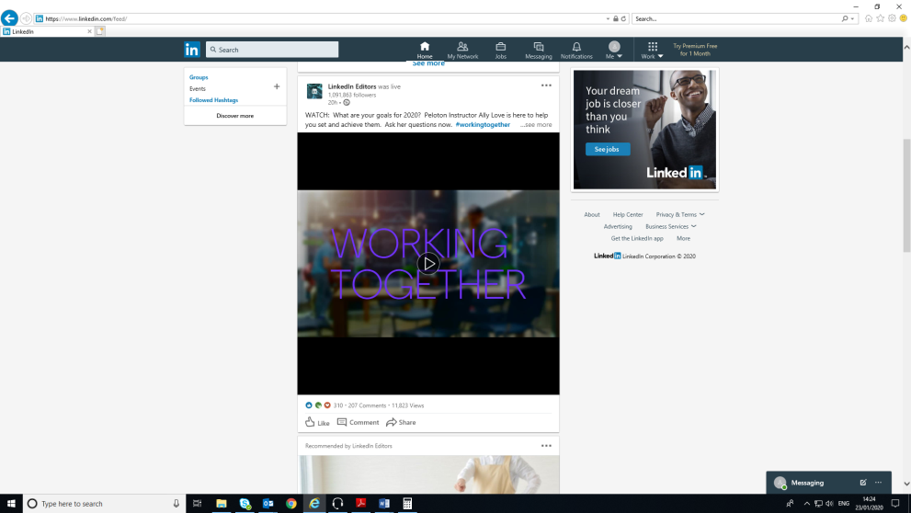
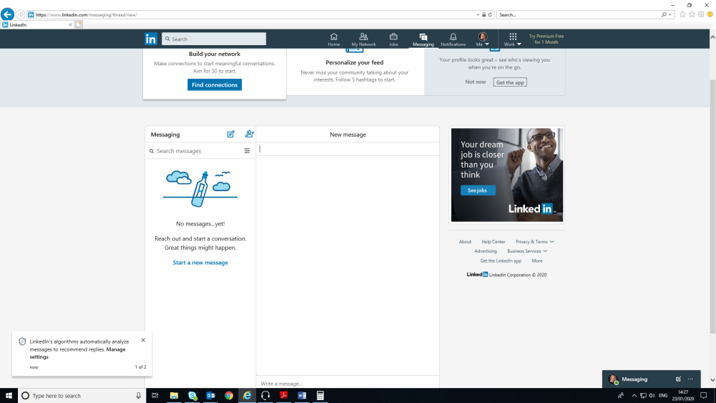

According to Morgan, D. and Chavez, A. (2017) article, they state that Facebook is not just for social use but can also be used for business. They said ‘some presenters believe that Facebook is strictly meant for playing and doing cool things. While business may accidently be generated on Facebook, most of your focus should be on LinkedIn where “real” business is conducted’. They argue that this is not true and that Facebook can be used for targeted marketing. Users are able to import email addresses to Facebook to create ads that will show to that specific list. Facebook can also segment the database so that marketing ads would reflect demographic and business specific ads. They say this then creates business leads, page views and likes. It seems to be cheaper to advertise on Facebook than LinkedIn. They claim that LinkedIn does not generate as many results as Facebook. Morgan, D and Chavez, A argue that you are more inclined to log into Facebook several times during a day but would not do this as much with LinkedIn. They imply that users are far more likely to comment, like and engage with company pages and ads than on LinkedIn. After completing my research, I feel this has changed my perception of using Facebook for business purposes. I would be far more inclined to use this platform to advertise business now, however; personally, I would still not use it for professional purposes, I would continue to use LinkedIn for this.

Conclusion
I have evaluated how modern technologies are used in the 21st century and have demonstrated how we use technology at the Royal College of Nursing. I have shown how I used modern technology to update a process for the RCN by creating a QR-code. I have learnt that technology and social media are a pivotal part of everyday life and if used correctly could benefit the user and businesses immensely. Having researched this topic and from reviewing the evidence, I would like to find out more detail about which social media platform generates more business results from specific marketing ads, LinkedIn or Facebook? According to Morgan, D. and Chavez, A. (2017) they suggest that Facebook creates more business, but this information is outdated.

References
Bizzi, Lorenzo. (2018) ‘the hidden problem of Facebook and social media at work: What if employees start searching for other jobs?‘Business Horizons, Jan 2018 Vol.61 (1), pp 23-33

Detrixhe, J. (2019) ‘The UK is going cashless and, like most of the world, has no plan for what happens next’ https://qz.com/1553642/britain-is-going-cashless-without-a-plan-for-what-happens-next/

https://join.unison.org.uk

https://www.rcn.org.uk/

https://social-media.co.uk/list-popular-social-networking-websites

Kellner, T. (2013) Jet Engine Bracket from Indonesia Wins 3D Printing Challenge https://www.ge.com/reports/post/77131235083/jet-engine-bracket-from-indonesia-wins-3d-printing/

Lumsden, E. (2018) ‘The Future Is Mobile: Financial Inclusion and Technological Innovation in the Emerging World’. Stanford Journal of Law, Business & Finance; Stanford Vol. 23, Iss. 1

McLean, R. (2014) ‘Facebook, Twitter and Pinterest, Oh My! Using Social Media as a Professional Development Tool’. The Agricultural Education Magazine; Henry Vol. 86, Iss. 4, (Jan/Feb 2014): 10-12.

Morgan, D. and Chavez, A. (2017) Facebook vs. LinkedIn for Lead Generation - Who Wins? SDM, Vol. 47, Iss. 7, p 38.

Perlow, L, A .(2012) Sleeping with your smartphone: How to break the 24/7 habit and change the way you work. Massachusetts. Harvard Business Review Press.

Salm, L. (2017) ‘70% of employers are snooping candidates’ social media profiles’. https://www.careerbuilder.com/advice/social-media-survey-2017

Appendix A



Appendix B

 | Description | UK Users | Total Users | Useful information
Facebook: | A social sharing networking site. | 35,130,000 | 2,417,000,000 | Highest traffic occurs between 1-3pm, however more engagement can be found between 7-8pm
YouTube: | The top website used for video uploading and viewing. | 23,000,000 | 1,900,000,000 | 1 billion hours of Youtube are watched daily
Instagram: | A photo and video sharing social networking. | 14,000,000 | 1,000,000,000 | 95 million posts are shared each day on Instagram
Twitter: | A Micro-blogging platform. | 13,000,000 | 883,000,000 | Year-on-Year the total ad engagement rate was up to 91%
Snapchat: | Send images and videos with a short life span over an app. | 16,200,000 | 600,000,000 | 528,000 Snaps are shared every minute
LinkedIn: | B2B platform for networking professionally. | 20,000,000 | 590,000,000 | More than 50% of all social traffic to B2B sites and blogs comes from LinkedIn
Tumblr: | A popular microblogging platform used to broadcast messages. | 9,000,000 | 550,000,000 | 45% of Tumblr's audience is people under the age of 35
Reddit: | An entertainment, social news and social networking website. | 6,600,000 | 330,000,000 | The average time a Reddit user spends on the site is 16 minutes
Pinterest: | A popular photo sharing website. | 10,300,000 | 266,000,000 | 50% of users have made a purchase after seeing a Promoted Pin on their feed
Vimeo: | A video uploading and sharing website. | 412,085 | 80,000,000 | Vimeo gets 715 million monthy video views

