University of Wales Trinity Saint David
Wales Institute of Science & Art



Evaluating the Effectiveness of Chosen
Maintenance Strategies for Dedicated Equipment:
ACMA6007
A

Ryan lewis
2318511
April 2026
Table of Contents
1. Introduction 2
2. Critical Review of Current Maintenance Practices 3
2.1 Overview of the Anodising Process Line 3
2.2 Current Maintenance Approach 5
2.3 Strengths of the Current Approach 6
2.4 Weaknesses and Limitations 6
2.4.1 Absence of Condition Monitoring 6
2.4.2 Reactive Response to Filtration Blockages 7
2.4.3 Lack of Electrical Infrastructure Monitoring 7
2.4.4 Maintainability Design Issues 8
2.4.5 Calibration Tolerance Gaps 8
2.5 Why Was This Approach Chosen? 8
3. Evaluation of Proposed Improvements 9
3.1 Installation of Flow Monitoring on Filtration Systems 9
3.1.1 Proposal Description 9
3.1.2 Theoretical Justification 9
3.1.3 Implementation Approach 9
3.1.4 Expected Benefits 10
3.2 Thermal Imaging of Rectifier Cables 10
3.2.1 Proposal Description 10
3.2.2 Theoretical Justification 10
3.2.3 Implementation Approach 10
3.2.4 Expected Benefits 10
3.3 Tighter Calibration Tolerances 11
3.3.1 Proposal Description 11
3.3.2 Theoretical Justification 11
3.3.3 Implementation Approach 11
3.3.4 Expected Benefits 11
3.4 Redesign of Push Button Control Panels 12
3.4.1 Proposal Description 12
3.4.2 Theoretical Justification 12
3.4.3 Implementation Approach 13
3.4.4 Expected Benefits 13
3.5 Electrical Condition Monitoring for Submerged Tank Heaters 13
3.5.1 Proposal Description 13
3.5.2 Theoretical Justification 13
3.5.3 Implementation Approach 14
3.5.4 Expected Benefits 14
3.6 Segmentation of the PPM Schedule 14
3.7 Integration into Revised PPM Schedule 15
4. Consideration of Costs and Resources 16
4.1 Direct Costs 16
4.2 Indirect Costs and Savings 17
4.3 Resource Requirements 17
4.3.1 Staff Training 17
4.3.2 Change Management Implications 18
5. Conclusions and Recommendations 18
5.1 Conclusions 18
5.2 Recommendations 19
Short-term (0–3 months) 19
Medium-term (3–12 months) 19
Long-term (12–24 months) 19
5.3 Final Remarks 19
6. References 20

Lists of tables and figures.
Figure 1: Layout of the anodising tanks 4
Figure 2: Process flow diagram of the anodising process. 5
Figure 3: Bathtub curve image (Ahmad and Kamaruddin, 2012) 7
Figure 4: Images from tank 8 and its degraded buttons. 12
Table 1: Revised copy of the PPM schedule for the process line. 16
Table 2:: Estimated costs and pay back periods 17

1. Introduction
Renishaw PLC is a global leader in metrology, healthcare, and additive manufacturing technologies (Renishaw, 2020). Its Miskin facility in Cardiff operates a complex anodising process line, a critical asset used to provide surface finishing for aluminium components. Maintaining this system is essential to ensure product quality, regulatory compliance, and safe operation (Renishaw, 2012).
This report evaluates the current preventative maintenance (PM) strategy and proposes targeted improvements based on condition monitoring and reliability engineering principles. Key areas of focus include flow monitoring of filtration systems, thermal inspection of electrical components, and improved maintainability through control panel redesign. These proposals align with modern maintenance approaches that prioritise data-driven decision-making to reduce unplanned downtime and improve asset performance (Gomaa, 2025; Afefy et al., 2019).
The report critically reviews existing practices, assesses proposed improvements, and considers their cost and implementation requirements before presenting practical recommendations. Given that downtime can cost up to £30,000 per day (Joynes, 2026), effective maintenance is essential to operational performance.

2. Critical Review of Current Maintenance Practices

2.1 Overview of the Anodising Process Line
The Renishaw anodising process line consists of multiple chemical tanks, each serving a specific function within the treatment process (Renishaw, 2012), as shown in

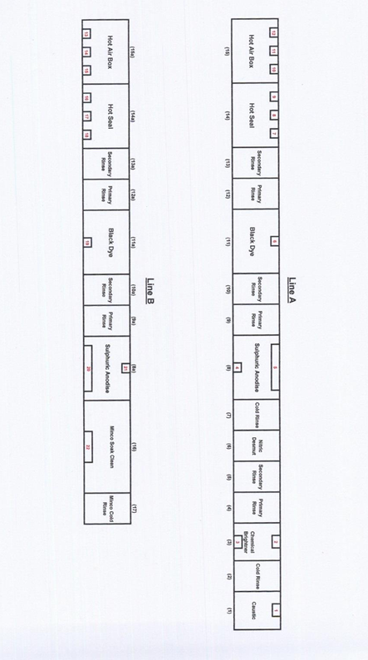

Figure 1: Layout of the anodising tanks
Each tank operates within controlled temperature ranges—from ambient up to 98°C—using heaters to maintain process conditions. The use of aggressive chemicals means that concentrations and parameters must be carefully managed to ensure product quality and safe operation.

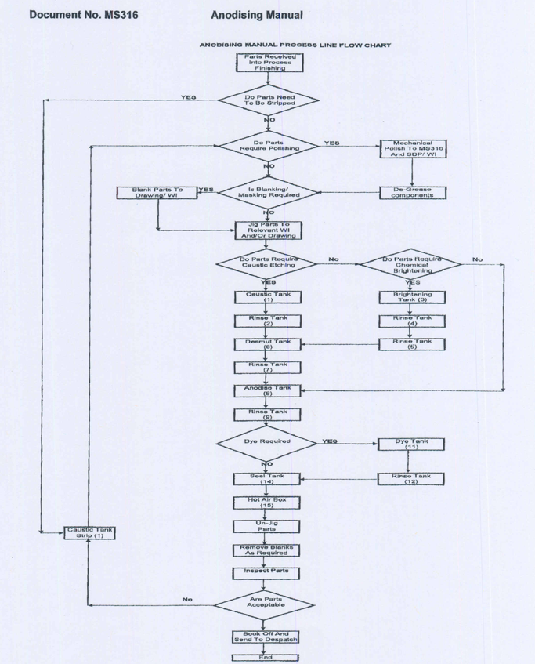

Figure 2: Process flow diagram of the anodising process.

2.2 Current Maintenance Approach
Maintenance of the process line is governed by a Planned Preventative Maintenance (PPM) schedule (ST01R) (see Appendix 1), based on fixed time intervals.
This reflects a traditional time-based maintenance (TBM) approach, where tasks are performed at scheduled intervals rather than in response to actual equipment condition (Syamsundar, Naikan and Wu, 2021).

2.3 Strengths of the Current Approach
The existing PM schedule has several strengths. Its structured format provides consistency and traceability, reducing the risk of missed tasks (Mobley, 2014). The inclusion of RCBO testing also demonstrates attention to electrical safety.
In addition, the requirement to consult operators recognises the value of frontline knowledge. This aligns with Total Productive Maintenance (TPM), where operators play an active role in routine inspection and are often best placed to identify early signs of deterioration (Ngoy and Israel, 2021).

2.4 Weaknesses and Limitations
Despite its strengths, the current maintenance approach has several important limitations.

2.4.1 Absence of Condition Monitoring
The most significant issue is the reliance on time-based maintenance without the use of condition monitoring. Condition-based maintenance instead uses real-time data to determine when intervention is required (Ahmad and Kamaruddin, 2012). Bloch and Geitner (1983, cited in Ahmad and Kamaruddin, 2012) highlight that most equipment failures precede detectable warning signs.
However, the current schedule does not monitor key parameters such as vibration, temperature, or flow rate, limiting the ability to predict failures in advance.

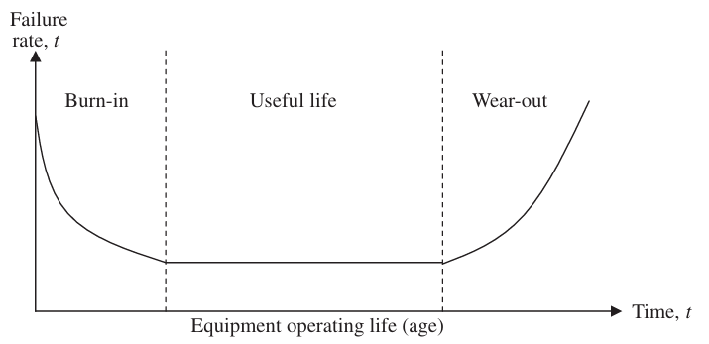

Figure 3: Bathtub curve image (Ahmad and Kamaruddin, 2012)
This is a missed opportunity. While the bathtub curve suggests some failures are age-related, only 15–20% actually follow this pattern, with the majority occurring randomly (Ahmad and Kamaruddin, 2012). As a result, relying solely on time-based intervals can lead to unnecessary maintenance or unexpected failures (Zhu et al., 2020).

2.4.2 Reactive Response to Filtration Blockages
The PPM schedule includes periodic cleaning of strainers (24 weeks) and replacement of feed pipes (48 weeks) (Bird, 2022), but does not monitor filter condition between intervals.
This means blockages are only identified once performance is affected or alarms are triggered, resulting in a reactive rather than proactive approach.

2.4.3 Lack of Electrical Infrastructure Monitoring
The process line depends heavily on electrical systems, including heaters, controllers, and rectifiers. While heater replacement is documented (Renishaw PLC, 2010), there is no method for predicting failure.
Similarly, rectifier cables receive only visual inspection, despite being critical to the anodising process. Degradation can increase resistance, leading to localised heating, failure, or fire risk.

2.4.4 Maintainability Design Issues
The push button control panels present a clear maintainability issue. Accessing electrical connections requires isolating and working under the tanks, resulting in significant downtime and safety constraints.
The fixed panel design makes even minor faults time-consuming to diagnose and repair. This contradicts Reliability Centred Maintenance (RCM) principles, which emphasise ease of access to reduce mean time to repair (MTTR) (Afefy et al., 2019). As noted by Aji and Uchendu (2025), minimising MTTR is essential for reducing downtime, and poor accessibility directly undermines this goal.

2.4.5 Calibration Tolerance Gaps
The process relies on pH electrodes calibrated monthly (Renishaw, 2012), with corrective action triggered at a 0.5 pH deviation. Given discharge limits of pH 6–10 (Renishaw, 2012), this tolerance may be too broad for effective control.
Tighter tolerances would allow earlier detection of electrode drift and reduce the risk of non-compliance.

2.5 Why Was This Approach Chosen?
The current time-based approach is likely a result of historical practice. Time-based maintenance was widely used before condition monitoring technologies became more accessible (Mobley, 2014).
Since the plant was commissioned in 2012, earlier limitations in available technology may have influenced this approach. In addition, regulatory pressures—such as legal requirements around effluent discharge (Water Industry Act 1991)—may have prioritised compliance at the output stage rather than proactive maintenance upstream.

3. Evaluation of Proposed Improvements

3.1 Installation of Flow Monitoring on Filtration Systems

3.1.1 Proposal Description
Install inline flow meters or differential pressure gauges on the outlet side of filters and strainers. These would allow periodic or continuous monitoring of flow, enabling trends to be tracked and gradual reductions caused by blockage to be identified early.

3.1.2 Theoretical Justification
As filters become clogged, differential pressure increases while flow rate decreases under constant pump conditions (Juanico et al., 1995; Ma et al., 2024; Singh et al., 2016). In condition-based maintenance, monitoring parameters must align with the failure mode—in this case, flow or pressure changes caused by blockage (Shanbhag et al., 2021).
Sampling frequency must be sufficient to capture system changes (Shannon, 1949). In practice, weekly operator readings would likely be adequate, although continuous monitoring would provide more reliable data and allow alarm thresholds to be set.

3.1.3 Implementation Approach
Low-cost mechanical flow meters (e.g., Key Instruments MR3000 Series) could be installed and recorded during routine inspections (RS Components, 2026). Alternatively, electronic flow transmitters (e.g., ICON Truflo UltraFlo 4000) could be integrated with the existing Mitsubishi FX2N PLC (Appendix 5) to enable real-time monitoring and alarms.
Costs range from approximately £100 to £1,500 per unit (Appendix 4), depending on the level of automation required.

3.1.4 Expected Benefits
- Early detection of filter blockage
- Condition-based filter replacement intervals
- Reduced unplanned downtime
- Improved fault diagnosis through trend data

3.2 Thermal Imaging of Rectifier Cables

3.2.1 Proposal Description
Introduce quarterly thermal imaging inspections of high-current DC rectifier cables supplying Tanks 8 and 8A. This would identify localised hot spots caused by increased resistance.

3.2.2 Theoretical Justification
Degraded or loose connections increase electrical resistance, generating heat that can be detected using thermography before failure occurs (Balakrishnan et al., 2022).
This supports a condition-based approach, enabling intervention before failure and improving mean time between failures (MTBF) (Maiorano et al., 2019).

3.2.3 Implementation Approach
A thermal imaging camera (e.g., Fluke or FLIR) would be required, with costs typically between £5,000 and £12,000 for a suitable mid-range model (Media, 2026; Appendix 6). Engineers could carry out inspections following basic training, with images stored and trended to identify deterioration over time.

3.2.4 Expected Benefits
- Reduced risk of electrical failure or fire
- Avoided production downtime
- Extended cable lifespan
- Improved compliance with electrical safety regulations

3.3 Tighter Calibration Tolerances

3.3.1 Proposal Description
Reduce the allowable difference between neutralisation tank pH meters from 0.5 pH to 0.2 pH, and increase calibration frequency from monthly to fortnightly.

3.3.2 Theoretical Justification
pH electrodes gradually degrade, causing measurement drift over time (Wiora and Wiora, 2018). A 0.5 pH tolerance may allow significant deviation before corrective action, increasing the risk of process instability or discharge non-compliance.
Tighter tolerances would allow earlier detection of drift and reduce the likelihood of alarms or process interruptions (Renishaw, 2010).

3.3.3 Implementation Approach
Existing Eutech Alpha pH 200 meters are capable of higher precision (±0.01 pH) (ManualMachine, 2026), so implementation would require only procedural changes and slightly increased operator involvement.

3.3.4 Expected Benefits
- Reduced risk of discharge consent violations
- Improved process stability
- Earlier detection of electrode degradation
- Demonstration of environmental compliance
This approach could also be extended to sump pump pH probes.

3.4 Redesign of Push Button Control Panels

3.4.1 Proposal Description
Replace fixed push button panels with removable units containing the same controls, designed for easy withdrawal from the tank cladding. This would provide safe and direct access to wiring connections.

3.4.2 Theoretical Justification
This proposal addresses maintainability—the ease with which equipment can be repaired. Push buttons are prone to failure due to chemical exposure and contamination, often becoming corroded and unresponsive
I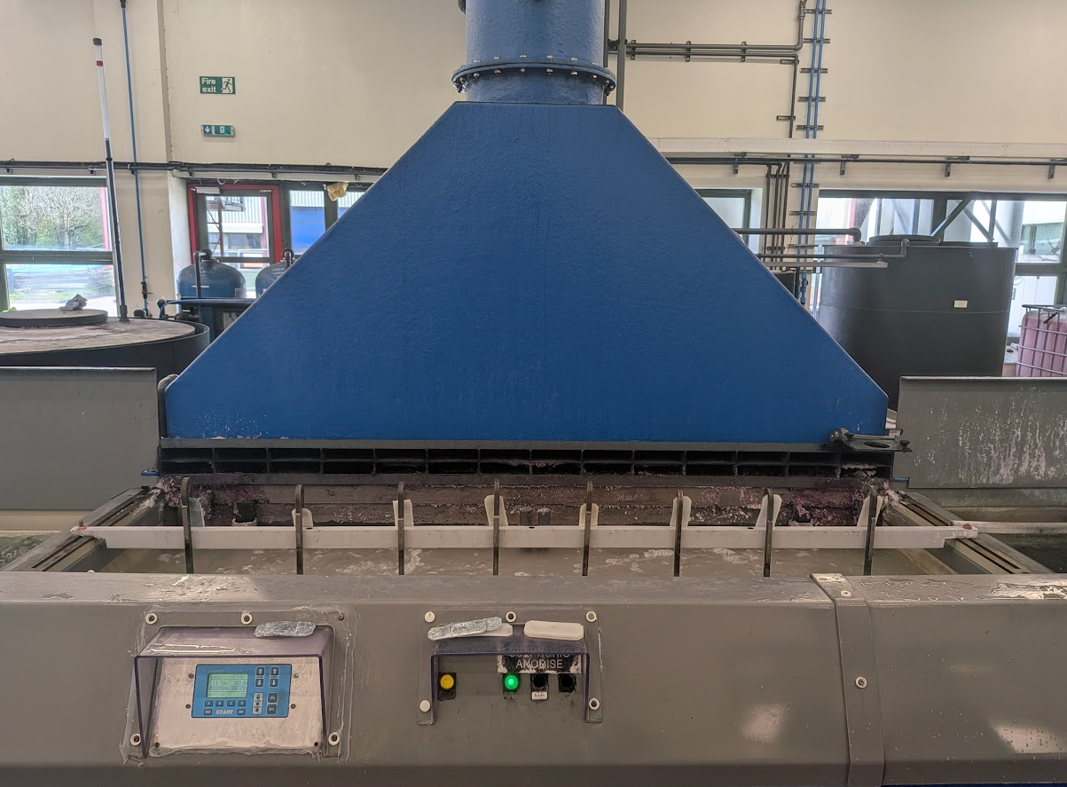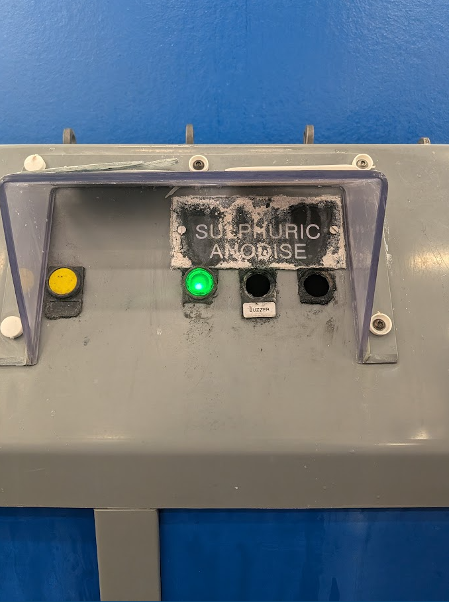

Figure 4: Images from tank 8 and its degraded buttons.
The current design significantly increases mean time to repair (MTTR), as accessing wiring requires isolating the system and working in restricted, unsafe conditions. MTTR includes diagnosis, repair, and reassembly time (Aguilar, 2022), all of which are extended by poor accessibility.
A removable design would simplify this process, allowing rapid replacement with minimal disruption. As availability is a function of MTBF and MTTR, reducing repair time directly improves operational performance (Alavian et al., 2019).

3.4.3 Implementation Approach
Removable control boxes would be designed and installed across all tanks. Each unit would include:
- Multi-pin connectors for quick disconnection
- PTFE seals for chemical protection
- Quick-release fixings
- Extended cable looms for easy withdrawal
This would require a one-time modification to existing wiring.

3.4.4 Expected Benefits
- Reduced MTTR (from hours to minutes)
- Improved engineer safety and working conditions
- Easier preventative replacement of worn components
- Potential integration of temperature probe wiring for improved accessibility

3.5 Electrical Condition Monitoring for Submerged Tank Heaters

3.5.1 Proposal Description
Introduce a condition-monitoring programme for tank heaters using resistance, insulation resistance, and current measurements. These tests can be performed without draining the tank, avoiding the current reactive approach (Ellis, 2008).

3.5.2 Theoretical Justification
Heating elements degrade over time, with resistance increasing prior to failure. Small changes in resistance can act as early warning indicators (Livina, Lewis and Wickham, 2024).
Similarly, reduced insulation resistance indicates moisture ingress (Shankar and Dave, 2021), while a drop in current draw suggests reduced heat output (Bell, 2026). Monitoring these trends enables prediction of failure and supports condition-based maintenance (Mählkvist, Ejenstam and Kyprianidis, 2024).

3.5.3 Implementation Approach
- Measure resistance monthly and trend against baseline values
- Conduct quarterly insulation (megger) tests
- Monitor current draw during operation using a clamp meter
Results can be logged in a simple spreadsheet to identify trends and plan replacements.

3.5.4 Expected Benefits
- Eliminates unnecessary tank drainage and cooling delays
- Reduces chemical waste
- Enables planned heater replacement
- Supports data-driven maintenance decisions (Gomaa, 2025)
This approach can also be applied to hot air box heaters.

3.6 Segmentation of the PPM Schedule
Restructuring the existing PPM schedule into smaller, area-based sections would improve maintenance effectiveness. Instead of completing all tasks at once, activities would be distributed across different areas and time periods.
This reduces time pressure and allows more thorough inspections. Rushed maintenance increases the likelihood of missed faults (Mobley, 2014), whereas a more focused approach improves detection of early-stage issues such as leaks or corrosion (Ahmad and Kamaruddin, 2012).
This change requires no additional resources but supports more consistent and effective maintenance, aligning with planned maintenance principles (Gomaa, 2025).

3.7 Integration into Revised PPM Schedule
The proposed improvements would be integrated into a new single area (Process line) PPM schedule as follows.
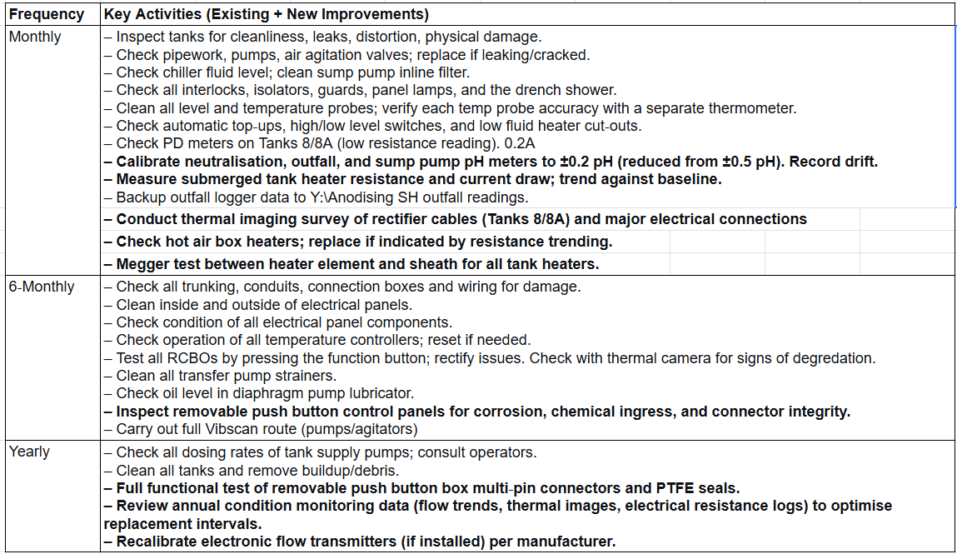

FTable 1: Revised copy of the PPM schedule for the process line.

4. Consideration of Costs and Resources

4.1 Direct Costs
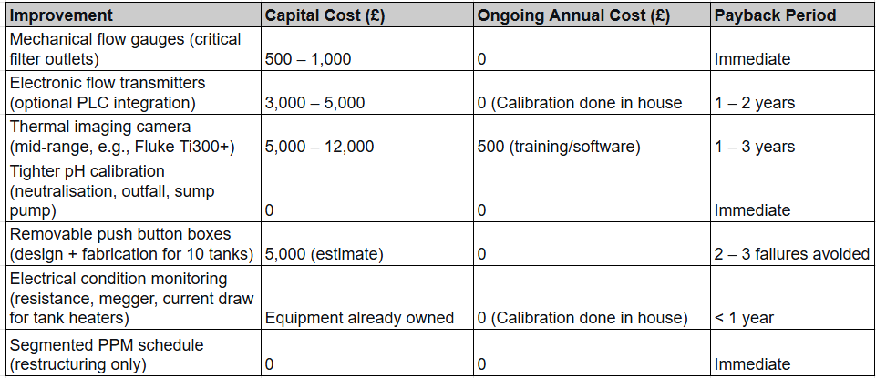

Table 2 Estimated costs and pay back periods

4.2 Indirect Costs and Savings
The maintenance literature consistently shows that condition-based approaches are more cost-effective than reactive or purely time-based strategies. Leoni et al. (2021) note that time-based maintenance can waste useful component life, whereas condition-based maintenance can reduce costs by up to 32.5%. Converting reactive tasks into planned, data-driven interventions therefore offers significant indirect savings.
For example, if the process line experiences two rectifier cable failures per year, each causing 8 hours of downtime at £1,205/hour (Section 1), this equates to an annual cost of £20,000. Implementing thermal imaging at an estimated cost of £6,500 (Fluke Ti300+; Appendix 5) could eliminate these failures, generating a net saving of approximately £13,500 in the first year alone.

4.3 Resource Requirements

4.3.1 Staff Training
- Thermography: One engineer trained from each shift trained in thermography. (Can then pass knowledge onto other engineers)
- Condition monitoring: Delivered in-house using existing materials
- pH calibration: No additional training required; procedural update only

4.3.2 Change Management Implications
Adopting condition monitoring represents a shift from time-based to evidence-based maintenance. Successful implementation depends on:
- Management support: Essential for approval of investment and resources
- Staff involvement: Engineers must understand the value of accurate, consistent data collection
- Data capability: Basic spreadsheet tracking may suffice initially, with scope to adopt dedicated software
Some resistance to change is likely, particularly if new practices are seen as additional workload. Clear communication of benefits and early involvement of maintenance staff can reduce this. As noted by Alfaro Solano and Preuß (2019), resistance should be treated as useful feedback rather than a barrier.

5. Conclusions and Recommendations

5.1 Conclusions
The current preventative maintenance strategy provides a structured foundation but lacks the condition monitoring and maintainability improvements now widely available. This analysis identified six key opportunities to enhance performance:
- Flow monitoring enables early detection of blockages, shifting from reactive to condition-based maintenance.
- Thermal imaging identifies cable faults before failure, reducing safety risks and downtime.
- Tighter pH calibration improves process stability and reduces the risk of non-compliance.
- Removable control panels reduce mean time to repair (MTTR) and improve safety.
- Electrical monitoring of heaters enables early fault detection without tank drainage.
- Segmented PPM scheduling improves inspection quality and reduces missed defects.
These improvements are practical, cost-effective, and aligned with reliability-centred maintenance (RCM) and condition-based maintenance (CBM) principles.

5.2 Recommendations

Short-term (0–3 months)
- Implement tighter pH calibration (0.2 pH, fortnightly)
- Install mechanical flow gauges at critical points and begin operator logging
- Start heater condition monitoring using existing tools
- Restructure the PPM schedule into area-based tasks
- Procure a thermal imaging camera and train one engineer, then record baseline thermal images.
- Prototype a removable push-button panel on a low-risk tank

Medium-term (3–12 months)
- Develop data trending and alarm thresholds
- Integrate condition-based tasks into the PPM schedule

Long-term (12–24 months)
- Roll out removable panels across all tanks
- Upgrade to electronic flow monitoring integrated with the PLC
- Extend condition monitoring to additional parameters
- Track performance using KPIs (MTBF, MTTR, planned maintenance %, unplanned stoppages)

5.3 Final Remarks
These improvements represent an incremental upgrade rather than a complete overhaul. By introducing targeted condition monitoring, improving maintainability, and refining existing practices, the process line can achieve greater reliability, reduced downtime, improved safety, and stronger environmental compliance.
As Moleda et al. (2023) highlight, maintenance strategy should be based on equipment criticality and available data, rather than a single fixed approach. Similarly, Farahani and Tohidi (2021) emphasise the need to integrate maintenance with production and quality decisions.
This report applies those principles in a practical context, presenting achievable actions that deliver measurable improvements in performance and cost.

6. References
Afefy, I., Mohib, A., El-Kamash, A. and Mahmoud, M. (2019) ‘A new framework of reliability centered maintenance’, Jordan Journal of Mechanical and Industrial Engineering, 13(3). Available at: https://jjmie.hu.edu.jo/vol-13-3/88-19-01.pdf (Accessed: 19 April 2026).
Ahmad, R. and Kamaruddin, S. (2012) ‘An overview of time-based and condition-based maintenance in industrial application’, Computers & Industrial Engineering, 63(1), pp. 135–149. Available at: :https://doi.org/10.1016/j.cie.2012.02.002. (Accessed: 19 April 2026).
Aji, J.O. and Uchendu, I. (2025) ‘Improving facility operations: A quantitative evaluation of MTBF, MTTR, and SLA targets’, European Journal of Innovative Studies and Sustainability, 1(3), pp. 247–261.Available at: doi.org/10.59324/ejiss.2025.1(3).20. (Accessed: 19 April 2026).
Alavian, P., Eun, Y., Liu, K., Meerkov, S.M. and Zhang, L. (2019) ‘The (α, β)-precise estimates of MTBF and MTTR: Definitions, calculations, and induced effect on machine efficiency evaluation’, IFAC-PapersOnLine, 52(13), pp. 1004–1009. Available at: https://doi.org/10.1016/j.ifacol.2019.11.326. (Accessed: 19 April 2026).
Alfaro Solano, G. and Preuß, M. (2019) An alternative approach on resistance to change and leadership and its resulting development of Kotter's change models. Master’s thesis. Linnaeus University. Available at: https://www.diva-portal.org/smash/get/diva2:1319367/FULLTEXT01.pdf (Accessed: 19 April 2026). (Accessed: 19 April 2026).
Balakrishnan, G.K., Yaw, C.T., Koh, S.P., Abedin, T., Raj, A.A., Tiong, S.K. and Chen, C.P. (2022) ‘A review of infrared thermography for condition-based monitoring in electrical energy: Applications and recommendations’, Energies, 15(16), p. 6000. Available at: https://doi.org/10.3390/en15166000. (Accessed: 19 April 2026).
Bell, I. (2026) Personal communication with R. Lewis, 10 April.
Bird, M. (2022) PPMST01-001 Renishaw PLC – Plant Maintenance. Internal report. Unpublished.
Eker, O.F., Camci, F., and Jennions, I.K. (2016), ‘Physics-based prognostic modelling of filter clogging phenomena, Mechanical Systems and Signal Processing, 75, pp. 395–412. Available at::https://doi.org/10.1016/j.ymssp.2015.12.011 .(Accessed: 19 April 2026).
Farahani, A. and Tohidi, H. (2021) ‘Integrated optimization of quality and maintenance: A literature review’, Computers & Industrial Engineering, 151, p. 106924. Available at: https://doi.org/10.1016/j.cie.2020.106924. (Accessed: 19 April 2026).
Gomaa, A.H. (2025) ‘Achieving maintenance excellence in manufacturing through integration of Lean Six Sigma and proactive approaches: A case study’, International Journal of Inventive Engineering and Sciences, 12(3), pp. 1–14. Available at: https://doi.org/10.35940/ijies.b1099.12030325. (Accessed: 19 April 2026).
Health and Safety Executive (2015) The Electricity at Work Regulations 1989: Guidance on Regulations. 3rd edn. London: HSE Books.
Instrumart (2026) ICON Truflo UltraFlo 4000 Series Ultrasonic Flow Meter. Available at: https://www.instrumart.com/products/42402/icon-truflo-ultraflo-4000-series-ultrasonic-flow-meter (Accessed: 19 April 2026).(Accessed: 19 April 2026).
Joynes, A. (2026) Personal communication with R. Lewis, 10 April.
Juanico, M., Azov, Y., Teltsch, B. and Shelef, G. (1995) ‘Effect of effluent addition to a freshwater reservoir on the filter clogging capacity of irrigation water’, Water Research, 29(7), pp. 1695–1702. Available at: https://doi.org/10.1016/0043-1354(94)00325-2 (Accessed: 19 April 2026).
Leoni, L., De Carlo, F., Paltrinieri, N., Sgarbossa, F. and BahooToroody, A. (2021) ‘On risk-based maintenance: A comprehensive review of three approaches to track the impact of consequence modelling for predicting maintenance actions’, Journal of Loss Prevention in the Process Industries, 72, 104555. Available at: https://www.sciencedirect.com/science/article/pii/S0950423021001637 (Accessed: 19 April 2026). (Accessed: 19 April 2026).
Livina, V.N., Lewis, A.P. and Wickham, M. (2020) ‘Tipping point analysis of electrical resistance data with early warning signals of failure for predictive maintenance’, Journal of Electronic Testing, 36(5), pp. 569–576. Available at: https://doi.org/10.1007/s10836-020-05899-w.(Accessed: 19 April 2026).
Mählkvist, S., Söderkvist Vermelin, W., Helander, T. and Kyprianidis, K. (2024) ‘Comparing feature and trajectory-based remaining useful life modelling of electrical resistance heating wires’, Annual Conference of the PHM Society, 16(1). Available at: https://doi.org/10.36001/phmconf.2024.v16i1.3913. (Accessed: 19 April 2026).
Maiorano, C. et al. (2019) ‘MTBF (metric that betrays folk)’, HAL. Available at: https://hal.science/hal-02965772 (Accessed: 19 April 2026).
ManualMachine (2026) Eutech Instruments Alpha pH 200 user manual. Available at: https://manualmachine.com/eutechinstruments/alphaph200/1112256-user-manual/ (Accessed: 17 April 2026).
Media, R. (2026) Best thermal imaging cameras for industrial use 2026. Available at: https://reliamag.com/guides/best-thermal-cameras-industrial-2026/ (Accessed: 19 April 2026).
Mobley, R.K. (2014) Maintenance Engineering Handbook. 7th edn. New York: McGraw-Hill.
Molęda, M., Małysiak-Mrozek, B., Ding, W., Sunderam, V. and Mrozek, D. (2023) ‘From corrective to predictive maintenance: A review of maintenance approaches for the power industry’, Sensors, 23(13), p. 5970. Available at: Researchhttps://www.researchgate.net/publication/372370311_From_Corrective_to_Predictive_Maintenance-A_Review_of_Maintenance_Approaches_for_the_Power_Industry/link/6806e694ded433155734f78f/download?_tp=eyJjb250ZXh0Ijp7ImZpcnN0UGFnZSI6InB1YmxpY2F0aW9uIiwicGFnZSI6InB1YmxpY2F0aW9uIn19Gate (Accessed: 19 April 2026).
Ngoy, K.R. and Israel, K. (2021) ‘The strategy of successful total productive maintenance (TPM): Implementation and benefits of TPM’, IJIRMPS, 9(6). Available at: https://d1wqtxts1xzle7.cloudfront.net (Accessed: 17 April 2026).
Ran, Y., Zhou, X., Lin, P., Wen, Y. and Deng, R. (2019) ‘A survey of predictive maintenance: Systems, purposes and approaches’, arXiv. Available at: https://arxiv.org/abs/1912.07383 (Accessed: 19 April 2026).
Renishaw PLC (2010) TRSP046 Renishaw anodising training notes. Internal document. Unpublished.
Renishaw plc (2020) About Renishaw. Available at: https://www.renishaw.com/en/about-renishaw--6432 (Accessed: 19 April 2026).
RS Components (2026a) Georg Fischer Signet 2551 Series magmeter flow sensor. Available at: https://uk.rs-online.com/web/p/flow-sensors/9010078 (Accessed: 19 April 2026).
RS Components (2026b) Key Instruments MR3000 Series variable area flow meter. Available at: https://uk.rs-online.com (Accessed: 19 April 2026).
RS Components (2026c) RS PRO paddle flow switch for liquid. Available at: https://uk.rs-online.com/web/p/flow-sensors/6134238 (Accessed: 19 April 2026).
Shanbhag, V.V., Meyer, T.J., Caspers, L. and Schlanbusch, R. (2021) ‘Failure monitoring and predictive maintenance of hydraulic cylinder: State-of-the-art review’, IEEE/ASME Transactions on Mechatronics, 26(6), pp. 3087–3103. Available at: https://doi.org/10.1109/tmech.2021.3053173. (Accessed: 19 April 2026).
Shankar, R. and Dave, S. (2021) Degradation and diagnostics of electrical machines. Master’s thesis. Chalmers University of Technology. Available at: https://odr.chalmers.se (Accessed: 19 April 2026).
Shannon, C.E. (1949) ‘Communication in the presence of noise’, Proceedings of the IRE, 37(1), pp. 10–21.
Syamsundar, A., Naikan, V.N.A. and Wu, S. (2021) ‘Estimating maintenance effectiveness of a repairable system under time-based preventive maintenance’, Computers & Industrial Engineering, 156, p. 107278.Available at: https://doi.org/10.1016/j.cie.2021.107278. (Accessed: 19 April 2026).
Szczap, J., Jung, S. and Pan, L. (2024) ‘Understanding the microscopic mechanism of clogging of both fibrous and mesh filters in flooded-bed wet scrubbers’, Fuel, 355, p. 129381. Available at: https://doi.org/10.1016/j.fuel.2023.129381.(Accessed: 19 April 2026).

Water Industry Act 1991. Available at: https://www.legislation.gov.uk/ukpga/1991/56/contents (Accessed: 17 April 2026).
Wiora, A. and Wiora, J. (2018) ‘Long-term laboratory tests of pH electrodes in industrial applications’, Sensors, 18(12), p. 4102. Available at: https://doi.org/10.3390/s18124102. (Accessed: 19 April 2026).

Appendices
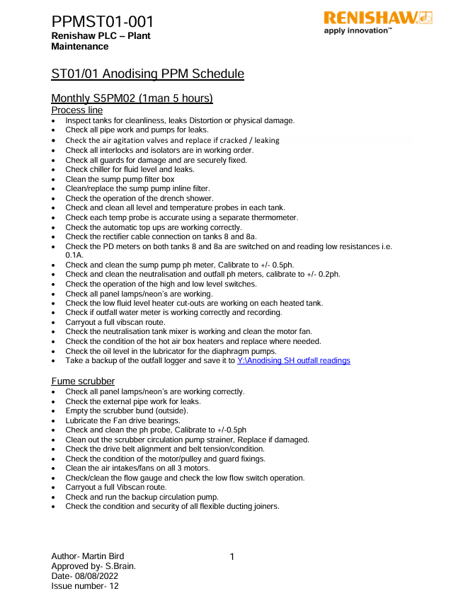
Appendix 1: Renishaw, anodising PPM Schedule
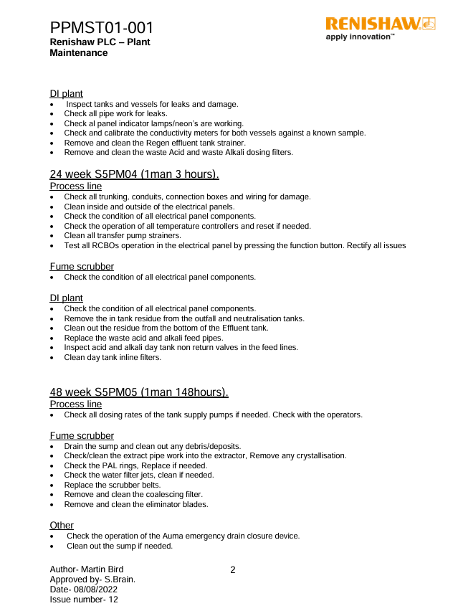
‌

Appendix 2: An extracted version of the relevant parts of the Anodising training notes which just include the heater change procedure.
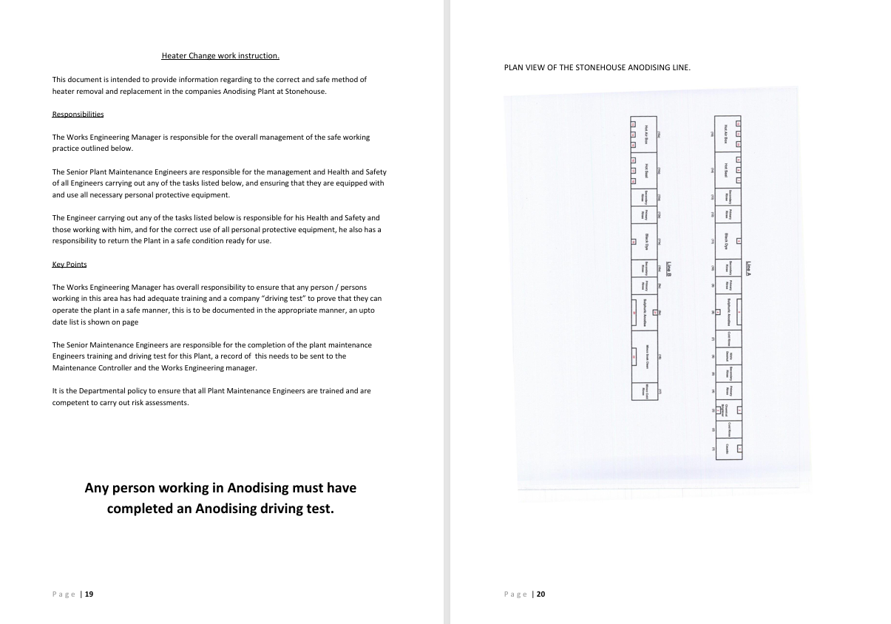
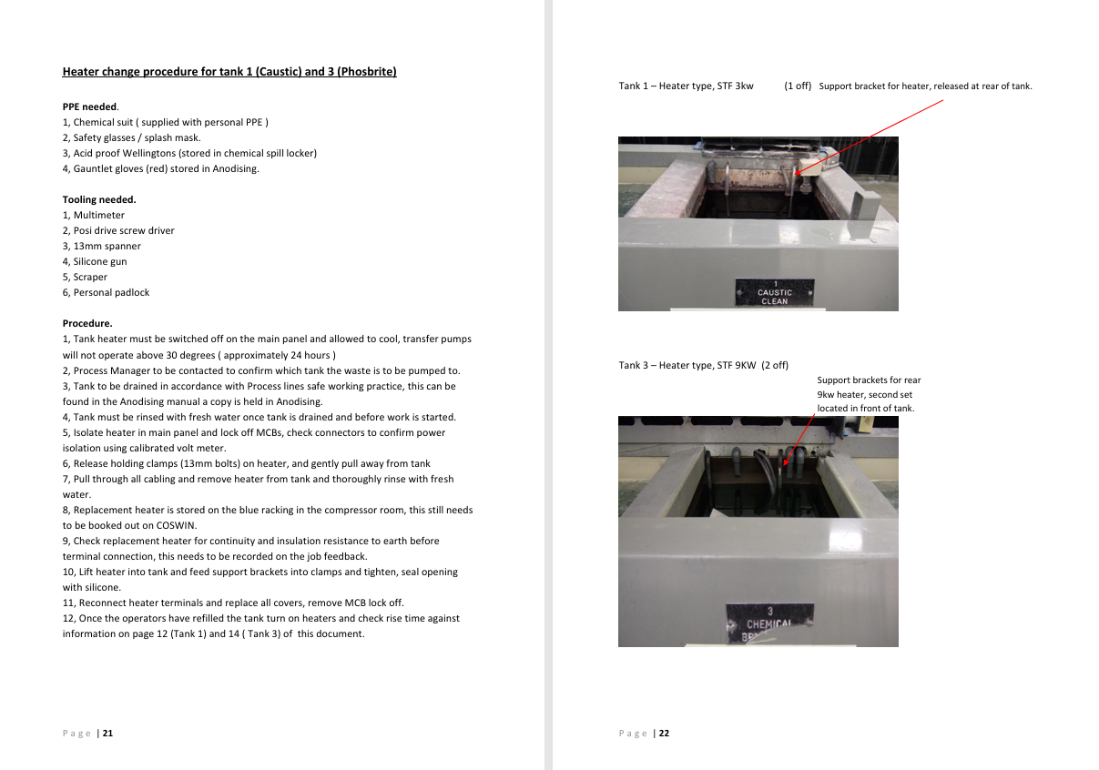
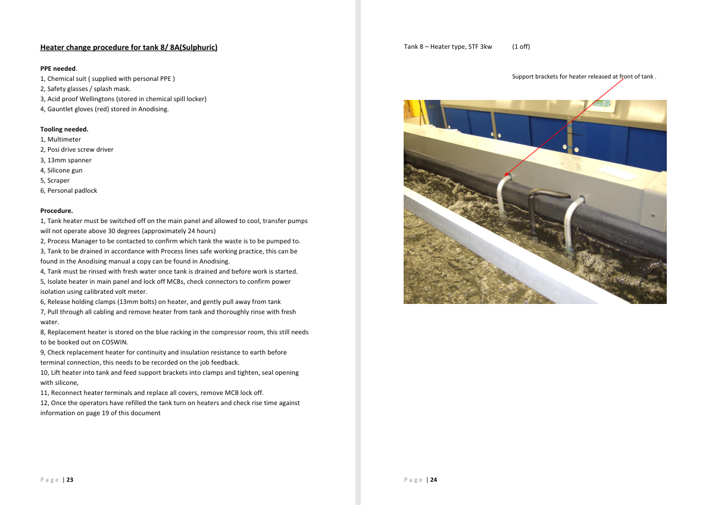
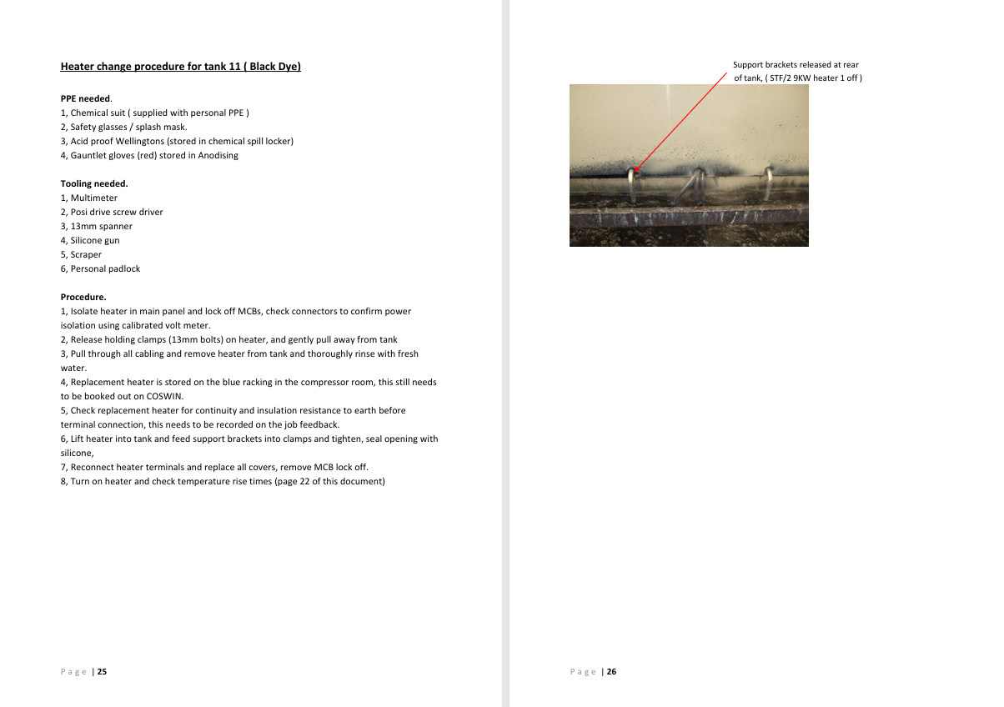
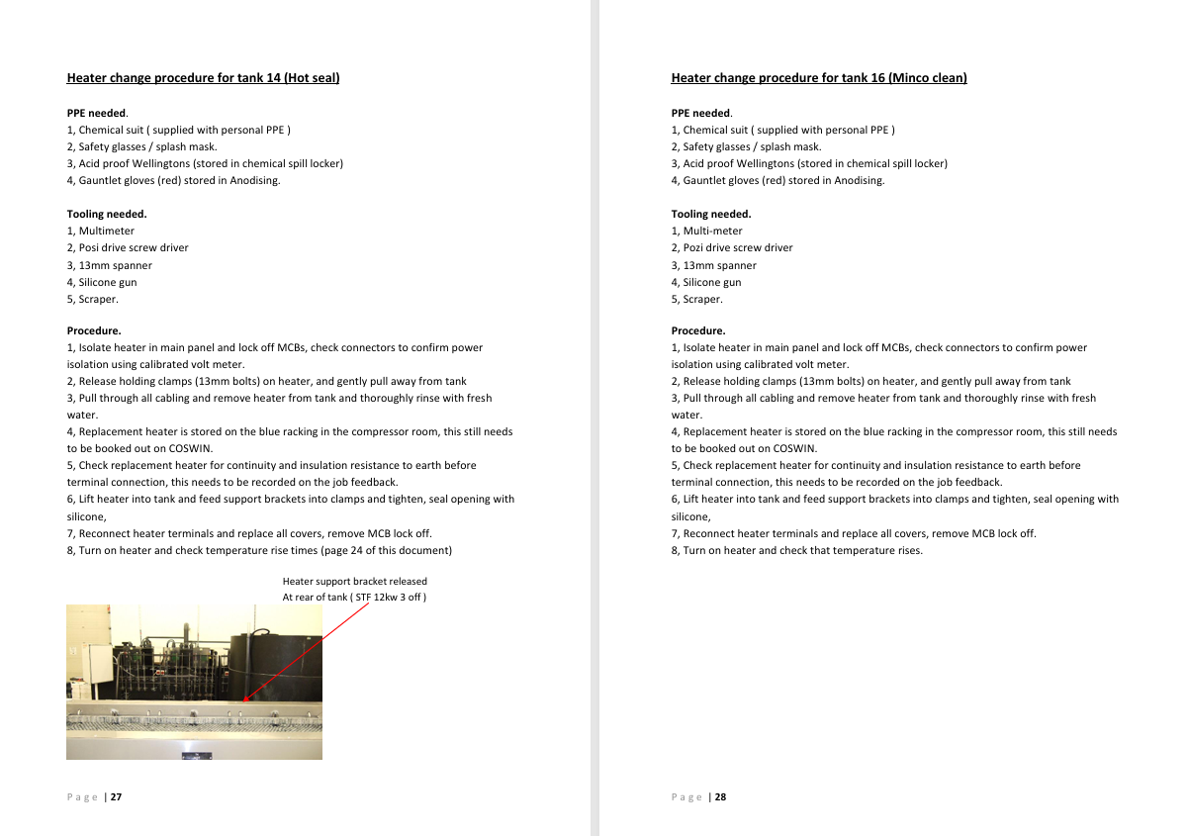
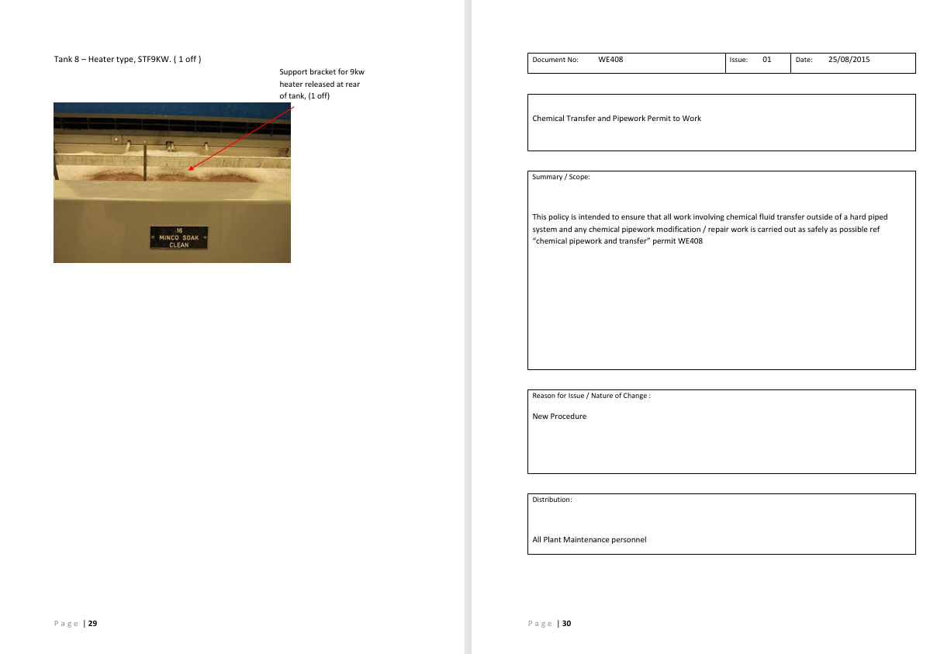
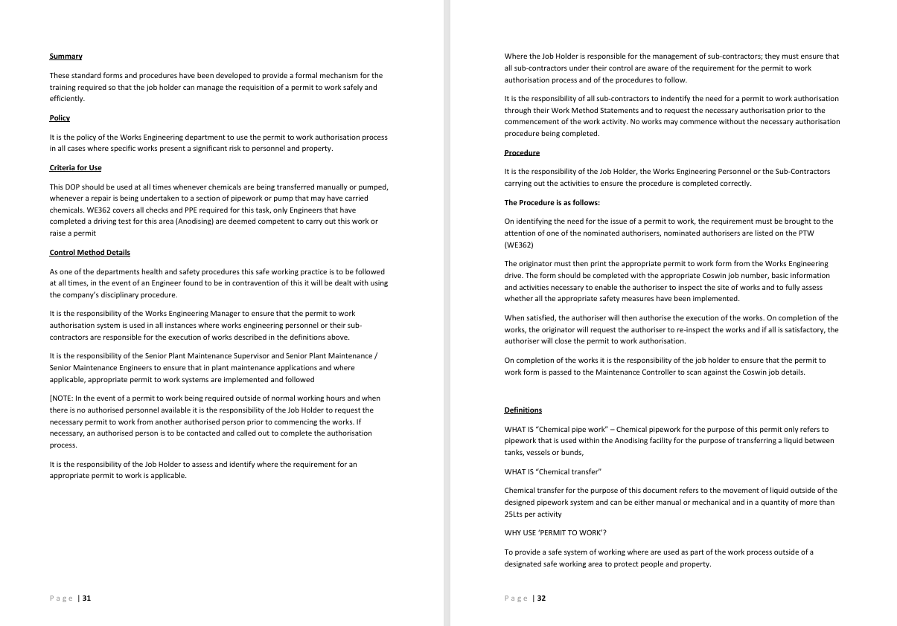

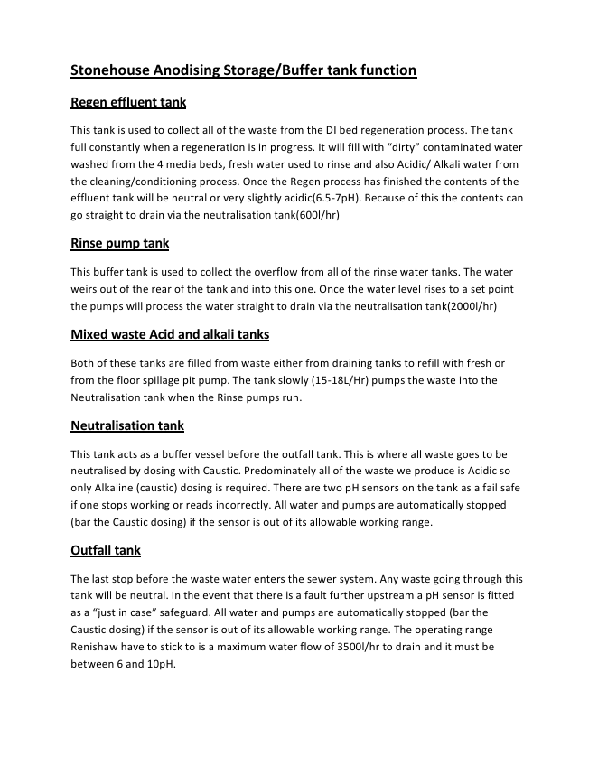
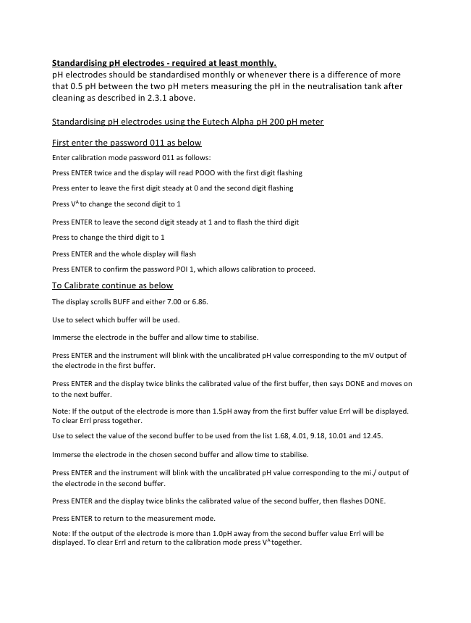
Appendix 3: An extracted version of the relevant parts of the anodising training notes which just include the PH probe calibration procedure.

Appendix 4: Comparison table of different flow meters.
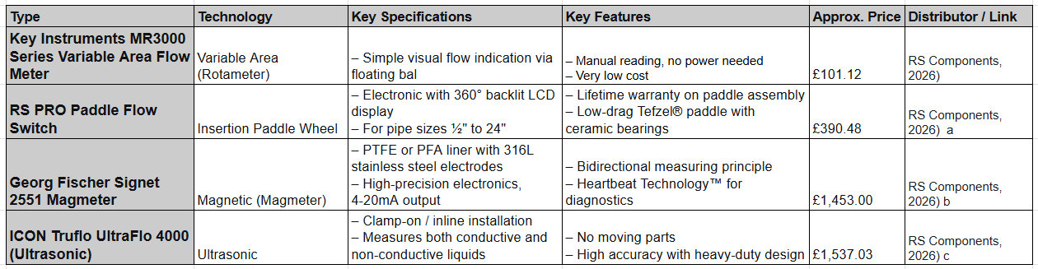

Appendix 5: Control panel schematic diagram, highlighting the PLC Mitsubishi FX2N-128MR-ES/UL and its available inputs/ outputs.
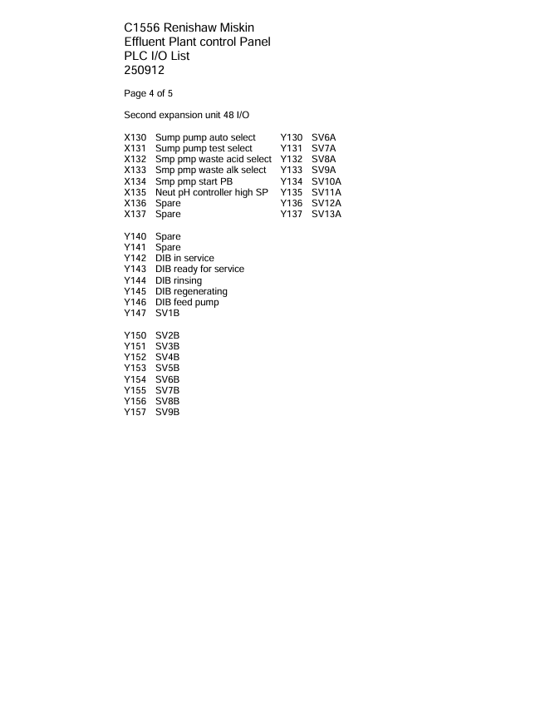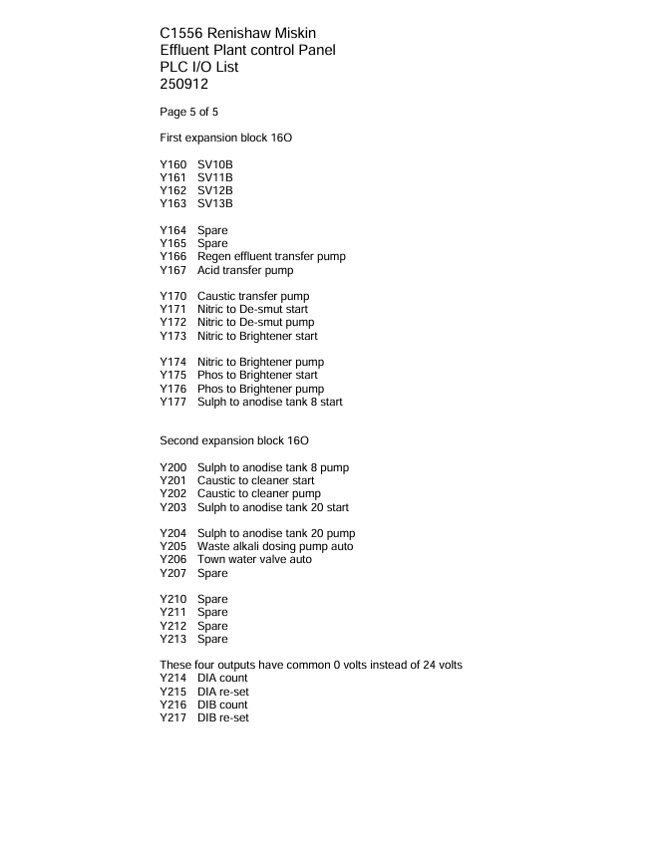

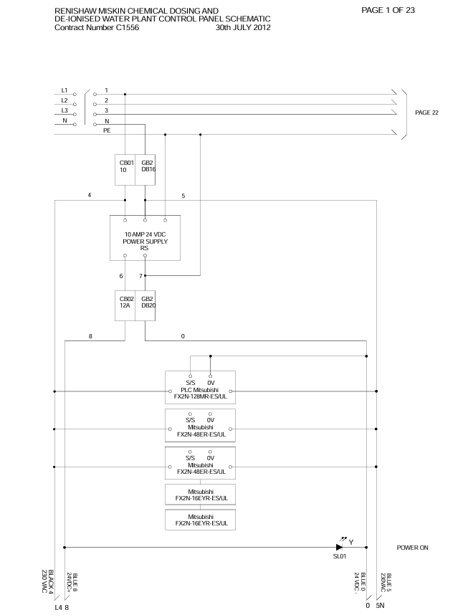
Appendix 6: Comparison table for thermal imaging cameras


