‘Islam does not permit the representation of human figures’ is this statement true? Discuss the following statement in reference to examples of Islamic art you have studied.
‘Islam does not permit the representation of human figures’ this statement is partially true. When referring to Islamic art and its prohibition to human representation we must look at whether the art has been commissioned for secular circles or religious. If talking about religious art, then “Figurative art is excluded from the decoration of religious monuments. This absence may be attributed to an Islamic antipathy toward anything that might be mistaken for idols or idolatry, which are explicitly forbidden by the Qur’an.” So, the Islamic faith does not permit human representations in art like the statement says. This is because the only person who should be worshipped in a mosque (or other religious setting) should be Allah. Therefore, we do have Islamic art that has both human and animal figures on them. The reason being as the art is in a secular setting meaning that there is no chance in it being mistaken as an idol. If we were to investigate the homes and workplaces of the rich than we would find “Such imagery [that] was clearly intended for an entirely secular setting, in which it referred power, wealth and leisure.” So, the statement is incorrect because there are examples of art which features human representations within them. But “such images occur primarily in secular and especially courtly arts and appear in a wide variety of media and in most periods and places in which Islam flourished.” Overall the statement is incorrect because there is Islamic art which depicts human figures in their paintings, books and sculptures. But we should only find this art in secular places where there is no fear of the images being worshipped as idols. This will be discussed within the essay.
In order to analyse Islamic art, we must first define what art is and the time span in which we are analysing it within. The oxford online dictionary defines art as being the way in which we express ourselves through our skills and imagination “typically in a visual form” such as paintings, sculptures, vases, mosaics, etc. We refer to Islamic art by using the word fann which is a “neologism because it traditionally meant ‘craft’ or ‘skill’”. Perhaps the most inclusive definition is “the term Islamic art describes all of the arts that were produced in the lands where Islam was the dominant religion or the religion of those who ruled.” The art being analysed will be from the life of Muhammad (6th century AD) to the mid-16th century and “applies to all art forms produced in the Islamic world.” Within this time frame we will see Islam spread and recede through multiple countries and be ruled by numerous dynasties.
One reason why people may think that human representations is banned in Islam is because of documents such as the Qur’an and the Hadith. The Qur’an is the word of Allah passed down through Muhammad. Although there is no law in the Qur’an against making art with figures in them it does state that no image should be worshipped alongside Allah. “God does not forgive the joining of partners with him: anything less than that he forgives to whoever he will, but anyone who joins partners with God is lying and committing a tremendous sin (4:48)”. From this we can gather that although figural art is not a sin, to worship such art in place of Allah is the worst sin imaginable. A reason for this is that “Muslims believe that God is unique and without associate and therefore that He cannot be represented, except by His word … [this means there is] no place for images of saints … [as] little of the Quran is narrative, so there was little reason to use illustrated stories to teach the faith.” This can explain why there is a misconception of why Islam does not allow for human figures in art. Now for the Hadith is “one of the vast lore of sayings about the deeds and words of Muhammad.” It is one of the most important documents to talk about the instructions given through Muhammad to those of the Islamic faith to remain faithful to Allah’s teachings. “All the Islamic injunctions against making religious images come from the Hadith, traditions recorded by various followers about what the Prophet said and did.” Within the Hadith we see a clear layout for why the idea of representing humans should be banned, this is because creating such art is seen as “usurping the creative function of the Creator and thus is attempting to assimilate himself to God.” In the Hadith it is said that “Those who paint pictures would be punished on the Day of Resurrection and it would be said to them: Breathe soul into what you have created.” The reason why the painters would be punished is because it is viewed as creating life, which is something that should be “unique to God”. Going from this then there should be no art that has figures of humans in it.
As previously mentioned the Hadith is used in conjunction with the Qur’an to guide Muslims about figural art. Professor John Esposito claims that “Muhammad is seen as the living Koran. His life Muslims are to emulate.” So, it makes sense that we should investigate Muhammad’s life and reflections/attitudes toward art. In doing so it is worth mentioning that “There is little doubt that [certain] utterances, placed in the mouth of the Prophet by later writers, give expression to an intolerant attitude towards figured art which Muhammad himself did not feel.” The general opinion held by Muhammad seems to be that “… the Prophet does not appear to have objected to the figures of men or animals on the woven stuffs with which his house in Medina was decorated, so long as they were in their proper place, being either sat upon in cushions or trampled underfoot in carpets.” So, Muhammad was okay with figural art if it was in an appropriate place. This explains why we don’t find figural art within mosques. For example, if we look at “the Dome of the Rock … completed in 691 under the order of the Caliph Abd al-Malik … is entirely devoid of figural imagery.” Another example is “the Aqsa Mosque … and the Great Mosque of Damascus … did not include human figures and animals.” We won’t find figural art in religious settings such as mosques because it would be blasphemous toward Allah. But there have been times where Muhammad has not tolerated figural art. He has even gone so far as to have demanded the destruction or removal of art which has figures on it. “Aisha: The Prophet entered upon me while there was a curtain having pictures (of animals) in the house. His face got red with anger, and then he got hold of the curtain and tore it into pieces.” Also, we see Muhammad destroying idols in the Ka’aba, “… he went into the Ka’aba - - the original place of worship in Mecca - - and found it full of idols, which he destroyed”. This means that Muhammad’s was mindful to “The great danger to be avoided was idolatry, any deviation from the absolute loyalty due to the One and Only God.” This also explains his behaviour toward having pictures drawn of himself as if “The fear was that intense reverence for the prophet might if unrestrained cross over into worship.”
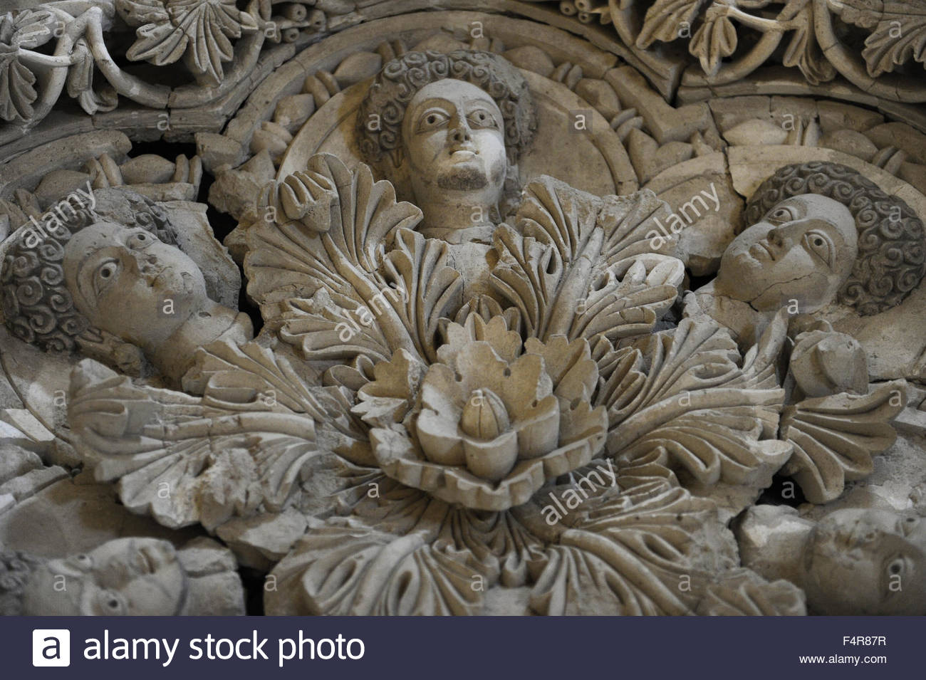
Fig. 1: http://www.alamy.com/stock-photo-hishams-palace-8th-century-ad-khirbat-al-mafjar-near-jericho-was-built-89021851.html
It makes sense that Muhammad’s attitudes would make an impression on his followers but whether they followed his teachings is something entirely different. “It is important to state at once that figural representation appeared at all times in all secular Islamic art; it was of course, more favoured in some periods than in others.” This leads to us finding figural Islamic art, some is even flaunted as a sign of “… power, wealth, and leisure.” This is because “it was generally limited to … elite classes who could afford fine art.” But the reason why secular art is allowed is because there is little to no chance of the art being worshipped as idols as there should be no religious activities occurring. For example, the Umayyad palace, Khirbat al-Mafjar had a doorway “elaborately decorated with a stucco statue” there was also such statues “of half-naked voluptuous dancers.” This was not a religious site as it was the “Retreat of the playboy prince al-Walid ibn Yazid” and the art found in the remains of the palace “suggested the pleasures that lay within.” So, within a secular setting the type of art displayed would be dependent on the person displaying it. If we look at “The art of the Fatimids … [who] frequently depicted animals and humans.” The Seljuk Turks also had “paintings and sculptures of animals and people.” But if we were to look at the “Mamluks of Egypt and Syria, inlaid metalwork produced before the 1320s bore images of courtly life”. After this there is a long period of about 200 years where figural art was not used. “This was largely due to the great Sultan al-Nasir Muhammad, whose taste for inscriptions rather than visuals for self-representation set a non-figural style which would define Mamluk metalwork.” Thus, the statement is incorrect because we do find numerous sources that have created figural art for patrons to place in their homes. The reason being because there is no chance of worshiping these images like one would worship to Allah. Instead they are seen as ornaments. Like “the private residences of sovereigns, such as Qasr ‘Amra and Khirbat Mafjar, were filled with vast figurative paintings, mosaics, and sculpture. And even go so far as to “Under the tolerant rule of the Saljuq princes of Asia Minor it was even possible for a school of sculpture to blossom forth for a brief period”.
The final reason why this statement is incorrect is because the art found within secular areas would have been viewed as ornaments rather than as idols. This is perhaps why “the Prophet does not appear to have taken exception to the dolls which ‘A’isha who is said to have become his wife at the tender age of nine, brought into the house; on one occasion he asked her what she was playing with, and she replied, ‘The horse (or, the horsemen) of Solomon’.” This is also why we have so many manuscripts with illustrations within them because there is no fear of them being worshipped. Rather they were used to illustrate books to make them appear more ornate. “The most obvious use of figural art was as illustration for narratives. The most famous example of this can be found in the Shahnameh, the Persian “Book of Kings”, which was composed by the great poet Abu’l-Qasim Firdausi in the late 9th and early 10th century.” Despite this though we do have evidence of “Some early illustrated manuscripts have had lines drawn across the throats of people illustrated in them, symbolically ‘killing them’, and a dish in the British Museum depicting an ibex has been similarly mutilated.” This shows how even though figures were created Muslims were cautious in making sure that they couldn’t be perceived, even accidently, as idols.
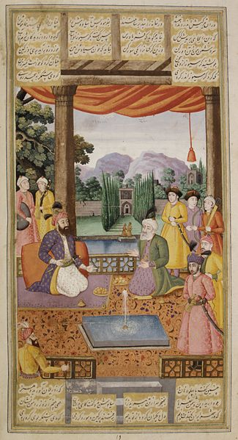
Fig. 2: https://commons.wikimedia.org/wiki/File:Shahnama_(Book_of_Kings)_Abu%27l_Qasim_Firdausi_(935%E2%80%931020).jpg
Overall, the statement is incorrect because there have been many times through Islamic history that art with human figures has been commissioned. Although it is understandably why there is a misconception on why Islam does not allow human figures to be made, this being because of the fear that these figures will start to be worshipped by individuals as they would pray to Allah. Something that should not happen because there is only one God. But this also explains why we do find Islamic art with human figures in secular settings. This is because there is no chance of mistaking these figures for idols, as they have no religious use. Like how in Christianity we see depictions of saints in stained glass windows.

Bibliography
Arnold, T. (2002). Painting in Islam. New Jersey: Gorgias Press.

Art, A. (2018). Figural Representation in Islamic Art | Essay | Heilbrunn Timeline of Art History | The Metropolitan Museum of Art. [online] The Met’s Heilbrunn Timeline of Art History. Available at: http://www.metmuseum.org/toah/hd/figs/hd_figs.htm [Accessed 6 Feb. 2018].

Bbc.co.uk. (2018). BBC - Religions - Islam: Prophet Muhammad (570-632). [online] Available at: http://www.bbc.co.uk/religion/religions/islam/history/muhammad_1.shtml [Accessed 3 Jan. 2018].

Berkey, J. (2011). The formation of Islam. Cambridge: Cambridge University Press.

Davies, J. (1982). Temples, churches and mosques. Oxford: Blackwell.

Denny, F. (1994). An introduction to Islam. New York: Macmillan.

Dodds, J. (1992). al-Andalus. New York: Metropolitan Museum of Art.

Economist.com. (2018). Cite a Website - Cite This For Me. [online] Available at: https://www.economist.com/blogs/economist-explains/2015/01/economist-explains-12 [Accessed 6 Feb. 2018].

Esposito, J. (1999). The Oxford history of Islam. Oxford, U.K: Oxford University Press.

Essential-humanities.net. (2018). Islamic Art | Essential Humanities. [online] Available at: http://www.essential-humanities.net/world-art/islamic/ [Accessed 6 Feb. 2018].

Esposito, J. (2000). The Oxford history of Islam. Oxford: Oxford Univ. Press.

Greenwood, W. (2018). Images and idols: the figurative in Islamic art. [online] alaraby. Available at: https://www.alaraby.co.uk/english/society/2016/7/26/images-and-idols-the-figurative-in-islamic-art [Accessed 6 Feb. 2018].

Humphreys, R. (2003). Islamic history. Oxford [etc.]: Oxford University Press.

Historyworld.net. (2018). HISTORY OF MUHAMMAD. [online] Available at: http://www.historyworld.net/wrldhis/PlainTextHistories.asp?historyid=aa55 [Accessed 3 Jan. 2018].

Hole, F. (1987). The archaeology of Western Iran. Washington: Smithsonian Institution Press.

Hoyland, R. (2001). Arabia and the Arabs. London: Routledge.

Humphreys, R. (2003). Islamic history. Oxford [etc.]: Oxford University Press.

Inside Islam. (2018). Important Sites: The Prophet’s Mosque. [online] Available at: https://insideislam.wisc.edu/2012/02/important-sites-the-prophets-mosque/ [Accessed 3 Jan. 2018].

Khan, M. (n.d.). Pilgrimage to the house of Allah. London: London Mosque.

Khan Academy. (2018). Arts of the Islamic World. [online] Available at: https://www.khanacademy.org/humanities/art-islam/beginners-guide-islamic-art/a/arts-of-the-islamic-world [Accessed 6 Feb. 2018].

Qph.ec.quoracdn.net. (2018). Cite a Website - Cite This For Me. [online] Available at: https://qph.ec.quoracdn.net/main-qimg-4d1d4141423a49e33d87babba364cf39 [Accessed 2 Jan. 2018].

ReligionFacts. (2018). Medina. [online] Available at: http://www.religionfacts.com/medina [Accessed 3 Jan. 2018].

ReligionFacts. (2018). Islamic Art and Depictions of Muhammad. [online] Available at: http://www.religionfacts.com/islam/art [Accessed 6 Feb. 2018].

Schacht, J., Arnold, T. and Bosworth, C. (1979). The legacy of Islam. Oxford: Oxford Univ. Pr.

Sibai, M. (1987). Mosque libraries, an historical study. London: Mansell.

Vaziri, M. (1992). The Emergence of Islam: Prophecy, Imamate, and Messianism in Perspective. New York: Paragon House.

ReligionFacts. (2018). Islamic Art and Depictions of Muhammad. [online] Available at: http://www.religionfacts.com/islam/art [Accessed 6 Feb. 2018].
Greenwood, W. (2018). Images and idols: the figurative in Islamic art. [online] alaraby. Available at: https://www.alaraby.co.uk/english/society/2016/7/26/images-and-idols-the-figurative-in-islamic-art [Accessed 6 Feb. 2018].
ReligionFacts. (2018). Islamic Art and Depictions of Muhammad. [online] Available at: http://www.religionfacts.com/islam/art [Accessed 6 Feb. 2018].
ART | DEFINITION OF ART IN ENGLISH BY OXFORD DICTIONARIES In-text: (Oxford Dictionaries | English, 2018) Your Bibliography: Oxford Dictionaries | English. (2018). art | Definition of art in English by Oxford Dictionaries. [online] Available at: https://en.oxforddictionaries.com/definition/art [Accessed 4 Feb. 2018].
Esposito, J. (1999). The Oxford history of Islam. Oxford, U.K: Oxford University Press.
Khan Academy. (2018). Arts of the Islamic World. [online] Available at: https://www.khanacademy.org/humanities/art-islam/beginners-guide-islamic-art/a/arts-of-the-islamic-world [Accessed 6 Feb. 2018].
Khan Academy. (2018). Arts of the Islamic World. [online] Available at: https://www.khanacademy.org/humanities/art-islam/beginners-guide-islamic-art/a/arts-of-the-islamic-world [Accessed 6 Feb. 2018].
ReligionFacts. (2018). Islamic Art and Depictions of Muhammad. [online] Available at: http://www.religionfacts.com/islam/art [Accessed 6 Feb. 2018].
Economist.com. (2018). Cite a Website - Cite This For Me. [online] Available at: https://www.economist.com/blogs/economist-explains/2015/01/economist-explains-12 [Accessed 6 Feb. 2018].
Economist.com. (2018). Cite a Website - Cite This For Me. [online] Available at: https://www.economist.com/blogs/economist-explains/2015/01/economist-explains-12 [Accessed 6 Feb. 2018].
ReligionFacts. (2018). Islamic Art and Depictions of Muhammad. [online] Available at: http://www.religionfacts.com/islam/art [Accessed 6 Feb. 2018].
Arnold, T. (2002). Painting in Islam. New Jersey: Gorgias Press.
ReligionFacts. (2018). Islamic Art and Depictions of Muhammad. [online] Available at: http://www.religionfacts.com/islam/art [Accessed 6 Feb. 2018].
Art, A. (2018). Figural Representation in Islamic Art | Essay | Heilbrunn Timeline of Art History | The Metropolitan Museum of Art. [online] The Met’s Heilbrunn Timeline of Art History. Available at: http://www.metmuseum.org/toah/hd/figs/hd_figs.htm [Accessed 6 Feb. 2018].
ReligionFacts. (2018). Islamic Art and Depictions of Muhammad. [online] Available at: http://www.religionfacts.com/islam/art [Accessed 6 Feb. 2018].
Arnold, T. (2002). Painting in Islam. New Jersey: Gorgias Press.
Arnold, T. (2002). Painting in Islam. New Jersey: Gorgias Press.
Greenwood, W. (2018). Images and idols: the figurative in Islamic art. [online] alaraby. Available at: https://www.alaraby.co.uk/english/society/2016/7/26/images-and-idols-the-figurative-in-islamic-art [Accessed 6 Feb. 2018].
Khan Academy. (2018). Arts of the Islamic World. [online] Available at: https://www.khanacademy.org/humanities/art-islam/beginners-guide-islamic-art/a/arts-of-the-islamic-world [Accessed 6 Feb. 2018].
ReligionFacts. (2018). Islamic Art and Depictions of Muhammad. [online] Available at: http://www.religionfacts.com/islam/art [Accessed 6 Feb. 2018].
Economist.com. (2018). Cite a Website - Cite This For Me. [online] Available at: https://www.economist.com/blogs/economist-explains/2015/01/economist-explains-12 [Accessed 6 Feb. 2018].
Arnold, T. (2002). Painting in Islam. New Jersey: Gorgias Press.
ReligionFacts. (2018). Islamic Art and Depictions of Muhammad. [online] Available at: http://www.religionfacts.com/islam/art [Accessed 6 Feb. 2018].
Dodds, J. (1992). al-Andalus. New York: Metropolitan Museum of Art.
Greenwood, W. (2018). Images and idols: the figurative in Islamic art. [online] alaraby. Available at: https://www.alaraby.co.uk/english/society/2016/7/26/images-and-idols-the-figurative-in-islamic-art [Accessed 6 Feb. 2018].
ReligionFacts. (2018). Islamic Art and Depictions of Muhammad. [online] Available at: http://www.religionfacts.com/islam/art [Accessed 6 Feb. 2018].
Esposito, J. (1999). The Oxford history of Islam. Oxford, U.K: Oxford University Press.
Esposito, J. (1999). The Oxford history of Islam. Oxford, U.K: Oxford University Press.
Esposito, J. (1999). The Oxford history of Islam. Oxford, U.K: Oxford University Press.
Esposito, J. (1999). The Oxford history of Islam. Oxford, U.K: Oxford University Press.
ReligionFacts. (2018). Islamic Art and Depictions of Muhammad. [online] Available at: http://www.religionfacts.com/islam/art [Accessed 6 Feb. 2018].
ReligionFacts. (2018). Islamic Art and Depictions of Muhammad. [online] Available at: http://www.religionfacts.com/islam/art [Accessed 6 Feb. 2018].
Greenwood, W. (2018). Images and idols: the figurative in Islamic art. [online] alaraby. Available at: https://www.alaraby.co.uk/english/society/2016/7/26/images-and-idols-the-figurative-in-islamic-art [Accessed 6 Feb. 2018].
Greenwood, W. (2018). Images and idols: the figurative in Islamic art. [online] alaraby. Available at: https://www.alaraby.co.uk/english/society/2016/7/26/images-and-idols-the-figurative-in-islamic-art [Accessed 6 Feb. 2018].
Arnold, T. (2002). Painting in Islam. New Jersey: Gorgias Press.
Arnold, T. (2002). Painting in Islam. New Jersey: Gorgias Press.
Greenwood, W. (2018). Images and idols: the figurative in Islamic art. [online] alaraby. Available at: https://www.alaraby.co.uk/english/society/2016/7/26/images-and-idols-the-figurative-in-islamic-art [Accessed 6 Feb. 2018].
Greenwood, W. (2018). Images and idols: the figurative in Islamic art. [online] alaraby. Available at: https://www.alaraby.co.uk/english/society/2016/7/26/images-and-idols-the-figurative-in-islamic-art [Accessed 6 Feb. 2018].

