Effective Teamwork and
Communication
Assessment 1

Teodor Plamenov Panev
Student ID: 2028893
Lecturer: Lloyd Beharry
Module Code: BMSW4002

1 of 9

Table of Content
Introduction ………………………………………………………………………………………………………………………….…… p.3
Models of Communication…………………………………………………..…………………………………………………….. p4
Shannon and Weaver…………. ……………….………….…………………………………………….………………………. p. 4,5
Schramm ………………….………………………………………………………………………………….…………………………. p. 5,6
Berlo…………. …………………………….……………………………………………………………………………………….……. p. 6,7
Communication Skills ………………………………………………………………………………………………………………. p. 8
Conclusion ………………………………………………………………………………………………………………………………. p. 8
References ………………………………………………………………………………………………………………………………. p. 9

2 of 9

Introduction

“The single biggest problem in communication is the illusion that it has taken place” George B. Shaw

Communication is the ability to comprehend the points others make and to be able to make points others understand. The key abilities for communication are speaking, concise and straightforward language, paper communication, listening to others, reading with speed, and understanding (Adair, 2009). Excellent communication skills are essential for the workplace. As discussed in this report, poor communication skills can affect the message and have dire consequences. On another side, clear communication between the parties can improve team efficiency. Increase productivity and help us advance in our careers. The purpose of this report is to cover three different models of communication and how they can help us to avoid and prevent difficulties both in the workplace and our private lives. Shannon and Weaver developed their method in 1948 for the Bell telephone company as a linear model. The model they created is widely used and the foundation for development in the field. Schramm built on the Shannon-Weaver method by adding feedback in 1954 to ensure better communication and prevent noise interference. He proposed a circular model as he proposed the communication is not a linear but a two-way street. Berlo focuses on the speaker and the emotional aspect of the communication using a linear model developed in 1964.

3 of 9

Models of Communication

Shannon and Weaver
One of the fundamental problems of communication is reproducing at one point either exactly or approximately a message selected at another point (Shannon, 1948). The famous Shannon and Weaver communication model was described in two papers dating from 1948 and 1949: Weaver's "Recent Contributions to the Mathematical Theory of Communication" and Shannon's "The Mathematical Theory of Communication." These two papers are classics and the foundation of information and communication theory. Shannon's work was undertaken in the laboratories of Bell Telephone and was first published in the Bell System Technical Journal (Genosko, 2012). In 1948 Shannon (mathematician) and Weaver (scientist), join together to develop the wildly used Shannon-Weaver model for Bell Telephone company (for telephones), which later extended to all different methods of communication.
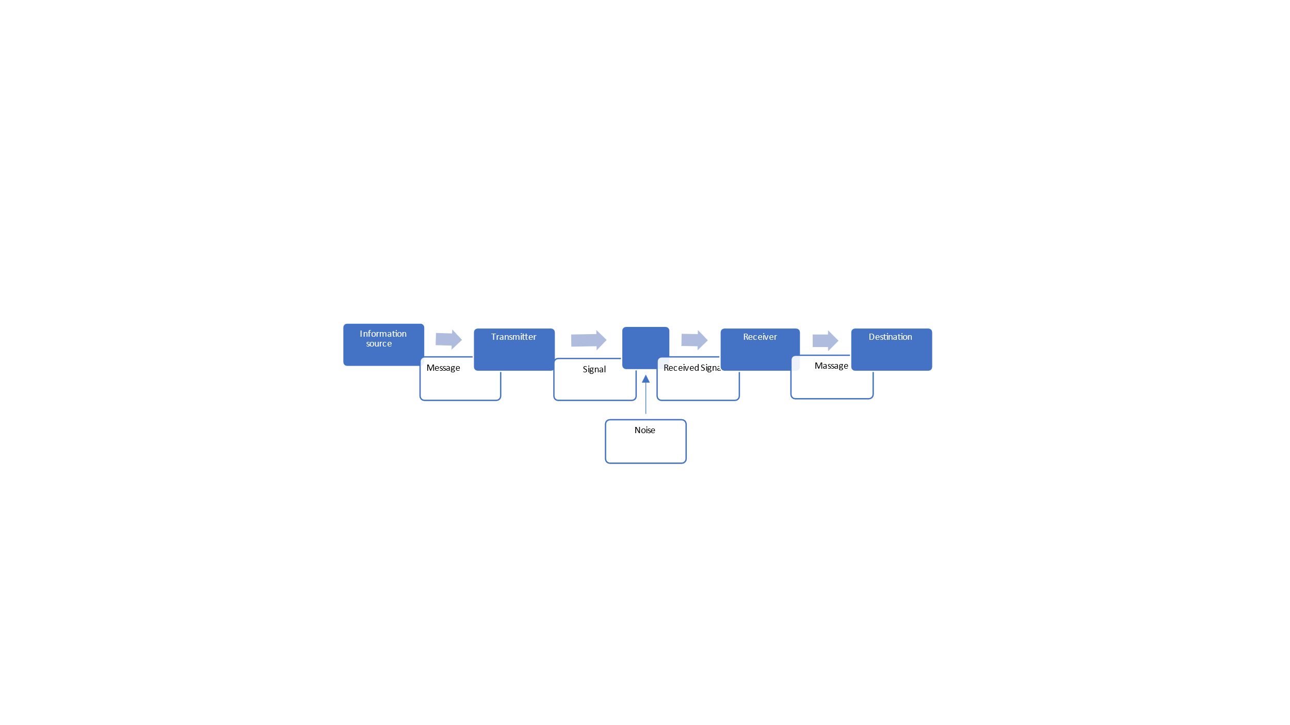

One of the critical aspects of this model is that noise can interfere with this model and be very disruptive. As we will see in the case study, we discussed in class about "Maria and Pedro" that the noise from the construction site made Pedro hear "kitchen" instead of "chicken." Maria called Pedro, who was working at the construction site, telling him to buy Chicken. However, due to noise from the construction site, he misunderstood the word "chicken" for "kitchen." This message disruption can be very destructive in our workplace and personal life.

4 of 9

A few years ago, we had a similar experience in our factory. We were ordering packaging materials. Due to poor communication, the receiver heard a wrong amount. When the delivery truck came, we found out about the mistake and had to place an emergency order for the missing materials in the middle of the working process. The cause of this unfortunate event was too much noise interfering with the communication. The disruption forced us to work overnight to fulfil our quota. This example shows us how noise interfering and disrupting the message can have dire consequences and disrupt the working process. Since then, we changed our company policy to always request confirmation for important messages to avoid disturbance in the working process.

Schramm
Also known as Osgood-Schramm, Schramm's model is circular, unlike the Shannon-Weaver liner model. It consists of all essential communication elements. First, it was proposed by Charles Osgood in 1954. Schramm's model, built on the foundation of the Shannon-Weaver model, proposes that communication is not linear but circular. W. Schramm later amended this model, which was mentioned in his book (Bhasin, 2021).

5 of 9
This Circular model takes the approach to explain that communication is a two-way street. It consists of Sender > Receiver > Sender as the message is encoded send to the receiver, where it is decoded and sent back. As the two parties change position and the sender becomes the receiver. This way, the interference of noise can be limited as the model suggests receiver send back feedback to confirm the correct decoding of the message.
Adapting a circular communication system for an important message is critical for every organization. With the help of feedback, noise interference can be avoided to achieve better communication. As we saw in the case study from our class about "Maria and Pedro." If Pedro had used the Schramm model, he should have repeated the message and asked if Maria meant chicken or kitchen. The same applies in the same way to my work-related example when a simple conformation about the number of packaging materials we require for our order could have prevented a major production delay in our factory.
Schramm model main advantage is addressing the noise disturbances that may occur during the decoding of the message sent as there is a feedback system. It is common practice in many sectors where communication is extremely important to always receive confirmation for the correct decoding of the message, like in the Police and the Army. This communication model makes it easier for the sender to receive an acknowledgment that his message has been received and understood correctly. It reduces the chance of wrong decoding or noise interference significantly.
Berlo
From the many models of communication that exist, Berlo's SMCR model is the most common and referred to. It helps most other models to expand their boundaries of what good communication means (Turaga, 2016). Berlo's SMCR uses a linear model and focuses more on the emotional aspect of the communication between the sender and receiver. SMCR stands for Sender-Message-Channel-Receiver, where the sender is one who sends the message, which is transmitted through the channel where disturbances might interfere. From the many models of communication that exist, Berlo's SMCR model is the most common and referred to. It helps most other models expand their boundaries of what good communication means (Turaga, 2016).
Berlo's SMCR uses a linear model and focuses more on the emotional aspect of the communication between the sender and receiver, taking in into account the different aspects in the communication between the sender and the receiver like communication skills, cultural differences, knowledge, social system, and attitude. The difference between non-effective and effective communication can be in these five critical aspects of communication. However, like in the Shannon-Weaver model of communication noise disturbance may occur.

6 of 9
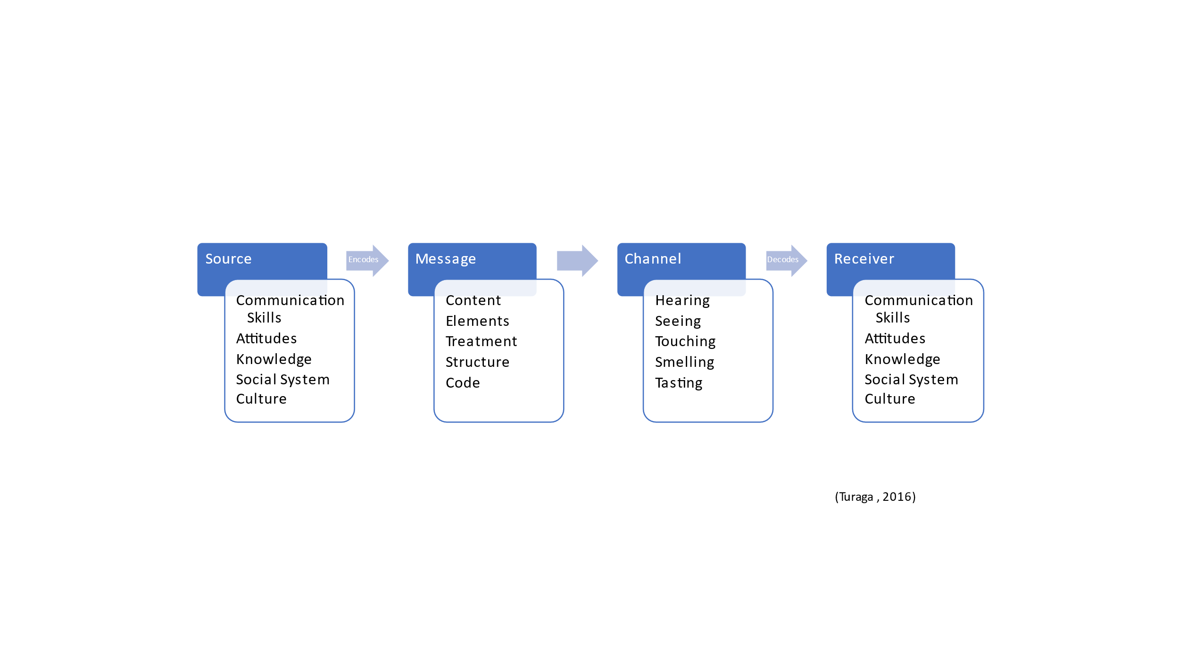
Poor communication may come from other factors as well and not only from noise. In the case study, we discuss in class "The professor and village people." When the professor's house was on fire, he went to the village to ask for help. However, he used a language that was uncomprehensive to the people in the village to describe the situation and ask for help. The study shows us how a different level in English can disrupt the message and prevent the receiver from understanding the correct information. Barlo takes this into account and puts five critical aspects in his communication model. If the professor had yelled, "My House is on Fire," then the village people would have understood that he was asking for assistance and helped him. Using a simpler language considering the receiver’s knowledge and culture is essential for clear and good communication.
Communication has increasingly started to occur in both verbal and nonverbal digital worlds. Emojis have become increasingly popular on social media, such as Facebook (Quintanilla, 2020). The emojis help us express and describe our feelings to help the receiver easier and correctly decode our message. Not appropriate for business and work-related correspondence, but emojis became more and more popular in our private correspondence. In an important conversation via WhatsApp with a person who did not know me well enough, I had to express my plan for action on a significant problem. However, my message was wrongly decoded as hostile intend. Since then, I had to change my mind set about emojis, which could have helped me to better express my intention and avoid miscommunication. The lack of body language, emotions can make non-verbal communication challenging. Even more, if you are trying to give a personal example in a report when you know you should not use "Personal pronoun in formal writing" :)
Berlo's method takes into account different aspects of communication that can help us better understand how to send and receive a clear message for good communication. In order to have better success both in our personal lives or in work related communication.

7 of 9

Communication Skills

Based on the importance of listening in the process of communication. Estimates of its frequency, personal success in communication, and in the team. The individual listening ability indicates the effectiveness of teamwork, the general organization, and maybe for the personal individual success chance, are likely to rest in a part of good listening skills. Listening skills and other communication abilities are likely to be a factor in getting promoted and other relevant rewards like prestige and influence. In the past, research has shown a relatively strong relationship between different social cognitive abilities and progress at the workplace (Sypher, et al., 1989). All communication skills are essential for smooth communication in our personal and professional lives. As the study shows, active listening is critical for our success and increases our chances to advance in our careers.

Conclusion

We can conclude that understanding the communication models and improving our communication skills can help us significantly both in our personal life and at the workplace. Applying Schramm's circular model to avoid critical communication lost due to noise interference can be beneficial to avoid miscommunication. Considering the receiver's ability to decode our message using Berlo's model can significantly increase our ability to send a good and clear message. The ability to communicate both verbally and non-verbal is critical for all aspects of our lives and essential for working well in a team. Actively listening and receiving information is as important as our ability to express ourselves, improving our work efficiency and our chance of advancement in our careers. Also, it will help us to achieve more meaningful and fulfilling relationships both on a professional and personal level.

8 of 9

References
Adair, J. E., 2009. How to grow leaders: The seven key principles of effective leadership development. London: Kogan Page.
Bhasin, H., 2021. Schramm’s Model of Communication | Elements, Advantages & Limitations. [Online]
Available at: https://www.marketing91.com/schramms-model-of-communication/
[Accessed 02 01 2022].
Genosko, G., 2012. Remodelling Communication: From WWII to the WWW. s.l.:University of Toronto Press.
Quintanilla, K. M., 2020. Verbal and Nonverbal Communication. In: Business and professional communication : KEYS for workplace excellence. Los Angeles: SAGE, pp. 20-60.
Shannon, C. E., 1948. A Mathematical Theory of Communication. Mobile Computing and Communications Review, 5(1).
Sypher, B. D., Bostrom, R. N. & Seibert, J. H., 1989. Listening, Conununication Abilities,. The Joumal ofBusiness Communication, pp. 293-302.
Turaga, R., 2016. Organizational Models of Effective Communication. .IUP Journal of Soft Skills, 10(2), pp. 56-65.

9 of 9

