University of Wales Trinity Saint David
Wales Institute of Science and Art


Modelling Industrial Control Systems in MATLAB

Control Technology _ ACMA6001

Catrina Morgan
2405745
03/08/2026
Table of Contents
1 Introduction 4
1.1 Aims 4
1.2 Objectives 4
2 Background 4
2.1 PID general background 4
2.1.1 Open Loop Control 4
2.1.2 Closed Loop Control 4
2.1.3 Proportional Action 5
2.1.4 Integral Action 5
2.1.5 Derivative Action 5
2.1.6 PID Summary 5
2.2 Cruise control standards 5
3 Encoding and Decoding Signals 6
3.1 Encoding code 6
3.2 Decoding code 6
4 PID tuning 7
4.1 Method 7
4.1.1 P, I, D and Output Limits 7
4.2 Results and analysis 8
4.2.1 Proportional Gain 8
4.2.2 Integral Gain 8
4.2.3 Derivative Gain 9
4.2.4 Final Tune 9
5 Time step impact 10
5.1 Method 10
5.2 Results and analysis 10
5.2.1 Worst Result 10
5.2.2 Best Result 11
6 Signal Delay Impact 12
6.1 Method 12
6.2 Results and Analysis 12
6.2.1 Worst Result 13
6.2.2 Best Result 13
7 Number of Bits impact 14
7.1 Method 14
7.2 Results and analysis 14
7.2.1 Worst Result 14
7.2.2 Best Result 15
7.2.3 Result Comparison 15
8 Conclusion 16
9 References 17
10 Appendices 20
10.1 Code 20
10.1.1 Control Algorithm 20
10.1.2 Control Function 20
10.1.3 Main 21
10.2 Figures 24
10.2.1 PID Tuning 24
10.2.2 Time Step Impact 37
10.2.3 Signal Delay Impact 38
10.2.4 Number of Bits Impact 40

Table of Tables
Table 1 - Summary of PID Terms 5

Table of Equations
Equation 1 - Control Output Conversion (Decimal to Binary) 6
Equation 2 – Raw Control Value Formula (Decimal to Binary) 6
Equation 3 – Physical Demand Conversion (Binary to Decimal) 6
Equation 4 – Physical Demand Value Formula (Binary to Decimal) 6

Table of Figures
Figure 1 - PID Controller Block Diagram 4
Figure 2 – Encoding Function in MATLAB 6
Figure 3 – Decoding Function in MATLAB 6
Figure 4 – PID Tuning (Proportional Gain) 7
Figure 5 – PID Tuning (Integral Gain) 7
Figure 6 – PID Tuning (Derivative Gain) 7
Figure 7 – PID Tuning (Limits Output) 7
Figure 8 – PID Tuning (Persistent Variable) 8
Figure 9 – PID Tuning (P=1, I=0.75, D=0.05) 9
Figure 10 – Time Step Impact (Ts = 1s) 10
Figure 11 – Time Step Impact (Ts = 0.05s) 11
Figure 12 – Signal Delay Impact (1.00s) 12
Figure 13 – Signal Delay Impact (10.00s) 13
Figure 14 – Signal Delay Impact (0.25s) 13
Figure 15 – Number or Bits Impact (4 Bit) 14
Figure 16 – Number or Bits Impact (16 Bit) 15
Figure 17 – PID Tuning (P=0, I=0, D=0) 24
Figure 18 – PID Tuning (P=1, I=0, D=0) 24
Figure 19 – PID Tuning (P=10, I=0, D=0) 25
Figure 20 – PID Tuning (P=5, I=0, D=0) 25
Figure 21 – PID Tuning (P=4, I=0, D=0) 26
Figure 22 – PID Tuning (P=3, I=0, D=0) 26
Figure 23 – PID Tuning (P=4.5, I=0, D=0) 27
Figure 24 – PID Tuning (P=4.5, I=1, D=0) 28
Figure 25 – PID Tuning (P=4.5, I=10, D=0) 28
Figure 26 – PID Tuning (P=4.5, I=2, D=0) 29
Figure 27 – PID Tuning (P=4.50, I=0.5, D=0) 29
Figure 28 – PID Tuning (P=4.5, I=0.75, D=0) 30
Figure 29 – PID Tuning (P=4.5, I=0.9, D=0) 30
Figure 30 – PID Tuning (P=4.5, I=0.8, D=0) 31
Figure 31 – PID Tuning (P=4.5, I=0.65, D=0) 31
Figure 32 – PID Tuning (P=4.5, I=0.7, D=0) 32
Figure 33 – PID Tuning (P=4.5, I=0.7, D=1) 33
Figure 34 – PID Tuning (P=4.5, I=0.7, D=10) 33
Figure 35 – PID Tuning (P=4.5, I=0.7, D=2) 34
Figure 36 – PID Tuning (P=4.5, I=0.7, D=0.5) 34
Figure 37 – PID Tuning (P=4.5, I=0.7, D=0.05) 35
Figure 38 – PID Tuning (P=4.5, I=0.7, D=0.01) 35
Figure 39 – PID Tuning (P=1, I=0.9, D=0.05) 36
Figure 40 – PID Tuning (P=1, I=0.8, D=0.05) 36
Figure 41 – Time Step Impact (Ts = 0.01s) 37
Figure 42 – Signal Delay Impact (-1.00s) 38
Figure 43 – Signal Delay Impact (0.50s) 38
Figure 44 – Signal Delay Impact (0.10s) 39
Figure 45 – Number or Bits Impact (8 Bit) 40
Figure 46 – Number or Bits Impact (32 Bit) 40

Introduction

Aims
The aim of this report is to assess the behaviour and performance of a digital cruise‑control system developed in MATLAB, gaining a clearer understanding of how digital control design choices influence system accuracy, stability, and responsiveness.

Objectives
The report will outline the encoding and decoding processes, analyse the PID controller and its gain selection, and investigate how bit‑depth, sampling time, and network delay influence performance. It will also discuss the practical trade‑offs involved in implementing a digital cruise‑control system.

Background

PID general background
Proportional‑Integral‑Derivative (PID) controllers regulate a system’s output by combining proportional, integral, and derivative actions to ensure the system reaches its target value and maintains it with stable, accurate control and minimal steady‑state error, see Figure 1.
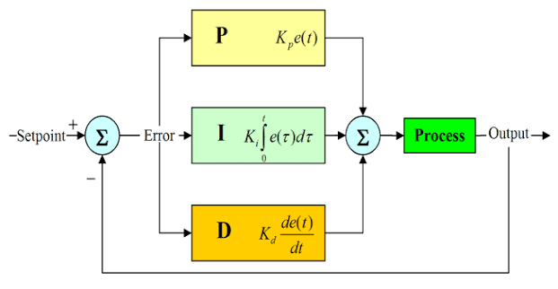
Figure 1 - PID Controller Block Diagram

Open Loop Control
Open loop control systems do not consider any feedback from the system.

Closed Loop Control
Closed‑loop control compares the actual output with the demand and adjusts behaviour through proportional, integral, and derivative actions. By tuning these terms based on feedback, the controller reduces steady‑state error and drives the system toward the desired output with stable, corrective behaviour.

Proportional Action
The difference between the desired and actual output defines the system error, and the proportional term responds directly to it. Increasing the proportional gain produces a faster reaction, but excessive gain causes overshoot and instability. Larger errors demand stronger corrective action, while smaller errors require only minor adjustments.

Integral Action
The integral term removes steady-state error within the system, reacting to the error accumulation over time. It achieves this by increasing the integral term until the offset is corrected to avoid falling short of the target.

Derivative Action
The derivative term predicts the error trend by tracking its speed and reacts to the rate of change. This allows for a reduction in overshoot by dampening the signal and thus improve the stability of the system overall.

PID Summary
Table 1 gives an overview of the PID term functions.
Table 1 - Summary of PID Terms
Term | Response Area | Improvement Area | Risk of Increasing
P | Current Error | Response Speed | Overshoot, Instability
I | Previous Error (Accumulated) | Steady-State Accuracy | Slow Response, Oscillation
D | Rate of Change of Error | Stability, Damping | Noise Amplification

Cruise control standards
Cruise control standards prioritise minimal steady‑state error, smooth non‑oscillatory behaviour, and stable vehicle dynamics. Engineers must tune PID gains to meet safety limits, actuator constraints, and comfort under varying conditions. ISO 26262 requires validated fault behaviour, while SAE J670 and ECE regulations define consistent dynamics and compliant driver‑assist interaction.

Encoding and Decoding Signals

Encoding code
Encoding converts a decimal value into a binary value by rounding to the nearest integer. This quantisation lets physical values be represented digitally but reduces analogue precision. Equation 1 gives the raw control output, Equation 2 applies the conversion, and Figure 2 shows the MATLAB implementation.
Equation 1 - Control Output Conversion (Decimal to Binary)
$$X_{Raw}= \frac{{(X}_{Physical}-m)×R}{M-m}$$

Figure 2 – Encoding Function in MATLAB
Equation 2 – Raw Control Value Formula (Decimal to Binary)
$${Control}_{Raw}=Dec2Bin\left(\frac{\left(Control-m_{ControlSig}\right)×R}{(M_{ControlSig}- m_{ControlSig})}\right)$$

Decoding code
Decoding converts binary values to decimal using scaling. This quantisation enables real‑world interpretation but introduces noise and reduces feedback accuracy because analogue detail is lost. Equation 3 gives the physical demand before conversion, and Equation 4 applies the binary‑to‑decimal mapping. Figure 3 shows the MATLAB implementation.
Equation 3 – Physical Demand Conversion (Binary to Decimal)
$$X_{Physical}= \frac{X_{Raw}×(M-m)}{R}+m$$

Figure 3 – Decoding Function in MATLAB
Equation 4 – Physical Demand Value Formula (Binary to Decimal)
$${Demand}_{Physical}=(\frac{Bin2Dec({Demand}_{Raw})×(M_{Demand}-m_{Demand})}{R})+m_{Demand}$$

PID tuning

Method

P, I, D and Output Limits
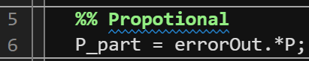
Figure 4 – PID Tuning (Proportional Gain)
Figure 5 – PID Tuning (Integral Gain)
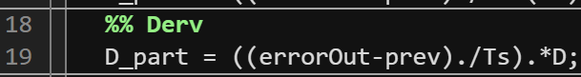
Figure 6 – PID Tuning (Derivative Gain)
The controller script (appendix) includes actuator limits to model realistic full‑throttle and full‑brake behaviour (Figure 28). Control outputs above 100 were capped at 100, and values below –100 were limited to –100, ensuring the actuator stayed within physical bounds and preventing unsafe or unrealistic commands during simulation.
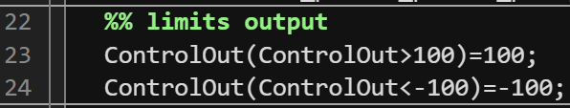
Figure 7 – PID Tuning (Limits Output)

Results and analysis

Proportional Gain
During MATLAB tuning, proportional gains were adjusted to assess their effect on velocity tracking. With all gains at zero, velocity simply followed the driver demand, Figure 17. P = 1, Figure 18, improved alignment, while P = 10, Figure 19, caused strong post‑braking oscillations. P = 5, Figure 20, removed oscillation but introduced sharp braking spikes, and lower gains (P = 3–4, Figure 21, Figure 22) increased steady‑state error. P = 4.5, Figure 23, offered the best balance, keeping velocity close to demand with reduced oscillation and manageable error.

Integral Gain
After setting P = 4.5, the integral gain was tuned for long‑term accuracy. I = 1, Figure 24, produced mild overshoot, while I = 10, , Figure 25, caused severe overshoot. Moderate values like I = 2, Figure 26, still exceeded demand, and I = 0.5, Figure 27, fell below it. Intermediate gains (0.75–0.9, Figure 28, Figure 29, Figure 30, Figure 31) drifted upward over time. I = 0.7, Figure 32, provided the most stable and accurate tracking.
A persistent variable stored previous error values, and with the simulation at 0.01 s and controller at 0.05 s, the code retrieved the error from five steps earlier to update the integral and derivative terms correctly.
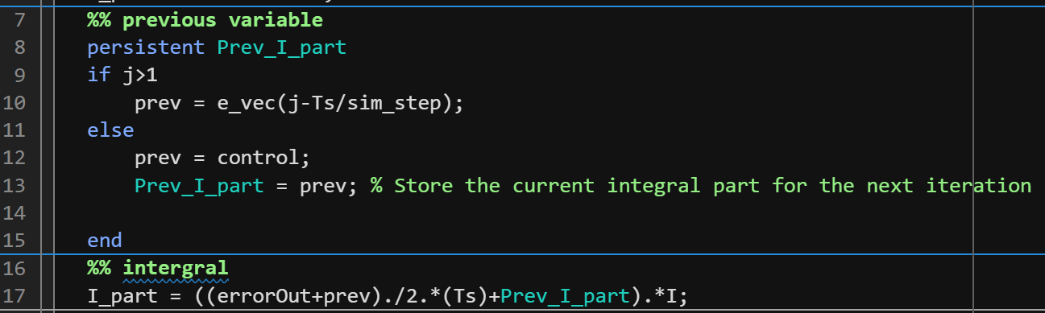
Figure 8 – PID Tuning (Persistent Variable)

Derivative Gain
After setting P = 4.5 and I = 0.7, the derivative gain was tuned to reduce transient spikes. With D = 1, Figure 33, some smoothing occurred but spikes remained. Raising D to 10, Figure 34, caused severe noise and collapse of the velocity response. A moderate D = 2, Figure 35, improved smoothing but introduced oscillations and velocity dips. Lower gains such as D = 0.5, Figure 36, reduced spikes yet still caused braking‑related drops, while D = 0.05 and D = 0.01, Figure 37, Figure 38, had negligible effect. Overall, derivative tuning offered limited benefit, with high values destabilising the system and low values providing minimal improvement.

Final Tune
After initial tuning, the controller was refined to remove overshoot and improve stability. With P = 1, I = 0.9, and D = 0.05, Figure 39, velocity overshot the driver demand despite a smooth throttle signal. Reducing I to 0.8, Figure 40, lessened the overshoot but remained unsafe. I = 0.75, Figure 9, delivered stable tracking, minimal steady‑state error, and well‑aligned actuator signals, providing the safest and most balanced performance.
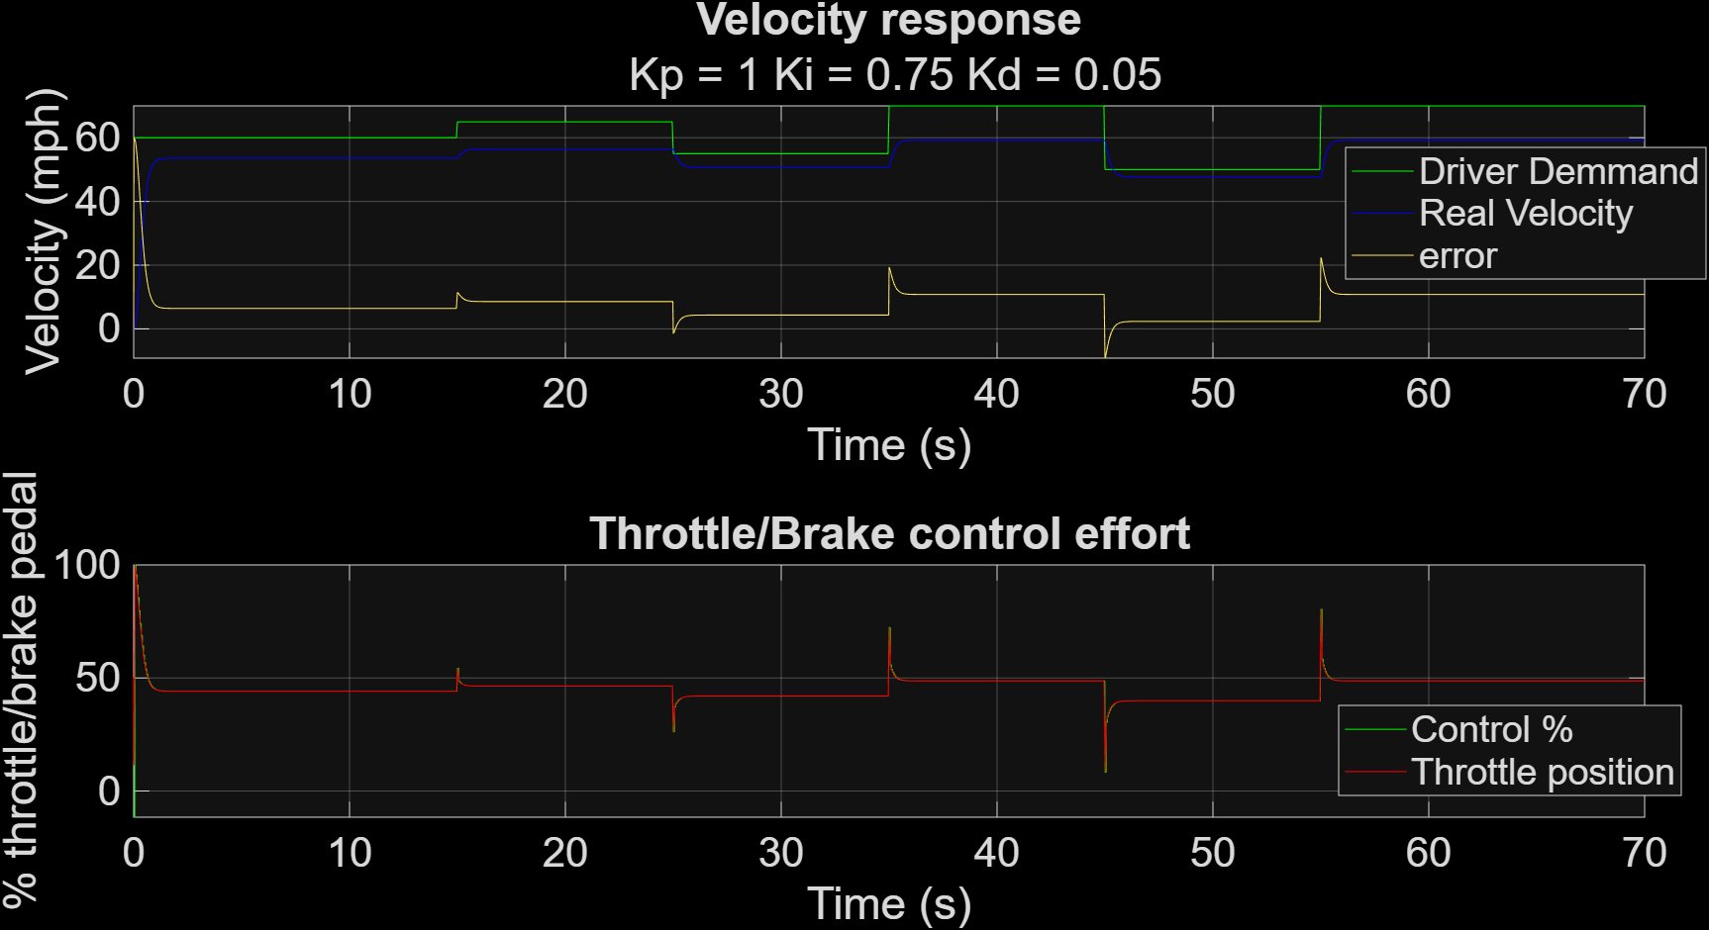
Figure 9 – PID Tuning (P=1, I=0.75, D=0.05)
The final PID gains delivered stable speed tracking, negligible steady‑state error, and controlled actuator behaviour. Automated tuning allowed systematic testing across sampling intervals, bit depths, and delays. The chosen gains offered a balanced response, providing fast correction while maintaining safe control effort.
Optimal parameters: P = 1, I = 0.75, D = 0.05, Timestep = 0.05, Bit depth = 16, Actuator delay = 0.

Time step impact

Method
The sampling time was varied in MATLAB, and the closed‑loop response evaluated for stability, overshoot, settling time, and control effort. The longest sampling interval that still maintained acceptable performance was then identified.

Results and analysis
The influence of timestep size on controller behaviour was assessed by comparing the standard 0.05‑second interval with both larger and smaller values. With Ts = 1, the system displayed clear oscillatory behaviour, and although the control‑percentage and throttle‑position signals aligned well, the resulting velocity adjustments appeared coarse and could translate into a noticeably jerky ride for passengers. Reducing the timestep to Ts = 0.01 decreased the accuracy of the throttle‑position signal, introducing unnecessary variability. These results indicate that the current 0.05‑second timestep provides the most stable and reliable performance, balancing responsiveness with smooth actuator behaviour.

Worst Result
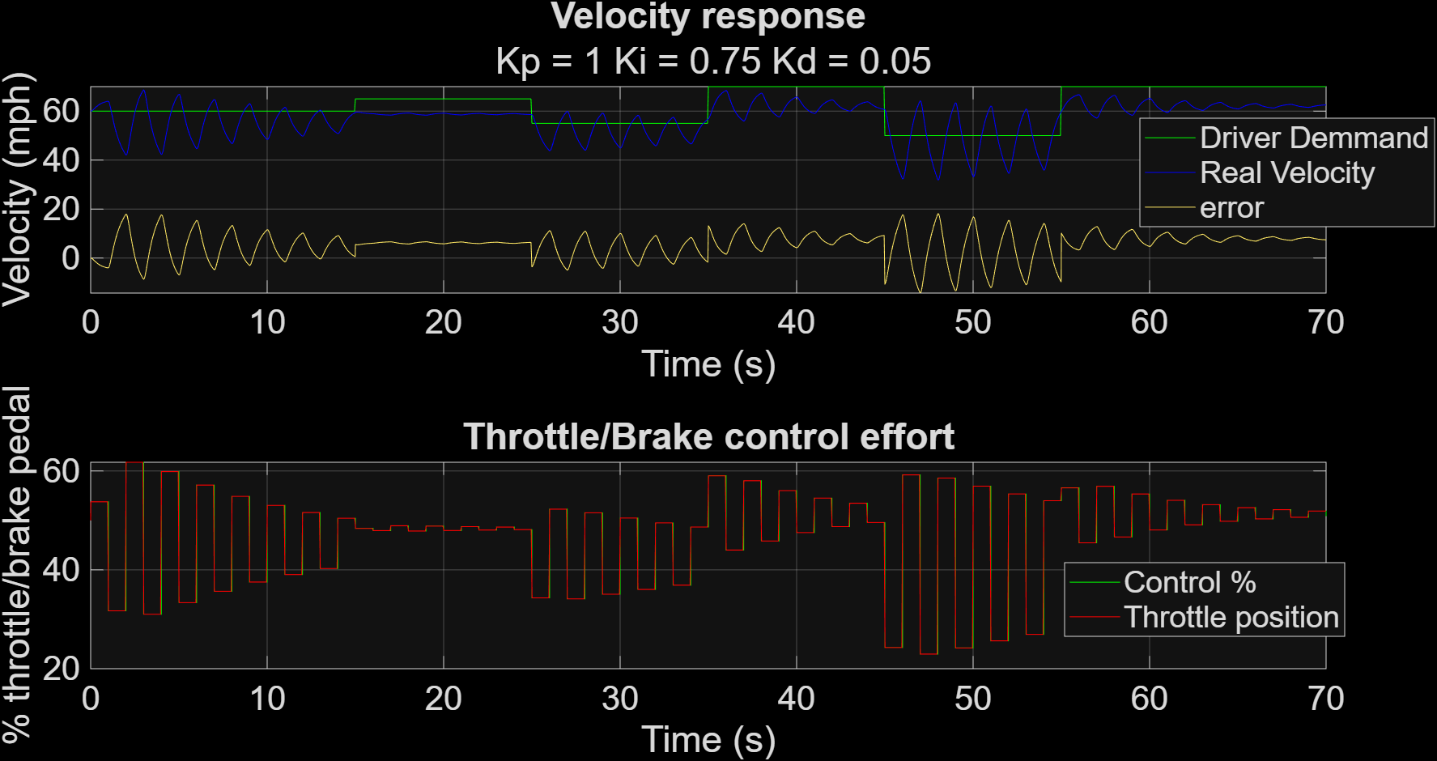
Figure 10 – Time Step Impact (Ts = 1s)

Best Result
Figure 11 – Time Step Impact (Ts = 0.05s)

Signal Delay Impact

Method
A communication delay was added to the feedback loop and gradually increased until performance degraded. The controller gains were then adjusted to assess how much delay the system could tolerate.

Results and Analysis
The impact of actuator‑signal delay was evaluated by adding positive and negative delays to the controller. With zero delay, the system provided the baseline response. A 1‑second delay, Figure 12, introduced oscillation and jerky throttle behaviour, creating unsafe phase‑shifted control. Negative delay, Figure 42, produced no change, as the controller cannot act before receiving a signal. A 10‑second delay, Figure 13, caused near‑total loss of control, with the velocity response drifting almost entirely out of phase. Smaller delays were then tested: 0.5 s, Figure 43, still caused misalignment, 0.25 s, Figure 14, offered only slight smoothing at the cost of accuracy, and 0.1 s, Figure 44, was too small to matter. Overall, any meaningful positive delay degraded stability or precision, while negative delay was physically irrelevant. Zero actuator delay provided the safest and most accurate behaviour, though minimal delay could be explored in future work for potential human‑factor benefits.
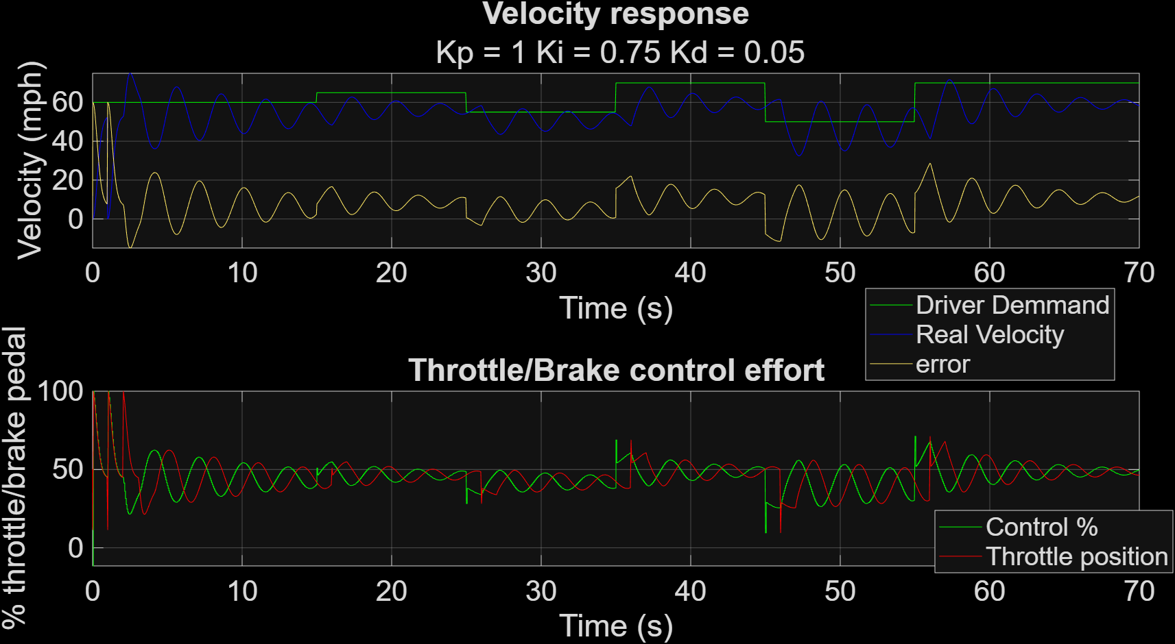
Figure 12 – Signal Delay Impact (1.00s)

Worst Result
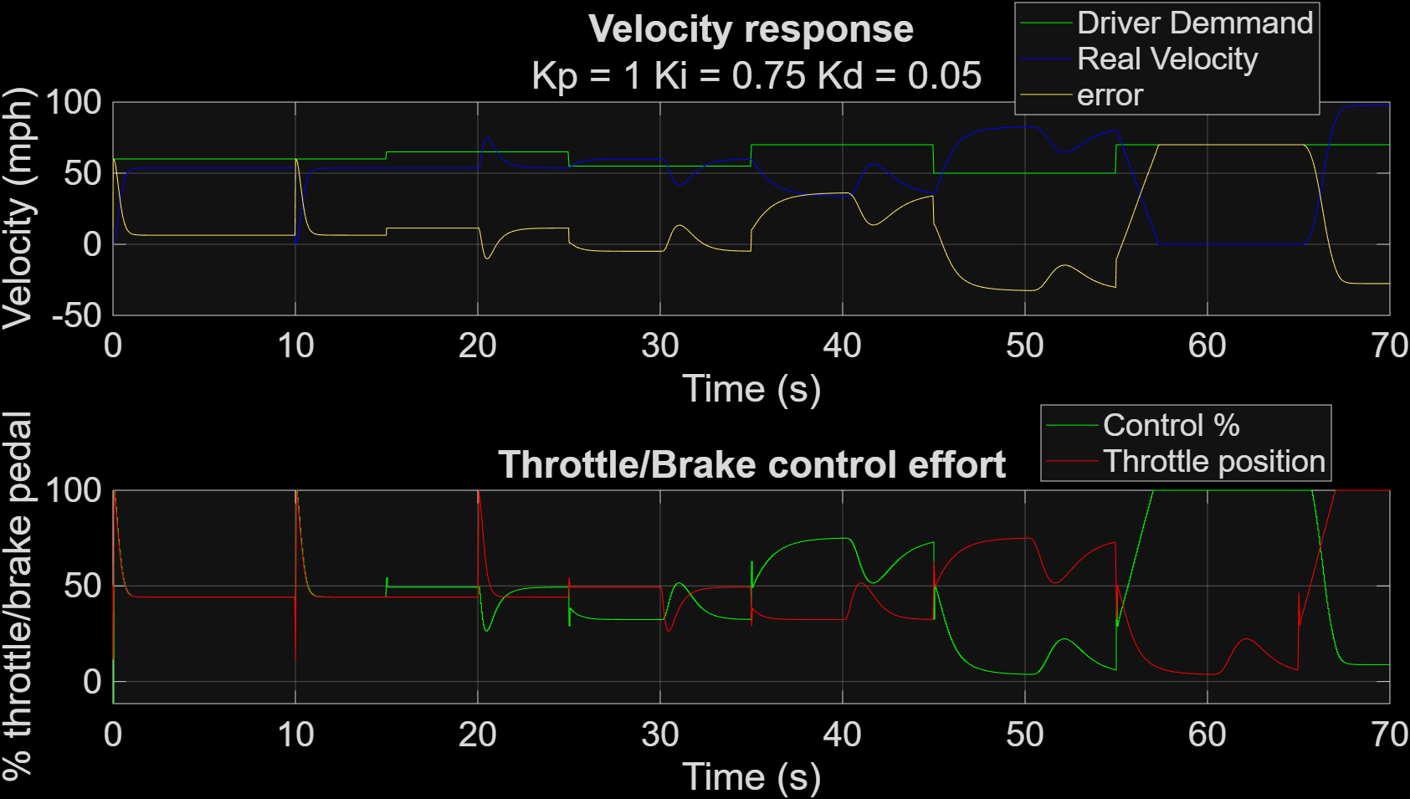
Figure 13 – Signal Delay Impact (10.00s)

Best Result
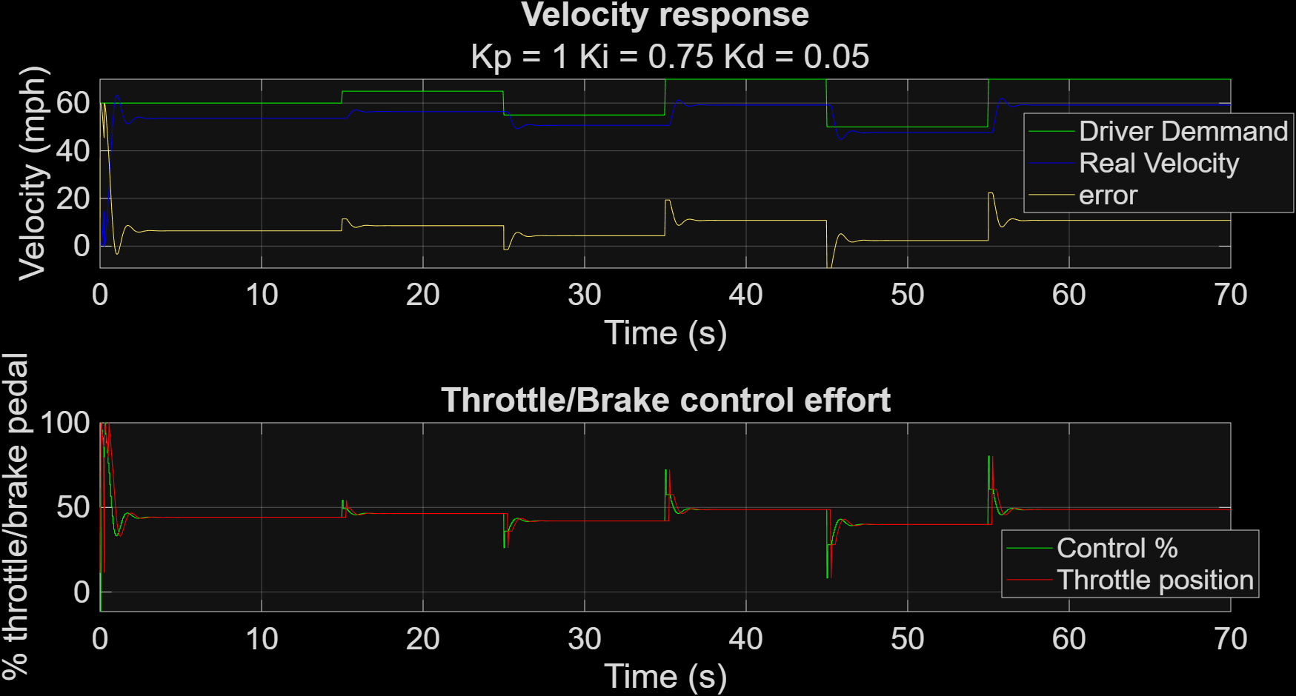
Figure 14 – Signal Delay Impact (0.25s)

Number of Bits impact

Method
The bit values used to encode and decode the control signal varied, and each resolution was assessed in terms of its quantisation noise, closed‑loop stability, and tracking accuracy.

Results and analysis
The impact of bit‑resolution on controller behaviour was evaluated by comparing 4‑, 8‑, 16‑ and 32‑bit representations of the control signal. The current 16‑bit system provided stable, accurate behaviour, while reducing the resolution to 8‑bit caused the control‑percentage signal to rise slightly above the throttle position, though only minimally. At 4‑bit, the system became unsafe, producing significant throttle noise, oscillation, and increased error. Increasing resolution to 32‑bit yielded results visually identical to the 16‑bit case, indicating no meaningful performance benefit. Given the absence of improvement and the additional computational cost, maintaining 16‑bit resolution is the most efficient and practical choice.

Worst Result
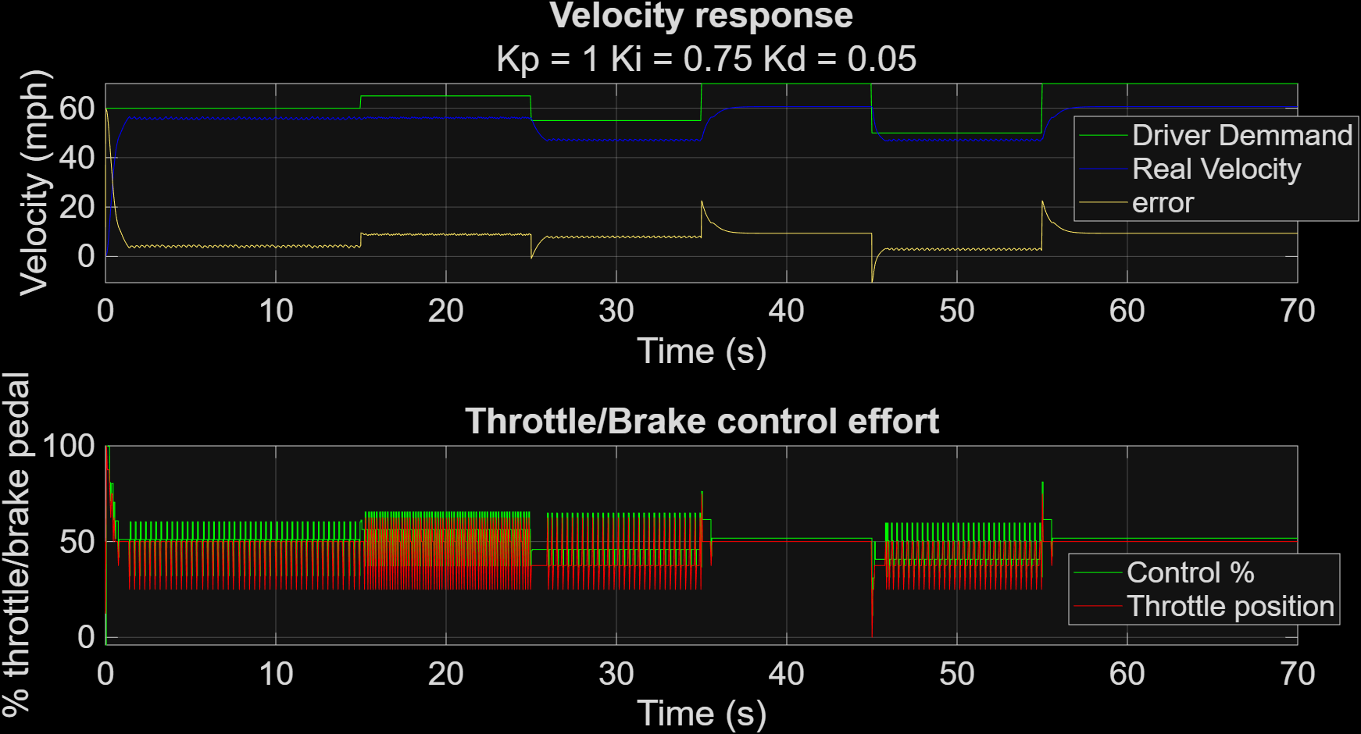
Figure 15 – Number or Bits Impact (4 Bit)

Best Result
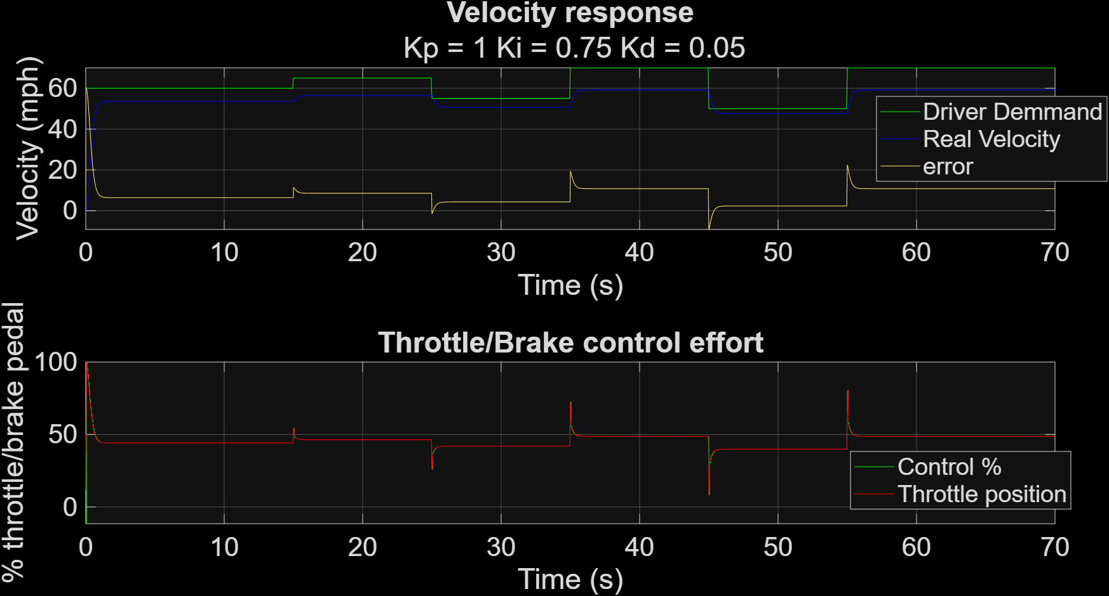
Figure 16 – Number or Bits Impact (16 Bit)

Result Comparison
Bit‑resolution testing showed that increasing precision beyond 16 bits provided no improvement, while reducing it caused clear degradation. Lower resolutions added noise, reduced stability, and increased throttle variability, though less severely than expected. Although higher bit depths theoretically offer finer quantisation, the simulation showed no practical benefit above 16 bits. Overall, 16‑bit resolution delivered the best balance of computational efficiency and control accuracy for this system.

Conclusion
This report analysed how quantisation, sampling time, delay, and PID tuning interact to determine cruise‑control stability, responsiveness, and overall reliability.
The final PID gains produced stable speed tracking, negligible steady‑state error, and a controlled actuator response. Automated tuning scripts enabled systematic testing across multiple sampling intervals, bit resolutions, and signal delays, allowing each configuration to be assessed for stability, responsiveness, and safety. The selected gains represent a balanced compromise, providing sufficiently rapid velocity correction while maintaining manageable actuator effort and smooth passenger experience. Based on the full set of simulations, the optimal cruise‑control parameters were determined to be P = 1, I = 0.75, D = 0.05, with a 0.05‑second timestep, 16‑bit resolution, and zero actuator delay, offering the most reliable and accurate performance across all tested conditions.
Further development could incorporate adaptive cruise‑control functionality, allowing the controller to adjust speed dynamically based on the distance to a leading vehicle. This would require additional sensing, decision logic, and modified control laws, but the existing PID framework provides a solid foundation for implementing and testing such behaviour in future work.

References
Advanced PID Control - ISA Book. (n.d.). [online] isa.org. Available at: https://www.isa.org/products/advanced-pid-control [Accessed 2 July 2026].
Antsaklis, P. and Baillieul, J. (2007). special issue on technology of networked control systems. Proceedings of the IEEE, 95(1), pp.5–8. doi:10.1109/jproc.2006.887291.
Bennett , S. (1993). Development of the PID controller. IEEE Control Systems Magazine, 13(6), pp.58–65. doi:https://ieeexplore.ieee.org/document/236341.
BRAZ, P. (1966). Processo Administrativo Disciplinar.
Chan, T.F. and Vese, L.A. (2001). Active Contours Without Edges. IEEE Transactions on Image Processing, 10(2), pp.266–277. doi:10.1109/83.902291.
Dorf, R.C. and Bishop, R.H. (2021). Modern control systems. [online] www.pearson.com. Available at: https://www.pearson.com/en-us/subject-catalog/p/modern-control-systems/P200000003484/9780137307098 [Accessed 30 July 2026].
Fig.2 PID Block Diagram PID stands for Proportional, Integral,... (n.d.). [online] ResearchGate. Available at: https://www.researchgate.net/figure/PID-Block-Diagram-PID-stands-for-Proportional-Integral-Derivative-control-A-PID_fig1_316709017 [Accessed 2 July 2026].
ISO - International Organization for Standardization (2018). ISO 26262-1:2018. [online] ISO. Available at: https://www.iso.org/standard/68383.html?utm_source=copilot.com [Accessed 5 July 2026].
Mahmood, A., Karrar Y.A. Al-bayati and Róbert Szabolcsi (2024). Comparison between genetic algorithms of proportional–integral–derivative and linear quadratic regulator controllers, and fuzzy logic controllers for cruise control system. World Electric Vehicle Journal, [online] 15(8), pp.351–351. doi:10.3390/wevj15080351.
Mouleeswaran, S., Elmadssia , S., Saadaoui, K. and Benrejeb, M. (2012). PID Controller Design Approaches - Theory, Tuning and Application to Frontier Areas. PID Controller Design Approaches - Theory, Tuning and Application to Frontier Areas. [online] doi:10.5772/2628.
Open-Loop Control System - an overview | ScienceDirect Topics. (n.d.). [online] www.sciencedirect.com. Available at: https://www.sciencedirect.com/topics/engineering/open-loop-control-system [Accessed 2 July 2026].
Pearson (2021). [online] Pearson.com. Available at: https://www.pearson.com/en-us/subject-catalog/p/discrete-time-signal-processing/P200000006509/9780131988422 [Accessed 2 July 2026].
Pearson (2026a). Search results: computer controlled systems | Pearson US. [online] Pearson.com. Available at: https://www.pearson.com/en-us/subject-catalog/p/computer-controlled-systems/P200000006513/9780133148992 [Accessed 2 July 2026].
Pearson (2026b). Search results: control system design | Pearson US. [online] Pearson.com. Available at: https://www.pearson.com/en-us/subject-catalog/p/control-system-design/P200000006512/9780130893550 [Accessed 2 July 2026].
Pearson.com. (2020). [online] Available at: https://www.pearson.com/en-us/subject-catalog/p/modern-control-engineering/P200000006507/9780136156734 [Accessed 2 July 2026].
Rajamani, R. (2012). Vehicle Dynamics and Control. Mechanical Engineering Series. Boston, MA: Springer US. doi:10.1007/978-1-4614-1433-9.
SAE International (2026a). SAE International | Advancing Mobility Knowledge and Solutions. [online] Sae.org. Available at: https://www.sae.org/standards/content/j670_202205/ [Accessed 18 July 2026].
SAE International (2026b). Sae International | Advancing Mobility Knowledge and Solutions. [online] Sae.org. Available at: https://www.sae.org/standards/content/j2364_201508/ [Accessed 19 July 2026].
Spong, M.W., Hutchinson, S. and Vidyasagar, M. (2020). Robot modeling and control. John Wiley & Sons.
Sundström, E., Hägglund, T., Bauer, M., Eker, J. and Soltesz, K. (2024). Reference Implementation of the PID Controller. IFAC-PapersOnLine, 58(7), pp.370–375. doi:10.1016/j.ifacol.2024.08.090.
T. , H. and K.J., Å. (1985). Automatic tuning of PID controllers based on dominant pole design. IFAC Proceedings Volumes, [online] 18(15), pp.205–210. Available at: https://doi.org/10.1016/B978-0-08-033431-8.50039-7 [Accessed 14 July 2026].
Tune PID controllers - MATLAB - MathWorks United Kingdom. (n.d.). [online] uk.mathworks.com. Available at: https://uk.mathworks.com/help/control/ref/pidtuner-app.html [Accessed 2 July 2026].
United Nations Economic Commission for Europe (2025). Working Party on Automated/Autonomous and Connected Vehicles - Introduction | UNECE. [online] Unece.org. Available at: https://unece.org/transport/road-transport/working-party-automatedautonomous-and-connected-vehicles-introduction [Accessed 17 July 2026].
Vimal V, Sarvesh Skandaa Kv and P, A.M. (2025). Cruise Control in Vehicle’s using PID Controller. International Journal of Engineering Research & Technology, [online] 14(7). doi:10.17577/IJERTV14IS070067.
Wang, L. (2026). PId Control System Design and Automatic Tuning Using MATLAB/Simulink | IEEE eBooks | IEEE Xplore. [online] Ieee.org. Available at: https://ieeexplore.ieee.org/xpl/ebooks/bookPdfWithBanner.jsp?fileName=9028308.pdf&bkn=9028308&pdfType=book [Accessed 17 July 2026].
Wang, S., Rajendran, P., Wang, J., Marimuthu, S., Raja, V. and Wong, K. (2026). Metaheuristic optimization of PID controllers: Methods, Applications, and Trends. Archives of Computational Methods in Engineering. doi:10.1007/s11831-026-10492-z.
Winner, H. and Schopper, M. (2015). Adaptive Cruise Control. Handbuch Fahrerassistenzsysteme, pp.851–891. doi:10.1007/978-3-658-05734-3_46.

Appendices

Code

Control Algorithm
%% calculate control signal and error (range of control [-100,100])
[control, error] = Controllerrrss(demand,velocity,P,j,I,e_vec,Ts,sim_step,control,D);
% CONTROL ALGORITHUM INSERTED!

Control Function
function [ControlOut,errorOut] = Controllerrrss...
(demand,velocity,P,j,I,e_vec,Ts,sim_step,control,D)
%Error
errorOut=demand-velocity;
%% Propotional
P_part = errorOut.*P;
%% previous variable
persistent Prev_I_part
if j>1
prev = e_vec(j-Ts/sim_step);
else
prev = control;
Prev_I_part = prev; % Store the current integral part for the next iteration

end
%% intergral
I_part = ((errorOut+prev)./2.*(Ts)+Prev_I_part).*I;
%% Derv
D_part = ((errorOut-prev)./Ts).*D;
%% control output
ControlOut = P_part+I_part+D_part;
%% limits output
ControlOut(ControlOut>100)=100;
ControlOut(ControlOut<-100)=-100;
end

Main
%% MAIN FILE FOR CRUISE CONTROLLER SYSTEM %%%%%%%%%%%%%%%%
% (1) initialize
% (2) set implementation parameters
% (3) set simulation parameters
% (4) simulation loop
% (5) plot results
%%%%%%%%%%%%%%%%%%%%%%%%%%%%%%%%%%%%%%%%%%%%%%%%%%%%%%%%%%
%% (1) Initialize %%%%%%%%%%%%%%%%%%%%%%%%%%%%%%%%%%%%%%%%
clc
clear
close all % house keeping
P = 1;
I = 0.75;
D = 0.05;
%%%%%%%%%%%%%%%%%%%%%%%%%%%%%%%%%%%%%%%%%%%%%%%%%%%%%%%%%%

%% (2) set implementation parameters %%%%%%%%%%%%%%%%%%%%%

% sampling time must be an integer multiple of sim_step
Ts = 0.05;
% number of bits used to encode velocity sensor signal. velocity sensor
% range in mph [0,150]
m_velocityS =0;
M_velocityS = 150;
n_bits_sensor_signal = 16;
% number of bits used to encode velocity demand signal. demand
% range in mph [30,110]
m_demand = 30; M_demand = 110;
n_bits_demand_signal = 16;
% number of bits used to encode throttle/brake actuator signal. actuator
% range in mph [-100,100] where [-100,0) is percentage of braking and
% (0,100] is percentage of throttle
n_bits_actuator_signal = 16;
R = 2.^n_bits_actuator_signal;
%%%%%%%%%%%%%%%%%%%%%%%%%%%%%%%%%%%%%%%%%%%%%%%%%%%%%%%%%%

%% (3) set simulation parameters %%%%%%%%%%%%%%%%%%%%%%%%%

sim_step = 0.01; % simulation time step in seconds
sim_time = 70; % simulation time length in seconds
T = 0:sim_step:sim_time; % simulation steps vector
% initialize vector where to store results for plots
[d_vec,u_vec ,y_vec,e_vec,Th_vec] = deal(nan(size(T)));
throttle_setting = 50; % initialize control action (throttle/brake setting)
% communication delay between controller and actuator in seconds.
% must be an integer multiple of sim_step
actuator_signal_delay = 0.00;
%% remove when in function
m_ControlSig = -100;
M_ControlSig = 100;
%%%%%%%%%%%%%%%%%%%%%%%%%%%%%%%%%%%%%%%%%%%%%%%%%%%%%%%%%%
[u, control] = deal(50);
%% (4) simulation loop %%%%%%%%%%%%%%%%%%%%%%%%%%%%%%%%%%%
velocity_real = 60;
for j = 1:length(T) % for every simulation step

loops_remaining = length(T)-j; % display progression
disp(loops_remaining)
% get vehicle raw veocity sensor measurement from the communication bus
[velocity_raw, velocity_real,throttle_setting] = getRawVelocity(n_bits_sensor_signal,velocity_real,throttle_setting, sim_step,u);

% decode raw bus signal (from x-bit binary to mph)
velocity = ((bin2dec(velocity_raw).*(M_velocityS-m_velocityS))/R)+m_velocityS;

if mod((j-1)*sim_step,Ts) == 0 % every sampling time

% get driver's velocity demand raw signal from the communication bus
demand_raw = getRawVelocityDemand(n_bits_sensor_signal,sim_step,j);

%% decode raw signal (from x-bit binary to mph)
demand = (bin2dec(demand_raw).*(M_demand-m_demand)./R)+m_demand; % DECODING FUNCTION INSERTED!

%% calculate control signal and error (range of control [-100,100])
[control, error] = Controllerrrss(demand,velocity,P,j,I,e_vec,Ts,sim_step,control,D); % CONTROL ALGORITHUM INSERTED!

%% encode control signal into x-bit binary number
control_raw = dec2bin((control-m_ControlSig)./(M_ControlSig-m_ControlSig).*R); % ENCODING FUNCTION INSERTED!

%% send control command to throttle/brake actuator via communication
% bus (record the control signal instance as u)
u = sendControlCommand(control_raw,n_bits_actuator_signal,actuator_signal_delay,j, sim_step, u_vec);
end

% store values for plotting
e_vec(j) = error;
d_vec(j) = demand;
u_vec(j) = control;
y_vec(j) = velocity_real;
Th_vec(j) = throttle_setting;
end

%%%%%%%%%%%%%%%%%%%%%%%%%%%%%%%%%%%%%%%%%%%%%%%%%%%%%%%%%%

%% (5) plot results %%%%%%%%%%%%%%%%%%%%%%%%%%%%%%%%%%%%%%

figure

% plot velocity response
subplot(2,1,1)
plot(T,d_vec,'g-');hold on
plot(T,y_vec,'b-');
plot(T,d_vec-y_vec); grid;
title('Velocity response');
subtitle([' Kp = ', num2str(P),' Ki = ', num2str(I),' Kd = ',...
num2str(D)]);
ylabel('Velocity (mph)'); xlabel('Time (s)');
legend('Driver Demmand','Real Velocity','error')

% plot throttle/brake actuator effort
subplot(2,1,2)
stairs(T,u_vec,'g-');
hold on;
plot(T,Th_vec,'r-'); grid;
title('Throttle/Brake control effort');
ylabel('% throttle/brake pedal'); xlabel('Time (s)');
legend ('Control %','Throttle position')
%%%%%%%%%%%%%%%%%%%%%%%%%%%%%%%%%%%%%%%%%%%%%%%%%%%%%%%%%%

Figures

PID Tuning

Proportional
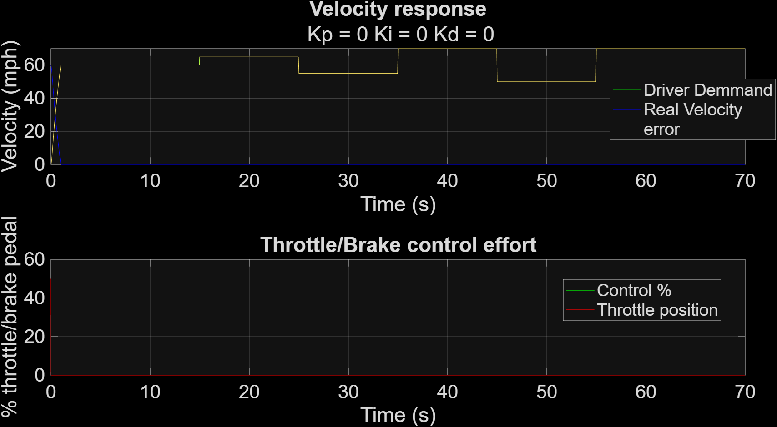
Figure 17 – PID Tuning (P=0, I=0, D=0)
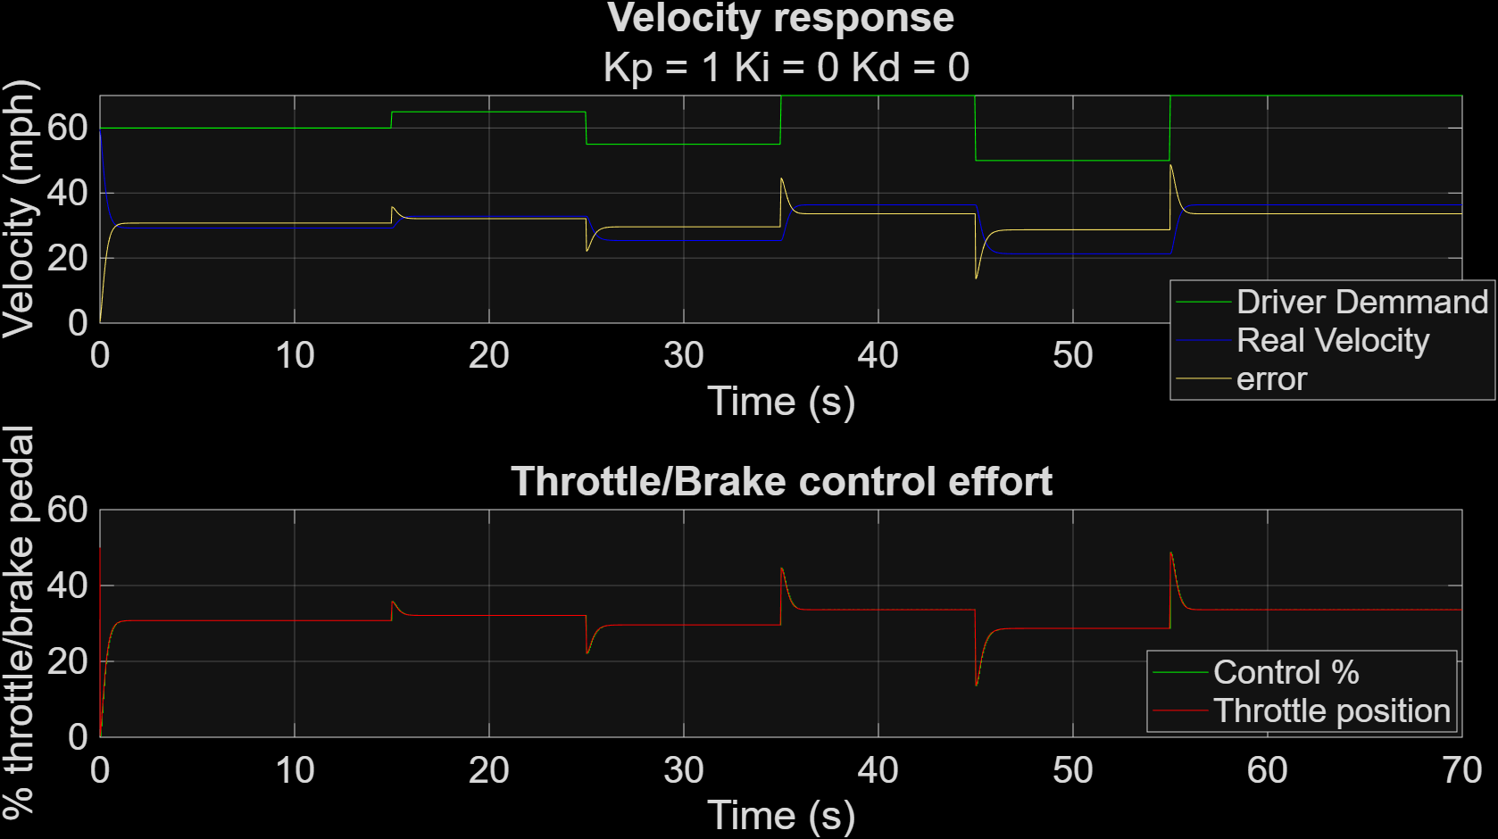
Figure 18 – PID Tuning (P=1, I=0, D=0)
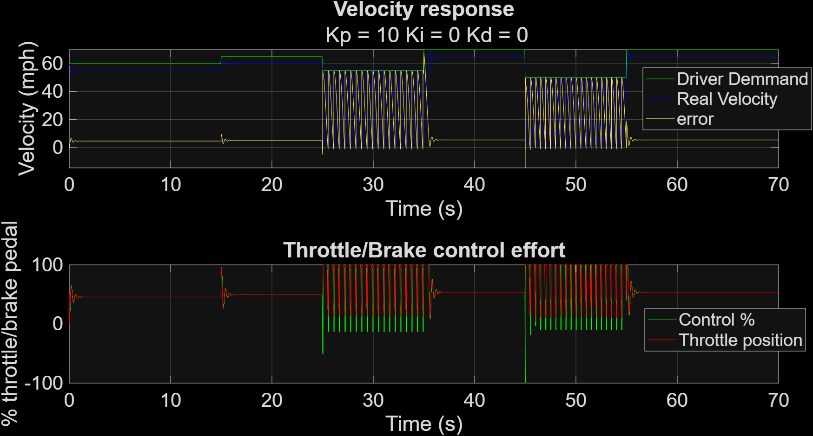
Figure 19 – PID Tuning (P=10, I=0, D=0)
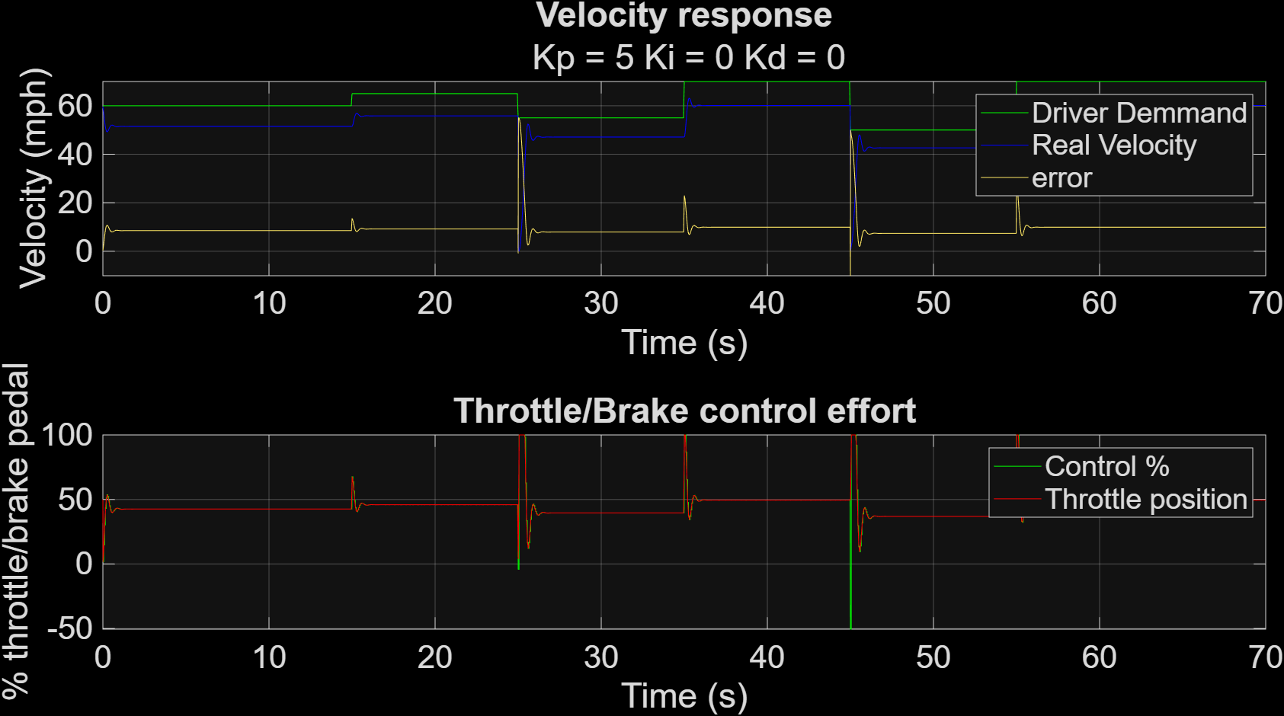
Figure 20 – PID Tuning (P=5, I=0, D=0)
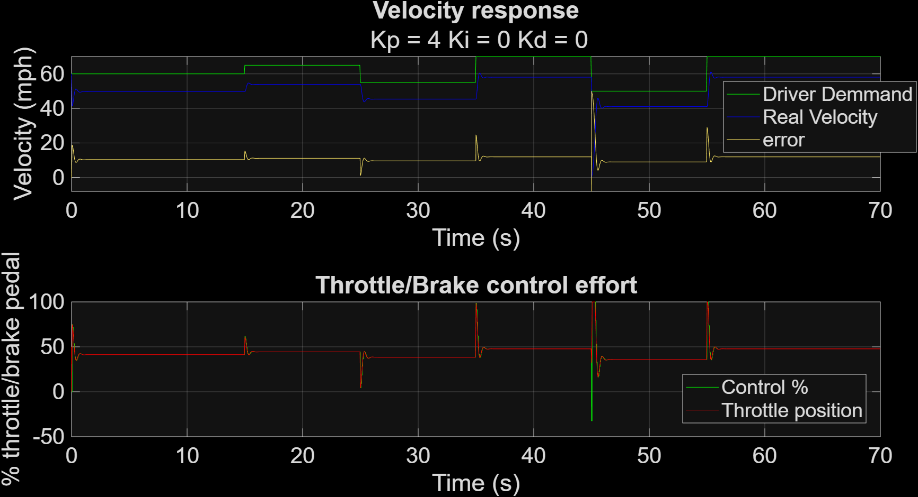
Figure 21 – PID Tuning (P=4, I=0, D=0)
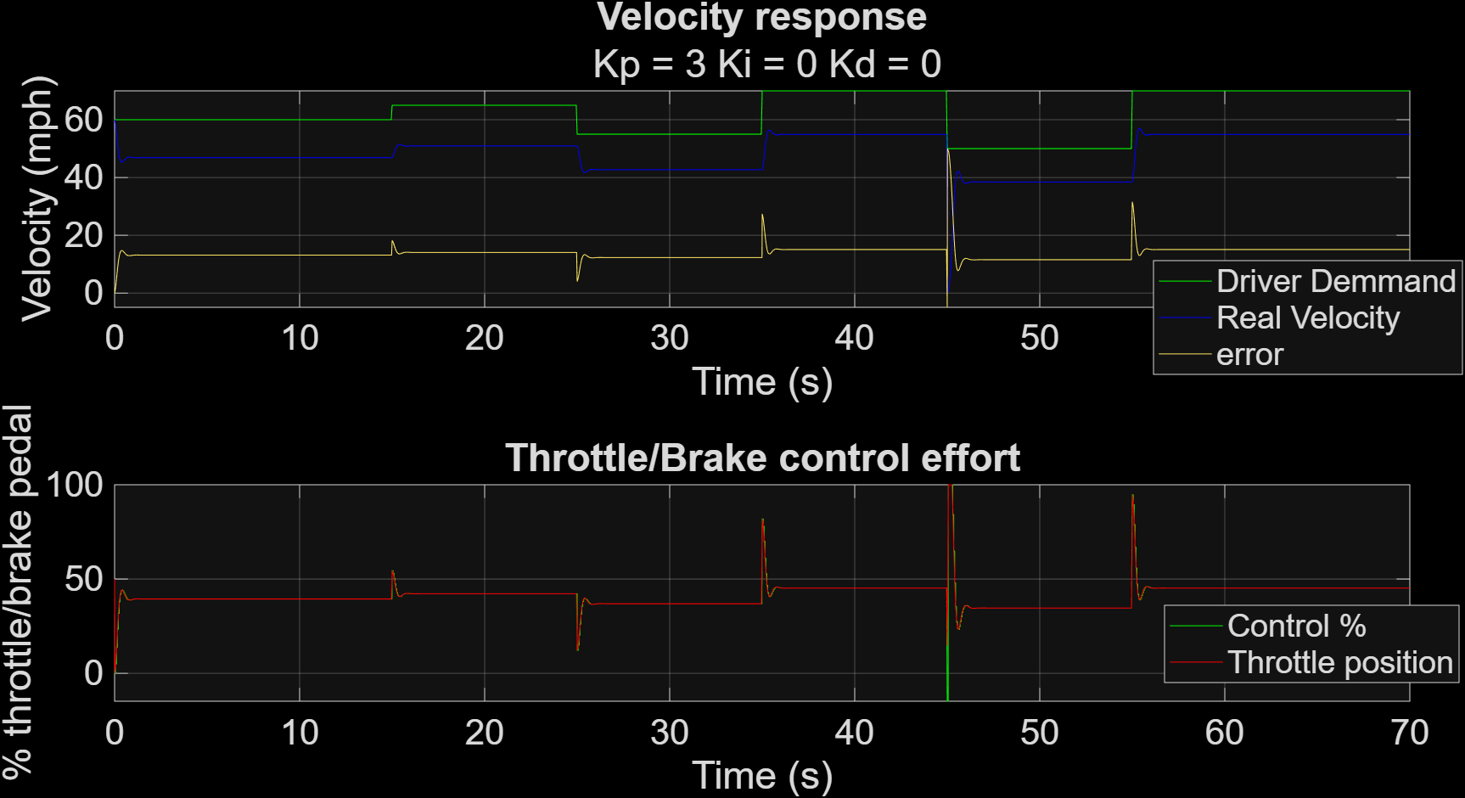
Figure 22 – PID Tuning (P=3, I=0, D=0)
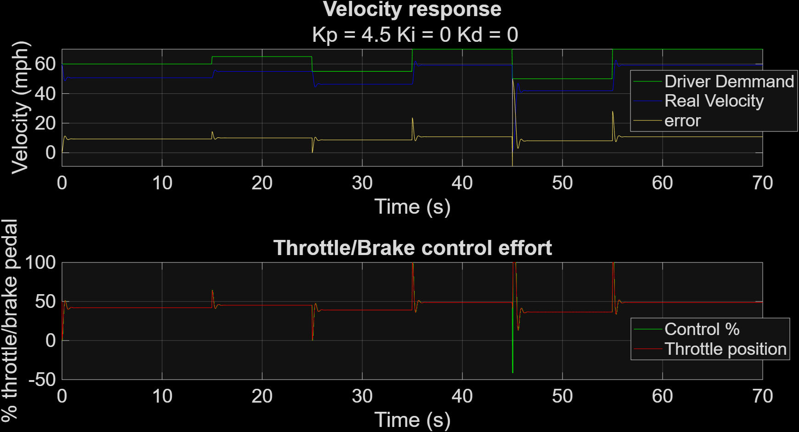
Figure 23 – PID Tuning (P=4.5, I=0, D=0)

Integral
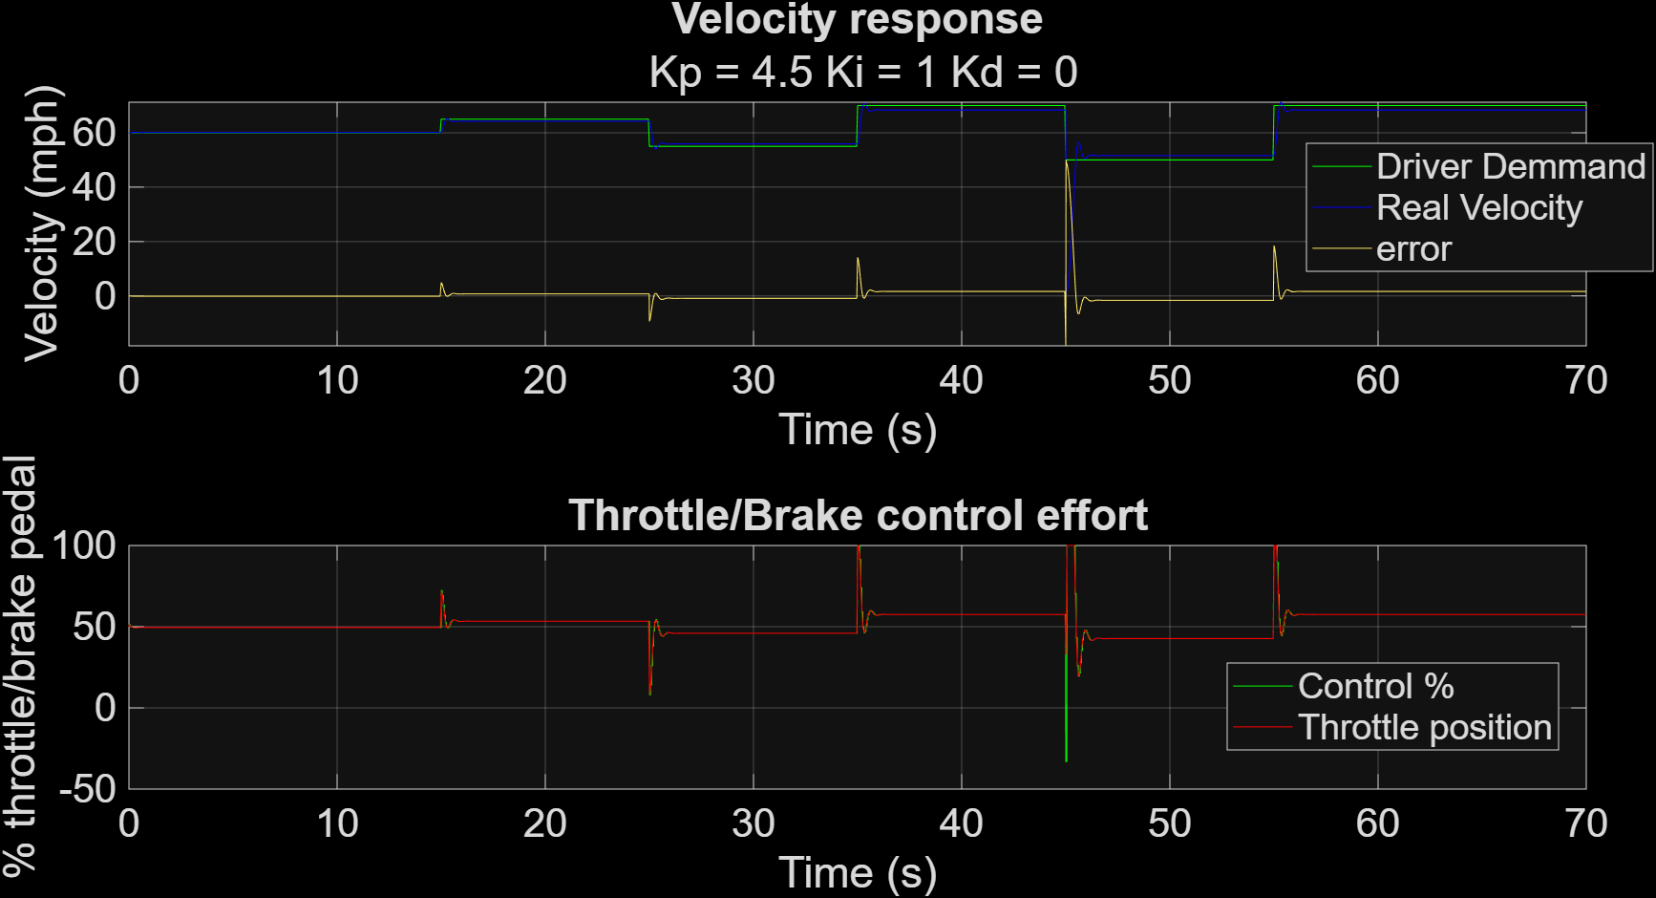
Figure 24 – PID Tuning (P=4.5, I=1, D=0)
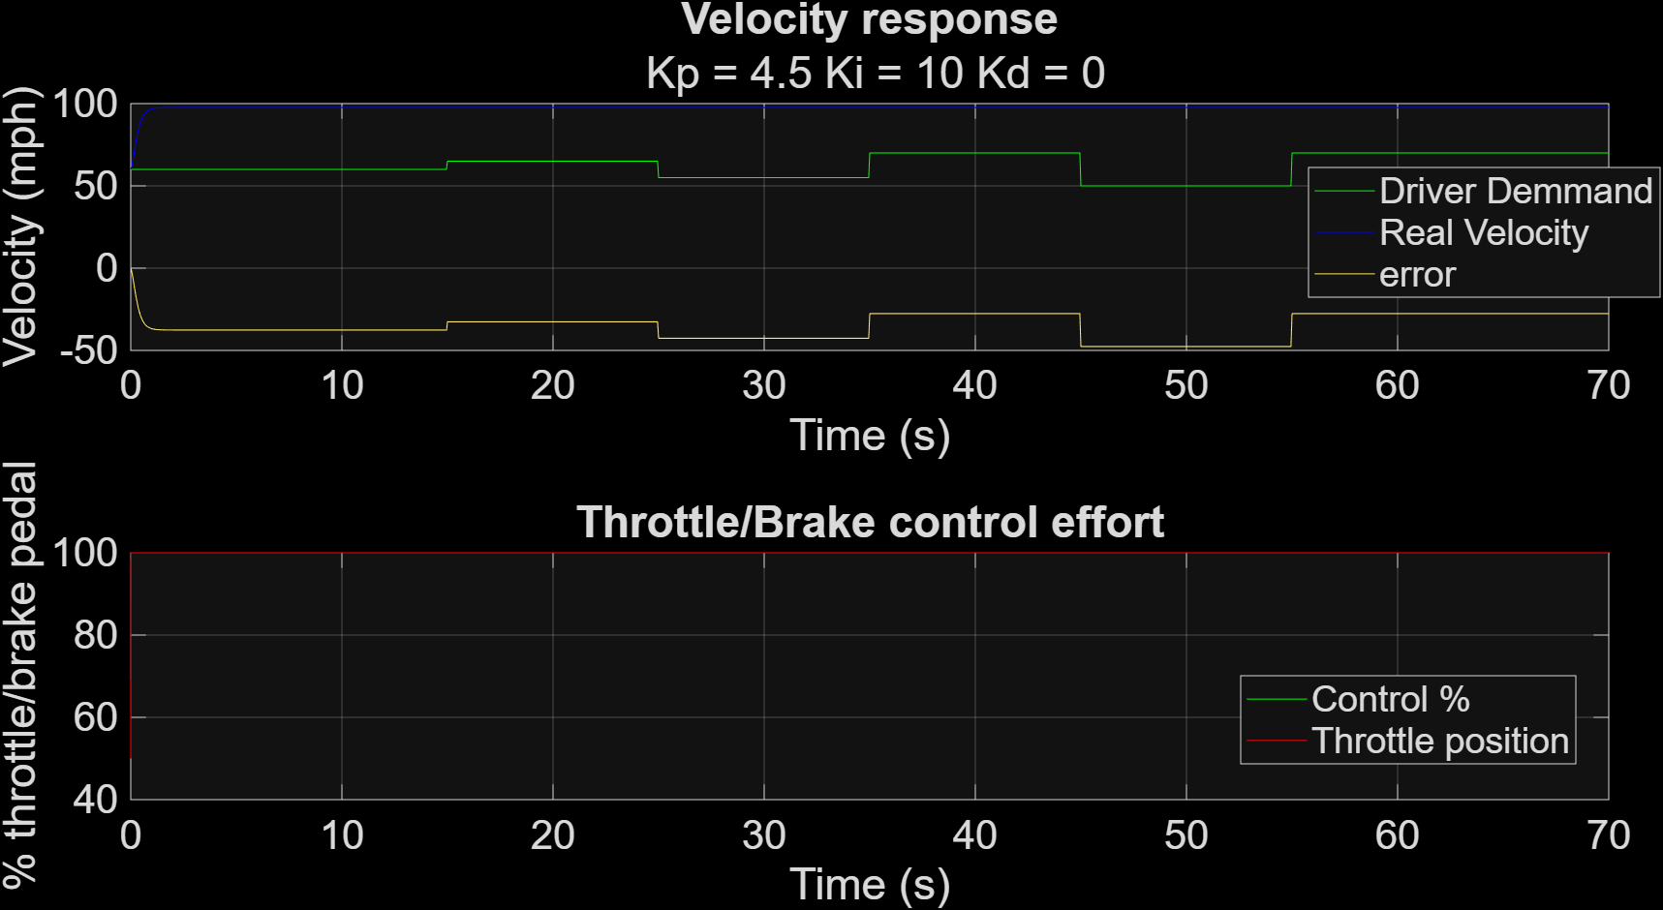
Figure 25 – PID Tuning (P=4.5, I=10, D=0)
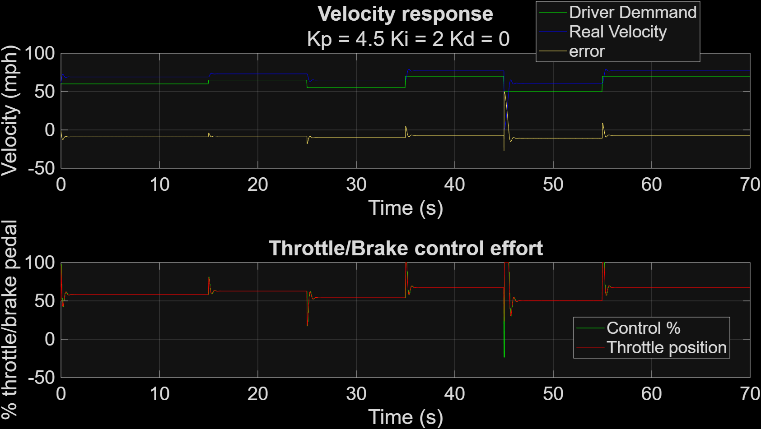
Figure 26 – PID Tuning (P=4.5, I=2, D=0)
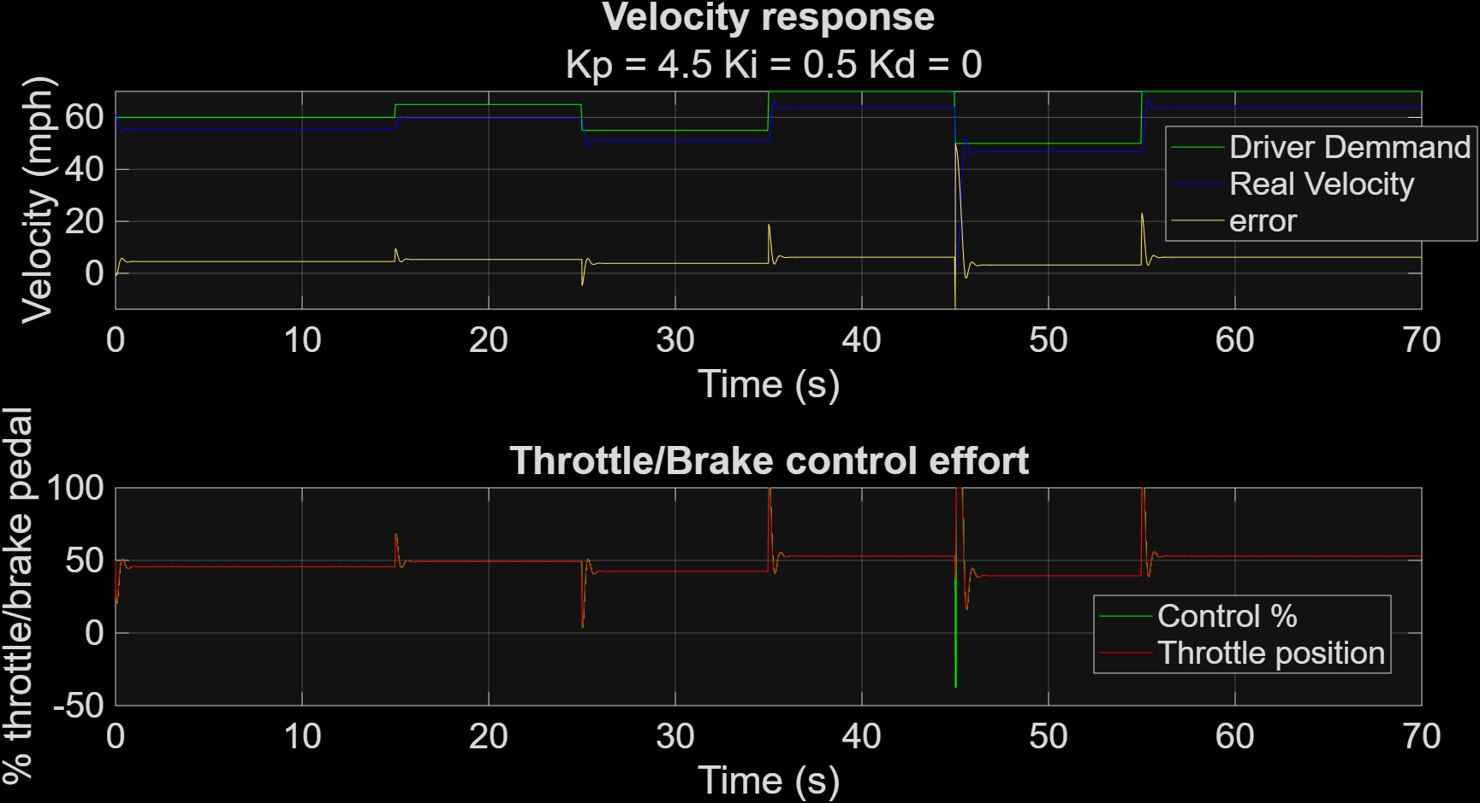
Figure 27 – PID Tuning (P=4.50, I=0.5, D=0)
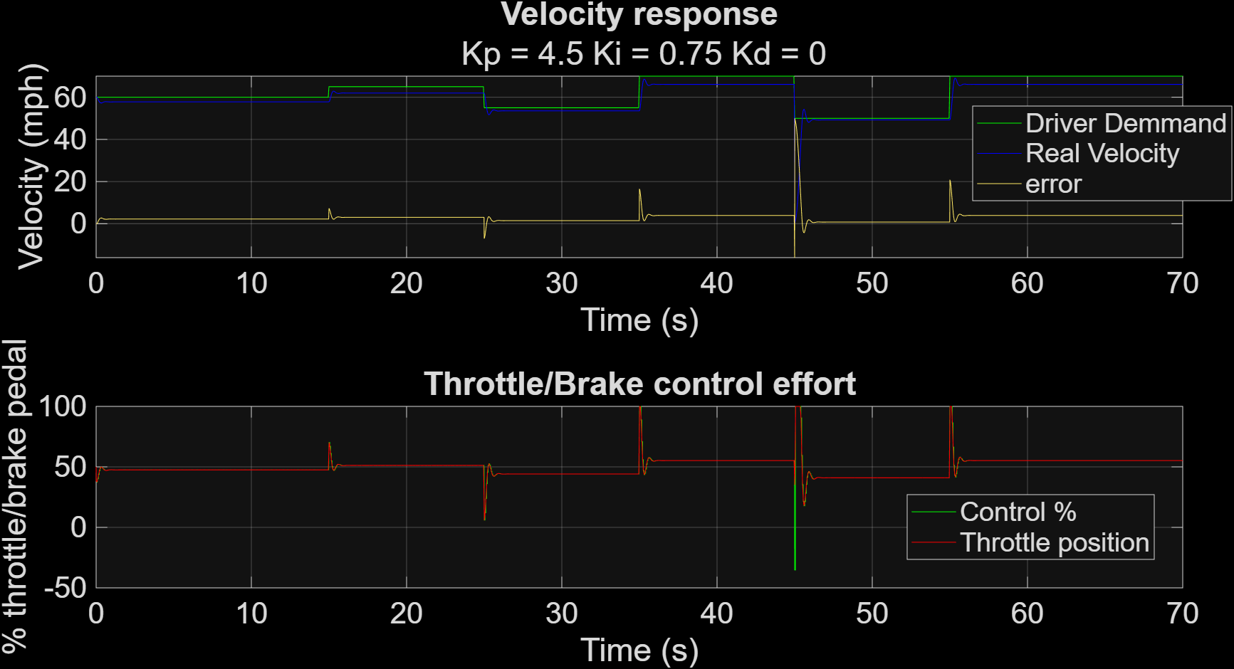
Figure 28 – PID Tuning (P=4.5, I=0.75, D=0)
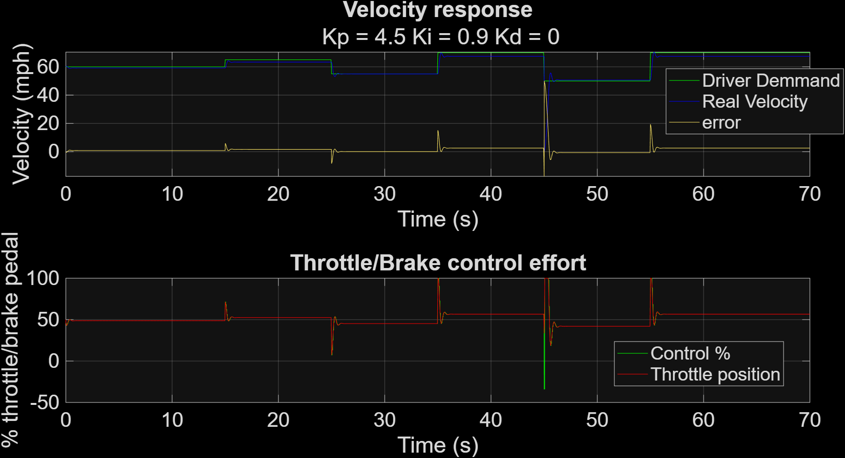
Figure 29 – PID Tuning (P=4.5, I=0.9, D=0)
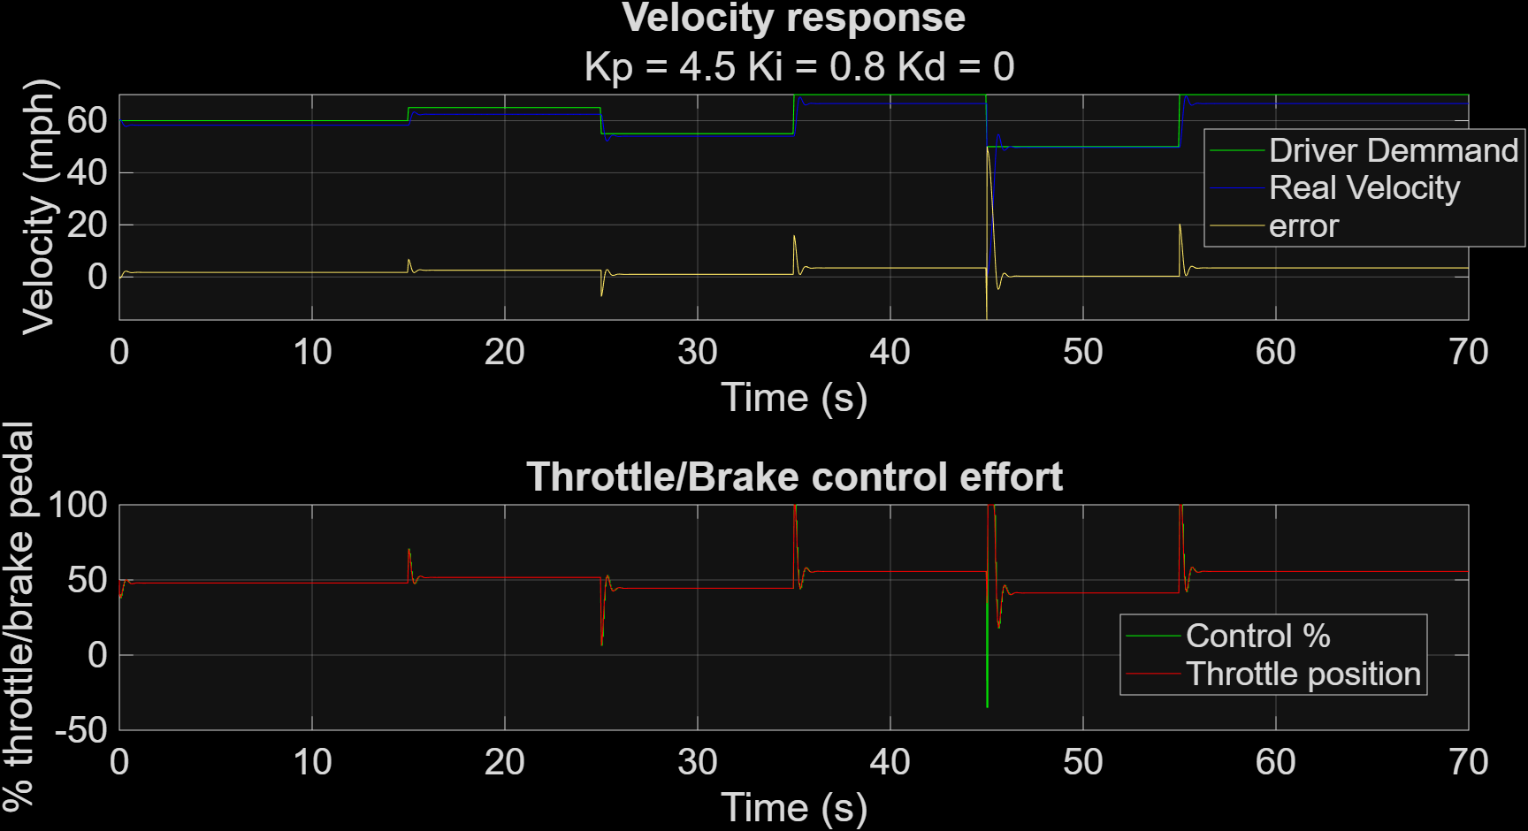
Figure 30 – PID Tuning (P=4.5, I=0.8, D=0)
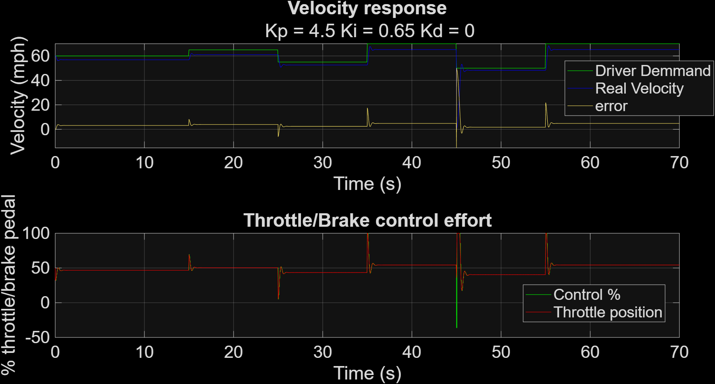
Figure 31 – PID Tuning (P=4.5, I=0.65, D=0)
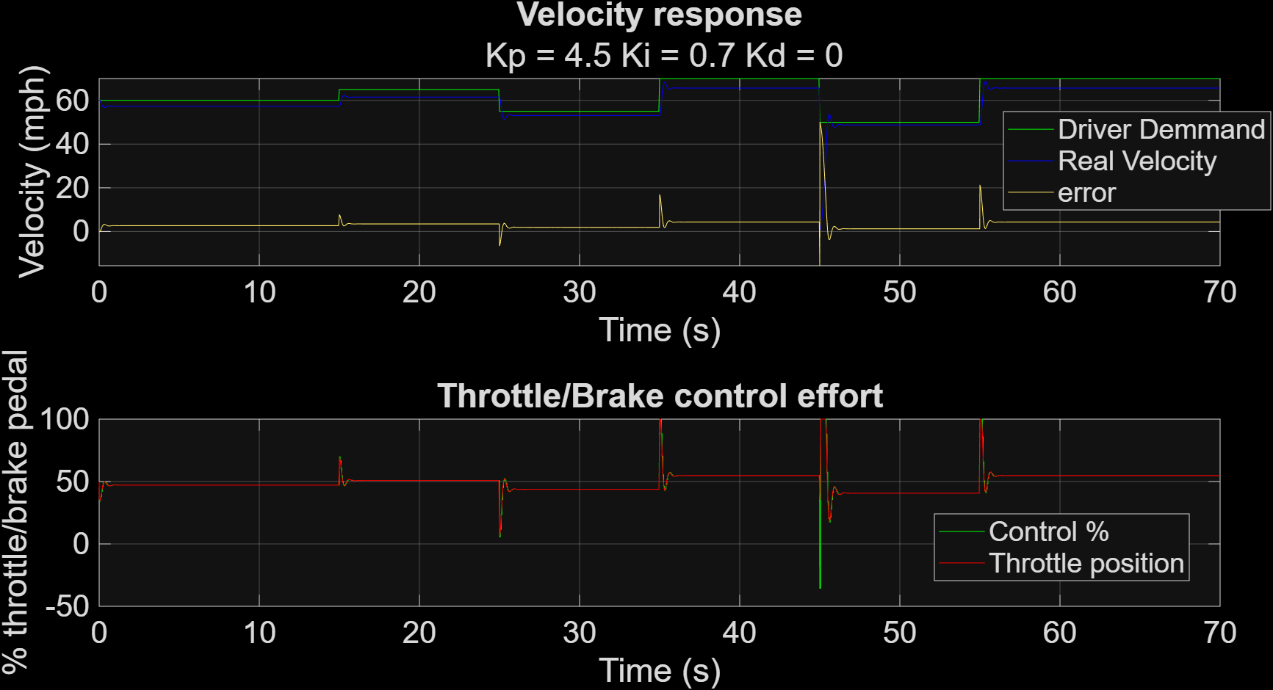
Figure 32 – PID Tuning (P=4.5, I=0.7, D=0)

Derivative
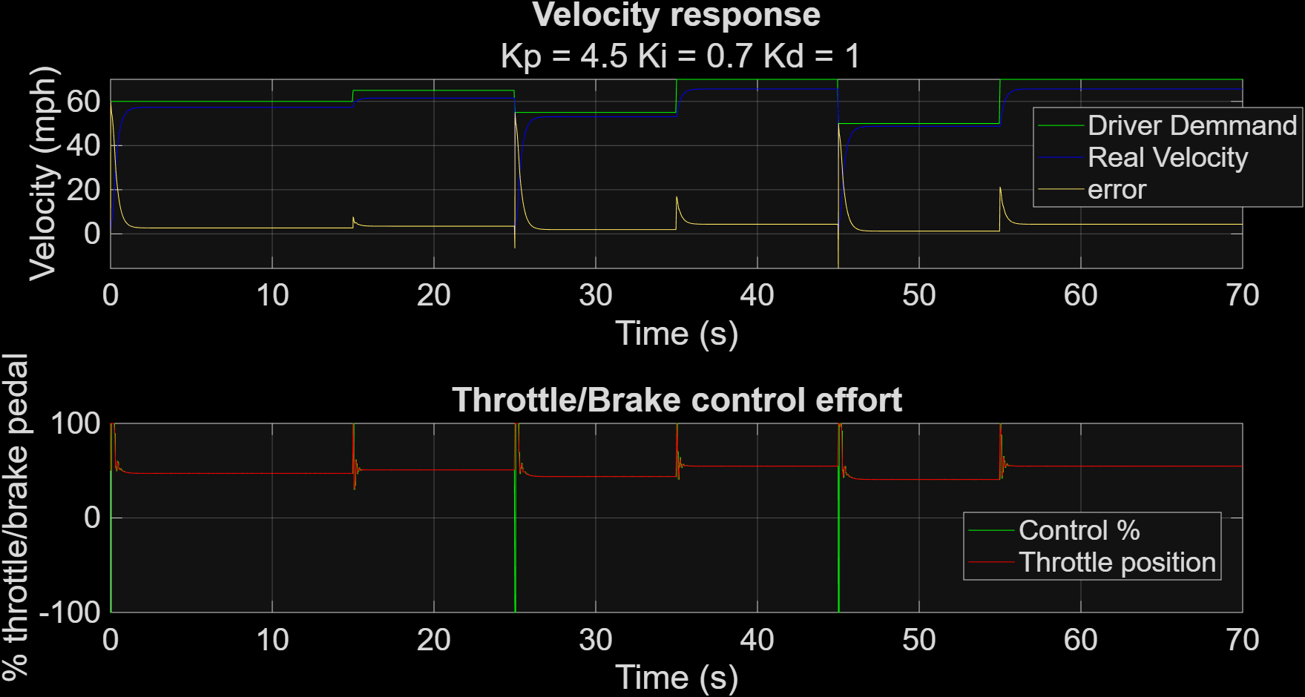
Figure 33 – PID Tuning (P=4.5, I=0.7, D=1)
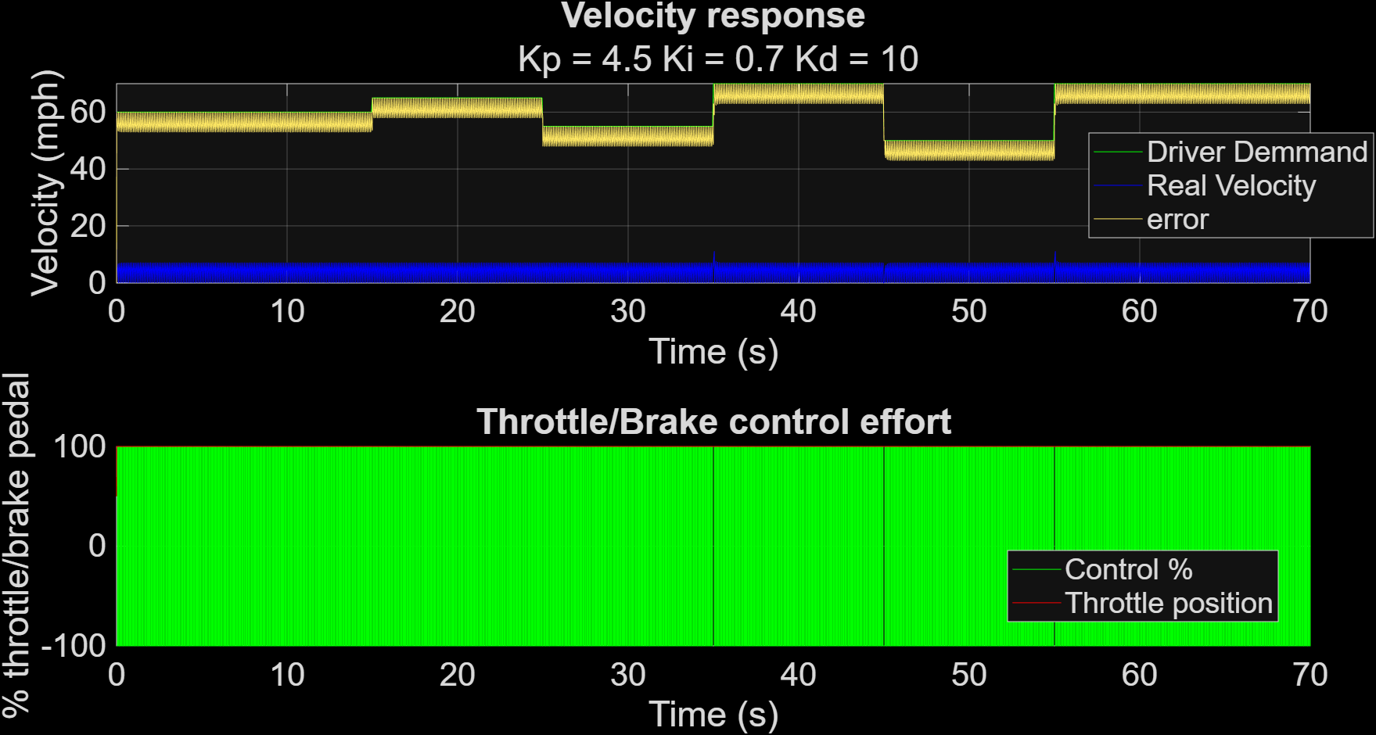
Figure 34 – PID Tuning (P=4.5, I=0.7, D=10)
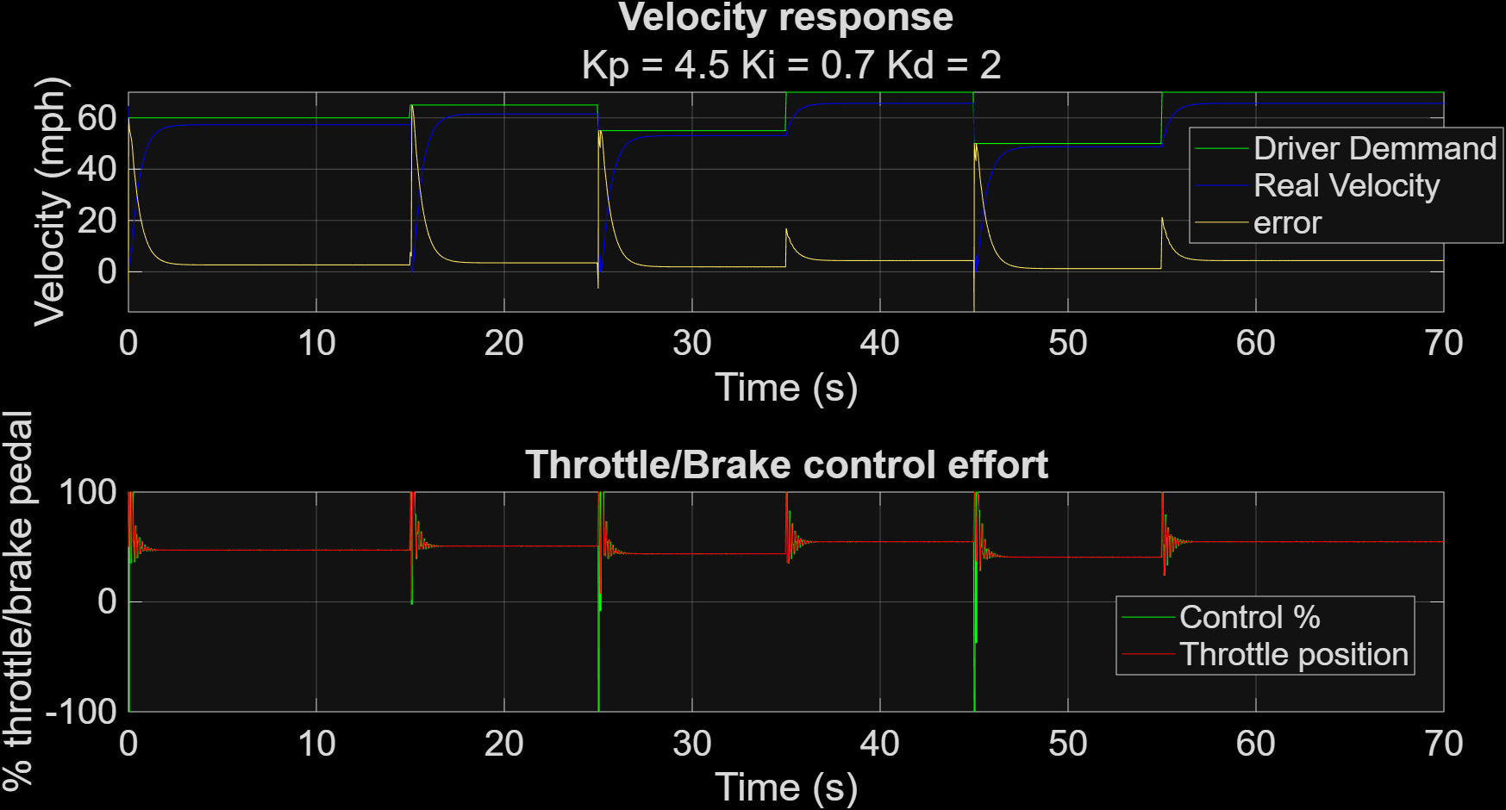
Figure 35 – PID Tuning (P=4.5, I=0.7, D=2)
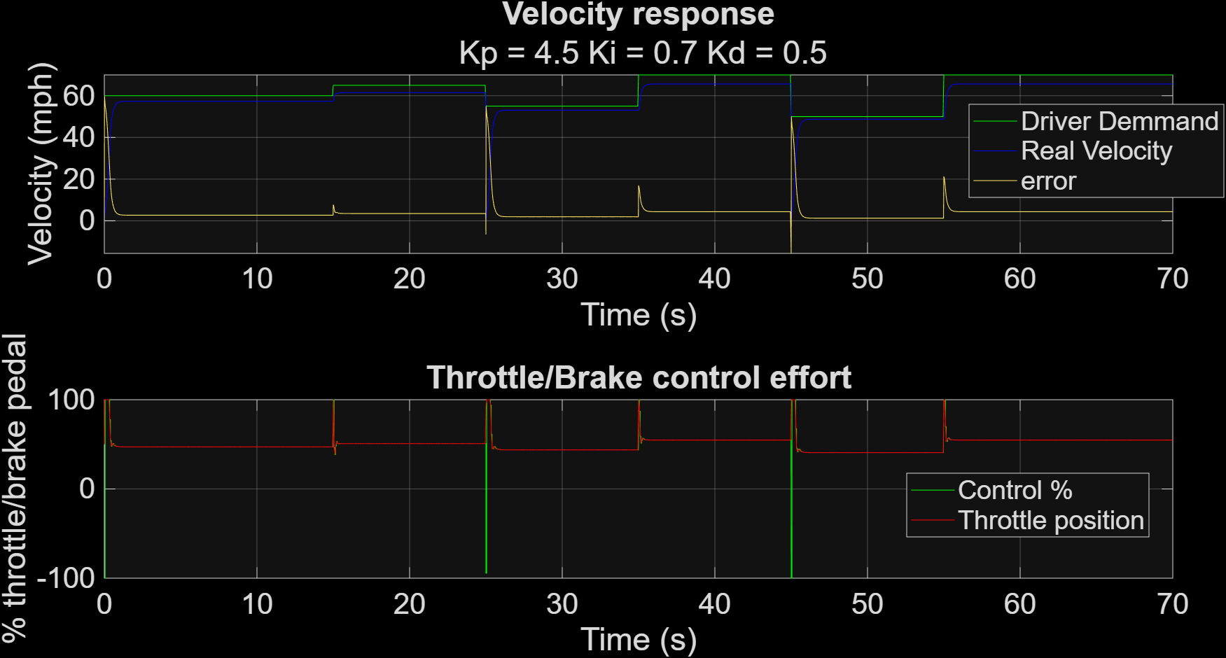
Figure 36 – PID Tuning (P=4.5, I=0.7, D=0.5)
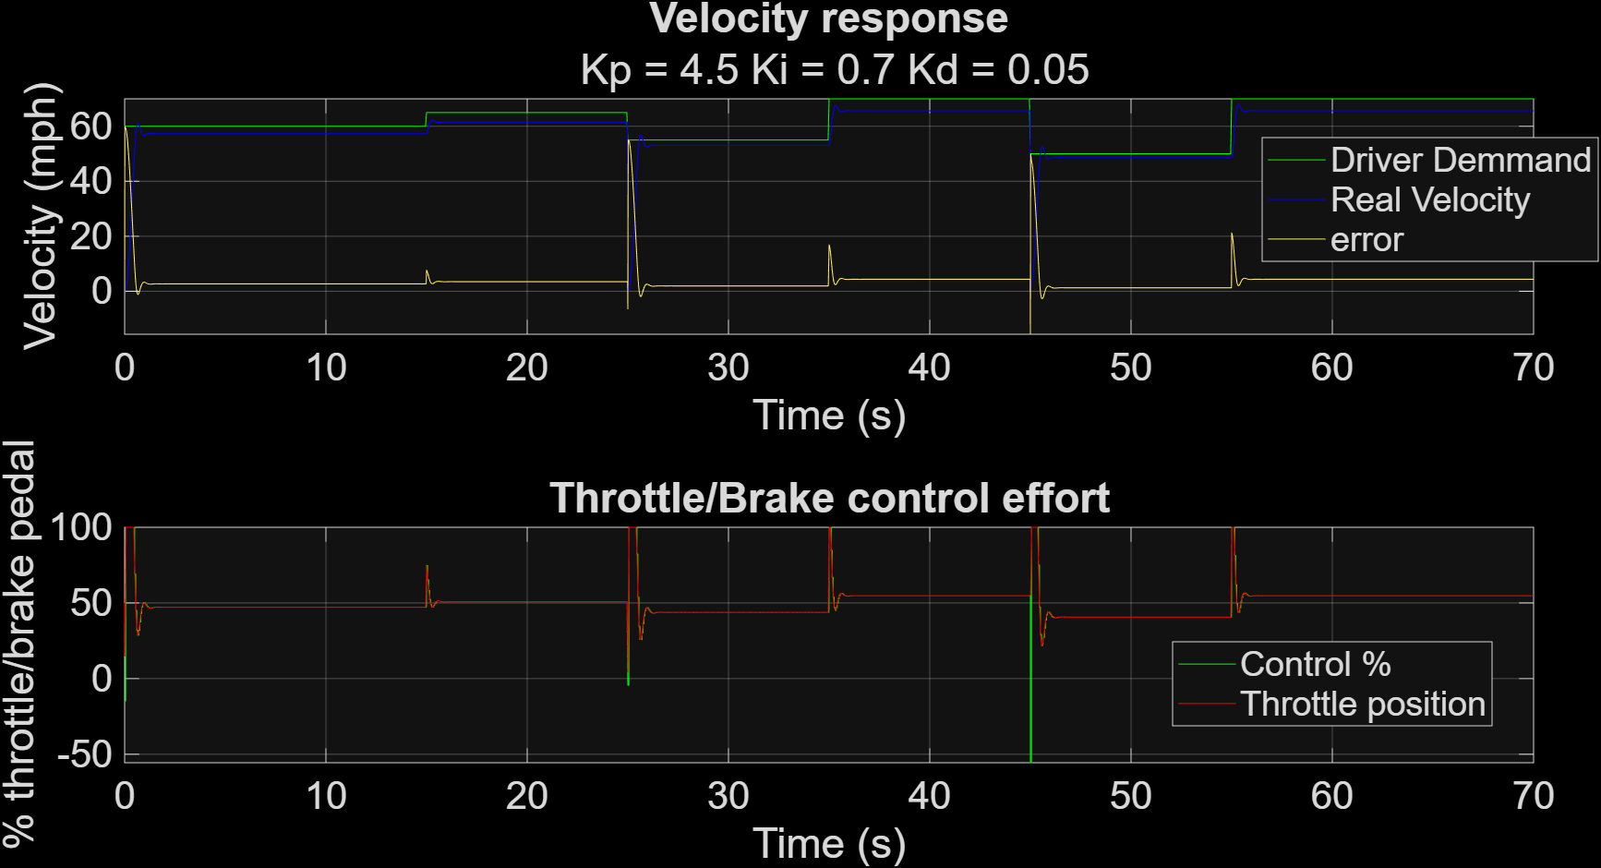
Figure 37 – PID Tuning (P=4.5, I=0.7, D=0.05)
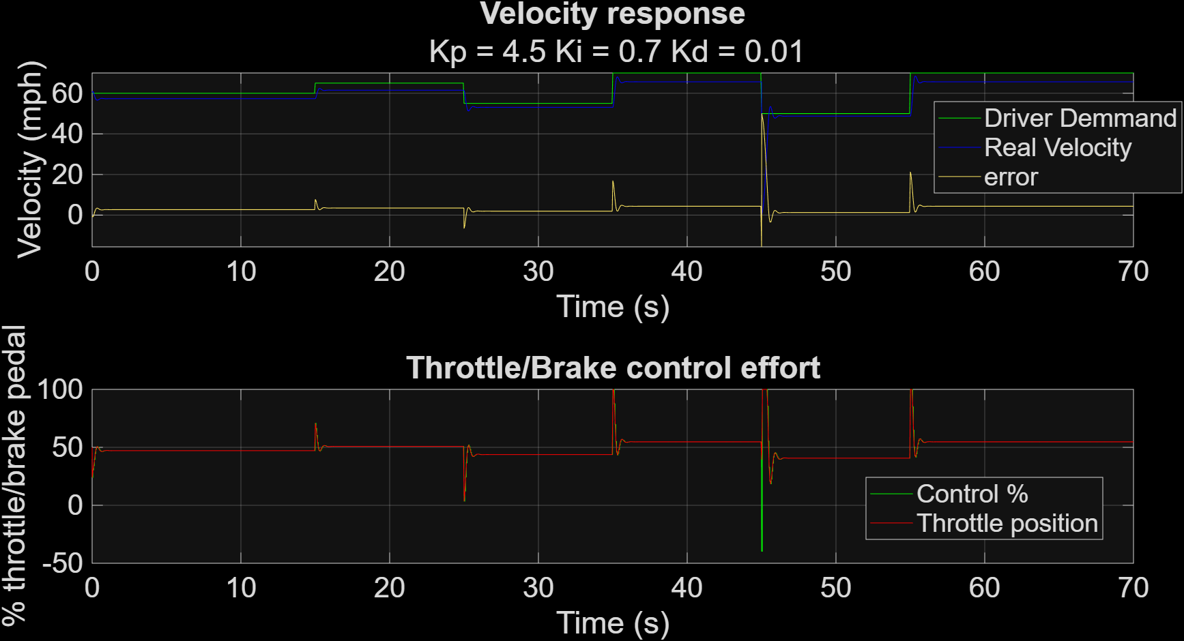
Figure 38 – PID Tuning (P=4.5, I=0.7, D=0.01)

Overall Fine Tune
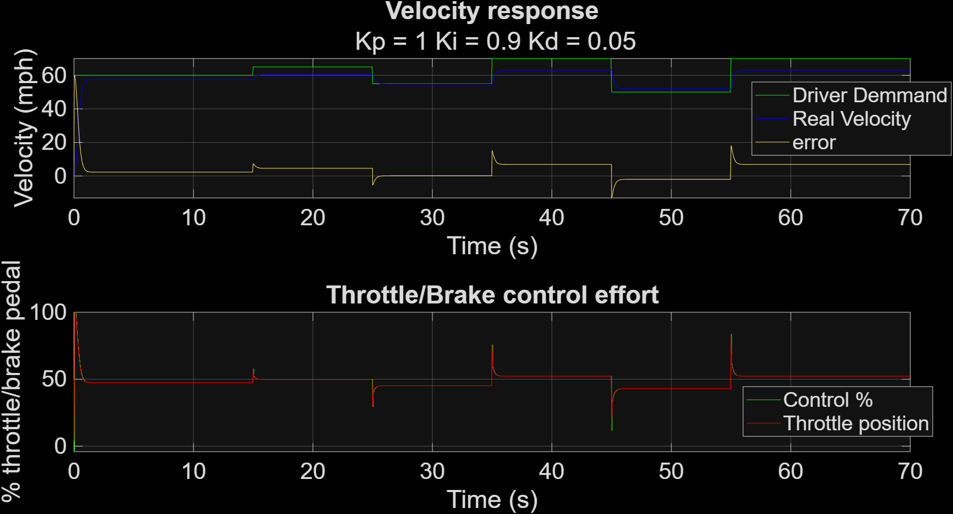
Figure 39 – PID Tuning (P=1, I=0.9, D=0.05)
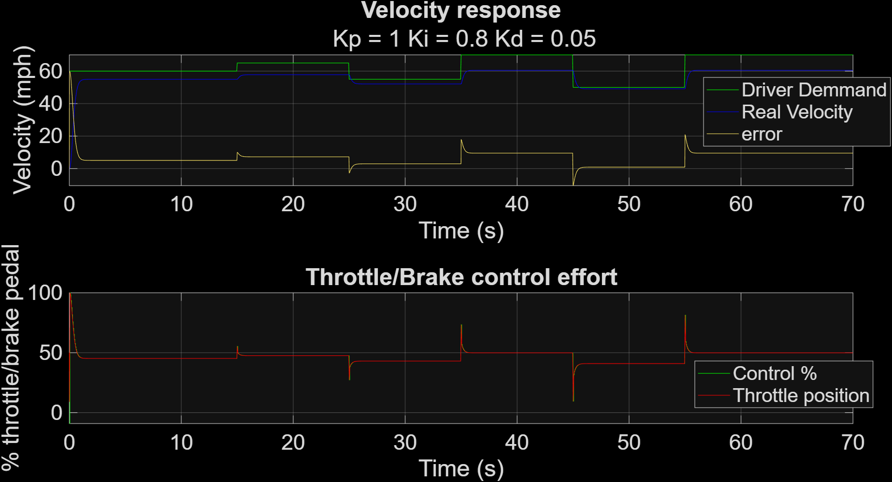
Figure 40 – PID Tuning (P=1, I=0.8, D=0.05)

Time Step Impact
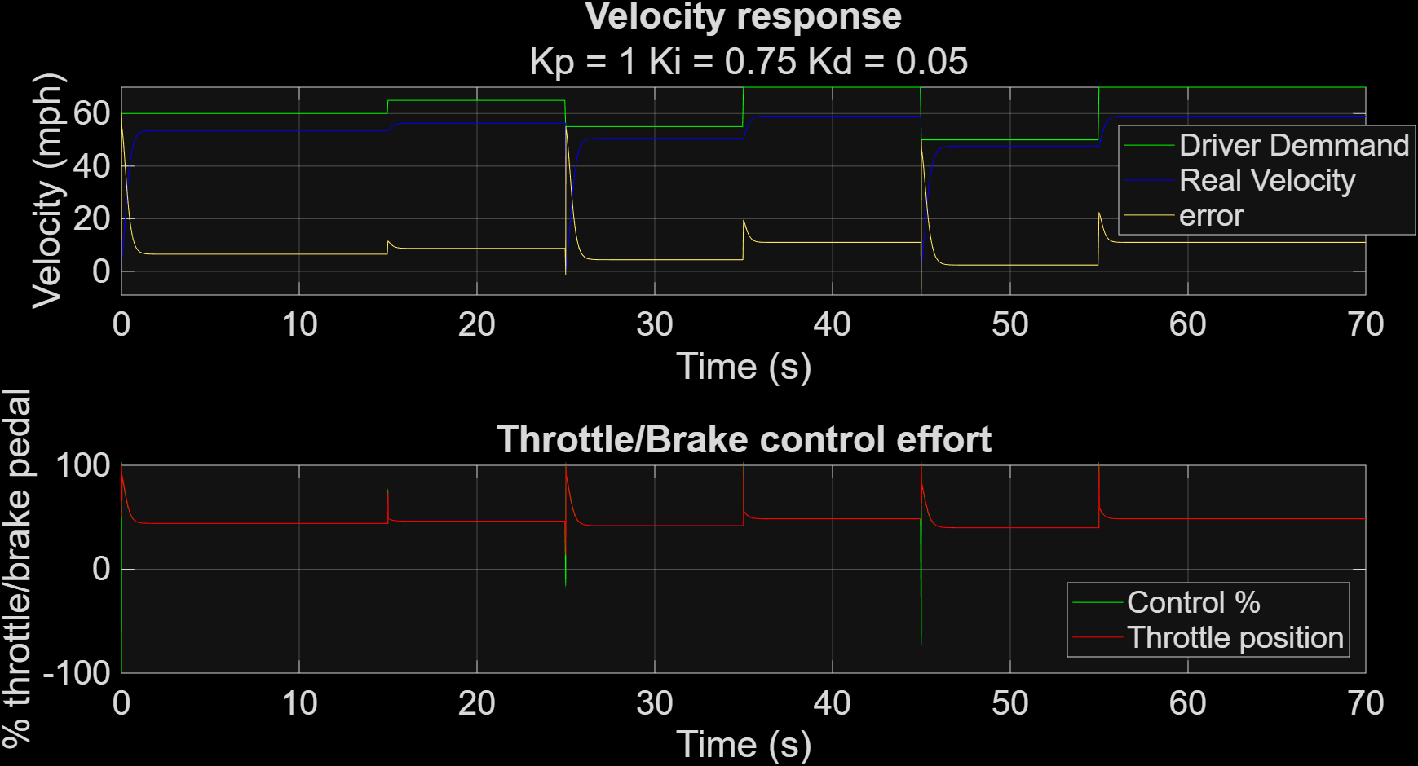
Figure 41 – Time Step Impact (Ts = 0.01s)

Signal Delay Impact
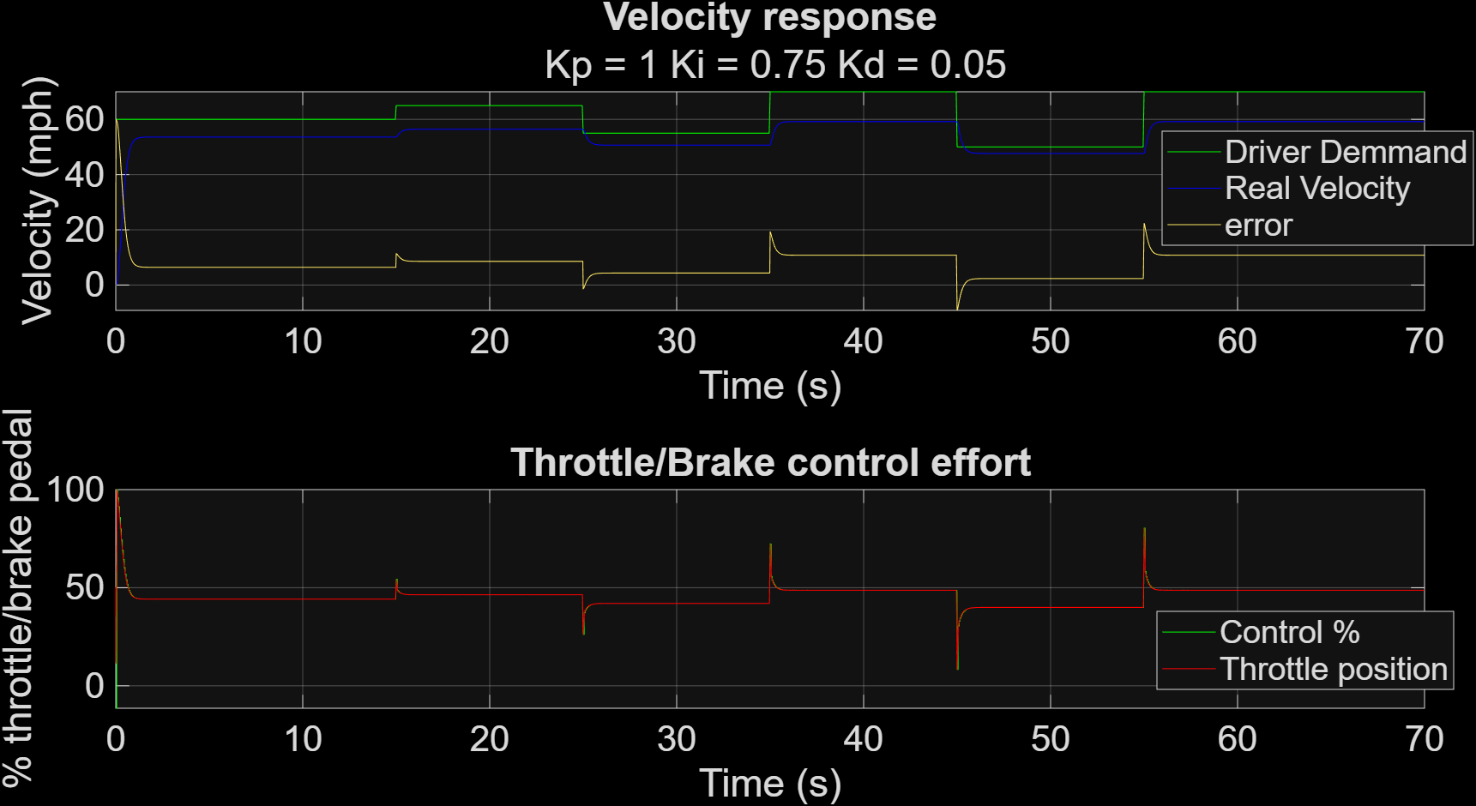
Figure 42 – Signal Delay Impact (-1.00s)
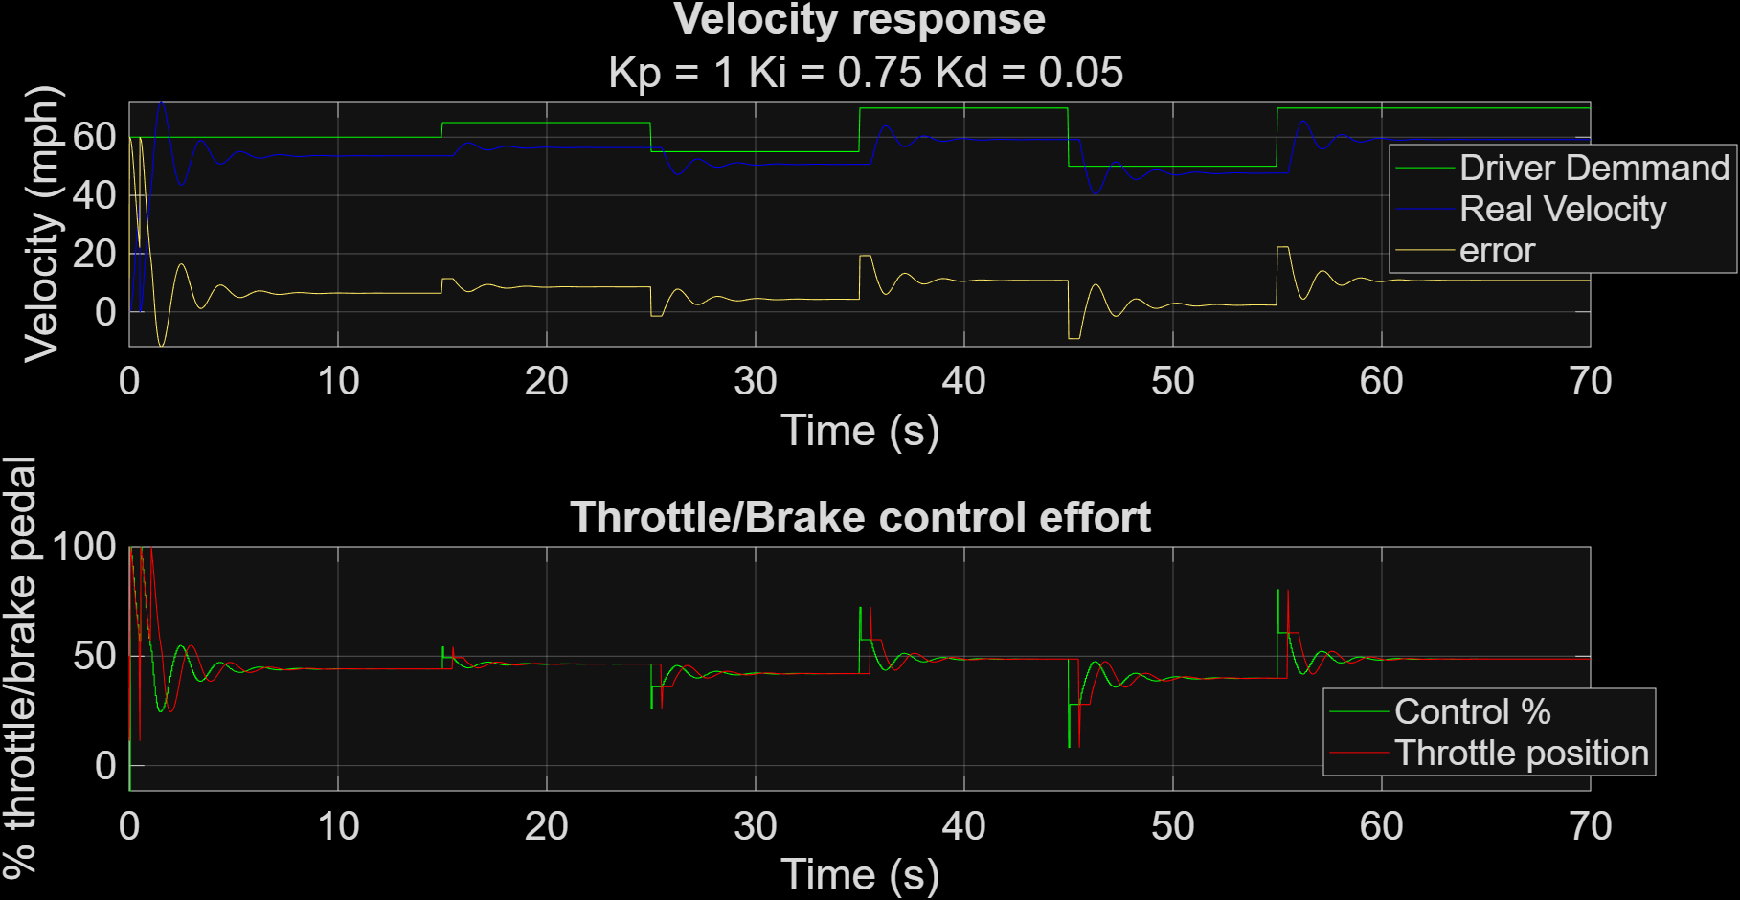
Figure 43 – Signal Delay Impact (0.50s)
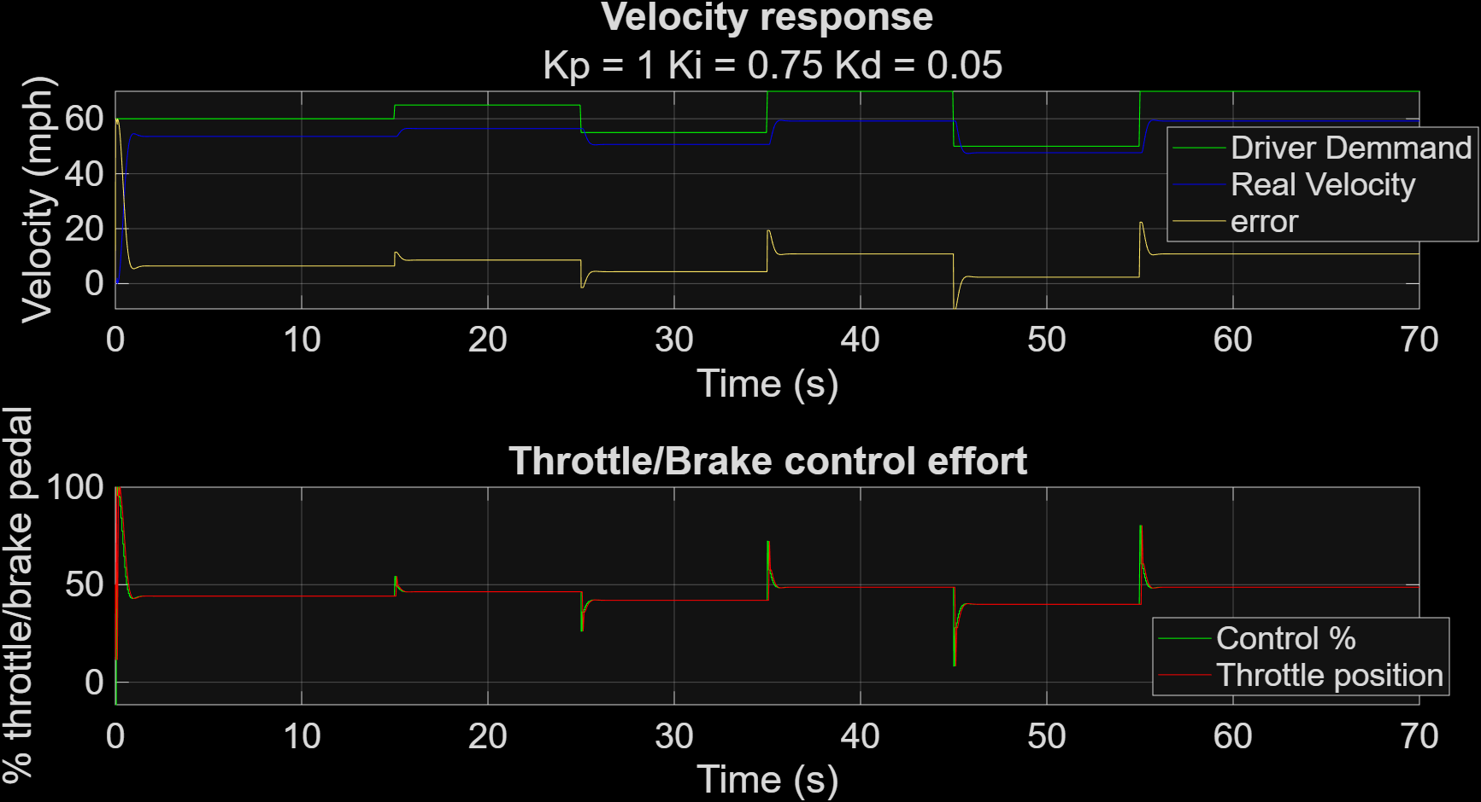
Figure 44 – Signal Delay Impact (0.10s)

Number of Bits Impact
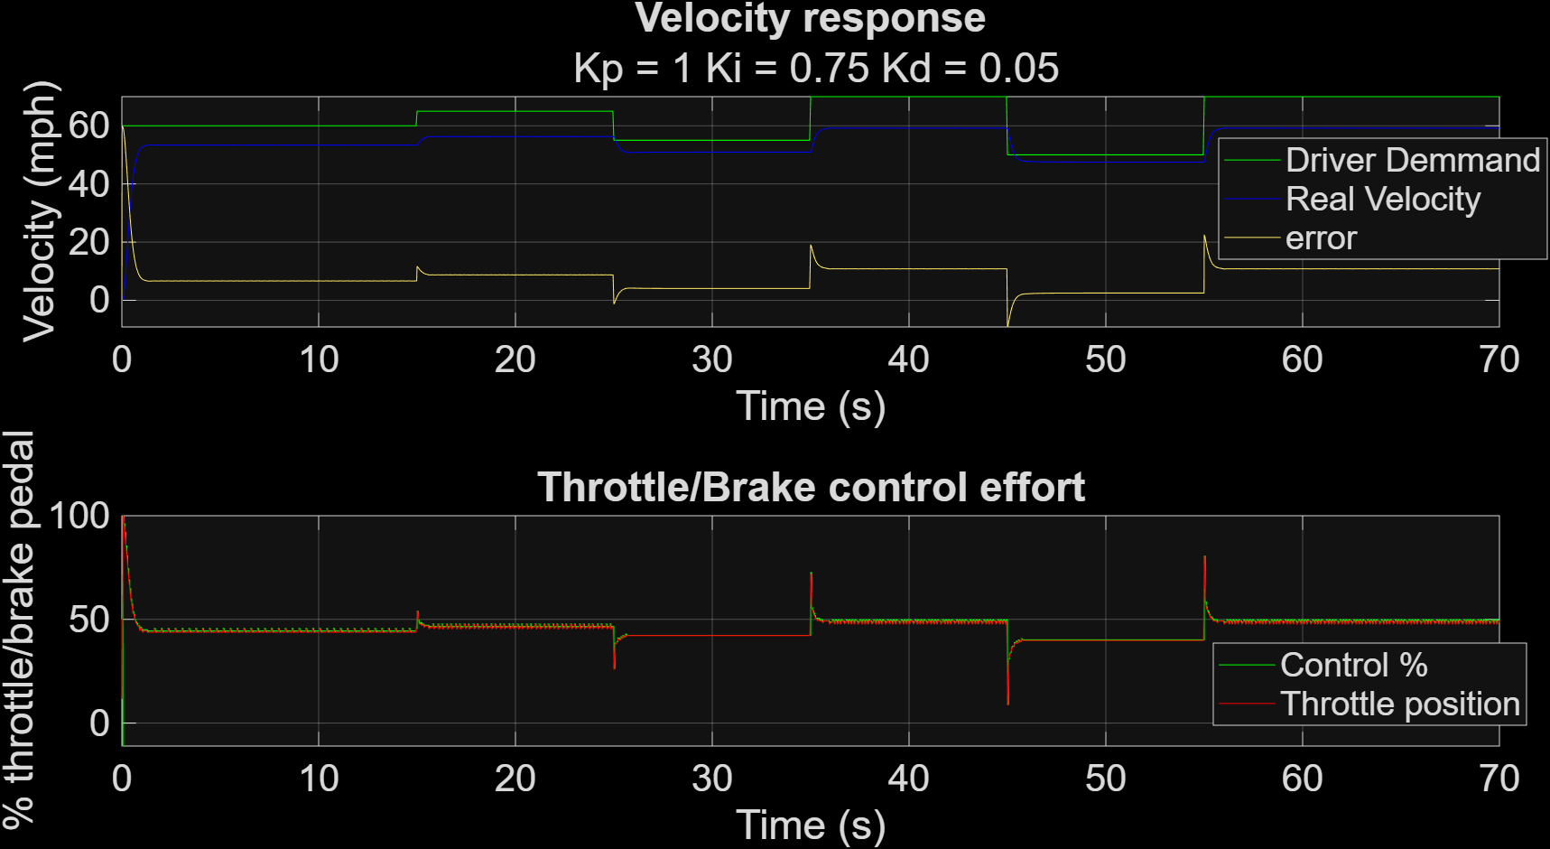
Figure 45 – Number or Bits Impact (8 Bit)
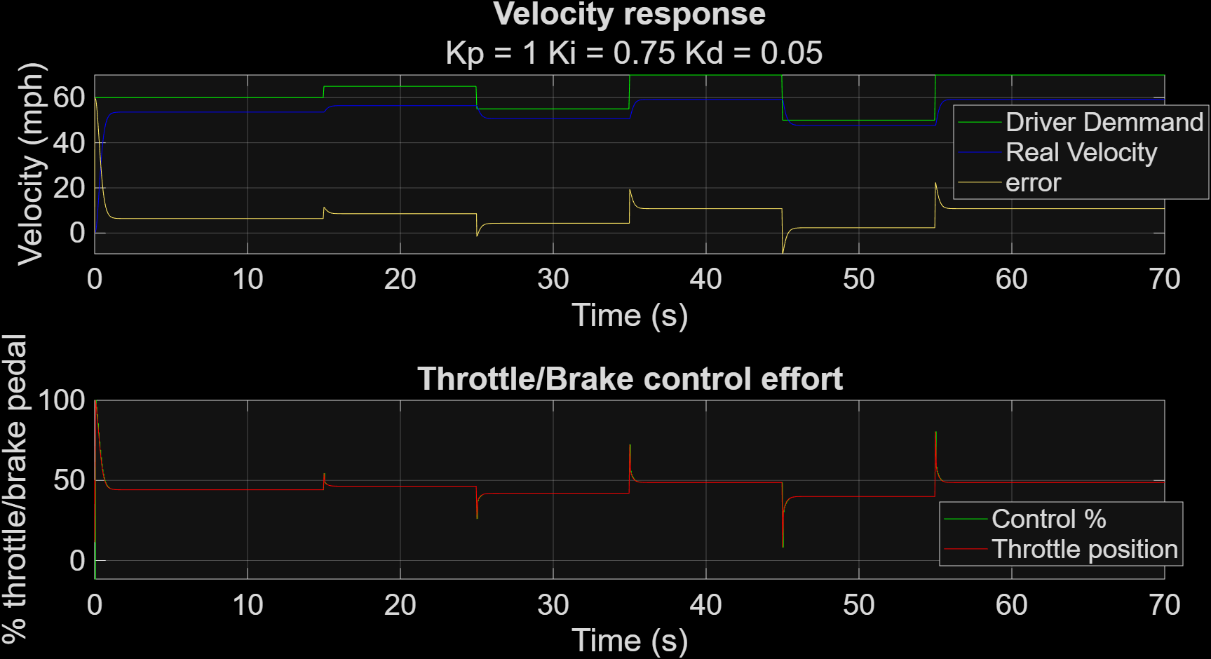
Figure 46 – Number or Bits Impact (32 Bit)

