

ACCA5012

Design and implement a 2D platform game in Unity

By
Rebecca Ryall
1705433



Table of Contents
Table of Figures 2
Introduction 3
Application Development Concepts 3
Mobile gaming 3
Requirements 4
The game levels 4
How to play the game 4
The gameplay identifying player-centric challenges and actions 5
Design and Implementation 5
Chosen Design 5
Evaluation 8
Testing Images of working game 8
Test sheet 9
Errors/ complications 9
References 10

Table of Figures
Figure 1 Game Background[4] 5
Figure 2 Santa[5] 6
Figure 3 present[6] 6
Figure 4 snowman[7] 6
Figure 5 helpful snowman[7] [6] 7
Figure 6 scene cloning working 8
Figure 7 health bar, present count, timer, magic dust working 8
Figure 8 Unable To Open Sprite Editor[8] 9

Introduction
This document will cover a break down of the 2d game how the game is played, images of the game running, as well as multiple test done on the game and a breakdown of what the game was intended to do. The 2D platform game built in Unity is named Saving Christmas, the game story is that Santa has accidently dropped all the presents out of his slay. the objective of the game is to collect all the presents that Santa dropped before they fall down the mountain, you need to be fast or Santa will not have enough time to deliver all the presents for Christmas morning.

Application Development Concepts

Mobile gaming
Mobile phone gaming iOS and android are known as the main competitors when it comes to Mobile games applications, most game applications are created to be used on either one of these platforms as gaming industry as progressed so has mobile gaming. overtime it become much bigger than previously thought due to new phones being released with more powerful hardware, that allow for more detailed designed games to be played on them with ease. The phones are not just designed in mind for gamers but for all customers needs the phones are improved with all features in mind but the phone companies are adding high specs and special modes that improve mobile phone gaming, gaming architecture as also been upgraded as newer game apps are more similar to the level of design and performance of some console and pc gaming experience and the gaming engines used to create them are cheaper then creating a pc or console game[1]. with a in depth game story and more immersive content to keep users interested, with more variety of game levels and difficulty modes then previous app game as well with all phone being compatible with either the app store or play store. purchasing game apps has gotten much easier, meaning children are also able to benefit from the evolution of game apps. Games are now being created in mind to improve education and learning which has helping fund the new and relative games being released today. also game companies are creating well established games released on either console or pc games in to mobile app games to keep up with the new trend of gaming app[2][3].
The evolution of mobile games is changed drastically in the last few years 3d games are a lot more common as technology is able to handle the visual content allowing players to game whenever and wherever they chose with thousands of games available to download in a mater of minutes and most the games are not expense still a vast majority are free with advertisement with most game and built in stores to get users to spend more money. Action videos games such as driving or racing games to First person shooter games are more common now with a choice of these 2d or 3d game[4].

Requirements
The games is a simple 2d platform where you control Santa in his sled with his reindeers pulling him along he is leaving the north pole when he accidently knocked the bag of present off the sled and now need to retrieve all but the presents have fallen down a mounting peek and are rolling down getting lost in the snow. Santa must collect them fast or he won’t be able to deliver all the presents in time for chiasmas morning.

The game levels
The many rule of the game is If Santa’s health bar becomes empty or you don’t collect enough present in the set time, then it’s game over this if a set rule in all game levels.
The rule for the first level is to collect 150 present points in 3 minutes what out there are a lot of trees making it hard to see. some snowmen have caught some of the falling presents and are going to hold on to it for Santa to pick them up well the other presents have scattered around. make sure you get them all but be careful to watch out for the spinning spikes they hurt Santa and his reindeers they could be hiding behind the trees so look out.
In level two the game gets a little tricky as you have only 2 minutes to collect 175 present points , you need to be careful of the spike as there are lot more, you still need to collect the loose presents and the present the helpful snowman are holding. There are a lot harder to see as the trees have gotten thicker so need to be careful, there are some changes from the first level as there are now two different snowmen. the helpful snowman from the first level is still helping but there is another snowman. These new snowmen are not to be trusted they are bad snowmen they don’t want to help you collect the presents they want them for themselves if you mistake a bad snowman for a helpful snowman your present count will be deducted.
Level three has some differences and similarities you have 2 minutes, but this time need to collect 200 present points. There is only the helpful snowman to collect the presents from the game level still containing the two opponents the first one being the spikes that deduct your health, the second being the bad snowman who will deduct your present count. So make sure to not accidently mistake him for the helpful snowman and watch out as the trees have gotten very thick. its begun to snow which has made visibility poor making it difficult to tell which snowman is who? as well as making it more difficult to see the spikes through the trees.

How to play the game
To control the game character (Santa) you just need to use click the left mouse trigger, to get Santa to fly up and go straight you must hold down the trigger in short bursts, if you just hold down the left trigger without releasing the trigger Santa will go to the very top and go across the screen you need to release the trigger to allow Santa to fall down to collect the presents.
The goal of the game was to have all 3 levels working and playable but due to time restrains and lack of knowledge wasn’t able to complete the game in full working order. The game plays through the first level and the menu design and button have me created. the game doesn’t have an end point just as yet and must be stop manually once reached the goal.

The gameplay identifying player-centric challenges and actions
The game design is set in such a way to give the play a fun and festive experience with the short storyline adding context to the games objective, the game challenges the player in different way one by choosing the correct time to release the trigger or to press the trigger depending on the location of the collectible objects. Secondly by different obstacles that may be in front of him that he needs to possibly dodge, by either dropping Santa down or by making him fly up. Thirdly timing is important Whereas dropping him at the wrong time could result in him getting hurt, if he loses all his live bar its game over for the user teaching the player to be careful. If dropping the play to often it could result in low him down which would result in loss of time to collect presents. The time is precious as the short time may stop the player reaching the goal of the game.

Design and Implementation

Chosen Design
The reasoning behind why background design for the saving Christmas 2d game was chosen was because the game is a Christmas themed background designed needed to convey this will out being too obvious. because the game is set on a snowy mountain the background image needed to match this. the chosen background as shown in figure 1 was perfect as it was light and Christmassy as well as showing a full moon to keep to the night before Christmas timeline the game is set in, the rounded snowy mountains and trees made it soft looking and playful.


Figure 1 Game Background[5]

The main character needed to be Santa Claus in his sled with the image of Santa as shown in figure 2 it needed to be edited to be able to be used. First the background of the image needed to be removed, then the presents in the slay on the image also needed to be removed as in the game Santa has lost all the presents out of the slay.
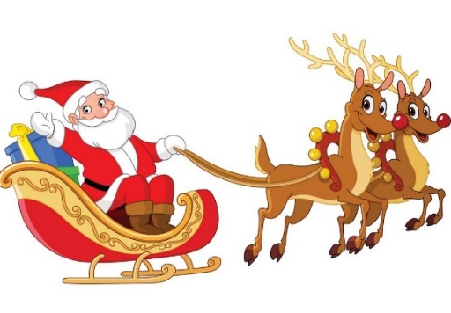
Figure 2 Santa[6]
When it came to creating the helpful snowman to be a game collectible, two separate images needed to be combine to be able to get the desired final design, one being the same loose present image shown in figure 3 that is used in the game as one of the collectibles. By editing and adding the present in to the snowman image shown in figure 4 was able to create the helpful snowman in figure 5.

Figure 3 present[7]

Figure 4 snowman[8]
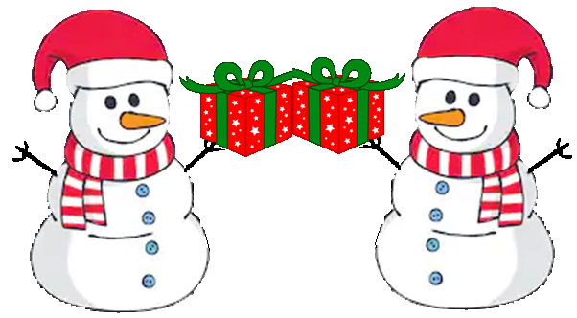

Figure 5 helpful snowman[8] [7]

Evaluation

Testing Images of working game

Objects and background test
The test shown in figure 6 was to check through each object within the prefab that needed to be clone and make sure it was duplicating them correctly. first the background was tested there was a problem originally as the background wasn’t visible, unity had displayed error message about a possible issue with one of the scene scripts. So after looking through each script for possible mistake or faulty code, the problem turned out to be a minor spelling error with one of the scene scripts and once correct it then cloned the background correctly and was now visible to the player.
The second test done was to check that all the objects in the game being the collectibles and the obstacles all duplicated and clone correctly with no problems. They need to be visible to the player and once out of view they needed to be destroyed to help free up memory, the present and helpful snowman and the spike was the object that was tested at first the helpful snowman was not in view and turn out to be on the wrong once corrected they all worked as they was meant to shown in figure 7.
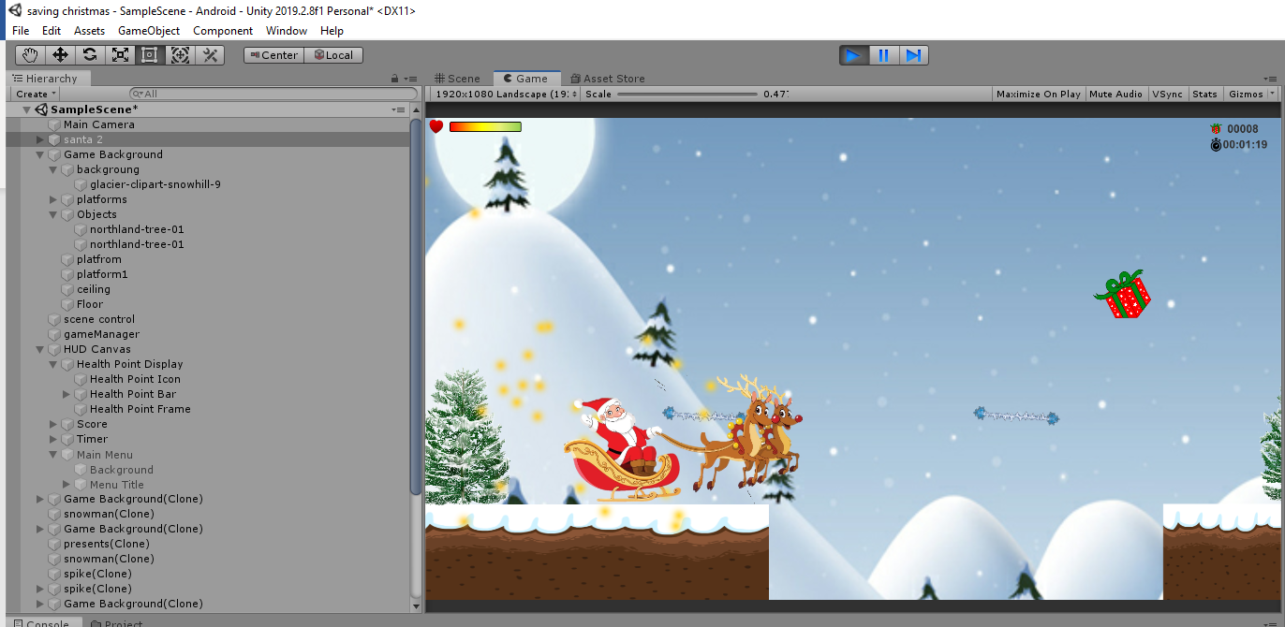
Figure 6 scene cloning working
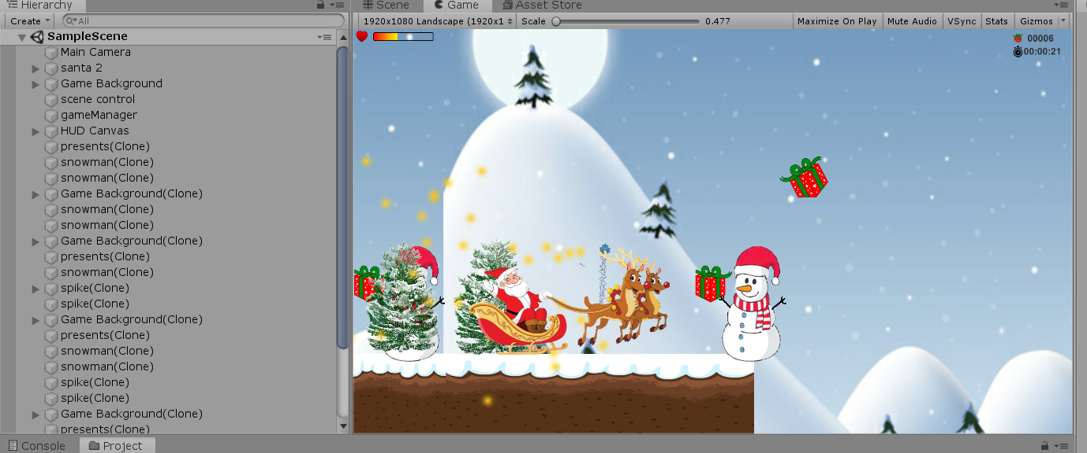
Figure 7 object working correctly

HUD test
When it came to testing the heads up display showing in figure 8 the HUD work but had some minor issues with seeing the timer numbers as the text was to small and the seconds on the timer was out of view and needed to be edited and repositioned and resize to make it visible to the player.
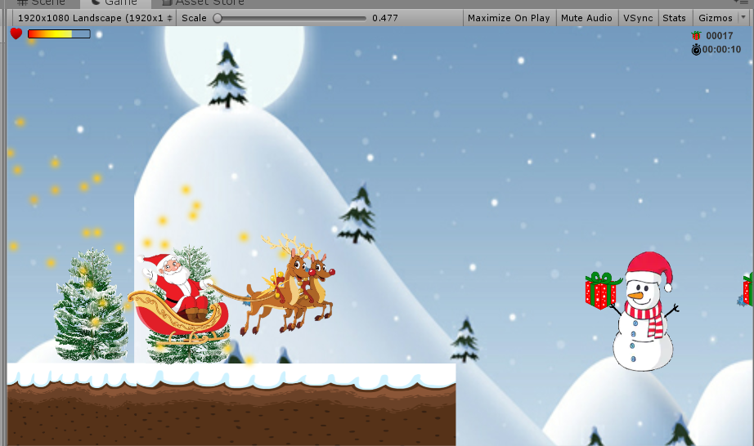
Figure 8 health bar, present count, timer, magic dust working

Main menu test
The main menu displayed in figure 9 was created with buttons but was unable to set to be functional with the game. The idea of how it would theoretically work as the main menu was to have it display at the begin of the game having all the levels grey out other than level 1 the player would have to complete each level in order to unlock the next level. The main was to be access within the game well the game was either pause or when then game had ended. But was not able to get this working in the way it was initially intended. as the game the menu will continue to display throughout the game so has been deactivated from being seen as a partial fix.

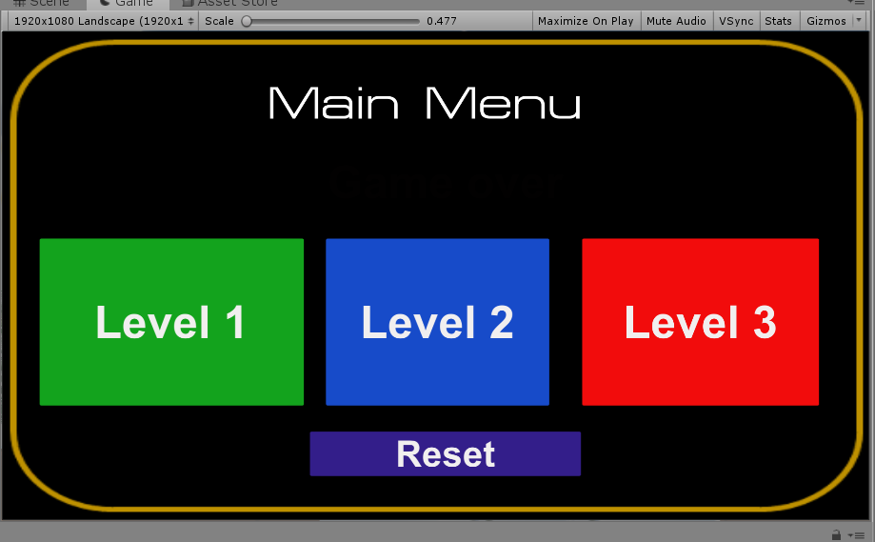
Figure 9 menu display

Test sheet
Date | Test/fault | Status
24/10/19 | Duplicate of scene not working. | Reason for not working spelling error in script resolved.
30/10/19 | Sprite editor not working. | Need to download 2d sprite package resolved.
05/11/19 | Helpful snowman not duplicating | Missing prefab from scene control resolved
06/11/19 | Not able to collet or go through helpful snowman | Colliders wasn’t set to is trigger resolved
10/11/19 | Getting menu buttons working | Unresolved
11/11/19 | Duplicating tree only on platforms | Unresolved
14/11/19 | Duplicating helpful snowman on platforms | Unresolved
15/11/19 | Set up working menu | Unresolved
21/11/19 | Creating second level and third level | Unresolved
30/11/19 | Creating end point in level one | Unresolved

Errors/ complications
Well attempting to create a sprite for the saving Christmas game the error shown in figure 8 continued to pop up well trying to access the sprite editor, which at the time meant was not able to make the snowman animated or present animated. Because unsure where to download the 2d sprite package from, after searching through the unity setting then searching the unity website for the download 2d sprite package. After some time came across a unity forum, where someone had explained how to resolve the problem and how and where to download the 2d spite package from.
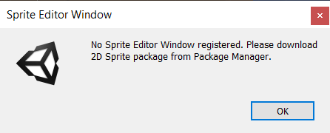
Figure 10 Unable To Open Sprite Editor[9]

References
[1] ‘How Much Does It Cost to Develop a Mobile Game?’ [Online]. Available: https://www.newgenapps.com/blog/cost-to-develop-mobile-game-development-cost. [Accessed: 28-Oct-2019].
[2] ‘Here’s what experts say mobile gaming will look like in 2020 | TechRadar’. [Online]. Available: https://www.techradar.com/uk/news/mobile-gaming-trends-2020. [Accessed: 01-Dec-2019].
[3] ‘Best phone for gaming 2019: the top 10 mobile game performers | TechRadar’. [Online]. Available: https://www.techradar.com/uk/news/best-phone-for-gaming. [Accessed: 25-Nov-2019].
[4] ‘Evolution of 3D games on mobile phones - IEEE Conference Publication’. [Online]. Available: https://ieeexplore.ieee.org/document/1493605. [Accessed: 28-Oct-2019].
[5] ‘Hill clipart snowy, Hill snowy Transparent FREE for download on WebStockReview 2019’. [Online]. Available: https://webstockreview.net/explore/hill-clipart-snowy/. [Accessed: 05-Dec-2019].
[6] ‘Santa sleigh Royalty Free Vector Image - VectorStock’. [Online]. Available: https://www.vectorstock.com/royalty-free-vector/santa-sleigh-vector-277742. [Accessed: 20-Nov-2019].
[7] ‘Clipart Of Magazines, Interior And Outstanding - Christmas Transparent Background Present Clipart, Cliparts & Cartoons - Jing.fm’. [Online]. Available: https://www.jing.fm/iclip/u2q8r5t4o0w7r5t4_clipart-of-magazines-interior-and-outstanding-christmas-transparent/. [Accessed: 21-Nov-2019].
[8] ‘Cartoon Snowman Isolated On White Background Stock Vector (Royalty Free) 350848877’. [Online]. Available: https://www.shutterstock.com/image-vector/cartoon-snowman-isolated-on-white-background-350848877. [Accessed: 20-Nov-2019].
[9] ‘Unable To Open Sprite Editor - Unity Forum’. [Online]. Available: https://forum.unity.com/threads/unable-to-open-sprite-editor.661843/. [Accessed: 30-Oct-2019].

