Nickai Marriott (2613266)
Academic Skills Assessment 1:


Reading Task Template
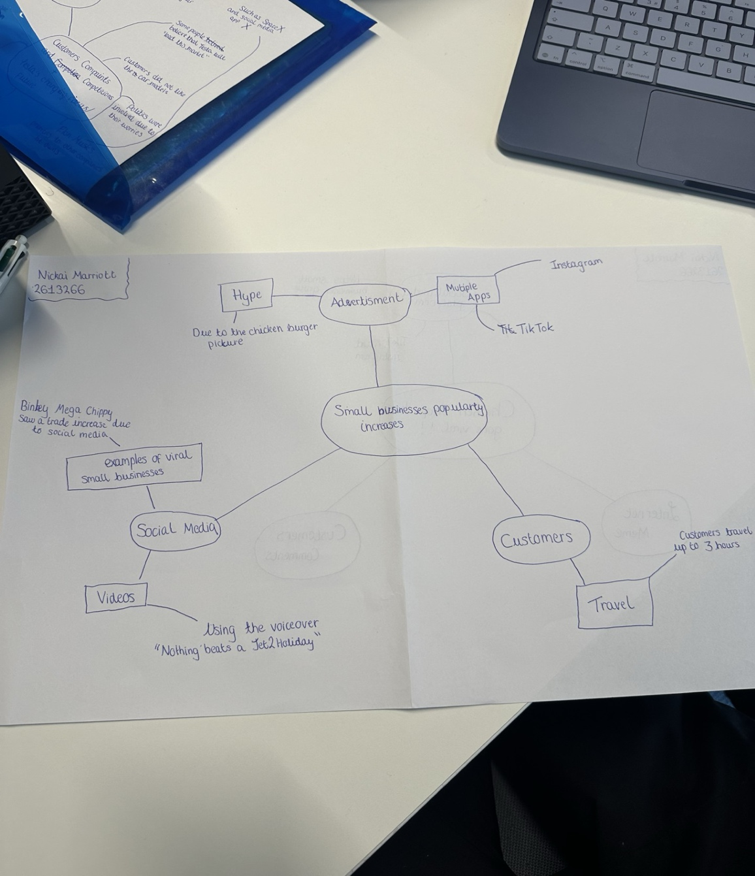

- What is the main idea of the whole text
The main idea of this text is that the impact of social media can transform a small business into a viral trend.

- What is one key point that supports the main idea, and which specific example from the text shows this?
There are examples in this article that supports the main idea about social media. For example, the two social media platforms that has been mentioned are “Instagram” and “TikTok”. Then the text mentions a question saying, “How does it feel when your business is at the centre of a viral trend?”

- What is a different key point that supports the main idea, and which specific example from the text shows this?
Another key point that has been mentioned is the customers’ reviews and travel. In other words, evidence that supports this is that in this article it says, “customers travelled three hours for our chicken burger”. Because of the attraction that it was receiving due to “the shop’s chicken burger is drawing customers from far and wide”. This is another piece of evidence that supports that case.

- Which part of the text do you think is most important, and why?
The most important piece in this article is that social media can increase a business’s sales. Whether it’s a small business or even an established one. The reason why is because the sandwich shop had a significant impact on the success of the business. When they post their food on viral content apps like TikTok and Instagram, they attract thousands of people that might not have known that this business ever existed.

Reflection:
- What did you find difficult in this task (including in-class components), and why was it difficult?
What I found difficult is that I feel like it’s not really detailed enough when it came to me making a mind map about this article. Then it almost felt like I’m repeating myself but just in a different way.

- What helped you with this difficulty, and how did it help you?
I think taking the time and analysing this article. Making sure that I don’t repeat myself and get confused with anything else. Plus, asking for help.

