DS 1

Screenshot/Photo 1
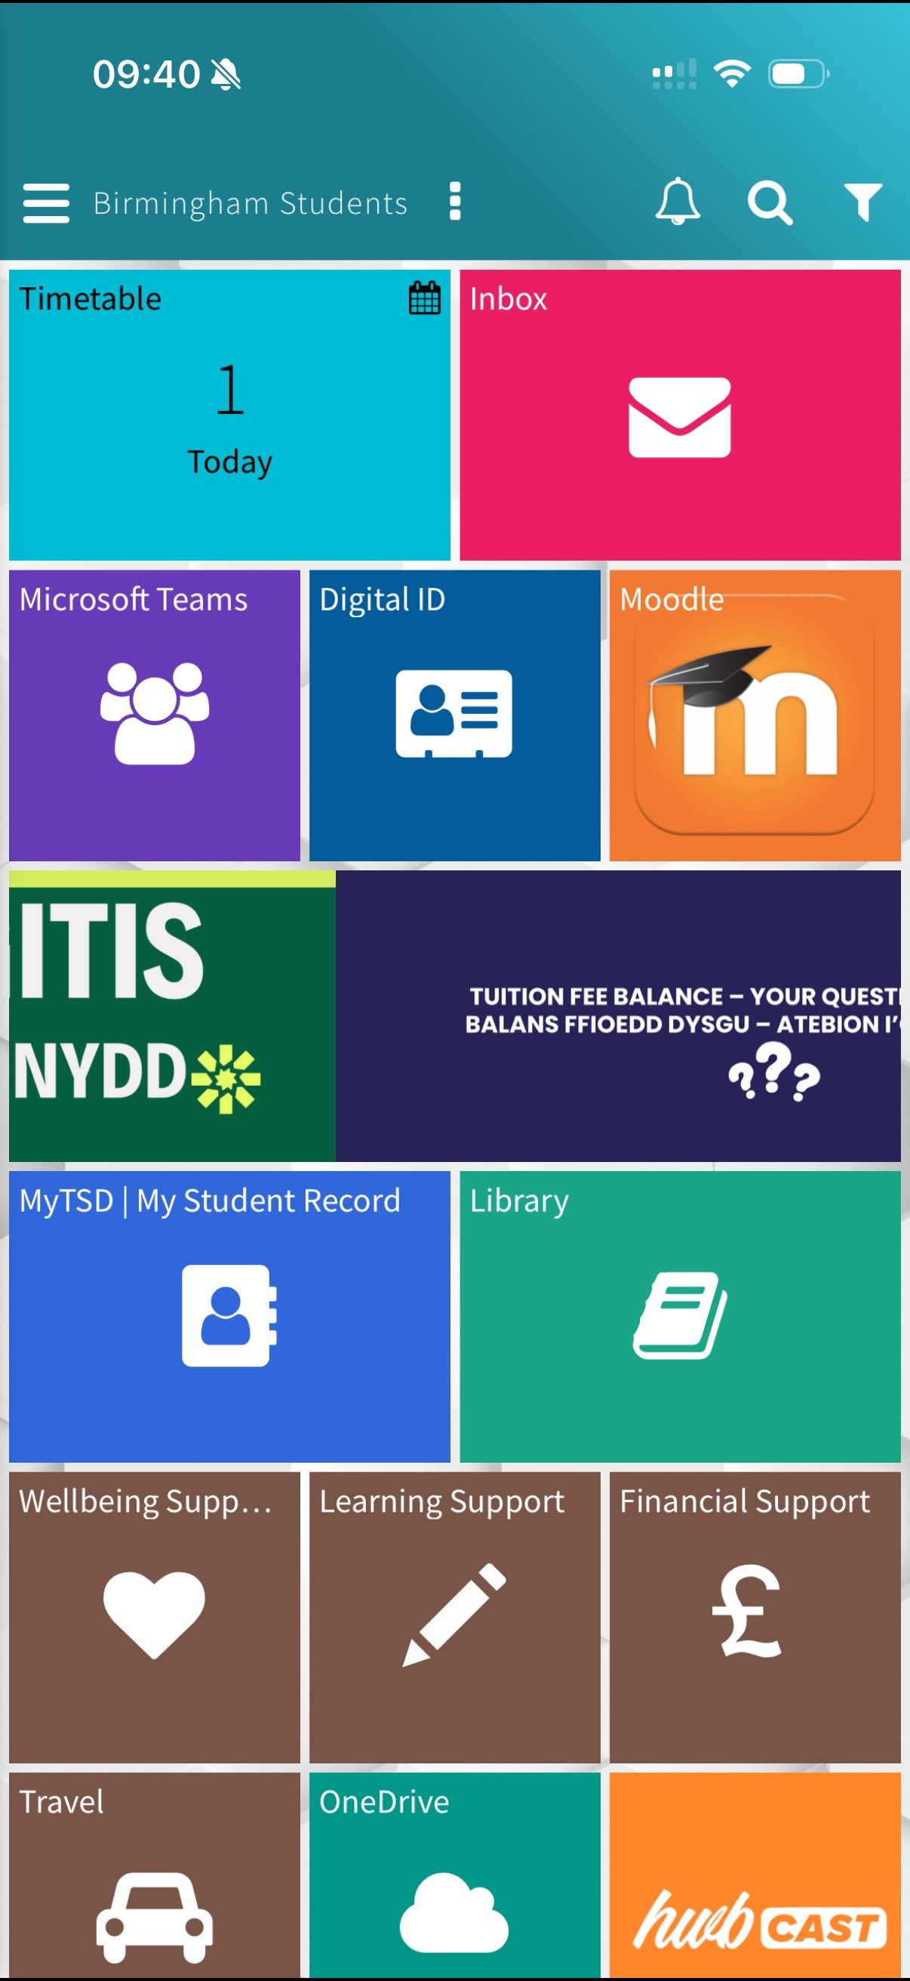

Moodle helps me with my university. Anything I need to access it is all on the hub. it is great help when it comes to my assignment. I can see my modules and assignments and contact any tutors. It is the main base when it comes to university without Moodle life would be so difficult

Screenshot/Photo 2
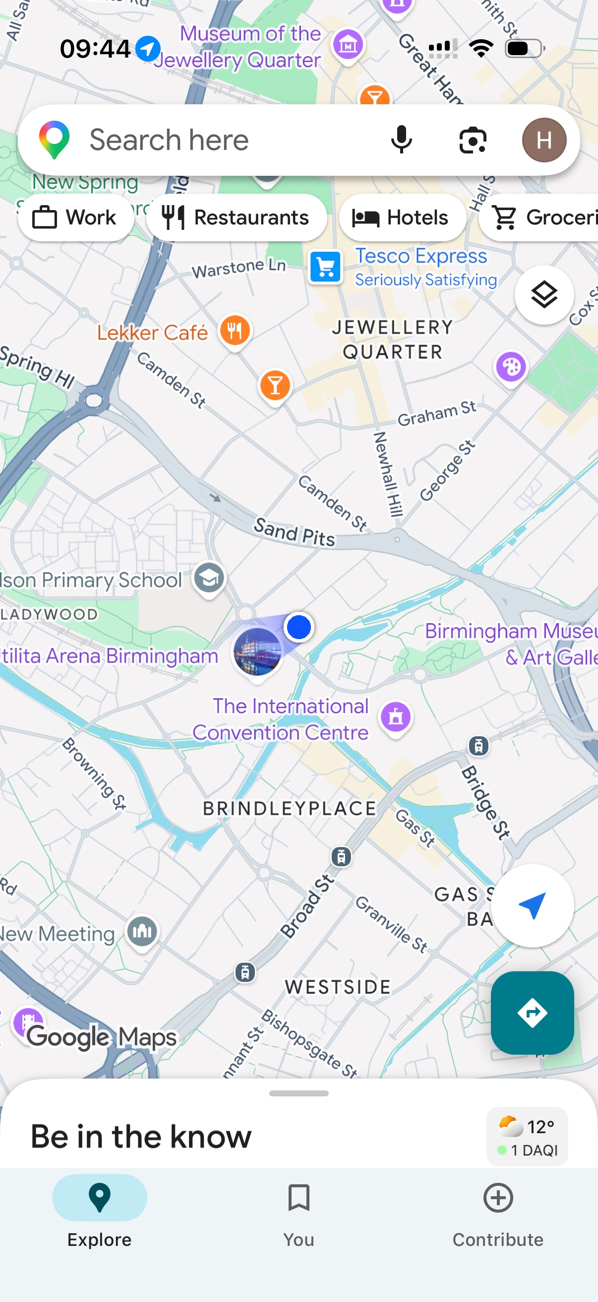
Google Maps shows that I use digital skills on a daily basis as I use google maps to help me get my way around from point a to point b. it tells me what way I need to go and gives me directions.

Screenshot/Photo 3
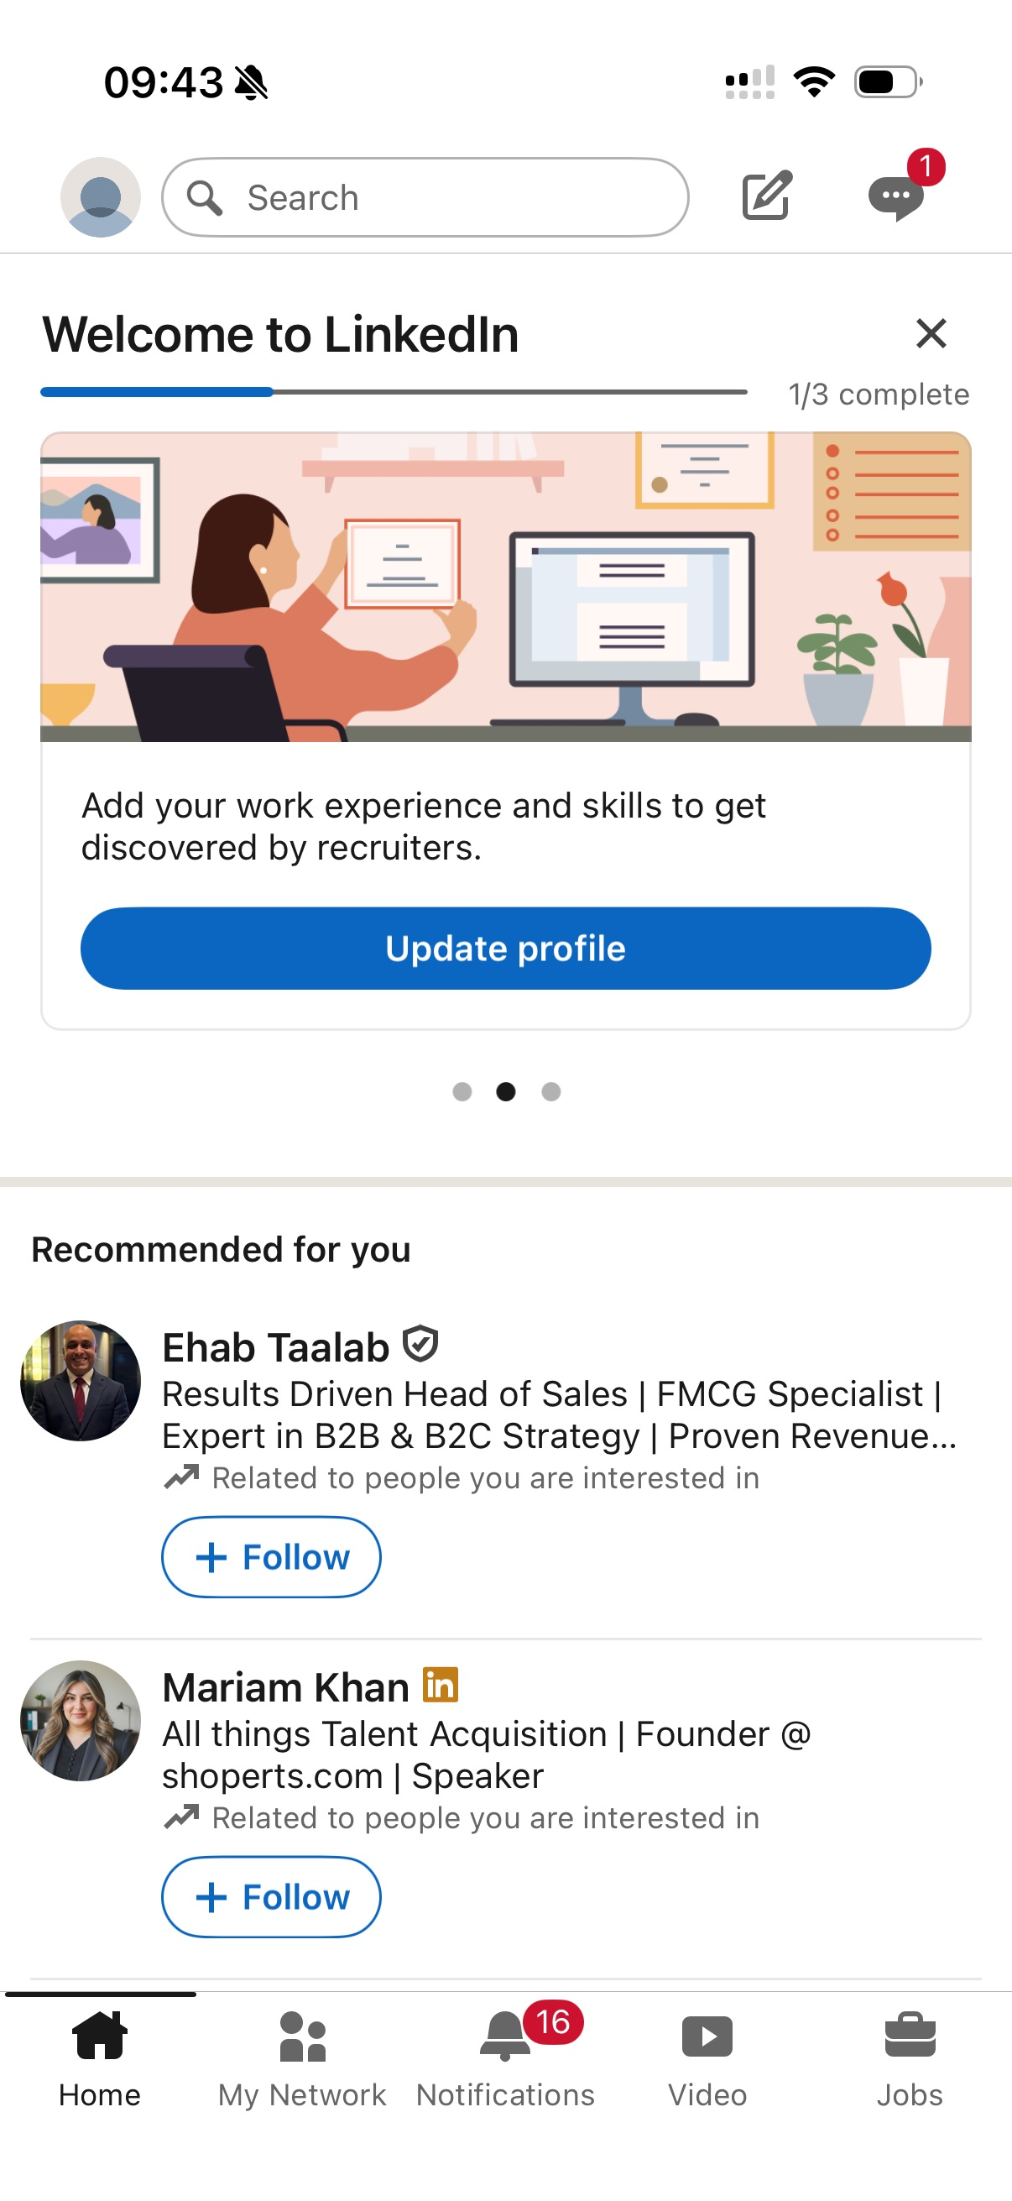
This is LinkedIn and it shows and helps me build my profile where all my qualifications and experience will help me meet other professionals. It can help me connect with other professionals in the industry and build my portfolio.

Screenshot/Photo 4
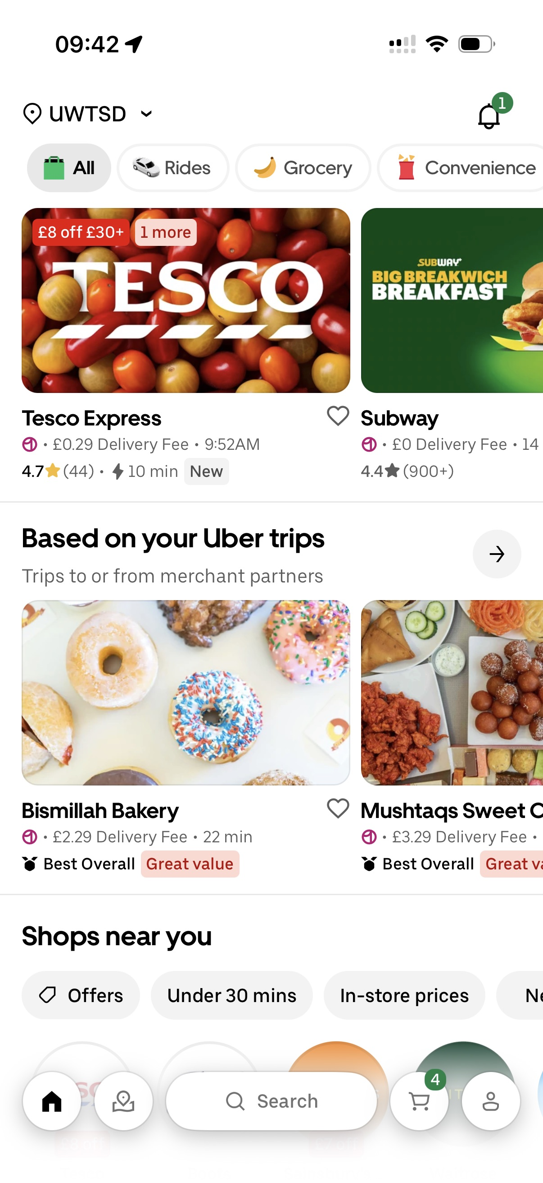
Uber eats I use very frequently it helps me choose what I want to eat by browsing through all the stores and then I decide what I want to eat and it gets delivered directly to my home. With uber there are other apps and services that I can use at the same time sometimes I have to get a taxi and it will arrive within minutes.

Screenshot/Photo 5
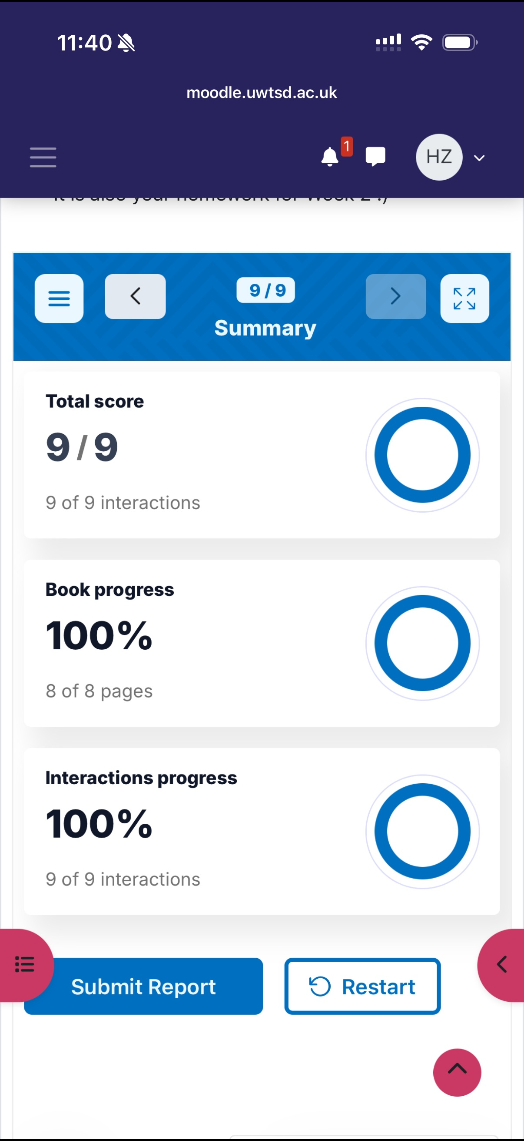
This shows how I have done online activities using Moodle to complete my work and to complete it I had to use my digital skills

Screenshot/Photo 6
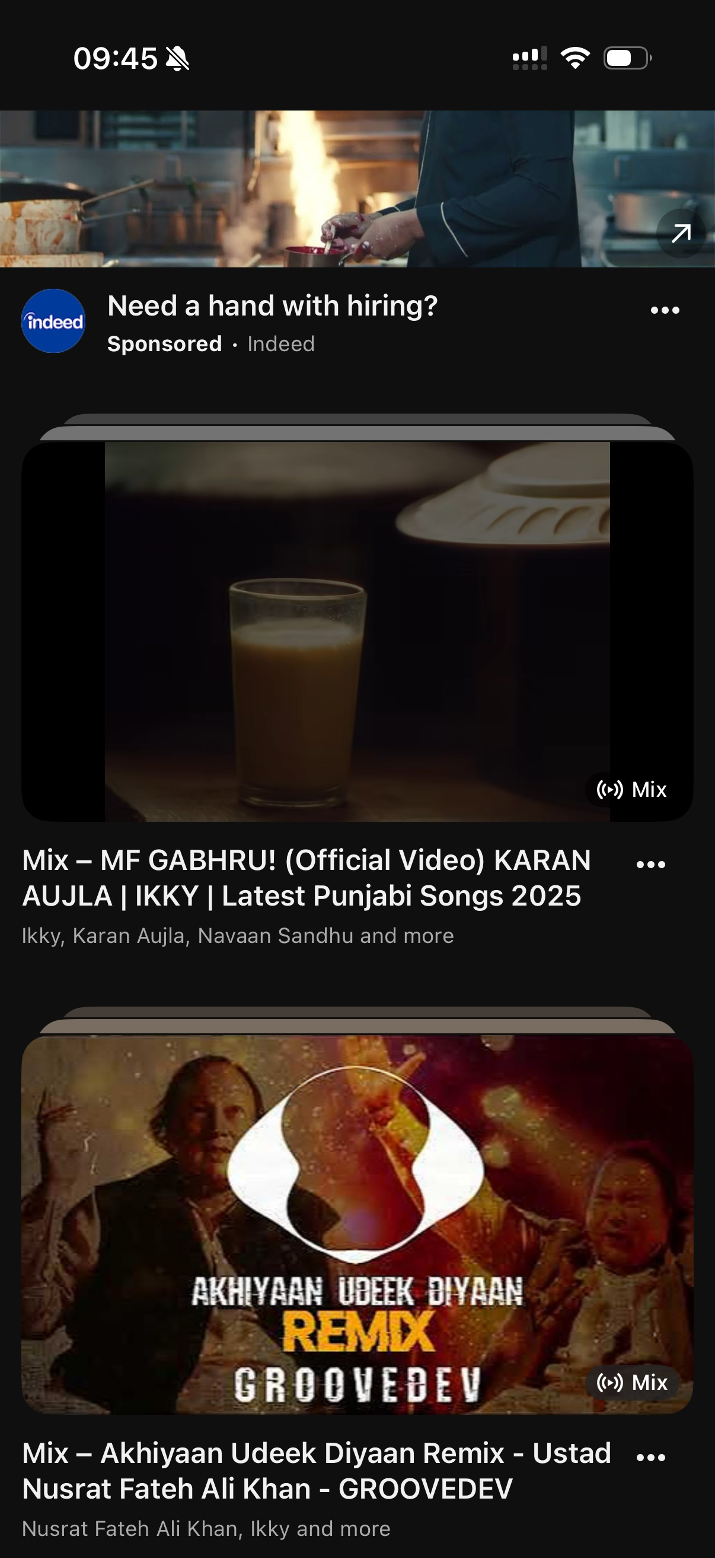
I use YouTube for many different reasons whether its listening to music or learn how to do something by watching a tutorial it would be an app where I use on a daily basis.

My Short Reflection
- Write 5–8 simple sentences about your digital life.
- You can use the sentence starters below if helpful.
I use digital tool help me with my work which helps me with my education. Ways of communication becomes easier. I feel confident because it helps me track the progress of what I am doing. I want to improve on using Moodle as there is a lot of sections such as the library where I still need to work out how to get around. I often use these tools as it makes life so much easier. I hope this module will help me use apps such as excel and learn in depth of how to organise the files. Digitals skills are important to me because it helps me organise my files and manage my day. If I need to know anything I used the internet to help me find the information. Using a computer to do my assignments has made me more confident to complete my work.

Sentence starters
- I use digital tools to …
- I feel confident when I …
- I want to improve …
- I often use these tools: …
- I sometimes feel nervous about …
- I hope this module will help me …
- Digital skills are important for me because …
You can write more if you want.

Submission Checklist
Before you submit, please check:
​​​ ☐ I added 4–6 screenshots
☐ I wrote short sentences for each screenshot
☐ I wrote my short reflection
☐ My work is my own
☐ My file opens correctly
​​☐ My file opens correctly

