

Prepared by:
Alina Mateta - 251187
The program :
HTML & CSS WEB DEVELOPMENT
Module name :


Introduction to Web and Database Concepts
Module code :
ACCA4023
Lecturer’s name :
Dr. Shah Room

Contents
Introduction: 3
Requirements: 3
Purpose: 3
Subject matter: 3
Intended audience: 4
Implementation: 4
Screenshots of the Webpages 4
Validation: 7
HTML Validation: 7
CSS Validation: 7
Evaluation 8
Part A 8
Website usability: 8
Website accessibility: 8
Search engine optimisation 8
Part B 9
Usefulness (Usability and Utility) 9
Search Engine Optimisation (SEO) 9
Accessibility: 10
Part C 12
References: 14
Appendix 14

Introduction:
This report details the comprehensive design, structural implementation, and multi-dimensional evaluation of TravelConnect, a responsive multi-page website engineered using modern semantic web standards. Historically, Hypertext Markup Language (HTML) functioned primarily as electronic text containing static cross-references; however, contemporary web architecture treats HTML as a dynamic framework hosting graphical objects interconnected with multifaceted digital assets. While HTML establishes the core structural layout of modern web platforms, Cascading Style Sheets (CSS) systematically dictate the visual presentation and rendering behaviour across user interfaces.
Recognizing that end-users access web resources through diverse operating systems, hardware configurations, browser clients, and connection speeds, rigorous pre-publication deployment testing is critical. Consequently, this project evaluates layout resilience against browser-level configuration changes, specifically examining how responsive typography adapts to client-side font adjustments. The development workflow was executed utilizing Visual Studio Code as the primary integrated development environment, with Microsoft Edge serving as the baseline testing engine alongside supplementary cross-browser verification. Ultimately, this documentation provides an empirical analysis of the platform's usability, Search Engine Optimisation (SEO) strategies, and accessibility compliance under the Web Content Accessibility Guidelines (WCAG 2.1), cross-referencing industry benchmarks with contemporary academic literature.

Requirements:
This section outlines the foundational specification metrics established prior to the development of the TravelConnect platform, defining its core objectives, content boundaries, and target demographic attributes.

Purpose:
TravelConnect is a secure, responsive web platform facilitating cross-cultural communication among global travellers. Designed as an interactive hub, it enables users to share authentic travel experiences and discover community-driven insights, while demonstrating the practical application of modern front-end web standards. Furthermore, it allows users to arrange both online and offline thematic meetups to exchange hands-on experience and cultural insights.

Subject matter:
The core content centres on global tourism and cultural exchange across three key modules:
Home & Layout Architecture: A welcoming landing interface featuring dynamic hero banners and integrated language selection controls (supporting English, Ukrainian, and Russian text variants).
Story Hub: A dedicated repository for user-generated travelogues and cultural narratives.
Join the Club: An onboarding subsystem utilizing interactive web forms for user registration and interest tracking.

Intended audience:
The platform targets independent travellers and backpackers seeking non-commercialized itineraries, expatriates focused on deep cultural immersion, and digital nomads requiring reliable, community-sourced destination data.

Implementation:

Screenshots of the Webpages
The first screenshot shows the English version of my website.
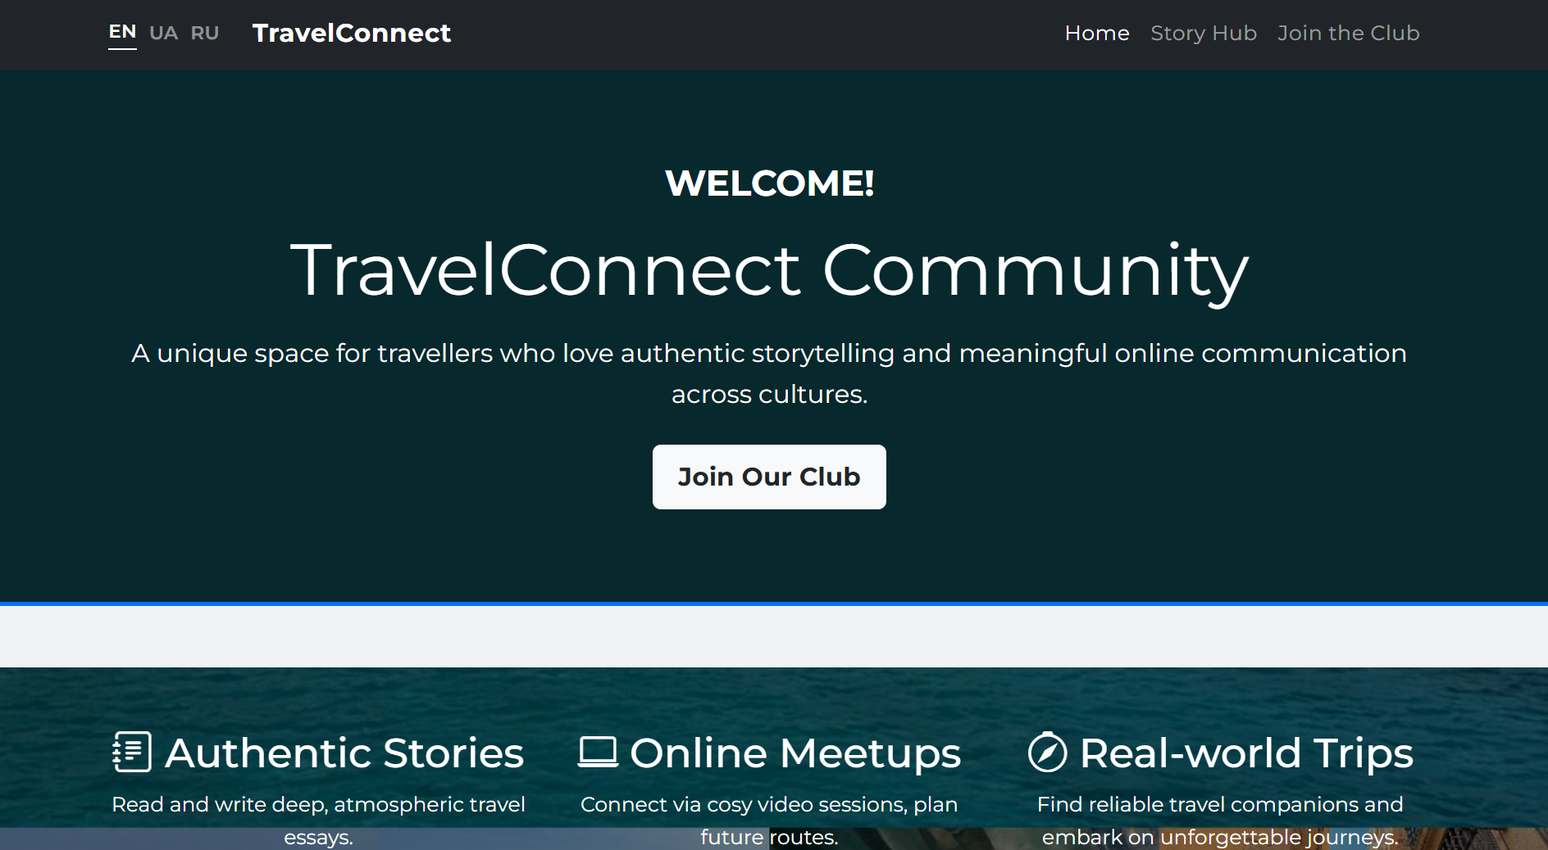

The website also features language switcher buttons for English, Ukrainian, and Russian. A screenshot of the Ukrainian version will now be shown.
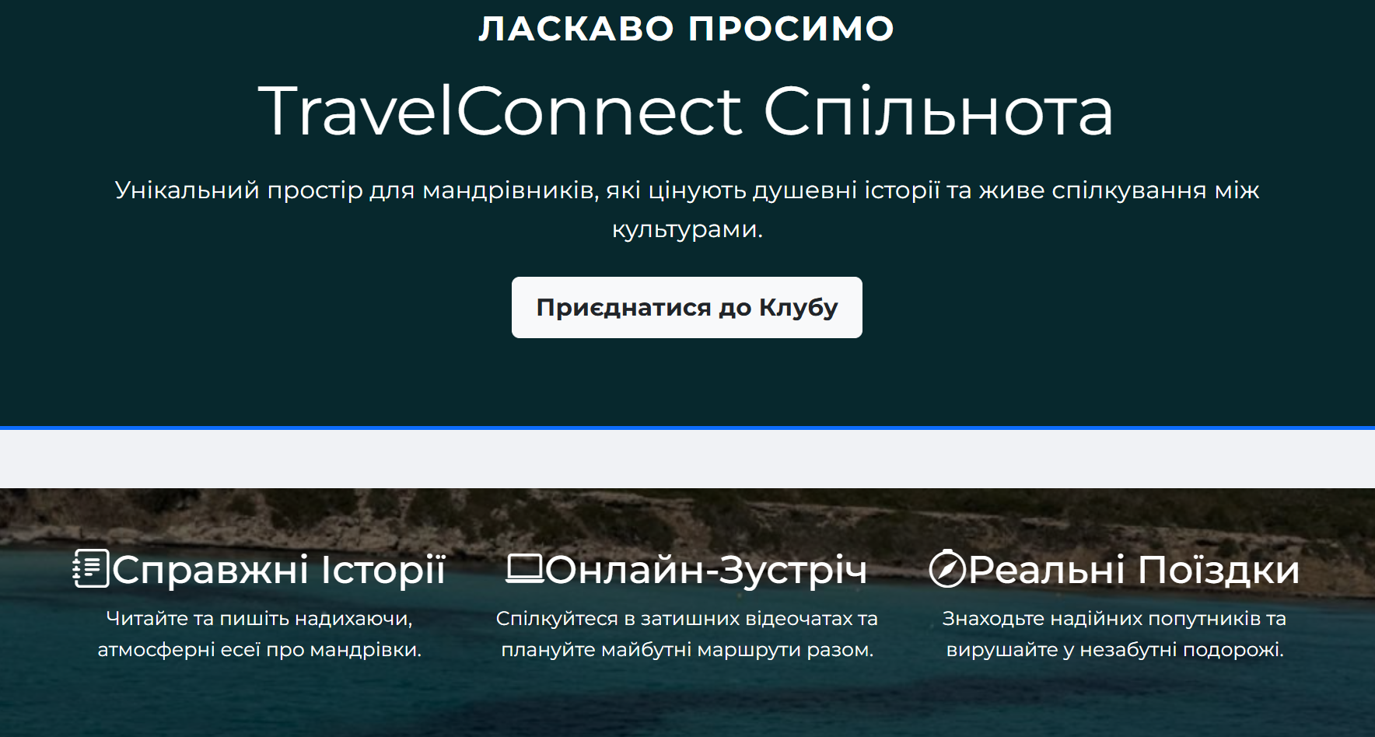
And here is the continuation of the second page, now translated into Russian for Russian-speaking users.

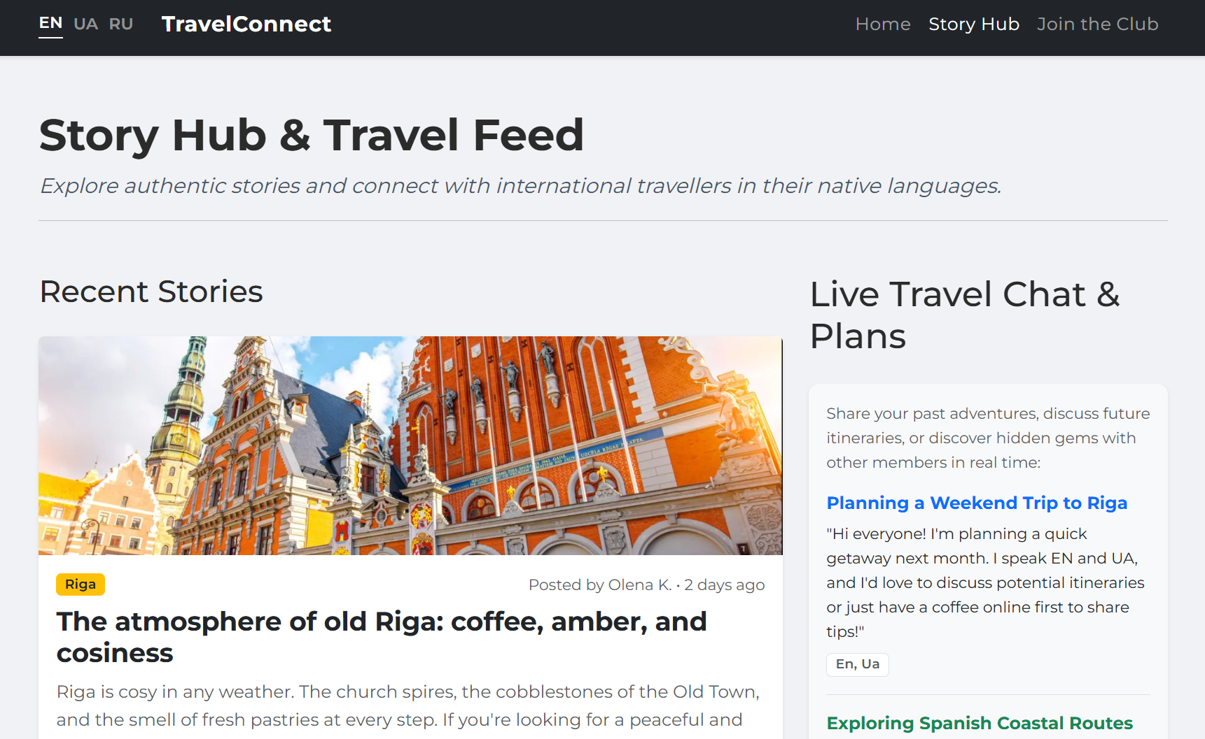

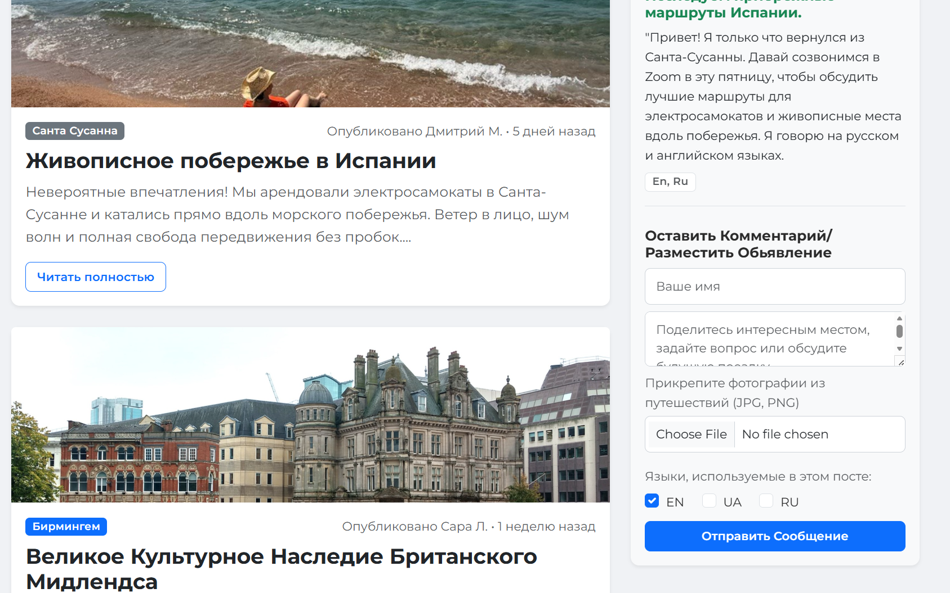
And finally, the third and final page featuring an interactive box.

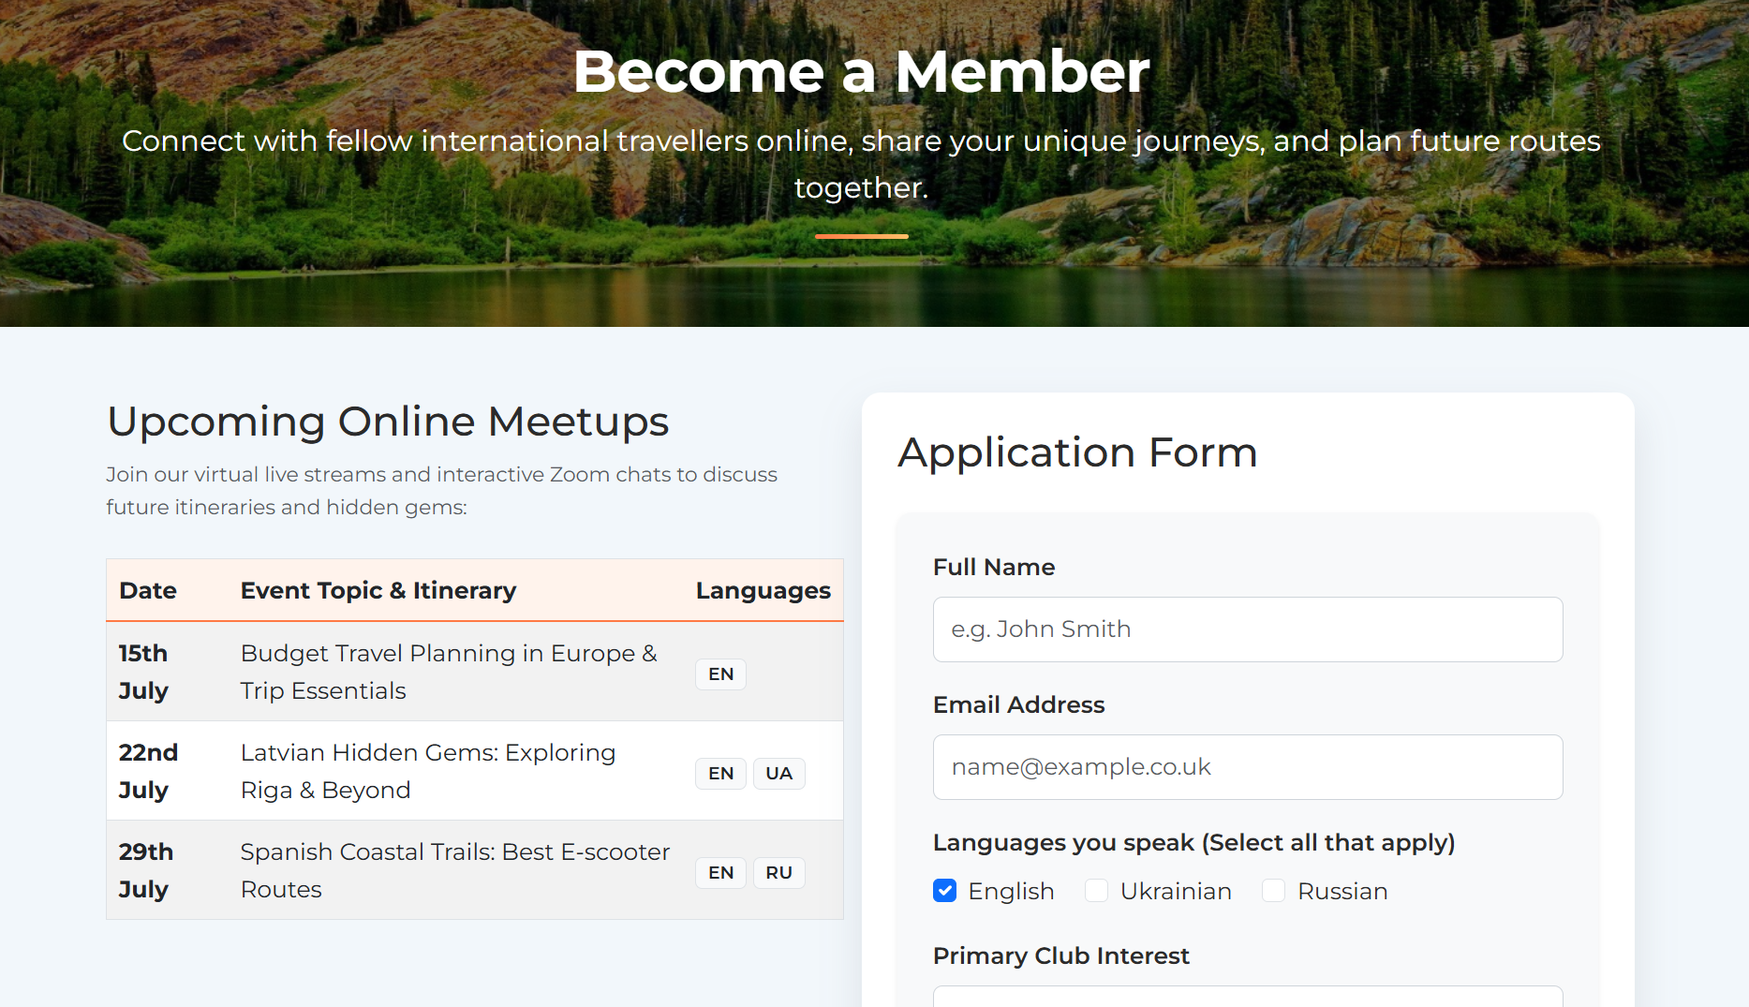

Validation:
Code validation is a fundamental quality assurance process ensuring that the TravelConnect platform adheres strictly to the technical standards established by the World Wide Web Consortium (W3C). This systematic evaluation eliminates syntax errors, guarantees consistent cross-browser rendering, and significantly improves accessibility for assistive technologies.

HTML Validation:
Hypertext Markup Language (HTML) structures web content using standardized tags regulated by the World Wide Web Consortium (W3C), operating via the Hypertext Transfer Protocol (HTTP) for data transmission where a standard document framework comprises explicit document type declarations, metadata head sections, and semantic body containers [1].
To ensure project compliance, the ⁠index.html⁠ file of the TravelConnect website was thoroughly evaluated using the official W3C Markup Validation Service. The initial validation run flagged a structural nesting error:
Error: The heading ⁠<h3>⁠ followed the main ⁠<h1>⁠ heading (⁠TravelConnect Community⁠), skipping the mandatory ⁠<h2>⁠ hierarchy level.
Correction: To maintain a logical heading outline required for search engines and screen readers, the subheadings (Authentic Stories, Online Meetups, and Real-world Trips) were corrected in the source code from ⁠<h3>⁠ to ⁠<h2>⁠.
Following this adjustment, the final checker output returned a perfect result with no errors or warnings, confirming full HTML5 compliance.

CSS Validation:
Cascading Style Sheets (CSS) complement HTML by separating presentation from structural content, a paradigm originally pioneered at CERN to optimize web document semantics. CSS governs visual aesthetics, including typography, layout configuration, colour schemes, and structural positioning.
To implement styles externally, a dedicated stylesheet (e.g., ⁠style.css⁠) is linked within the HTML ⁠<head>⁠ using the ⁠<link rel="stylesheet" href="css/style.css">⁠ element, employing relative file paths for optimal portability. In accordance with CSS syntax standards, declarations are nested within curly braces ⁠{}⁠ following a defined selector, with properties and values specified precisely (e.g., defining dimensions in pixels and establishing borders via the ⁠border⁠ property) [2].
The website’s primary stylesheet was formally verified using the official W3C CSS
The evaluation was conducted during the deployment and testing phase using a local server environment.
Additionally, the validation service provided a standardized XHTML/HTML code snippet to display the official "W3C CSS" compliance badge on the website, alongside a unique referrer URI query linking directly to the real-time validation results. This confirms that the style layer of TravelConnect successfully meets all interoperability standards.

Evaluation

Part A

Website usability:
In modern web development, usability directly dictates whether an end-user can successfully navigate structural layouts and retrieve information without technical friction or cognitive overload. Academic frameworks establish that usability cannot be treated as an isolated property of code; instead, it represents a dynamic interaction attribute encompassing learnability, operational efficiency, and error recovery. Empirical studies confirm that interfaces optimized for low cognitive friction significantly minimize human error during complex interaction pathways, underscoring the absolute necessity of user-cantered design principles to enhance overall technology acceptance and long-term user retention [3].

Website accessibility:
According to foundational literature in digital inclusion, web accessibility is defined as the systematic development of technologies that remove technical barriers for users with visual, auditory, motor, or cognitive limitations. Rather than an optional feature, academic frameworks position accessibility as an intrinsic dimension of web architecture aimed at providing equitable user experiences. To operationalise these principles, the World Wide Web Consortium (W3C) established the Web Content Accessibility Guidelines (WCAG) [4].
Recent research evaluates the practical impact of these compliance standards, proving that rigorous optimization of accessibility components such as fluid responsive layout structures and explicit element contrast directly minimises cognitive fatigue and reduces task completion times, thereby elevating the user experience across both impaired and mainstream user bases [5].

Search engine optimisation
The evolution of digital brand promotion mandates strict compliance with Search Engine Optimisation (SEO) strategies, integrating both creative and technical elements to drive organic traffic while avoiding penalizable "Black Hat" methods like keyword stuffing. Technically, search engine crawlers continuously scan and parse semantic source code, cross-referencing page metadata with on-page content to index platforms accurately within Search Engine Result Pages (SERPs). A robust technical SEO framework must accommodate distinct user search behaviours—specifically navigational, informational, and transactional queries—ensuring optimal content mapping, higher domain authority, and sustainable customer acquisition pathways [6].

Part B

Usefulness (Usability and Utility)
The TravelConnect platform successfully marries utility (functional features) with a seamless user experience (look and feel). From a utility perspective, the site includes an interactive portal with structured forms on the 'Join the Club' page and structured layout containers on the 'Story Hub', delivering the exact core informational services promised to the user base.
Crucially, the platform features a multilingual interface supporting English, Ukrainian, and Russian, which significantly enhances its global utility by enabling seamless cross-cultural communication across diverse demographics, including native speakers and multilingual communities in the Baltic and Eastern European regions.
In terms of usability, the interface applies a consistent layout grid across all three pages, ensuring a predictable user journey. Elements are intuitively structured, and navigation is effortless thanks to a sticky header navigation links mechanism.
Recommendation for future improvement: While the site currently relies on static local code blocks, a future iteration should implement a backend relational database (such as PostgreSQL) to dynamically render and handle user-generated travel narratives and profile creations in real time.

Search Engine Optimisation (SEO)
To ensure clean indexation by search engine spiders, the following tactical on-page SEO techniques were directly hand-coded into the TravelConnect platform:
Semantic Navigation: The main language switcher and menu links are enclosed within a structural HTML5 ⁠<nav>⁠ element, signalling the site's primary layout architecture to crawling bots.
Targeted Meta Tags: The head section explicitly incorporates dynamic ⁠viewport⁠ scaling, a focused ⁠description⁠ attribute to boost organic click-through rates (CTR), and precise semantic ⁠keywords⁠ (e.g., travel community, cultural exchange) for accurate domain classification.
Logical Heading Outline: Rectified during W3C validation, the content flow strictly follows an H1 on H2 hierarchy (e.g., Authentic Stories altered from ⁠<h3>⁠ to ⁠<h2>⁠), facilitating seamless document mapping for indexers.
Image Optimization: All graphical assets embed unique, descriptive ⁠alt⁠ attributes, ensuring visual content is fully searchable and accessible to image crawlers.

Accessibility:
Tool used: Colour Contrast Checker & WAVE Evaluation Tool (with reference to WCAG 2.1).
Initial Issues: "Missing form label" errors in hub.html and insufficient color differentiation (colour Diff: 434) on non-active navigation links.

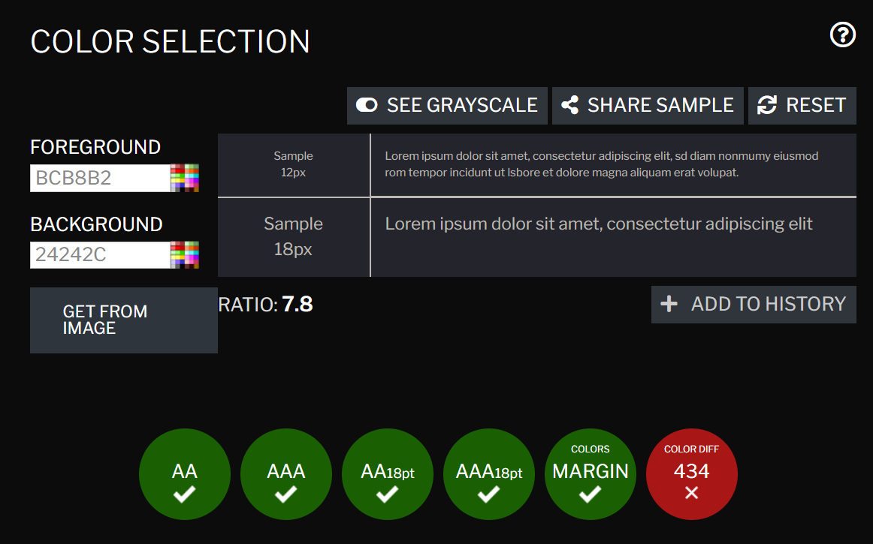
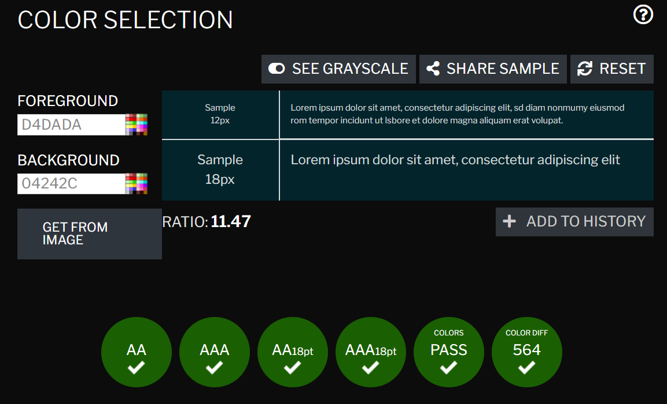
Solutions Applied:
Added missing ⁠aria-label⁠ tags to form inputs for improved screen reader navigation.
Corrected heading structure hierarchy across pages using Bootstrap typography classes.

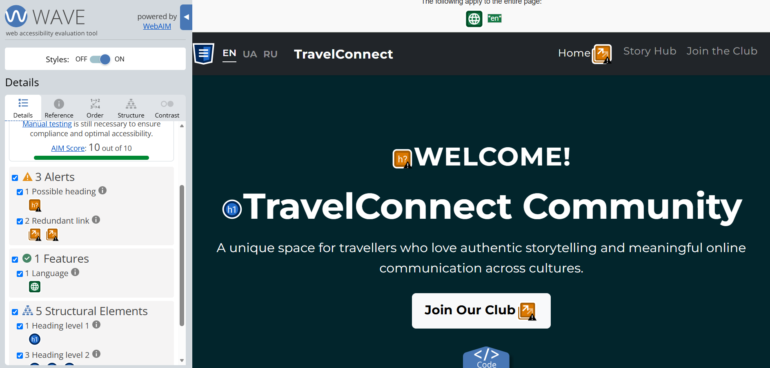
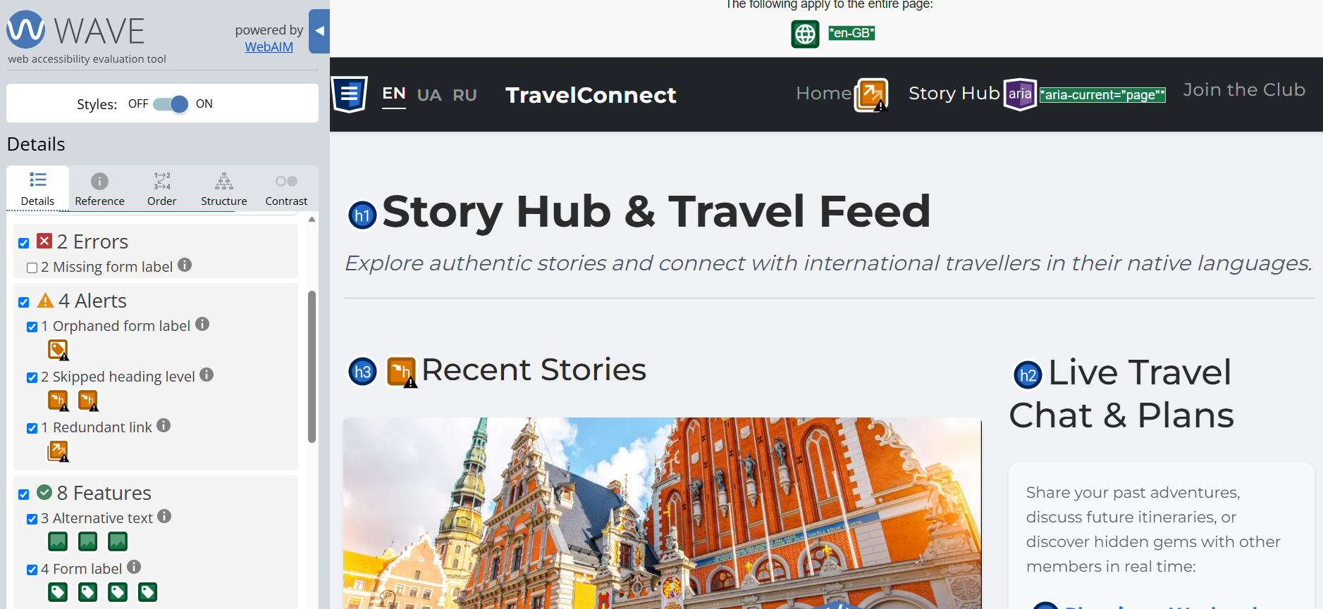
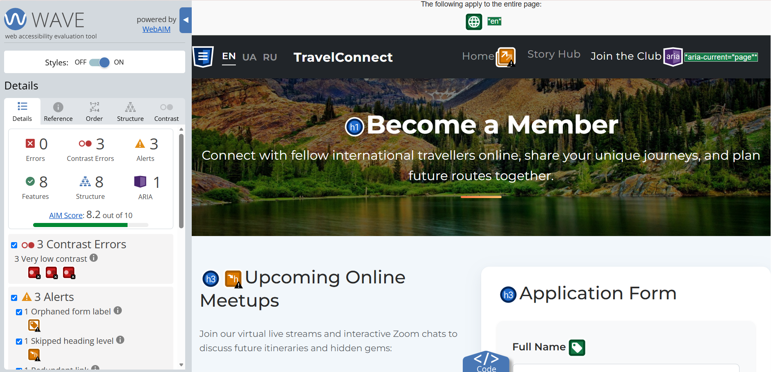

Result: All critical errors completely resolved. The final WAVE AIM Score ranges from a minimum of 9.9 to a maximum of 10 out of 10 across all platform pages.

Part C

Area | Website1 | Website2
Weblink of the Website | https://www.very.co.uk | https://www.argos.co.uk
Usability | System Usability Scale (SUS): 67.5 | System Usability Scale (SUS): 57.5
Accessibility | 11 Errors  Homepage (AIM Score: 5.8/10)  Active Basket Page (AIM Score: 7.4/10)  Women's Category Page (AIM Score: 7.7/10) | Homepage (9 Errors | AIM Score: 7.4/10)  Active Basket Page (7 Errors | AIM Score: 8.7/10)  Women's Category Page (7 Errors | AIM Score: 8.4/10)
SEO | Severely hindered by DOM bloating and structural flaws. The layout is heavily over-segmented (44 <h2>, 59<h3>, 35<h4>) and plagued by 56 images completely lacking alt text, which deeply compromises organic traffic optimization. | Highly optimized technical structure. Combines a valid <h1> index tag with an extensive subheading hierarchy. Excellent image optimization, leveraging 70 functional alt attributes on image links to maximize indexing efficiency in visual search engines.
Mobile Friendliness | Highly optimized for mobile touchscreens, with promotional grids reflowing quickly into horizontal swipe carousels. Elements dynamically adapt to screen rotation instantly, maintaining text readability and precise button tap execution. | Fully responsive layout with flawless visual scaling and near-instant orientation shifting upon screen rotation. Touch targets are large and highly responsive, transforming the dense catalogue into a frictionless, fluid mobile feed.
Conclusion | Offers a superior user experience with a higher SUS score (67.5) and excellent mobile swiping interactivity, but requires critical technical overhauls to fix severe heading bloating and empty ⁠alt⁠ text fields that compromise accessibility and SEO. | Demonstrates exceptional, industry-standard technical optimization, delivering robust web accessibility (higher AIM scores, skip links) and flawless semantic SEO alignment despite a lower subjective usability rating (57.5).

References:
[1] M. McGrath, HTML, CSS & Javascript in Easy Steps. In Easy Steps, 2020.
[2] E. Glass, How To Build a Website with CSS and HTML. DigitalOcean, 2020.
[3] S. Ntoa, “Usability and User Experience Evaluation in Intelligent Environments: A Review and Reappraisal,” International Journal of Human-Computer Interaction, vol. 41, no. 5, pp. 1–30, Sept. 2024, doi: 10.1080/10447318.2024.2394724.
[4] WEB ACCESSIBILITY : a foundation for research. S.L.: Springer, 2020.
[5] D. Pratomo, D. W. P. Andani, and Ramadiani, “Evaluation of the System Usability Scale (SUS) in Measuring the Use of the Durian Website at SMA Negeri 1 Long Iram,” International Journal of Advance Social Sciences and Education (IJASSE), vol. 3, no. 4, pp. 233–242, Aug. 2025, doi: 10.59890/ijasse.v3i4.114.
[6] M. Michaels, SEO Mastery 2023 #1 Workbook to Learn Secret Search Engine Optimization Strategies to Boost and Improve Your Organic Search Ranking. 2023.

Appendix
Here is the CSS style block
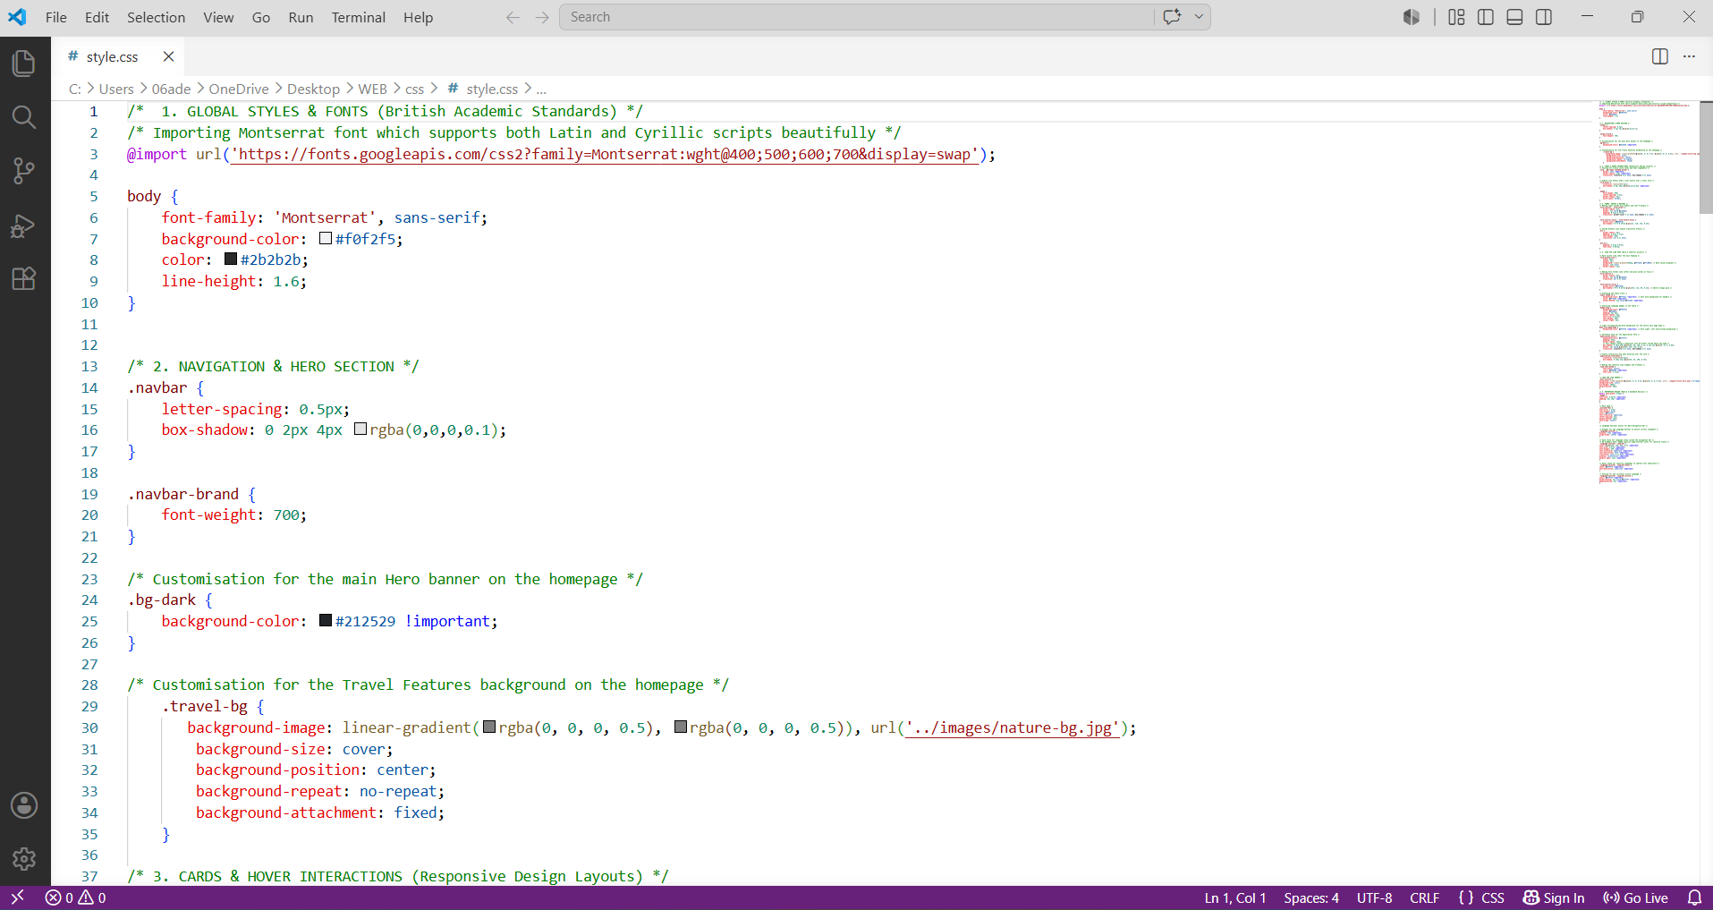
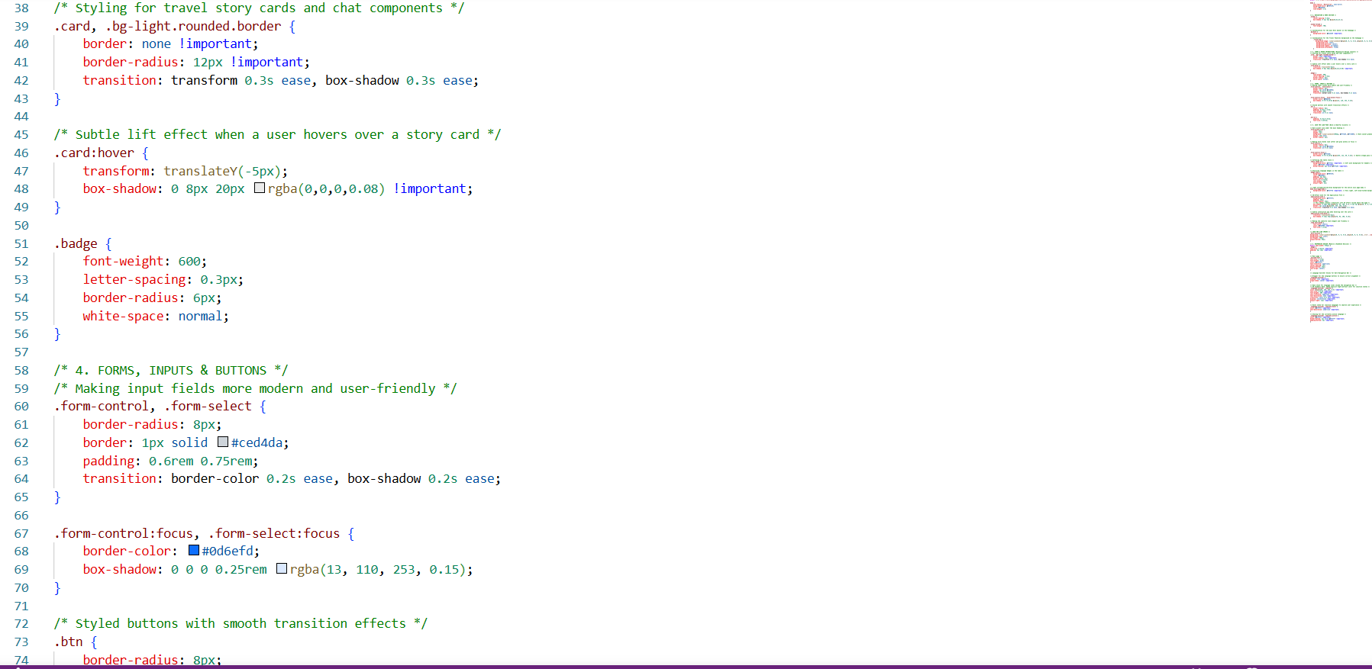
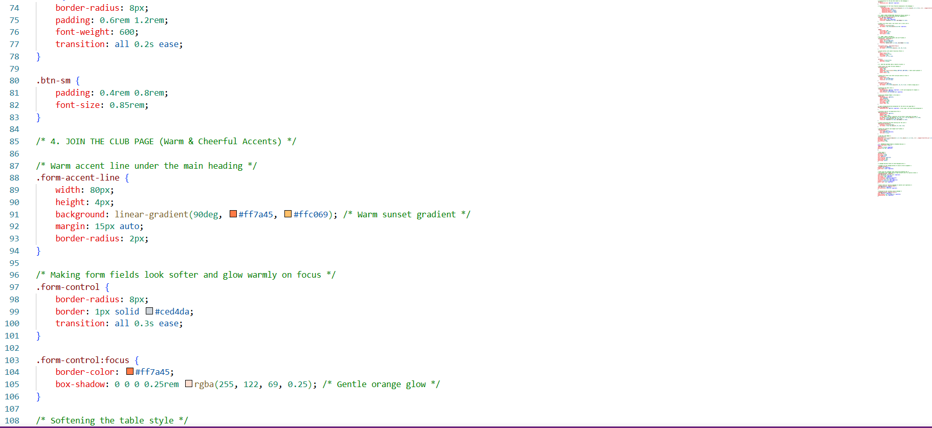
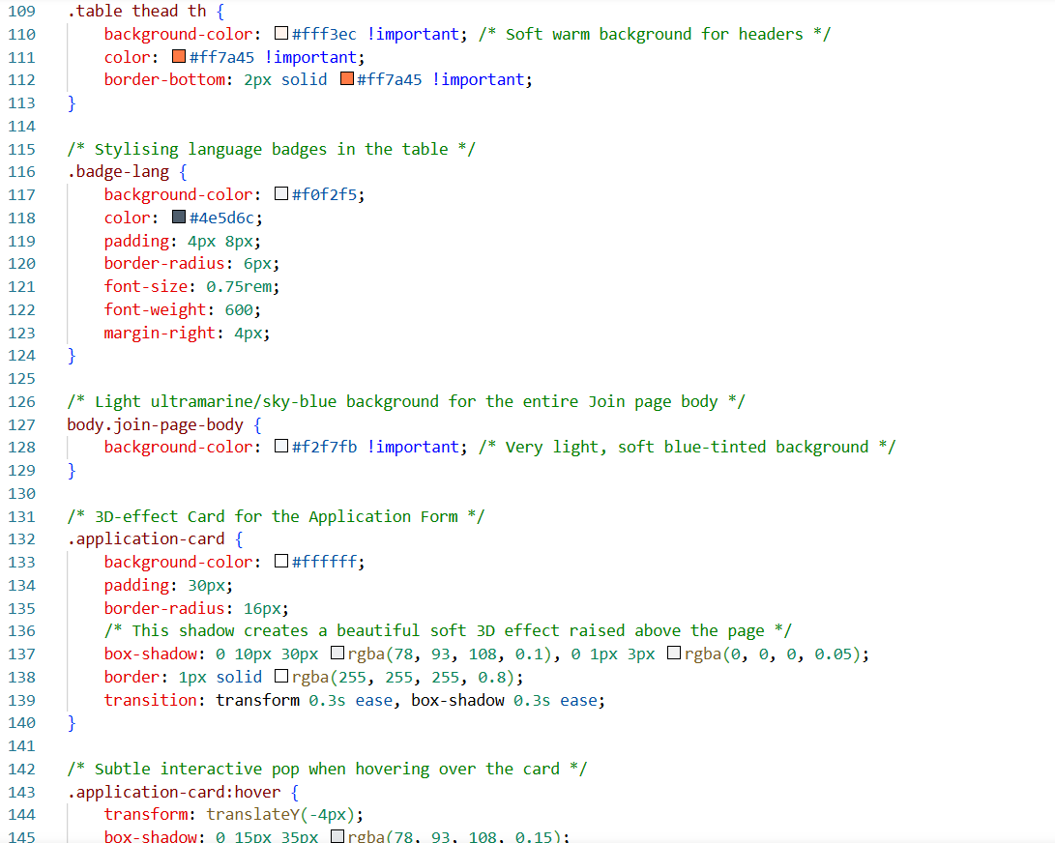
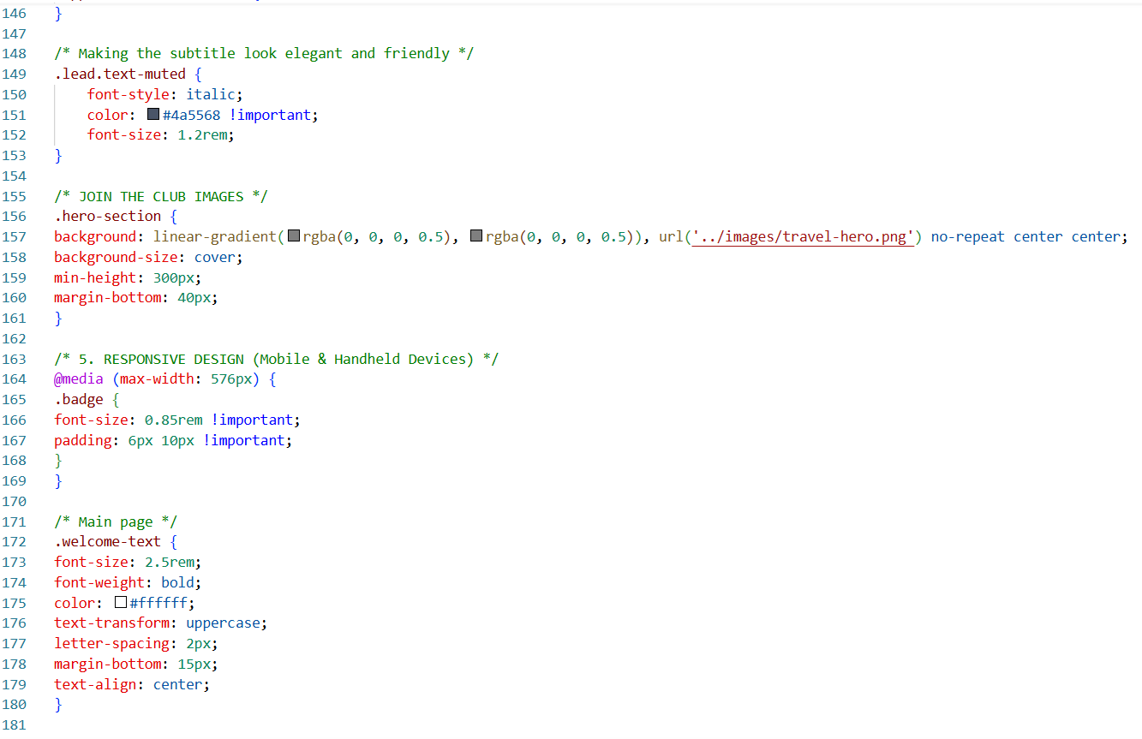
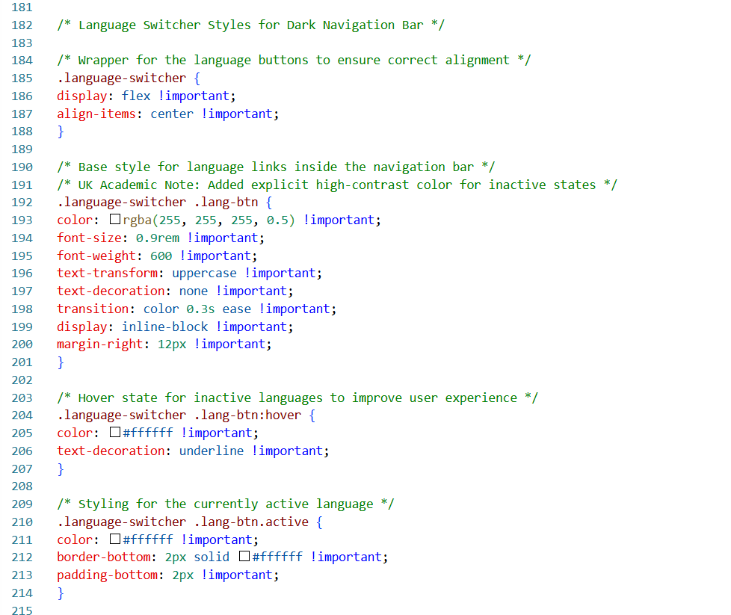
This is the Hub HTML
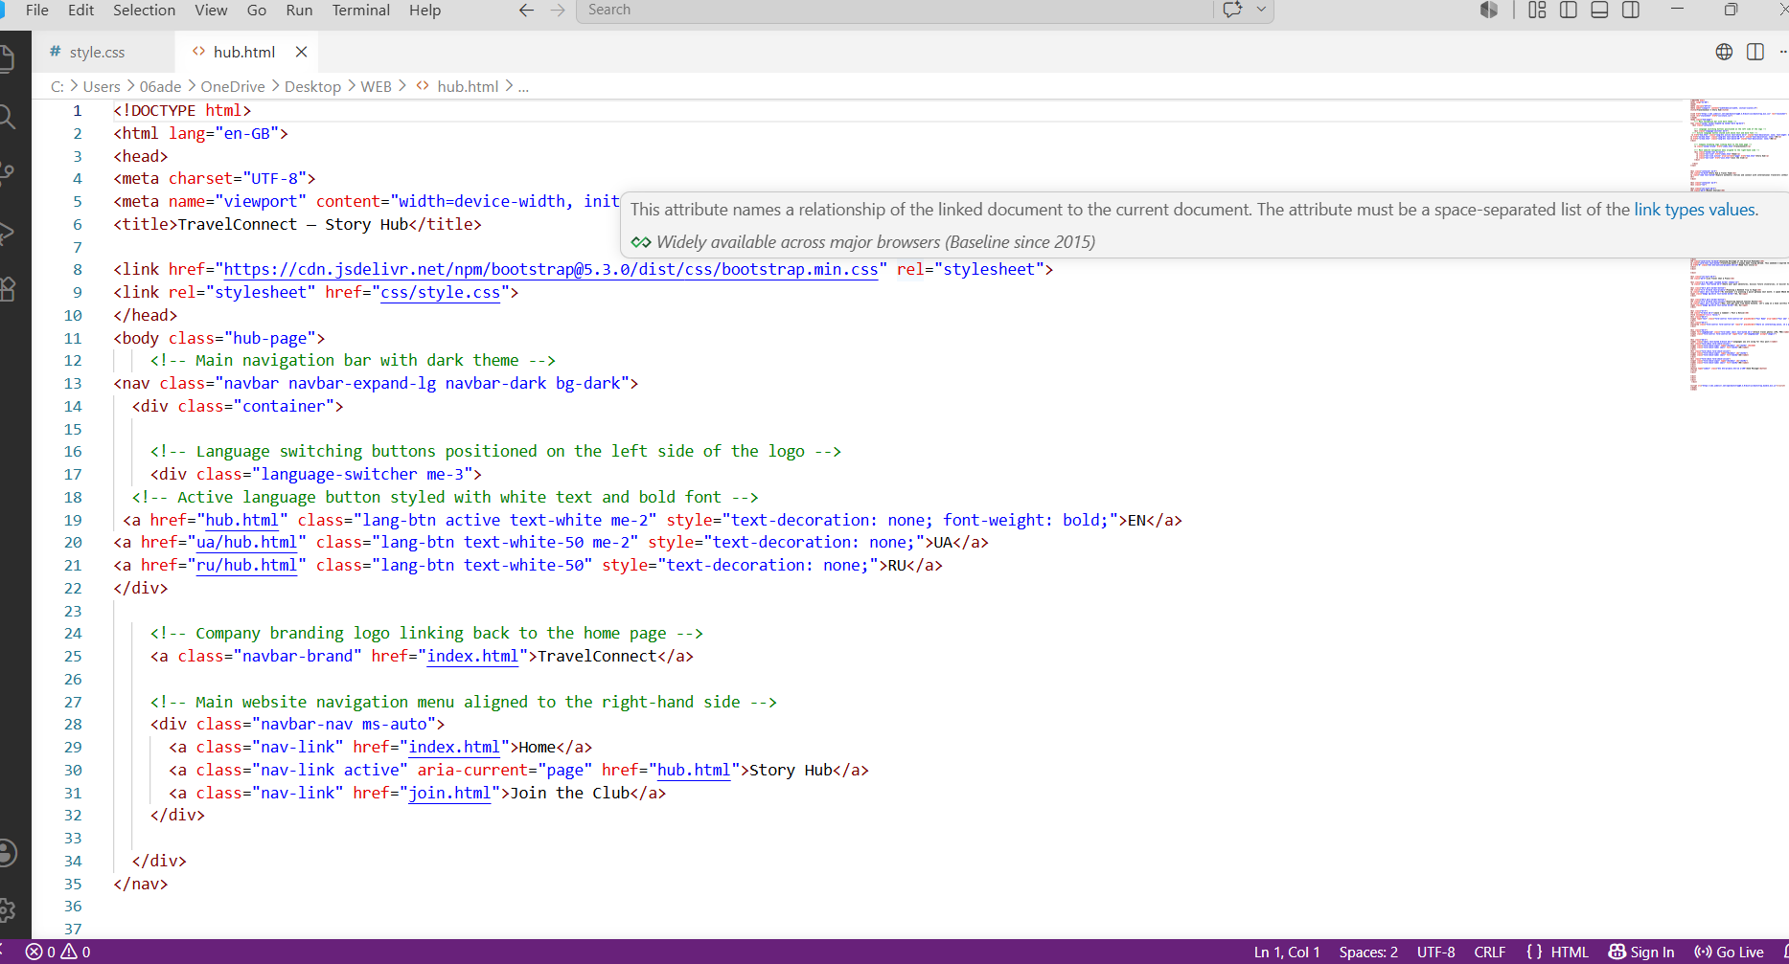
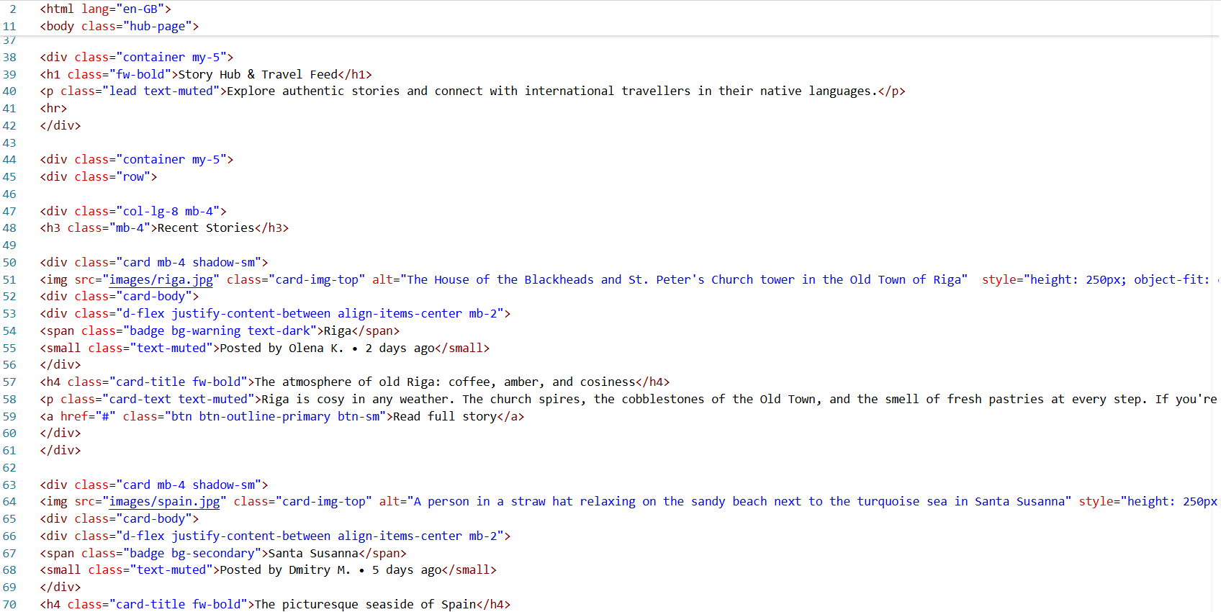
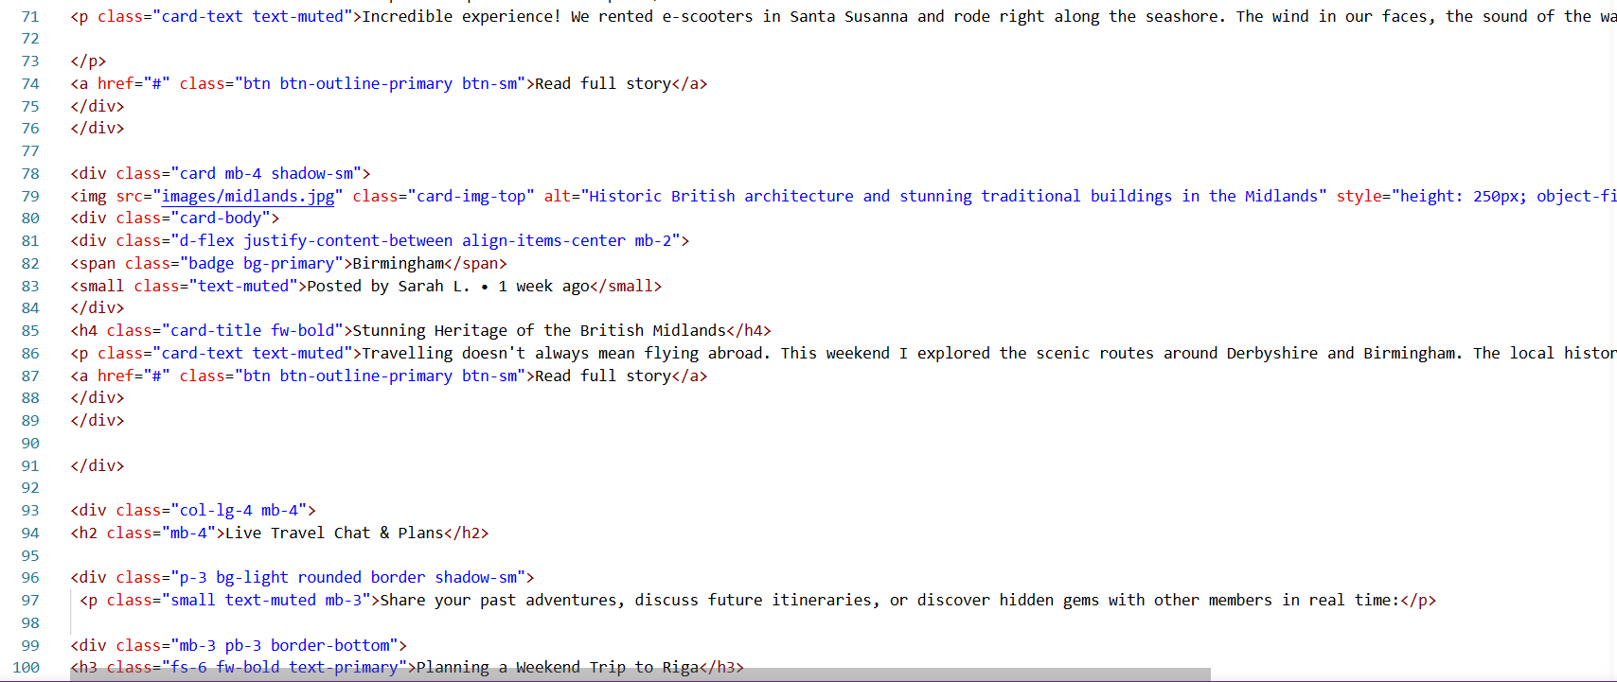
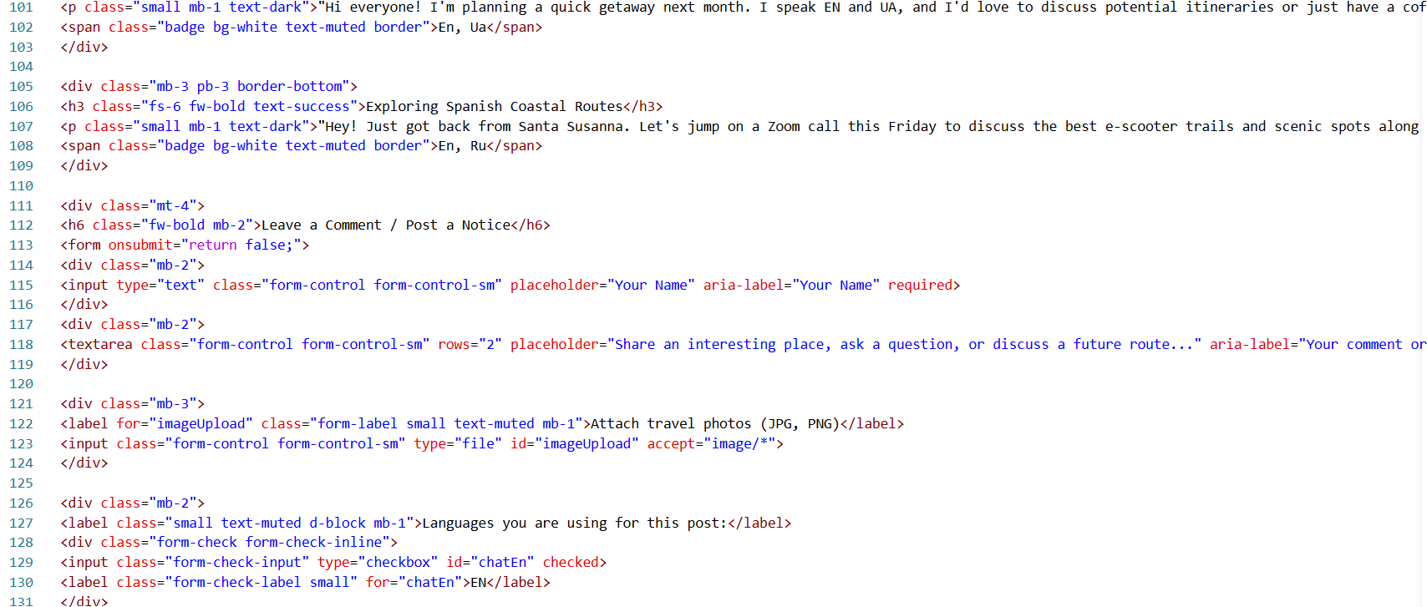
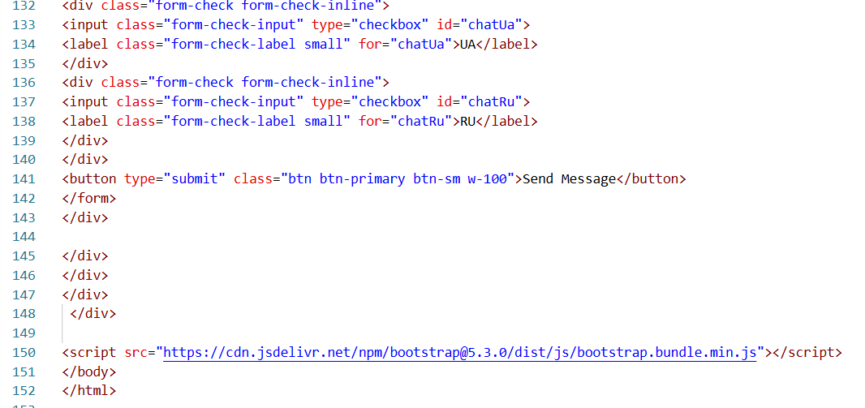
This is the index HTML block
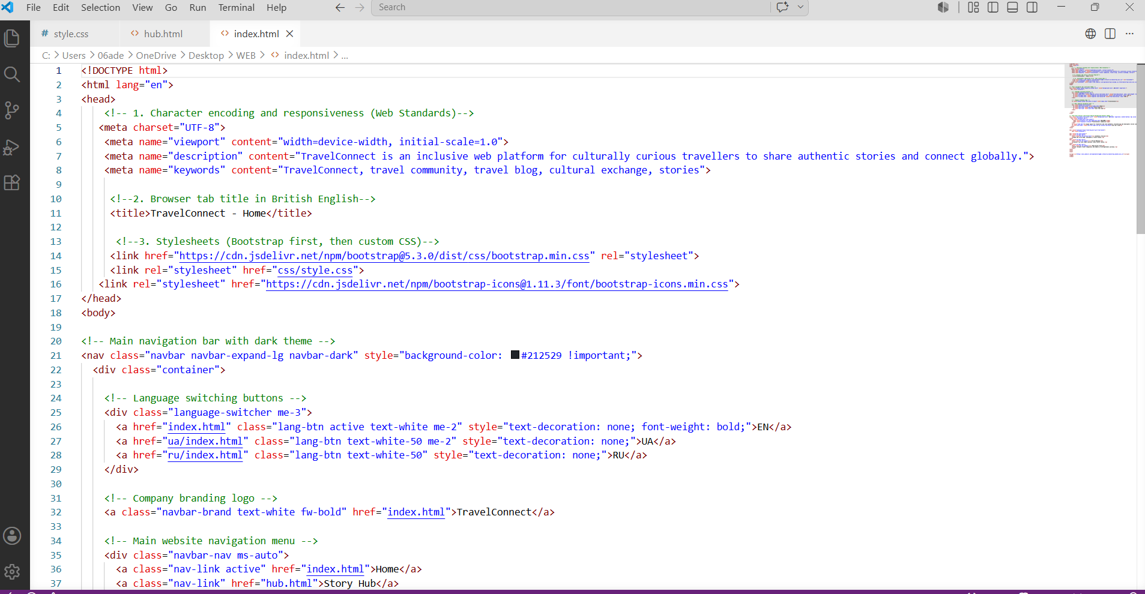
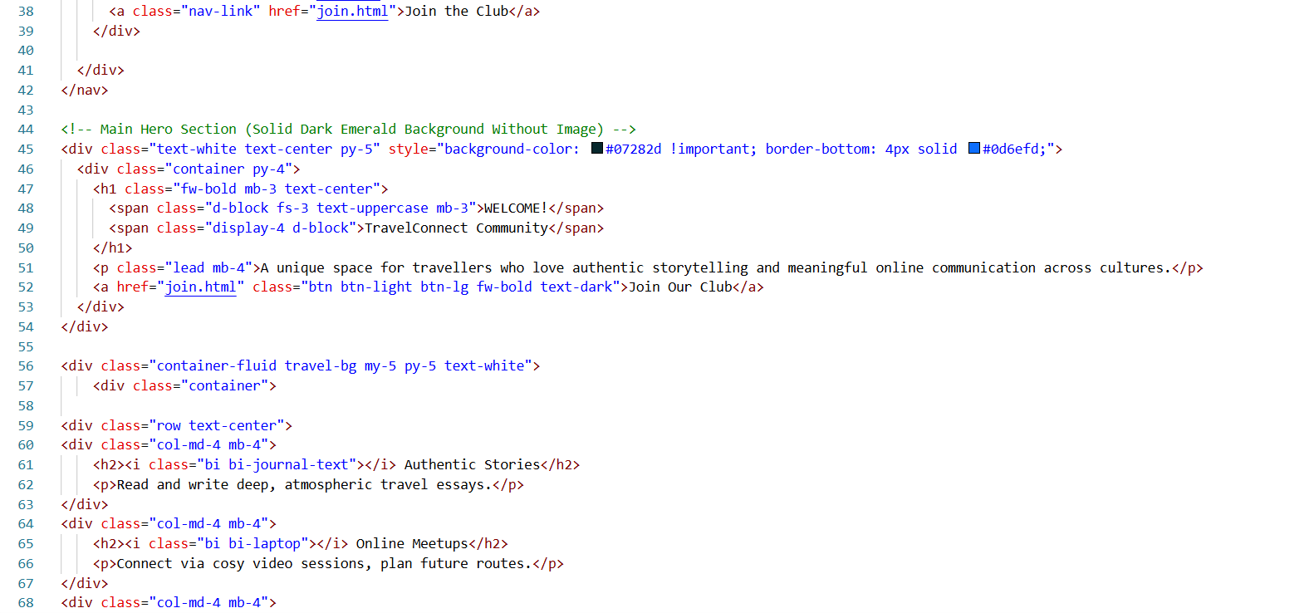
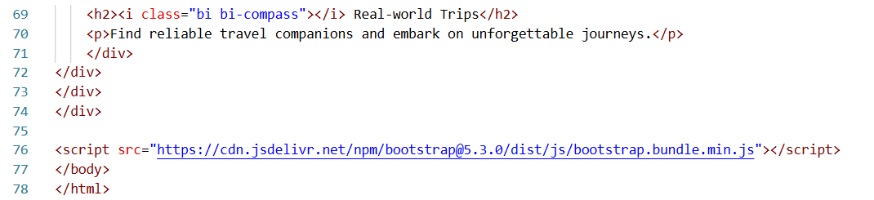

Join HTML

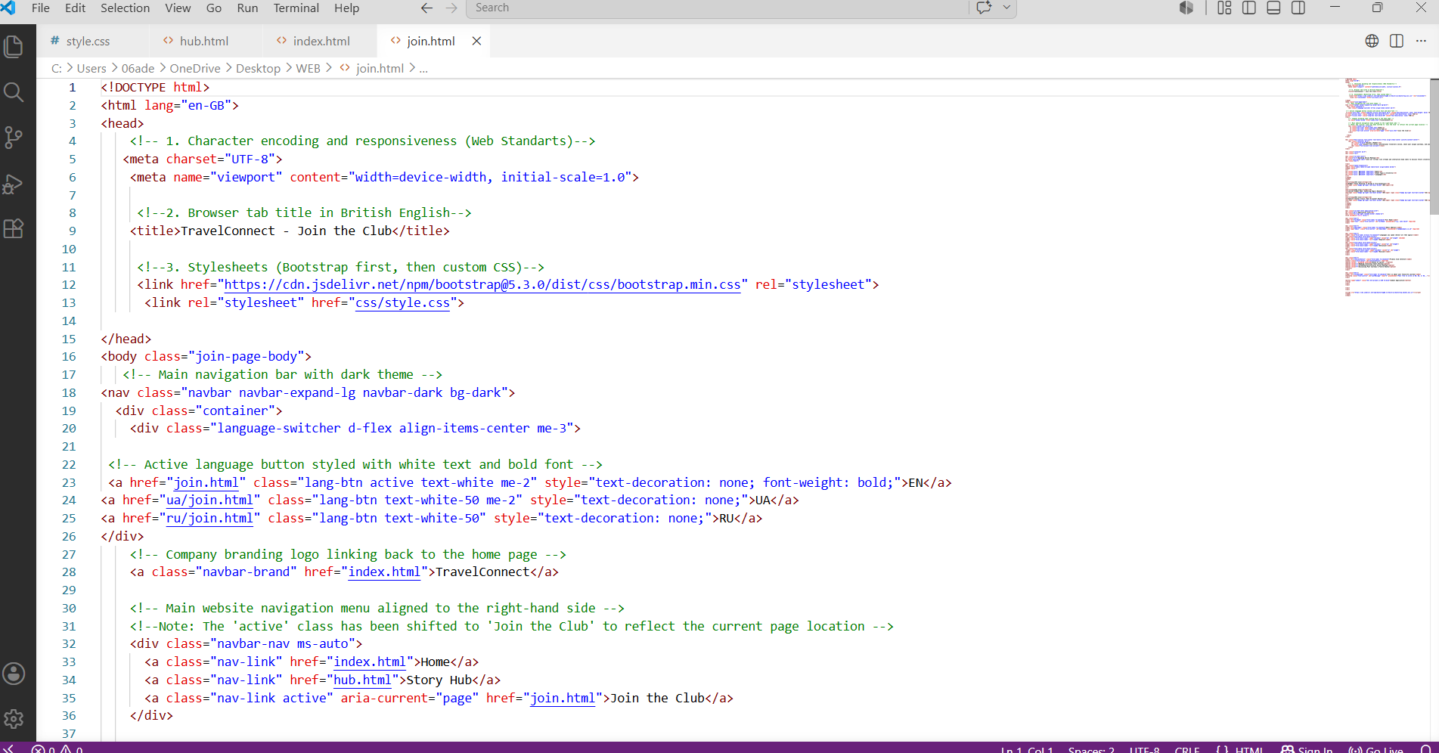
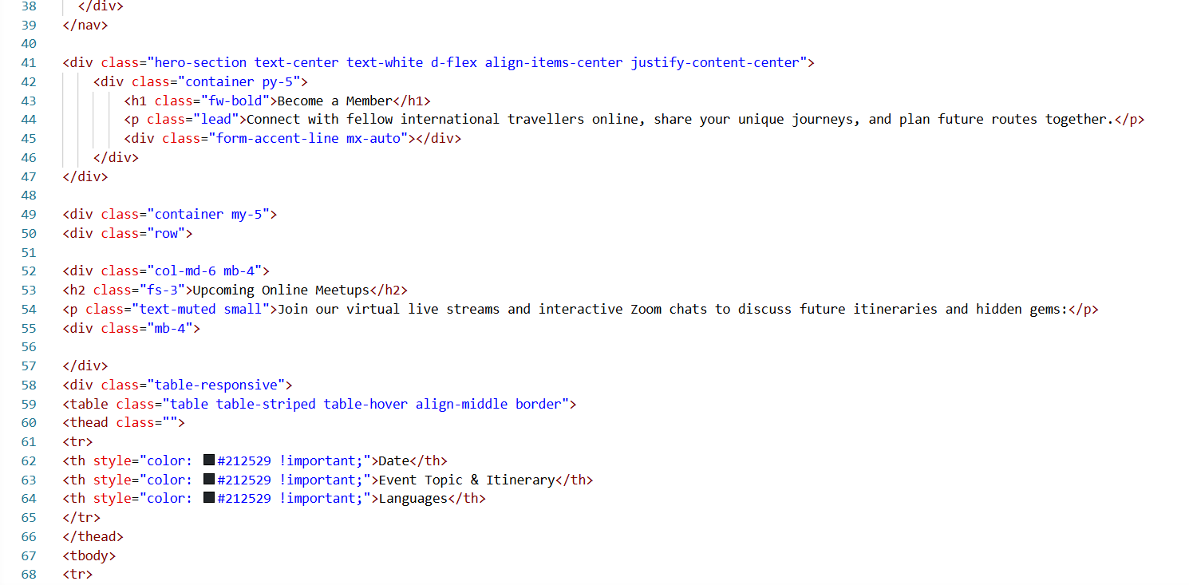
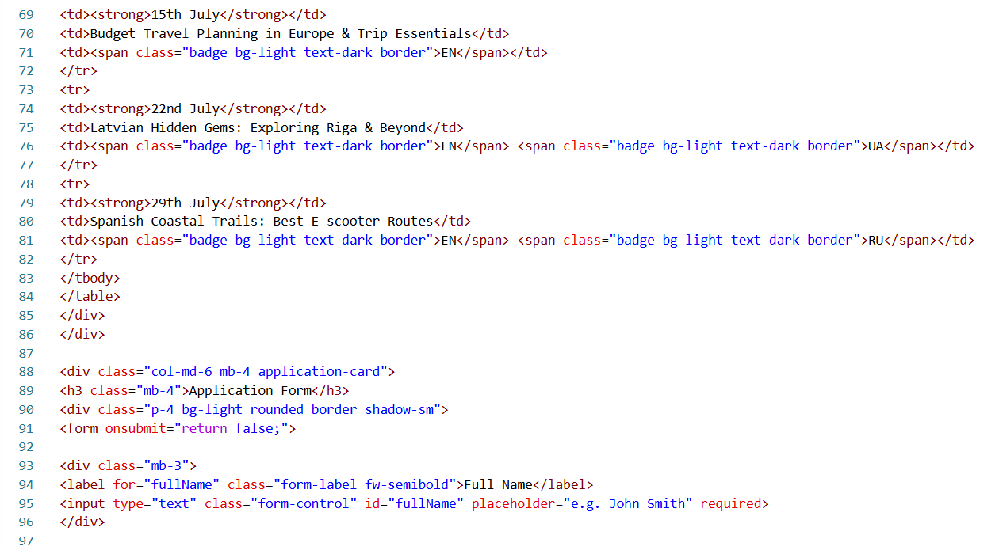
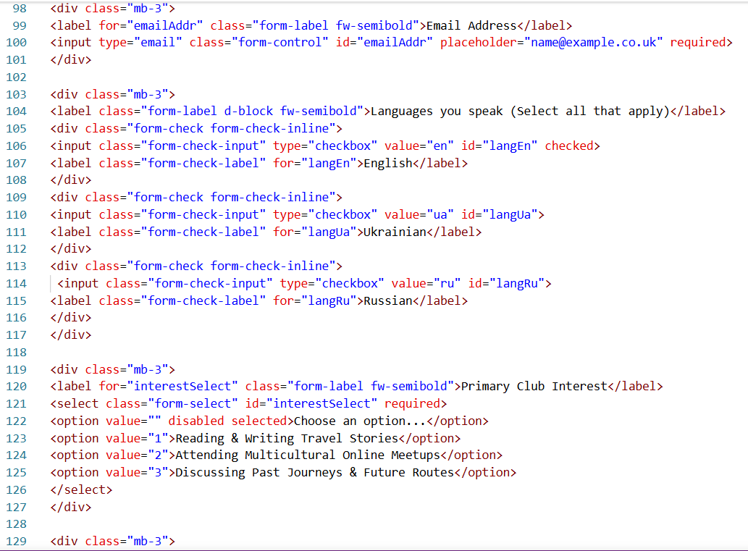
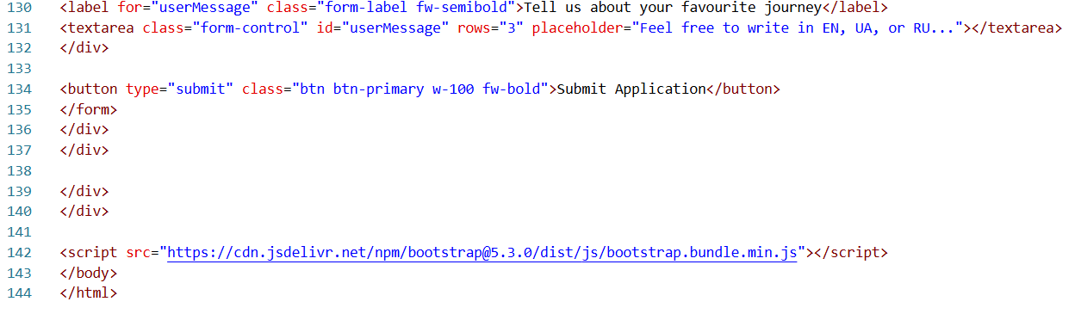

Hub HTML ua

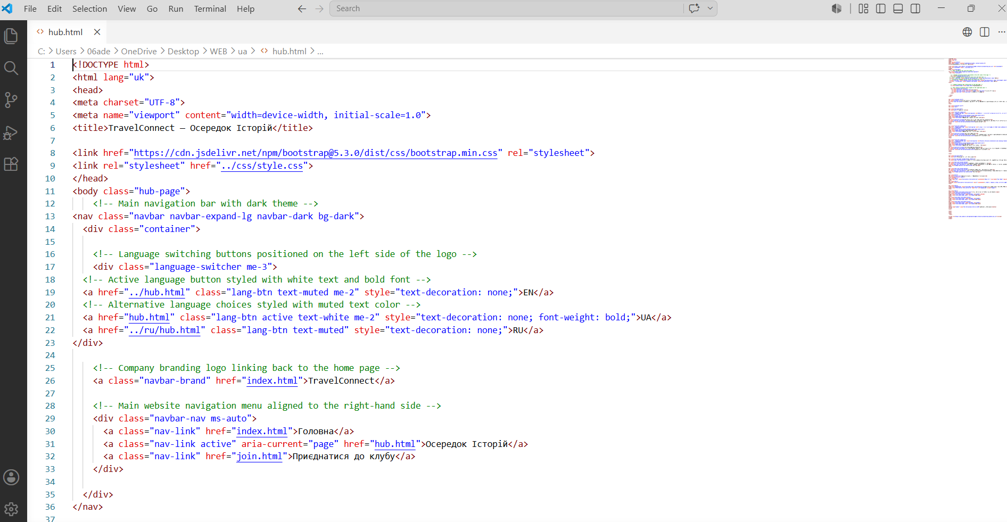
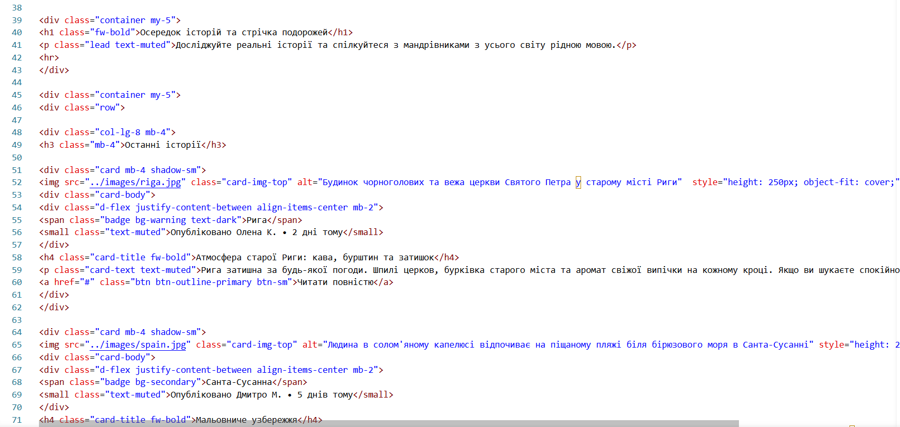
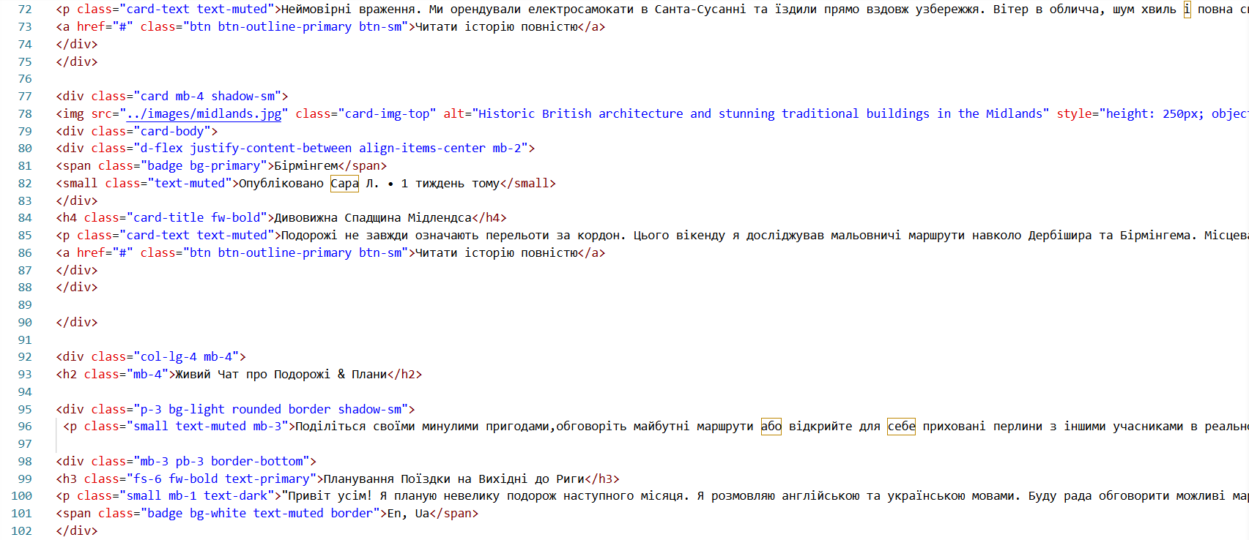
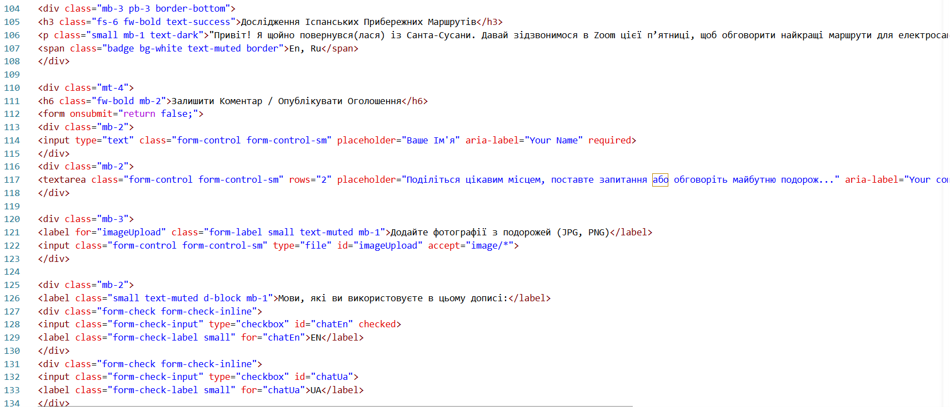
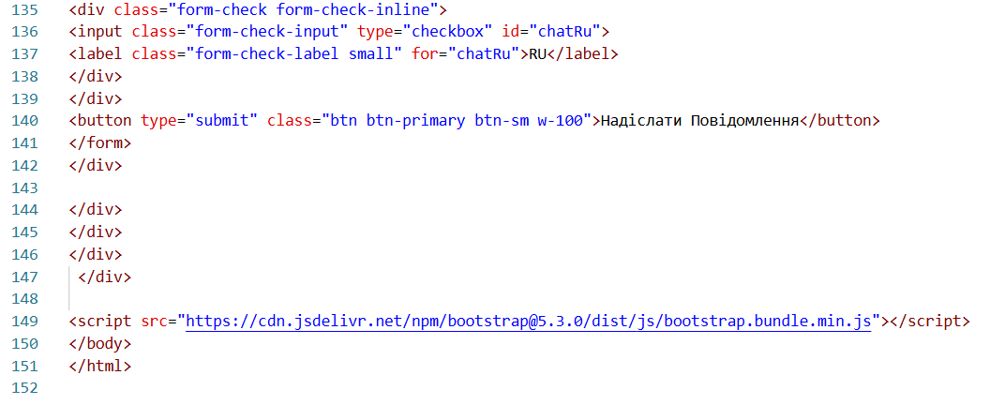

Index HTML ua

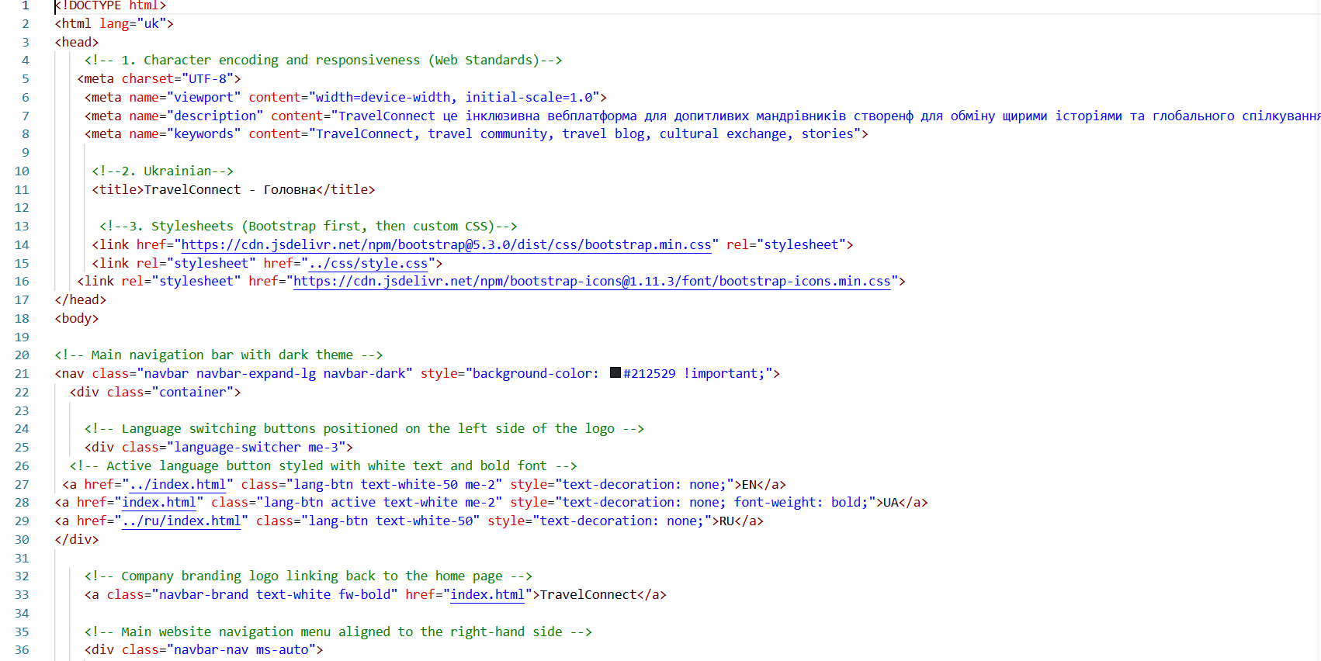
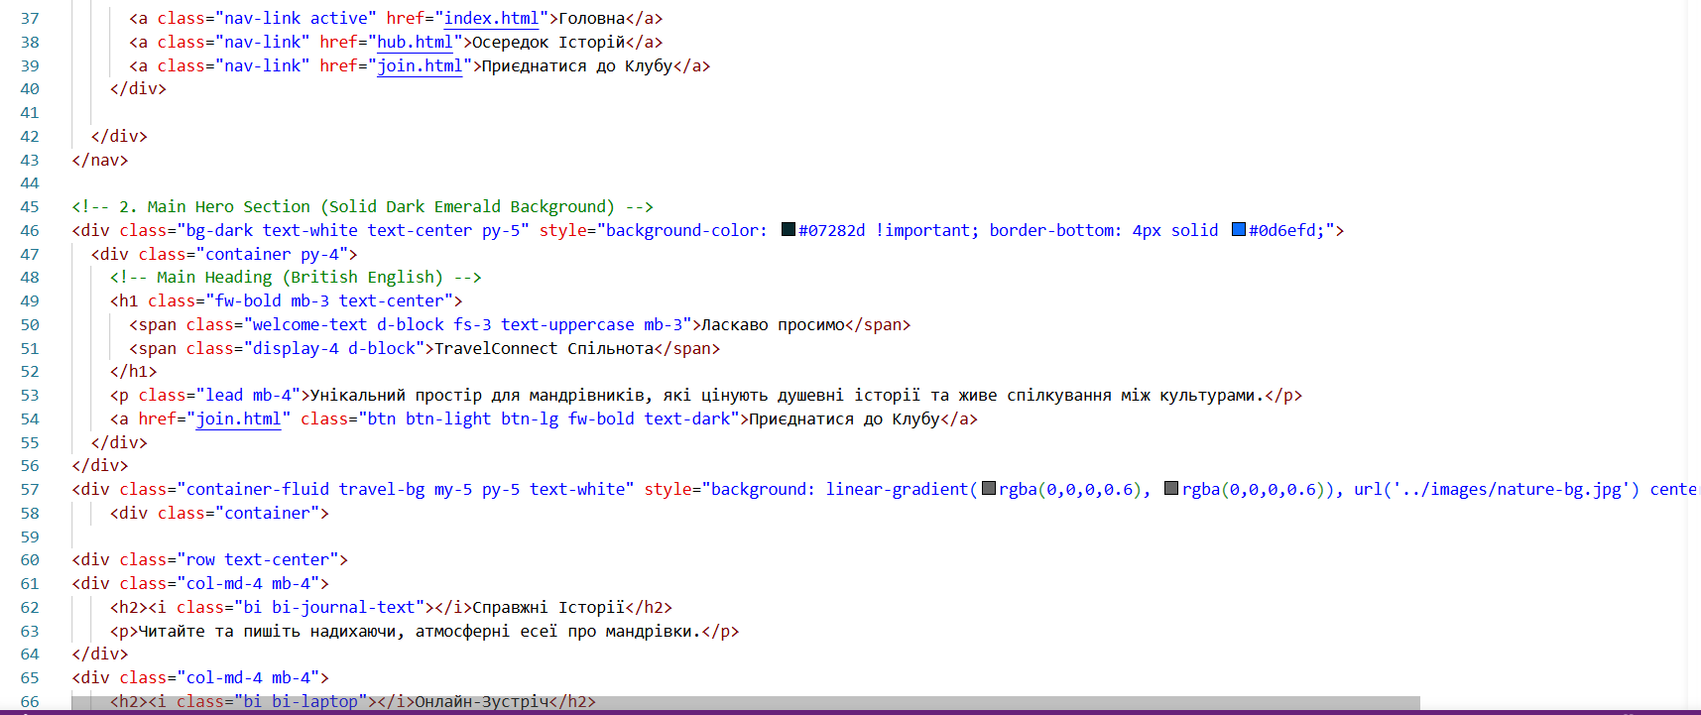
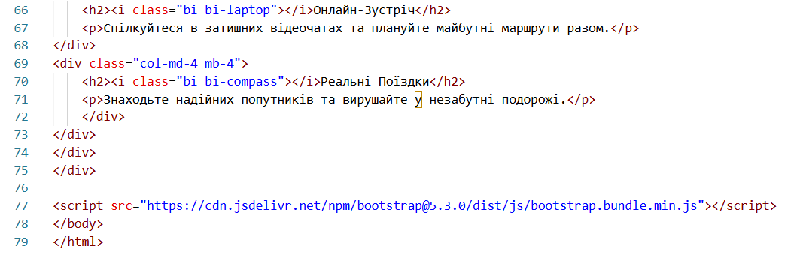

Join HTML ua

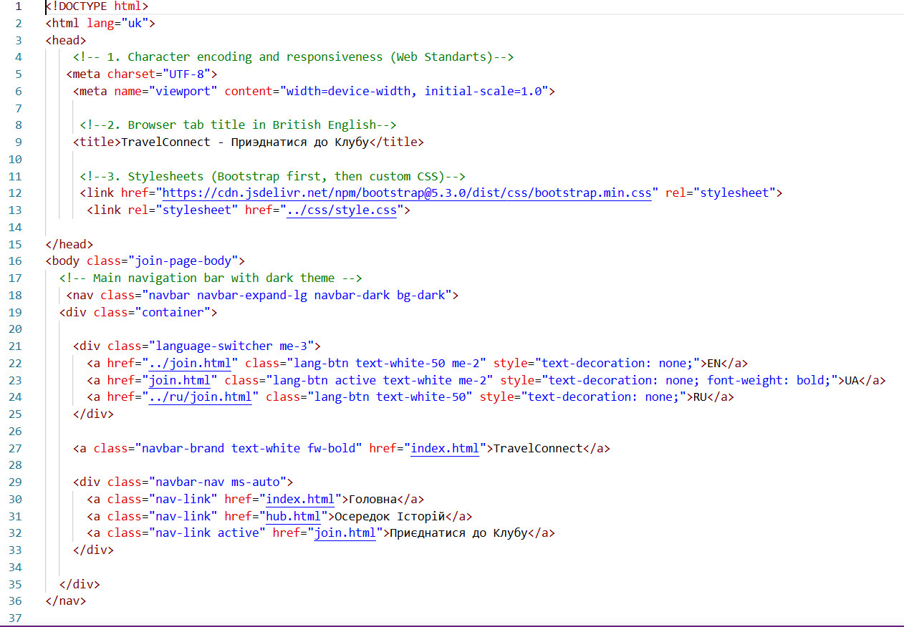
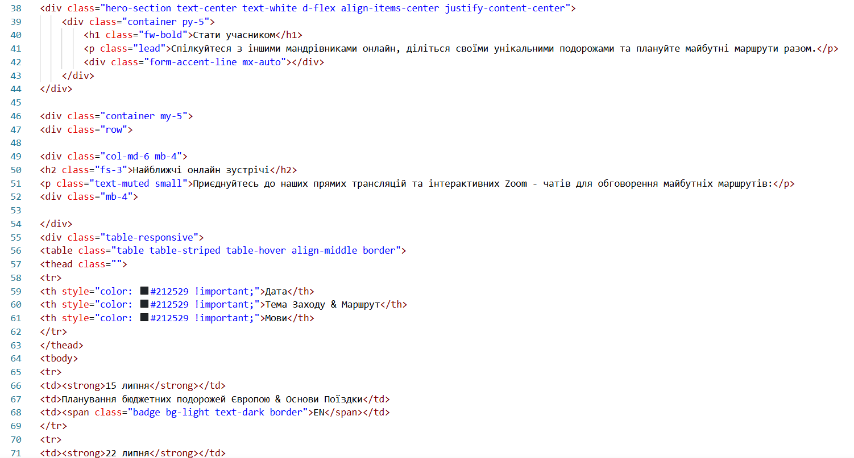
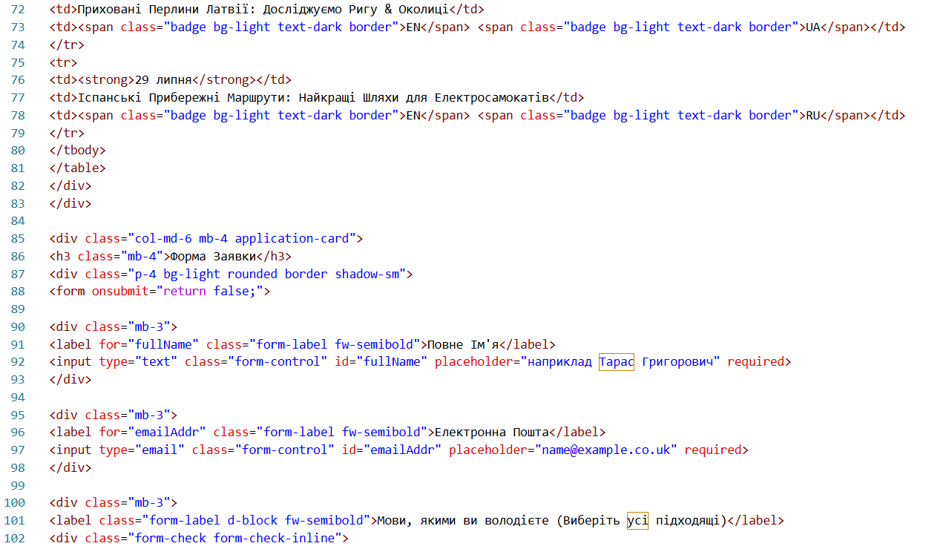
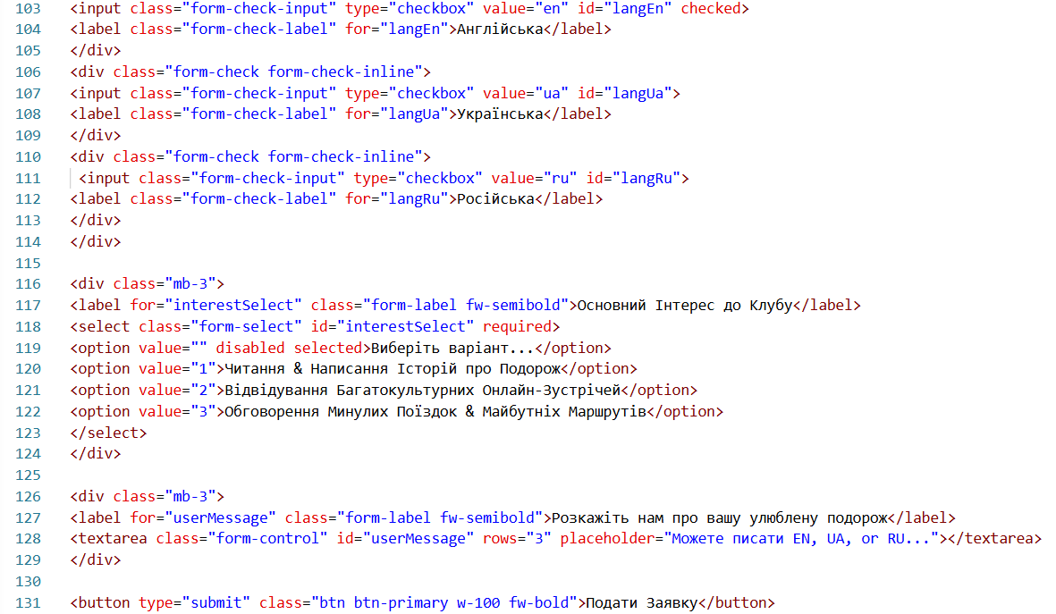
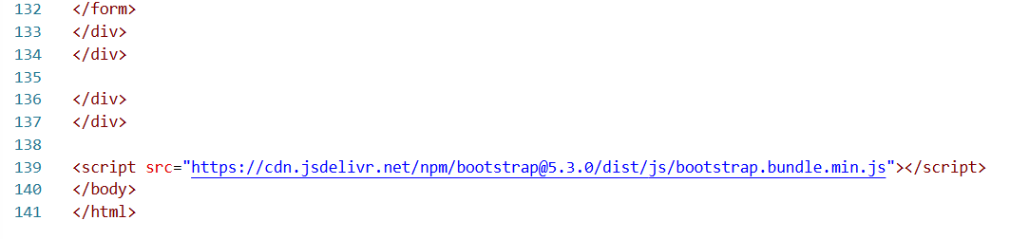

Hub HTML ru

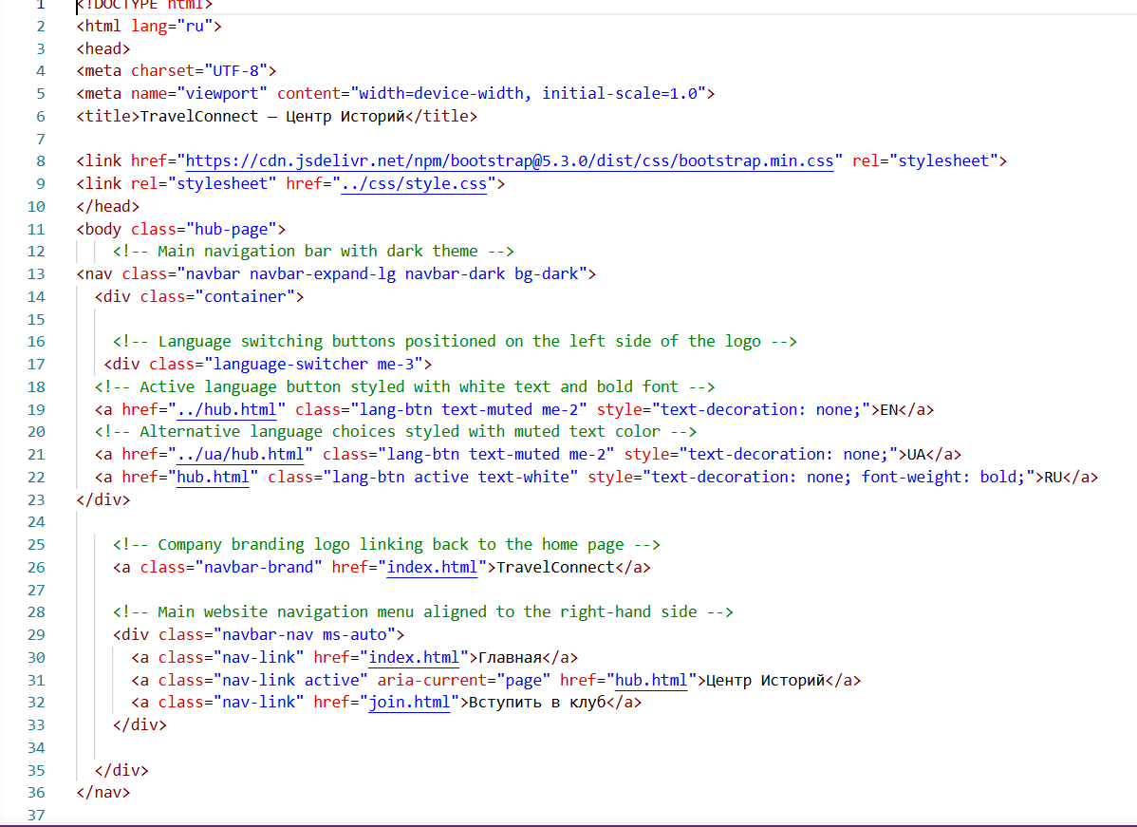
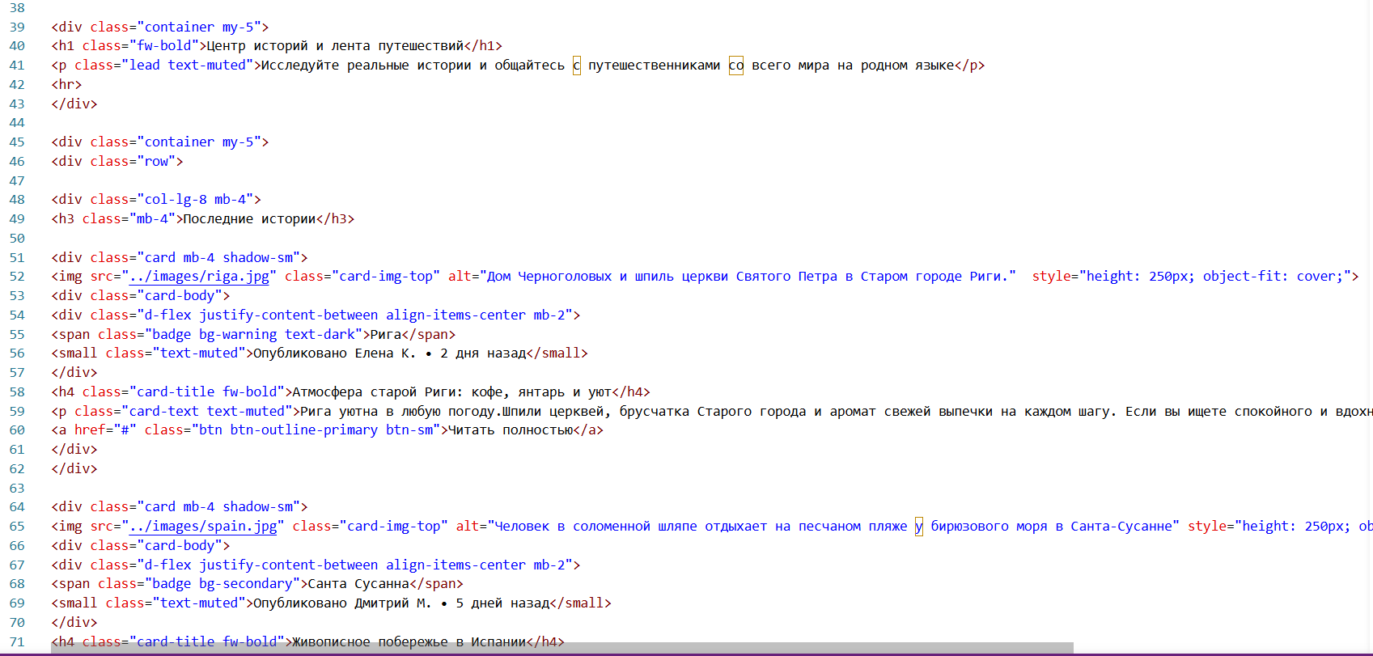
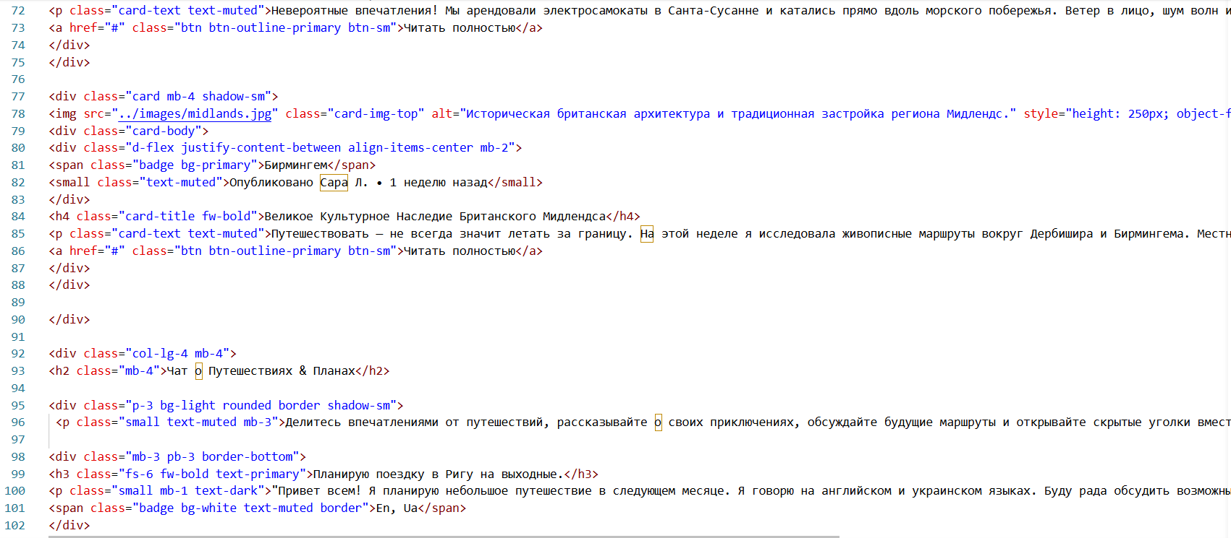
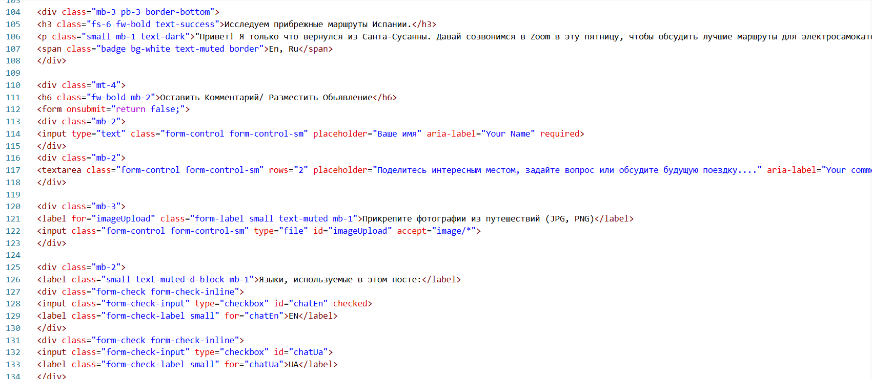
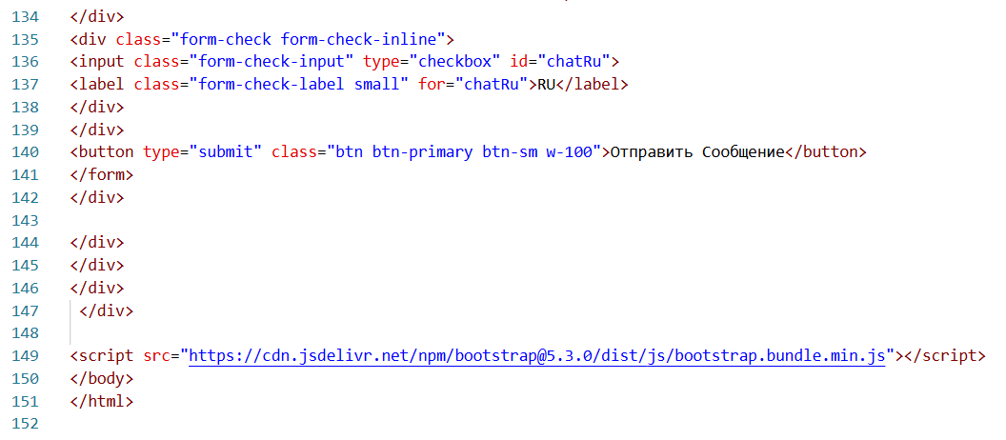

Index HTML ru

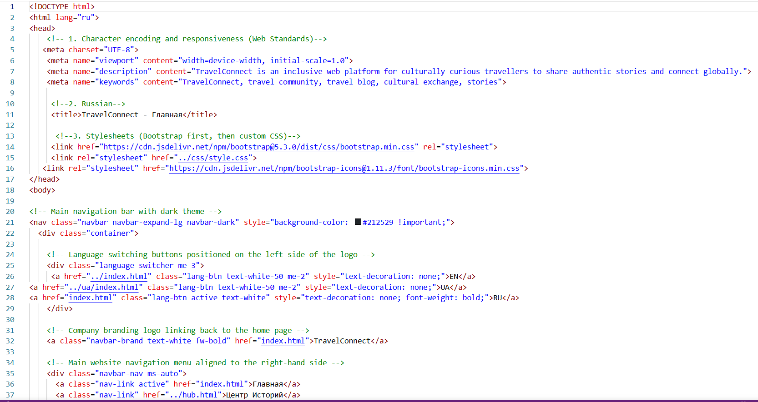
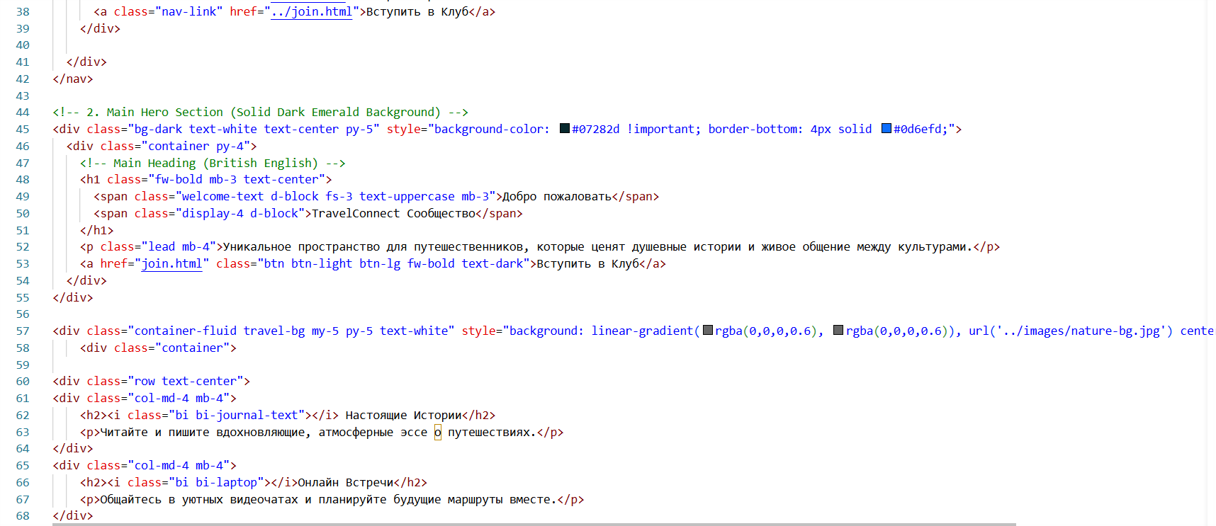
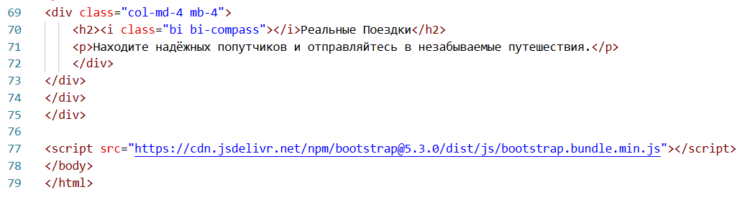

Join HTML ru



