Module Title: Managing Projects in the Organisation

Module Code: (BMSK5004)

Lecturer Name: Paul Ranson

Student Name: Eidran Hussain

Student Number: 1711192

Introduction
The main focus of this report will be on how Rock Solid as an organisation will carry out the task of relocating Vinters Antiques from their shop which is based in Shirley, to a warehouse on Stratford Road in Sparkbrook Birmingham. Rock Solid is a business which assist and support other organisations and businesses in relocating their business to different areas. As well as this the business offer’s and specialises in project planning, removals and management services.
The Vinters is a respectable family business that has multiple strong business links and relationships with its community. As well as this, the business also holds a valuable large section in the market due to the excellent service it has been providing to its customers over many years. The Vinters specialise in and are a unique antique business. There are four employees who work together and run the business with the owner who is the 3rd generation family owner.
It is the responsibility of Rock Solid as a business to take it upon themselves to relocate Vinters to their new preferred location by ensuring they reduce costs, the amount of time that will be consumed and make the move convenient. Vinters have an excellent reputation which they have been able to maintain due to the high standards of quality and service they deliver as a business as a result of their knowledge in their chosen market. Nevertheless, Vinters Antiques have now decided and feel that they need to expand their business and capture a larger market in order to gain more business acknowledgement, customers, and success. Therefore, they have reached out to Rock Solid to help and assist the business in being able to make this successful move.
Potential Risks
Through this section of the report I will indicate and elaborate on some of the most common risks associated with managing the project. There is always a fair share of risks when handling and managing a project regardless of the project been small or big. These risks can have an effective impact on delivering the project accordingly, and on the overall successful completion of the project. In relation Boitnott (2020) claims while success is the ultimate goal, business risk may stop you from achieving the goals you set (Boitnott, 2020). Therefore, it is important for the business to be able to identify possible potential risks and be able to ensure they come up with a business plan in order to enable them to overcome their risk and result in delivering an effective service to their customers.
Cost Risk
Cost is a common potential risk which occurs when the cost estimation is not accurate which can result in an escalation in costs and cause a loss to the company. Therefore, it is important calculations are done accurately and are correct in order to prevent certain risks from occurring. Nevertheless, to avoid this from occurring and the business facing loss there are multiple policies that can be followed and put into place. For example, you should pay a lot of attention to your project planning, attempt to stay within the scope that was originally planned, use good scheduling tools and charts, and constantly track and measure the progress (Viswanathan, 2012). These are a few procedures that can be followed and maintained in order to ensure you are on track with your costs throughout your project and in order to avoid common cost issues that may arise.
Schedule Risk
Schedule is also an important factor when it comes to business project plans. It is important for a business to work according to a schedule to ensure they are completing tasks on time and to ensure the productivity of the task and to be able to meet the given deadline to clients. Nevertheless, schedule as a feature is also seen as a risk as certain activities can sometimes take longer to complete than expected. A lack or slip in a schedule would result in increasing costs and would also delay the project benefits which may mean the business could be left with a possible loss of competitive advantage (Project Management, 2020). Therefore, it is important businesses have regular reviews of the productivity of the work and keep on track of their business plan schedule to ensure everything is moving accordingly and effectively in order to prevent further issues.
Performance Risk
A performance risk is the potential danger that a service or project will not deliver as much value as required (Spacey, 2019). There is always a performance risk while carrying out a business project as there is a concern that the project will fail to produce consistent results according to the project specifications. Therefore, it is vital businesses are on track with their performance and relate back to the project specification on a regular basis to ensure it is been met and that they are performing and delivering a service at a high standard which they have promised to their service users.
Project Plan:
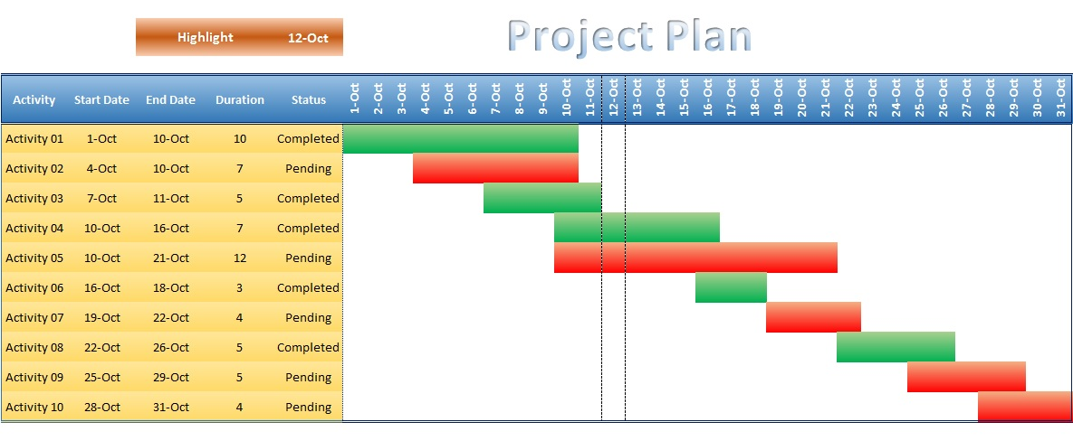
There are many methods businesses can follow in order to make it easier for them to carry out and complete tasks in order to meet their overall project goal. Gantt chart is a method made up of several different elements that a business may use in order to plan, track and carry out a project. Rock Solid as an organisation use the method of the Gantt chart in order to plan, achieve and succeed in their projects. A Gantt chart is a horizontal bar chart that visually represents a project plan over time; nevertheless, a modern Gantt chart shows you all the tasks and who is responsible for each task in the project (TeamGantt, 2020).
A Gannt chart is broken down into 8 key factors. These factors consist of:
- A Task List
- Timeline
- Dateline
- Bars
- Milestones
- Dependencies
- Progress
- Resource Assigned
All these factors play a big role in organising and managing a project. Therefore, we at Rock Solid can use this tool to help us plan and achieve our goal in helping the Vinters relocate their business. There are many benefits from using this tool for example, it will indicate and highlight to us how long the project is going to take, who is associated with what task and alongside this we will be able to track the progress of tasks and of our project using the chart.
Another benefit a Gannt chart offers is that it promotes transparency. The chart will show details of each team members tasks and milestones in one section so everyone who is part of the project is aware of each other’s workload and can help those who are struggling to meet individual targets efficiently. This kind of transparency in the work process boosts teamwork, honesty and humbleness within the team (Kashyap, 2019). Therefore, using a Gannt chart will not only result in managing our project successfully it will also result in being able to strengthen our team at Rock Solid and ensure employees are not struggling and everyone is working together as a strong team in order to meet project goals and gain further business success.
Another method Rock Solid use in order to manage and plan projects is an iron triangle. A project management triangle is also known as an iron triangle. It is a model of constraints that put together project management. Managing a project successfully has been traditionally associated with the ability of the constraint limits of projects in scope, time, cost, and quality called iron triangle (Visual Paradigm, 2020).
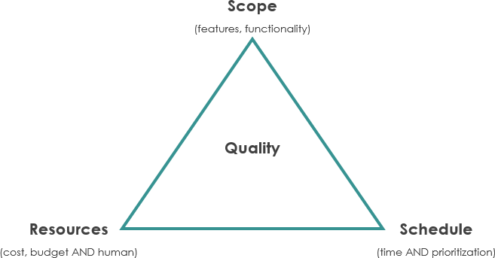
Project managers often require a balance in between the key factors that constrain the overall project delivery. The key factors are known as Scope, Schedule, and Cost. These three factors work together and build a strong relationship known as the iron triangle. The Scope is referred to the total amount of work that is involved in delivering the project. The Cost is referred to the total of all the resources that are required in order to complete the project. The Schedule reflects the time that is estimated and allocated for project tasks and project completion. These three factors play a huge role in project managing as they break down the project making it easier for businesses to plan and complete their projects accordingly.
Therefore, Rock Solid will also be using this method as well as the Gannt chart in order to plan and successfully achieve their project. Rock Solid will put these strategies in place in order to deal with any project constraints that may arise and complete their task. They will use the subheadings in order to direct them and guide them in making a further detailed plan highlighting all the main goals and actions that need to be taken and completed in order for the successful move. Rock Solid will work as a team using these methods in order to create the best business project plan for the task associated to them by Vinters Antiques. The business will create the best plan taking into consideration the scope, cost and schedule discussed by the Vinters.
Rock Solid will ensure the communication between both businesses is on point as communication is the key between project planning and business success. Possessing and delivering excellent communication skills will help business leaders and their teams in every aspect of business operations and result in positive team relationships (Leonard, 2019). Nonetheless, Rock Solid will also complete this task effectively and efficiently in order to ensure they do not consume too much time as consuming too much time may be an issue for the Vinters simply because they want to relocate as soon as possible in order to get their business up and running.
Even though Rock Solid are going to be using methods such as the ones discussed and addressed above to plan and direct their project there may still be many obstructions that may arise and come in the way of them achieving their final project goal. However, it is the responsibility of Rock Solid as a professional organisation to be able to overcome these barriers and always have other options to enable to redirect their team meeting their goals and making their project a success. This will result in furthering their business towards success and leaving a positive, beneficial impact on their business within its market.
Conclusion
To conclude the main aim for Rock Solid as an organisation is to successfully relocate the Vinters Antiques. Throughout this assignment there have been risks identified and discussed that Rock Solid may face while completing this project and making the move. However, it is the responsibility of the business to be able to overcome and avoid those risks from occurring in order to be able to process the relocation smoothly without any disappointment. However, on the other hand, methods that are going to be followed have also been elaborated on in order to be able to help and direct Rock Solid in creating the best project plan and keeping and maintaining on track and up to date with the project. Nonetheless, throughout this project we as a business are going to ensure we maintain clear communication with the Vinters including giving them regular feedback and updates of where we are with the move to ensure they are aware of what is happening and are regularly satisfied that they can trust us. Alongside this we as a professional organisation will also let them know if there are certain challenging aspects that may arise, and follow it up with a plan and reassure the Vinters that they will get their business relocated in their new chosen destination successfully, overcoming any issues that may occur, ensuring success for both organisations.

References:
Boitnott, J. (2020) 7 Business Risks Every Business Should Plan For. [Online] Accessed on 25th March 2020. Available at: https://www.americanexpress.com/en-us/business/trends-and-insights/articles/7-business-risks-every-business-should-plan-for/
Kashyap, S. (2019) Top 11 Benefits of Gannt Charts in Project Management. [Online] Accessed on 26th March 2020. Available at: https://www.proofhub.com/articles/benefits-of-gantt-charts
Leonard, K. (2019) Importance of Good Communication in Business. [Online] Accessed on 24th March 2020. Available at: https://smallbusiness.chron.com/importance-good-communication-business-1403.html
Project Management (2020) Types of Risks in Project Management. [Online] Accessed on 25th March 2020. Available at: https://project-management.com/types-of-risk-in-project-management/
Spacey, J. (2019) 5 Examples of Performance Risk. [Online] Accessed on 20th March 2020. Available at: https://simplicable.com/news/performace-risk
TeamGannt (2020) What is a Gannt Chart? [Online] Accessed on 26th March 2020. Available at: https://www.teamgantt.com/what-is-a-gantt-chart
Viswanathan, B. (2012) 6 Ways to Prevent Cost Overruns. [Online] Accessed on 20th March 2020. Available at: https://project-management.com/6-ways-to-prevent-cost-overruns/
Visual Paradigm (2020) What is Iron Triangle of Projects? [Online] Accessed on 25th March 2020. Available at: https://www.visual-paradigm.com/project-management/what-is-iron-triangle-of-projects/

