This essay aims to explore the concept of gender ideology to determine how self-identity is formed and shaped. This will include a critical reflection of the relational dialectics between individual, culture, family and society and the impacts of power on individual, social and political attitudes which may affect equality and diversity in practice. The position of power and control and how this may impact on both diverse populations and human rights will be discussed through the lens of hegemony theory with an emphasis on the mass media and its influence on social learning.
A profound question about human life is why men and women, and boys and girls, behave differently in many circumstances but similarly in others. There is no one discipline that provides a sovereign, overarching answer, but each discipline favours certain types of causes (Eagley and Wood, 2015, p. 458).

From the time of our birth, we are assigned a biological sex (e.g., ‘it’s a boy/girl!’). What ensues is an intricate process of realising what it means to be male or female, masculine or feminine, heterosexual, homosexual, bisexual, pansexual. The concept of gender identity and its formation has been a topic of great academic interest and debate (Oakley, 1972; West and Zimmerman, 1983; Lorber and Farrell, 1991; Lorber, 1994; Nicholson and Seidman, 1995; Brickell, 2006; Mikkola, 2019). Within the model of identity there are intersectional elements in which individuals differ (e.g., socially and psychologically), encompassing gender, race/ethnicity, sexual orientation, socioeconomic status and disability (Elliot, 2001; Croteau, 2002). When gender is viewed as difference (e.g., male and female) the debate has focused mainly on the role biology and culture play (Oakley, 1972) in our understanding of the self and of the way in which gender systems are constructed. According to Acker (1990, 92) institutions are constructed by how people experience each other in a social dimension. This includes gender socialisation (Cameron, 1997) as people perform gender in the way in which they experience life. Acker also proposes that the differing ways in which people perform their everyday practices is what shapes and reshapes gender institutions.

The hierarchical running of these institutions plays a major role in shaping societal values and norms, including the formation of identity and behaviour of its members (Balzer, 2002). However, hierarchical foundations have been criticised as affording privilege and advantage to some members of society while supporting the oppression and disadvantage of others (West and Zimmerman, 1983; Lorber and Farrell, 1991; Lorber, 1994). For example, being white, male and heterosexual could be considered as a privileged social status as opposed to being African, male and homosexual (Croteau, 2002). According to the International Gay and Lesbian Association, homosexuality is forbidden in 34 African countries as well as many other parts of the world (Carroll and Ramón Mendos, 2016). Criminalisation entails imprisonable sentences and even death. For example, in thirteen nation states, including Sudan, Saudi Arabia and Pakistan, the maximum penalty for engaging in same-sex sexual activity is death (see Appendix a, State-sponsored Homophobia, World Survey of Sexual Orientation Laws, pp. 189-191). These prohibitions create numerous equality and human rights issues, (e.g., discrimination and violence) impacting on identity, health, family relations and the right to sexual diversity (World Health Organisation, 2020).

The intention of this essay is to explore the mechanisms of power and the dominating forces that (re)produce and support the gender hierarchy and in doing so create intersections of inequality and human rights issues for both vulnerable and diverse groups of people universally. The concept of human rights was developed to enable all individuals’ basic rights and freedoms. The only time these rights and freedoms would ever be restricted or taken away is when a person breaks the law or is a threat to national security. The fundamentals of human rights relate to principles of dignity, fairness, equality, respect and independence. These principles are adhered to by legislation, in the UK, e.g., our human rights are protected by the Human Rights Act 1998 (Equality and Human Rights Commission, EHRC, 2019). However, this is likely to be replaced soon for a new Bill of Rights (Horne and Maer, 2010). Indeed, there are concerns that the UK ’s departure from the EU could have ramifications for equality (see, EHRC, 2016 for full details) and domestic laws, which protect or develop equality and human rights, this includes protection against discrimination, for example:
The Equality Act 2010 is the domestic legislation which prohibits discrimination and makes provision intended to advance equality. Domestic legislation will not be immediately affected by EU exit. However, whereas currently the UK is required to retain parts of the Equality Act 2010, following EU exit the Government could, in theory, repeal some or all of its provisions (EHRC, 2016, p. 9).

This next section will reflect on several perspectives and theories that may help in the understanding of these mechanisms of power and how they may impact on gender, identity and behaviour. In terms of biology, biological determinism hypothesises that human behaviour is controlled by a person's genetic characteristics or by their physiology (Whittier, Taylor and Rupp, 2011). An early perspective of this theory presented by Geddes and Thomson (1889, cited in Mikkola, 2019, p. 2) proposes ‘that social, psychological and behavioural traits are caused by metabolic state.’ According to this hypothesis, women are ‘anabolic,’ conservers of energy, passive by nature and static. Men on the other hand are ‘katabolic,’ energetic, eager and passionate. An analysis of these characteristics concluded that the ‘anabolic’ nature as opposed to the ‘katabolic’ nature was unsuited, nor concerned in matters pertaining to social affairs and politics. This study of gender may be of significance in how hegemonic institutions and hierarchical gender systems are constructed as this analysis of gender justifies the subordination of women. Indeed, women were denied voting rights on the grounds that they were not biologically suited to politics (Mikkola, 2019). This is supported by Ortner (1974, cited in Moore, 2013, p. 80) who ‘suggested that the devaluing of nature in relation to culture accounted for the hierarchical relations between women and men.’

The concept of hegemony for Gramsci (1971) is when a group of people (or a nation state) adopt a political, intellectual and principled role of leadership within a hegemonic system that is underpinned by a shared worldview or ideology. Whereas hierarchy relates to a system in which members of a group or society are ranked according to comparative status or power. In reflecting this, the above model of gender neither takes into consideration intersections of differences between males and differences between females (Nicholson and Steidman, 1995; Mikkola, 2019), nor does it pay consideration to when gender identity does not resemble the gender/sex (male or female) that was assigned to a person at birth. Indeed, this binary model of gender does not support gender/sexual diversity on many levels; such as the needs of those who identify as non-binary or transgender. For instance, ‘Individual’s whose gender identity conflicts with biological sex assignment or societal expectations of gender expression as male and female’ (Bilodeau and Renn, 2004, p. 29). This includes sexual orientation, which may impact largely on the lived experiences of those who do not fit societal expectations, i.e., expressing oneself in a society that largely follows heteronormative values (Nicholson and Seidman, 1995). For instance, when a person does not fall into the traditional male/female binary model, sexual identity can become problematic (Giammattie, 2015). This, places sexual diversity in a position of conflict with heteronormative gender norms (Gordon & Meyer, 2007). For example, a large body of research (Faulkner and Cranston, 1998; Fergusson, Horwood and Beautrais, 1999; Russell and Joyner 2001; Ueno, 2005) suggests that adolescents who identify as bisexual, lesbian or gay are more likely than those who identify as heterosexual to exhibit symptoms of mental suffering including depression, suicidal ideation and suicide attempts. Despite many countries implementing legal protections to support the LGBT community, research (Carroll, 2016) reveals that LGBT people are subjected to greater economic disparity and violence than heterosexual people. Furthermore, countries such as India, Kenya and Lebanon have criminal prohibitions on gender non-conformity and same-sex relations.

A contemporary definition of biological determinism adds that anatomy and genetics affords men to be the more dominant gender by nature whereas women are natural care givers by virtue of their procreative abilities (Moore, 2013; Chandler and Munday, 2020). This theory is related to Connell’s (1987) concept of hegemonic masculinity and the term was used to signify characteristics attributed to real men. These characteristics distinguished men from women and subordinate masculinities and justified men in general to hold positions of power in society (Kareithi, 2014) thereby generating systems of inequity in relation to gender, sexual orientation, race, class and disability (Donaldson, 1993; Pyke, 1996). Furthermore, de Melo-Martin (2002) argues that biological perspectives of human nature disregard the impacts that institutions, social values and practices have on the lived experiences of diverse individuals universally and maintains that;
What constitutes a problem for those who are concerned with social justice is not the fact that particular behaviours might be genetically determined, but the fact that our value system and social institutions create the conditions that make such behaviours problematic (de-Milo Martin, 2002, p. 2).

Furthermore, Buss (1996) and Wilson (1978) argue, that even if sexual differences are genetic, this does not mean that they are not subject to change over time.

Gender, from a social postmodernism perspective, is understood as something that is socially constructed rather than biologically assumed (Nicholson and Seidman, 1995). This perspective views behaviour and personality characteristics as seperate from the body. Thus, gender and sex are understood as separate, in this case, society shapes not only the characteristics and behaviour of its members but it also shapes the ways in which the body is represented. This could suggest that if the body is viewed as something to be interpreted, then sex, according to Nicholson and Seidman (1995, p. 39), ‘is not something that is separate from gender but is, rather, that which is subsumable under it.’ From a feminist perspective, these two perceptions of gender could suggest that women’s subordination is based on the fact that their position in society is largely determined by biological difference.
A poststructuralist perspective, a term associated with Foucault (1979) and Derrida (1967, 78) explores sexuality in terms of heterosexual homosexual opposition. Poststructuralist queer theory examines sexuality to gain a better understanding as to why heterosexuality has held a position of dominance over other sexual individualities. However, a poststructuralist queer theory has wider inferences for sociological approaches to sexuality; indeed, queer theory is not about focusing primarily on the LGBT community, but instead offers sociology a chance to critically analyse the position and reproduction of heterosexuality. This suggests, that a poststructuralist perspective perhaps aims to understand heterosexuality as something that is socially constructed (Namaste, 1994). A fundamental of gender socialisation is the position that role theory plays in the forming and shaping of males and females to fulfil family and work-related positions in society. For instance, Eagley and Wood (2015) propose that societies carry out numerous methods of socialisation to encourage personality traits and skills that enable role performance of its members and that biological and psychological processes are entangled within genders. However, Connell (1985; 87; 95; and Carrigan, Connell, and Lee, 1987) criticised role theory initially and then also sex role theory because of its failure to conceptualise the position of power and conflict as a key element of the relationships between and within genders; this included the inability to understand transformation as a consequence of the paradoxes within gender relations. Consequently, sex role theory failed to understand the connection between social institutions and human agency due to its dependence on biological perspectives (Demetrakis, 2001).

This next section is going to explore further the mechanisms of power and control, engaging the mass media as an institution and influencer of gender ideology through social learning. The mass media has been implicated as playing a major role in the influencing of dominant ideological perspectives of gender (Giaccardi et al., 2016; Harding, 2008; Ward, Merriwether and Caruthers, 2006). In this case, gender role ideology refers to a common viewpoint concerning the roles, rights, and responsibilities adopted by men and women in society. This entails distinctive roles for men and women; men play the role of the breadwinner and women the homemaker, for instance. However, these ideologies of the family structure have been heavily criticised (West and Zimmerman, 1983; Lorber and Farrell, 1991; Lorber, 1994) for creating inequality and human rights issues on many levels, such as unequal opportunities between men and women (e.g., the gender pay gap) and between same sex couples for instance. The mass media has also been criticised for the sexualisation of culture, through magazines, television, film, radio and social media. This has been illustrated in the way that magazines use celebrities and models for advertising campaigns, many of which promote the sexualised body as a representation of femininity (Davis, 2018; Collins, 2011; Gill, 2007) and masculinity (Papadopoulos, 2010). For example, a study concerning the advertising of beer and non-beer in entertainment and sports channels revealed that 75 per cent of beer and 50 per cent of non-beer adverts were understood to be sexist and presented women in objectifying roles (Papadopoulos, 2010; Rouner, Slater, and Domenech-Rodriquez, 2003). Whereas representations of men as hypermasculine not only encourage the phenomenon of hegemonic masculine scripts (Mosher & Sirkin, 1988) to be played out among men, e.g., macho behaviours, but also inverts the male gaze (Patterson and Elliot, 2002). The establishments of consumer culture (Slater, 1997) play a key role in the creation of bodily norms (Patterson and Elliot, 2002; Stuhldreher and Ryan, 1999; Thomson and Hirchman, 1995) and a failure to meet with these modern ideals of self-image could be symptomatic of poor self-perception (Foucault, 1979; Patterson and Elliot, 2002).

A study was undertaken in India (Shaikh, Bughio and Kadri, 2015) to demonstrate the position of gender representations in advertising and the impacts on gender equality. The findings of this study indicated that through patriarchal ideology, advertisers use several strategies to naturalise stereotypical roles of male and female. For example, an advertisement for the Kenwood Chef narrates as follows; ‘the chef does everything but cook; that is what wives are for’ (Shaikh, Bughio and Kadri, 2015, p. 32). Another showed a family sitting at the dinner table (two children, and two men, presumably a father and a grandfather) however, it is the woman (mother figure) in the picture who serves the meal. Other examples related to the use of women’s beauty products; these adverts not only suggest that physical beauty is an important part of being a woman, they also endorse the position of a woman’s role in a family setting to be one that is passive. These adverts promote a heteronormative view of gender and family life, excluding diverse family structures, e.g., LGBT families. Furthermore, Collins (2011) argues that the media frequently portrays women in subordinate and sexualised roles, such as nonprofessional heteronormative domestic roles, and that women are used in sexual scripts. For example, a study by Downs and Smith (2010, cited in Collins, 2011) revealed that 41 per cent of female characters used in many of the top-selling video games wore revealing clothing or were presented to be in part or entirely naked. In addition, these women’s bodies were presented in an unrealistically proportioned manner whereas men were not generally found to be portrayed in the same way (Dill and Thill, 2007). This hyper sexualisation of women and children is a growing concern, particularly regarding its influence on young people through gaming and social media use (Papadopoulos, 2010); impacting largely on the construction of self-identity, gender and sexuality. Moreover, it is the position of sexuality in online social networking that has been implicated as a key influence in this self-construction (Davis, 2018).

According to McQuail (2010), mass media theory refers to the phenomenon of mass communication to large audiences of people around the world. He argues that the mass media has played a central role in the shifting trends of contemporary society and culture (Harding, 2008) impacting on individual experience and the socioeconomic system. This includes how social values and norms are influenced and perceived, such as in the socialisation of gender and gender ideology. Ideology, for Tomkins (1965, cited in, Mosher and Tomkins, 1988, p. 62), is defined as a ‘biosocial construction that humans use to understand, justify, and celebrate how they live in the world.’ Furthermore, visual learning has been recognised to be the most influential mode of learning (see, Bandura, 1986). Indeed, Smith et al., (2019) proposes that:
In the process of our becoming, visual communication plays a crucial role, one that is particularly vulnerable to emotional learning and to manipulation by political, economic and other vested interests (Smith et al., 2019, pp. 60-61).

In view of the fact that the mass media creates large profits for privately owned corporations (Jhally, 2006; O’Shaunnesey and Stadler, 2005) and some of the points raised above, how the media represents or misrepresents (Collins, 2011; Davis, 2018) gender roles could be highly influential in supporting the gender hierarchy. In addition, the rise of violence on television is a human rights’ concern; male characters, for instance, have consistently been observed as the perpetrators of physical violence compared with female characters, which could impact on violence against women and children (Glascock, 2001; Smith et al., 1998). Indeed, the Crime Survey for England and Wales (CSEW, Office for National Statistics, 2018) revealed that women were more likely to experience all forms of domestic violence than men. Papadopoulos (2010) argues that violence against women and girls on television has risen since 2004 by 120 per cent and that violence against adolescent girls has risen by 400 per cent. In 92 percent of these cases, the violence was visual, rather than implied, which implicates the position of social learning in these instances. Furthermore, statistics from the CSEW also estimated that approximately 3.1 million adults have experienced sexual abuse before the age of 16 years; this includes both adult and child offenders, whereas, 73,260 sexual offences were against children in that same year (Office for National Statistics, 2019). Papadopoulos (2010) asserts that greater corporate social responsibility is called for (see, Rush and La Nauze, 2006).

This essay has explored several perspectives and theories to try to understand how gender identity is formed and shaped and the implications for equality and diversity in practice. Evidence would suggest that Patriarchal hegemonic structures incline to support heteronormative values as perhaps a means of social control, by exploiting the process of gender socialisation. For instance, through gender socialisation, men and women are moulded to carry out family and occupational positions in society. The hypothesis of biology as a perspective of gender fell short of explaining the impacts of social institutions, practices and values on the lived experiences of diverse populations universally, such as how the criminalisation of same sex relations in many parts of the world creates vast equality and human rights issues for gender and sexual individuality. In addition, the mass media as an institution has been implicated as reinforcing the gender hierarchy by promoting patriarchal and heteronormative values to be the most dominant, including hegemonic masculinity. Moreover, the media’s role in the sexualisation of culture has been associated with the rise in violence against women and children, impacting on some of the most vulnerable groups of people in society. Considering the fact that, visual representations of gender have been identified as playing a major role in the social learning process, perhaps policy makers have a duty to explore more effective ways of addressing corporate responsibility. Finally, the concept of difference between and within gender identity could be a fundamental consideration to addressing equality and diversity in practice.

References
Acker, J. (1990) ‘Hierarchies, Jobs, Bodies: A Theory of Gendered Organizations.’ Gender and Society 4, pp. 139–58 [google scholar]. Available at: https://scholar.google.co.uk/scholar?cluster=6550510291311809133&hl=en&as_sdt=0,5 (Accessed: 09 February 2020).
Acker, J. (1992) ‘Gendered Institutions: From Sex Roles to Gendered Institutions.’ Contemporary Sociology 21, pp. 565–69 [jstor]. Available at: https://www.jstor.org/stable/2075528?seq=1 (Accessed: 09 February 2020).
Balzer, W. (2002) ‘Searle on Social Institutions: A Critique’, Dialectica, 56(3), pp. 195-211 [wiley] Available at: https://onlinelibrary.wiley.com/doi/pdf/10.1111/j.1746-8361.2002.tb00239.x (Accessed: 09 February 2020).
Bandura, A. (1986). Social foundations of thought and action: A social cognitive theory. Englewood Cliffs, NJ: Prentice-Hall.
Bilodeau, B. L. and Renn, K. A. (2004) Analysis of LGBT Identity Development Models and Implications for Practice [google scholar]. Available at: https://scholar.google.co.uk/scholar?cluster=10824320848510499074&hl=en&as_sdt=0,5 (Accessed: 28 January 2020).
Brickell, C (2006) ‘The Sociological Construction of Gender and Sexuality’, The Sociological Review, 54(1), pages, 87-113. Available at: https://journals.sagepub.com/doi/pdf/10.1111/j.1467-954X.2006.00603.x (Accessed 27 January 2020).
Buss, D. M. (1996) ‘Sexual Conflict: Evolutionary Insights into Feminism and the ‘Battle of the Sexes’.’ In Buss, D. M. and Malamuth, N. M. (eds.). Sex, Power, Conflict. Evolutionary and Feminists Perspectives. New York: Oxford University Press, 296-318.
Carroll, A., and Ramón Mendos, L. (2016). State-sponsored Homophobia, a World Survey of Sexual Orientation Laws: Criminalisation, Protection and Recognition. 11th Edition. Available at: https://www.researchgate.net/publication/324861896_State_Sponsored_Homophobia_2017_A_world_survey_of_sexual_orientation_laws_criminalisation_protection_and_recognition
(Accessed: 09 February, 2020).
Cameron, D. (1997) ‘Performing Gender Identity: Young Men’s Talk and the Construction of Heterosexual Masculinity’, in Johnson, S. and Meinhof, U. (eds.) Language and Masculinity. Oxford: Blackwell, pp. 47-64.
Chandler, D., and Munday, R. (2011) A Dictionary of Media and Communication. Oxford: Oxford University Press.
Collins, R. L. (2011) ‘Content Analysis of Gender Roles in Media: Where Are We Now and Where Should We Go?’, Sex Roles, 64, pp. 290–298 [google scholar]. Available at: https://scholar.google.co.uk/scholar?cluster=12188375147885035642&hl=en&as_sdt=0,5 (Accessed: 03 February 2020).
Connell, R. W. (1985) ‘Theorising Gender’, Sociology, 19(2), pp. 260-272 [google scholar]. Available at: https://scholar.google.co.uk/scholar?cluster=15603422084882134456&hl=en&as_sdt=0,5 (Accessed: 13 February 2020).
Connell, R. (1987) Gender and Power: Society, the Person, and Sexual Politics. Stanford University Press.
Carrigan, T., Connell, R., and Lee, J. (1987) ‘Towards a New Sociology of Masculinity’ in Kaufman, editor, Beyond Patriarchy: Essays by Men on Pleasure, Power, and Change, pp. 156-168. Toronto: Oxford University Press.
Connell, R. W. (1995) Masculinities. Sydney: Allen and Unwin.
Croteau, J. M., Talbot, D. M., Lance, T. A., and Evans, N. J. (2002) ‘A Qualitative Study of the Interplay Between Privilege and Oppression’, Journal of Multicultural Counselling and Development, 30, pp. 238-258 [wiley]. Available at: https://onlinelibrary.wiley.com/doi/pdf/10.1002/j.2161-1912.2002.tb00522.x (Accessed: 06 February 2020).
Davis, S. E. (2018) ‘Objectification, Sexualization, and Misrepresentation: Social Media and the College Experience’, Social Media and Society, pp, 1-9. Available at: https://journals.sagepub.com/doi/pdf/10.1177/2056305118786727 (04 February 2020).
De Melo-Martin, I. (2002) When is Biology Destiny? Biological Determinism and Social Responsibility. Available at: http://philsci-archive.pitt.edu/id/eprint/1062 (Accessed: 30 January 2020).
Demetrakis, Z. D. (2001) ‘Connell's Concept of Hegemonic Masculinity: A Critique’, Theory and Society, 30(3), pp. 337-361 [jstor]. Available at: https://www.jstor.org/stable/657965?origin=JSTOR-pdf&seq=1 (Accessed: 05 February 2020.
Derrida, J. (1967) 1978. ‘Structure, Sign, and Play in the Discourse of the Human Science.’ Pp. 278-93 in. Writing and Difference, translated by Alan Bass. Chicago: University of Chicago Press.
Dill, K., and Thill, K. (2007) ‘Video game characters and the socialization of gender roles: Young people’s perceptions mirror sexist media depictions.’ Sex Roles, 57, pp. 851–864.
Donaldson, M. (1993) ‘What Is Hegemonic Masculinity?’, Theory and Society, 22(5), pp.643-657. Available at: https://ro.uow.edu.au/cgi/viewcontent.cgi?article=1149&context=artspapers (Accessed: 28 January 2020).
Elliot A. (2001). Concepts of the Self. Cambridge: Polity.
Equality and Human Rights Commission (2016) Ensuring strong equalities legislation after EU exit inquiry: our response to the Women and Equalities Committee inquiry. Available at: https://www.equalityhumanrights.com/en/legal-responses/ensuring-strong-equalities-legislation-after-eu-exit-inquiry-our-response-women-and (Accessed:09 February 2020).
Equality and Human Rights Commission (2019) What are Human Rights? Available at: https://www.equalityhumanrights.com/en/human-rights/what-are-human-rights (Accessed: 08 February 2020).
Faulkner A. H., Cranston K., (1998) ‘Correlates of same-sex sexual behaviour in a random sample of Massachusetts high school students’, American Journal of Public Health, 88(2), pp. 262–266. [PubMed: 9491018].
Fergusson, D. M, Horwood, L. J, Beautrais, A. L. (1999) ‘Is sexual orientation related to mental health problems and suicidality in young people ? Archives of General Psychiatry, 56(10), pp. 876–880. [PubMed: 10530626].
Foucault, M. (1979) The History of Sexuality. Vol.1. Translated by R. Hurley. London: Penguin.
Giaccardi, S., Ward, L. M., Seabrook, R. C., Manago, A., and Lippman, J. (2016) ‘Media and Modern Manhood: Testing Associations Between Media Consumption and Young Men’s Acceptance of Traditional Gender Ideologies’, Sex Roles, 75 (3,4), pp. 151-163, [google scholar]. Available at: https://scholar.google.co.uk/scholar?cluster=3123766766061169990&hl=en&as_sdt=0,5 (Accessed: 06 February 2020).
Gordon, A. R., and Meyer, I. H. (2007) ‘Gender nonconformity as a target of prejudice, discrimination, and violence against LGB individuals’, Journal of LGBT Health Research, 3(3), pp. 55–71. doi:10.1080.15574090802093562.
Glascock, J. (2001) ‘Gender roles on prime-time network television: Demographics and behaviors’, Journal of Broadcasting & Electronic Media, 45, pp. 656-669.
Gramsci, A. (1971) Selectíons from the Prison Notebooks. Hoare, Q., and Nowell Smith, G. (Eds.) London: Lawrence & Wishart.
Harding, C. (2008) ‘The Influence of the 'Decadent West': Discourses of the Mass Media on Youth Sexuality in Indonesia’, Intersections: Gender and Sexuality in Asia and the Pacific, 18 [google scholar]. Available at: https://scholar.google.co.uk/scholar?cluster=1895949073457389279&hl=en&as_sdt=0,5 (Accessed: 06 February 2020).
Horne, A., and Maer, L. (2010) Key Issues for the New Parliament 2010: From the Human Rights Act to a Bill of Rights? Available at: https://www.parliament.uk/documents/commons/lib/research/key_issues/Key-Issues-From-the-Human-Rights-Act-to-a-Bill-of-Rights.pdf (Accessed 09 February 2020).
Jhally, S. (2006) Advertising, cultural criticism, and pedagogy. The Spectacle of Accumulation: Essays in Culture, Media, and Politics. Peter Lang: New York.
Kareithi, P. J. (2014) ‘Hegemonic masculinity in media’, in Media and gender: a scholarly agenda for the Global Alliance on Media and Gender. Paris: United Nations Educational, Scientific and Cultural Organization. Available at: https:://scholar.google.com/scholar?hl=en&as_sdt=0%2C5&q=Hyper-masculinity+in+the+media&btnG= (Accessed: 28 January 2020).
Lorber, J., and Farrell, S. A. (1990) The Social construction of gender. Sage Publications.
Lorber, J. (1994). ‘Night to His Day: The Social Construction of Gender.’ In. Paradoxes of Gender. Yale University Press.
McQuail, D. (2010) McQuail’s Mass Communication Theory. 6th edition. Los Angeles. London. New Delhi. Singapore. Washington DC: Sage Publications. Available at: http://www.bou.ac.ir/portal/file/?171392/Mass.Communication.Theory.6th.Edition-(McQuails)-.pdf (Accessed: 03 February 2020).
Mikkola, M. (2019) ‘Feminist Perspectives on Sex and Gender’, The Stanford Encyclopedia of Philosophy (Fall 2019 Edition), Edward N. Zalta (ed.), URL = https://plato.stanford.edu/archives/fall2019/entries/feminism-gender/ (Accessed: 16 November 2019).
Moore, H. (2013) ‘Divided we Stand': Sex, Gender and Sexual Difference’, Feminist Review, 47, pp. 78-95 [jstor]. Available at: http://www.jstor.org/stable/1395255 (Accessed 11 February 2020).
Mosher, D. L. and Tomkins, S. S. (1988) ‘Scripting the Macho Man: Hypermasculine socialisation and Enculturation’, The Journal of Sex Research, 25(1), pp. 60-84. Available at: http://beyondutopia.net/leadership-lectures/tomkins-1.pdf (Accessed: 03 February 2020).
O'shaugnessy, M., and Stader, J. (2005) Media and Society: An Introduction (3rd. Ed). Oxford University Press.
Patterson, M., and Elliott, R. (2002) ‘Negotiating Masculinities: Advertising and the Inversion of the Male Gaze’, Consumption, Markets and Culture, 5(3), pp. 231-249. [google scholar]. Available at: https://scholar.google.co.uk/scholar?cluster=17149651993763682065&hl=en&as_sdt=0,5 (Accessed: 30 January 2020).
Papadopoulos, L. (2010) Sexualisation of Young People Review: Review [google scholar]. Available at: https://scholar.google.co.uk/scholar?cluster=4686484028901259957&hl=en&as_sdt=0,5 (Accessed: 05 February 2020).
Oakley, A. (1972) Sex, Gender and Society. London: Temple Smith.
Office for National Statistics (2018) Domestic Abuse: Findings from the Crime Survey for England and Wales: Year Ending March 2018. Available at. https://www.ons.gov.uk/peoplepopulationandcommunity/crimeandjustice/articles/domesticabusefindingsfromthecrimesurveyforenglandandwales/yearendingmarch2018 (Accessed on 10th February 2020).
Office for National Statistics (2019) Child sexual abuse in England and Wales: year ending March 2019. Available at: https://www.ons.gov.uk/peoplepopulationandcommunity/crimeandjustice/articles/childsexualabuseinenglandandwales/yearendingmarch2019 (Accessed:10 February 2020).
Pyke, K.D. (1996) ‘Class-based masculinities. The interdependence of gender, class, and interpersonal power’, Gender and Society, 10, pp. 527-549.
Rouner, D., Slater, M. D., and Domenech-Rodriguez, M. (2003) ‘Adolescent evaluation of gender role and sexual imagery in television advertisements’, Journal of Broadcasting & Electronic Media, 47, pp, 435–454.
Russell S. T., and Joyner K. (2001), ‘Adolescent sexual orientation and suicide risk: evidence from a national study’, American Journal of Public Health, 91(8), pp. 1276–1281. [PubMed: 11499118].
Shaikh, M., Bughio, F. A., and Kadri, S. A. (2015) ‘The representation of men and women in advertisements: A critical discourse analysis’, The Women-Annual Research Journal, 7, pp. 108-141. [google scholar]. Available at:
https://scholar.google.co.uk/scholar?cluster=5143086137243766872&hl=en&as_sdt=0,5 (Accesssed: 30 January 2020).

Slater, D. (1997) Consumer Culture and Modernity. Cambridge: Polity Press.

Smith, S. L., Wilson, B. J., Kunkel, D., Linz, D., Potter, W. J., Colvin, C. M., and Donnerstein, E. (1998) ‘Violence in television programming overall’: University of California Santa Barbara study (National Television Violence Study, 3). Newbury Park, CA: SAGE.

Thompson, C. J. and Hirschman, E. (1995) ‘Understanding the Socialized Body: A Poststructuralist Analysis of Consumers’ Self-Conceptions, Body Images and Self-Care Practices,’ Journal of Consumer Research, 22, pp. 139-153.

Ueno K. (2005) ‘Sexual orientation and psychological distress in adolescence: examining interpersonal stressors and social support processes’, Social Psychology Quarterly, 68, pp. 258–277.

Ward, L. M., Merriwether, A., and Caruthers, A. (2006) ‘Breasts Are for Men: Media, Masculinity Ideologies, and Men’s Beliefs About Women’s Bodies’, Sex Roles, 55, pp. 703–714 [google scholar]. Available at: https://scholar.google.co.uk/scholar?cluster=10195652847955626312&hl=en&as_sdt=0,5 (Accessed: 06 February 2020).

West, C, and Zimmerman, D. (1987) ‘Doing Gender’, Gender and Society 1(2), pp. 125-51 [jstor]. Available at: http://links.jstor.org/sici?sici=0891-2432%28198706%291%3A2%3C125%3ADG%3E2.0.CO%3B2-W (Accessed: 27 January 2020).
Whittier, N., Taylor, V., and Rupp, L. (2011) Feminist Frontiers. Ninth edition. McGraw-Hill Education.
Wilchins, R. A. (1997) Read My Lips: Sexual Subversion and the End of Gender. New York: Firebrand Books.
Wilchins, R. A. (2002) ‘Queerer Bodies.’ In J. Nestle, C. Howell, and R. A. Wilchins (eds.), Genderqueer: Voices from Beyond the Sexual Binary. Los Angeles: Alyson.
Wilson, E. O. (1978) On Human Nature. Cambridge, Mass: Harvard University Press.
World Health Organisation (2020) Gender and human rights: sexual and reproductive health. Available at: https://www.who.int/reproductivehealth/topics/gender_rights/sexual_health/en/ (Accessed: 09 February 2020).

This first map demonstrates sexual orientation laws in the world as an overview (page 190)

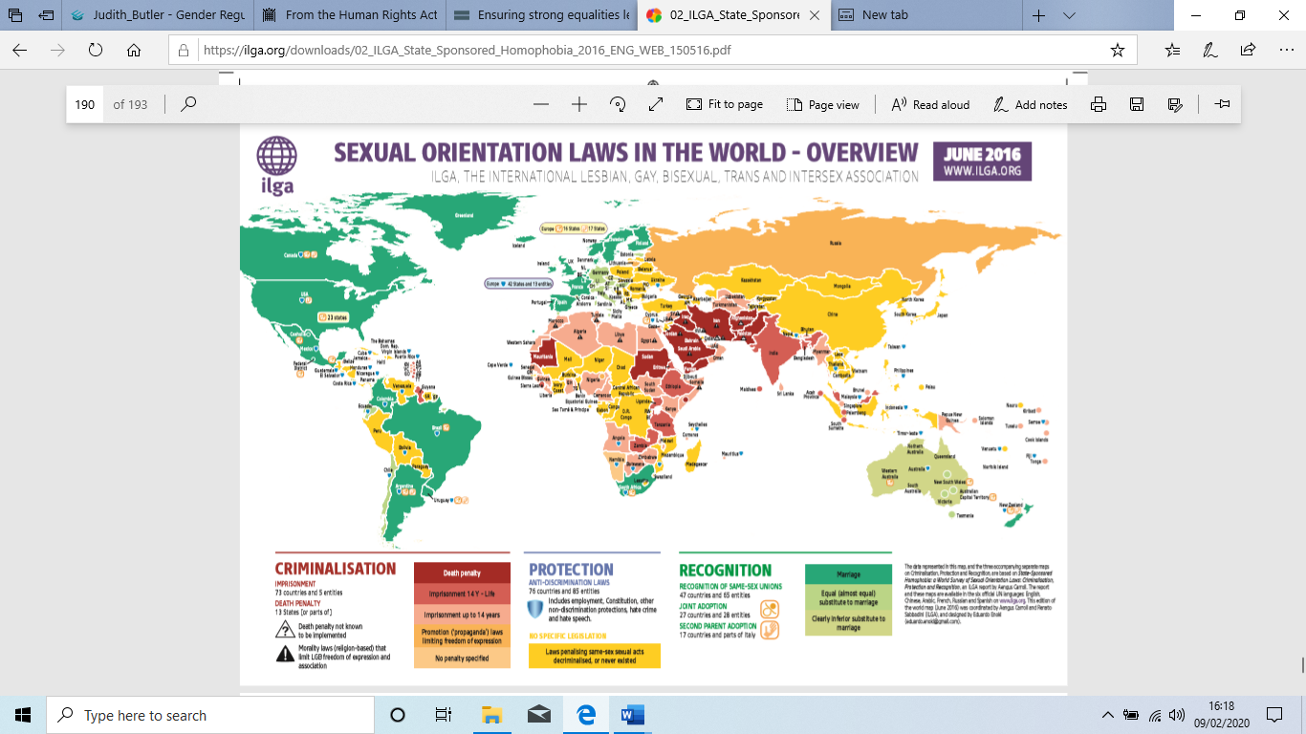
Appendix, a, ‘State-sponsored Homophobia, World Survey of Sexual Orientation Laws: Criminalisation, Protection and Recognition’ pp. 189 -191. Carroll, A., and Ramón Mendos, L. (2016).

This is an Overview map that looks (from a red to green spectrum) at laws that criminalise same-sex sexual relations, laws that include the protection of sexual minorities, and laws that recognize our relationships and families.
1. As explained on the map’s legend in more detail, in the criminalising countries different punishments are indicated in shades of red: for example, death is deep red, and ‘propaganda laws are orange.
2. Countries that have decriminalised, or where same sex relations were never penalised, are coloured yellow.
3. There are small blue shields across this map that indicate there is some form of protection in law, for example, from hate crime or non-discrimination in employment.
4. The countries in shades of green represent those where marriage or civil unions of some form are recognised. On a number of these, small icons represent the presence of joint adoption or second parent adoption that do not discriminate against same sex couples.
Reading this Overview map and looking at the Seychelles – the coding reads that it is a criminalising country, with a penalty of under 14 years, but it also has some non-discrimination provisions that are inclusive of sexual orientation.

The second map in this series focuses on criminalisation. Having indicated the categories in the first map, this delves deeper into the nature of the criminalisation:
1. The base colour of a country indicates the nature of the actual crime – sodomy, acts against nature, buggery, etc. This is explained in the legend in more depth.
2. The second element - maximum sentences - is indicated by a capital letter A through E – ranging from death (A) to 1 month in jail or a fine (E).
3. There are male/female icons for men and for women to indicate which of the binary genders (or those perceived to be in one category or the other by law) is included within the scope of that law.
4. The final element – represented by handcuffs – indicates whether there have been arrests in the past three years (as found in our research).
Reading this Criminalisation map, and looking at Tanzania, one sees the charge is ‘against nature’, with a sentence of between 15 years and life, where the law only applies to men, and where there have been arrests in the past there years.
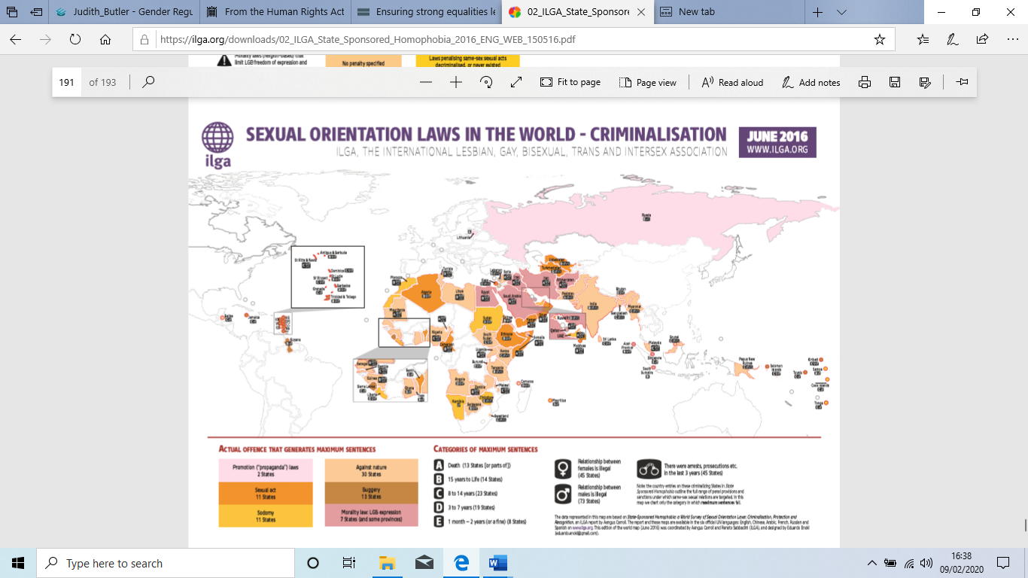
Page. 191 Criminalisation

1.
Where a country is coloured blue, it has employment law that protects against discrimination on grounds of sexual orientation. 2. A pink dot signifi es Constitutional protection, and an orange dot means there are other protections (health, education, housing, etc) that include sexual orientation in their texts. 3. The letter A indicates hate crime legislation inclusive of sexual orientation. 4. B means laws that protect from incitement to hatred (hate speech). 5.
C indicates that there is a national human rights institution active. These are often important sites for the early development of what will become laws and policies in States.
Reading this Protection map, and looking at Germany, one sees that it has protective employment law (blue), some other nondiscrimination law (orange dot), but no hate crime or incitement to hatred laws (absence of A and B), while it does have a human rights institution inclusive of sexual orientation (C). Luxembourg on the other hand has the same, but has both hate laws (A and B).
The fi nal map is on Recognition. Much as the Overview map, this specifi es
1. The status of relationship recognition: marriage, strong or weak civil partnership. 2. Where joint adoption and second parent adoption exist in Europe (the most dense area).
Reading this Recognition map, and looking at Iceland, one sees there is marriage equality in that State, and both joint adoption and second parent adoption are available to same sex couples.

The third map (blue) concerns Protection. The Overview map indicated protection with a shield – this map explains the nature of those protections in detail.
1. Where a country is coloured blue, it has employment law that protects against discrimination on grounds of sexual orientation.
2. A pink dot signifies Constitutional protection, and an orange dot means there are other protections (health, education, housing, etc) that include sexual orientation in their texts.
3. The letter A indicates hate crime legislation inclusive of sexual orientation.
4. B means laws that protect from incitement to hatred (hate speech).
5. C indicates that there is a national human rights institution active. These are often important sites for the early development of what will become laws and policies in States.
Reading this Protection map, and looking at Germany, one sees that it has protective employment law (blue), some other non-discrimination law (orange dot), but no hate crime or incitement to hatred laws (absence of A and B), while it does have a human rights institution inclusive of sexual orientation (C). Luxembourg on the other hand has the same but has both hate laws (A and B).
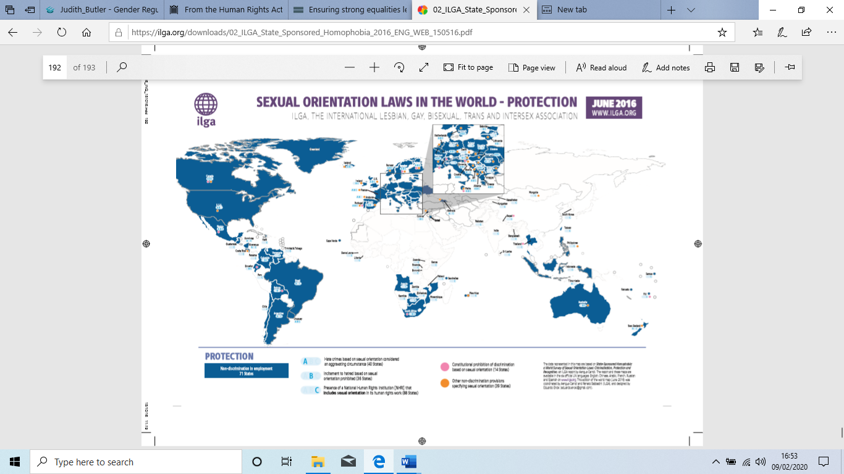
Page 192 Protection

