Dissertation Proposal
How did Elizabeth I represent herself during her time and how does this compare to modern representations of her?
Many films and books have been written about the imagined life of Elizabeth I, some more historically accurate than others. In Elizabeth’s own time she commissioned many portraits of herself with symbols purposefully used to portray herself to others in a way that she approved of the symbols changed based on the political message that she aimed to portray. In modern times she still holds people’s imaginations due to controversies in her reign and also the fact that she never married which lends itself to forbidden romances on the silver screen. Elizabeth’s reign was a tumultuous time as yet again after the reformation England was a Protestant country again changed after the reign of Mary I who made England a Catholic country and punished Protestants. This clash of religions left Elizabeth in a precarious position as the Pope was against her reign as was Spain and the French who aimed to put Mary Queen of Scots on the throne, therefore, Elizabeth used portraits and the symbols within as a form of propaganda to portray her message to the world that she was a secure and powerful ruler. This is seen in the most recent film featuring Elizabeth called Mary Queen of Scots which details their rivalry as monarchs. As Mary was Elizabeth’s catholic cousin who some saw as having a more legitimate claim to the throne due to the fact Elizabeth was declared as illegitimate after her mother was beheaded, this fed into Elizabeth’s need for control to prove that she was the legitimate ruler of England.
This is a compelling question to ask how, Elizabeth represented herself compared to how others in the modern day have represented Elizabeth. This is because in her own portraits it can be seen that symbols were changed or altered later perhaps due to a meaning that Elizabeth decided against. Portraits are interesting to look at as science has advanced allowing us to look underneath the paintings so that we can see how the painting evolved, or some like the portrait below were cleaned but underneath the layers have been revealed.
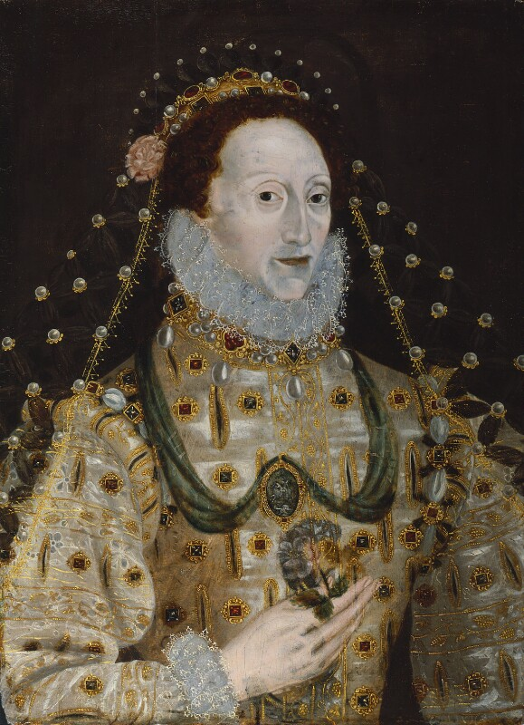
Queen Elizabeth I by unknown from 1580s to 1590s
I am also very interested in the symbolism of this time as it was implied and art was also used by others in the Elizabethan court to further gain favour with the queen as it was used to encourage her to marry as they did not want to openly ask for this in fear that the Queen would take offense as often those presenting this fact were in hopes that Elizabeth would consider them a candidate for marriage. The image that Elizabeth portrayed of herself changed on the basis of the political climate throughout her reign which can be seen in the evolution of her portraits. The detailed account from one of these cases is written by George Gascoigne called The Princely Pleasures, at the Court at Kenilworth, this was done by Robert Dudley some say as a bid to propose to Elizabeth with a special play put on begging Elizabeth to marry which will be interesting to analyse the symbols used to portray the meaning subliminally as some say that he put this pay on specifically to propose. After her reign Elizabeth still, intrigued others and one of her controversies inspired Walter Scott’s book titled Kenilworth written in 1821 sparked Victorian intrigue into the death of Amy Robsart. Who was married to Queen Elizabeth’s favourite Robert Dudley who died under suspicious circumstances, being found dead at the bottom of a staircase in her stately home in Oxford, this was suspicious as there were rumours surrounding Elizabeth and Dudley’s relationship, the rumours also went so far as to speculate that Dudley was planning on poisoning his wife. Therefore, with these rumours prevalent at court when she was found dead it sparked intrigue and ruined Dudley’s reputation as many believed there was foul practice at play. This book went on to inspire others to make films and plays because of this work including Victor Hugo. Many films have based their films on Elizabeth around romances with her favourites such as Robert Dudley and Francis Drake using history to portray what the writers of the films imagine as may have happened or perhaps are inspired by the rumours of the court to produce a pseudo history to entertain audiences. This carried on into the 20th century as we are still captivated by the mystery as we will never know if she was killed or merely fell down the stairs in a tragic accident. The most recent film Mary Queen of Scots does not have a lot of scholarship written on it which is a gap that through my research I hope to fill. Therefore, it will be good to look at and analyse as it is exploring one of the biggest controversies of Elizabeth’s reign as many feel sorry for Mary and others see why Elizabeth had to do it. This will therefore be interesting to look into how this is portrayed as the filmmakers could take an objective view or they may lean towards one side more and make them appear more sympathetic than another therefore colouring the audiences view of the character and perhaps even the historical event itself. The analysis of films and literature also allows us to see how people in the modern day view the Elizabethan era and also can allow us to see how the politics and historical events occurring in the moment of writing films and literature how that effects the view of the author and how that in turn effects the portrayal of the time. For instance, the views from this event could change based on the recent vote for Scottish independence therefore modern-day interpretation of the event could alter their portrayal based on whether they are for or against Scottish independence. This could therefore mean the writer would portray Mary as a tragic victim of English oppression therefore making Elizabeth the villain and aggressor in the matter.
The evidence which I shall be using is a mix of portraits from her time as some of them like the Armada portrait have had work done where they x-ray the paintings to reveal the different layers of the portrait which then shed new light on the portrait as it presents what has been changed. I shall also be using the national portrait gallery to obtain the portraits as they have been digitised for ease of use, furthermore the use of digitised paintings allows for zooming in on the image and therefore able to pick out small details, of course going to art galleries and museums to view the portraits would also allow to see details that perhaps do not appear as clearly on a digital version. To help analyse these symbols I shall be using Gloriana portraits of Queen Elizabeth I by Roy Strong who has been the director of the National Portrait Gallery thus having detailed knowledge of the portraits owned of Elizabeth thus his book details the different symbols and also the meaning behind these symbols. I shall also be using the Langley letter which details the gardens at Kenilworth, owned by Robert Dudley as he was gifted the castle in 1563, which he specifically made for Elizabeth in her visit in 1575 and see if the myths which adorn the fountain could have any subliminal images associated with them. These images would perhaps urge Elizabeth to marry or perhaps consider Robert Dudley a potential suitor and The Princely Pleasures, at the Court at Kenilworth written by George Gascoigne which detail the entertainments which occurred in Kenilworth castle and research the symbolism found in these entertainments. I shall also use Walter Scott’s novel Kenilworth to explore the Victorian attitude towards Elizabeth I and how they represented her based on their strict rules on decorum. I shall be using many films that focus on queen Elizabeth most notably Mary Queen of Scots I shall also use previous films and perhaps even Blackadder to be used as a comparison between how Elizabeth is portrayed in a historical drama compared to a historical comedy. I shall also be using scholarship to back up my points that detail literature about Elizabethan portraits and scholarly reviews of films and how the history was portrayed. I shall also be using biographies of Elizabeth’s life so that I can discern the political climate at the time of the portraits were commissioned in and also the historical events the films are based on thus knowing what in the film is historical fact and what is fiction made for the entertainment of the audience. I shall also be using England's Elizabeth: An Afterlife in Fame and Fantasy by Michael Dobson and Nicola J. Watson to analyse how her image has changed throughout time as it depicts the different iterations of Elizabeth from plays to novels to books.

I propose that the structure of my dissertation will start with a focus on portraits of queen Elizabeth. While looking at the portraits I will be considering the meaning of the symbolism used within the portraits and how they related to what was happening politically at the time of the portraits. I have not yet come to a definitive conclusion whether I shall add my analysis of the gardens and festivities of Kenilworth castle in the first chapter discussing how Elizabeth was portrayed by others in her time or perhaps put it into the second chapter considering how others have portrayed her. I will also be considering why some symbols were painted over and the reasoning behind this. The second chapter of my dissertation shall move into the work of Walter Scott and analyse his portrayal if Elizabeth in his novel Kenilworth and why he portrayed her in this way. Also, in the second chapter I shall analyse plays written in her time by William Shakespeare as often plays detailing the Tudors such as Henry VIII was commissioned by her so would have some influences from her own reign, thus Shakespeare would have to portray the Tudors in a positive light. In my third and final chapter I plan to analyse Elizabeth’s portrayal in modern film and television, paying particularly close attention to the most recent portrayal of Elizabeth in Mary Queen of Scots. I shall also be considering how her portrayal in movies has perhaps changed and if her portrayal changes based on how the writers view particular events and controversies within her reign. So far, the conclusion that may be reached would be that Elizabeth used portraiture to portray a message of herself as a strong ruler who is married to her country and is the virgin queen, compared to modern interpretations which portray her flaws such as her emotional outbursts portraying her as more of a three-dimensional human character than she would want those around her to believe during her own time.
In conclusion, this is a timely question as the representation of queen Elizabeth has changed through time based on what political events were happening during the period which in turn coloured how the writers perceived previous historical events. Kenilworth has proven to be a classic book inspiring plays and movies furthermore it excites suspicion into the controversy that permeated Elizabeth’s reign and also is still intriguing today as it is a mystery that will never be solved, we can merely speculate as the events of that day in 1560. There are also a multitude of books detailing her life but only a few go into detail about the symbolism behind the portraits and her recent portrayal in films. The most recent film Mary Queen of Scots poses a keen interest due to the recent political climate due to the rise in support in Scottish independence especially after vote the vote to leave the EU. Therefore, this could change how queen Elizabeth is viewed as it may reflect the feelings of the creators when the film was written.

Bibliography:
Primary Sources:
Gascoigne George, The Princely Pleasures at the Court at Kenelwoorth: In the Year 1576 (1821), 1st edn (US: Kessinger Publishing, 1900).
Sir Walter Scott, Kenilworth (US: CreateSpace Independent Publishing Platform, 2009).
Secondary sources:
Dobson Michael and Watson J. Nicola, England's Elizabeth: An Afterlife in Fame and Fantasy (Oxford: Oxford University Press, 2002).
Martyn Trea, Elizabeth in the Garden: A Story of Love, Rivalry and Spectacular Design (London: Faber and Faber Ltd, 2008).
Skidmore Chris, Death and the Virgin (London: Weidenfeld and Nicolson, 2010).
Starky David, Elizabeth (London: Vintage Books, 2001).
Strong Roy, Gloriana portraits of Queen Elizabeth I, 2nd edn (London: Thames & Hudson Ltd, 1987).
Weir Alison, Elizabeth the Queen (London: Vintage Books, 2009).
Films:
‘Anonymous’, dir. by Roland Emmerich (Sony Pictures Releasing, 2011).
‘Elizabeth: The Golden Age’, dir. by Shekhar Kapur (Universal Pictures, 2007).
‘Elizabeth’ dir. by Shekhar Kapur (Gramercy Pictures,1998).
‘Mary Queen of Scots’, dir. by Josie Rourke (Universal Pictures, 2019).
Portraits:
Marcus Gheeraerts the Younger, The Ditchley portrait [Oil on canvas] (1592) <https://www.npg.org.uk/collections/search/portrait/mw02079/Queen-Elizabeth-I-The-Ditchley-portrait?LinkID=mp01452&search=sas&sText=Elizabeth+I&role=sit&rNo=10> (accessed 16/10/19).
Oliver Isaac, Elizabeth I and the Three Goddesses [Watercolour and body colour on vellum] (1590) <https://www.npg.org.uk/collections/search/portrait/mw224945/Queen-Elizabeth-I-Elizabeth-I-and-the-Three-Goddesses?LinkID=mp01452&search=sas&sText=Elizabeth+I&role=sit&rNo=9> (accessed 16/10/19).
Unknown, Armada portrait [Oil on panel] (1588) <https://www.npg.org.uk/collections/search/portrait/mw02077/Queen-Elizabeth-I> (accessed 16/10/19).
Unknown, Queen Elizabeth I [Oil on panel] (1580-90) <https://www.npg.org.uk/collections/search/portrait/mw02076/Queen-Elizabeth-I?LinkID=mp01452&search=sas&sText=Elizabeth+I&role=sit&rNo=6>(accessed 15/10/19).
Unknown, The Coronation portrait [Oil on panel] (1600) <https://www.npg.org.uk/collections/search/portrait/mw02070/Queen-Elizabeth-I?LinkID=mp01452&search=sas&sText=Elizabeth+I&role=sit&rNo=12> (accessed 16/10/19).

Unknown, Queen Elizabeth I [Oil on panel] (1580-90) <https://www.npg.org.uk/collections/search/portrait/mw02076/Queen-Elizabeth-I?LinkID=mp01452&search=sas&sText=Elizabeth+I&role=sit&rNo=6> (accessed 15/10/19).
George Gascoigne, The Princely Pleasures at the Court at Kenelwoorth: In the Year 1576 (1821), 1st edn (US: Kessinger Publishing, 1900).
Sir Walter Scott, Kenilworth (US: CreateSpace Independent Publishing Platform, 2009).
‘Mary Queen of Scots’, dir. by Josie Rourke (Universal Pictures, 2019).
I shall be using portraits such as: The Armada Portrait, by unknown from 1588 Queen Elizabeth I, by unknown from 1580s to 1590s The Ditchley portrait, by Marcus Gheeraerts the Younger from 1592 Elizabeth I and the Three Goddesses, by Isaac Oliver from 1590 The Coronation portrait, by Unknown from 1600 (copy of lost portrait from 1559)
Roy Strong, Gloriana portraits of Queen Elizabeth I, 2nd edn (London: Thames & Hudson Ltd, 1987).
George Gascoigne, The Princely Pleasures at the Court at Kenelwoorth: In the Year 1576 (1821), 1st edn (US: Kessinger Publishing, 1900).
Michael Dobson and Nicola J. Watson, England's Elizabeth: An Afterlife in Fame and Fantasy (Oxford: Oxford University Press, 2002).

